7 July 2022

Disability Advocacy Secretariat
Department of Social Services
By email

Dear Disability Advocacy secretariat

RE: National Disability Advocacy Framework submission

The Physical Disability Council of NSW (PDCN) appreciates the opportunity to contribute to the consultation on the draft for a new National Disability Advocacy Framework 2022-2025 (the Framework).

Due to internal capacity issues, PDCN have not been able to provide a separate written submission, however have contributed and wish to add our support to the submission completed by our national peak body, the Disability Advocacy Network Australia (DANA) on the draft Framework and what is needed to realise its intended Outcomes.

We would like to add particular emphasis to the inclusion of the NDIS Act 2013 as one of the key pieces of legislation that should inform the Principles of the Framework.

We completely agree with the proposed shared responsibilities for this framework and the provision of advocacy across both Federal and State and Territory jurisdictions, this is of fundamental importance to achieving the outcomes of the Framework.

Our organisation believes the highest priority is a commitment to fully funding disability advocacy organisations to be able to meet the current unmet demand and need for advocacy, alongside of the establishment of a nationally coordinated approach to guidelines, processes and outcomes reporting.

We urge the Disability Reform Ministers and their respective governments to prioritise this work and make strong commitments on disability advocacy funding and collaboration to help realise the vision of Australia’s Disability Strategy 2021-31 and the National Disability Insurance Scheme: an Australia that includes and values people with disability and respects human rights for all.

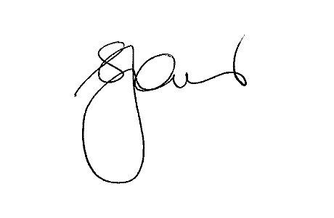
Sincerely,

Serena Ovens
Chief Executive Officer

