Summary report: Consultations on the

Draft National Disability Advocacy Framework 2022-2025

The Australian, State and Territory Governments have drafted a new National Disability Advocacy Framework 2022-2025 (draft Framework). From April – July 2022, the Department of Social Services asked for feedback on the draft Framework.
The Framework shows how governments will work to:
- help protect the rights of people with disability
- help break down barriers for people with disability
- continue to meet the needs of people with disability as things change.
The draft Framework wants to make sure:
People with disability access effective disability advocacy that promotes, protects and ensures their full and equal enjoyment of all human rights, enabling full community participation and inclusion.

Engagement
We spoke to more than 520 people. About half of them were people with disability. They talked about:
- what they think about the draft Framework
- how well they think disability advocacy is working
- what they think needs to be done to make sure there are good outcomes from disability advocacy.
A snapshot of the activities and who participated is on page 4.
There were specific community discussions with First Nations people in four communities across Northern Territory, Queensland, and New South Wales.
This summary report reflects The Social Deck’s independent analysis of the common things people shared during consultations.

Vision – what good advocacy looks like
The wordcloud below shows the words people used most when asked what good advocacy looks like. They said advocacy should be empowering and must be accessible and timely so that people can get it when they need it. When people ask for advocacy, they want to make sure it will be respectful, inclusive and person-centred. People also said that good advocacy should be independent, listen to what a person needs and give clear advice about how it can help support a person’s rights and access.
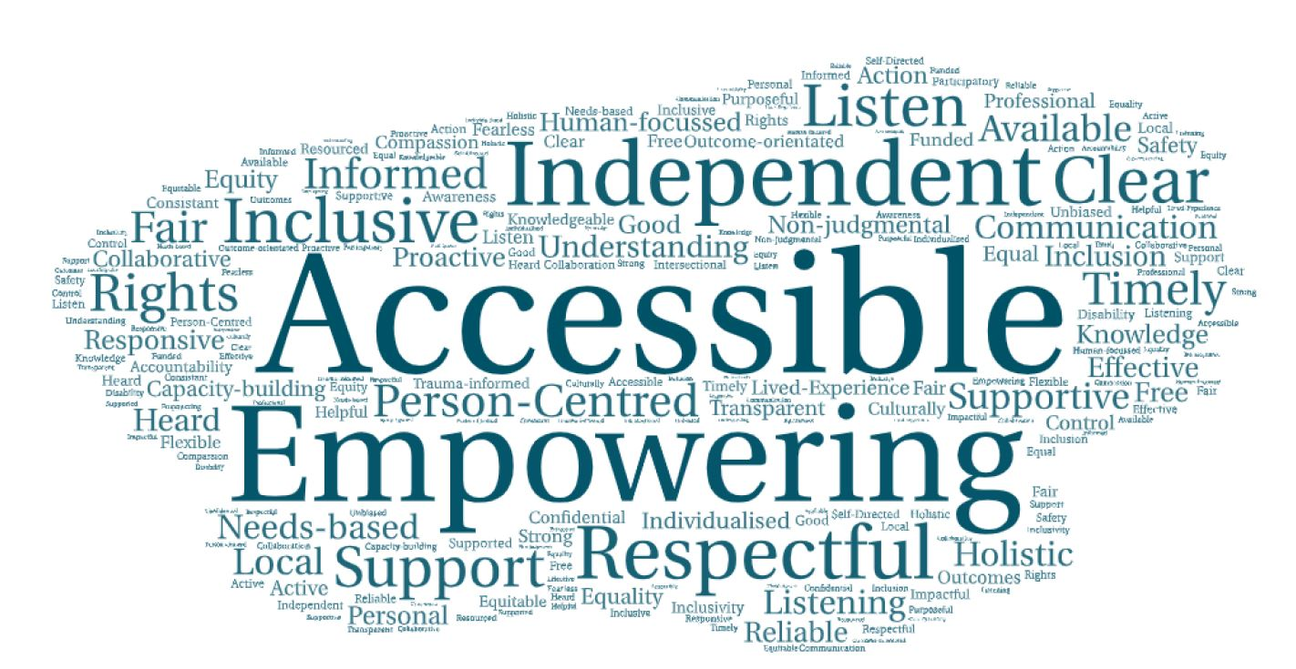
Figure 1. Combined responses across community forums to the question: ‘What three words would you use to describe what good advocacy looks like?’

What needs to happen to make sure there is good advocacy
People with disability, their families and carers gave a range of reasons why they may be unable to get good advocacy. Advocacy organisations also said there are some key issues that affect their ability to support people with disability. People said these issues need to be addressed so the Framework is effective and gets good outcomes for people with disability.
People raised the following common barriers and issues:
- Funding and resourcing for advocacy organisations. Many organisations reported that funding for advocacy has not kept pace with an increasing demand for advocacy services, suggesting complexity in systems such as the introduction of the National Disability Insurance Scheme (NDIS), housing and healthcare as contributing factors. Aboriginal and Torres Strait Islander people and organisations said a lack of resourcing is making it hard to get much-needed advocacy supports in community.
- Awareness and understanding of advocacy, what it is and how it is used.
- Geographic barriers, like having less access to advocacy in regional areas.
- Cultural barriers and considerations, including making sure that people know that advocacy comes in many forms for different cultures and communities and not all cultures know or understand the term ‘advocacy’.
- More training and staff in advocacy services to support people. People with disability and organisations both said that services have problems keeping staff because of poor resourcing.
- Issues with coordination between services. People said they need to share their stories multiple times and go through different people to get problems fixed. This was especially important in Aboriginal and Torres Strait Islander communities and for people who may be experiencing issues with financial insecurity and access to housing, health or other vital services.
- Trust and fear of judgement, with some people saying they are worried about asking for advocacy in case it affects the support they get (for example, from disability services you complain about). Aboriginal and Torres Strait Islander participants said that trust is an important part of making sure advocacy is culturally safe.

Feedback on the draft Framework
Participants most commonly suggested the following areas of change or consideration for the draft National Disability Advocacy Framework. Some people, and many organisations (in their submissions), also gave specific feedback to update wording. These are being considered by governments.
Principles
The principles in the draft Framework were broadly supported.  People supported having a dedicated principle for Aboriginal and Torres Strait Islander people with disability but said this should be moved to earlier in the Framework. | Common areas people suggested need to be improved or clarified in the principles:  - Co-design with people with disability to be in place across all areas  - Include improved access to information as part of the principles  - Better acknowledge communities, families, and people who play an informal advocacy role  - Stronger wording about how to make sure people have access to advocacy that meets their needs and in the location they choose  - Don’t assume people know their rights. Make sure there is awareness and education about this as part of improving disability advocacy  - Make sure it’s clear that all types of advocacy—e.g. access to services or justice—must be designed for people’s needs and be safe and culturally appropriate  - Make sure the principles talk about advocacy being independent without conflicts of interest  - Focus on the social model of disability, where society is responsible for inclusion and accessibility.  - Support the principles with action.
Outcomes
Most people supported the outcomes and didn’t find any major gaps.  People had several comments about what is needed to achieve the outcomes. These included that governments need to be able to measure progress against these outcomes to show that advocacy is making a positive difference to people’s lives. | Common areas of feedback about the outcomes:  - People with disability should be at the front of policy and decision making  - Advocacy must protect the rights of people with disability  - Outcomes need to address the current lack of access to advocacy for many people with disability  - Participants were worried that some people with disability are being left behind because there are not enough advocates in the community to meet the needs of people with different kinds of disability  - There needs to be a focus on improving complaints processes so people’s rights are upheld and they are safe  - Funding and support are needed for advocates to help achieve the outcomes set out in the Framework, especially towards:  - greater participation of people with disability in the community  - improved accessibility in communities  - better public awareness  - Include an outcome that helps make sure more people understand the barriers faced by people with disability  - Recognise that more advocacy is needed to help people navigate, access and use complex systems including the NDIS, housing and healthcare  - Outcomes should improve the awareness and understanding of advocacy among people with disability and in the community
Commitments
People agreed with the responsibilities and commitments outlined in the draft Framework.  People generally thought the most important commitments were:  - involvement of people with disability  - fair advocacy funding  - awareness of rights of people with disability and importance of advocacy. | Common areas of feedback about the commitments:  - The need for a clear plan for putting the Framework into action, so it is not just words on a page  - Governments need to make sure people with disability are involved in all parts of the design of advocacy and how it is carried out  - Advocacy services and support should be community-led and designed with First Nations and Torres Strait Islander people  - Funding for disability advocacy should be fair and not based on population, but for who and where it’s needed
Implementation
People were concerned there isn’t enough detail about how the Framework will be put into practice, especially how governments will make sure it works the same across all states and territories. | Common things people said are needed to implement the Framework, and make sure advocacy is right for disability now and into the future:  - More funding, for longer periods  - Promoting the Framework (and disability advocacy) widely  - Showing if advocacy is working and how, backed up by evidence  - Making sure people with disability are involved in designing, running and reviewing the National Disability Advocacy Framework.
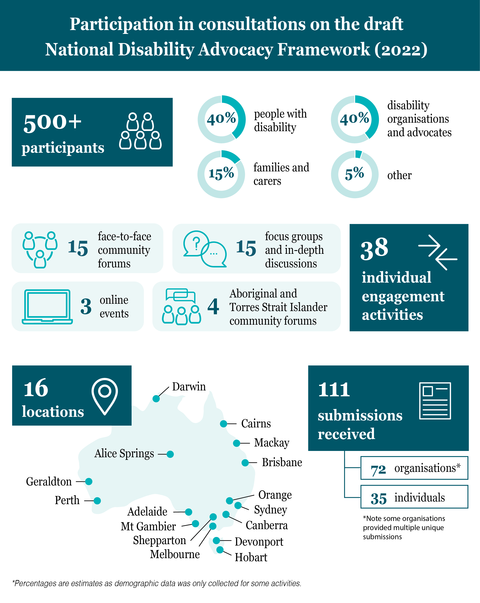
Figure 2. Infographic showing the number of participants, percentages of representation and types of activities undertaken during the consultations to inform the National Disability Advocacy Framework 2022-2025

