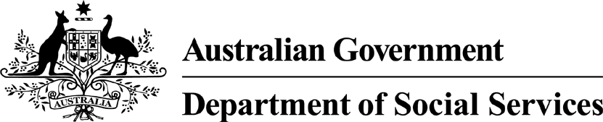

Draft National Disability
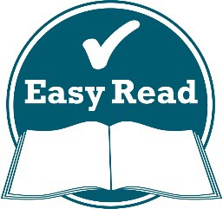
Advocacy Framework 2022–2025

An Easy Read guide
We want to know what you think

Questions to think about

Question 1
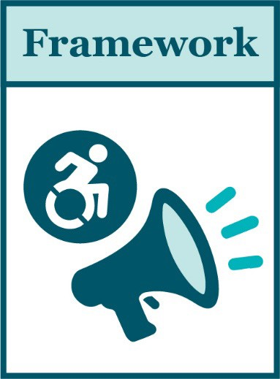
Does our Framework include everything you think disability advocacy is about?
If you don’t think so, what do we need to change?
Please share your answer in the box below.

no, advocay services also make sure research projects are ethical. I would like disability advocates not only to protect the person but make sure they recieve all their human rights they deserve and provide examples of action they can take if they are not upheld. Taking part in the community and recieving extra support when necessary is just a couple of examples.

Question 2
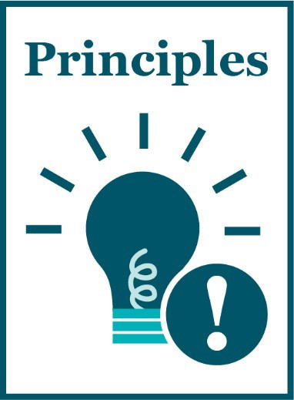
Will our principles work well to help disability advocacy deliver good services?
If you don’t think so, what do we need to change?
Please share your answer in the box below.
advocacy will not work well if the person with a disability cannot understand what is said and it is essential for good advocacy. There is lots of news and information but the easy English is limited. I would like to see a responsibility of providing more in EE. It would be very helpful if governments use easy words in speaking to us. Also the NDIS could have an advocacy team ensuring individuals understand.

Question 3
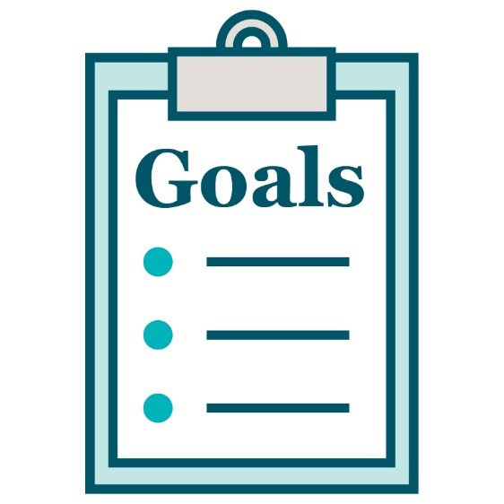
Will our goals work well?
Which goals are most important to you?
What goals are missing?
Please share your answer in the box below.
i think they are good. i did not see anything about people with disability being able to understand all aspects of their life.

Question 4
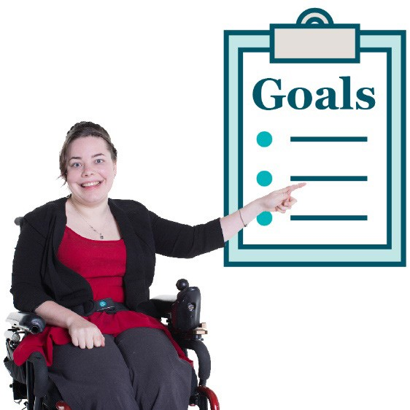
Will the way we want to reach our goals work well?
Are there other ways we can reach our goals?
Please share your answer in the box below.

as long as the principles are followed and the goals are acted upon with a committment from government they should work well. this framework could be a responsibility of advocacy services too.

Question 5
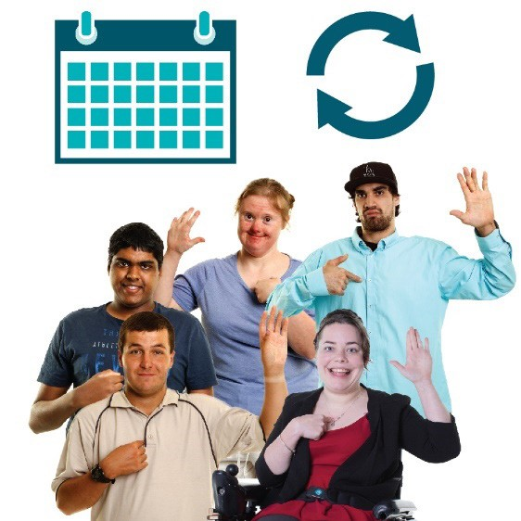
Does our Framework talk about what we need to do for people with disability:
- now?
- in the future?
If you don’t think so, what do we need to change?

Please share your answer in the box below.
yes

Question 6
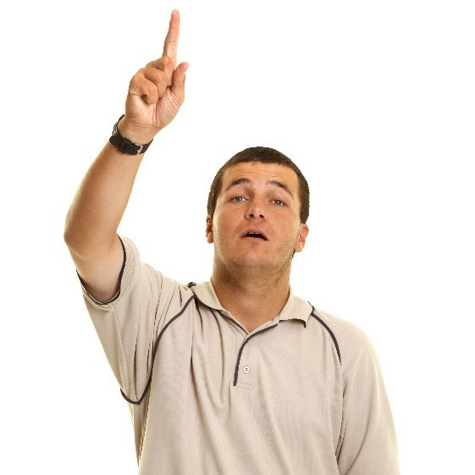
Do you have anything else to share about our Framework?
Please share your answer in the box below.

it is good that it is reviewed and updated often. this framework could be widely shared with all people so they know what to expect.

What happens next?
We will:
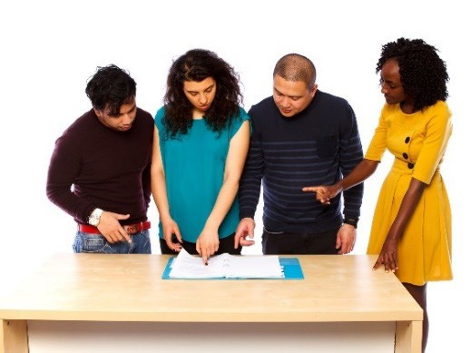
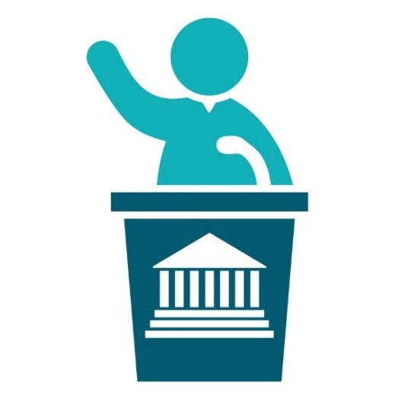
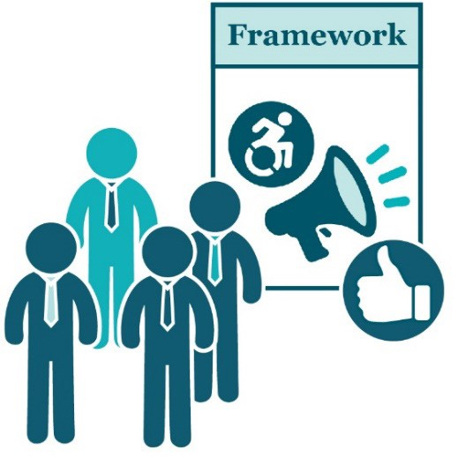
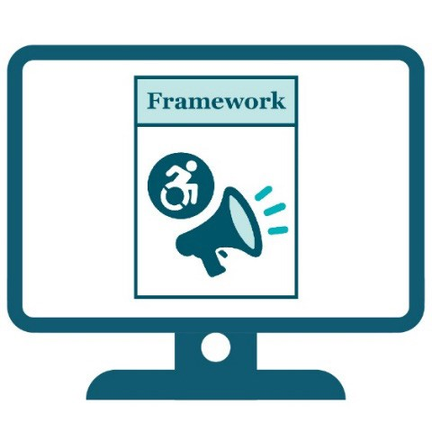
- look at your ideas

- use them in the final plan.

We will give our final plan to the minister for disability in each state and territory.

A minister leads an area of the government.

All the ministers for disability will agree to the Framework.

Then we will share the Framework on our website.

Word list
This list explains what the bold words in this document mean.
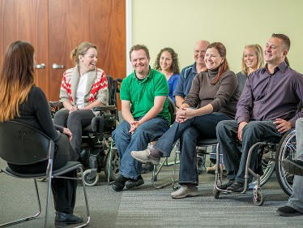
Advocacy services Advocacy services:
- support you
- help you have your say

- give you information and advice.

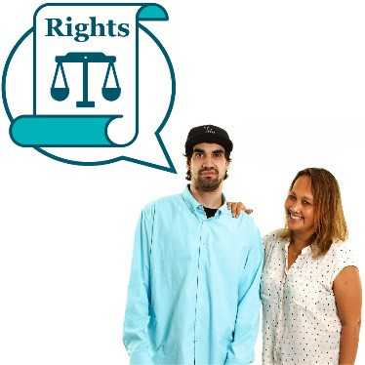
Disability advocacy
Disability advocacy is when someone supports you to speak up for your rights.

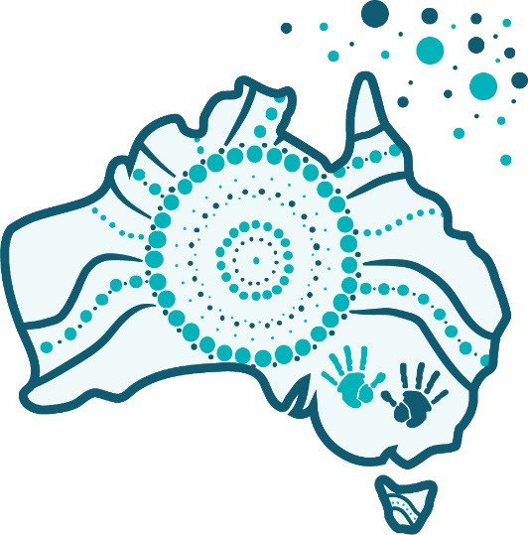
First Nations peoples
First Nations peoples are also known as Aboriginal and Torres Strait Islander peoples.

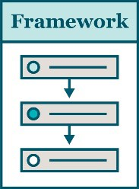
Framework
A framework explains how things should work.

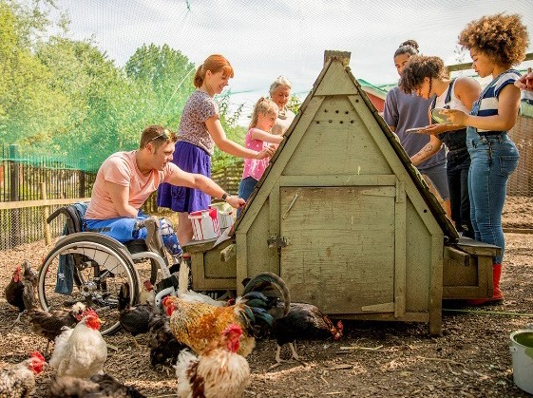
Inclusive
When something is inclusive, everyone can take part.

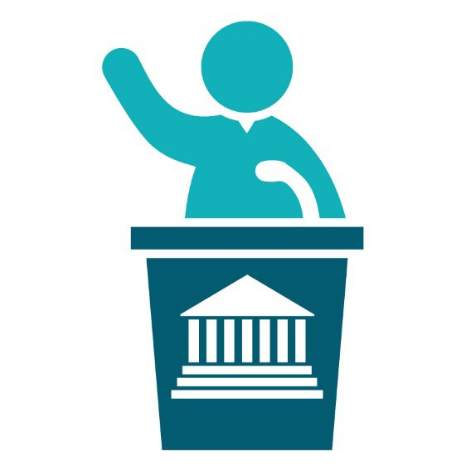
Minister
A minister leads an area of the government.

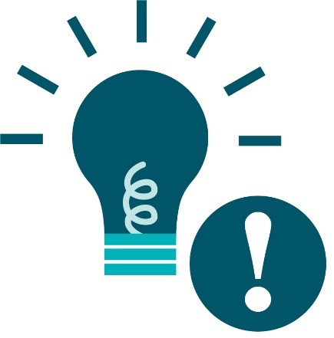
Principles
Principles are important ideas that we should always think about.

Rights
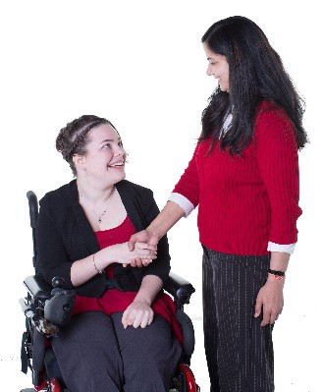
Rights are rules about how everybody should be treated:
- fairly
- equally

- with respect.

Contact us
TTY

1800 555 677

Speak and listen
1800 555 727

DisabilityAdvocacySecretariat@dss.gov.au

www.engage.dss.gov.au

This Easy Read document was created by the Information Access Group using stock photography and custom images. The images may not be reused without permission. For any enquiries about the images,
please visit www.informationaccessgroup.com. Quote job number 4611-B.

