Let’s yarn about a National Autism Strategy
Australia will soon have a National Autism Strategy that will help autistic people live the lives they want and deserve.
Before that happens, the Government will ask communities what they think should be in it. Aboriginal and Torres Strait Islander voices will be heard when consultations begin later in 2023.

For equity in life outcomes
Many parts of life are not equal between autistic people and the general population. This gap in equality is bigger for Aboriginal and Torres Strait Islander autistic people.
A National Autism Strategy would help to give autistic people equal opportunity for life outcomes like:
- living long and healthy lives
- getting a job and having a fulfilling career
- opportunities at school or university.
The strategy will have a national focus on getting better life outcomes for autistic people.
It will look at how governments and services can better work together to support autistic people.
Visit dss.gov.au/National-Autism-Strategy to see how you can have your say.

Hearing your voices
Listening carefully to the community is the first step to deciding what goes in the Strategy.
There is a group of people called an Oversight Council, including autistic people, that will support the development of the Strategy. They will also help the government make sure autistic people can share their ideas, thoughts and experiences.

Help shape the change
You can help develop the National Autism Strategy. Consultations will begin later in 2023.
Find out more about the National Autism Strategy and how you can be involved at: dss.gov.au/National-Autism-Strategy
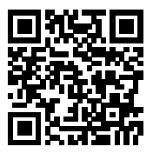
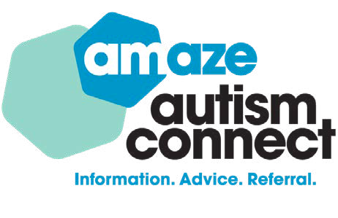
Autism Connect is a free, national helpline providing independent and expert autism information that you can trust over phone, email and webchat.
Call 1300 308 699 to speak with an Autism Connect Advisor or visit amaze.org.au/autismconnect/ to find out more or connect via email or webchat.
24/7 support from First Nations crisis counsellors is available at 13YARN (13 92 76) or by visiting 13yarn.org.au

