Public consultation on the Disability Services and Inclusion Bill 2023
Summary Report
DSS September 2023

Contents
1.0 Introduction 3
1.1 Accessibility 3
2.0 Consultation overview and findings 4
2.1 First Round – A New Act to Replace the Disability Services Act 1986 4
2.1.1 Demographics 4
2.1.2 Consultation Questions 6
2.1.3 Actions and changes after the first round 11
2.2 Second Round – Disability Services and Inclusion Bill 2023 12
2.2.1 Demographics 12
2.2.2 Consultation questions: 13
2.2.3 Actions and changes after the second round 23
3.0 Conclusion 24

1.0 Introduction
The Disability Services and Inclusion Bill 2023 (the Bill) is designed to help deliver the Government’s commitment to enable people with disability to participate fully in society, exercise choice and control over their lives and to improve job opportunities, job readiness and support in employment.
The Bill will repeal and replace the Disability Services Act 1986 (DS Act) and establish a modern legislative framework for the funding and regulation of programs targeted for the benefit of people with disability, their families and carers. The Bill will provide legislative authority for new and existing spending on disability related programs outside the National Disability Insurance Scheme (NDIS). Arrangements and grants made under the proposed Act will be supported by appropriate quality safeguards such a mandatory Code of Conduct and certification standards where appropriate.
To help inform the drafting of this Bill, the department held two rounds of public consultations via DSS Engage website.
- The first round of consultation sought feedback on the intended approach to the repeal and replacement of the Act, which informed the development of the exposure draft of the Bill.
- The second round of consultation included the release of the exposure draft of the Bill and sought feedback on the specific wording and framing of the Bill. This feedback informed the final wording of the Bill that was introduced into the Parliament.
In both rounds of consultation, people with disability were the largest category of respondent.

1.1 Accessibility
The consultation was conducted via DSS Engage, including consultation materials and options for completing an online survey or uploading a submission. Consultation materials were also made available in Easy Read and Auslan formats. Submissions were accepted via email, mail and over the phone. On request, consultation materials were also made available via post.
DSS Engage has been designed to meet Australian Government standards, including those that relate to access for people with disability. The website also aims to conform to Double A of the Web Content Accessibility Guidelines version 2, developed by the World Wide Web Consortium.
Online information sessions were conducted using Microsoft Teams. Invitations were sent via Eventbrite and participants were required to register for a free ticket to receive the link for the meeting. If this was inaccessible, the link was provided directly. The online sessions included live Captioning and an Auslan interpreter was present.

2.0 Consultation overview and findings

2.1 First Round – A New Act to Replace the Disability Services Act 1986
The first round of consultation took place from 7 November 2022 to 12 February 2023. The aim of this consultation was to introduce the plans for repealing and replacing the DS Act, and give the public the opportunity to provide feedback on proposed direction of the new Bill. This consultation period included two rounds of targeted online seminars for organisations who receive funding from the Department of Social Services, including Disability Representative Organisations, Disability Employment Services providers, and advocacy organisations. These seminars were attended by 255 individuals.
Almost 200 responses were received during the first round of consultation and helped to inform the development of the Bill.

2.1.1 Demographics

Submissions received
In total, 189 submissions were received through the first round of consultation. A majority were submitted through DSS Engage, with a small number received by email, phone call, and by mail. As shown in Figure 1 below, of these submissions, half of the respondents identified that they were responding as individuals (50 per cent), with the remainder responding on behalf of organisations (43 per cent) or choosing not to respond to this question (7 per cent).
Figure 1 - Who responded - Individuals and organisations
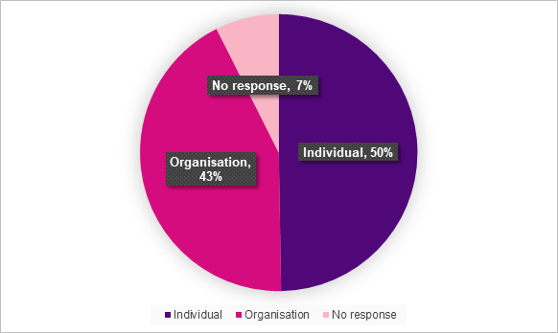
Figure 2 below provides further demographic information about respondents. Many respondents identified as a person with disability (41 per cent) or a carer, friend, or family member (21 per cent). Responses were also received from disability service providers (14 per cent), disability employment providers (12 per cent), peak bodies (10 per cent), and advocacy providers (10 per cent). In addition, 8 per cent of respondents identified that they worked at a disability organisation, 4 per cent of respondents identified as mainstream providers, and 18 per cent selected ‘other’. Note that this question allowed multiple responses.
Figure 2 - Who responded - Identities and roles
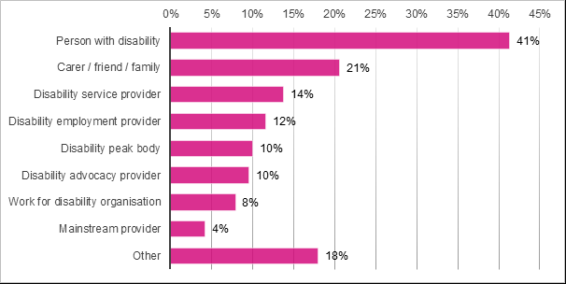
A majority of respondents indicated that they live in a city area (62 per cent), followed by regional (19 per cent) and rural and remote (4 per cent). Remaining respondents preferred not to answer or did not respond (15 per cent).
Responses were received from every state and territory. Respondents included people who identified as culturally or linguistically diverse (12 per cent) and Aboriginal and Torres Strait Islander (2 per cent).

Targeted seminars for existing funded organisations
Alongside public consultation, the department held targeted seminars for organisations who are currently funded by the department to deliver disability supports and services. Seminars were run daily during the week of 5 December 2022 and the week of 30 January 2023.
These seminars were deigned to engage with Disability Representative Organisation (DROs), Disability Employment Service (DES) program providers, Disability Employment Continuity of Support (DECoS) program providers and National Disability Advocacy Program (NDAP) providers. A total of 255 individuals attended these sessions, with 99 attending the first round and 156 attending the second.

2.1.2 Consultation Questions
Feedback received addressed a broad range of topics and issues. To aid in summarising and interpreting these responses, feedback received was sorted into seven broad categories (Figure 3 refers):
- Objects and principles – 18 per cent
- Government funded services - 17 per cent
- Barriers – 15 per cent
- Consultation and co-design – 12 per cent
- Accessibility – 9 per cent
- Definitions – 9 per cent
- Choice and flexibility – 5 per cent
The majority of the remaining feedback related to issues that were assessed as out of scope for the new bill. The inclusion of specific chronic and episodic illnesses were most commonly raised under this category. The new bill does not provide a definition for the term “disability” and does not prescribe a target group. Rather, the bill aims to be broad and flexible to allow for programs funded under the Act to define target groups based on need and circumstance appropriate to the program.
Other issues commonly raised were the National Disability Insurance Scheme (NDIS) and social security payments such as the Disability Support Pension (DSP). The new Act will have no impact on the social security payments and relates to the Commonwealth funded disability services outside of the NDIS.
Overall, responses from individuals showed deep engagement with the consultation materials and responses were detailed and diverse in their nature.
Figure 3 – Feedback received by category
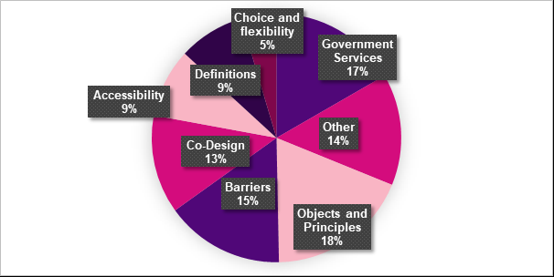
Key themes and feedback about what was most important to respondents under each question are discussed below.

Question 1: Do you agree with the proposed objects for the new Act? What other objects should be included in the new Act?
Of 189 unique submissions received, 154 responses were received to this question (81 per cent). A majority of responses mentioned the objectives and principles of the new Bill. Responses were concerned with inclusion and full participation under the new bill. The respondents were in support of the Bill giving effect to the UN CRPD.
“We welcome the intention of the new Act to give effect to the Convention on the Rights of Persons with Disabilities (CRPD) in promoting the rights, freedom and capacity of people with disability.”
A number of responses indicated that the new bill should be fully inclusive and encourage and support full participation and choice for people with disability.
“I do agree with what has been proposed. I feel that the person living with Disability must have as much choice and control over their lives as possible.”
Responses also indicated that language used in the new bill should be person-centred and holistic. Harm prevention, quality and safeguarding were frequently raised as important principles. Specific feedback was received about the proposed Objects and Principles, with a number of additions and alterations suggested. This included suggestions that the text should draw on the Objects and Principles of the NDIS Act, the definitions and language of the UN CRPD, and the content of the Disability Services (Principles and Objectives) Instrument 2018.
Respondents wanted to be sure that future programs will be created in consultation with people with disability and their families and carers.
Furthermore, responses to this question discussed the importance of addressing barriers, including providing support for education and employment and awareness raising campaigns. Gaps in services and eligibility issues were also raised.

Question 2: Do you agree with the proposed approach to the target group? How do you think the target group should be defined?
A total of 137 responses (72 per cent of total responses) were received for the question regarding target groups. Of these responses, the major concern involved eligibility. Many responses called for the inclusion of episodic or fluctuating disabilities and chronic illnesses. Intersectionality and diversity were the next concern. Many responses wanted to assure that people with compound disadvantage are not left out and diversity is considered in the design of programs. Of those who responded the term ‘disability’ should be defined, many preferred either the social model of disability or the definition used in the United Nation Convention on the Rights of Persons with Disabilities (UN CRPD):
“Yes. Adoption of a social model of disability is long overdue. It acknowledges the complexities experienced by those living with disability (and their families) and points to the additional stresses, needs and strengths that they may bring to their lives.”

Question 3: Do you agree with our suggested principles for avoiding duplication and requiring coordination? What other principles do you think should apply?
Of 121 responses (64 per cent of total responses) to this question, a majority expressed concerns regarding barriers. A common theme of feedback was that gaps between systems were much more of an issue for people with disability than duplication of services. Many expressed concern that a focus on reducing duplication may draw focus away from filling gaps in service delivery:
“However, we are concerned that in the desire to avoid duplication and require coordination, the central point of this Act is lost. The focus of the Disability Services Act should be on those people who fall through the cracks, and who currently do not receive support, due to other problems with the system.”
Commonwealth services were also raised frequently with concerns about mutual and legislative obligations between the Commonwealth government and the states and territory jurisdictions:
“While it is important that services provided by the Commonwealth and States and Territories are not duplicated, it is equally important that people with disability are not excluded from services due to differing eligibility criteria or, due to gaps if neither agency takes responsibility for providing the service. Therefore, coordination is vital to avoid both duplication and gaps in services.”
Concerns were shared regarding the current operation of the NDIS, how the new Bill would interact with the NDIS and specific issues with the NDIS, including eligibility and accessibility.

Question 4: Do you think the new Act should include a definition for disability? Do you have any additional comments?
In total, 139 respondents (74 per cent of total respondents) provided feedback on this question. Out of these 139 responses, 72 respondents (52 per cent) were in favour of a definition of disability being included. For example, some respondents agreed:
“a definition of disability should be included and that the definition should be in line with the UNCRPD.”
In a similar vein, a number of submissions suggested that any definition should be based on the social model of disability. However, there was no clear consensus on a suitable definition, with a range of existing definitions being raised by different respondents.
Conversely, 48 per cent of respondents did not think a definition of disability should be included. A majority of these respondents had concerns that the inclusion of a definition would serve to exclude certain people with disability, including those with chronic illness or episodic conditions. The following excerpt is a good example of the concerns raised:
“No, a definition is too hard to make and will likely end up excluding people who need the support. It is a case of "where do we draw the line?" […] I feel anyone who needs the services should be able to access them without having to pass a defined "level" of disability, whether that be temporarily or permanently, as the situation happens to be.”

Question 5: How do you think that quality and safeguarding arrangements should be managed by the new Act?
Of the 121 responses (64 per cent) to this question, 75 per cent indicated support for regulatory alignment across similar sectors. There was a general recognition of the need for effective regulation, along with the need to consider the regulatory burden for providers operating across multiple sectors:
“Currently, there is a large amount of overlapping quality and safeguarding requirements and audits that, as a service provider, we must meet. This creates much waste of time and money that could be invested in consumer services. A key beneficiary is mostly for-profit businesses performing the external assessments.”
There were also many calls for the strengthening of quality and safeguarding practices. Suggestions included investigative powers, a reliable complaints mechanism and harsher repercussions for breaches.
“I agree with the proposed recommendations, and to ease the burden of duplication, but be closely monitored for any breaches that disadvantage the person with disability/aged care sector.”

Question 6: Do you agree with the supports and services listed in the paper? What other kinds of supports and services should be included in the new Act?
Question 6 received the highest number of responses with 187 submissions providing a response to this question (99 per cent). Across all responses, accessibility was the most commonly raised issue. Respondents stated that all supports and services should be accessible for anyone who may wish to access them. This included use of accessible language, affordability of services, and an uncomplicated application process or referral system. Addressing barriers, and supporting employment, education, health and full participation were also frequently mentioned. This is demonstrated in the following excerpts:
“Improved integration with health, education and employment sectors would improve whole of life support for people with disabilities, at the moment the funding silos mean many people do not receive the support they need to reach their full potential.”
“Yes, we agree with the support and services listed. However, we recommend that support for health (physical and mental health) and wellbeing be explicitly articulated.”

Question 7: Do you consider it necessary to retain separate provisions for employment services and rehabilitation employment program, or could they be combined
116 responses were received for this question (61 per cent of total responses). Of those who responded, 86 expressed a preference for whether the two should be combined (50 respondents, 58 per cent) or kept separate (32 respondents, 37 per cent):
“I think they should be combined together as they are both similar in assessing criteria requirements for employment. I think it would be more effective.”
This was not a universal view, with some respondents in favour of retaining distinctions between the types of service, recommending:
“maintaining separate provisions for the aforementioned areas as each of these program areas provides significantly different services based on the priorities and requirements of the different target groups.”
The Bill provides for broad categories of supports and does not specifically address the structure of programs that receive funding.

Comments and other relevant factors
A total of 101 additional comments were received. Comments were evenly spread across the categories and reflected feedback provided under each question.
Many respondents included references to relevant frameworks or other legislation (both domestic and international) that they considered strong reference points for good practice (such as The Care Act 2014 (UK) and Article 12 of the CRPD). These were noted separately for review. A number of organisations also raised the topic of supported decision making.
Feedback was also provided about the form that the legislation should take, with a focus on ensuring that it was accessible and understandable:
“Consider the complexity of the legislation. It should not require a lawyer to interpret. People with disabilities should be able to interpret the Act themselves or with a carer or advocate.”
Similarly, respondents discussed the importance of promoting the new Act and its intent and impact to people with disability:
“so they can engage if they want and to know their rights if they want to make a challenge or request support.”
A number of respondents also called for feedback from other reviews to be reflected in the Bill, extending from the 1996 Australian Law Review Commission (ALRC) report 79: Making Rights Count: Services for People with a Disability, through to the evidence and themes emerging from the Royal Commission into Violence, Abuse, Neglect and Exploitation of People with Disability (the Disability Royal Commission).

2.1.3 Actions and changes after the first round
Feedback from the first round of consultation informed the development of the exposure draft of the Bill. The Objects and Principles were drafted to include and combine the themes of the NDIS Act and Disability Services (Principles and Objectives) Instrument 2018. Recommendations made during the consultation were considered and implemented where possible within the intended scope of the Bill. Feedback also expressed concern about service gaps, rather than overlap or duplication. While the department will continue to work to ensure supports are not duplicative, this has not been included as an explicit principle of the Bill.
Given the divergent views expressed about the inclusion of a definition for disability, including definitional issues, it was decided to refrain from defining disability within the Bill, ensuring it would be read and interpreted broadly. This broad and inclusive approach was embedded in the Bill, including in the range of supports and services which are able to be funded under the Bill, as well as the funding mechanisms available to program designers.
Feedback was supportive of improved and aligned quality and safeguarding requirements, but expressed caution about the regulatory impact for service providers. Consequently, the Bill was drafted to retain existing arrangements for all current providers until their current funding arrangements end, while also making all providers (existing as well as new) subject to a Code of Conduct. In addition, the Bill retains the National Standards for Disability Services as the default standard for accreditation, while providing a mechanism for recognising alternative standards where appropriate.
Where feedback was not incorporated, this was generally because it went beyond the scope of the Bill. This included calls to address issues in other sectors, or for the Bill to address the rights of people with disability in any sphere. Under Australia’s Disability Strategy 2021-31, all governments have a responsibility to advance the rights and inclusion of people with disability. At the Commonwealth level, the Disability Discrimination Act 1992 and Australian Human Rights Commission Act 1986 is the primary means for upholding rights and addressing discrimination, and this Bill is not intended to reduce or replace the arrangements established through those Acts.
Actions were also taken to address feedback about the consultation itself. This included feedback that Easy Read documents were much too long to be useful. For the second round of consultation, Easy Read content was split into a number of smaller documents. This included an overall summary of the Bill, as well as specific documents to explain what the Bill would mean for people with disability and for providers.

2.2 Second Round – Disability Services and Inclusion Bill 2023
The exposure draft of the Bill was released for public consultation from 3 July 2023 to 13 August 2023. Two rounds of public seminars were held online to discuss the intent and content of the Bill and encourage feedback. These seminars were attended by 295 people.
In total, 65 submissions were received in the second round of consultation. Based on the feedback provided, a number of changes were made to the draft Bill to address concerns or incorporated preferred wording.
To aid in collating and interpreting responses, respondents were also asked to indicate their views about aspects of the draft Bill on a five point Likert scale.

2.2.1 Demographics

Submissions
In total, 65 submissions were received in the second round of consultation. The majority were submitted through DSS Engage, with a small number received by email, or in-person. Of these submissions, almost half of the respondents identified that they were responding as individuals (30), with the remainder responding on behalf of organisations (16) or choosing not to respond (19) to demographic questions (Figure 4 refers).
Figure 4 – Number of Individual and organisation responses
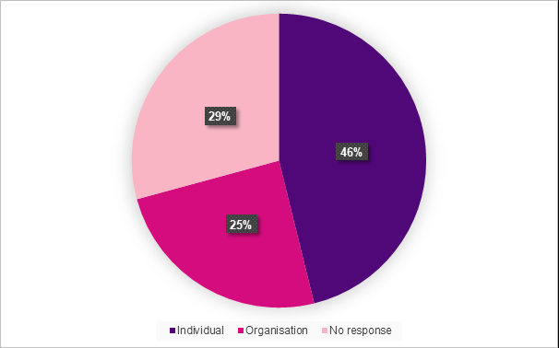
As shown in Figure 5 below, a quarter of respondents identified as a person with disability (25 per cent), carer, friend, or family member of a person with disability (19 per cent). Responses were received from disability service providers (7 per cent), disability employment providers (2 per cent), peak bodies (9 per cent), and advocacy providers (15 per cent). In addition, 6 per cent of respondents identified that they worked at a disability organisation, 4 per cent of respondents identified as mainstream providers, and 14 per cent selected ‘other’. Note that this question allowed multiple responses.
Figure 5 – Who responded - Identities and roles
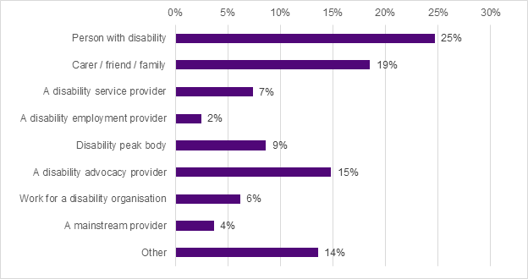
A majority of respondents indicated that they live in a city area (64 per cent), followed by regional (25 per cent) and rural and remote (6 per cent). Remaining respondents preferred not to answer or did not respond (5 per cent).
Responses were received from every state and territory except the Northern Territory. Respondents included people who identified as culturally or linguistically diverse (17 per cent) and Aboriginal and Torres Strait Islander (5 per cent).

Public Seminars
In total 295 people attended online public seminars. The first three days held from 18 to 20 July had 122 attendees and the second set held from 1 to 3 August had 173 attendees. Questions could be submitted anonymously before or during the seminars and responses were compiled into a Frequently Asked Questions document.
A recording of the seminar was uploaded to the DSS Engage website for those who were unable to attend.

2.2.2 Consultation questions:
Responses received were generally positive about the draft Bill. Comments were reviewed and coded according to the same categories as those used in the first round consultation.
In addition, comments which could be specifically addressed within the wording of the draft Bill were reviewed, and all which were feasible and aligned with the intent and scope of the Bill were incorporated in the final text of the Bill.
Figure 6 – Frequency of themes raised in responses
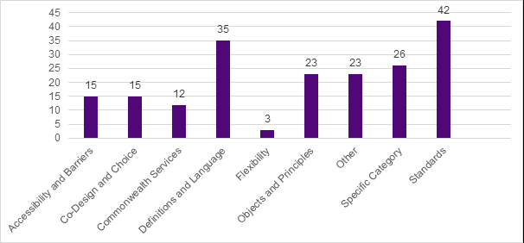
Consistent with the first round of consultation, respondents provided feedback on a wide range of issues, which were grouped to identify the broad themes of the consultation (Figure 6 refers).
The definitions and language used in the draft Bill were frequently raised, with respondents supportive of the broad and inclusive definitions and the decision to forego a definition of disability. At the same time, a number of respondents continued to diverge on the question of defining disability. Respondents were positive about the contemporary language used, with actionable feedback focused on clarifying or adding to the definitions provided. Figure 7 provides more information about the sub-themes that were raised.
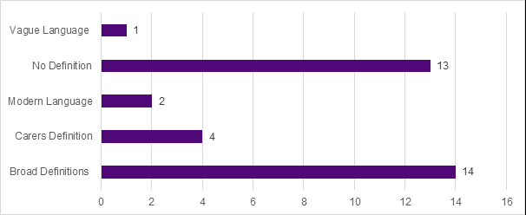
Figure 7 – Sub-themes raised in relation to Definitions and Language Theme

Standards under the Bill were the most frequently mentioned theme overall. Respondents engaged thoughtfully with the proposed approach to quality and safeguarding and supported the proposed mandatory Code of Conduct.
The main concern expressed was how the Code of Conduct would be upheld, with respondents generally expressing that the effectiveness of implementing and monitoring the Code of Conduct was highly important in ensuring the overall effectiveness of quality and safeguarding arrangements under the Bill. Figure 8 below depicts the frequency of each sub-theme.
Figure 8 – Sub-themes raised in relation to Standards theme
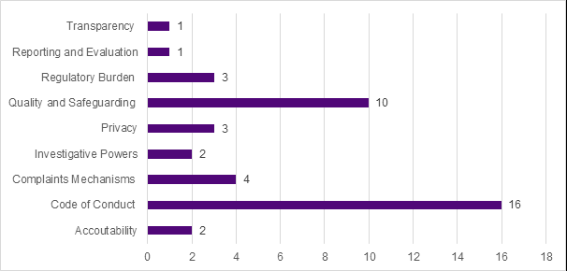
As shown in Figure 9 below, a range of feedback was received in relation to eligible activities under the Bill. This included suggestions for additional eligible activities which should be included, along with suggested changes to the definitions of those already included in the draft Bill. Where comments were within scope and actionable, changes were made to the draft Bill to amend definitions and in some cases add eligible activities. In some cases suggested additions were already covered within the scope of another eligible activity.

Figure 9 – Suggestions received in relation to eligible activities
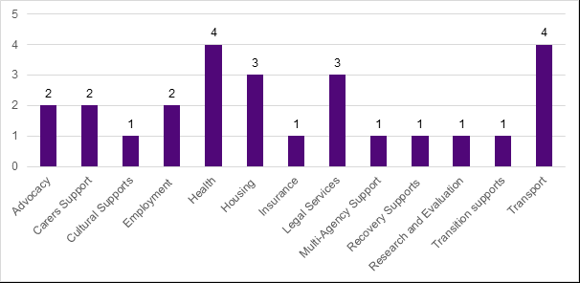

Question 1: Please tell us how much you agree or disagree with the objects and principles in the Bill
A clear majority of respondents agreed or strongly agreed to the objects and principles in the Bill. Illustrative positive and negative responses included:
Strongly agree / agree comments:
“We are pleased that the Bill includes reference to those who do not have a permanent disability.”
“In person centred approach we should be looking at helping people to live a good life, not cut them off as they are not disabled enough.”
Strongly disagree / disagree comments:
“There should be a stronger focus on accessibility to ensure all people with disability (whether they received funded services or not) are included.”
“I agree that everyone should be able to access support and help and I do appreciate that written there, but it’s not happening out in the real world”

Figure 10 – Question 1: Please tell us how much you agree or disagree with the objects and principles in the Bill.
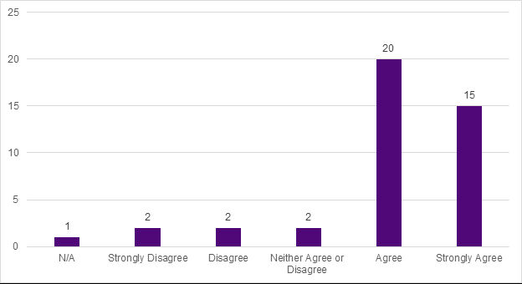
Figure 11 shows the relative frequency of feedback by theme, noting that individual responses could address multiple themes. Definitions and language used in the Bill were the most frequently raised issue under this question (27 percent). Many of these responses were in relation to the exclusion of a definition of disability. Some respondents were concerned that not including a definition for disability would cause confusion about who can access services. Others agreed with the decision not to include a definition of disability.
Figure 11 – Question 1 – Per cent of responses by theme frequency
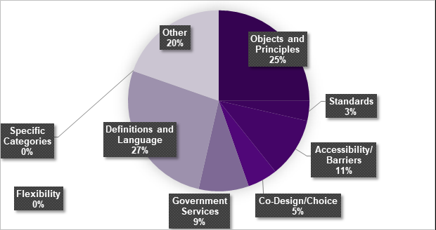

Question 2: Please tell us how much you agree or disagree with this broad approach to who should receive supports and services.
Responses showed majority support to the proposed broad approach. Supportive responses focused on the need for additional supports and services outside the NDIS. Negative responses expressed doubt that the expanded approach in the Bill would translate to additional supports and services.
Strongly Agree / agree comments:
“Currently, it is near impossible to access support services without an NDIS plan. This is primarily because of money - economically for service providers it's better for them to only cater to NDIS participants. If they decide not to, because of the rising inflation, as well as the 'disability tax', it's extremely difficult to afford these services in the first place.”
“Disabilities are so diverse and regardless of the degree of disability people are entitled to support to make functioning in the world accessible. The broad approach is more inclusive.”
Strongly disagree / disagree comments:
“You are just maintaining the status quo.”
“Without a definition of disability the Act becomes more or less meaningless as it might be regarded as an Australian Services and Inclusion Act... If other people can benefit from funded activities them some other phrases can be added as required so that people with disability remain in the centre of the legislation and not just the title.”
Figure 12 – Question 2: Please tell us how much you agree or disagree with this broad approach to who should receive supports and services.
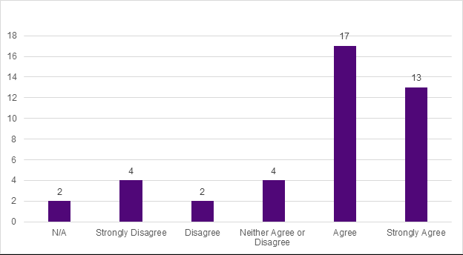
Responses to this question addressed many themes, with no single theme dominating. Of these themes, Accessibility and barriers were mentioned slightly more often, accounting for 20 per cent of issues raised. Concerns under this theme were mostly to do with eligibility for services and questioned whether the Bill does enough to address gaps in services.
Figure 13 – Question 2 - Theme Frequency
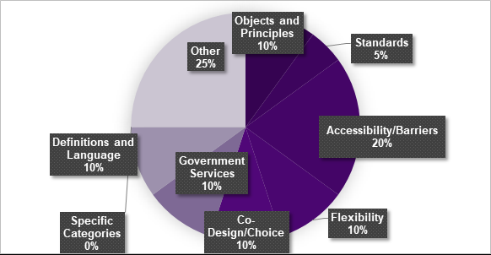

Question 3: Please tell us how much you agree or disagree with these categories in the Bill.
There was general agreement with the service categories included in the draft Bill. Whether they agreed or disagreed overall, respondents provided constructive feedback about the wording of definitions and suggested additional categories of supports. Illustrative positive and negative responses included:
Strongly agree / agree comments:
“Transport should be explicit within this legislation, as there are many operators that refuse people with disability. It is only assumed that accessibility, recreation, employment and independent living infers transportation is provided, when in fact it does not.”
“I think possibly a little broader in terms of possibility of giving the carers some help financially also?”
Strongly disagree / disagree comments:
“Under no circumstances should capacity be a category.”
“I agree with the categories included; however suggest that financial administration / management services should also be included. Given many persons with a disability have limited capacity to make financial decisions and require a financial attorney or administrator, these services should be subject to the Act also.”
Figure 14 – Question 3: Please tell us how much you agree or disagree with these categories in the Bill
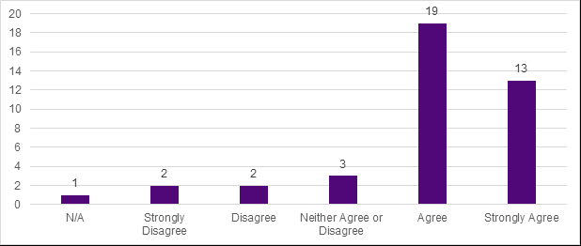
Service categories that respondents raised most frequently were transport and housing. The department recognises the importance of these services, while noting that responsibility lies primarily with state and territory agencies.
Generally responses were supportive of the service categories, with a number of respondents agreeing with the approach while raising additional categories or services, or suggesting amendments to definitions. The department has implemented suggested edits to definitions of categories where possible. For example, the definition for capacity building services and supports has been revised based on feedback, the definition for information supports and services has been adjusted to make clear that translation and interpretation services are covered, and categories have been added to cover community inclusion, counselling and carer supports and services that support people with disability.
Figure 15 – Question 3 - Theme Frequency
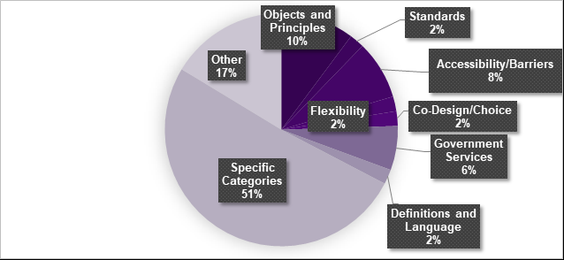

Question 4: Please tell us how much you agree or disagree with the arrangements in the Bill to ensure delivery of safe and quality supports and services.
There were a range of responses to this question, although a clear majority agreed with the proposed approach. Illustrative positive and negative responses included:
Strongly Agree / agree comments:
“I see this as extremely necessary to shore up the NDIS and ensure that it is financially viable in the future. It will also help to ensure that dodgy operators are quickly identified and have severe implications for any individual or organization that fails to act in the best interest of the participant.”
“We already have stringent quality and safeguarding legislation and compliances which need to be met. Acknowledgement of those multiple existing systems will reduce duplication and repetitive regulatory burden.”
Strongly disagree / disagree comments:
“The Bill should allow for independent auditing of providers against the quality standards (where providers are providing services governed by the standards).”
“There is no information here about how complaints of Code of Conduct breaches will be investigated and resolved. Codes specified in acts are generally problematic as many people involved in delivering services under the Act(s) have not given informed consent to abide by them and may not even know their behaviour is covered by them.”
Figure 16 – Question 4: Please tell us how much you agree or disagree with the arrangements in the Bill to ensure delivery of safe and quality supports and services.
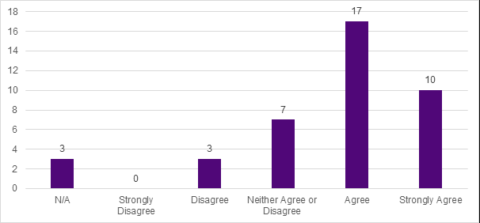
As shown in Figure 17 below, respondents to Question 4 frequently raised standards which would apply under the Bill. To further explore these responses, Figure 18 depicts the sub-themes that respondents raised in relation to standards. Key concerns included how the Code of Conduct would function and what investigative powers the department would have in case of an alleged breach.
General support for the arrangements in the Bill was tempered by caution that effectiveness would depend on implementation. Complaints mechanisms were also raised. The department will continue to work toward ensuring clarity regarding the function of the Code of Conduct and refining of the complaints mechanism.
Figure 17 – Question 4 - Theme Frequency
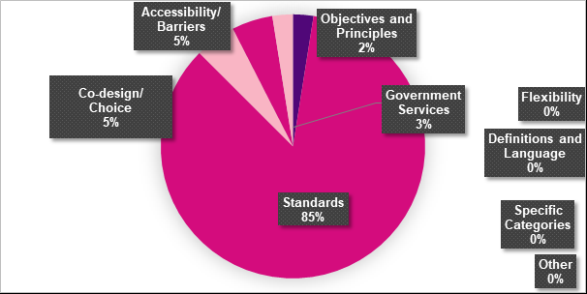
Figure 18 – Question 4 – Sub-themes raised in relation to Standards
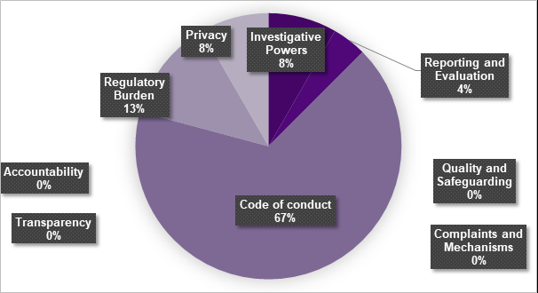

2.2.3 Actions and changes after the second round
Feedback received in the second round identified a number of specific changes to the draft Bill. The department reviewed submissions to identify actionable changes (as distinct from general feedback about the purpose and scope of the Bill). In general, the approach was to accept and action changes unless there would be issues with doing so – such as changing the scope of the Bill or impacting on other legislation or jurisdictions.
Some suggested changes were unnecessary because the text of the Bill already dealt with the issues effectively. For example, it was suggested that the definition of advocacy supports and services should cover both individual and systemic advocacy and the department has confirmed that the current wording already covers these categories.
Additional eligible activities were suggested. Some, such as transport, are beyond the department’s jurisdiction and were not added. Others, like counselling supports and services, carer supports and services, and community inclusion supports and services, have been added to the Bill. The Information, Linkages and Capacity Building (ILC) Program was also suggested. This was not added as eligible supports within the Bill already cover all of the components within the ILC program. In addition, the Bill includes the power for the Minister to add additional activities as needed, ensuring that the Bill can continue to provide authority for future services and supports which are not covered by the current list of eligible activities.
Definitions in the Bill were amended in a number of places to ensure that accurate and clear wording has been used. This also included adding definitions for additional categories of support that were suggested.
A number of smaller changes suggested through the Bill were also made. Generally, these changes clarified or expanded on particular clauses to ensure they functioned as intended and addressed issues raised through the consultation.
More general feedback about the Bill has also assisted in the development of rules and instruments which operationalise aspects of the Bill, including in relation to complaints and information handling. This feedback will also be used to inform the development of supporting material in relation to the Bill to assist people with disability to understand their rights under the new Bill, and to ensure providers and program managers understand the requirements established, including the Code of Conduct.

3.0 Conclusion
Both rounds of public consultation informed development and refinement of the Disability Services and Inclusion Bill 2023.
Feedback received during the first round of consultation was broad and covered a wide range of topics. It helped in determining the approach and framing of the Bill, in particular recognition of the importance of a human rights focus in the Objects and Principles, the social model of disability, and the complexities underlying any attempt to define disability.
Feedback in the second round allowed language to be improved, definitions to be clarified and additions made to ensure that the Bill is fit for purpose. This round of consultation also highlighted the importance of getting regulatory settings right and indicated a need for clear communication about the function of the new Bill, especially in relation to how the Code of Conduct will operate and how complaints will be managed.
The consultation process allowed the department to engage with a wide variety of organisations and individuals, including people with a disability, to gain an understanding of the breadth of perspectives on disability policy and legislation.
Overall, responses from the public consultation were largely positive, and provided useful feedback and suggestions. Responses from a wide range of individuals and organisations were valuable in both the drafting and refining of the Bill.
The department is grateful to all individuals and organisations who provided feedback that has helped to shape the development of the Bill.

