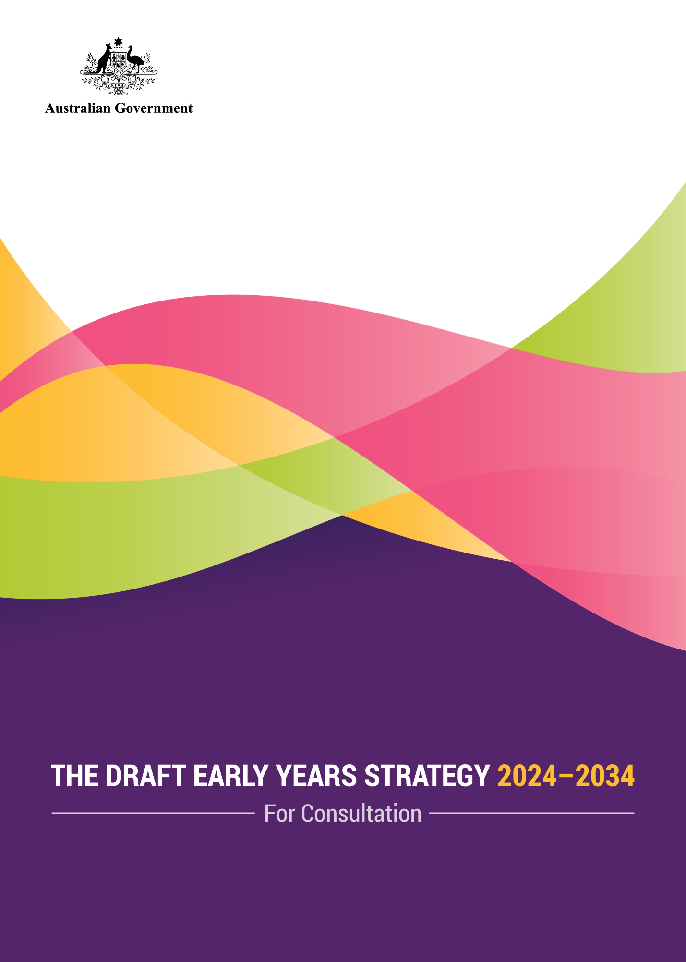

Table of contents
Acknowledgement of Country 1
Early Years Strategy – Executive Summary 2
Demographics 8
Strategy overview 9
Guiding Principles 10
Outcomes 11
Priority Focus Areas 12
Children and their early years matter 13
We know a lot about what matters in early childhood 18
A commitment to a fairer outcome for children 28
Over the next decade the Australian Government will deliver better early childhood outcomes 33
The Early Years Strategy vision, principles, outcomes and priority focus areas 43
The Vision 43
The Guiding Principles 45
The Outcomes 47
The Priority Focus Areas 50
Delivery through Action Plans 59
Appendix 1 – How the Strategy was developed 61
Appendix 2 – The evidence in detail 63
What we know about Australia’s young children and how they are faring 63
Appendix 3 – Australian Government Supports and Services 70
Appendix 4 – Spotlight on strategies 74

Acknowledgement of Country
The Australian Government acknowledges the traditional owners of Country throughout Australia on which we gather, live, work and stand. We acknowledge all traditional custodians, their Elders past, present and emerging, and we pay our respects to their continuing connection to their culture, community, land, sea and water.

Early Years Strategy – Executive Summary

Introduction
Every child deserves the opportunity for the best start to life, setting a strong foundation to achieve their goals and dreams, no matter where they are born or raised.
In Australia, there are more than 1.5 million children who are between 0 and 5 years of age. All of these children should have a strong start in life and thrive in their early years. They should reach their full potential, nurtured by empowered and connected families, who in turn, are supported by strong communities.
This is the Australian Government’s vision for the early years.
The Early Years Strategy is the overarching 10-year framework to shape how the Australian Government prioritises young children’s wellbeing and delivers the best possible outcomes for Australia’s young children. It is an ambitious call to action to help drive and align policy efforts and investments.
This is a wellbeing strategy that respects children’s rights.
The Strategy has been shaped by evidence and what we have heard in consultations with parents, families, carers, early childhood experts, the early childhood sector and young children.

Why an Early Years Strategy
The Australian Government has developed the Early Years Strategy to articulate the value we place on the early years and early childhood, what we want for all young children, and our understanding of success.
The Early Years Strategy wraps around everything we value about early childhood, with what we know about its importance and what we know about how to make a difference.

About the Strategy
The Strategy is a statement on what the Australian Government values and what it is trying to achieve for children aged 0 to 5 years.
It is a strategy for every child in their early years in Australia, as well as their parents, families, caregivers, kin and the communities who support them.
It provides a framework to guide how we will work across Government. It will support better decision making around policies and programs that affect young children. It clearly articulates how the Australian Government will prioritise and support child-centred policy development and investment. It increases the Government’s accountability for improving young children’s wellbeing.
The Strategy will be the basis for working collaboratively with others – families, communities, the philanthropic and early childhood sectors and workforces, and state and territory governments with whom the Australian Government has many areas of shared responsibility – to create positive change and ensure all children thrive.
The Strategy sets out what is known about how young children develop, what they need for their wellbeing and how they are currently faring. It profiles the investment and assistance the Australian Government provides to support families and children and their communities in the early years. It embeds a new way to collaborate and coordinate effort across Government to make that investment and support work more effectively.
The Strategy is the platform that will create opportunities to transform young lives by putting children, and their families, at the centre of decisions that affect them.
As well as a vision to aspire to, the Strategy includes five guiding principles to inform what the Government will do (from consultation to policy development through to delivery), and then how it will be done. The guiding principles support policy makers to ensure all activities are: child and family-centred; strengths-based; respectful of families and the community; equitable, inclusive and respectful of diversity; and evidence informed.
The Strategy has eight high-level outcomes. The outcomes describe what success looks like in achieving the vision of the Early Years Strategy. They are linked together, and require contributions from multiple actors, interventions and supports across children’s lives, reflecting the complexity and interconnectedness of child wellbeing.
Six outcomes are child-focused. One outcome honours what children themselves value, which are opportunities to play and imagine. Five outcomes are about children’s health and wellbeing: children are nurtured and safe; children are socially emotionally and physically healthy; children are learning; children have strong identities and connections to culture; and children have their basic needs met.
Two outcomes focus on children’s immediate contexts and environments – one outcome is about families being empowered, connected and supported; the other is about communities being strong and inclusive places to live, grow, play and connect.
There are four priority focus areas where the Australian Government will focus its attention to have the greatest impact to achieving the outcomes, and what will inform implementation of the Strategy. The Australian Government priorities are to: value the early years; empower parents and caregivers; support and work with communities; and strengthen accountability and coordination.
A series of action plans will detail the practical steps to achieving, the vision and outcomes, and will be framed around the priority focus areas. Aligned with the 10-year horizon, an initial focus will be on strengthening connections and foundations across the Australian Government to deliver better early childhood outcomes both now and into the future.
The Strategy’s impact will be monitored, including through progress reports.

Purpose
This Strategy will deliver the best possible outcomes for Australia’s children in many different ways, as outlined below.

Early years are profoundly important
We know the early years are profoundly formative. They are a critical, but short, window of opportunity to influence and make the biggest impact on children’s development. They are when the building blocks come together for life-long physical, emotional, social and cognitive health and wellbeing.
The Strategy puts the early years and how much they matter on the national stage. It is an opportunity to increase the visibility and awareness of child development among all Australians, commensurate with its importance.

A good future starts in early childhood
We know a child’s future begins with, and is shaped by, a good early childhood. Get it right in the early years and we have children who are nurtured, safe and healthy, able to play, imagine, learn and grow in strong families, connected to culture and community. We also have parents, caregivers and kin who feel confident, supported and included within their communities.
The Strategy is the foundation for action to deliver good early childhoods for all Australia’s children, which, in turn, will set them up for a great future.

An investment in the early years is an investment in the future of the nation
We all have a responsibility to make sure all our children have what they need to thrive right now and into the future.
Supporting early childhood development is an investment in delivering better long-term outcomes for children and for Australia. As children are our future, the quality of their early years will not only influence their lives, but also the nation’s future. The decisions we make today will create the world our children will live in tomorrow.
An investment in the early years is a sound investment in the future productivity, prosperity and wellbeing of the nation.
The Strategy is a down payment on Australia’s future, with the power to generate valuable returns on investment and to change the trajectory of a child’s life.

We can do better on supporting all children to thrive and reach their potential
We want to ensure every child, no matter their circumstances including where they grow up, can reach their full potential. This is not where we are now, but with a targeted focus on the early years we can turn this around.
The Strategy provides the framework to act on opportunities to keep doing well for children, as well as help to ensure that no child is left behind.

A great childhood is a worthwhile objective in its own right
Childhood is also a precious time. Children and childhood have an intrinsic value, a value not limited to who they will become or what they will contribute to society as they grow and mature into adults.
The Strategy is a celebration of early childhood.

Embed a new approach: Listening to children and families
We know how important it is to listen to the perspectives of children and families. We know how important it is to empower each parent, caregiver, kin, family and community to be part of the journey of raising children – so they get the support relevant to their needs, at the right time, and in the right way.
The Strategy provides the commitment to embed the voices and perspectives of children and their families in the policies and decisions that affect them.

An integrated, holistic whole-of-Government approach
We know child wellbeing is multidimensional and dynamic. Children’s growth isn’t neatly segmented in a way that aligns with how the Australian Government organises itself. To improve child wellbeing in areas of Government responsibility requires effective policy integration and policy coherence.
It requires an integrated, holistic, whole-of-Government approach to the early years that can better position the Government to respond to the challenges and needs of Australia’s children and families, and future reform opportunities. The Strategy helps connect and join-up work across Government.
The Strategy supports better alignment in how Government works to deliver the integrated policy response required to enhance child wellbeing. It will drive coordination and collaboration across Government and break down silos.

Working together
Supporting the early years requires action by families, communities, services, all tiers of government who share responsibilities across early childhood systems including state, territory and local governments, and the non-government and service sector. It benefits from philanthropic investment. Effective collaboration and well-coordinated government and non-government activities at the Australian Government, state and territory and local level help to create the environments that are needed to support strong early childhood health and wellbeing.
For children’s early lives, there are many areas where the Australian Government and state and territory governments share responsibility—requiring a shared approach, with children and families at the centre of policy considerations. Similarly, there are many areas where the Australian Government’s support works alongside investments and efforts from across the sector—requiring close collaboration and coordination to ensure activities and support intersect effectively. The Strategy recognises the need for high quality and supported workforces. The Strategy signals to others how we can work together to create positive change and achieve the outcomes we are striving for.

Accountability and responsibility
To be sure we are delivering on the Strategy vision, we need to understand how we are tracking and be clear on what we are doing to support the early years.
Through an outcomes framework and regular reporting on what impact Government policies and supports are having on Australia’s children, the Strategy signals the strengthening of accountability and responsibility for the wellbeing, education, health and development of Australia’s children by the Australian Government to the Australian community.

Delivery
The Strategy will be operationalised through three phases of action plans, with the first action plan to be delivered in 2024. The action plans will be how the Government delivers on the Strategy’s vision through tangible activities.

Respect for diversity
Every child in Australia is unique. Children do and should mirror the diversity of our modern nation. The Strategy recognises, respects and reflects this diversity.
There are children from Aboriginal and Torres Strait Islander families who can draw on more than 60,000 years of experience in loving and raising strong proud children. Aboriginal and Torres Strait Islander children should be able to thrive and grow up healthy, supported by strong families, and proud in culture.
Some children are born to parents from culturally and linguistically diverse backgrounds. Some children are born to coupled parents, single parents, or into blended families. There are children who are born overseas and move to Australia in their early years or into military and veteran families. Some children have or acquire disability or have a family member with a disability. There are children, in their early years, who will live with kin or other carers. Children’s neighbourhoods and communities may also look different depending on where they live.
Any reference to parents, caregivers and families in the Strategy acknowledges the diversity of people who fulfil these important relationship roles for the children in their lives, including biological mothers and fathers, adoptive and LGBTIQA+ parents, kinship and other carers, and extended family members (and many combinations of all of these).
This Strategy acknowledges, values, and embraces the similarities and differences among children. It is a Strategy for all children.

What we heard through consultations during development of the Strategy
The Australian Government committed to broad and deep consultation in developing the Strategy to get an understanding of multiple perspectives on the early years, how early years supports and services are working around Australia, and the Australian Government’s role.
Through all consultations, there were recurring themes, with participants wanting to:
- see children and families thrive and have an equal opportunity to reach their potential no matter where they are born or growing up
- provide the conditions which give rise to children being nurtured, safe, healthy, learning, participating and having their basic material needs met
- see families who are empowered, connected and supported, and communities that are strong and inclusive places for children to live, play and connect and where children can access the resources, supports and services they need
- prioritise focusing on supporting children, parents, kin, carers and communities, strengthening how decisions are made and system enablers that deliver good results.
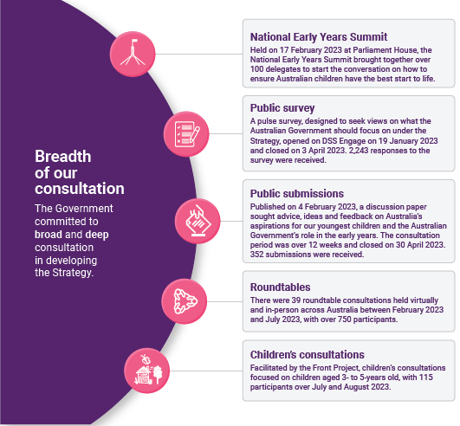

Demographics
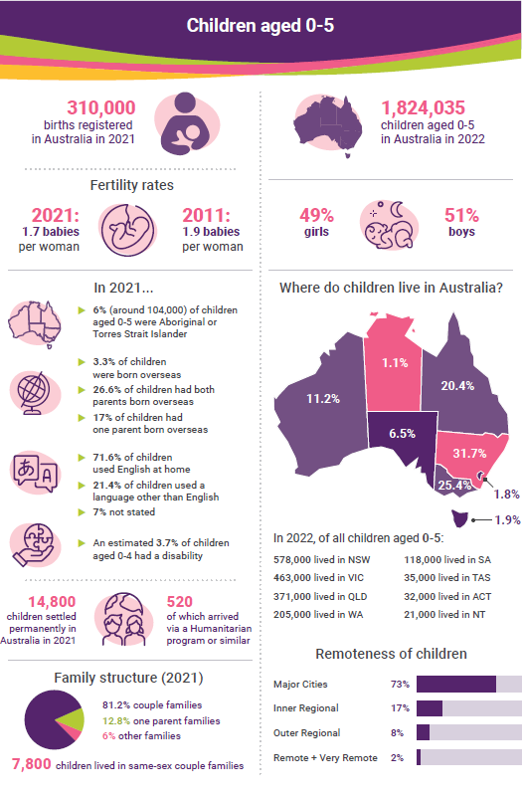

Strategy overview
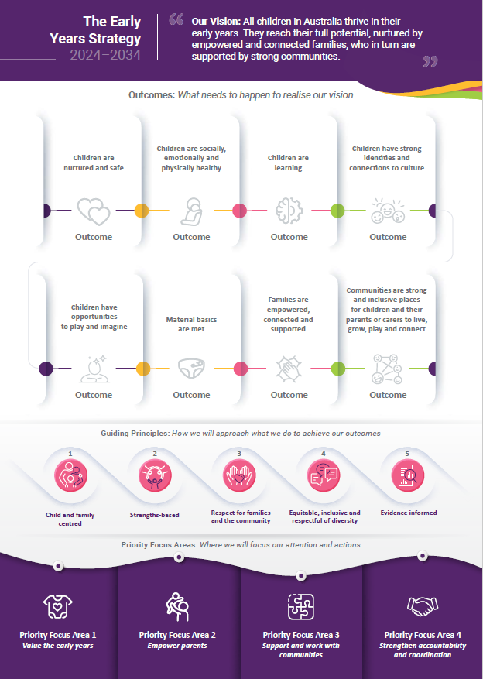
Guiding Principles
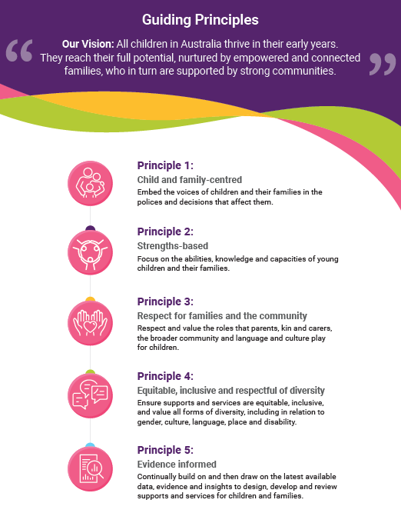

Outcomes
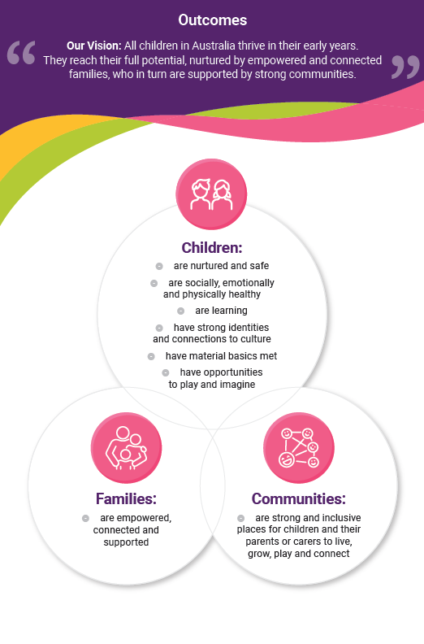
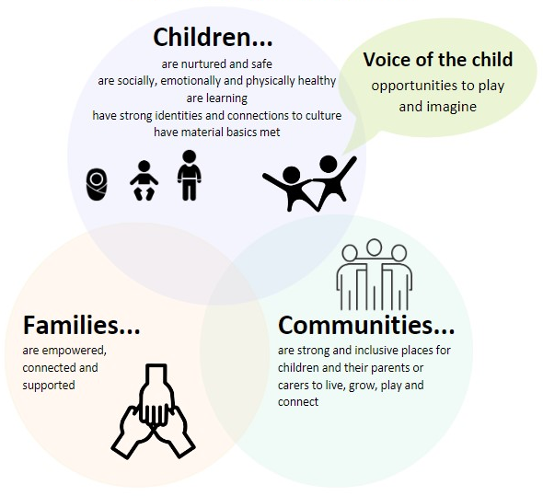
Priority Focus Areas
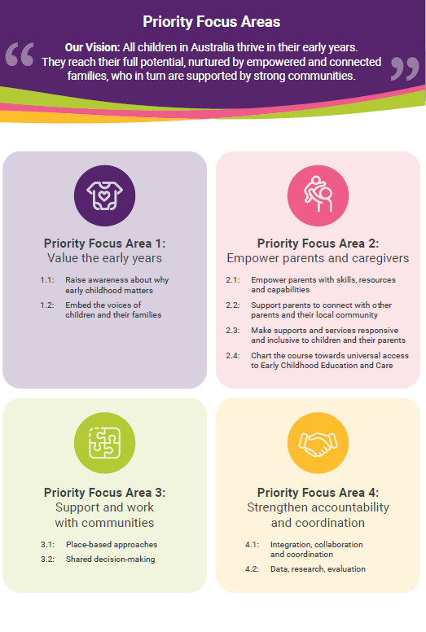

Children and their early years matter
The early years is a vital period of development in a child’s life. By committing to action under this Strategy, we support our youngest children in Australia and set them up for success, which benefits not just them, but communities and the nation.

The early years provide a critical window to influence children’s development
The early years provide the opportunity to have the biggest impact on child development.
Each person is shaped though a complex interaction of the genes and the environment in which they are raised. For all children to thrive and reach their potential, we must take a whole of child focus in the early years – their physical, mental and emotional development as well as their sense of wellbeing and identity, and their place in the world.
The early years of a child’s life, from the important pre-conception period, and the antenatal period right through to five years of age and often referred to as the first 2,000 days, are a critical window of opportunity where it is possible to positively influence a child’s development, sense of identity, health, learning, safety, resilience and happiness.
There are several different stages of growth and development in the early years, including the antenatal period, birth and the first days, and the infant, toddler and preschool stages.
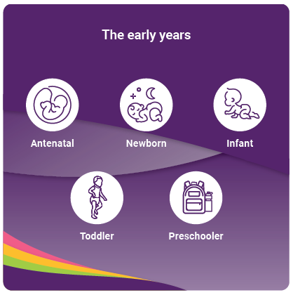
Each year in Australia, we welcome over 300,000 babies. The nurturing they receive before they are born and how they grow, play and develop into infants, toddlers and then preschoolers shapes not only their early childhood, but the rest of their lives.
The impact of a child’s early childhood will be felt throughout their life.
“The first five years of a child’s life is one of the most critical stages in shaping an individual’s life course, including brain development, behaviour and learning, and health and wellbeing outcomes into adulthood. The Early Years provide powerful opportunities to make a real difference to children’s life chances.” (Submission)
Children’s genes provide a blueprint which, when combined with relationships, environments and experiences, shape the most malleable organ in the body – the brain.
Brains are built. How they are built (their architecture), and whether they are strong or fragile, is the foundation for the learning, health and behaviour that follow.
A child’s early years – especially the first 1,000 days – is when the developing brain is most responsive to being shaped by the environment. The most important feature in that environment is the relationships a child has with parents, caregivers and extended family.

If you don’t get a good start in the early years, it is hard to catch up
In the first few years of life, more than one million neural connections are formed in our brains each second – a pace never repeated again.
While brain development continues throughout life and positive changes can be made at any age, it becomes a slower process to ‘rewire’ or change the brain architecture as we age..
The objective in the early years is to develop a strong foundation, so that children can achieve good health and wellbeing outcomes over their life course.
The role of early brain development in shaping the people we become reinforces the importance of a dedicated focus on the early years.
Children deserve every chance to achieve good health and wellbeing and to reach their potential.
A focus on the early years is a commitment to prioritising prevention and early intervention. This means preventing problems occurring before they begin and addressing them early when they do so that risk factors can be reduced and protective factors increased. Starting early is what is required to give children the best possible start in life.

Investing in young children is investing in Australia’s future
The benefits of investing time, effort and resources in the early years are substantial and can impact outcomes for both the child, and society more broadly, over the course of their life.
Investments in the early years have immediate and direct benefit to the child. Children can achieve better outcomes across health, wellbeing, education, and other domains. It can also help ensure they have a fulfilling childhood with opportunities to experience play, nurturing and connection.
“We want children to blaze their own path in terms of the opportunities they need.” (Community roundtable consultation)
Investing in the early years of a child’s life sets them up to be a well-functioning and positive contributor to their society. There are also long-term benefits more broadly for individuals, families and communities.
With healthy early childhood development, the building blocks for “educational achievement, economic productivity, responsible citizenship, lifelong health, strong communities and successful parenting in the next generation”, are established. Healthy early childhood development helps to grow citizens who can contribute to Australian society and make us stronger as a nation.

Investing in young children’s development leads to better outcomes
Studies over the past few decades in Australia and overseas reinforce what we have known for a long time – investment in the early years is a sound investment in both the lives of children and families today and for the future productivity, prosperity and wellbeing of the nation.
The evidence demonstrating the benefit of investing in the early years has been influential internationally and across Australia, with many countries and jurisdictions having child wellbeing plans in place.
“The evidence is clear overall that early childhood intervention is effective and the return on investment is strong. The science is, however, more robust in some areas than others, but generally more research is needed from within our uniquely Australian context.” (Submission)
The Effective Provision of Pre-School Education (EPPE) Project found that children from both advantaged and disadvantaged communities are less likely to be developmentally vulnerable if they attended preschool. Those who attend preschool typically outperform their peers in physical, social, cognitive, communicative and adaptive development.
Children who are developmentally on track when they start school are more likely to stay on track, complete school education, get a job and contribute positively to the broader society.
Research conducted in 2019 analysed the economic impact of early childhood education in Australia and found that for every $1 invested in preschool education, Australia receives $2 back over a child’s lifetime.
A 2010 study found that in Australia, the potential value of future benefits that can be realised as a result of prevention and early intervention is over $5.4 billion per annum.
Seminal research in the United States has shown that every $1 invested in quality early years programs from 0 to 5 years can yield returns of between $4 and $16.
The Strategy represents the commitment of the Australian Government to continually build on the data, research and evidence base, particularly around understanding what works.
“More must be done to gather data that will track the health and developmental progress of all children, and for that data to be used to inform the development, implementation and evaluation of services to support children and families.” (Submission)

Not investing in the early years leads to poorer individual and society-level outcomes
A lack of appropriate and well-targeted investment in early childhood development affects the long-term health and wellbeing of individual children. The consequence of not addressing adverse environments can create deficits in skills and abilities. This drives down economic productivity and increases social costs.
Children who do not receive optimal care or stimulation, who are poorly nourished, neglected or abused, can experience physiological and behavioural changes that make them more susceptible to chronic health conditions later in life such as heart disease, diabetes, depression and dementia.
Research shows that by Grade 3, children assessed as vulnerable are a year behind their peers on NAPLAN (the national literacy and numeracy assessment), and by Grade 5 they are on average two years behind. Evidence shows these children are more likely to drop out of education early without the skills they need to go on to tertiary education or vocational training.
Children who experience poverty at some time in their childhood are likely to have poorer cognitive and social outcomes and are more likely to be obese and have lower levels of general health. Furthermore, there are substantial differences in developmental outcomes for children who had experienced persistent poverty, compared to children who were never poor.

Childhood is a precious time and we value children
Children, and childhood, are intrinsically important.
Children bring their own perspectives, value and influence to the world, while also being shaped by the world around them. They give joy and purpose to the lives of many, and help bring families, and communities, together. There is a shared pleasure and purpose in contributing, directly or indirectly, to the raising of children and knowing they are growing, developing and reaching their potential.

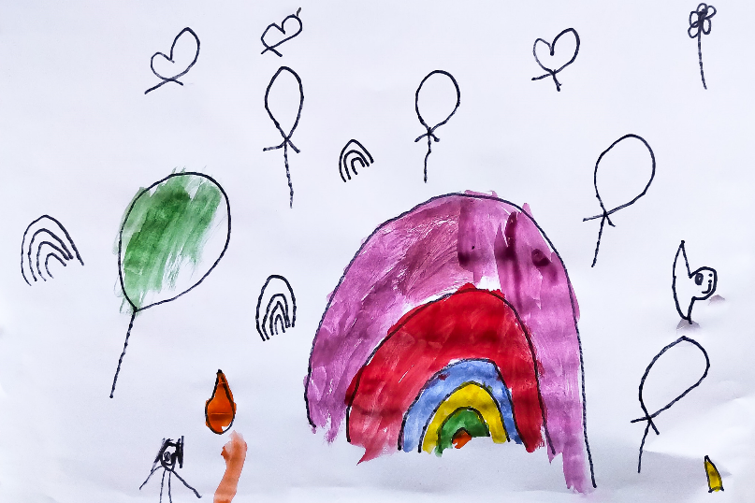

“This is me at the beach and I saw a rainbow and ice-creams, and I saw a flower.” (Children’s consultation)
When we prioritise children’s health and wellbeing, we all benefit.
“We want them to have a strong sense of being loved, cared for, safe and in the embrace of family who can reinforce their sense of calm.” (Parents roundtable consultation)
We focus on the early years not just because of what we can achieve for future generations but because we also want children to have great childhoods. We want to celebrate the contributions children make to those around them and society, ensure they are treated with dignity and respect, and enable them to have their voices heard and included in decisions about their lives.

Children bring joy and playfulness to those around them
Children bring great joy and happiness to families and communities. They encourage adults around them to look at the world with fresh eyes and open thoughts. Quality time spent playing, reading and being active with children provides many benefits to parents and caregivers, siblings and extended family members, friends and those living nearby. There are also benefits of intergenerational groupings – therapy for both old and young as they interact socially together.
“All children deserve a childhood full of love, family and personal discovery. Children’s voices need to be at the centre of every discussion about them.” (Children with Disability/Developmental Concerns roundtable consultation)

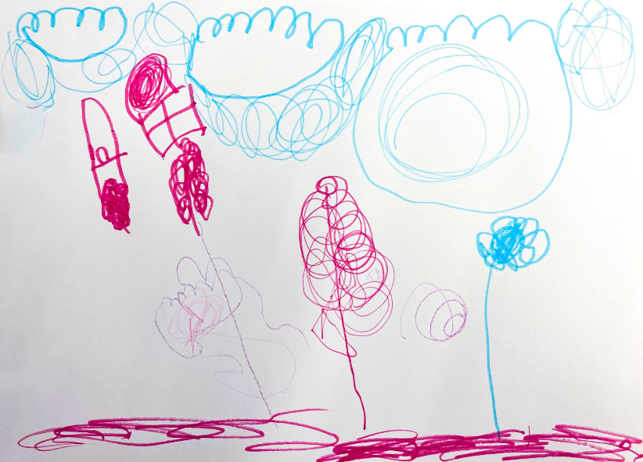

“A tree house with clouds, snails and a crocodile. Grown-ups and kids sleeping.” (Children’s consultation)
Connecting with young children can reduce stress, can build strong bonds with others and can improve mental and physical health and wellbeing. Children may test the resilience of adults who care for them at times, but raising children provides opportunities for families to navigate challenges and build new skills and competencies.
Children with disability
In our consultations with parents of children with disability, we heard they shared a vision for an inclusive society in which their child had equitable opportunities to participate and learn.
“I want my child to feel valued and included and be able to go to school and have a chance at learning and growing with her peers in a safe and welcoming environment. I want her not to be underestimated.” (Children with disability or developmental concerns roundtable consultation)
They want their child to have a voice, and for their individual needs recognised.
“Our vision is that children and young people with disability are valued and living empowered lives with equality of opportunity.” (Submission)
This Strategy aligns with Australia’s Disability Strategy 2021-2031 vision that people with disability can participate as equal members of the community.
We know a lot about what matters in early childhood
The Strategy recognises that children grow and develop in the context of their families, communities and society. Action to improve outcomes for young children must encompass all of these spheres. The Strategy also recognises the importance of ‘stacking’ early childhood with protective factors.

The importance of families, communities and society
A child’s development is shaped by the people and relationships, communities, cultures and society that surround them. Children are part of Australia’s social ecology, and we recognise that they affect, and are affected by, a complex range of social and environmental interactions (see Figure 1).
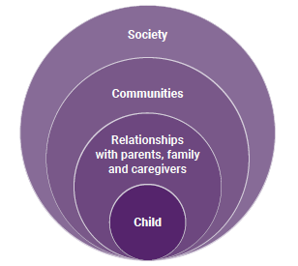
Figure 1: Social ecology of child development
"I want my children to be happy and to be able to build a strong connection to the community." (Parent roundtable consultation)

The goal is to ‘stack the scale’ in favour of positive protective factors
We can think of children’s development like a scale, with positive, protective factors on one side, and significant adversity or trauma on the other side.
In the early years, the goal is to tip or ‘stack the scale’ in favour of protective factors that can have a positive impact on children and their development and also minimise the impact of any adverse childhood experiences. Over time, the cumulative impact of positive experiences can make it easier to achieve positive outcomes.
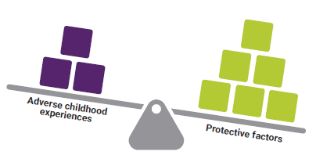

Nurturing relationships are what matters most for babies and young children
The single most important protective factor that helps children develop well and build resilience is having at least one stable and committed relationship with a parent, caregiver or other adult.
A child's early relationships, environments and experiences can either support or inhibit their healthy development.
Sensitive and nurturing relationships build foundational language and communication skills, and create secure attachment relationships, which lead to higher levels of cognitive competence and fewer psychological problems. They provide a significant buffer for children when they experience high levels of stress, and contribute to them building resilience.
Children, especially as an infant and then a toddler, need many positive interactions with responsive caregivers, often called ‘serve and return’.
Serve and return
There are many ways parents, caregivers and families can build positive and responsive relationships with young children. Similar to a game of tennis, ‘serve and return’ is when a baby or young child babbles, cries or communicates with gestures or movements, and an adult responds with words, singing or hugging. New neural connections in the brain are built and strengthened, which help develop early communication and social skills. Close interactions and responsiveness with plenty of ‘serve and return’ opportunities that are often joyful and fun, create a rich brain-building environment.
Children thrive when these relationships are based on a strong connection to their own culture including the experiences, values and beliefs of their families and their communities. For example, when connection to culture and society is strong, children develop a sense of belonging and a safe environment to develop their own language and way of being.
For Aboriginal and Torres Strait Islander children, connection to family, kin, community, culture and Country are critical to their development and wellbeing. Aboriginal and Torres Strait Islander peoples have a close relationship and connection to Country, which enables ways of being, learning, knowing and doing.
When there is respect and understanding of the importance of Aboriginal and Torres Strait Islander culture and child-rearing practices, this helps to build safe and secure environments for children to develop a strong sense of identity.
“For Aboriginal and Torres Strait Islander children, culture should be at the core for children to grow, stay connected and thrive, giving every child the best possible start in life, laying a strong foundation for their future success and wellbeing.” (Submission)
The Australian Government also acknowledges the importance of culture for children from culturally and linguistically diverse backgrounds who have a rich heritage of their own, and recognises their need to stay connected to it to help them thrive.

Hearing children’s voices
This Strategy is child-focused and children aged 3 to 5 were consulted in its development, sharing their experiences and aspirations through words, painting, drawing and sculpting – the things that are important to them.
They told us about the importance of play, being in nature and relationships with parents and others, and the Strategy reflects their feedback.
“Mum, Dad and family. I’m drawing the things I love.” (Children’s consultation)
“Mama, me and my sister. I have a lot! A dog also.” (Children’s consultation)
“Dad – he’s the biggest in the family. He’s bigger than a car.” (Children’s consultation)
To ensure the Government continues to capture children’s voices and what is important to them, an outcome (Outcome 5 – Children have opportunities to play and imagine), principle (Guiding Principle 1 – Child and family-centred) and priority (Priority Focus Area 1 – Value the early years) have been included in the Strategy.
The approach to hearing children’s voices aligns with the United Nations (UN) Convention on the Rights of the Child, which includes a principle about respecting the views of the child.

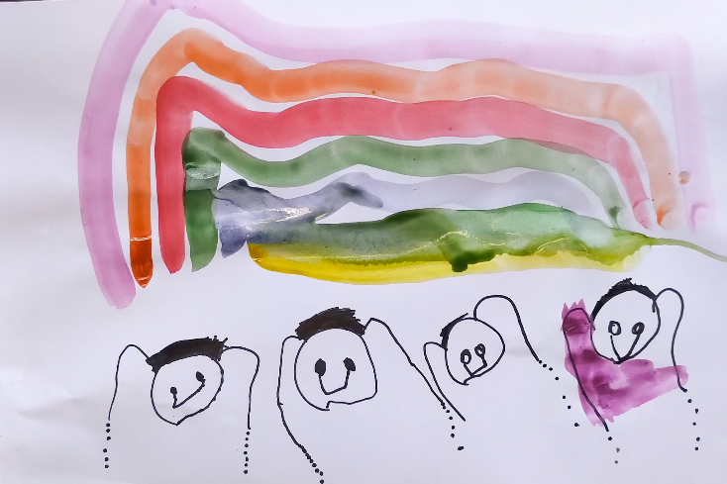

“This is me, this is my brother, this is my Mummy and this is my Daddy.” (Children’s consultation)

Parents and their children
In consultations for this Strategy, parents recognised their central role in their child’s life and in their child’s access to opportunities, connections and services.
“Families need to feel safe and included with services that are involved with their children.” (Parent roundtable consultation)
"When kids have equal access they can build a sense of belonging." (Grandparent roundtable consultation)
They wanted their children to be happy, healthy and given every opportunity to thrive. They expressed that children should have safe spaces to play, access to the environment and quality time with their family and people who love them.
“To be happy, healthy, be heard, validated and celebrated.” (Parent roundtable consultation)
“Children should have opportunities for play and connections, time outdoors, time with parents, time to have fun, to spend time with friends, with family, quality times with families, time in playgrounds” (Parent roundtable consultation)
Parents also expressed that they wanted quality time to be with their children, access to the resources and services they need and to be empowered to perform their important role.
“Empower parents as experts in their children and provide them with the tools to support their children.” (Parent roundtable consultation)
“Children can spend quality time with their parents.” (Parent roundtable consultation)
They also reflected on what mattered for their children.
“Kids love being around their family and being outside. Having good friends and getting time to spend with them. Being around people and friends.” (Parent roundtable consultation)

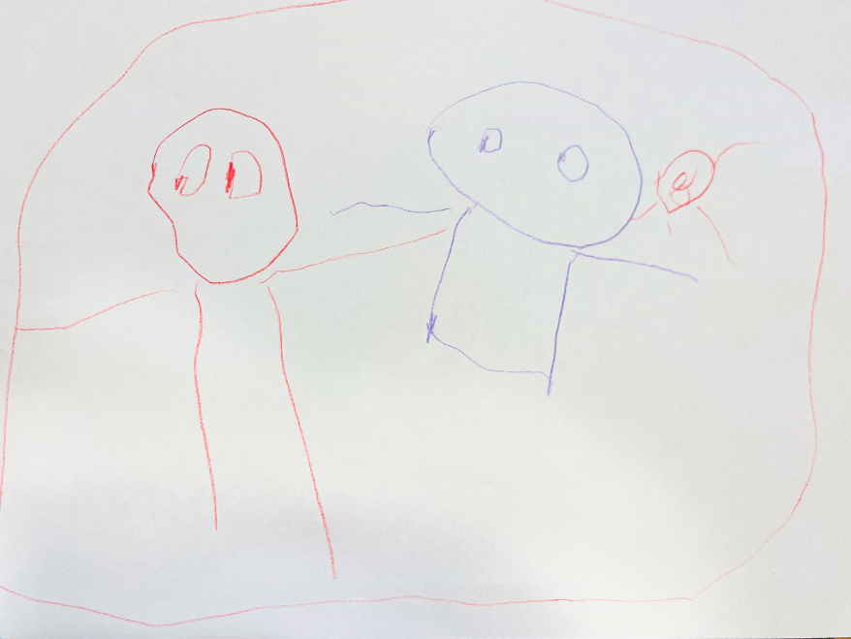

“My special person might be my Nan. I made [drew] me with my Nan and my baby [sibling]. Sometimes she visits at my house and she plays games.” (Children’s consultation)

Parents and caregivers are a child’s first and most important teacher
Children’s first and most important teachers are their parents, families and caregivers, including kinship carers. When adults form special bonds with young children and spend time closely interacting with them, children are able to make sense of their world and develop their own responses.
Families provide the first learning environment in their homes. There are many ‘teachable’ moments in every day with parents, siblings and other family members. Children learn best when they have access to everyday objects, books and natural materials to investigate and satisfy their curiosity.
“Acknowledging the learning that occurs in homes every day with parents. Education doesn't begin in formal settings. How can we elevate, value and support families with their role in teaching their children.” (ECEC roundtable consultation)
Children learn and are stimulated continuously through their environment, especially when a responsive adult is talking to them and playing with them. This might be by counting when climbing stairs, predicting the next part of a familiar storybook or by remembering the words and rhythm of the songs, which they sing together. Playing simple games with children such as peek-a-boo is great for building relationships and creates a sense of belonging and joy.
These simple activities are powerful ways parents, caregivers and families stimulate thinking and imagination, which improves social and emotional skills and helps to build better brains and bodies. Parental engagement has many positive impacts on children’s development and education outcomes.
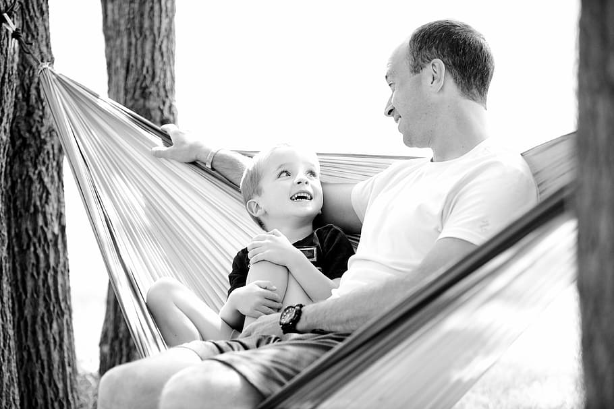

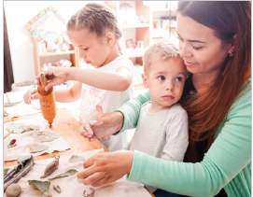

Communities are where children and their families live, play and grow
Early childhood environments, including outside the home, also help build children’s brains and bodies.
Communities matter and help shape development in many ways. Physical and social environments have a significant effect on children’s developing brains and bodies.
The network of people around children and families, including friends, neighbours and educators, has a role in creating positive environments and experiences to support children’s health and wellbeing. These broader social supports offer connection, safety and security.
“That they grow and thrive in a family and community network in which they feel loved and supported to play and explore in a natural environment, with opportunities to develop their own agency and unique characteristics as a learner.” (Survey response)
Importantly, all children should be supported to live accessible and connected lives within their communities. This includes children with disability or developmental delay who should experience full participation in all aspects of life.
The built and natural environment, for example, affects how children access spaces to play and spend time in nature, in turn influencing their physical, social and emotional health.
“This is my Dad and that’s my Mum … we go to the park and play and look at flowers.” (Children’s consultation)
“I can go camping with my Dad and sister, and my dog is there.” (Children’s consultations)
“Access to green space gives children a wider understanding of the world, it exposes them to different walks of life, nature, learning through play.” (Grandparent roundtable consultation)
All environments children experience, including before they are born, shape their development. This includes good nutrition, dental care, adequate sleep, rest, activity, and connection with others.
Quality antenatal care during pregnancy, and regular antenatal care in the first trimester, is associated with better maternal health in pregnancy, fewer interventions in late pregnancy and positive child health, development and wellbeing outcomes. Good support during pregnancy, birth and the early months and years of a baby’s life can improve short and long-term outcomes for mothers and babies.
Broader economic and social factors, such as economic security, social inclusion, safe and secure housing and access to high quality health care are also important.

Early education settings are opportunities for children to grow and learn
Early education settings, such as early childhood education and care (ECEC) settings, which in the early years include preschools, long day care, in home care and family day care, along with other settings such as playgroups and libraries, are also opportunities for children to grow and learn.
When children attend ECEC settings they have opportunities to learn through play, and socialise with other children, facilitated and extended by qualified educators and teachers. This is supported by an approved early years curriculum including through the Early Years Learning Framework which has recently been refreshed.
For Aboriginal and Torres Strait Islander children, ECEC services also provide an opportunity for them to strengthen their cultural identity and sense of belonging within their communities. Aboriginal and Torres Strait Islander Community Controlled Organisations (ACCOs) play a critical role by overcoming the barriers faced by Aboriginal and Torres Strait Islander children and families to ensure ECEC services meet their needs.
Early childhood education helps to enhance children’s learning at this critical stage to create a foundation for lifelong learning, skill development and wellbeing. Experiences at preschool, underpinned by the early years curriculum, help children to develop their vocabulary, communication skills, maths skills and problem solving abilities, as well as the ability to concentrate, follow instructions and get along with others – skills that are critical to later success in a school classroom.
Moreover, the benefits of investing in high quality early childhood education extend beyond positive school performance. Studies highlight that early childhood education breaks down the barriers to educational success faced by children in disadvantaged circumstances thus ensuring they have basic skills they need for life.
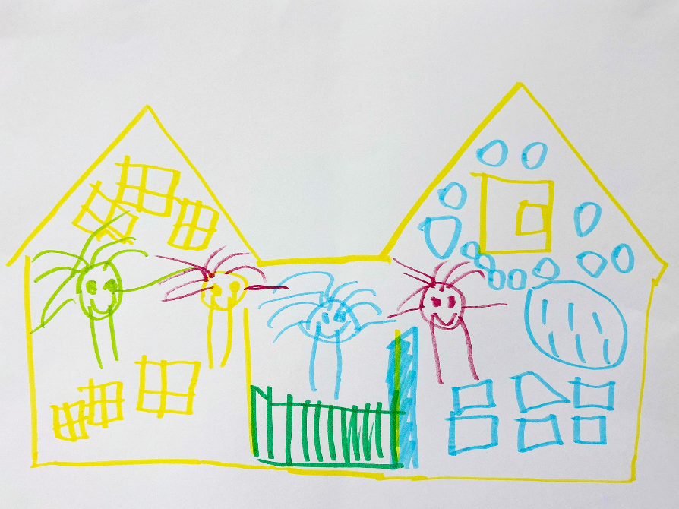

“The whole school! The bag, the gate, the window, the puzzle, the people.” (Children’s consultation)
A universal early childhood education and care system
High quality ECEC delivers a triple dividend in Australia. Participating in quality ECEC is associated with stronger developmental outcomes for children when they start school. Access to affordable services allows parents to work, study, train or volunteer in the secure knowledge their child is safe. These benefits have a larger economic and wellbeing benefit for Australia – with families able to participate in the economy, and children being given strong foundations for their future learning and growth.
Recognising the multiple benefits that can accrue from access to quality ECEC, a priority area of focus in both this Strategy (Priority Focus Area 2.4) and the Employment White Paper ‘Working Future’, is charting the course for universal access to ECEC in Australia that is high quality, equitable, affordable, and accessible in a fiscally responsible sustainable manner.
This course will be guided by the principles embedded in the long-term national vision for ECEC developed collaboratively by the Australian Government and state and territory governments, in close consultation with the ECEC sector.
Actions to achieve this outcome will be informed by the comprehensive Productivity Commission inquiry into Australia’s ECEC system commissioned by the Australian Government. The Productivity Commission will make recommendations to support affordable, accessible, equitable and high-quality ECEC that reduces barriers to workforce participation and supports children’s learning and development.
ECEC is a central part of children’s early years. In 2022, 48% of children, aged 0 to 5 used Government-subsidised ECEC services and 89% of children counted as in the ‘state-specific year before school’ were enrolled in preschool. The principles of this Strategy provide important guiderails for this reform, in particular, to ensure the path to universal ECEC takes a child and family centred approach.

Protective factors and coping skills not only help children to thrive, they can also mitigate any impact on their development from adverse experiences
Australia’s policy frameworks are designed to ensure children have a happy and healthy start in life.
When children do not have all that they need in their early years, including when they experience greater adversities, this can affect their development.
We can agree that all children should have great opportunities right from the start. Challenges in early childhood development can occur for a range of complex reasons and within a wide range of families and in a wide range of circumstances. It is important to avoid making assumptions about outcomes based only on a child’s family background or circumstances.
Learning to cope with stress or adversity is a normal part of brain development. The evidence tells us that all children need to experience some ‘stressors’ in their lives in order to grow healthy brains and build lifelong resilience. The evidence also tells us that when there is too much stress or stress over a prolonged period, this can disrupt healthy brain development and other biological systems, and even weaken the immune system.
We know that some children may experience adversity or adverse events in the early years. When a stressful experience is buffered by nurturing relationships with trusted adults, it helps babies and very young children to develop resilience, which helps them cope with stress and adversity later in life.
If children do not have a nurturing and responsive relationship with an adult, or if they experience adversity, for example, physical or emotional abuse, neglect, or their parent or other primary caregiver experiences serious illness, they can experience the effects of excessive stress.
Overall, poor early childhood experience can lead to physiological and behavioural changes, including to children’s brain development, and can make children more prone to poor long-term outcomes.
This includes being susceptible to impairments in learning, memory and regulating behaviour, and chronic health conditions later in life such as heart disease, diabetes, depression and dementia. Research has found that approximately 80% of young people in juvenile justice settings in Australia have experienced multiple traumatic stressors. Trauma in early childhood can impair school readiness, academic achievement and both physical and mental health through the lifespan.

‘Stacking the scales’ with protective factors will drive good outcomes for all children
Children thrive when they have what they need to develop well. We know from the science of early childhood development that when protective factors such as responsive relationships and supportive environments are present, children, even those experiencing challenges, are better able to cope and achieve good outcomes.
Strengthening foundational adult relationships by supporting families and communities, can prevent early harm and strengthen developing brains, ensuring that a child’s early development is on track or if required, can get back on track, to give them the best start in life.
For example, assisting adults to build the skills necessary for success in parenting and the workplace can protect children from the adverse impact of poverty in early childhood.
Healthy protective behaviours are also important and begin before a child is born. Factors such as not being exposed to smoking or alcohol in pregnancy are protective. Other protective factors include having lots of fruit and vegetables and good mental health.
When the added protection and buffering of protective factors outweighs adversity early in life, children are more likely to complete school education, become lifelong learners, be prepared for adult life with work, family and friends, and be active members of their community.
“My biggest hope for children is that they can have their basic needs covered – housing, food, education, affordable access to the health system and a safe and loving home life.” (Submission)

This means that to prioritise early childhood development we need to first support and empower parents and caregivers, and then the communities that wrap around them
Because we know that early childhood outcomes are not pre-determined, it is important to leverage opportunities to support what matters most in early childhood.
Relationships are the foundation of positive growth and development for children. One of the most important contributions we can make is to support the foundational relationships that really matter to children in their early years. When we focus on these foundational relationships, children and their parents, families and caregivers are supported to do better now and into the future.
Communities and the broader Australian society also have an important role in wrapping around children and families. We need to focus on the relationships children have in their communities with, for example, educators, and we need to empower communities to support children.
“Therapies are great – but it’s not always about more services. We need to build families capacities, build parents capacity, have more opportunities for children to be who they are and not something that needs fixing.” (Parent roundtable consultation)
A commitment to a fairer outcome for children
The Australian Government supports early childhood health and wellbeing because it is the fair thing to aspire to for every single child.

Australians value fairness
The Australian Government, through this Strategy, aspires to do more than just having most children do well. It is about all children thriving.
We need to treat all of Australia’s children equitably and make sure they all have what they need to thrive in their early years and into the future. We want all Australian children to enjoy a positive start to life, reach adulthood equipped to meet life’s opportunities and challenges, and to realise their own unique potential. It is important to understand how children are faring now, so we can work towards achieving our aspiration for all children to be thriving into the future.

Understanding how Australia’s children are faring
There are many examples of how children are getting a great start in life in Australia.
There are high numbers of children born at a healthy birth weight, and Australia has high levels of childhood immunisation, and high participation in preschool.
One way that we measure how children are faring in Australia is through the Australian Early Development Census (AEDC). By measuring the domains of physical health and wellbeing, social competence, emotional maturity, language and cognitive skills, communications skills and general knowledge the AEDC provides an indication of how young children have developed by the time they start school.
The latest AEDC conducted in 2021 shows that the majority of children (54.8%) are developmentally on track on each of the five measured domains. This is a slight drop from a high of 55.4% in 2018, with the drop possibly due to the impact of the COVID-19 pandemic.
We also know that some children experience adverse events in their lives.
We recognise there are too many children in the child protection system – in 2021-22, about 178,000 children came into contact with the child protection system.
Children may witness domestic and family violence between other family members, or be subjected to violence by other family members. This can have a range of effects on their health, wellbeing, and social and emotional development. Over the longer-term, children who are victims of violence themselves or witnesses of intimate partner violence can be twice as likely to have a psychiatric diagnosis, emotional and behavioural difficulties, and impaired language skills at age 10.
Children may experience mental health disorders either directly or indirectly. The World Health Organization estimates that worldwide, around 8% of children aged 5 to 9 and 14% adolescents aged 10 to 19 years live with a mental health disorder. Up to 1 in 5 children in Australia live with a parent with a mental illness.
There are also pockets of entrenched or persistent disadvantage, and commonly these are concentrated in specific locations.

All children should thrive and reach their potential
The Australian Government knows that all children deserve to be supported to reach their potential and thrive.
Results from the AEDC across Australia are mixed. Some children are at risk of not reaching their potential. Some children are experiencing higher rates of vulnerability, but there are also pockets of progress. These experiences can be compounded when children face intersecting experiences of disadvantage and vulnerability.
A fair outcome for children is about reducing disadvantage and vulnerability. A fair outcome is about making sure every child has the same opportunities, right from the start.
“If we can grow a generation of kids that are centred in their wellbeing that sets a great foundation for their learning and sense of purpose. Particularly in relation to the social and emotional domain of wellbeing – laying the groundwork at that age. It sets them up to be a great contributor to their community.” (Parent roundtable consultation)
An example of where improvement has occurred is the number of children who are developmentally vulnerable on one or more AEDC domain(s) who have a language background other than English compared with those children with English only. The gap has steadily narrowed from 10.5 percentage points in 2009 to 4.5 percentage points in 2021.
For Aboriginal and Torres Strait Islander children, the proportion who are on track in all five domains is increasing at a faster rate (8.0 percentage points between 2009 and 2021) than the whole population (4.1 percentage points).
Overall, the proportion of Aboriginal and Torres Strait Islander children on track in all five AEDC domains rose between 2009 and 2018 (from 26.3% to 35.2%), but then declined slightly to 34.3% in 2021. This is the first time developmental readiness has declined since 2009.
The Australian Government recognises that increased collective efforts are needed to support Aboriginal and Torres Strait Islander children to be school-ready and thrive, in genuine partnership with Aboriginal and Torres Strait Islander families, stakeholders, communities and states and territories. For example, for Aboriginal and Torres Strait Islander children in the Connected Beginnings program which connects families to and integrates services, the proportion of children on track in all five AEDC domains has increased since it was rolled out.
The Australian Government also recognises the unique experience of military and veteran children and their families and is committed to supporting them during and after service.
While many military and veteran families report overall positive wellbeing, the children of military and veteran families often deal with challenges that are not faced by civilian families, such as frequent relocations, school changes, disruptions to education, loss of social networks, and separation from close family members. Additional concerns may arise during deployment and transition to civilian life, as a result of worry about the parent's wellbeing and changes in the home environment. There is, for example, evidence of a higher percentage of emotional, hyperactive or peer problems, including an increased vulnerability to behavior problems among the children of current serving Australian Defence Force members when compared to the general population.
It is important to note that for some children their development may not be best measured against universal developmental milestones. Children who are not measured as developmentally on track through the AEDC can still reach their individual potential. This is where other measures, such as broader measures of wellbeing including health, can be critical to understanding the true experiences of these children and their families.
“For all children to grow up safe with equal rights and opportunities to learn and develop. I hope for all children to experience happiness and a safe and supportive learning environment.” (Survey response)
Children’s rights and Australia’s international obligations
At the international level, the Australian Government has obligations to respect, protect and fulfil the rights of children under:
- the United Nations Convention on the Rights of the Child (CRC)
- the Optional Protocol to the Convention on the Rights of the Child on the Sale of Children, Child Prostitution and Child Pornography
- the Optional Protocol to the Convention on the Rights of the Child on Involvement of Children in Armed Conflict
- the United Nations Convention on the Rights of Persons with Disabilities (CRPD)
- the International Covenant on Civil and Political Rights (ICCPR)
- the International Covenant on Economic, Social and Cultural Rights (ICESCR)
- the Convention on the Elimination of All Forms of Discrimination against Women (CEDAW).
This Strategy is consistent with Australia’s international obligations under the core international human rights treaties, and recognises the importance of children in the early years having the full enjoyment of their rights.
The CRC recognises that childhood is a special, protected time, in which children must be allowed to grow, learn, play, develop and flourish with dignity. The rights set out in the CRC enshrine the principle that children should not be subject to discrimination, the best interests of the child should be a primary consideration when making decisions affecting children, the rights of children to survival and development should be protected, and the views of the child should be respected.
These concepts and principles are important building blocks in the development of Australian Government policies and strategies to support children because they help to ensure the approach is child-centered and rights-based. The Strategy demonstrates the Australian Government’s commitment to children’s rights through its Vision, Guiding Principles and Outcomes, which do not discriminate, are in the best interests of children, are child centred, support the safety and promote the development of children, and reflect the views of children.
The Australian Government is responsible for reporting to the United Nations Committee on the Rights of the Child in relation to Australia’s implementation of its obligations under the:
- Optional Protocol to the Convention on the Rights of the Child on the Sale of Children, Child Prostitution and Child Pornography
- Optional Protocol to the Convention on the Rights of the Child on Involvement of Children in Armed Conflict.

Where children are born and raised should not impact their health and wellbeing
All children deserve a fair outcome, regardless of where they are born or raised. We know that not every community is providing children with the opportunities they need to thrive.
There are increasing rates of developmental vulnerability the further away a child is from a metropolitan centre. The AEDC Report demonstrates that children from major cities were less likely to be developmentally vulnerable on one or more domains (20.8%) compared with children from remote and very remote areas (34.4%).
Children from the most socio-economically disadvantaged Local Government Areas (LGAs) are less likely to be developmentally on track on all five AEDC domains (42.7%) in comparison with those from the least socio-economically disadvantaged LGAs (63.4%).
The AEDC results show that the gap in developmental vulnerability on one or more domains between the most socio-economically disadvantaged locations and the least disadvantaged locations has increased, widening to 18.3 percentage points in 2021 from 17.4 in 2018.

The Strategy acknowledges the range of factors that affect child development
The myriad of factors affecting child development is why the Strategy includes outcomes that measure elements from how children are learning, to their health, to the strength of their families. It is the sum of all these factors that matter.
The importance of the balance between protective and adverse factors in early childhood is why the Strategy emphasises tipping the scale in favour of the positives.
Also acknowledged is that some children, families and communities will need different supports at different times in their lives. We know there are times when we need to acknowledge the unique differences that exist across Australia’s children, families and communities, embrace the strengths that these differences bring and adjust our approaches to get the best possible outcomes for children.

Targeting entrenched disadvantage
The Australian Government’s Targeting Entrenched Disadvantage package is an integrated approach designed to address entrenched and concentrated community disadvantage with a strong focus on intergenerational disadvantage and improving child and family wellbeing. The package lays the foundations for community-led change, facilitates genuine partnership and capability building alongside key stakeholders, and complements universal social service offerings. This package supports the Australian Government working in partnership with state and territory governments, communities, and other key stakeholders to make an enduring difference in the lives of disadvantage Australians.
This Targeting Entrenched Disadvantage package will:
- extend the Stronger Places, Stronger People initiative to enable community-led change in partnership with 10 communities and state and territory governments, and to enhance shared decision-making and local solutions in 6 of these communities
- establish a whole of government Framework to Address to Community Disadvantage, to identify strategic objectives and key principles to guide how Government works in partnership with communities and to support more impactful investment in initiatives that address disadvantage
- support the Life Course Data Initiative that will capture data insights to improve our understanding of how communities experience disadvantage, including through longitudinal data. This will help guide local decision making and better direct funding
- establish a new Outcomes Fund which will see the Australian Government partner with states, territories and social enterprises to tackle disadvantages by funding projects that deliver outcomes in communities
- support a new strategy to partner with philanthropy through the Investment Dialogue on Australia’s Children – enabling the government to coordinate efforts and direct funding where it is needed most to improve the wellbeing of children and their families, by working with communities to reduce intergenerational disadvantage in Australia.
Over the next decade the Australian Government will deliver better early childhood outcomes
This Strategy provides an agreed framework to facilitate better coordination of Australian Government early childhood programs, policies and services.
From the release of the Early Years Strategy, work will continue across the Australian Government and with parents, families, caregivers and our partners to help children to reach their potential and optimise their future.

We will build on the Australian Government’s strong record of investing in the early years
There is significant investment by the Australian Government in policies and programs that impact children and their families in the early years, and we know that many children in Australia are doing well as a result.
With the breadth and scope of its current investment, the Government has a strong foundation for its contribution to future success in the early years. It means the work delivered through the Strategy does not need to start at the very beginning, nor does the Government need to completely redesign every early years targeted program or support for families or communities.
As the ongoing framework for the Government’s decision-making, the Strategy does create new opportunities to maximise the value and impact of the Government’s investments and role in supporting the early years, to achieve the best outcomes we can for all children. It provides the foundation to focus, realign and coordinate better, in the interests of children’s wellbeing.
Australian Government policies and programs should be well connected and operate effectively with early childhood supports offered by others, including state and territory governments.
This Strategy communicates the ways families should be encouraged to access these supports and have awareness of what is available to them.

A snapshot of how the Australian Government supports the early years
The Australian Government provides support across the different ages and stages of development in the early years, and includes a mix of universal and targeted policies and programs. How each child and family is supported reflects their unique circumstances.
Throughout the antenatal and postnatal period, families receive support through funding for pregnancy, birthing, maternity and newborn healthcare. The Medicare Benefits Schedule and the Pharmaceutical Benefits Scheme subsidise medical and prescription medicine costs. The National Immunisation Program helps protect children by preventing or reducing the severity of diseases that can be prevented by vaccination.
Through the Family and Children Activity program, there are programs that strengthen family relationships and prevent breakdown through broad-based counselling, with other services supporting the wellbeing and safety of children.
Parents, health and education professionals and the food industry can access resources on healthy eating, nutrition, and physical activity for infants and young children.
Intensive supports, such as through the Australian Nurse Family Partnership Program (a nurse-led home visiting program), are important early investments in the future of children.
Pilots supporting children with early signs of autism or developmental delay are helping to build the evidence base for the types of early interventions that can improve outcomes for young children and their families.
The Australian Government helps parents make their own choices about balancing work and family by providing financial assistance to families in a range of circumstances. Eligible families can access help to meet the costs of raising children through family assistance payments, and some parents may also access income support payments such as Parenting Payment. Paid Parental Leave supports parents to take time away from paid work following birth or adoption.
Local insights are informing place-based models of investment to strive for fairer outcomes for children and families. Stronger Places, Stronger People operates in 10 communities across Australia, and is creating better futures for children and their families through locally tailored and evidence-driven solutions to local problems, in partnership with local communities. The Communities for Child Facilitating Partners program, is a place-based model of investment supporting children and families in 52 disadvantaged communities across Australia.
Subsidies for ECEC and preschool funding, alongside investments in playgroups and toy libraries, support children to learn skills they need for life.
An affordable and accessible ECEC system is also a key enabler of workforce participation – especially for women – and productivity, which benefits the Australian economy. Investment in quality ECEC also reduces disadvantage for children as it provides access to a quality early learning program under the National Quality Framework, supporting their early learning and development before they enter the formal schooling system. The Australian Government supports quality ECEC through funding of the Australian Children’s Education and Care Quality Authority and by working with states and territories to implement the National Quality Framework.
The Australian Government recognises that a high quality and stable ECEC workforce supports children’s learning and development as well as workforce participation in the broader economy. The Government is committed to implementing Shaping Our Future, the 10-year National Children’s Education and Care Workforce Strategy. Co-designed by all Australian governments and the ECEC sector, Shaping Our Future outlines 21 actions to support the recruitment, retention, sustainability and quality of the ECEC sector workforce.
Central to this is the need to ensure ECEC educators and teachers are valued as professionals, with rewarding career opportunities. From 1 July 2023, the Government has also invested in supporting the skills and training of the ECEC workforce. This includes supporting ECEC educators, teachers and centre managers to undertake professional development training and supporting teachers to undertake paid practicum placements or participate in a practicum exchange program.
ECEC delivered by ACCOs also plays a critical role in ensuring ECEC services meet the needs of Aboriginal and Torres Strait Islander children and families, providing opportunity for Aboriginal and Torres Strait Islander children to strengthen their cultural identity and sense of belonging within their communities.

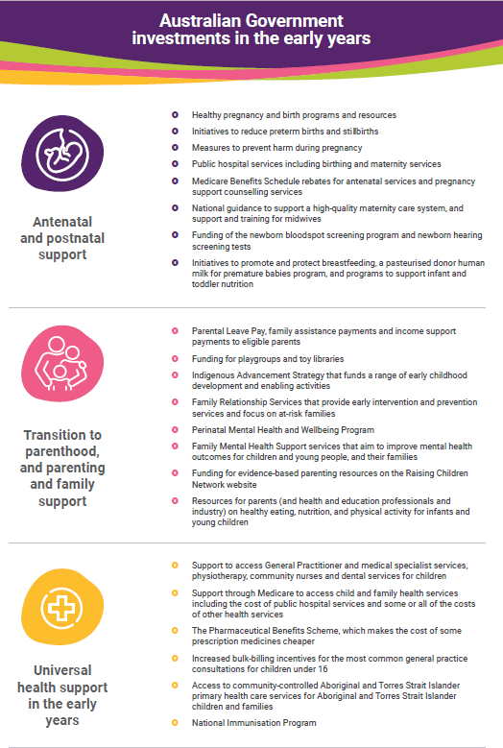

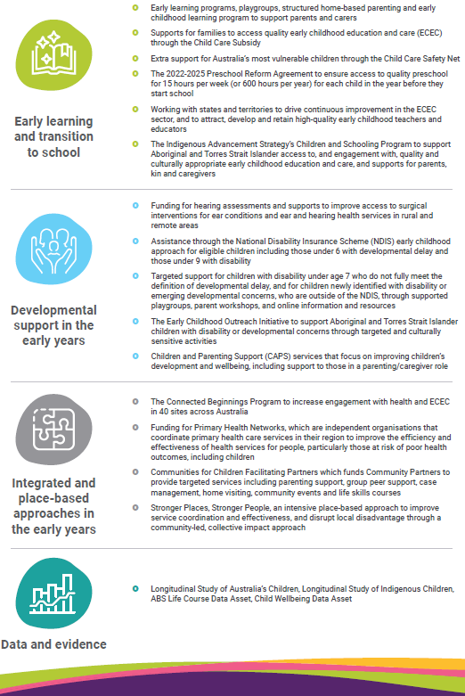

See also: Appendix 3 – Australian Government supports and services for more information

Complementary Australian Government initiatives and reforms
The Australian Government is driving reform in many arenas that will help build protective factors in the early years or address childhood adversity or poor health. These activities are the result of extensive stakeholder engagement, policy work and comprehensive consultation.
This includes the work we do with state and territory governments on areas of national interest and effort, including through the Preschool Reform Agreement and the Early Childhood Care and Development Policy Partnership.
The Strategy is the interlocking piece. It provides a unifying framework to align and amplify work across the Australian Government and to promote cooperation on priorities.
It is not the role of the Strategy to be the ‘home’ for all policies that affect young children, but its role is to influence and connect that work.
When policies and programs are connected and working in pursuit of common goals, they can achieve outcomes greater than the sum of their parts, and work better in the service of the needs of children, their families and communities.
This is why the Strategy acknowledges a range of complementary work being undertaken across Government, with details provided in Table 1: Existing national strategies, agreements and reforms, and Table 2: Reviews and inquiries, reports.
Many of the strategies, agreements and reforms listed below are addressing more complex challenges in early childhood, or areas where a focused effort will deliver good outcomes.
The Strategy recognises the importance of the National Agreement on Closing the Gap (the National Agreement) in ensuring that Aboriginal and Torres Strait Islander children experience the same development outcomes as non-Indigenous children. The National Agreement includes four Priority Reforms: Formal partnerships and shared decision-making; Building the community-controlled sector; Transforming mainstream organisations; and Shared access to data and information at a regional level.
The Priority Reforms are embedded in the Strategy and will continue to be embedded throughout the Strategy’s implementation.
The Strategy also recognises and amplifies the National Aboriginal and Torres Strait Islander Early Childhood Strategy, which was developed in partnership with Aboriginal and Torres Strait Islander communities.

Table 1. Existing national strategies, agreements and reforms
The Early Years Strategy builds on and aligns with many other existing Government priorities, strategies and reforms, and provides a focal point for amplifying the impact of these other key pieces of work. Table 1 outlines the current existing national strategies, agreements and reforms.
Existing national strategies, agreements and reforms
Treasury Wellbeing Framework: Measuring What Matters  Tracks progress towards a more healthy, secure, sustainable, cohesive and prosperous Australia. | National Agreement on Closing the Gap  Outlines how Aboriginal and Torres Strait Islander people and all governments will work in genuine partnership to overcome the inequality experienced by Aboriginal and Torres Strait Islander people.
National Action Plan for the Health of Children and Young People 2020-2030  Aims to ensure all children and young people are healthy, safe and thriving. | National Aboriginal and Torres Strait Islander Early Childhood Strategy  Sets the vision that Aboriginal and Torres Strait Islander children (0 to 5 years) are born healthy and remain strong, nurtured by strong families, and thrive in their early years.
National Children’s Mental Health and Wellbeing Strategy  The Strategy is the first of its kind in the world, with a focus on children from birth through to 12 years of age, as well as the families and communities that nurture them. The Strategy includes guiding principles, focus areas and key objectives and actions to improve children’s mental health and wellbeing. | Early Childhood Care and Development Policy Partnership  Brings together governments and Aboriginal and Torres Strait Islander representatives to develop recommendations to improve early childhood outcomes for Aboriginal and Torres Strait Islander children and families, in line with all Australian governments’ commitments under Closing the Gap.
National Fetal Alcohol Spectrum Disorder (FASD) Strategic Action Plan 2018-2028  Reduces the prevalence of fetal alcohol spectrum disorder and the impact it has on individuals, families, carers and communities. | National Plan to End Violence against Women and Children 2022-2032  Prevents and responds to violence against women in children in Australia, with the aim to end gender-based violence in one generation.
Australian National Breastfeeding Strategy: 2019 and Beyond  Provides a framework for integrated, coordinated action to shape and inform Australian Government, state, territory and local government policies and programs to support mothers and families to promote and protect breastfeeding. | Safe and Supported: the National Framework for Protecting Australia’s Children 2021-2031  Aims to ensure children and young people in Australia reach their full potential by growing up safe and supported, free from harm and neglect.
National Preventive Health Strategy 2021-2030  Works to improve the health and wellbeing of all Australians at all stages of life. | National Strategy to Prevent and Respond to Child Sexual Abuse 2021–2030  Aims to ensure children and young people in Australia are protected and safe from sexual abuse in all settings, and victims and survivors of abuse are supported and empowered.
Australia’s Disability Strategy 2021-2031  Is the national disability policy framework agreed to by all levels of governments, that is an enabler to people with disability being able to fulfil their potential as equal members of their communities. Supporting the 1 in 6 Australians that identify with disability. | National Quality Framework (NQF) Review  Provides a national approach to the quality of education and care services across Australia.
Preschool Reform Agreement 2022-2025  Agrees to Australian Government funding for preschool to the end of 2025, and reforms to improve preschool participation and outcomes.  Economic Inclusion Advisory Committee  The Committee’s role is to provide independent advice to Government before every Federal Budget on economic inclusion and tackling disadvantage. | Approved Learning Frameworks (ALFS)  The NFQ includes two national ALFS that support early childhood educators and promote children’s learning: Belonging, Being and Becoming: Early Years Learning Framework for Australia provides a learning framework for children aged 0 to 5, while My Time, Our Place: Framework for School Age Care in Australia provides a learning framework for Out of School Hours Care.
Early Childhood Care Development Sector Strengthening Plan  Sets out actions to support and build the Aboriginal and Torres Strait Islander community controlled early childhood care and development services sector in line with all Australian governments’ commitments under Closing the Gap. | Shaping Our Future: National Children’s Education and Care Workforce Strategy  Supports the recruitment, retention, sustainability and quality of the workforce in the children’s education and care sector.
Commonwealth Child Safe Framework  Sets minimum standards for creating and maintaining child safe culture and practices in Australian Government entities. | National Autism Strategy (in development)  Will provide a strategy to improve life outcomes for all autistic Australians.
National Strategy to Achieve Gender Equality  The National Strategy to Achieve Gender Equality will guide whole-of-community action to make Australia one of the best countries in the world for a gender-equal society. | The Wiyi Yani U Thangani (Women’s Voices) National Framework for Action  (To be launched March 2024) The National Framework for Action guides public and private investment in strengths-based initiatives that are designed and led by Aboriginal and Torres Strait Islander women and girls.

Table 2: Reviews and inquiries, reports
Productivity Commission Inquiry into Early Childhood Education and Care
An inquiry into the ECEC system, including centre-based day care, preschools, family day care, outside school hours care and in home care. The final inquiry report is due to Government by 30 June 2024.

Australian Competition and Consumer Commission Childcare Inquiry 2023
An inquiry into the market for the supply of childcare services.
Final report to be provided by 31 December 2023.

Independent Review of the National Disability Insurance Scheme
An independent review of the design, operations and sustainability of the NDIS.
Final Report to be provided by November 2023.

Intergenerational Report 2023: Australia’s Future to 2063
The Report projects the outlook of the economy and the Australian Government’s Budget to 2062-63.

ECEC Vision
On 31 August 2022, National Cabinet tasked Education Ministers to develop a national, long-term vision to support parents’ workforce participation and children’s education and development outcomes.

Policy integration and better coordination and collaboration supports children’s wellbeing
Parents do not see their children through a lens of which Government agency provides a service, such as health or education or any other silo, and neither should the Australian Government. Children’s health and wellbeing must be treated holistically.
When it comes to raising healthy, happy, well-adjusted children, all facets and aspects that intersect in their lives need to be considered.
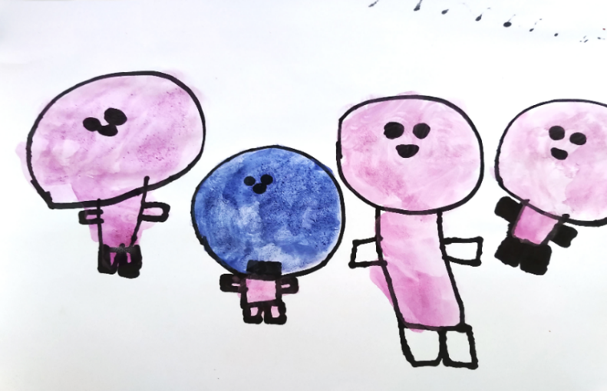
Cohesive plans for child well-being, such as this Strategy, are a widespread tool for policy integration, adopted by many OECD countries, to make a positive contribution to coordinating child well-being agendas.

“That’s my Mum, that’s my Dad, that’s my brother, and that’s me as a baby sucking my dummy. Outside it’s raining just a few drops.” (Children’s consultation)

Programs and funding that impact early childhood development are delivered by many Australian Government departments including Social Services, Education, Health, Attorney General’s and the National Indigenous Australians Agency.
Accountability for Australia’s children will be strengthened through a more coordinated, joined up approach across the Australian Government. Accountability will drive better results for children’s wellbeing.
Silos create barriers that impede collaboration across organisations and may hinder the Australian Government’s efforts to deliver the best outcomes for children and families.
Supporting early childhood development requires a holistic approach to achieve desired outcomes.
The capacity of the Australian Government to do so effectively has been impacted by a lack of coordination and collaboration across Government.
That is changing, with the development process behind the Early Years Strategy making significant progress in building coordination and collaboration across Government departments. The Strategy’s development has been made possible through new cross Australian Government governance arrangements, bringing together the key agencies with shared responsibilities in early years policy and programs.
But more change is needed.
“Tackling silos is one of the most important things to provide good support.” (Culturally and linguistically diverse roundtable consultation)
“Streamline and integrate services so families can access health, education, support without having to jump through multiple hoops.” (ECEC roundtable consultation)
Guided by the vision of children thriving and reaching their potential, the Strategy will inform how the Australian Government invests over the next decade in the early years to improve child wellbeing.
A shared early years vision, underpinned by outcomes that matter to children’s wellbeing, will drive policy coherence across the Australian Government.
Prioritising coordination across the Australian Government will improve accountability for the wellbeing, education and development of Australia’s children.

Aboriginal and Torres Strait Islander children are strong, healthy and well in community with connection to culture
As outlined in the National and Aboriginal and Torres Strait Islander Early Childhood Strategy, Aboriginal and Torres Strait Islander children should be able to thrive and grow up healthy, supported by strong families, and proud in culture. Across Australia, families and communities successfully support and nurture their young children. However, wide gaps in early childhood development outcomes persist.
The National Aboriginal and Torres Strait Islander Early Childhood Strategy was developed in partnership with SNAICC – National Voice for our Children and the Australian Government. It sets out five key goals for Aboriginal and Torres Strait Islander children, the outcomes to be achieved and the opportunities for reform. The Early Years Strategy re-affirms these goals and relevant opportunities for reform will be incorporated within the Strategy’s action plans.
Through embedding the Priority Reforms set out in the National Agreement on Closing the Gap (the National Agreement), the Australian Government is working in partnership with Aboriginal and Torres Strait Islander people, communities and organisations, to implement the policy reform and supports needed to improve early childhood development, health and wellbeing outcomes for Aboriginal and Torres Strait Islander children. The Early Years Strategy embeds throughout the commitments made through the National Agreement.
The Early Childhood Care and Development Policy Partnership is a shared decision-making mechanism implemented by the Australian Government to enable Aboriginal and Torres Strait Islander peoples to work in genuine partnership with governments to drive community-led, early childhood care and development outcomes. The Partnership brings together governments and Aboriginal and Torres Strait Islander representatives to develop recommendations to improve early childhood outcomes for Aboriginal and Torres Strait Islander children and families across several sectors including early childhood education and care, maternal and child health, child safety and children and families.
The Australian Government is also committed to strengthening the Aboriginal and Torres Strait Islander community controlled early years sector. The Early Childhood Care and Development Sector Strengthening Plan was released in late 2021 and outlines the critical role of Aboriginal and Torres Strait Islander Community Controlled Organisations in leadership and service delivery to support the safety, wellbeing, health and development of children in their early years. The Early Years Strategy reaffirms the areas of action outlined in the Sector Strengthening Plan.

The Early Years Strategy vision, principles, outcomes and priority focus areas
The Early Years Strategy sets out a bold vision and guides the efforts of the Australian Government to improve wellbeing outcomes for all children in Australia from 0 to 5 years.
The Early Years Strategy vision, guiding principles, outcomes and priority focus areas describe the things we know need to work well to achieve the results Australians, including children, want the Strategy to achieve. They take into account the whole child, and reflect the critical importance of parents and families, supported by connected communities.
- Vision – what the Australian Government aspires to achieve though the Strategy to secure the best start in life for young children in Australia
- Guiding Principles – how the Australian Government does its early years work
- Outcomes – the changes needed in order for the vision to be realised
- Priority Focus Areas – where the Australian Government will focus its attention to have the greatest impact to meet the outcomes, and what will inform the activities in Action Plans.

The Vision
All children in Australia thrive in their early years. They reach their full potential,
nurtured by empowered and connected families, who in turn are supported by strong communities.
This vision expresses the shared hopes, dreams and aspirations for Australia’s babies, infants, toddlers and into their preschool years – preparing them for their future by having the best possible start in life.
It distils what we have heard from parents and communities and from the services supporting them. It embodies a commitment to wellbeing, equity and fairness.
As with any vision it is aspirational and reflects the destination, not the starting point.

Together we will achieve more for children
The vision cannot be realised by the Australian Government alone – it sets the direction and course for our collective efforts across Government, through partnerships with other governments, the service sector, communities, and with families themselves. It sets a national aspiration for whole-of-child care. It shows the importance of nurturing and connecting with newborn babies from the very moment they open their eyes, of supporting parents to feel informed and empowered in their role, and be confident to connect with communities that can help them.
The vision responds to what we heard through the consultation period. For example, when asked ‘what are your biggest hopes for children in the early years?’ Australians told us they want all children to:
- feel safe, supported, loved and secure
- grow, learn and develop in safe and secure environments
- develop the skills they need to set them up for success later in life.

The Vision is bold, clear and concise
The vision places children at the centre of this Strategy.
It is our holistic aspiration to support every child, with no child left behind, and encourages all of us to support all children to thrive, enjoy their early years, and reach their potential.
“That’s me as a baby and I’m getting a little bit bigger. That’s me playing soccer. I’m going to be a soccer player and I’m going to the World Cup.” (Children’s consultation)
“Parents and communities should be supported and empowered to provide safe, caring, and nurturing experiences and environments for ALL children.” (Submission)

The Guiding Principles
The Guiding Principles inform how the Australian Government will work to support children and families in the early years through its actions, decisions and behaviour.
The Guiding Principles have already informed the approach to developing the Strategy.
The Guiding Principles will shape activity under the Priority Focus Areas.
The following table sets out five Guiding Principles, which shape the Strategy’s approach, from consultation and development, to delivery and implementation.

Principles | What we will do | How we will do it
Principle 1: Child and family-centred | Embed the voices of children and their families in the policies and decisions that affect them. | Seek out, listen to and act on the perspectives of children and families.  Focus on what they tell us they need, and be flexible and responsive when circumstances change.  Prioritise children’s perspective and keep their wishes, feelings and expertise in focus.  Recognise each family has individual goals, expectations and values.
Principle 2: Strengths-based | Focus on the abilities, knowledge and capacities of young children and their families. | Recognise children and families know their lives and needs best and have unique strengths, capabilities and resources.  Empower children and families to set their own goals that build on their existing strengths.
Principle 3: Respect for families and the community | Respect and value the roles that parents, kin, carers, community, language and culture play for children. | Recognise parents and caregivers roles as first teachers who know their children best.  Recognise and support families and local communities to maintain strong culture and links to their heritage, languages, traditions and to Country.
Principle 4: Equitable, inclusive and respectful of diversity | Ensure supports and services are equitable, inclusive, and accessible, and value all forms of diversity including in relation to gender, culture, language, place and disability. | Equity and inclusion are a non-negotiable.  Ensure supports and services are culturally safe and appropriate.  Recognise, respect and facilitate the role of non-government organisations, including the Aboriginal and Torres Strait Islander community controlled sector, in providing supports and services
Principle 5: Evidence informed | Continually build on and then draw on the latest available data, evidence and insights to design, develop and review supports and services for children and families. | Focus on building and improving an Australian evidence base to better support the development, implementation and monitoring of supports and services.  Enable data sharing and evidence for use by governments and communities to evaluate interventions and resources.

The Outcomes
The outcomes describe what success looks like in the early years.

The Strategy identifies eight outcomes to inspire and measure change
The outcomes cannot be achieved by the Australian Government on its own. They require the efforts of all those involved in the early years including parents, families and caregivers, communities, all tiers of government, the service sector and the philanthropic sector. This includes through how we work to join up our work.
For the Australian Government, the outcomes focus our efforts, and signal to other stakeholders what we are aiming to achieve in the early years.
The outcomes also support development of an Outcomes Framework that will help the Australian Government to measure and report the results we achieve. This Framework will be supported by a range of indicators reflecting the multidimensional nature of each outcome and the intersections across outcomes.
We will know we have met our Vision for the early years when the outcomes are achieved.
The outcomes reflect what we heard in consultations about what matters in the early years and recognise that children’s outcomes are shaped by their families’ wellbeing and resources.
They are grounded in wellbeing frameworks and models that take a holistic approach to children and situate their wellbeing in relation to their parents and caregivers, then communities and society. They are evidence-based and internationally recognised as the elements that matter to young children’s health and wellbeing.
While the outcomes have been customised for this Strategy, they do align with the six domains that form the Nest, a wellbeing framework developed by ARACY – the Australian Research Alliance for Children and Youth. There are two areas covered in this Strategy which are additional to the ones outlined in the Nest: outcomes specifically for parents and for communities and one that reflects the voice of young children.
The interconnected nature of child wellbeing means that the child well-being outcomes overlap, where uplifting one area of children’s lives often requires improving outcomes in, and/or connections with other areas. In practice, they operate as rich feedback loops to each other.
The outcomes are multidimensional, capturing different aspects of children’s lives. They are the goals we will use to measure how children are faring here and how well they are growing and developing. They are also the goals we will use to measure how supported families are, as well as the communities that wrap around them.
There is a dedicated outcome that reflects what young children told us they valued (play and imagination). Above all others this will be a constant reminder of the importance of valuing children and their voices.
“Thriving children are doing well in multiple aspects of their lives. They're healthy and active, with access to good food, healthcare, and a safe environment. Emotionally, they're resilient and confident, able to handle their feelings and build positive relationships with others. They have a strong sense of who they are and where they come from, embracing their cultural identity and feeling like they belong.” (Family services roundtable consultation)
“The Early Years Strategy needs to value children for who they are now and allow childhood to be playful and carefree, in addition to providing them with a good start to life.” (Submission)
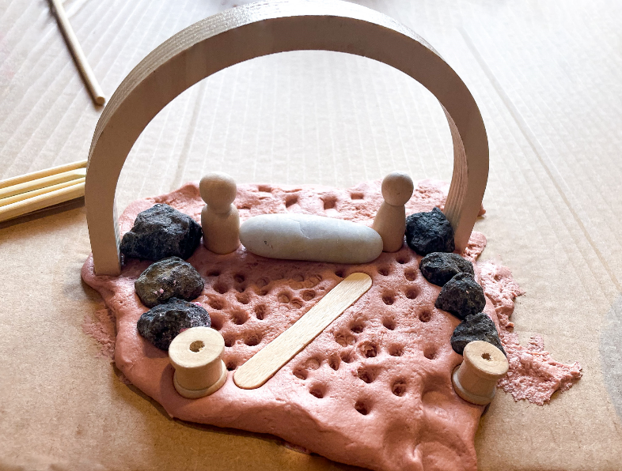

“I made a park I like to play in.” (Children’s consultation)
“Parents and primary carers cannot do the job of raising children in isolation. The phrase may be overworn, but it still ‘takes a village’ to raise a child. The confidence, knowledge and skills required to be a parent come from family, friends and community.” (Submission)
The outcomes are:

Children are nurtured and safe
- This means children are supported by their parents, caregivers and families, nurtured and safe from harm within their homes and communities, and able to spend quality time with their parents, family and friends.

Children are socially, emotionally and physically healthy
- This means children have the best possible opportunities, to build self-esteem, respect and resilience, develop physical capabilities, social competence and mental wellbeing and live happy, healthy lives. Strong language and communication skills support healthy development and enable children to express their emotions and connect positively with others.

Children are learning
- This means children are engaged in positive, safe and stimulating learning environments that build healthy brains and bodies from the very moment they come into their world.
- From birth, children learn through play when they explore and engage with the people and environment around them. They learn best in safe and stimulating environments and when engaged in positive and responsive relationships with their families and carers at home and with educators and teachers in ECEC settings. Environments that promote and extend children’s cognitive capabilities help children to better think, understand the world around them and solve problems. This foundational learning established early in life promotes the development of confident and creative individuals and creates a strong pathway for successful learning in formal education settings.

Children have strong identities and connections to culture
- This means all children have the best opportunities to grow up in environments where they can develop positive social and emotional connection to their peers and others, are connected to their own culture, language, beliefs and identity and are supported to exercise increasing autonomy as they age and develop.
- All cultures and family identities are respected and valued. Australia’s multiculturalism and the diversity of all families is celebrated in the Early Years Strategy.
- This includes ensuring that Aboriginal and Torres Strait Islander children’s connection to culture is strong, in particular to their own cultural identity, and they have access to culturally safe and appropriate early childhood education and care. Aboriginal and Torres Strait Islander culture, lore, wisdom and knowledge are acknowledged and respected.

Children have opportunities to play and imagine
- This means honouring childhood through providing children with the right to be children in the here and now – to have opportunities to play, imagine and express themselves creatively. It is about all children, and their families, having the opportunity to experience the joy of early childhood.
- Play is important to young children. We need to value it more as a society. We need to understand what children want and what works to stimulate them – such as open ended play and toys, playtime outside, lots of imaginative play, dress-ups, rhymes, singing, and quality playtime with those they love.

Material basics are met
- This means children have access to items that are regarded as essential or necessary. This may include adequate food and nutrition, healthcare, household income and housing.
- It recognises that economic participation is the best way to alleviate poverty and disadvantage and that one of the best ways of achieving this is through having a job.

Families are empowered, connected and supported
- This means supporting and empowering parents, carers, and families to meet the health, social, emotional, developmental and educational needs of children in the early years. It means they are equipped with the skills, capabilities and resources they need to support children to thrive in their early years.

Communities are strong and inclusive places for children and their parents or carers to live, grow, play and connect
- It takes a village to raise a child. This means communities must be safe, inclusive and enriching places that welcome children and their families, encourage a sense of belonging and a connectedness to people, land and nature and an environment that assists children develop social and other skills essential for healthy childhood development. Communities can be based on geographical location and involve the sharing local amenities, supports and services and the built and natural environment. Other communities are not based on location but rather where people connect (for example through online networks) based on shared circumstances, including the LGBTIQA+ community and the disability community.

The Priority Focus Areas
The Priority Focus Areas outline where the Australian Government will direct efforts to achieve the vision and outcomes.
Throughout the consultations, we heard from parents and families that in the early years they wanted enough time to spend with their children. They wanted to be empowered and supported, beginning during pregnancy. They also wanted to provide their children with what they need, focusing on families’ strengths.
The Australian Government seeks to further empower parents, caregivers and families to raise thriving children as well as strengthen the early childhood development arrangements that supports them.
To do this we need to re-examine Australian Government services that support children and parents, as well as the communities they live in, and identify opportunities to improve how we work.
We will do this by prioritising four key focus areas:
- Value the early years
- Empower parents, families and caregivers
- Support and work with communities
- Strengthen accountability and coordination
Actions to deliver each priority focus area will be outlined in the Action Plans.

Priority Focus Area 1: Value the early years

Priority Focus Area 1.1: Raise awareness about why early childhood matters
Building awareness of the critical importance of the early years and the factors that support early childhood development will ensure children are surrounded by change agents well equipped to provide early childhood environments which support the health and wellbeing of all babies, infants, toddlers and pre-schoolers.
How people view the first five years of life is an important determinant of the priority the early years are given by parents, communities, organisations and wider society. While the science is clear about the importance of early childhood development, there is an opportunity to ensure everyone has the understanding and knowledge to act.
This priority addresses the opportunity to ensure that how we prioritise early childhood, and how we should all act to achieve good outcomes for children and families in the early years, aligns with what the science and evidence tells us. Everyone has a role to play in supporting the early years.
The Australian Government is in a unique position to build awareness across the nation.
There is an opportunity to shape how parents, families, caregivers and the broader community understand and value early childhood and shaping that knowledge will improve children’s health and wellbeing.
With its focus on building public awareness, this priority provides a solid foundation for action across the other priority focus areas.
To do this we will look at opportunities to:
  - Raise awareness across the community about the importance of early childhood to ensure children, parents, families and caregivers are supported on their development journey.
  - Target efforts to raise awareness about the importance of early childhood, the value of children within our society, the critical role of parents and those who work with children.
  - Provide clear and consistent messaging for parents and caregivers on the importance of brain development and how that can be influenced in the early years.

Priority Focus Area 1.2: Embed the voices of children and their families
When our policies, programs and delivery reflect the voices and perspectives of children and families, we have the best chance of supporting children’s social, emotional, cognitive, physical and communication and language development.
This approach will require the Australian Government to think and act differently about how we undertake our work in the early years.
A priority focus area on elevating children and family voices complements the guiding principle which commits the Australian Government to embedding and reflecting children’s and families’ voices at the centre of what we do. As a priority focus, it signals that the Australian Government will create opportunities to observe, listen and talk with children and families and take action to elevate these voices.
- To do this we will look at opportunities to:
  - Actively consult with children, families, caregivers and, more broadly, communities, about what they need and don’t need, what they think works and doesn’t work, and how and when they want to access supports.
  - Build and embed the perspectives of children and families into each stage of the design, delivery and improvement of Australian Government policies and programs that support early childhood development.
  - Ensure that data collection and evaluation takes into account the experiences of children and families and the communities that work with them so these views can inform improved service design and investment.

Priority Focus Area 2: Empower parents and caregivers

Priority Focus Area 2.1: Empower parents, families and caregivers with skills, resources and capabilities
Children thrive when families, parents and caregivers have the support they need.
Helping parents is helping babies and young children because parents, families and caregivers play a crucial role in building the foundational skills young children need. Relationships are the building blocks of positive growth and development.
Parents, families and caregivers are empowered when they know what is important for children’s development in the early years, including what children need to be healthy and happy, and what they need to support them to learn.
Parents and other caregivers are empowered when they have the skills, resources and capabilities to help their children develop and learn, and they need to know where to access support.
Parents, like other members of the Australian community, will benefit from awareness raising outlined in Priority Focus Area 1, but also benefit from particular efforts to support growth in their skills, knowledge and capabilities. It recognises that when parents are thriving, this is good for children.
To do this we will look at opportunities to:
  - Ensure evidence-based information about early childhood health and development that is comprehensive and contemporary is available and accessible to parents, caregivers and the wider community.
  - Equip parents and families with the knowledge, skills and capabilities to help them help their children grow.
  - Support and encourage parents to seek help and navigate the available resources, services and supports.
  - Strengthen parenting supports.
  - Ensure supports are culturally responsive, including recognition of the role the Aboriginal and Torres Strait Islander community-controlled sector plays in ensuring Aboriginal and Torres Strait Islander parents, caregivers and families are empowered in a culturally appropriate manner
  - Increase information about the services and supports available for children and families.

Priority Focus Area 2.2: Support parents to connect with other parents and their local community
In many cases, parents and caregivers will reach out to informal support networks to find information or get help. This could be extended family, kin, or peer networks such as friends or neighbours, parent/grandparent groups, playgroups, social media groups and/or message boards. In other cases, parents and caregivers may feel isolated and not know where to go for support.
These networks are where parents and caregivers can learn from the experiences of others in similar situations to their own, and gain the confidence and skills to be their child’s first teacher.
A focus of the Strategy is looking holistically at what parents and families need, balancing opportunities to strengthen and empower parents and caregivers through informal support (this focus area) with a responsive and accessible service system (the next focus area).
- To do this we will look at opportunities to:
  - Help parents connect with other families and learn from each other.
  - Support the enablers of strong informal and community networks.
  - Make communities safe and inclusive spaces for all families.

Priority Focus Area 2.3: Make supports and services responsive and inclusive to children and their parents
A recurring theme from our consultations was the importance of ensuring children and families can access the support and resources they need to thrive – in particular, through a service system that is accessible, flexible and equitable. This means that supports and services are delivered at a scale and intensity that is proportionate to the degree of need.
Most families will access formal supports at particular milestones in their child development journey, such as Parental Leave Pay, parenting resources, health services and ECEC.
Some families might need more specialised or targeted supports when an issue arises such as a concern about a child’s health or development, changes in a caregiver’s mental health and wellbeing, or moving to a new town.
When children and parents need these supports, they should be easy to access, and high quality. Responsive services listen and then provide for the needs of children and families using them, address barriers to access, and ensure they are effective and fit for purpose.
All services should be culturally safe, culturally responsive, trauma informed and not stigmatising.
There is a strong call to ‘flip the burden of knowledge’ that currently asks parents and carers to navigate the maze of available information and services to find what is valuable to them. Families value knowing what supports are available, and when, where and how to access them.
Responsive and accessible services are supported by a strong and capable early years workforce.
- To do this we will look at opportunities to:
  - Ensure the Australian Government’s early childhood health and development supports are responsive to the needs of children and families by being high quality, evidence-informed, targeted, accessible, respectful and inclusive of disability, language and diversity, culturally safe and responsive, flexible and proportionate to the degree of need.
  - Support equitable access to supports so that no matter where they live, or who their parents are, children can access the supports they need.
  - Enable and encourage early access to supports when required by empowering parents, kin and caregivers to detect and act on early developmental delay signals, and by connecting families with the supports they need.
  - Help to ensure services are easy to navigate for the people who use them.
  - Support the early years workforce through capacity and capability building.

Priority Focus Area 2.4: Chart the course towards universal access to Early Childhood Education and Care
The Australian Government is committed to charting the course for universal access to ECEC in Australia that is high quality, equitable, affordable and accessible. While expanding access to ECEC is complex, and there are challenges related to workforce shortages and thin markets in some areas of Australia, there is a clear need to improve access to quality ECEC, so that all Australians can benefit from this essential service, particularly in rural, regional and remote communities and for children from disadvantaged backgrounds who stand to benefit the most.
ECEC provides the building blocks to support cognitive growth and development of children, including social skills and emotional health that are fundamental to lifelong learning and achievement throughout life. There is also evidence that attending a quality preschool program is particularly beneficial for the most vulnerable and disadvantaged children who are less likely to meet developmental milestones.
ECEC provides significant benefits for children’s early learning and development, helping to break intergenerational cycles of disadvantage, and providing a strong foundation for children’s later life outcomes. If not addressed early, developmental vulnerability becomes more difficult and costly to tackle as a child falls further behind. Without high-quality ECEC and targeted early intervention, early experiences of disadvantage may become entrenched and set a trajectory for poorer outcomes later in life.
While children from disadvantaged backgrounds are most likely to benefit from high-quality ECEC, they are among the least likely to participate in it. An equitable, accessible, affordable and culturally responsive ECEC system would ensure all families can access ECEC services, regardless of where they live or their cultural backgrounds, and that services are flexible enough to meet the needs of families and communities. The Aboriginal and Torres Strait Islander community controlled sector plays a critical role in overcoming the barriers faced by Aboriginal and Torres Strait Islander children and families in accessing ECEC and delivering quality, culturally responsive services that allow children to thrive.
ECEC also supports parents. An accessible, affordable ECEC system is a key enabler of workforce participation, especially for women. Barriers to workforce participation are more pronounced for women, who are overrepresented in part-time and casual employment, and twice as likely as men to be working part-time or casually from age 35.
High quality ECEC means that services are delivered by a qualified workforce, are culturally inclusive and responsive, and meet standards in providing learning and development outcomes for children to ensure that they are engaged as lifelong learners. A sustainable ECEC workforce who are valued and respected is central to maintaining quality ECEC.
- To do this we will look at opportunities to:
  - Respond to the Productivity Commission (PC) inquiry into ECEC and the Australian Competition and Consumer Commission (ACCC) Childcare inquiry.
  - Work with state and territory governments to identify opportunities to realise the National Vision for ECEC, underpinned by the key principles of quality, affordability, equity, and accessibility.
  - Continue to work with state and territory governments to implement the Preschool Reform Agreement, including measures to improve attendance and outcomes such as the Preschool Attendance Measure and the Preschool Outcomes Measure.
  - Continue to work with state and territory governments to ensure the ECEC system can attract, retain and support a high quality ECEC workforce, including implementing the actions under the National Children’s Education and Care Workforce Strategy.
  - Partner with children, families and communities and their representatives to understand their needs and preferences, so the system is inclusive and responsive to them.
    - This includes partnering with Aboriginal and Torres Strait Islander children, families, communities and organisations—including through the Early Childhood Care and Development Policy Partnership—with shared decision-making and shared stewardship of the system.
  - Work with all providers to build a stronger and more integrated ECEC system with higher levels of support and higher expectations.
  - Support the Government’s workplace relations reform agenda, including mechanisms to drive increased pay and conditions for the ECEC workforce, to attract and retain a high-quality ECEC workforce.

Priority Focus Area 3: Support and work with communities

Priority Focus Area 3.1: Place-based approaches
When policies and services align with local needs, they are responsive to community context and priorities. This leads to effective and efficient supports and services, and provides children, from a range of different communities, with the opportunities they need to thrive.
The approach we are taking in the Strategy is consistent with calls for local flexibility and responsiveness. Place-based approaches are tailored and targeted to the specific circumstances of a place. They involve the community (residents as well as service providers, businesses, governments and other local stakeholders) as active participants in policy development and service delivery, and focus on building local solutions to local problems.
They also provide opportunities for children and families to have a say about the policies and services that affect them.
- To do this we will look at opportunities to:
  - Work with and support communities to deliver better outcomes for children tailored to local contexts, including through community-led shared accountability.
  - Explore and implement mechanisms – including governance models that support greater local lead solutions based on evidence.
  - Look at the disparity in outcomes between children in major cities compared to those in remote and/or very remote areas and opportunities to address.
  - Use and share data and evidence about place-based initiatives, including lessons about their concepts, principles and practices, to build upon existing Australian Government place-based initiatives
  - Share community level data with communities.
  - Explore flexible funding models, including funding for outcomes.

Priority Focus Area 3.2: Shared decision-making
Everyone has a role to play in supporting the early years. Communities have an important role in designing and delivering local solutions that empower their community and have been shown to work.
Shared decision-making brings together the goals and preferences of the community and the best available evidence about what works.
Policies and services that align with local needs, respond to community context and priorities and are well integrated, lead to efficient and effective delivery of outcomes. They also allow for equitable investment, so communities that are facing particular types of disadvantage and need more support or bespoke responses, can be provided with additional support.
- To do this we will look at opportunities to:
  - Support shared decision making, with families and children at the centre.
  - Encourage a greater culture and capacity within Australian Government agencies for shared decision making, such as through co-design and user-led design, to better enable wider community input into the design and delivery of policies, programs and supports and accountability and metrics that lead to equitable services.

Priority Focus Area 4: Strengthen accountability and coordination

Priority Focus Area 4.1: Integration, collaboration and coordination
Currently, responsibility for the programs and funding that impact early childhood development sits across Australian Government departments – including Social Services, Education, Health, the National Indigenous Australians Agency and Attorney-General’s. The development of the Early Years Strategy provides the ongoing strategic direction for the Australian Government’s future investment, and a new way of working across government for coordination and collaboration in the early years.
Ongoing collaboration across the Australian Government in the early years will include working with all of our partners – state, territory and local governments, service providers, philanthropy and communities – to make children’s and parents’ experiences of Australian Government funded services as seamless as possible. Achieving good outcomes happens when children’s social, physical and emotional health, learning, and their connection to community and culture are all strong.
Good policy making for children’s wellbeing calls for government ministries, agencies and other service providers to better collaborate. This priority unites the Australian Government on a common goal and enduring purpose – to foster a system-wide response that enables collaboration and promotes coordinated and integrated policies and supports in the early years. This joined up approach reduces the risk of fragmentation, duplication of effort, and missed opportunities to address gaps.
Optimising early childhood development requires Government to take a holistic approach. Consultations indicated that the capacity to do so effectively has been impacted by a lack of coordination and collaboration. When we collaborate, we are working collectively to achieve our vison for children to thrive and reach their potential. This requires greater effort to improve policy coherence, transparency and accountability. It also requires governance structures to be in place to give effect to this.
- To do this we will look at opportunities to:
  - Align monitoring on early years investments across the Australian Government consistent with the Early Years Strategy vision and outcomes.
  - Coordinate and integrate supports and services.
  - Ensure the individual and joint roles and responsibilities of agencies are clear and transparent within the Australian Government to support improved collaboration, coordination and joined-up decision-making.
  - Ensure that different actors including state, territory and local governments, providers and community members have a clear understanding of Australian Government roles and responsibilities in the early years, to improve the Australian Government’s transparency and accountability, and foster collaboration across sectors.
  - Recognise and acknowledge when things are not working – and be prepared to be adaptive and responsive.
  - Continue and develop the strong and effective cross-agency senior governance and advisory arrangements that have supported the Strategy’s development (outlined in Appendix 1).

Priority Focus Area 4.2: Data, research, evaluation
Data, research and evaluation is essential to understanding how a child’s experiences growing up shape and influence their life outcomes. To achieve the Australian Government’s vision for children in the early years, we need to be able to measure the outcomes, report on progress to the Australian community and understand whether what we are doing is having the impact that we want.
- To do this we will look at opportunities to:
  - Capture data that reflects the voices of children, parents, kin, caregivers and communities and their lived experiences.
  - Enhance data nationally and locally, to provide a better profile of families and children and their experiences.
    - This includes the Australian Bureau of Statistics Life Course Data Asset, which will improve understanding of how communities experience disadvantage, including through longitudinal data.
    - The Child Wellbeing Data Asset that is being developed by the Australian Institute of Health and Welfare (AIHW) will be an enduring, child-centred linked data asset. Through linked data, the Child Wellbeing Data Asset will provide new insights on how children transition through major development stages, and how they interact with government supports that enable them to thrive.
  - Share community and service level data, and make it easy to understand and interpret, to give parents, kin, carers and communities the tools they need to make decisions about their priorities and to drive service improvement
  - Improve information and data sharing and analysis across governments, providers, communities and academia to improve our collective understanding of the early years and, how children are faring and what is supporting them to thrive, as a basis for ongoing collaboration and decision making and to help solve the complex problems for children and their families.
  - Support a focus on the early years through existing Australian Government funding streams for data, research and evaluation.
  - Build and then share the evidence base about ‘what works, for whom and in what circumstances’ and ensure new research adapts to the changing lives of families.
  - Further enhance a culture of evaluation, and strive to ensure that programs have evaluation built in.
  - Develop and implement a robust and clear Outcomes Framework, with clear performance indicators, and backed by access to high quality and timely data.
  - Implement transparent and robust cross-agency accountability arrangements, including through data sharing, regular reporting and strong evaluation processes.

Delivery through Action Plans
The Strategy will be implemented through Action Plans over its 10-year course, and this implementation will be measured by an Outcomes Framework to assess progress and effectiveness.
The Strategy will be operationalised through Action Plans delivered over the next 10 years. The Action Plans will include practical steps developed in the context of the vision and priorities and with an eye to what needs to be achieved (the outcomes) to deliver good results for children in Australia.
There will be three phases of Action Plans. The first and second Action Plans will be three years in duration; the final Action Plan will span four years.
This approach to delivery will ensure the Australian Government can be agile and responsive to contemporary challenges and opportunities, while still retaining an enduring focus on the vision, outcomes and priorities.
Achievements against Action Plans will be continually monitored to measure progress and ensure accountability for delivery, including through public facing progress reports.
The Strategy and Action Plans will be accompanied by an Outcomes Framework which will provide measurable indicators so we can track the progress and success of the actions taken under the Strategy and monitor progress against the outcomes and vision. The Outcomes Framework will support an evaluation of the Strategy, will be delivered as part of the third and final Action Plan.
While the Strategy is focused on the Australian Government’s investment in the early years, its objectives cannot be achieved without the contribution of all actors. This includes:
- parents, caregivers and families and young children
- state and territory governments
- the early childhood sector more broadly
- service delivery partners, and
- the philanthropic sector.
To achieve our outcomes the Australian Government will look to partner and collaborate with other actors in the system.
Noting the outcomes of the Strategy are broader than the Australian Government’s responsibility alone, the Strategy will also support working collaboratively with states and territories on areas of joint responsibility to achieve reform over time.
The First Action Plan will commence in 2024 and be informed by the views, perspectives, expert advice and evidence collected during the development of this Early Years Strategy. It will also benefit of insights from targeted consultation. It will include the perspectives of children and families.
Noting that nothing else will work well unless the foundations are right, a key initial focus will be strengthening these foundations. The First Action Plan will align the Government’s early years policies and programs to the vision and priorities, and will include embedding new ways of working across Government to improve collaboration and accountability. This and subsequent Action Plans will also capture progress and actions arising from interconnected major reviews and reform activities, including in ECEC.

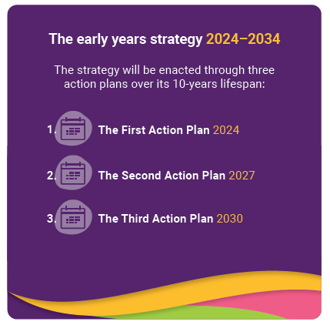

Governance and monitoring
A feature of the Strategy is a commitment to an ongoing Australian Government senior-level Steering Committee to oversee implementation of the Strategy, and monitor progress and reporting against the Action Plans.
An ongoing advisory body will provide expert advice to the Steering Committee to guide the implementation and monitoring of the Strategy. Details of these governance arrangements will be settled in the development of the First Action Plan.

Appendix 1 – How the Strategy was developed
The Early Years Strategy has been shaped by the voices, ideas and experiences of young children, families and the early childhood sector from across Australia, and is built on a strong base of national and international research.
The Early Years Strategy was developed through wide consultation and an examination of research and evidence.
It directly reflects the views of children, parents, kin and carers, early childhood experts and the early childhood sector, about the things that are important to help young children develop and learn. It also draws on a considerable body of national and international research that supports the evidence-based approach taken by the Strategy.

Consultations

Breadth of our consultation
The Government committed to broad and deep consultation in developing the Strategy to obtain an understanding of multiple perspectives on the early years, how early years supports are working around Australia, and the Australian Government’s role.
To allow for significant and meaningful participation, the consultation approach provided multiple mechanisms over a 7-month period. Engagement on the Early Years Strategy included the following opportunities:

National Early Years Summit
Held on 17 February 2023 at Australian Parliament House, the National Early Years Summit brought together over 100 delegates to start the conversation on how to ensure Australian children have the best start in life.

Public survey
A pulse survey, designed to seek views on what the Australian Government should focus on under the Strategy, opened on DSS Engage on 19 January 2023 and closed on 3 April 2023. The survey received total of 2,243 responses.

Public submissions
Published on 4 February 2023, a discussion paper sought advice, ideas and feedback on Australia’s aspirations for our youngest children and the Australian Government’s role in the early years.
The consultation period was over 12 weeks and closed on 30 April 2023. A mix of individuals, peak bodies, universities and think tanks, service providers and governments submitted a response, with 352 submissions received.

Roundtables
There were 39 roundtables held in person and virtually across Australia between February 2023 and July 2023, with over 750 participants.
Roundtables were held in every state and territory. This included roundtables hosted by the Minister for Social Services, the Hon Amanda Rishworth MP, and the Minister for Early Childhood Education, the Hon Dr Anne Aly MP, and in select cases by Members of Parliament.

Children’s consultation
Children’s consultation set out to identify what matters most to children in their lives, including people, places and activities, and ask them what would make today a better day. Children aged 3 to 5 years had their say through community painting/artwork, loose materials landscape creation, and semi-structured discussion (happiest moment/ memory).

Governance arrangements
A senior-level Australian Government Steering Committee oversaw development of the Strategy. The Steering Committee was supported by the Early Years Strategy Advisory Panel, a group of experts who provided direct advice, shared their insights and expertise, and worked collaboratively with Government to develop the Strategy. An interdepartmental Working Group also supported the Steering Group.

Appendix 2 – The evidence in detail
There are more than 1.5 million children aged 0 to 5 in Australia. They come from diverse backgrounds, families and circumstances.
For us to achieve better outcomes under the Early Years Strategy, we must start with a deep understanding of early childhood and the factors that enable children to thrive, how children in Australia are currently faring, and the current landscape of early years and children’s policy. We must also consider that children today will occupy a very different world to the one that has shaped their parents’ lives, and must be prepared to react with resilience and adaptability to what may come.

What we know about Australia’s young children and how they are faring
The Early Years Strategy focuses on the wellbeing of all children in the early years. While the focus on all children is an important feature of the Strategy, understanding who and where Australia’s young children are, and what we know about them and their similarities and differences, helps to inform policies and approaches.

Children born in Australia each year
In 2021, there were approximately 310,000 births registered in Australia, a slight increase following lower birth registrations of around 294,000 in 2020. Aboriginal and Torres Strait Islander children accounted for 7.6% of registered births in 2021.
In 2021, the total fertility rate was about 1.7 babies per woman. While this was higher than the 2020 rate (1.6 babies per woman), overall, the total fertility rate has been declining since 2011 when it was 1.9 babies per woman.
In 2021, the median age of mothers was 31.7 years and the median age of fathers was 33.7 years. The median age of parents has generally increased since the 1970s.

Children aged 0 to 5 in Australia
At 30 June 2022, an estimated 1.82 million children aged 0 to 5 lived in Australia. Boys made up a slightly higher proportion of the population than girls (51% compared with 49%).
The number of children aged 0 to 5 living in Australia has increased from approximately 1.79 million in 2012.
However, due to sustained low fertility rates and increasing life expectancy, the number of children aged 0 to 5 as a proportion of the entire Australian population has steadily fallen from 7.9% in 2012 to 7.0% in 2022.

Where children live in Australia
Children aged 0 to 5 typically live with their families, and so their geographic distribution will generally be similar to that of all Australians. In 2022, of all children aged 0 to 5:
- Around one-third (32% or 578,000) lived in New South Wales
- One-quarter (25% or 463,000) lived in Victoria
- One-fifth (20% or 371,000) lived in Queensland
- 11% (205,000) lived in Western Australia
- 7% (118,000) lived in South Australia
- 2% (35,000) lived in Tasmania
- 2% (32,000) lived in the Australian Capital Territory
- 1% (21,000) lived in the Northern Territory.
In 2021, most children aged 0 to 5 lived in major cities (73% or 1.33 million), with 17% (315,000) living in Inner Regional areas, 8% (141,000) living in Outer Regional areas and 2% (42,000) living in Remote and Very Remote areas.

Children’s backgrounds
In 2021, 6% (or around 104,000) of children aged 0 to 5 were Aboriginal and Torres Strait Islander children. Approximately 13% of the Aboriginal and Torres Strait Islander population was aged 0 to 5, compared to 6.8% of the non-Indigenous population.
In 2021, just over 3% (around 59,300) of children aged 0 to 5 were born overseas. More than one-quarter (27% or around 473,000) of children aged 0 to 5 had both parents born overseas, while another 17% (around 302,000) had one parent born overseas.
In 2021, almost three-quarters of children aged 0 to 5 (72% or 1.272 million) used English at home, while around one-fifth (21% or around 381,000) spoke a language other than English at home, and around 7% (125,000) were not stated or not classifiable.
In 2021, almost 14,800 children aged 0 to 5 were permanently settled in Australia, including around 520 who arrived in Australian under the Humanitarian Program for refugees and others in refugee-like situations.

The make-up of families
This section presents data according to a national definition of a family used for official statistical purposes. The Australian Bureau of Statistics (ABS) defines a family as 2 or more persons, one of whom is at least 15 years of age, who are related by blood, marriage (registered or de facto), adoption, step or fostering, and who usually live in the same household. This definition may not always align with how a child defines their family, and it may not align with the concept of a family for Aboriginal and Torres Strait Islander Australians.
In 2021, 81% (around 1.4 million) of children aged 0 to 5 lived in couple families, slightly higher than in 2011 (76%) and 2016 (79%). About 13% (around 228,000) of children lived in one-parent families in 2021, while for another 6% (around 107,000) of children, family composition was other or not defined.
The majority of children aged 0 to 5 living in couple families in 2021 lived with their natural or adopted parents (90% or around 1.3 million):
- 5.6% (around 80,400) lived in blended families – a family with at least one child of both partners (natural or adopted) and at least 1 step child
- 3.8% (around 54,300) lived in step families – a family with at least one step child and no natural or adopted children.
Children living in one-parent families, blended or step families may live according to shared-care arrangements agreed between their original parents; however no nationally consistent data is available on these arrangements. Less than 1% of children in couple families lived in other arrangements, such as grandparent families and families with foster children only.
In 2021, approximately 7,800 (0.4%) children aged 0 to 5 lived with a same sex parent couple. The number of children living with a same sex parent couple has almost doubled since 2016 (from approximately 4,300 children).

The antenatal period
The foundations for good health start during the antenatal period, and the first years of life. Maintaining a healthy lifestyle during pregnancy contributes to better outcomes for the baby and the mother.

Smoking during pregnancy
In 2021, the majority women who gave birth (around 92%) reported not smoking during the first 20 weeks of their pregnancy, while around of 8% (around 25,600) women did report smoking during the first 20 weeks of their pregnancy. Between 2011 and 2021, the proportion of women who smoked during the first 20 weeks of pregnancy fell from 13% (around 37,700) to 8% (25,600).
In 2021, of women who reported smoking during their pregnancy, 72% reported that they continued smoking after the first 20 weeks. Between 2011 and 2021, the proportion of women who continued smoking after the first 20 weeks of pregnancy rose from 70.8% to 72.4%. However, over this time, the total number who continued to smoke has decreased from around 26,700 to 18,500.

Drinking during pregnancy
In 2021, the majority women who gave birth (around 97%) reported not consuming alcohol during the first 20 weeks of their pregnancy, while around of 3% (around 5,565) women did report consuming alcohol during the first 20 weeks of their pregnancy.

Antenatal care
In 2021, around 80% of women (or 246,000) attended antenatal care visits in their first trimester. The number has increased from around 188,000 (or 66%) in 2011. Young women (aged less than 25), Aboriginal and Torres Strait Islander women, women living in remote or very remote areas and women from the lowest socioeconomic areas were less likely to attend antenatal care in the first trimester.

Teenage mothers
In 2021, the proportion of women who gave birth aged under 20 (teenage mothers) was 1.5% (around 4,800). This proportion has more than halved since 2011, falling from 3.7% (around 11,000).
The proportion of Aboriginal and Torres Strait Islander teenage mothers has almost halved since 2011, falling from 19% (around 2,200) to 10% (around 1,500) in 2021.

Births and infants

Births
In 2021, there were approximately 310,000 births registered in Australia, a slight increase following lower birth registrations of around 294,000 in 2020.
In 2021, the total fertility rate was about 1.7 babies per woman. While this was higher than the 2020 rate (1.6 babies per woman), overall, the total fertility rate has been declining since 2011 when it was 1.9 babies per woman.
In 2021, the median age of mothers was 31.7 years and the median age of fathers was 33.7 years. The median age of parents has generally increased since the 1970s. In 1975 the median age of mothers was 25.8 years, and the median age of fathers was 28.6 years.
The health of a baby at birth is a key determinant of subsequent health and wellbeing. Low birthweight has been associated with increased risk of coronary heart disease, diabetes, hypertension and stroke in adulthood. Following birth, breastfeeding is a protective factor by reducing infant mortality, protecting against illnesses, and helping develop the baby’s microbiome.
In 2021 the majority of live born infants had a healthy birthweight (93.7% compared with around 6.3% (19,600) with low birthweight). There has been very little change in the proportion of children with low birthweight since 2011.

Breastfeeding
Breastfeeding is a known protective factor for infant health and wellbeing, and it supports bonding between mother and baby.
In 2020-21, of infants aged 0–3 years:
- four out of five (80%) received breast milk at 4-months old
- almost three-quarters (74%) received breast milk at 6-months old
- around half (51%) received breast milk to 12-months old.
- In 2020-21, 35% of infants aged 0 to3 exclusively breastfed for at least 6 months.

Infant mortality rate
In 2021, the mortality rate for infants aged less than 1 was 3.3 per 1,000 live births. The infant mortality rate has decreased from 2011 (3.8 per 1,000 live births).

Early childhood health and wellbeing
As children grow, immunisation protects them from harmful, and potentially fatal diseases.

Immunisation
In 2022, the proportion of children who were fully immunised was:
- 94% for 1-year-olds
- 92% for 2-year-olds
- 94% for 5-year-olds.

Children with disability
In 2018, around 57,800 (3.7%) of children aged 0 to 4 were estimated to have disability, of whom around 36,000 (2.3%) were estimated to have a severe or profound disability. A higher proportion of boys (4.8%) were estimated to have a disability than girls (2.7%).
As of 30 June 2023, there were around 99,400 children aged under 7 with a NDIS plan and around 14,600 accessing early connections through the NDIS, that is, early childhood interventions that are available for children with developmental delay or a disability without requiring a diagnosis.

Child mortality rate
In 2022, the mortality rate among children aged 0 to 4 years old was 0.8 per 1,000 children. The rate has decreased from 0.9 per 1,000 in 2011.

Play, early learning and care
In 2022 among children aged 1 to 5 who played most days of the week, 44% played outside at home in the front or back yard on at least 4 days a week, 45% played outside away from home on at least 4 days a week, 71% played inside not using a digital device on at least 4 days a week, and 27% played inside using a digital device (eg. iPad, computer or phone) on at least 4 days a week.
Early home learning experiences in the first 3 years of life are important as, for most children the home is the main influence on child language and cognitive development. In 2017, 79% of children aged 0 to 2 were regularly read to or told stories by a parent on 3 or more days in the previous week. Also in 2017, 44% of children aged 0 to 2 had between 25 and less than 100 books in the home.
Women tend to spend more time caring for children and less time on employment related activities, compared to men. More female parents of children under 15 years participate in child care activities than male parents (89% compared to 73%).Female parents who participated in child care, spent 3 hours 34 minutes while male parents spent 2 hours 19 minutes.
- 54% of children are ‘always or usually’ cared for by the mother
- 37% of children are equally for between the mother and father
- 11% of children are always or usually cared for by the father.

Fruit and vegetable consumption
In 2020-21, over 8 in 10 (85%) children aged 2 to 4 met the recommendations for daily fruit consumption. Just over 1 in 5 (21%) children aged 2 to 4 met the recommended guidelines for vegetable consumption.

Sugar sweetened drinks
Over 9 in 10 (91%) of children aged 2 to 4 did not usually consume sugar sweetened or diet drinks. Nearly 1 in 10 (9%) of children aged 2 to 4 usually consumed sugar sweetened or diet drinks on at least a weekly basis.

Early childhood education and care (ECEC)

ECEC attendance
In the December quarter 2022, 48% (or around 884,000) of children aged 0 to 5 used government subsidised ECEC. This was consistent with proportions over the previous 12 months (ranging from around 48% to 49%).
Between the September quarter 2020 and the December quarter 2022, use of ECEC has been consistently highest for children aged 3 (between 60% to 68%) and lowest for children aged less than 1 (between 6% to 12%).
The quality of education and care services has consistently risen in recent years, with 89% of the 15,765 approved ECEC services in Australia meeting or exceeding the National Quality Standards at 1 July 2023.

Preschool participation
In 2022, around 89% (284,000) of eligible children were enrolled in a preschool program in the year before full-time school and around 86% (273,000) were attending.
Children were most commonly enrolled in centre-based day care (around 47% or 134,000), followed by dedicated preschool (around 39% or 110,000). Enrolments across both preschool and centre-based was least common (around 14% or 40,100). Over 95% of children enrolled were enrolled for 15 hours or more per week.
In 2022, around 99% (18,900) of eligible Aboriginal and Torres Strait Islander children were enrolled in preschool in the year before full-time school and around 91% (17,500) were attending. Aboriginal and Torres Strait Islander children were most commonly enrolled in dedicated preschool (49% or 9,200), followed by centre-based day care (39% or 7,400). Enrolments across both dedicated preschool and centre-based day care services was least common (around 13% or 2,400).

Child mental health
The World Health Organization estimates that worldwide, around 20% of children and adolescents suffer from a mental health condition and that mental disorders are likely to become the leading cause of morbidity and mortality by 2030.
Among children aged 5 to 14, mental disorders make up 3 of the 5 leading causes of the total burden of diseases for children in Australia.
There are multiple risk factors for childhood mental illness including genetic predisposition, individual personality factors, family factors (including parents with mental illness), and adverse childhood experiences.
Up to 1 in 5 children in Australia have a parent with a mental illness.

Housing and labour force status

Housing stress
In 2021, 18% (around 316,000) of children aged 0 to 5 were living in households with housing costs (mortgage repayments or rent payments) that were above 30% of their household income.

Homelessness
In 2021, 0.5% (almost 9,000) children aged 0 to 5 were homeless.

Labour force status
A family’s economic situation is closely related to the labour force status of the individuals within the household. Family joblessness can affect children by reducing a family’s overall financial security and economic wellbeing. Joblessness denies families an important income stream, and the associated financial constraints can increase financial stress and reduce parental investment in children’s needs such as education, food and housing.
In 2022, around 89% of families with a youngest child aged 0 to 4 had one or more parent employed, and around 9% of families had no parent employed.

Child safety

Substantiations of child protection notifications
In 2021–22, around 16,200 children aged 0 to 4 (including unborn children) were subjects of substantiated maltreatment.
Between 2019–20 and 2021–22, the rate of children aged 0 to 4 (including unborn children) who were subjects of substantiated maltreatment, decreased from 11.7 to 10.7 per 1,000 children.

Out-of-home care
At 30 June 2022, around 9,700 children aged 0 to 4 were in out-of-home care.
Between 30 June 2020 and 30 June 2022, the rate of children aged 0 to 4 who were in out-of-home care remained relatively stable for all children, from 6.7 to 6.4 per 1,000 children.

Domestic violence
An estimated 2.6 million people aged 18 years and over (13%) witnessed violence towards a parent by a partner before the age of 15.

Appendix 3 – Australian Government Supports and Services
The Australian Government provides a wide range of supports and services for children and their families in the early years.
Australian Government investment in the early years is substantial. The Australian Government helps children and families through the provision of information, resources, supports and services, as well as funding initiatives that increase and upskill the workforce that supports children and families.
Families want to do their best to raise their children well, and parents and carers supplement their own activities by accessing early years supports and services including general health, early childhood education and care (ECEC) services, and more specialised and targeted supports and services for some families.
While interactions with Australian Government services will vary for each child and family based on their individual circumstances, all children and families will engage with Australian Government supports and services at some stage.
Responsibility for these initiatives is spread across a number of Australian Government agencies. The Early Years Strategy provides a framework to ensure these supports and services are developed and delivered in an integrated and coordinated way so that the contribution they make to the children’s development and wellbeing outcomes is as effective as possible.
Where key early years supports and services are delivered by state and territory governments, the Australian Government often supports these programs through universal systems like the Medicare Benefits Schedule, or by providing national strategic direction and evidence based guidelines.

Antenatal and postnatal support
In the antenatal period, the Australian Government promotes healthy pregnancies and births through a range of resources and programs including the Pregnancy, Birth and Baby website and hotline and guidelines for pregnancy care and postnatal care (in development). The Australian Government has a number of initiatives to reduce preterm births and stillbirths and provides support to families bereaved by stillbirth and miscarriage. The Government also funds measures to prevent harm from alcohol and tobacco use during pregnancy, including a strategy to prevent and manage Fetal Alcohol Spectrum Disorder (FASD). Prevention and early diagnosis of neurodevelopment conditions like FASD, and early intervention can lead to better outcomes for children and their families.
Through the National Health Reform Agreement, the Australian Government supports state and territory government delivered public hospital services, including birthing and maternity services. The Medicare Benefits Schedule provides rebates for ultrasounds, blood tests, fertility and in vitro fertilisation treatments and pregnancy support counselling services. The Australian Government also provides national guidance to support a high-quality maternity care system, and support and training for midwives.
The Australian Government supports newborn health by funding the newborn bloodspot screening program and newborn hearing screening tests.
In the first years of life, great nutrition is critical for a child’s overall development and wellbeing. To facilitate this, the Australian Government supports initiatives to promote and protect breastfeeding, provide pasteurised donor human milk to premature babies, restrict the marketing and advertising of infant formula, and improve the food supply in relation to infant and toddler foods.
The Australian Government also provides a range of resources for parents, health and education professionals and industry on healthy eating, nutrition, and physical activity for infants and young children. This combination of initiatives seeks to assist families and communities to make informed decisions about infant and young child feeding and facilitate access to nourishing foods.

Transition to parenthood
To support the transition to parenthood, the Australian Government provides a range of payments, programs and resources.
Parental Leave Pay helps parents take time away from work to care for their baby. Family assistance payments including Family Tax Benefit, Newborn Supplement, Multiple Birth Allowance and Rent Assistance are available to eligible parents from the birth of their children and throughout the early years. Income support payments are also available to parents who need them, both before and after the birth of their child.
The Australian Government provides a range of resources to help parents learn about child development and support play and connection. For example, it funds parenting support, playgroups, toy libraries, and evidence based parenting resources on the Raising Children’s Network website.
The Indigenous Advancement Strategy funds a range of early childhood development and enabling activities to support Aboriginal and Torres Strait Islander children and families, such as facilitated playgroups and family and community access and engagement activities.
Becoming a parent can also be difficult, and raise many new challenges and issues. To support parents’ mental health, the Australian Government delivers a Perinatal Mental Health and Wellbeing Program, family mental health support services and general mental health supports like Head to Health.

Universal health support in the early years
Across the early years, Australian Government supports include access to General Practitioner and medical specialist services, and services such as paediatricians, physiotherapy, community nurses and dental services for children.
Child and family access to health services is supported through Medicare. This means if a person has treatment as a public patient at a public hospital, they do not pay for medical treatments and some or all of the costs of other health services. The Pharmaceutical Benefits Scheme, which makes the cost of some prescription medicines cheaper. More recently, the Australian Government has increased bulk-billing incentives for the most common general practice consultations for children under 16 to support GPs to continue to bulk bill children. (Note this takes effect from 1 November 2023.)
Aboriginal and Torres Strait Islander children and families are able to access Australian Government-funded community-controlled Aboriginal and Torres Strait Islander primary health care services, and around 50% do so.
The National Immunisation Program is available from birth and continues throughout the early years and beyond.

Early learning and transition to school
The Australian Government supports children’s learning and development in the early years through early learning programs, playgroups, structured home-based parenting and early childhood learning programs to support parents and carers to be their child’s first teacher and prepare children for school.
The Australian Government supports families to access quality early childhood education and care (ECEC). Quality care and education for children in their early years sets them up for later life achievement, providing a strong basis for learning foundation skills necessary to engage in their community and gain employment. Preschool in particular has been found to support children’s cognitive and social development.
Most families who use ECEC in the early years have the cost of their child’s care subsidised through the Child Care Subsidy.
A base entitlement to 36 hours per fortnight of subsidised care is available for families with Aboriginal and Torres Strait Islander children and children attending preschool in the year before full-time school, regardless of activity hours or income level.
The Australian Government provides extra support for Australia’s most vulnerable children through the Child Care Safety Net:
- Additional fee assistance to families facing barriers to early childhood education and care services for vulnerable or at-risk children through the Additional Child Care Subsidy.
- Grants through the Community Child Care Fund (CCCF) to improve further access to ECEC in Australia by helping services address barriers to ECEC participation, particularly in disadvantaged, regional and remote communities.
- Assistance for approved early childhood education and care services to include children with additional needs through the Inclusion Support Program (ISP).
However, it is not enough to simply provide access to ECEC; ensuring care is of high quality is also necessary if we are to achieve good outcomes for children. The Australian Government supports the quality of ECEC by working collaboratively with State and Territory Governments on ECEC system policy settings and regulatory functions to drive continuous improvement in the sector, and in measures to attract, develop and retain high-quality early childhood teachers and educators.
The Australian Government also supports ECEC services to improve their capacity and capability to be more inclusive for children with additional needs.
The 2022-2025 Preschool Reform Agreement aims to ensure access to quality preschool for 15 hours per week (600 hours per year) for each child in the year before they start school. It locks in Australian Government funding to states and territories until the end of 2025.
The Indigenous Advancement Strategy’s Children and Schooling Program supports Aboriginal and Torres Strait Islander children and families’ access to and engagement with quality and culturally appropriate early childhood education and care, and supports parents, kin and carers to confidently take a role in child development.

Development support in the early years
The Australian Government provides a range of targeted supports in the early years, recognising the opportunity to identify and address emerging concerns early to have lasting impacts on children’s health, and social and emotional wellbeing.
The Australian Government funds a number of programs to prevent hearing problems, particularly for Aboriginal and Torres Strait Islander children, who are at far greater risk of otitis media (middle ear infection). This includes programs to help parents, carers and teachers identify and prevent ear disease in Aboriginal and Torres Strait Islander children, hearing assessments, and supports to improve access to surgical interventions for ear conditions or ear and hearing health services in rural and remote areas.
Children younger than 6 with developmental delay and children younger than 9 with a disability may be assisted through the early childhood approach under the National Disability Insurance Scheme (NDIS). The NDIS early childhood approach helps children and families to build their capacity and supports greater inclusion in community and everyday settings.
Targeted support is also available for children with disability, developmental delay or emerging developmental concerns and their families through a number of specific early childhood initiatives such as the National Early Childhood Program and through other Australian Government funded supported playgroups, parent workshops and online information and resources.
The Early Childhood Outreach Initiative supports Aboriginal and Torres Strait Islander children with disability or developmental concerns through targeted and culturally sensitive activities.

Integrated and place-based approaches in the early years
The Australian Government also delivers a number of programs that aim to provide more integrated services to children and families in the early years that are responsive to local strengths and needs.
Connected Beginnings draws upon the strengths and knowledge of Aboriginal and Torres Strait communities to increase engagement with health and ECEC in 40 sites across Australia. It improves access to existing early childhood, maternal and child health and family support services to ensure children are safe, healthy and ready to thrive at school by the age of 5.
The Australian Government also funds Primary Health Networks, which are independent organisations that coordinate primary health care services in their region. This program helps to better coordinate Australian Government and state and territory-funded health services in each region and respond to local community priorities.
Communities for Children Facilitating Partners use a model where a Facilitating Partner Organisation funds Community Partners to provide services targeted to their community, identified by a local committee. These services include parenting support, group peer support, case management, home visiting, community events and life skills courses.
A more intensive place-based approach is Stronger Places, Stronger People, which not only aims to improve service coordination and effectiveness, but disrupt local disadvantage through a community-led, collective impact approach.
Appendix 4 – Spotlight on strategies
The Early Years Strategy will knit together existing Australian Government strategies aimed at supporting and improving the lives of children in Australia.
The following strategies intersect with and complement the Early Years Strategy, and cover areas of strategic focus that are important to the success of the Strategy such as child safety, and the wellbeing of Aboriginal and Torres Strait Islander children, and children with disability or developmental delay.

National Agreement on Closing the Gap
In July 2020, the Australian Government, all state and territory governments, and the Coalition of Peaks signed the National Agreement on Closing the Gap (National Agreement). The National Agreement seeks to overcome the entrenched inequalities faced by Aboriginal and Torres Strait Islander people, pushing for equality in life outcomes for all Australians.
The National Agreement is built around four Priority Reforms to change the way governments work with Aboriginal and Torres Strait Islander communities, organisations, and people across the country. The Priority Reforms are based on what Aboriginal and Torres Strait Islander people have been saying for a long time is needed to improve their lives, and have been committed to by all Australian, state and territory governments.
The Priority Reforms must inform all government action including legislation, policy, and practice, whether these actions are targeted for Aboriginal and Torres Strait Islander peoples or impact them as part of the general population. The Priority Reforms are listed below.
1. Formal Partnerships and Shared Decision Making
Aboriginal and Torres Strait Islander people are empowered to share decision-making authority with governments to accelerate policy and place-based progress on Closing the Gap through formal partnership arrangements.
2. Building the Community-Controlled Sector
There is a strong and sustainable Aboriginal and Torres Strait Islander community-controlled sector delivering high quality services to meet the needs of Aboriginal and Torres Strait Islander people across the country.
3. Transforming Government Organisations
Governments, their organisations and their institutions are accountable for Closing the Gap and are culturally safe and responsive to the needs of Aboriginal and Torres Strait Islander people, including through the services they fund.
4. Shared Access to Data and Information at a Regional Level
Aboriginal and Torres Strait Islander people have access to, and the capability to use, locally relevant data and information to set and monitor the implementation of efforts to close the gap, their priorities and drive their own development.
Aboriginal and Torres Strait Islander children have the right to thrive and to grow up healthy, supported by strong families and proud in culture. Cultural identity, kinship structures, and connection to culture are strongly recognised as protective factors for children’s safety, health, wellbeing and development. Families and communities who have been impacted by intergenerational trauma and discriminatory policies that perpetuate disadvantage often have complex needs, and are most in need of targeted and intensive healing and support services that are culturally-safe and welcoming.
The Early Years Strategy complements and supports the National Agreement and other initiatives outlined below that support the Closing the Gap targets, through its focus on child and family wellbeing for all children and families, and its aim to better integrate and coordinate Australian Government supports and services for all children in the early years.
All 17 Closing the Gap socio-economic outcome areas are interconnected and can contribute to positive outcomes for children in the early years. The Early Years Strategy child and family wellbeing outcomes support the following early years-focused Closing the Gap outcome areas:
- Outcome area 2: Aboriginal and Torres Strait Islander children are born healthy and strong.
- Outcome area 3: Aboriginal and Torres Strait Islander children are engaged in high-quality, culturally appropriate early childhood education in their early years.
- Outcome area 4: Aboriginal and Torres Strait Islander children thrive in their early years.
- Outcome area 12: Aboriginal and Torres Strait Islander children are not overrepresented in the child protection system.
- Outcome area 13: Aboriginal and Torres Strait Islander families and households are safe.

Alignment with the National Aboriginal and Torres Strait Islander Early Childhood Strategy
The purpose of the National Aboriginal and Torres Strait Islander Early Childhood Strategy is to pave the way for governments, non-government sectors and communities to collectively support Aboriginal and Torres Strait Islander children to grow up healthy, engaged with education, connected to family and community, and strong in culture. The Strategy aims to align and coordinate cross-portfolio effort across the whole-of-government and the early childhood systems and sectors, and aligns with commitments under the National Agreement.
There is alignment between the Early Years Strategy 2024-2034 to support all children in the early years, and the National Aboriginal and Torres Strait Islander Early Childhood Strategy, released in 2021. The Early Years Strategy does not replace the National Aboriginal and Torres Strait Islander Early Childhood Strategy. Rather it respects the National Aboriginal and Torres Strait Islander Early Childhood Strategy and seeks to amplify it.
The vision for the Early Years Strategy is consistent with and supports the vision of the National Aboriginal and Torres Strait Islander Early Childhood Strategy, which is:
Aboriginal and Torres Strait Islander children (0 to 5 years) are born healthy and remain strong, nurtured by strong families and thrive in their early years.
The National Aboriginal and Torres Strait Islander Early Childhood Strategy focuses on the priority areas of education, health, workforce, safety, housing, disability and cultural connection. Figure 2 illustrates the five goals of the National Aboriginal and Torres Strait Islander Early Childhood Strategy, and identifies outcomes and opportunities under each goal.
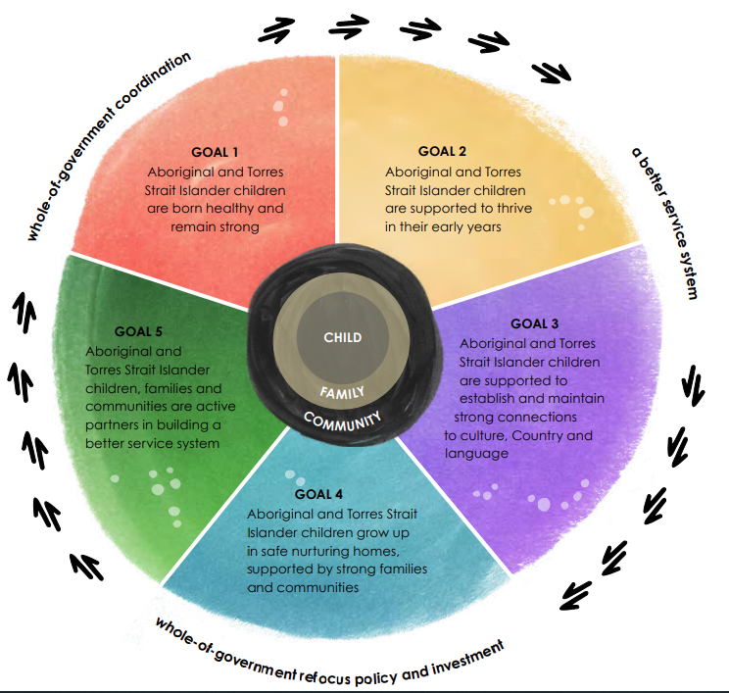
Figure 2: National Aboriginal and Torres Strait Islander Early Childhood Strategy – goals

Early Childhood Care and Development Policy Partnership
The Early Childhood Care and Development Policy Partnership (the Partnership) brings together Australian governments and Aboriginal and Torres Strait Islander representatives to enable genuine partnership to drive community-led and holistic early childhood programs to help children achieve their full potential.
The Partnership builds on the National Aboriginal and Torres Strait Islander Early Childhood Strategy and Early Childhood Care and Development Sector Strengthening Plan, both of which provided the organising foundation for the operating context for the Partnership. The Partnership continues to have oversight and drive development of policy reforms outlined in the National Aboriginal and Torres Strait Islander Early Childhood Strategy and Early Childhood Care and Development Sector Strengthening Plan.
The Partnership is also complemented by the Early Years Strategy through its shared vision to drive a more integrated and coordinated approach that recognises the holistic needs of children, in particular Aboriginal and Torres Strait Islander children.
Child safety
All children have the right to be free from harm, and will have better development and life outcomes when they can grow up in safe environments and with access to supports if they experience adversity or trauma.
The Australian Government has a number of strategies and programs to address child safety issues such as child protection, child sexual abuse and family violence.
For example, the Government works with states and territories to deliver: the National Plan to End Violence Against Women and Children 2022-2032; Safe and Supported: the National Framework for Protecting Australia’s Children 2021-2031; the National Strategy to Prevent and Respond to Child Sexual Abuse 2021-2030; and the National Quality Framework which has a strong focus on ensuring the safety and protection of children attending Early Childhood Education and Care services.
The Government delivers a range of initiatives under these strategies ranging from resources to awareness campaigns, programs and services, as well as data and research.
This also involves engaging with the family law system through a range of specialised programs focused on early intervention and prevention, improving outcomes for families, and culturally safe supports for Aboriginal and Torres Strait Islander families.
The Aboriginal and Torres Strait Islander First Action Plan 2023-2026 under Safe and Supported focuses on safety and wellbeing of children including reducing their overrepresentation in out-of-home care.
The First Action Plan (2023-2027) of the National Plan to End Violence against Women and Children provides a roadmap for the first 5-year effort towards achieving the vision of the National Plan. It sets out the initial scope of activities, areas for action and responsibility with respect to outcomes, and outlining how we will make the commitments set out in the National Plan a reality. It includes an outcome committing to ensuring that “children and young people are safe in all settings and are effectively supported by systems and services”. A dedicated Aboriginal and Torres Strait Islander Action Plan, Aboriginal and Torres Strait Islander Action Plan 2023-2025, will work alongside the First Action Plan.
Endnotes

This Strategy has used the term ‘Aboriginal and Torres Strait Islander’ when referring to Aboriginal and Torres Strait Islander peoples, communities and organisations, in alignment with the National Aboriginal and Torres Strait Islander Early Childhood Strategy.
National Aboriginal and Torres Strait Islander Early Childhood Strategy (2021), National Aboriginal and Torres Strait Islander Early Childhood Strategy National Indigenous Australians Agency: Australian Government
Center on the Developing Child, 2007, The Science of Early Childhood Development (InBrief)
Submission to the Early Years Strategy Discussion Paper by Life Course Centre (2023) Life Course Centre submission to the Early Years Strategy discussion paper, 2023
Center on the Developing Child: National Scientific Council on the Developing Child (2010) Early Experiences Can Alter Gene Expression and Affect Long-Term Development: Working Paper No. 10
Center on the Developing Child: National Scientific Council on the Developing Child (2007) The Timing and Quality of Early Experiences Combine to Shape Brain Architecture: Working Paper No. 5
Center on the Developing Child: National Scientific Council on the Developing Child (2007) The Timing and Quality of Early Experiences Combine to Shape Brain Architecture: Working Paper No. 5
Center on the Developing Child: National Scientific Council on the Developing Child (2004) Young children develop in an environment of relationships. Working Paper No. 1
Center on the Developing Child (2007) The Science of Early Childhood Development (InBrief)
National Scientific Council on the Developing Child (2020) Connecting the Brain to the Rest of the Body: Early Childhood Development and Lifelong Health Are Deeply Intertwined: Working Paper 15
Center on the Developing Child, What is Early Childhood Development? A Guide to the Science (ECD 1.0)
Submission to the Early Years Strategy discussion paper by Australian Psychological Society (2023) The Australian Psychological Society submission
Sylva, Kathy & Melhuish, Edward & Sammons, Pam & Siraj, Iram & Taggart, Brenda (2004) The Effective Provision of Pre-School Education (EPPE) Project: Findings from Pre-school to end of Key Stage 1
The Front Project, 2019, A Smart Investment for a Smarter Australia: Economic analysis of universal early childhood education in the year before school in Australia
Department of Social Services (DSS) (2010) Positive Family Functioning, final report by Access Economics Pty Ltd for Department of Families, Housing, Community Services and Indigenous Affairs
Heckman: The economics of human potential (2023) The Heckman Equation Home Page - The Heckman Equation
Submission to the Early Years Strategy discussion paper by Telethon Kids Institute (2023) Telethon Kids Institute submission to the Early Years Strategy discussion paper
Center on the Developing Child: National Scientific Council on the Developing Child (2020) Connecting the Brain to the Rest of the Body: Early Childhood Development and Lifelong Health Are Deeply Intertwined: Working Paper No. 15
The Front Project (2022) Supporting all children to thrive: The importance of equity in early childhood education
Warren, D. Australian Institute of Family Studies (AIFS) (2017) Social Policy Research Paper No. 47 Low Income and Poverty Dynamics Implications for Child Outcomes (aifs.gov.au) Commonwealth of Australia (Department of Social Services)
Radford, Katrina & Gould, Ryan & Vecchio, Nerina & Fitzgerald, Janna Anneke. (2018). ‘Unpacking intergenerational (IG) programs for policy implications: A systematic review of the literature’ Journal of Intergenerational Relationships. 16. 302-329. 10.1080/15350770.2018.1477650.
Nomaguchi, K., & Milkie, M. A. (2020) ‘Parenthood and well-being: A decade in review’ Journal of Marriage and Family, 82(1), 198–223
ibid.
Submission to the Early Years Strategy discussion paper by Children and Young People With Disability (2023) Children and Young People With Disability Public Submission
Bronfenbrenner, U., & Morris, P. A. (2006). The Bioecological Model of Human Development. In R. M. Lerner & W. Damon (Eds.), Handbook of child psychology; Vol. 1: Theoretical models of human development (pp. 793–828). New York: John Wiley & Sons, Inc.
Center on the Developing Child (n.d) Resilience, accessed 24 October 2023
Center on the Developing Child (2021) 3 Principles to Improve Outcomes for Children
Center on the Developing Child: National Scientific Council on the Developing Child (2010) Early Experiences Can Alter Gene Expression and Affect Long-Term Development: Working Paper No. 10
Center on the Developing Child: National Scientific Council on the Developing Child (2004) Young children develop in an environment of relationships. Working Paper No. 1
Center on the Developing Child (n.d) Resilience, accessed 24 October 2023
Center on the Developing Child: National Scientific Council on the Developing Child (2004) Young children develop in an environment of relationships. Working Paper No. 1
National Aboriginal and Torres Strait Islander Early Childhood Strategy (2021) National Aboriginal and Torres Strait Islander Early Childhood Strategy | National Indigenous Australians Agency (niaa.gov.au)
ibid.
Submission to the Early Years Strategy discussion paper by Indigenous Allied Health Australia (2023) Indigenous Allied Health Australia
Relationships and child development, 2023, Relationships & child development | Raising Children Network.
JM Zosh et al. (2017) Learning through play: a review of the evidence (white paper), The LEGO Foundation, DK, page 16
Center on the Developing Child: National Scientific Council on the Developing Child (2004) Young children develop in an environment of relationships. Working Paper No. 1
ibid.
Submission to the Early Years Strategy discussion paper by the Fathering Project (2023) The Fathering Project Public Submission
Center on the Developing Child: National Scientific Council on the Developing Child (2023) Place Matters: The Environment We Create Shapes the Foundations of Healthy Development: Working Paper No. 16
Australian Institute of Health and Welfare (AIHW) (29 June 2023) Australia’s mothers and babies [media release], AIHW, accessed 24 October 2023
Dr R Hutchinson & J Vo-Phuoc (n.d.) It’s not as simple as ‘nature or nurture’: the impact of socioeconomic influences on children, PWC Australia, accessed 24 October 2023
Australian Children’s Education and Care Quality Authority (n.d.) Standard 1.2 Practice – Case study 1 | ACECQA, accessed 24 October 2023
OECD (2017), Starting Strong 2017: Key OECD Indicators on Early Childhood Education and Care, Starting Strong, OECD Publishing, Paris, https://doi.org/10.1787/9789264276116-en
D Phillips, et al. (2017) Puzzling it out: The current state of scientific knowledge on pre-kindergarten effects – A consensus statement, Washington DC: Brookings Institution, accessed 24 October 2023
D Higgins, A Dean (2020) A population approach to early intervention and prevention, Ensuring all children get the best start in life | Australian Institute of Family Studies (AFIS) website, accessed 24 October 2023
Center on the Developing Child: National Scientific Council on the Developing Child (2005 /2014) Excessive Stress Disrupts the Architecture of the Developing Brain: Working Paper No. 3. Updated Edition
Monks, H., Mandzufas, J., & Cross, D. (2022) ‘The Impact of Poverty on the Developing Child: A Narrative View’, Life Course Centre Working Paper Series, 2022-06. Institute for Social Science Research, The University of Queensland
Center on the Developing Child: National Scientific Council on the Developing Child (2020) Connecting the Brain to the Rest of the Body: Early Childhood Development and Lifelong Health Are Deeply Intertwined: Working Paper 15
ibid.
Royal Australasian College of Physicians (2011) The Health and Wellbeing of Incarcerated Adolescents [PDF 227KB], Sydney
Center on the Developing Child (n.d.) Early Childhood Mental Health, accessed 25 October 2023
Center on the Developing Child: National Scientific Council on the Developing Child (2023) Place Matters: The Environment We Create Shapes the Foundations of Healthy Development: Working Paper No. 16
Monks, H., Mandzufas, J., & Cross, D. (2022) ‘The Impact of Poverty on the Developing Child: A Narrative View’, Life Course Centre Working Paper Series, 2022-06. Institute for Social Science Research, The University of Queensland
Center on the Developing Child: National Scientific Council on the Developing Child (2007) The Timing and Quality of Early Experiences Combine to Shape Brain Architecture: Working Paper No. 5
Submission to the Early Years Strategy discussion paper by Anglicare Southern Queensland (2023) Anglicare Southern Queensland Public Submission
AIHW (2021) ‘National Perinatal Data Collection’ annual update 2021 data visualisations (Table 4.2) Canberra
Department of Health and Aged Care (2023) ‘Immunisation Data: Historical coverage’ [data tables for all children], Canberra
Australian Bureau of Statistics (ABS) (2023) ‘Preschool Education 2022’, ABS Website, accessed 31 August 2023
Australian Early development Census (AEDC) (2022) Australian Early Development Census National Report 2021, AEDC, accessed 14 September 2023
ibid.
ibid.
AIHW (19 September 2023) Child Protection Australia 2021-22 [web report], AIHW, accessed 26 September 2023
Campo, M. (2015) Children's exposure to domestic and family violence: Key issues and responses (CFCA Paper No. 36) Melbourne: Child Family Community Australia information exchange, Australian Institute of Family Studies
LJ Conway, F Cook, P Cahir, S Brown, S Reilly, D Gartland, F Mensah and R Giallo (2021) ‘Children’s language abilities at age 10 and exposure to intimate partner violence in early childhood: results of an Australian prospective pregnancy cohort study’, Child Abuse & Neglect, 111:104794, doi:10.1016/j.chiabu.2020.104794
World Health Organization (2022) World mental health report: transforming mental health for all, Geneva: World Health Organization
AIHW 2020. Australia’s children. Cat. no. CWS 69. Canberra: AIHW, Australia's Children (aihw.gov.au)
The Connected Beginnings program draws upon the strengths and knowledge of Aboriginal and Torres Strait communities to increase engagement with health and ECEC in 40 sites across Australia. It improves access to existing early childhood, maternal and child health and family support services to ensure children are safe, healthy and ready to thrive at school by the age of five.
Dirwan, G. and O. Thévenon (2023) "Integrated policy making for child well-being: Common approaches and challenges ahead", OECD Papers on Well-being and Inequalities, No. 16, OECD Publishing, Paris, doi.org/10.1787/1a5202af-en
Productivity Commission Dashboard, Closing the Gap Socioeconomic Outcome Area 4 Aboriginal and Torres Strait Islander children thrive in their early years - Dashboard, Productivity Commission, Australian Government, accessed 25 October 2023
Submission to the Early Years Strategy discussion paper by Australian Multiple Births Association (2023) Australian Multiple Births Association Public Submission
Bronfenbrenner, U., & Morris, P. A. (2006) The Bioecological Model of Human Development. In R. M. Lerner & W. Damon (Eds.), “Handbook of child psychology; Vol. 1: Theoretical models of human development”, (pp. 793–828). New York: John Wiley & Sons, Inc.
OECD (n.d.) Child Wellbeing Outcomes, OECD, accessed 25 October 2023
Goodhue, R., Dakin, P., Noble, K. (2021) What’s in the Nest? Exploring Australia’s Wellbeing Framework for Children and Young People. ARACY, Canberra
Dirwan, G. and O. Thévenon (2023) Integrated policy making for child well-being: Common approaches and challenges ahead, OECD Papers on Well-being and Inequalities, No. 16, OECD Publishing, Paris
Submission to the Early Years Strategy discussion paper by Toy Libraries Australia (2023 Toy Libraries Australia Public Submission
Submission to the Early Years Strategy discussion paper by Playgroup Australia (2023) Playgroup Australia Public Submission
Workplace Gender Equality Agency (2022), Wages and Ages: Mapping the Gender Pay Gap by Age | WGEA
ABS (2021) Births, Australia [key statistics], ABS Website, accessed 22 August 2023
ibid.
ibid.
ABS (December 2022) National, state and territory population [key statistics], ABS Website, accessed 16 June 2023
ibid.
ABS (2022) ‘Regional population by age and sex’, obtained by data request on 9 September 2022
ABS (2021) ‘Census of Population and Housing’, [Tablebuilder], produced by AIHW on request
ibid.
Department of Home Affairs (2023) Settlement reports, accessed 25 August 2023
ABS (2011) 2901.0 - Census Dictionary, 2011, ABS Website, accessed 16 June 2023
ABS (2011) ‘Census of Population and Housing’, [Tablebuilder], produced by AIHW on request
ibid.
ibid.
AIHW (2020) Australia’s children. Cat. no. CWS 69. Canberra: AIHW, accessed 25 October 2023
AIHW (2021) National Perinatal Data Collection annual update 2021, [Data sets], AIHW Website, accessed 16 August 2023
ibid.
ibid.
AIHW (2021) National Perinatal Data Collection annual update 2021, [Table 2.1], AIHW Website, accessed 16 August 2023
ABS (2017-18) National Health Survey: First Results, [Table 17.1, 17.3], ABS Website, accessed 26 October 2023
ABS (2022) Births, Australia [key statistics], ABS Website, accessed 22 August 2023
ibid.
ibid.
AIHW (2020) Australia’s children. Cat. no. CWS 69. Canberra: AIHW, accessed 25 October 2023
AIHW (2021 National Perinatal Data Collection annual update 2021, [Table 4.2], AIHW Website, accessed 16 August 2023
AIHW (2023) Australia's mothers and babies: Breastfeeding, [Figure 1], AIHW Website, accessed 26 October 2023
AIHW (2023) Australia's mothers and babies: Breastfeeding, [Figure 2], AIHW Website, accessed 26 October 2023
ABS (2021) Deaths, Australia, ABS Website, accessed 23 August 2023
AIHW (2020) Australia’s children. Cat. no. CWS 69. Canberra: AIHW, accessed 25 September 2023
Department of Health and Aged Care (2023) ‘Immunisation Data: Historical coverage data tables for all children’, Australian Government
AIHW (2018) Microdata: Disability, Ageing and Carers, Australia, [TableBuilder] by AIHW on request
National Disability Insurance Scheme (NDIS) (2023) Quarterly report to disability ministers for Q4 of Y10, NDIS, accessed 10 October 2023
ABS (2023) ‘Deaths, Australia. Data explorer dataset (Deaths, Year of registration, Age at death, Age-specific death rates, Sex, States, Territories and Australia)’, [Tablebuilder], produced by AIHW on request
The Royal Children's Hospital National Child Health Poll (2022) Australian families: How we play, Poll Number 28, The Royal Children's Hospital Melbourne, Parkville, Victoria
ABS (2020-21) How Australians Use Their Time, ABS Website, accessed 13 October 2023
K Hand, J Baxter, M Carroll & M Budinski (2020) Life during COVID-19: Early findings (Families in Australia Survey report), Melbourne: Australian Institute of Family Studies, AIFS Website, accessed 22 September 2023
ABS (2022) ‘National Health Survey 2020-2021, Australia’, [Table 10.1, 10.3], produced by AIHW on request
ABS (2022) ‘National Health Survey 2020-2021, Australia’, [Table 10.1, 10.3], produced by AIHW on request
Department of Education (2023) ‘Child Care Subsidy’, [data report 2020-22], produced by AIHW on request
Australian Children’s Education and Care Quality Authority (ACECQA) (2023) National Quality Framework Snapshot Quarter 2, ACECQA, accesses 16 August 2023
ABS (2023) ‘Preschool Education 2022’, ABS Website, accessed 31 August 2023
World Health Assembly, 65 (‎2012) Global burden of mental disorders and the need for a comprehensive, coordinated response from health and social sectors at the country level: report by the Secretariat, World Health Organization, accessed 20 October 2023
AIHW (2020) Australia’s children. Cat. no. CWS 69. Canberra: AIHW, accessed 11 October 2023
Center on the Developing Child: National Scientific Council on the Developing Child (2008/2012) Establishing a Level Foundation for Life: Mental Health Begins in Early Childhood: Working Paper 6 [Updated Edition]
A E Reupert, D J Maybery and N M Kowalenko (2013) Children whose parents have a mental illness: prevalence, need and treatment, The Medical Journal of Australia, MJA Open 2012; 1 Suppl 1: 7–9
ABS (2011) ‘Census of Population and Housing’, [Tablebuilder], produced by AIHW on request
ibid.
ABS (2022) ‘Labour Force Status of Families’, [Tablebuilder], produced by AIHW on request
AIHW analysis (2019–20 to 2021–22) Child Protection Australia, [Table S3.6 & P2], produced by AIHW on request
AIHW analysis (2019–20 to 2021–22) Child Protection Australia, [Table S5.5 & P4], produced by AIHW on request
ABS (2021-22) Personal Safety, Australia, ABS Website, accessed 5 September 2023
Australian Government (2020) National Agreement on Closing the Gap, Australian Government: Closing the Gap, accessed 23 August 2023

