Summary report:
  - Consultations on the National Housing and Homelessness Plan
The Australian Government is developing a National Housing and Homelessness Plan (the Plan). It is doing this with state and territory governments to help more Australians get safe and affordable housing. The Plan will create a shared national vision to improve housing outcomes and help address homelessness.
To develop the Plan, the Australian Government released an Issues Paper. It asked people to give feedback about the following 7 focus areas:
- homelessness
- homelessness services
- social housing
- Aboriginal and Torres Strait Islander housing
- the housing market, including renting and owning a home
- planning, zoning and development
- the impacts of climate change on housing security
During August to November 2023, consultations with community members and stakeholders took place to help inform the National Housing and Homelessness Plan. This included a submission process and 73 face-to-face and online events. A picture of the events and who participated is on the last page.
This is a summary of the main insights people shared during consultations. The statements in this report and attachments reflect community and stakeholder views, and not those of the Australian Government.

Vision and outcomes for a national plan
These are the things people most often said the National Housing and Homelessness Plan should do:
Build foundations for change, to shift from managing homelessness (and a lack of housing) to preventing and eventually eliminating it
Ensure all Australians have access to safe and adequate housing
Make housing choices possible without discrimination, segregation or exclusion
End homelessness in Australia
“It’s about fundamental affordability of housing and this plan could set that at a national level.” – Participant, Brisbane stakeholder roundtable

What the Plan should achieve
These are the things that people consistently said the National Housing and Homelessness Plan should achieve:

Housing that is affordable for everyone
- More houses need to be built. This includes social housing and subsidised housing for those in need

Make housing more secure
- Prioritise tenant rights

Sustainable housing
- More environmentally sustainable housing
- Stable policies that don’t constantly change. This means long-term commitment and cooperation across governments

Inclusive housing design and policies
- Equitable access to housing; equal treatment and opportunities in housing for all
- More accessible housing. Houses should be designed to meet the needs of people with disability and be culturally appropriate

A more holistic housing system
- Additional support services alongside housing, like mental health support, job training, etc
- Better coordination between governments, not-for-profits and the private sector

Innovate the housing and homelessness system
- Think outside the square. Use new ideas and solutions to tackle housing and homelessness

Funding and investment in housing and homelessness
- Increase funding for housing solutions from governments and private investment
- Increase and adapt funding for homelessness services to meet demand

A society that values the right to housing
- Improve education for the public and policymakers about housing issues

Housing communities that support future generations
At the youth forum in Hobart, young people shared their vision for housing. Young people said everyone has the right to housing and to be helped to get housing without facing discrimination or feeling unsafe.
They want sustainable and safe neighbourhoods, where communities are connected and cared for. They said housing needs to come in different shapes and sizes but all neighbourhoods should include green spaces and have nearby support services. Community gardens, culture and art should be included in designs.

Principles to guide the Plan
The most common words and themes describing the key principles that should guide the National Housing and Homelessness Plan were:
- Affordability. Making housing affordable for everyone.
- Equity and equality. Making sure everyone has access to housing no matter how much they earn, their cultural background, or other differences.
- Housing as a human right. Recognising housing is a basic human right for everyone.
- Accessibility. Making sure housing is accessible to people of all abilities and needs.
- Sustainability. Making sure that homes are good for the environment and give everyone lasting housing solutions.
- Housing First approach. Focusing on getting housing for people right away without having to meet conditions or requirements first.
- Safety and security. Making sure people have secure housing and that homelessness support and services are provided in a way that keeps everyone safe.
- Involving people with lived experience. Making sure we include those who have faced homelessness or struggled to find secure housing when designing programs and services.
- Inclusive and culturally safe. Making sure housing policies are inclusive, culturally sensitive and suitable, particularly for First Nations communities. This includes understanding the specific needs of different First Nations communities.
- A united approach. Working together across different areas and levels of government to put a plan in place.
- Focusing on the individual and understanding their experiences. Providing housing and homelessness support in a way that takes each person’s unique story and needs into account. Being kind, understanding the impact of trauma and thinking about how different people might have different needs.
- Secure funding and support. Making sure there is funding for housing initiatives

Key themes and ideas by focus area
The following pages are common challenges and potential solutions that stakeholders raised.

Homelessness
‘Just because people are homeless doesn’t mean they don’t want one and don’t want to try. We are limited if we don’t get the house. Our options are limited.’ – targeted discussion participant (person experiencing homelessness)

Common Challenges

Lack of affordable and available housing
Many find it hard to access affordable housing and there is a perception that current settings favour private investment in housing over community need. Many stakeholders said there is less housing available for the community and so people are more at risk of homelessness.

Costs of living impact who can afford housing
People are struggling to afford a place to live, which makes more people vulnerable to homelessness. This was especially for people on income supports (like pensions and unemployment benefits) and is even more of an issue for vulnerable groups like older people and people with disability who find it harder to get work.
Some people who could previously afford to rent in their neighbourhoods can no longer access private rentals, increasing pressure on social housing and causing higher risks of homelessness.

Housing supply in regional and remote areas
A lack of housing was a particular issue in some regional areas where there is pressure from tourism and industries (e.g. mining). This means it’s more expensive and takes longer to build.
People coming into regional centres temporarily for things like hospital visits, sorry business and to escape natural disasters puts pressure on housing, causing people to live in overcrowded homes or to be forced into homelessness.

Potential solutions suggested by stakeholders

Housing First approach
Use the Housing First method. This is a global model that says safe, long-term housing and wrap around support should be the first thing we offer people. It can help reduce homelessness and make housing more stable.

Focus on prevention
Focus on preventing and eliminating homelessness, instead of managing it. People said we need a joint approach from all levels of government, industry and the community to prevent homelessness. This includes early intervention and providing holistic services with housing, such as more mental health and substance abuse supports.

Subsidies to afford rent
Provide higher housing subsidies for groups at risk. This includes young people, singles and families on low-incomes, older people and victims of domestic and family violence.

Improve community understanding of homelessness
Work on getting rid of the stigma around homelessness. This includes using education and awareness programs with local campaigns that fit the needs of different communities

Homelessness services

Common Challenges

Long-term funding for homelessness services
Across the country, not enough funding is provided to homelessness services. This particularly relates to the length and levels of funding.

Inadequate support and crisis accommodation to respond to homelessness
There are not enough crisis accommodation and support services to help with homelessness. This is a particular problem for supporting people with complex needs and in regional areas.
People with lived experience of homelessness said temporary accommodation can be unsafe. Often, there is a lack of basic facilities for cooking, showering and laundry.

Lack of coordination
People often don’t know what housing options are available to them, particularly as they move from crisis to transitional to long-term accommodation. Services and support that helps to prevent homelessness during these transitions are not well coordinated.
‘Often what we have is these sort of short term funding cycles. Weeks before funding runs out for a programme before it's potentially rolled over and that can mean that workers leave because they don't have security of employment and the effectiveness of the work is really compromised when it's based on relationships with clients’ – Stakeholder forum participant

Potential solutions suggested by stakeholders

Better tailored homelessness supports to meet diversity of people impacted
Tailor homelessness support and services so people get the right help in ways that are culturally safe and accessible to them. We need to understand their circumstances.
Services and support need to be trauma-informed.

Longer term funding that meets demand
Longer term funding for homelessness services is needed. It should be flexible enough to respond to demand. For example, more people need help when there are long wait periods for social housing or following natural disasters.

More early intervention services in temporary and social housing
Focus more on early intervention services in homelessness policies and funding. This includes holistic, wrap-around services like financial counselling, and mental health and substance abuse supports. This will help prevent homelessness and stop it re-occurring.

Capacity building and training to build services in regional areas
More local services that support people experiencing homelessness are needed. There should be more investment in training and skills development for workers and young people. This is particularly important in regional areas, many of which are dealing with emerging homelessness issues. It includes expanding regional university and TAFE options to support homelessness service delivery

Better data collection on homelessness
Governments and communities need a better understanding of homelessness. This requires better data to be collected about where homelessness is a problem. This will let governments and services know where the most investment is needed.

Social housing

Common Challenges

Lack of social housing
There is a severe lack of social housing. In some regional and remote locations there are 10 year waiting lists.

Quality of social housing
A lot of social housing and affordable housing is in poor condition. This means it is only used as temporary housing and isn’t safe for families to live in.

Loss of subsidies to afford housing in the private rental market
There were lots of concerns about rental subsidy programs. In particular, people suggested rental subsidies often aren’t reaching the people who are experiencing housing insecurity due to limited eligibility criteria. People also raised concerns that existing programs like National Rental Affordability Scheme (NRAS) are being discontinued.

Diversity of social housing and utilising unused properties and land
There has not been enough investment in building different types of social housing. Lots of people also suggested there are unused buildings and land that could be more quickly used for social housing.
People said governments and the private sector are not working together on this. Planning and zoning laws are outdated.

Potential solutions suggested by stakeholders

More social housing
Governments should have clear strategies to build social and affordable housing quickly, in places where it is needed. We need more action and investment in social and affordable housing. This will reduce and prevent homelessness into the future.

Mandatory inclusionary zoning
Require inclusionary zoning by putting rules in place to make sure all new developments set aside a percentage of land for social and affordable housing.

Set targets and collect data
Set targets for social housing. All levels of government and private investors need to work together to reach the targets. This includes collecting and sharing data to see if we are meeting targets and to monitor where there are housing shortages.

Different models of housing to break the cycle of homelessness
Use housing models designed for younger people, like foyer models and youth shelters to effectively prevent housing insecurity. These initiatives focus on education and relationships with landlords. They can be a great way to provide early intervention and help young people become independent.

Incentives, collaboration and local initiatives
Private investors and landlords need incentives like tax breaks and subsidies to provide more social and affordable housing. They could also partner with communities and governments to deliver social and affordable housing models.
Collaboration needs to happen at the local level to support community initiatives. This will improve how resources are directed to areas in need and makes sure housing is culturally relevant and sustainable.
‘The planning system needs to deliver value back to community. Inclusionary zoning is the way to do it but it’s not applied in enough places systematically. Help from local government is needed but what we really need is for state government to not be a blocker. This will grow affordable housing.’ – stakeholder roundtable participant

Aboriginal and Torres Strait Islander housing
‘Homelessness becomes more acute for Aboriginal people – private housing is often not an option for us because we’re either stereotyped or we can’t afford it.’ - Participant, yarning circle

Common Challenges

Inaccessible housing
In every yarning circle, people talked about long waitlists and a lack of funding. They also said red tape when dealing with government agencies stopped them getting suitable housing.

Discrimination and inequities
There are some big obstacles in the housing system for First Nations peoples. People suggested that the rules and how they work are set up in a way that disadvantages First Nations peoples. This means their culture, language and connection to Country is not taken into account.
Some people reported being discriminated against when trying to enter the private rental market.

Housing insecurity caused by overcrowding
Culturally, it's common and expected that extended family stay with you in your house. This can lead to overcrowded homes. Housing department staff then pressure tenants to make family leave their house. There are problems with First Nations peoples being forced off Country and away from families and their communities.
Many people believe it would be better to let more family members live together in public housing. This means changing how we define overcrowding, especially in First Nations communities, as well as how housing is designed.

Potential solutions suggested by stakeholders

Invest in and fund Aboriginal controlled housing services
Give local Aboriginal and Torres Strait islander organisations more funding, training and support. They know the community best and should have more control of housing.

Tailor housing to community needs
Design housing that caters for Culture, family and climate. Build larger homes that have areas for family to gather inside or outside. Think about the weather conditions.

Fix the systemic issues
Treat First Nations peoples fairly in our public systems. Make the rules and red tape in the housing system easier to understand so that First Nations peoples are not disadvantaged in the housing sector.

Incentives, collaboration and local initiatives
Working together is important at the local level to support community-led projects. Teamwork helps to direct resources to areas in need and makes sure that housing is more culturally relevant and long-lasting.

A separate First Nations Housing and Homelessness Plan
Focus on the issues that affect First Nations peoples most. Pay special attention to allocating funding and making policies that will fix the issues.

Housing markets

Common Challenges

Price of housing compared to income
The cost of rent and house prices are too high. There is a big gap between income and current prices.

Lack of housing that’s affordable and meets people’s needs
There is a lack of housing, particularly affordable and different types of housing to suit people’s needs. Housing supply is limited, meaning it is hard for people to get a rental. For people who have specific needs, like people with disability, it is even harder.
‘You can’t access houses that aren’t there.’ – community forum participant
‘There is a diversity of needs so there needs to be a diversity of housing products.’ - community forum participant

Private investment impacts on the housing market
Many people raised concerns that the use of housing for private investment and commercial value, such as for short-term letting, is having a big impact on the price of housing and housing supply. Some people said that housing is viewed as an investment, or a means to generate wealth within the private market, instead of as fundamental infrastructure required to meet people’s basic needs.
People are concerned that the surge of platforms like Airbnb is reshaping housing availability and making the supply of rental properties tighter. They suggested this is driving up costs, especially where there is a seasonal or regular flow of visitors and workers. People suggested this leads to a lack of secure housing for ‘local’ community.
‘If we want these communities to thrive, those essential workers, have to have appropriate accommodation and affordable accommodation and then they can help everybody else and in the community.’ – stakeholder forum participant

Potential solutions suggested by stakeholders

Tenant protection
Look at rental rules and tenant rights. For example:
- review application process and identifying information
- abolish no-fault evictions
- improve dispute resolution processes
- reduce bond requirements
- let tenants make minor changes
- introduce minimum standards for energy efficiency in rentals
- improve accessibility, maintenance and repairs.
Teach people about their rights as tenants. This is especially needed for young people and people from culturally and linguistically diverse backgrounds.

Financial help for people to rent and buy
Expand rental subsidies, including the amount and who is eligible for them. Put more rent-to-buy schemes in place and review First Home Buyer grants. This will help more vulnerable groups of people like First Nations peoples, young people, victims of domestic and family violence and older women.
Programs to help people own their own home are also important and could include:
- shared equity schemes that let people buy a share in a property
- rent-to-buy programs that let renters put part of their rent payments towards a deposit to buy the property.

Stabilise housing prices and improve supply
Governments could put in place policies to help reduce or stabilise house prices. People suggested this include consideration of rental caps and changes in policies for short-term letting, in particular.
People also suggested reviewing planning and zoning rules to allow more high and medium density developments as more supply may help to reduce prices. This could also include having faster, cheaper and simpler approval processes for affordable housing developments.
‘The private sector has such a hold on housing in Australia... Nothing will change if there is not serious reform to the private sector.’ – community forum participant

Community-driven housing and innovation
Encourage community-led housing co-ops and developments. These models can mean sustainable and affordable homes because they use different types of housing (e.g. specialist disability accommodation, tiny and modular homes).
Government laws and support are needed to help increase community-led and co-op housing projects.
‘For SDA, the framework that is established offers an incredible financial incentive for developers to build accommodation amended to a person with disability. However, I would like to have the Specialist Disability Accommodation have a requirement that a significant percentage becomes some sort of mechanism for co-ownership.’ – targeted forum participant

Planning, zoning and development
‘Current rules and community opposition make it very difficult to create extra residences in the inner and middle-ring suburbs of our capital cities. And so new housing construction in Australian cities is relatively unresponsive to demand, and the density of Australian cities has barely changed in the past 35 years.’ – Submission

Common Challenges

Lack of available and affordable land for housing development
Land is not being released for housing developments when it is needed and there are too many delays in the development process.

Restrictive zoning laws and lack of flexibility in planning schemes
Local zoning and planning laws often make it hard to increase housing density (especially high and medium density developments). Look at re-zoning commercial or rural areas to meet housing demand.

Lack of diversity in housing products being delivered by private developers
Private developers are not building different types of houses for what the community needs. Instead, they are maximising their investment returns with ‘cookie cutter’ housing. Planning approvals need to address this by mandating different types of housing be built.

Potential solutions suggested by stakeholders

Involve communities
Involve communities in designing and planning housing developments to get better housing outcomes. Include diverse voices and involve different sectors like health and transport.

Better coordinate planning
Link housing to transport, services, jobs, green space and essential services so that affordable housing is not built away from town centres and people’s jobs.

More flexible zoning
Commonwealth and state and territory governments could make zoning laws more flexible. This will help provide different types of housing (especially high and medium density developments). Re-zone commercial and rural areas to build more housing.

Ensure accessibility in planning and development stages
Developments must meet accessibility standards. There should be more inclusive building and neighbourhood designs. This means making sure the planning, design and development stages involve people with disability.

The impacts of climate change on housing security

Common Challenges

Housing insecurity after disasters
There is a huge impact on housing from natural disasters. There are immediate impacts of people having to move to temporary accommodation, as well as long-term impacts in communities such as people being unable to return to their homes when there is limited other housing available.

Funding for sustainable and disaster-resilient housing
There is not enough funding or focus on preparing housing for the future. For example, retrofits and making housing more energy efficient, and preparing houses to be more disaster-resilient.

Need for regulatory and policy development
The standards are not strong enough to make sure new builds consider risks like flooding, bushfires and erosion. Building houses in high-risk areas is putting housing security at future risk.

Poorer households are more vulnerable
Lower income groups find it hard recover from damage caused by disasters. They can’t afford solar, batteries or better ventilation to make homes climate resilient. Climate change and extreme weather events and disasters are making insurance unaffordable or unavailable in some areas. This leads to inequities.
‘There's going to be ongoing challenges with insurance affordability and availability in those vulnerable areas. And so when we talk about the need to increase the stock of social affordable housing there also needs to be a really strong requirement to ensure that there's a relationship between what are the risks in terms of where we're building and what's the land use planning requirements.’ – stakeholder forum participant

Potential solutions suggested by stakeholders

Secure housing after disasters
Plan and respond better to natural disasters. This will mean people are given safe and secure housing after natural disaster events.

Energy efficiency measures
Put regulations in place for higher energy efficiency ratings. Give incentives to install renewable energy in homes. This will improve sustainability and self-sufficiency and lower costs.

Encourage green, well-connected communities
Design communities with good public and active transport, green spaces and community gardens. This will bring people together and improve social outcomes. It will also reduce climate change impacts.

Address climate risks in planning stage
Planners need to actively consider climate risks when approving new developments. This will prevent new developments being built in areas affected by climate related issues.

Community engagement and education about sustainable practices in housing
Educate the community about sustainable practices. People need to know about and understand what is available to make their homes sustainable. This can also help to reduce the impact of high energy prices and help people prepare for natural disasters.

Participation to inform the National Housing and Homelessness Plan
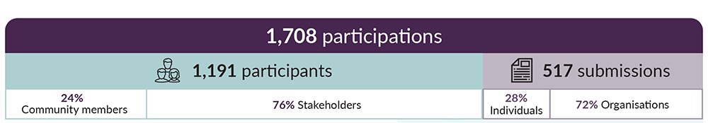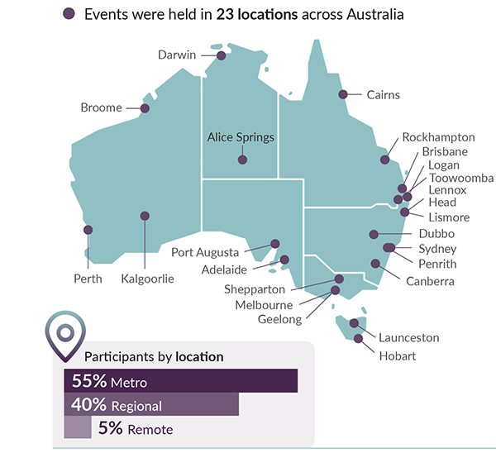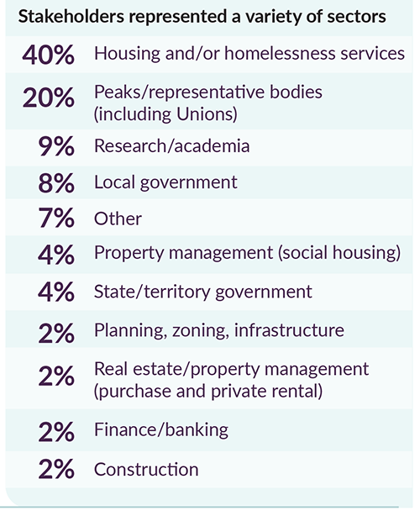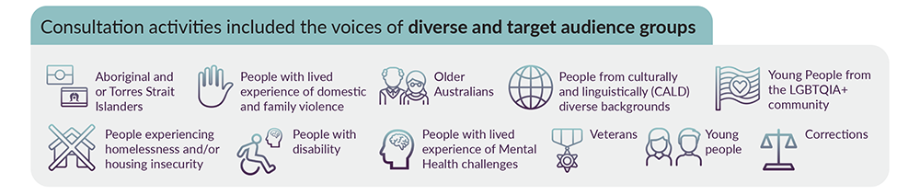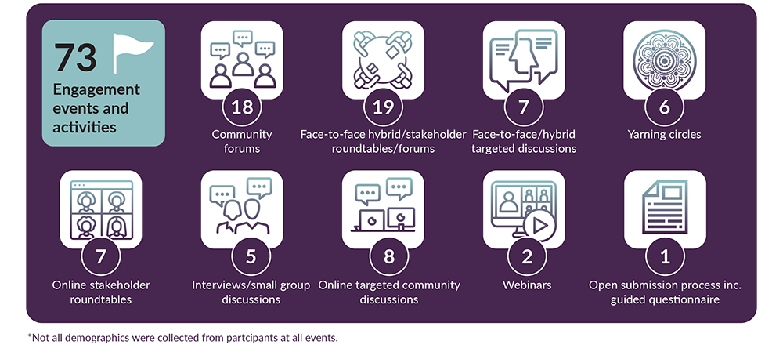
Figure 1 Not all demographics were collected from participants at all events.

