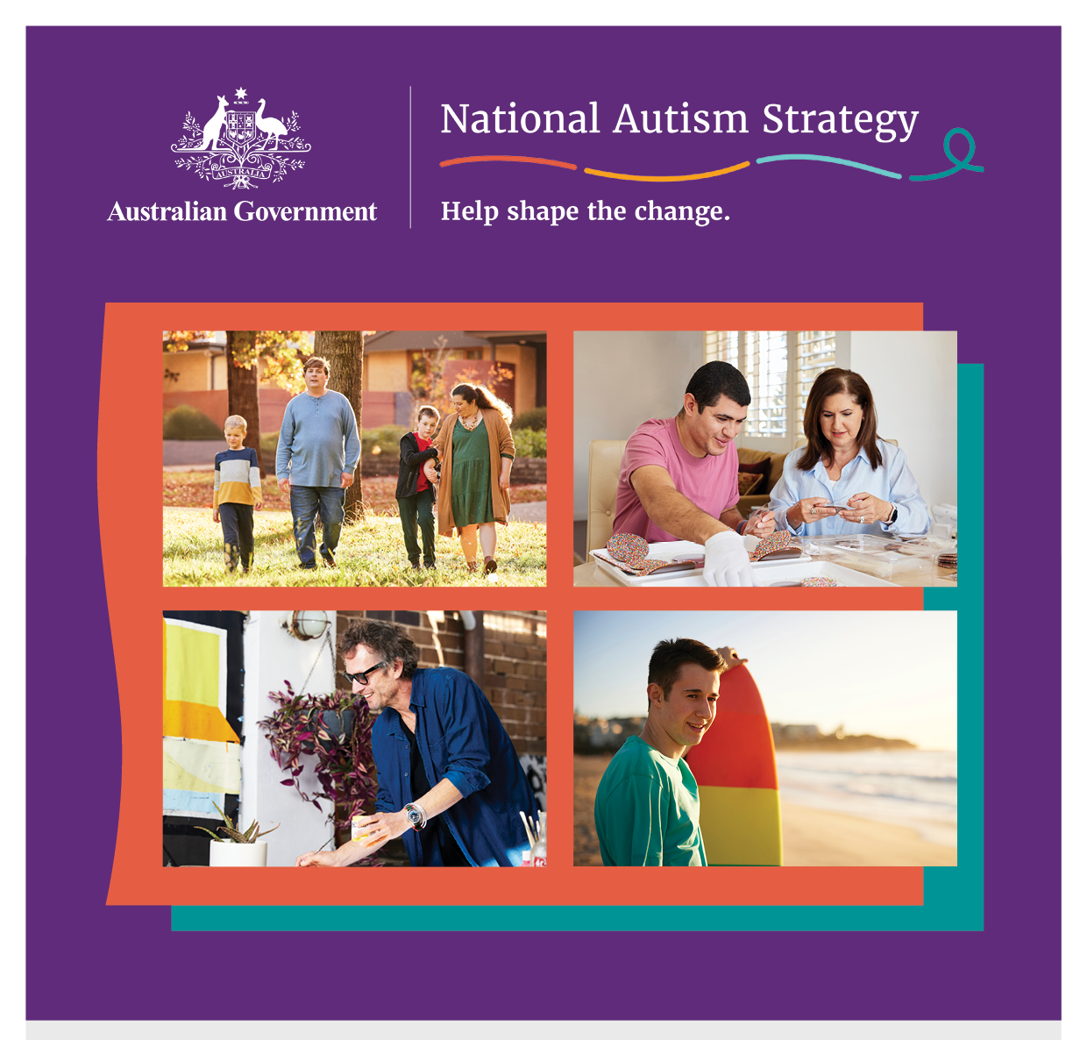

Developing a National Autism Strategy
Overview of consultation themes
December 2023

Acknowledgement of Country
The Department of Social Services acknowledges the Traditional Owners of Country throughout Australia on which we gather, live and work. We acknowledge all Traditional Custodians, their Elders past, present and emerging and we pay our respects to their continuing connection to their culture, community, land, sea and water.
The consultations that inform this report took place on the unceded lands of First Nations peoples across Australia. The Social Deck acknowledges the Traditional Custodians who have lived on and cared for Country for thousands of generations, and recognises their continuing connection to land, waters and community. We pay our respects to them and their cultures, and to Elders past and present.

Acknowledgement of community and partners
The Social Deck and Department of Social Services wish to acknowledge the invaluable contributions of many people and groups as part of the consultations that inform this report. Thank you to the thousands of Autistic people, their families and communities, as well as other stakeholders, who gave their time and shared their experiences and ideas.
A special thank you to our Autistic co-facilitators and our partners who made the consultations possible. In total 14 organisations and more than 15 Autistic individuals were involved in facilitating events and discussions. A full list of them is in the full report.
Statement on language:
People use different words to talk about Autism, and each person will have their own way of talking about Autism and about themselves. Some people in the Autistic and Autism community like to use ‘Autistic person’ (identity-first language), some like to say ‘person with Autism’ (person-first language), and some are fine with using either. The Australian Government is using identity-first language to talk about the National Autism Strategy. This means that we will usually use the term Autistic person or Autistic people throughout this overview.

Content note:
Some people may find information in this overview confronting or distressful. Support is available by contacting one of these key support services:
- Lifeline (24/7): 13 11 14
- Beyond Blue (24/7): 1300 224 636
- 13YARN (24/7): 13 92 76
- Kids Helpline (24/7): 1800 551 800
Find Autism-specific support services: https://www.amaze.org.au/autismconnect/
The Social Deck wrote this overview for the Australian Government Department of Social Services. When we refer to ‘we’ in this report, we are referring to The Social Deck.
This is an overview of the full Consultation Report for the National Autism Strategy. The full report is 64 pages and has more information about what people said about different issues.
The consultation process and this report responds to the National Autism Strategy discussion paper.

About the consultation
The Australian Government Department of Social Services is working with the Autistic and Autism community to create a National Autism Strategy that will support Autistic people across Australia to live the lives they want and deserve.
From 4 September to mid-November 2023, more than 2000 people shared their thoughts and ideas on what should be included in the National Autism Strategy. This included Autistic people and families, carers, advocates, researchers and other stakeholders.
We had different ways for people to share their ideas so they could choose what worked best for them. The activities included:
- 18 open community forums and workshops (face-to-face and online)
- 21 targeted Autistic Voices forums (face-to-face and online)
- 45 focus groups and targeted discussion groups
- 14 interviews
- 3 other engagements

Figure 1. Participants by engagement type

Who participated?
Autistic people were the largest contributors (878 participants identified as Autistic). Participants came from all states and territories.
Families and carers of Autistic people were the second largest group to participate (746 identified as family members and carers).
Just over 17% of participants have another disability. In forums just for Autistic people, more than one-third have additional disabilities.
In addition:
- about 14% of participants identified as LGBTIQA+
- 6% identified as from Culturally and Linguistically Diverse (CALD) backgrounds
- 2% identified as First Nations people.
We held over 20 targeted discussions with people from priority and intersectional population groups. They included:
- First Nations Autistic people
- Autistic people from Culturally and Linguistically Diverse (CALD) backgrounds
- Autistic people from the LGBTIQA+ community
- Autistic women and girls
- Young Autistic people (30 and under)
- Older Autistic people
- Autistic people who use augmentative and alternative communication (AAC) or are non-verbal
- Autistic people with intellectual disability
- Autistic people with high and complex needs
- Autistic people living in segregated accommodation, group homes and institutions.

What should a National Autism Strategy achieve?
Autistic people and the Autism community want the National Autism Strategy to include everyone.
It should recognise Autistic people’s strengths, range of abilities and different support needs.
It is important the Strategy leads to a better quality of life for all Autistic people.
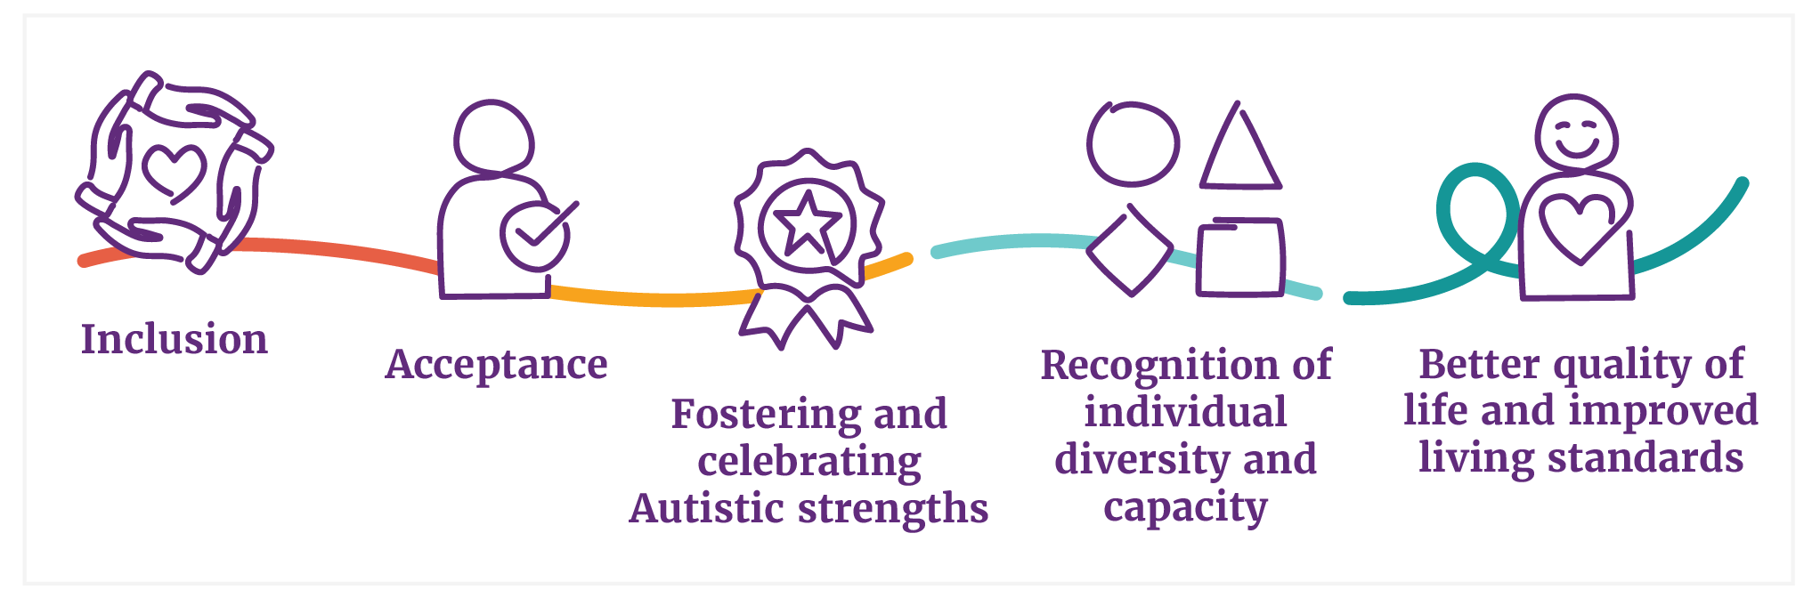

What will help us get there?
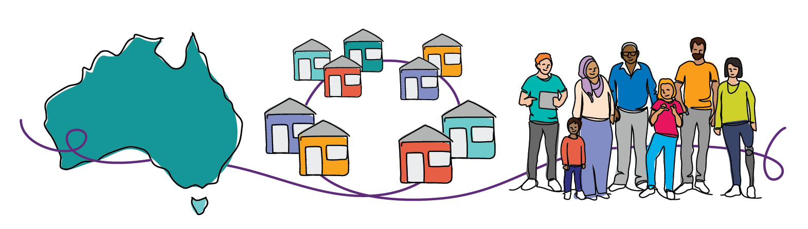
A unified national approach:
All levels of governments work together, and they work with different organisations. This includes regular services and groups run by or to help Autistic people and their families.
Autistic led design and co-design:
Autistic leaders will help guide the National Autism Strategy. This includes having Autistic people and their families in the design process and making sure there are ways for people to keep updated and to give feedback.
Person-centred:
The Strategy respects the rights and independence of every Autistic person. It also recognises diversity.

Main themes
The consultation covered a lot of different areas. People raised important issues and ideas that affect different parts of life. We grouped these into key themes that the National Autism Strategy could focus on.
Rights, autonomy and safety | - Ensuring equal opportunities  - Promoting and supporting self-advocacy and decision-making  - Recognising and nurturing leadership of Autistic individuals
Understanding Autism | - Implement national awareness and public education campaigns  - Autism understanding training for consumer-facing services  - Support advocacy to challenge and reduce the stigma often faced by Autistic individuals  - Educate from a young age  - Ensure positive representation in media, and in sports and arts
Social inclusion | - Improving community understanding and acceptance of Autism  - Sensory-friendly public physical and online spaces  - Supporting social connections and peer support  - Improving access to legal support and a more inclusive justice system  - Improving and adapting communication and information  - Having access to accessible transport  - Neuro-affirming spaces and support systems
Education and learning | - Autism training for teachers and schools  - Pathways and transitions from schooling to further education and work  - More supports for Autistic students  - Inclusive higher education  - Inclusive educational practices
Employment and income support | - Employment support and training for Autistic people  - Autism-friendly workplaces  - Income support  - Removing hiring biases
Diagnosis, services and supports | - Issues with NDIS access and use  - Affordable, accessible and safe services  - Safe and inclusive diagnosis  - Support for Families and Caregivers  - Affordable and timely diagnosis  - Improved diagnostic tools and processes  - Continuity of support services  - Respite services for caregivers
Health and mental health | - Enhanced mental health care  - Autism-friendly healthcare  - Training for healthcare professionals  - Care for co-occurring conditions  - Addressing high rates of mental illness

A First Nations perspective
First Nations Autistic people can face unique challenges and discriminations that make it harder to get an Autism diagnosis and the support they need. When we spoke to First Nations Autistic people and their families, they said they often feel isolated and not believed. They said they and their communities need better support from governments and services. This includes more access to support in regional and remote areas, with First Nations-led and trauma-informed care.
Renay Barker-Mulholland, a First Nations artist and Autistic member of the National Autism Oversight Council created this artwork to show what we learned from First Nations people.
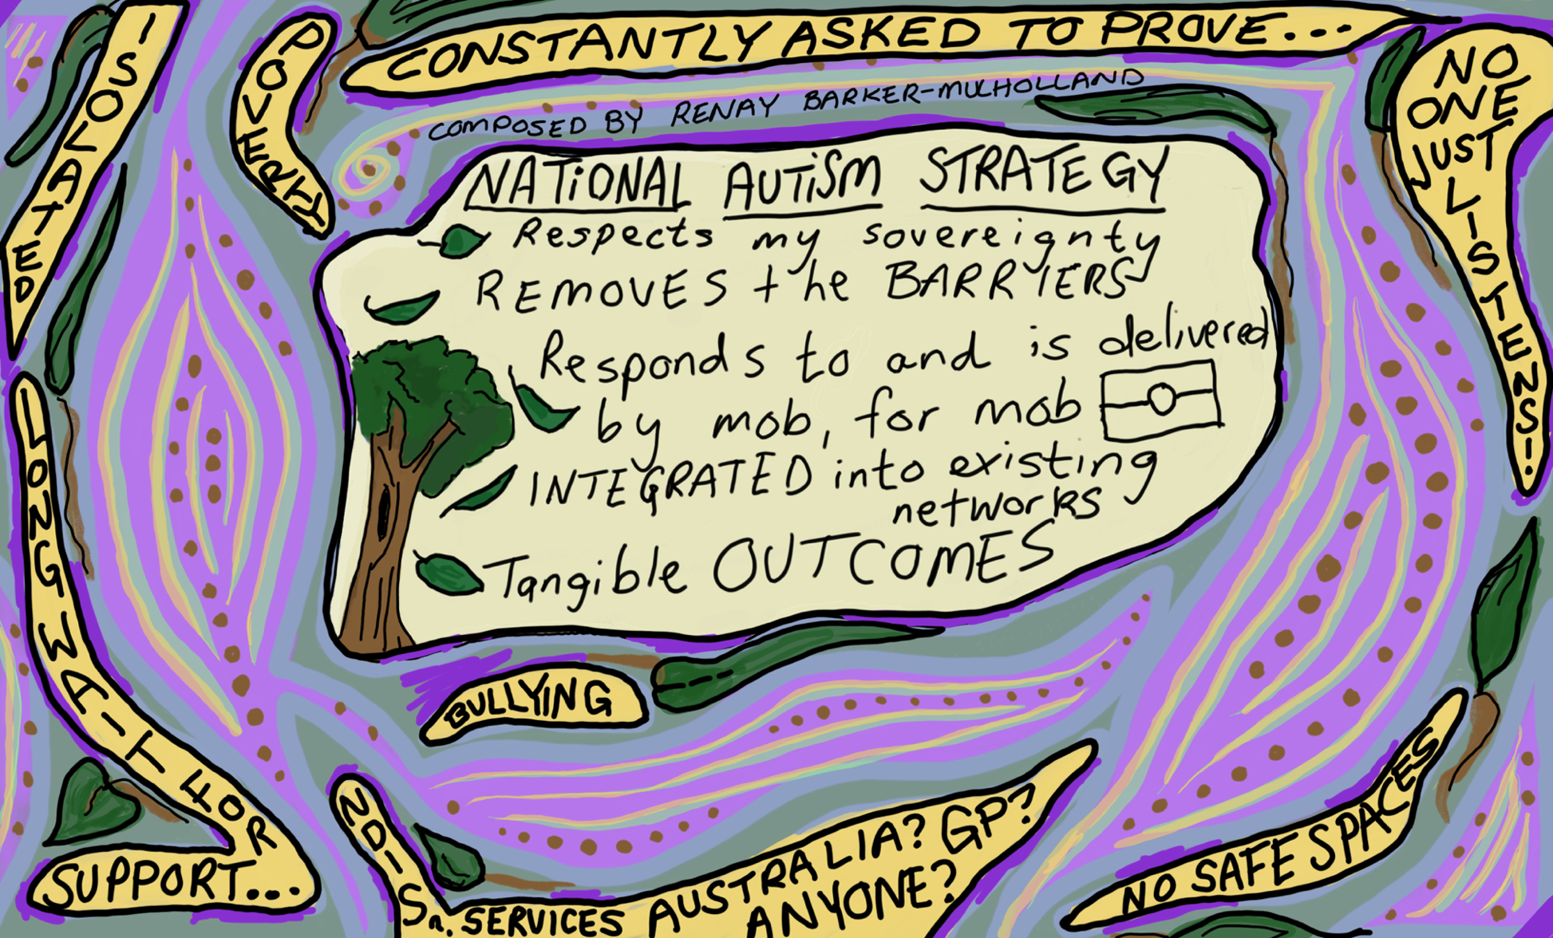
Figure 2. Illustration of themes by First Nations artist and Autistic member of the National Autism Oversight Council, Renay Barker-Mulholland
For more information about developing the National Autism Strategy, go to dss.gov.au/national-autism-strategy

