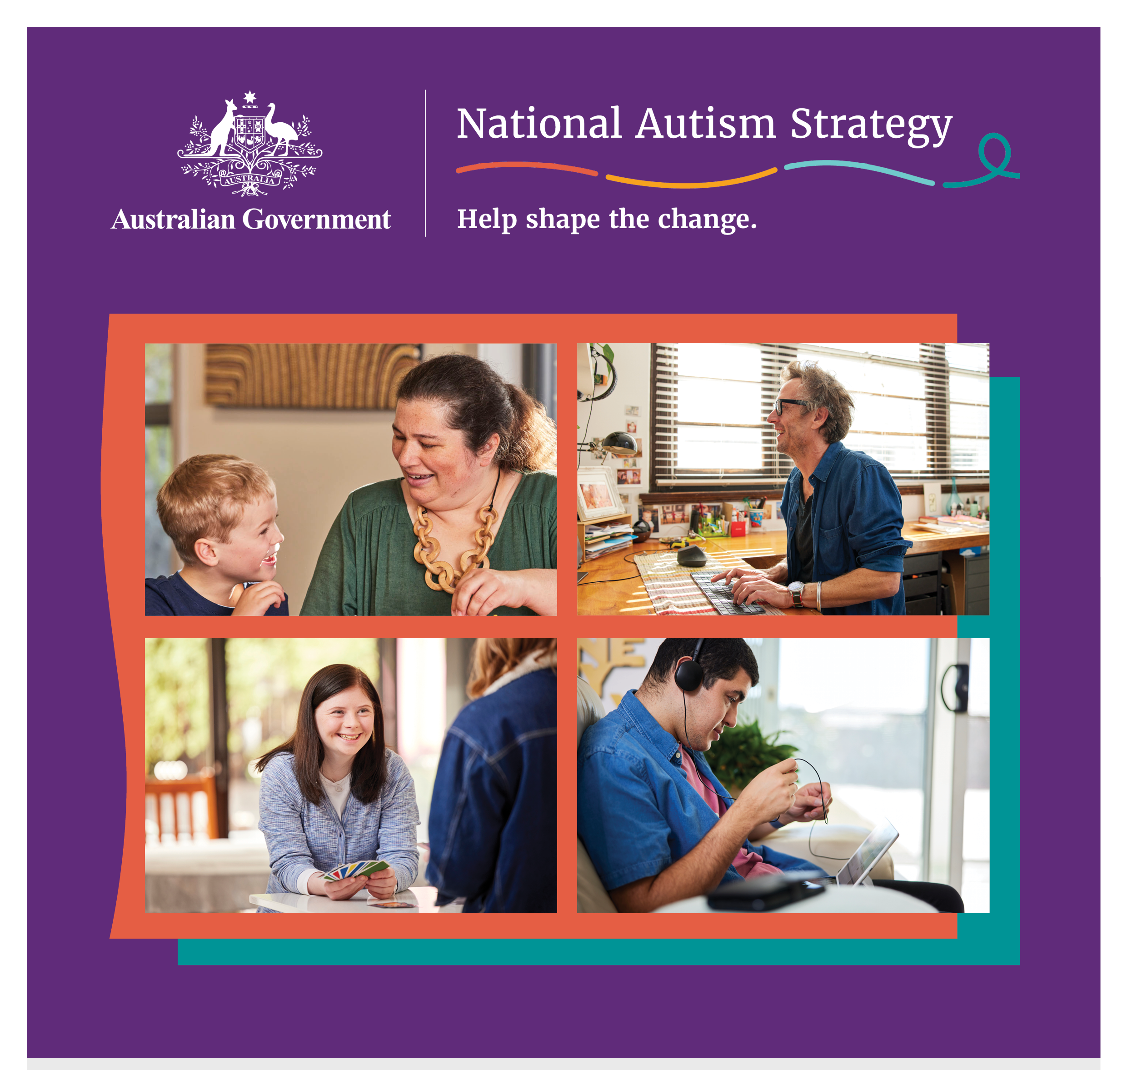

Developing a National Autism Strategy
Consultation report (Stage 2) – Summary version
December 2023
Contents
Acknowledgement of Country 2
Acknowledgement of community and partners 3
About the consultation 4
Who participated? 5
An ambitious National Autism Strategy 5
What should a National Autism Strategy achieve? 6
What will help us get there? 6
Summary of main themes 7
Rights and autonomy 7
Understanding Autism 8
Social inclusion 9
Economic inclusion 10
Diagnosis, services and support 12
Health and mental health 14
A First Nations perspective 15

Acknowledgement of Country
The Department of Social Services acknowledges the Traditional Owners of Country throughout Australia on which we gather, live and work. We acknowledge all Traditional Custodians, their Elders past, present and emerging and we pay our respects to their continuing connection to their culture, community, land, sea and water.
The consultations that inform this report took place on the unceded lands of First Nations peoples across Australia. The Social Deck acknowledges the Traditional Custodians who have lived on and cared for Country for thousands of generations, and recognises their continuing connection to land, waters and community. We pay our respects to them and their cultures, and to Elders past and present.

Acknowledgement of community and partners
The Social Deck and Department of Social Services wish to acknowledge the invaluable contributions of many people and groups as part of the consultations that inform this report. Thank you to the thousands of Autistic people, their families and communities, as well as other stakeholders, who gave their time and shared their experiences and ideas.
A special thank you to our Autistic co-facilitators and our partners who made the consultations possible. In total 14 organisations and more than 15 Autistic individuals were involved in facilitating events and discussions that inform this report. A full list of them is in the full report.
Statement on language:
People use different words to talk about Autism, and each person will have their own way of talking about Autism and about themselves. Some people in the Autistic and Autism community like to use ‘Autistic person’ (identity-first language), some like to say, ‘person with Autism’ (person-first language), and some are fine with using either. The Australian Government is using identity-first language to talk about the National Autism Strategy. This means that we will usually use the term Autistic person or Autistic people throughout this overview.

Content note:
This report contains content about abuse, bullying, discrimination, hospitalisation and suicide.
Some people may find information in this report confronting or distressful. Support is available by contacting one of these key support services:
- Lifeline (24/7): 13 11 14
- Beyond Blue (24/7): 1300 224 636
- 13YARN (24/7): 13 92 76
- Kids Helpline (24/7): 1800 551 800
Find Autism-specific support services: https://www.amaze.org.au/autismconnect/
The Social Deck wrote this report for the Australian Government Department of Social Services. When we refer to ‘we’ in this report, we are referring to The Social Deck.
This is a summary of the full Consultation Report for the National Autism Strategy. The full report is 64 pages and has more information about what people said about different issues.
The consultation process and this report responds to the National Autism Strategy discussion paper.

About the consultation
The Australian Government Department of Social Services is working with the Autistic and Autism community to create a National Autism Strategy that will support Autistic people across Australia to live the lives they want and deserve.
From 4 September to mid-November 2023, more than 2000 people shared their thoughts and ideas on what should be included in the National Autism Strategy. This included Autistic people and families, carers, advocates, researchers and other stakeholders.
We had different ways for people to share their ideas so they could choose what worked best for them. The activities included:
- 18 open community forums and workshops (face-to-face and online)
- 21 targeted Autistic Voices forums (face-to-face and online)
- 45 focus groups and targeted discussion groups
- 14 interviews
- 3 other engagements

Figure 1. Participants by engagement type

Who participated?
Autistic people were the largest contributors (878 participants identified as Autistic). Participants came from all states and territories.
Families and carers of Autistic people were the second largest group to participate (746 identified as family members and carers).
Just over 17% identified as having another disability. In forums just for Autistic people, more than one-third have additional disabilities.
In addition:
- about 14% of participants identified as LGBTIQA+
- 6% identified as from Culturally and Linguistically Diverse (CALD) backgrounds
- 2% identified as First Nations people.
We held over 20 targeted discussions with people from priority and intersectional population groups. They included:
- First Nations Autistic people
- Autistic people from Culturally and Linguistically Diverse (CALD) backgrounds
- Autistic people from the LGBTIQA+ community
- Autistic women and girls
- Young Autistic people (30 and under)
- Older Autistic people
- Autistic people who use augmentative and alternative communication (AAC) or are non-verbal
- Autistic people with intellectual disability
- Autistic people with high and complex needs
- Autistic people living in segregated accommodation, group homes and institutions.

An ambitious National Autism Strategy
The Autistic and Autism community wants an ambitious national strategy for Australia. A Strategy that gives Autistic people the same level of access as other people in the community. They want a strategy that ‘levels the playing field for Autistic people and their families.’
People said it needs action and must be upheld. They want ‘measures that mean something to Autistic people’ and ‘consequences for failures to uphold the Strategy.’

What should a National Autism Strategy achieve?
Five main ideas stood out for what the National Autism Strategy should do:
Inclusion:
This means changing our systems, society, and attitudes in all four areas discussed in the National Autism Strategy paper.
Acceptance:
We need better understanding of Autism in every part of our community. This will help make Australians more aware of Autism and make sure every Autistic person feels like they belong.
Fostering and celebrating Autistic strengths:
We should focus on and recognise the strengths of Autistic people as something normal.
Recognition of individual diversity and capacity:
We must understand that every Autistic adult and child has different experiences and goals, and they should all have equal chances in every part of life.
Better quality of life and improved living standards:
We need systems and supports to meet basic needs. This includes health and mental health services to stay well, and equal opportunities for Autistic people to access and succeed in education and employment.

What will help us get there?
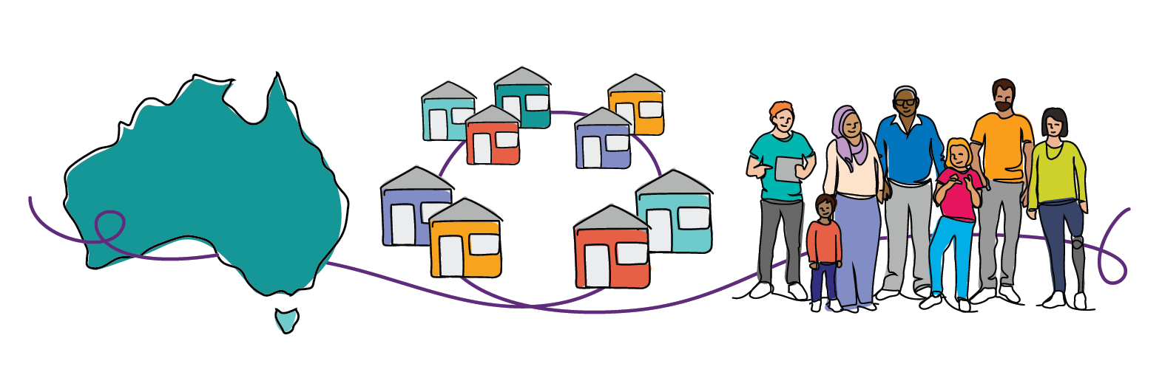
A unified national approach:
All levels of government work together and they work with different organisations. This includes regular services and groups run by or to help Autistic people and their families.
Autistic led design and co-design:
Autistic leaders will help guide the National Autism Strategy. This includes having Autistic people and their families in the design process and making sure there are ways for people to keep updated and give feedback.
Person-centred:
The Strategy respects the rights and independence of every Autistic person. It also celebrates their diversity.

Summary of main themes

Rights and autonomy
One of the main ideas from the consultations is about making sure the rights of Autistic people are respected. This includes their families and carers. The chart below lists the areas people talked about the most to help improve these rights and independence.
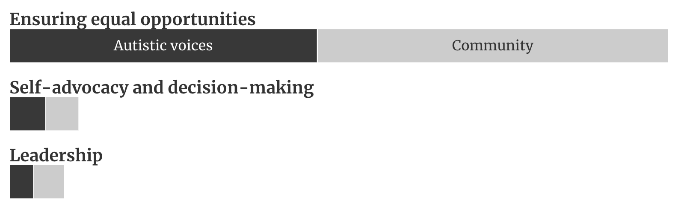
Figure 2. Comparative frequencies of key themes regarding rights and autonomy
The following were the main points and ideas raised about rights and independence for Autistic people:
- It’s important that Autistic people have the same chances as everyone else in all areas of life, like school, work, where they live, and when they go out.
- These equal opportunities should be backed up by laws and better systems.
- Autistic people should be helped to speak for themselves and make their own choices.
- Supported decision-making helps to uphold the rights and dignity of Autistic people. Autistic people with high and complex needs must have a say in their lives and be supported to make their own choices.
- The National Autism Strategy should see and help grow the ability of Autistic people to be leaders and bring about change.
- Cultural practices need to be safe. It is important to involve First Nations people in putting the Strategy into action.

Understanding Autism
During all our discussions, the issue people talked about the most was that many people don't understand Autism well.
The chart below lists the topics that came up the most. These are the areas we need to focus on to help people better understand Autism.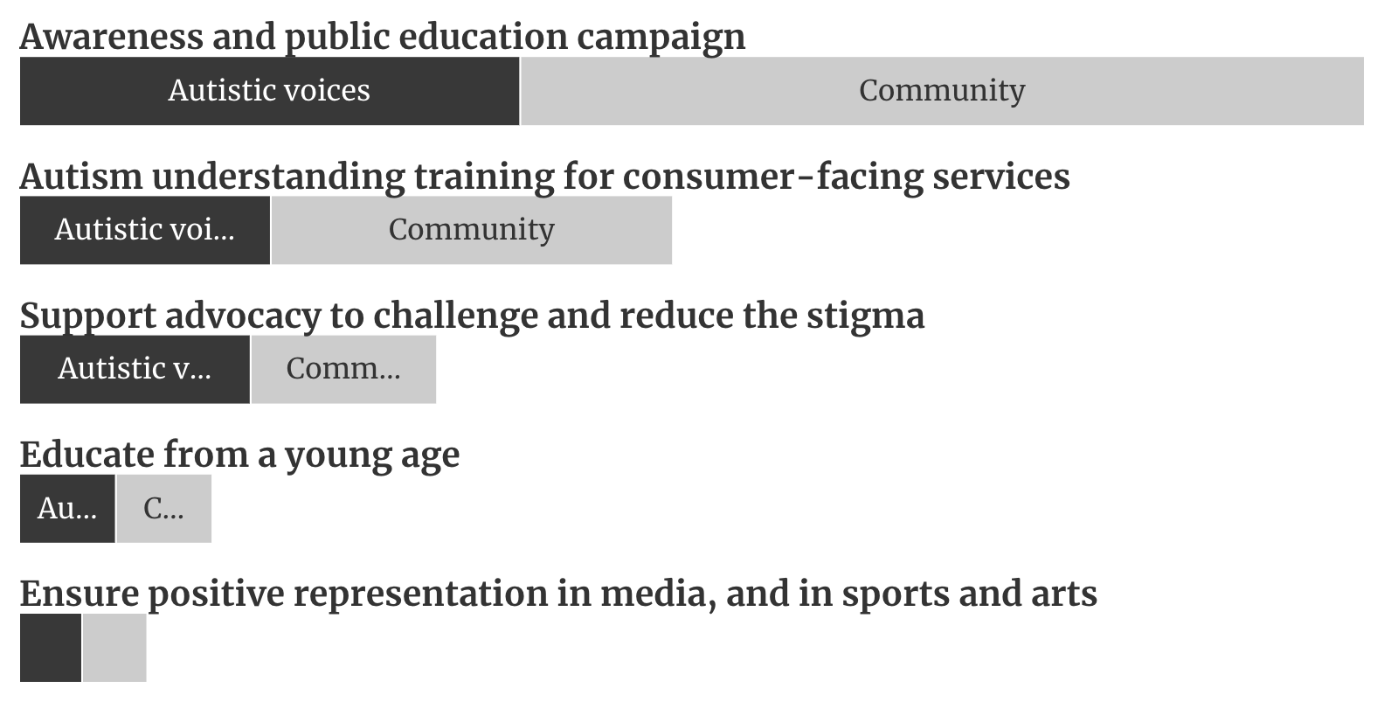
Figure 3. Comparative frequencies of key themes regarding understanding Autism
The following were the main points and ideas raised about making Autism better understood in the community:
- Because Autism is an invisible disability, we need clear plans and focus to help people understand how it can be different for each person.
- We need to work more on how Autism is seen in a negative way. This includes changing harmful views and stereotypes.
- The National Autism Strategy should fight against unfair biases that hurt many Autistic people. This includes tackling biases in jobs, schools, the justice system and housing.
- Public education campaigns are a popular idea to:
- reduce stigma
- debunk stereotypes
- correct misunderstandings about Autism.
- Autism understanding training is needed for customer-facing jobs and services. This includes places like shops, cafes, transport, healthcare, education and policing.
- Supporting advocates is important to fight stigma. We need to help those with complex communication and support needs to speak out and raise awareness of their intersectional identities and the barriers they face.
- Teach children about Autism from a young age, like in primary schools. This is an important way governments can help society understand and be aware.
- Show positive examples of Autistic people in the media, and in sports and arts. This will increase the visibility of Autistic people, of all types, in the community.
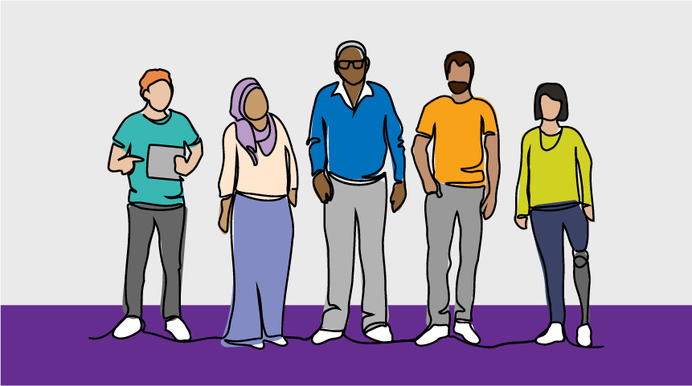

Social inclusion
The chart below shows the most talked about topics for Social Inclusion.
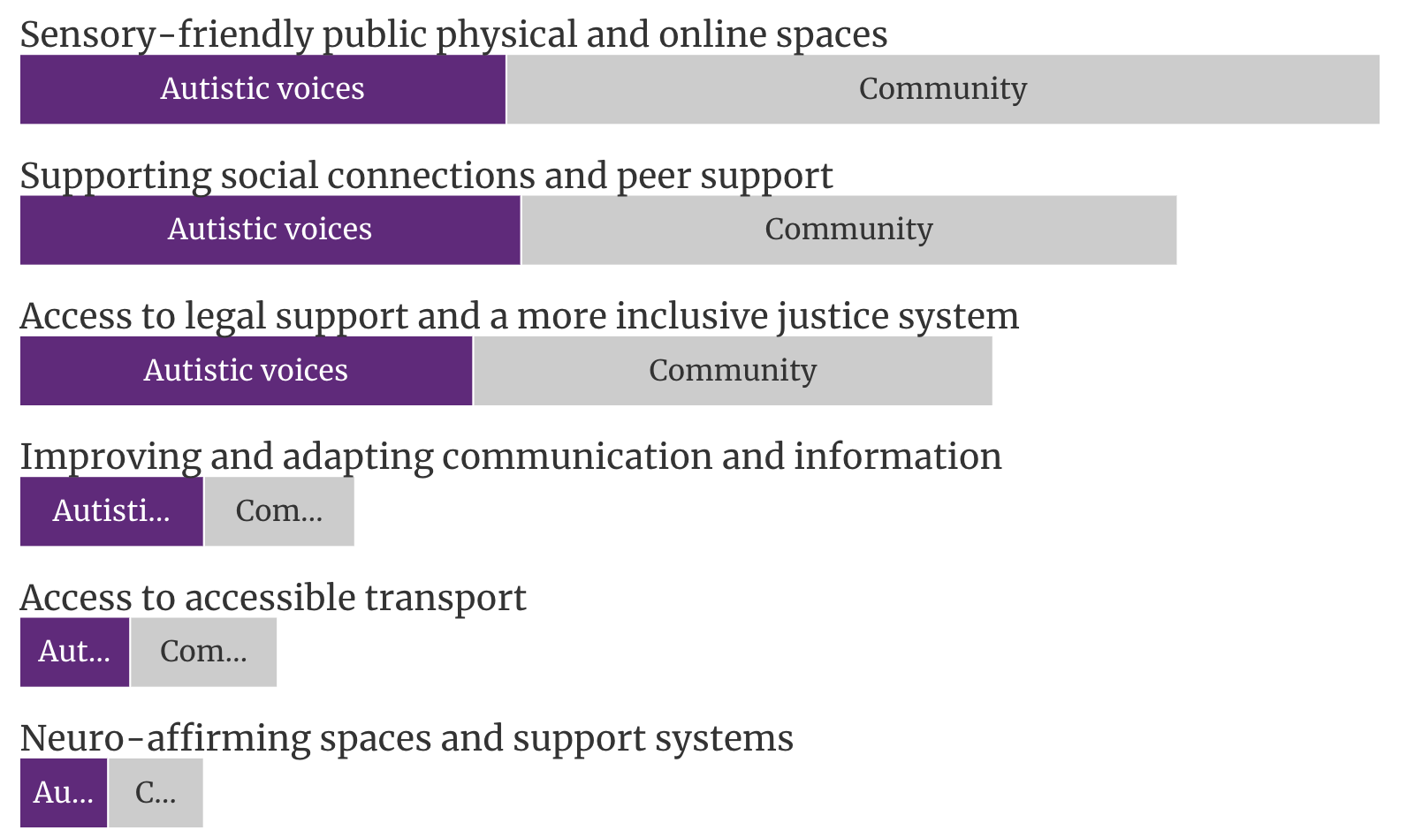
Figure 4. Comparative frequencies of key themes regarding social inclusion
The following were the main points and ideas raised about improving social inclusion:
- We need more sensory-friendly public spaces, both physical and online. This includes places like schools, workplaces and community centres. It also means easy-to-use website designs, accessible online platforms, and thoughtful virtual communication methods.
- Supporting and funding events and activities for social connections and peer support. This helps Autistic people come together in safe and inclusive spaces like the Autistic Voices forums.
- A more inclusive justice system. This involves improving understanding of Autism in the justice system. It includes police, courts, prisons, and legal professionals, and having better support for Autistic young people.
- Improve access to legal support. This means more protections for Autistic people and affordable, accessible legal services specially designed for Autistic people.
- Improving and adapting how we communicate and share information to fit the diverse communication styles of Autistic people. This includes how they get information and how they communicate.
- Accessible public transport. This will make it easier for people to get around, including going to events, socialising and travelling to work or study.
- Making sure our environments and support systems recognise and affirm neurodiversity. This means understanding and respecting the different ways Autistic people experience the world. We need to adapt services and places to match this.
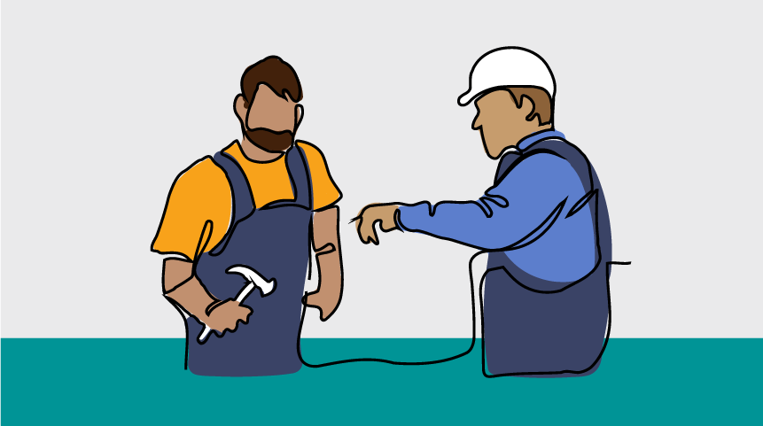

Economic inclusion
Feedback on economic inclusion is grouped in two main areas:
- Education and learning
- Employment and business, and income support

Education and learning
The chart below lists the areas people mentioned the most about education.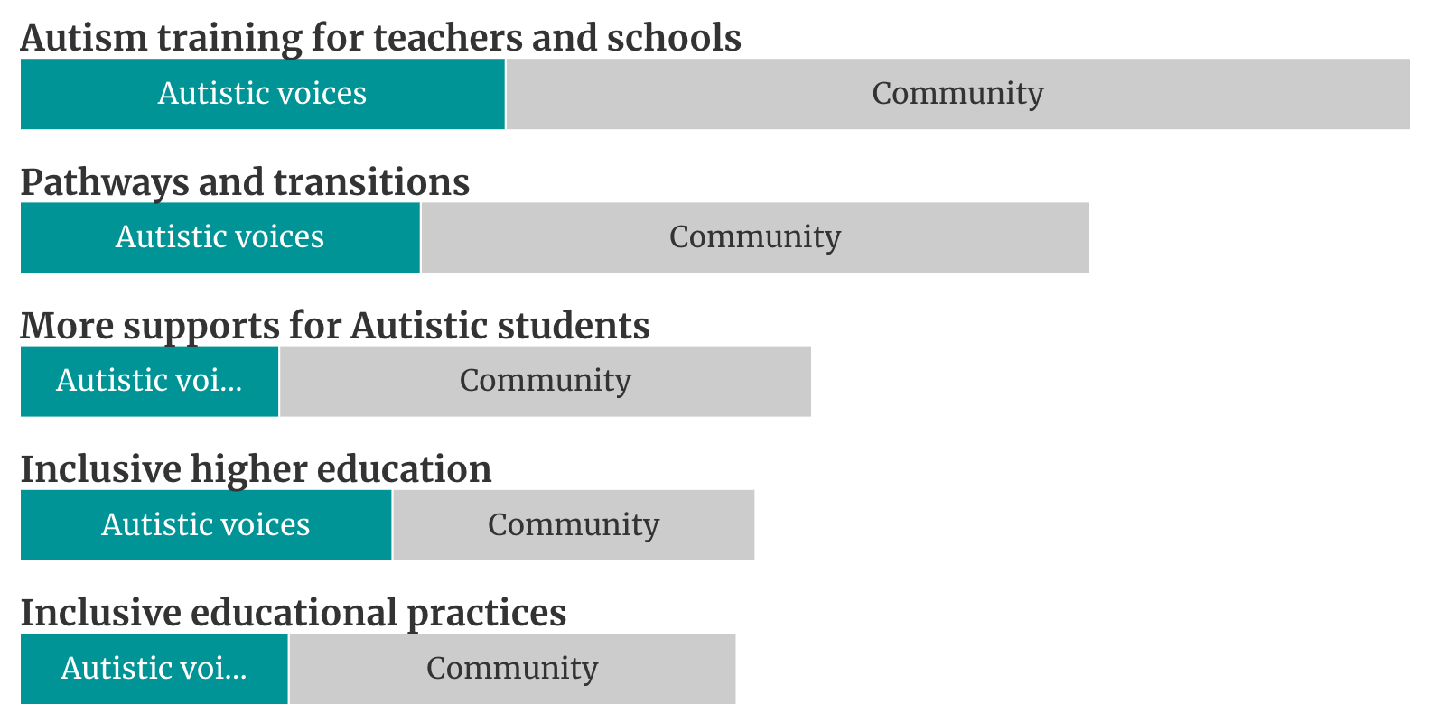
Figure 5. Comparative frequencies of key themes regarding education and learning
The following were the main points and ideas raised about improving education:
- Improve and mandate training for all education leaders, teachers and staff on how to support Autistic students.
- Autism awareness training in schools and other education settings is designed and led by Autistic people. This includes young people.
- Make mainstream classrooms and learning more inclusive for Autistic students. This means giving them choices in education. Schools should adapt their environments and teaching methods to meet the needs of Autistic students as standard practice.
- Make universities and TAFEs more inclusive for Autistic students. This includes having mental health, social and academic support for Autistic students.
- Autistic students need more support to learn at school. This includes mental health, social and academic help designed for neurodivergent students.
- Better pathways and support for moving from school to further education and work. Young Autistic people say this transition time needs more support because it is a lot of change at once.

Employment and income support
The chart below lists the areas that people mentioned the most about employment.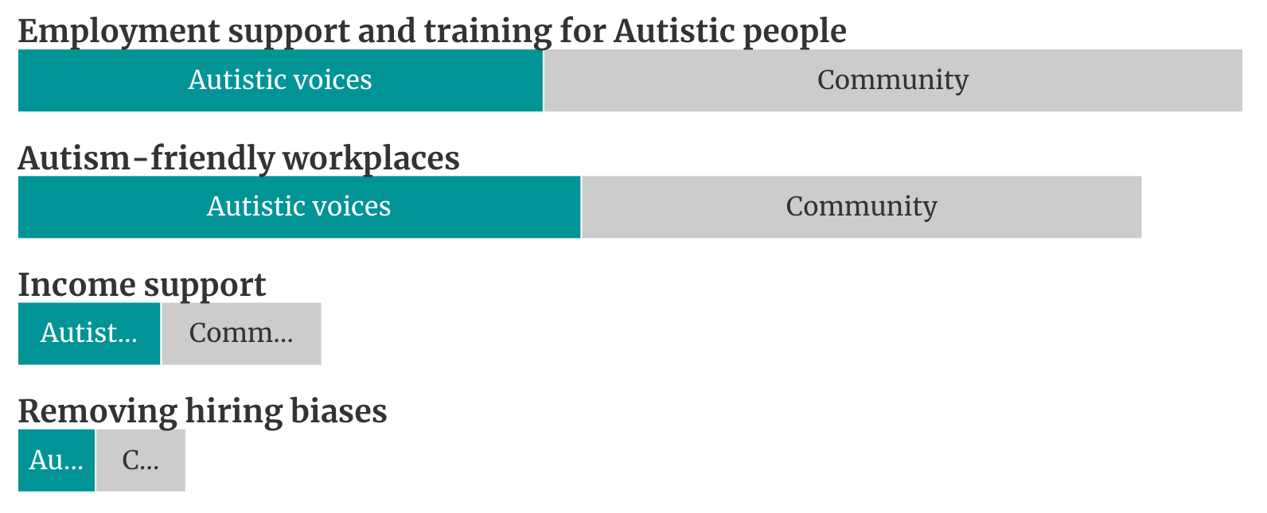
Figure 6. Comparative frequencies of key themes regarding employment and income support
The following were the main points and ideas raised about improving employment outcomes:
- We need more special job pathways and job training designed for Autistic people. This should suit their strengths and needs.
- Employers should be required to make workplaces more Autism-friendly. This means raising awareness as well as better rules for workplace changes for invisible disabilities like Autism.
- We should highlight how having Autistic people at work benefits everyone. This shows why it's good to make workplaces more inclusive for Autistic people.
- Tackle biases and barriers that make it harder for Autistic people looking for jobs. This includes changing traditional job interviews and stopping the assumption that Autistic people are only good at STEM jobs.
- Income and financial supports like the Disability Support Pension and NDIS should better help Autistic people to meet their basic needs. This is because they often have higher living costs due to barriers accessing the community and services, and costs for medications or other needs.
- Some people said there should be more help for Autistic people to start and grow their own businesses. Many Autistic people begin businesses because of workplace barriers and their ability to come up with creative solutions and ideas. These are often micro-businesses, which may get funding help if the Government supported access to micro-business and entrepreneurship programs.

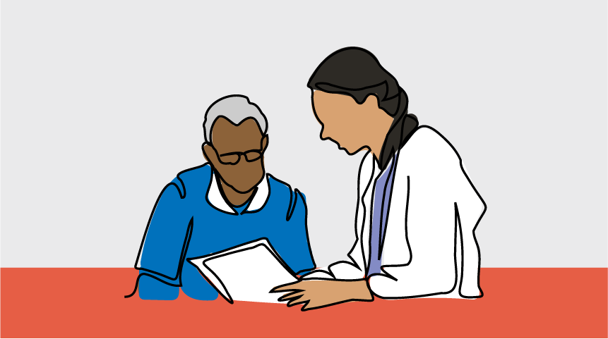

Diagnosis, services and support
Autistic people shared that it's often hard for them to get a diagnosis or afford it. This has a big impact on their lives, including their ability to get supports.
A lot of comments focused on the NDIS. People are worried that changes to the NDIS will mean less support for Autistic people. They want the Strategy to find ways for Autistic people and children to always get the support and services they need. This includes increasing respite services for caregivers.
The chart below lists the areas that people talked about the most to improve the process of diagnosis and accessing supports and services.
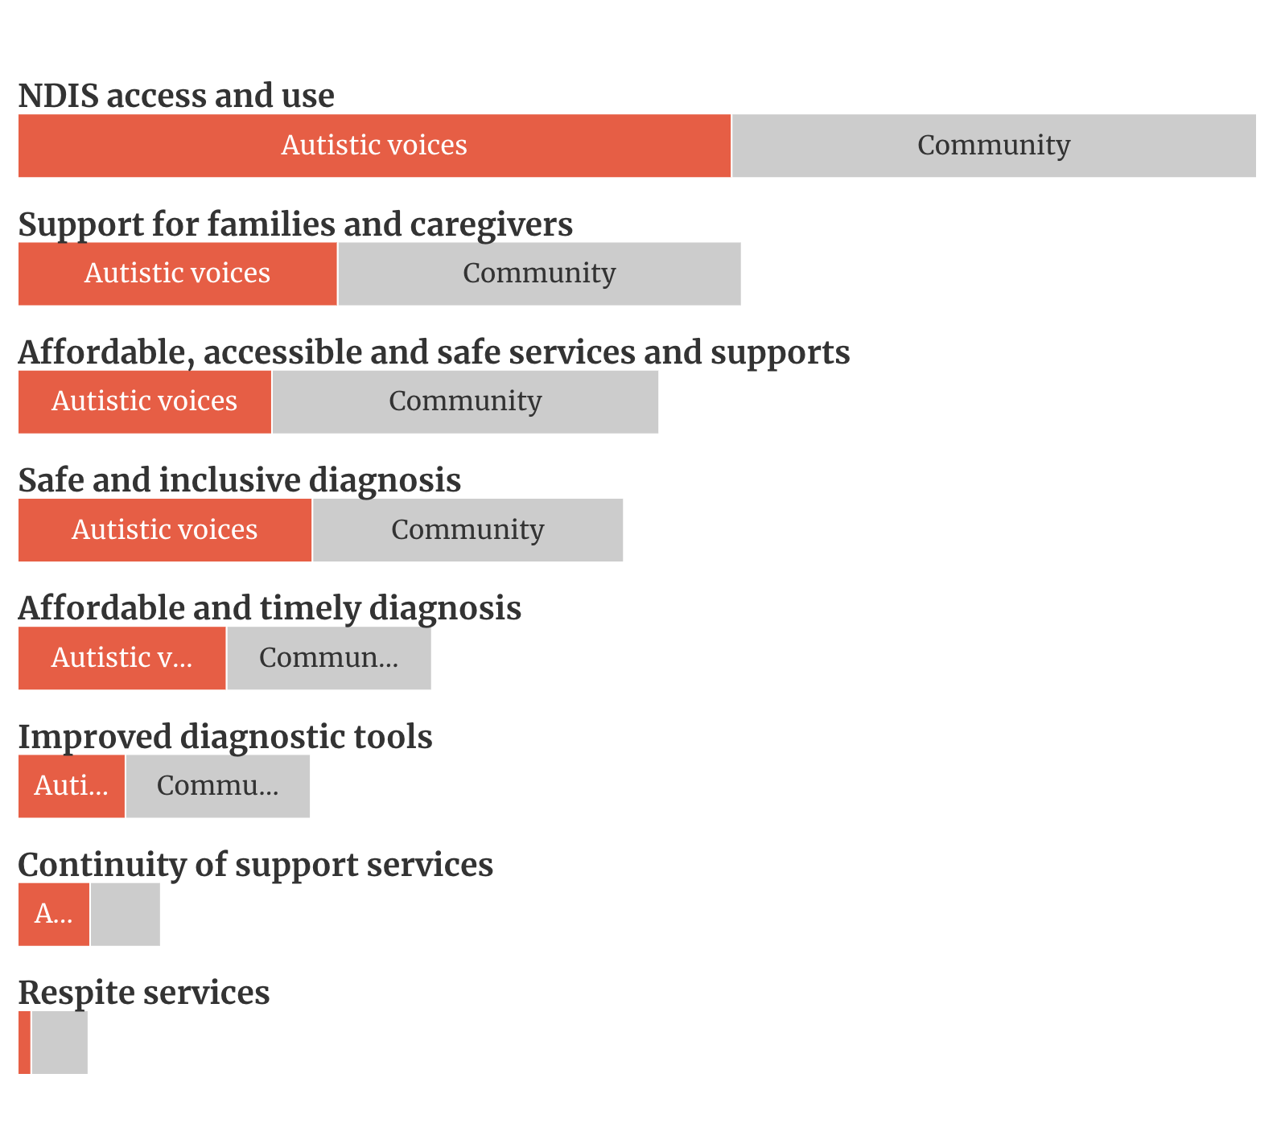
Figure 7. Comparative frequencies of key themes regarding diagnosis, services and support
The following were the main points and ideas raised about improving diagnosis:
- Autistic adults and children should be able to get diagnoses that are affordable, quick and easy to access. Making these changes will require big change in the current systems for diagnosis and health. Participants think GPs could have a key role, and government should support their training and involvement more.
- We need better access to diagnosis in regional areas. This is due to a lack of services and professionals. People report waiting over two years just to start the diagnosis process, and then more time and lots of travel for the actual process.
- Diagnosis should be more affordable, especially for families with multiple members needing a diagnosis.
- Make the diagnosis process for Autism more respectful, less intrusive and free from stigma. It should affirm neurodiversity, be informed by trauma care, be gender-affirming, and culturally safe and responsive.
- Improve diagnostic tools, especially for girls in their early years. There are concerns about gender and age biases in current tools and methods. The criteria and tools often focus too much on how Autistic traits appear to others, not on the person’s internal experience.
The following were the main points and ideas raised about improving access to supports and services:
- Make sure there is ongoing support for Autistic people, especially with the current review of the NDIS and the reduced state and territory government disability supports since the NDIS started.
- Improve the NDIS by making it easier to access and navigate. Offer more tailored support, for Autistic adults, children and families.
- Improve information and training for NDIS staff and planners about Autism.
- Focus on continuity of services and smooth transition support for Autistic people, especially children. This involves improving the transitions between different support systems.
- Make it easier for Autistic people and families to find and access new services.
- Support families and carers of Autistic people. This includes providing enough respite care, and giving families and caregivers the resources, education, and assistance they need. This helps the overall wellbeing of the whole family and the mental health of caregivers.
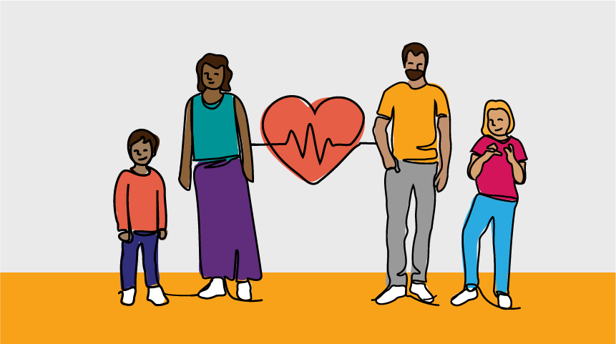

Health and mental health
As part of the National Autism Strategy, a separate National Roadmap to Improve the Health and Mental Health of Autistic People is being developed. This is led by Department of Health and Aged Care. A separate co-design and consultation process is underway to develop the roadmap.
The chart below shows the areas that people discussed the most about health and mental health.
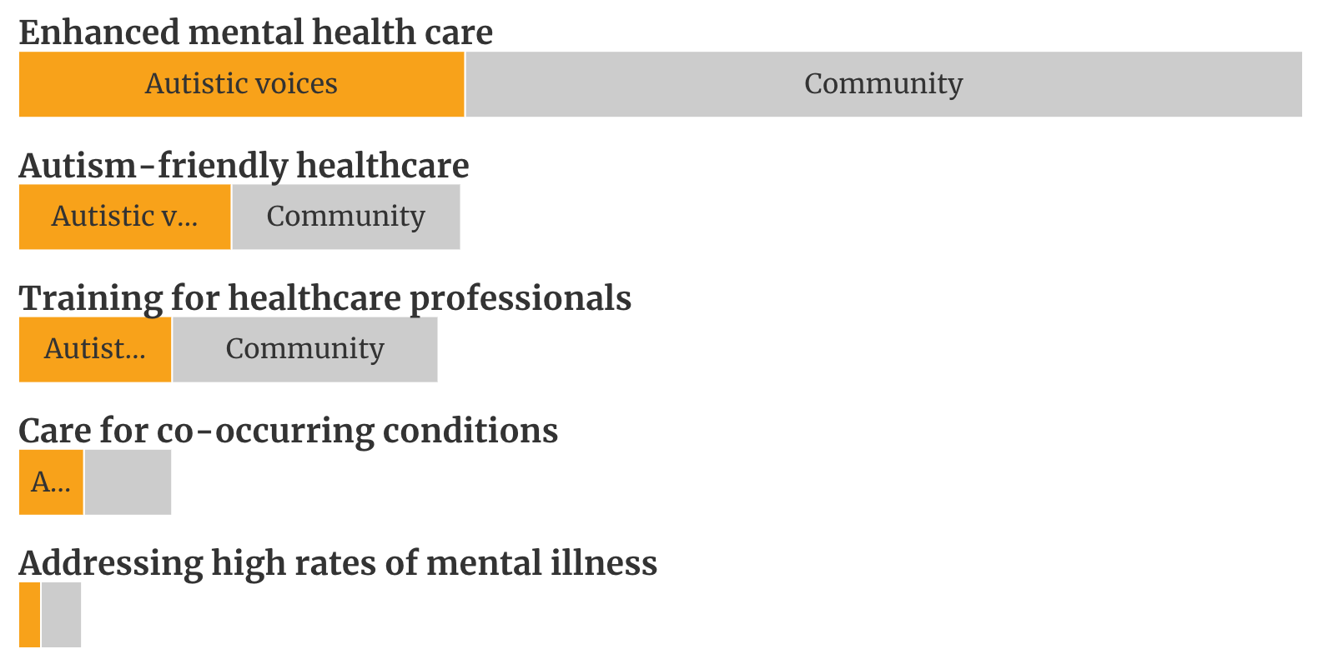
Figure 8. Comparative frequencies of key themes regarding health and mental health
The following were the main points and ideas raised about improving health and mental health:
- Increase the availability of mental health services and supports. This is important due to the high demand and long waiting times for help.
- Give appropriate and tailored mental health support to Autistic people. This support should affirm neurodiversity and consider other intersecting factors.
- Better understand and address the high rates of mental illness in the Autism community. This includes improving the advice from medical professionals for co-occurring Autism and mental health conditions.
- Support better diagnosis to reduce mental health impacts on Autistic adults.
- Improve healthcare settings for Autistic people. Make adjustments like having quiet rooms, communication tools and less sensory input. Make sure every hospital’s Emergency Department has specific trained support for Autistic people.
- Provide better training for healthcare professionals to understand Autism. This includes guidance for nurses in GP clinics and other places to help Autistic children with basic health needs, like vaccinations, to prevent future health problems.
- Recognise and support the assessment and management of conditions that occur alongside Autism.

A First Nations perspective
Renay Barker-Mulholland is a First Nations artist and Autistic member of the National Autism Oversight Council. She shows what came up in discussions with First Nations people in her artwork below.
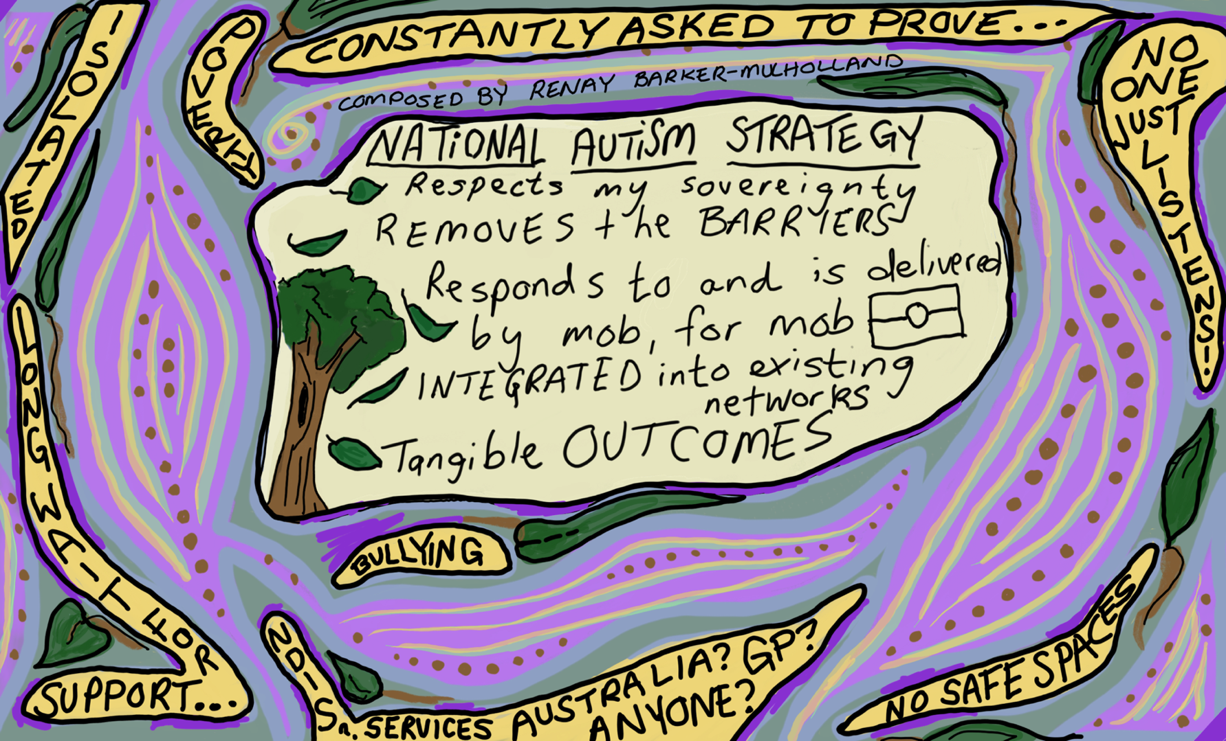
Figure 9. Illustration of themes by First Nations artist and Autistic member of the National Autism Oversight Council, Renay Barker-Mulholland
The discussions with First Nations Autistic, and/or neurodivergent people talked about the unique challenges and discriminations faced by First Nations Autistic people. Comments focused on:
- Participants are under-resourced and feel isolated.
- It is hard to get an Autism diagnosis and support, mostly because of financial issues and a lack of cultural awareness from organisations and healthcare providers.
- There is a need for emotional support from and for their community.
- Challenges exist in education and work environments. More engagement with these settings is needed to show the strengths and skills of the Autistic First Nations community.
- Support systems are broken. This means families, especially parents, are the main source of support without having much help themselves. Community and extended family supports that are so often relied on, but not available to Autistic and neurodivergent people.
- Social impacts of Autism create barriers to community involvement, like social anxiety, difficulty connecting and communicating and feeling excluded and bullied. There’s a need for better listening, understanding without assumptions, and more accessible information about available resources and support.
- Improve access to support in regional and remote areas, as well as First Nations-led care, such as a specific First Nations Autism workforce. This would improve culturally appropriate support, backed by Autism specialists.
For more information about developing the National Autism Strategy, go to dss.gov.au/national-autism-strategy

