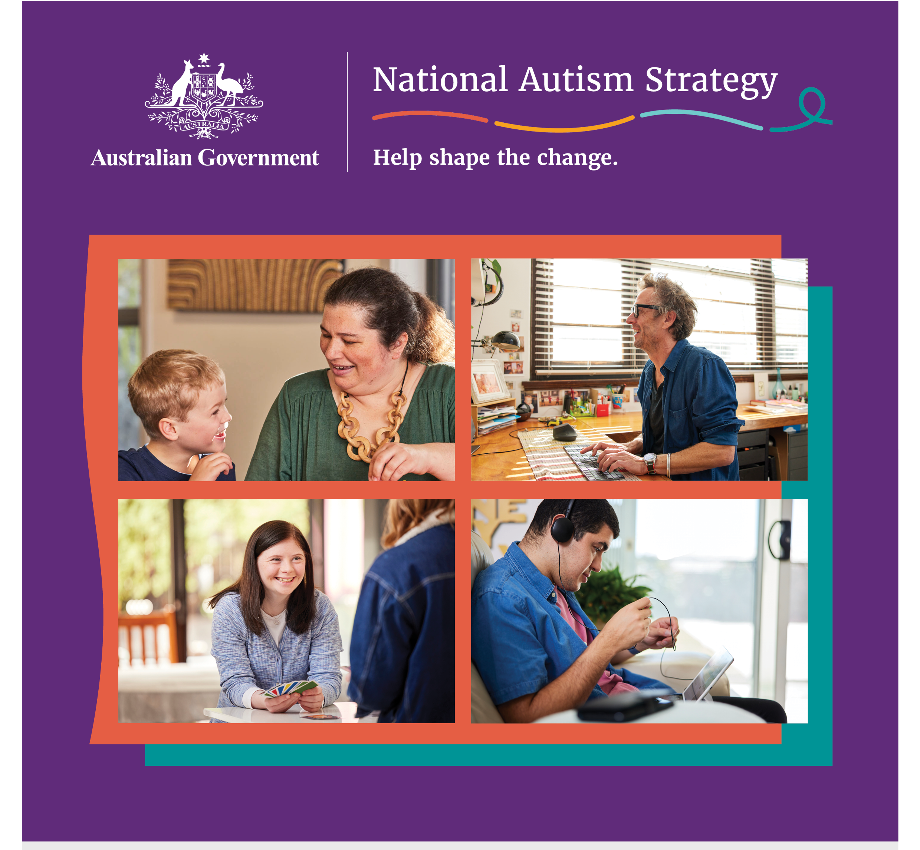

Developing a National Autism Strategy

Consultation report (Stage 2)
December 2023

Table of Contents
About this report 4
Acknowledgements 5
Executive summary 6
Participation and methods of engagement 9
1. An ambitious National Autism Strategy 13
What will help us get there? 14
2. Rights and autonomy 15
3. Understanding Autism 17
4. Feedback on the four themes of the National Autism Strategy discussion paper 20
4.1 Social inclusion 20
4.2 Economic inclusion 26
4.3 Diagnosis, services and support 34
4.4 Health and mental health 40
5. Involving Autistic people and the community in the National Autism Strategy 45
6. Implementation and monitoring the National Autism Strategy 46
Appendix A: Specific focus areas for target audiences and intersectional groups 48
First Nations Autistic people 49
Autistic people from culturally and linguistically diverse (CALD) backgrounds 52
Autistic young people 53
Older Autistic people 54
Autistic women and girls 55
Autistic people who are LGBTIQA+ 56
Autistic people Autistic people who use augmentative and alternative communication or are non-verbal 57
Autistic people with high and complex needs (including with intellectual disability) 58
Parents and carers of Autistic people with high and complex needs 60
Appendix B: Detailed participation 62
Targeted discussion groups, interviews and other engagement types 62
Community forums, Autistic Voices forums and webinar 64

Acknowledgement of Country
The Department of Social Services acknowledges the Traditional Owners of Country throughout Australia on which we gather, live and work. We acknowledge all Traditional Custodians, their Elders past, present and emerging and we pay our respects to their continuing connection to their culture, community, land, sea and water.
The consultations that inform this report took place on the unceded lands of First Nations peoples across Australia. The Social Deck acknowledges the Traditional Custodians who have lived on and cared for Country for thousands of generations, and recognises their continuing connection to land, waters and community. We pay our respects to them and their cultures, and to Elders past and present.
Statement on language:
People use different words to talk about Autism, and each person will have their own way of talking about Autism and about themselves. Some people in the Autistic and Autism community like to use ‘Autistic person’ (identity-first language), some like to say, ‘person with Autism’ (person-first language), and some are fine with using either. The Australian Government is using identity-first language to talk about the National Autism Strategy. This means that we will usually use the term Autistic person or Autistic people throughout this report.
Content note:
This report contains content about abuse, bullying, discrimination, hospitalisation and suicide.
Some people may find information in this report confronting or distressful. Support is available by contacting one of these key support services:
- Lifeline (24/7): 13 11 14
- Beyond Blue (24/7): 1300 224 636
- 13YARN (24/7): 13 92 76
- Kids Helpline (24/7): 1800 551 800
Find Autism-specific support services: https://www.amaze.org.au/autismconnect/

About this report
This report has been written by The Social Deck for the Australian Government Department of Social Services. When we refer to ‘we’ in this report, we are referring to The Social Deck.
The consultation process and this report responds to the National Autism Strategy discussion paper, which was released on 4 September 2023. The was Stage 2 of the National Autism Strategy co-design and consultation process as shown in the Autism CRC co-design process (figure 1).
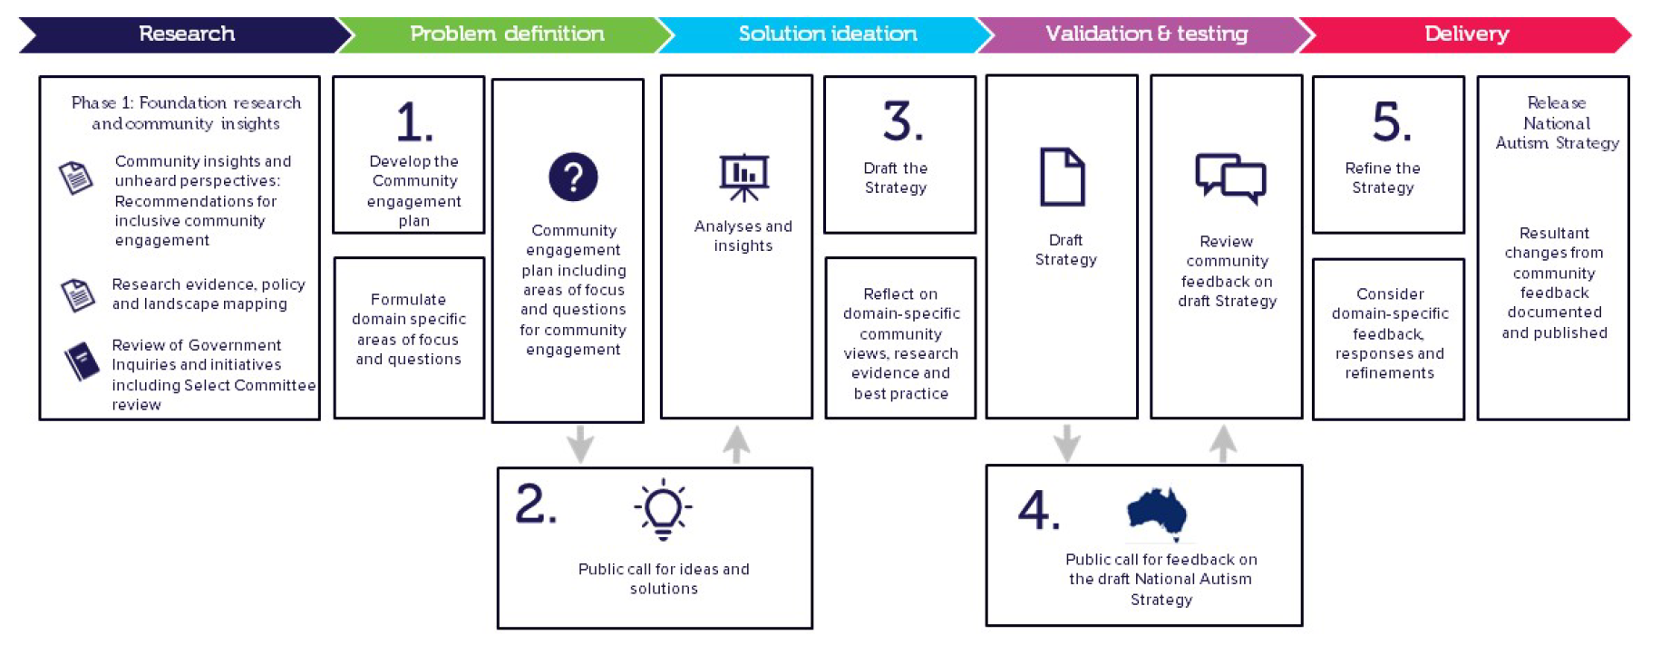
Figure 1. National Autism Strategy co-design and consultation process
Autistic people and families, carers, advocates, researchers and other stakeholders were asked what needs to be done through a National Autism Strategy to help improve outcomes for Autistic people across all stages of life. This report presents the key themes that emerged from thousands of data and responses received. It consolidates input from across all types of events and engagement methods (written, audio and video, online and face-to-face).
The statements in this report reflect community and stakeholder views, and not those of the Australian Government.

Previous reports informing this consultation
The discussion paper was informed by the findings of the Senate Select Committee on Autism. A key recommendation of the Select Committee’s report was to develop a person and family-centred National Autism Strategy.
It was also informed by the Stage 1 co-design and engagement process (led by Autism CRC). This included an engagement plan and Autism CRC’s Community Insights and Unheard Perspectives report developed from a survey completed by 645 people and workshops and interviews with Autistic people, families and carers, and representatives from organisations.
Stage 1 also included reports focused on engagement with priority groups, developed by:
- Women with Disabilities Australia
- Inclusion Australia
- First People’s Disability Network
- Autism Aspergers Advocacy Australia (A4)

Acknowledgements
The Social Deck and Department of Social Services wish to acknowledge the invaluable contributions of many people and groups as part of the consultations that inform this report. Thank you to the thousands of Autistic people, their families and communities, as well as other stakeholders, who gave their time and shared their experiences and ideas.
A special thank you to our Autistic co-facilitators and our partners who made the consultations possible, particularly our main project partners:
- Autistic Self Advocacy Network of Australia and New Zealand (ASAN AUNZ)
- JFA Purple Orange
Thanks to individual facilitators across the country including:
Abby Sesterka (Sydney, NSW, Canberra, ACT and online)
Nyx Harris (Sydney and Lismore, NSW)
Tori Haar (Melbourne and Ballarat, VIC and online)
Alana Doyle (Melbourne, VIC)
James Murphy (Adelaide, SA and online)
Ally Finnis (Mount Gambier, SA and online)
Geraldine Robertson (Devonport and Hobart, TAS)
Pen Brake (Devonport, TAS)
Michael Gammon (Hobert, TAS)
Kay Barnard (Perth and Bunbury, WA)
Nick Avery (Bunbury, WA)
Alix Harrigan (Cairns and Brisbane, QLD and online)
Katharine Annear (online LGBTIQA+)
Nick Glover (online Older Autistic people and UTAS)
Orion Kelly (online workshop)
The following members of the National Autism Strategy Oversight Council also supported facilitation of events:
Clare Gibellini (National Webinar, WA, NT)
Renay Barker-Mulholland (First Nations targeted discussions)
Victoria Gottliebsen (Darwin, NT and online Autistic health professionals and researchers)
Josie Barbaro (online Autistic health professionals and researchers)
Jenny Karavolos (online parents and carers)
Heidi La Paglia Reid (online UTAS)
These organisations were paid to facilitate targeted discussion groups as part of these consultations:
Autistic Self Advocacy Network of Australia and New Zealand (ASAN AUNZ)
Autism Community Network (ACN)
Autism Queensland
Autism Tasmania
Children and Young People with Disability Australia (CYDA)
Different Journeys (Victoria)
Inclusion Australia
Kiind (WA)
Kindred (NSW)
National Ethnic Disability Alliance (NEDA)
Scope Australia
VALID
Women With Disabilities Australia (WWDA)
Yellow Ladybugs
We would also like to acknowledge and thank the support of Australian Autism Alliance, Amaze and Autism CRC in helping to promote the consultations and share information with the Autistic community and stakeholders.

Executive summary
For many years Autistic people and other members of the Autism community have called for a dedicated National Autism Strategy. Life outcomes for Autistic people are worse than they should be. A National Autism Strategy will provide a coordinated, national approach to how governments and services can better support Autistic people and their families.
The Australian Government committed to the development of a National Autism Strategy in response to findings of the Senate Select Committee on Autism, which recommended a person and family-centred National Autism Strategy to improve life outcomes for Autistic people
On 4 September 2023, the federal Minister for Social Services, the Honourable Amanda Rishworth MP released the public consultation process to develop the National Autism Strategy (the Strategy). The consultation process was designed to:
- test what the Government has heard through co-design and previous inquiries to understand gaps
- further hear the voices of Autistic people and the wider community and encourage those who haven’t had the opportunity to be heard.
Public engagement involved Autistic people and their families and carers, the Autism and broader disability sector, as well as researchers and professionals.

Community engagement
A multi-method engagement process was undertaken by engagement specialists, The Social Deck, between 4 September and mid-November 2023. Community engagement was designed with consideration to the Autism CRC co-design and community insights report. This made sure people were able to contribute in a variety of ways and to choose the methods that best suited them. This included the opportunity to contribute no matter where they lived in Australia.
There were more than 2,000 participations with people from all states and territories. Autistic people were the largest contributor to these consultations. More than 100 separate engagement activities were held and this included over 20 different targeted discussions with people from intersectional and priority population groups.

What should a National Autism Strategy achieve?
Autistic people’s vision for a National Autism Strategy centred on inclusion, acceptance, fostering and celebrating Autistic strengths, recognition of individual diversity and capacity and better quality of life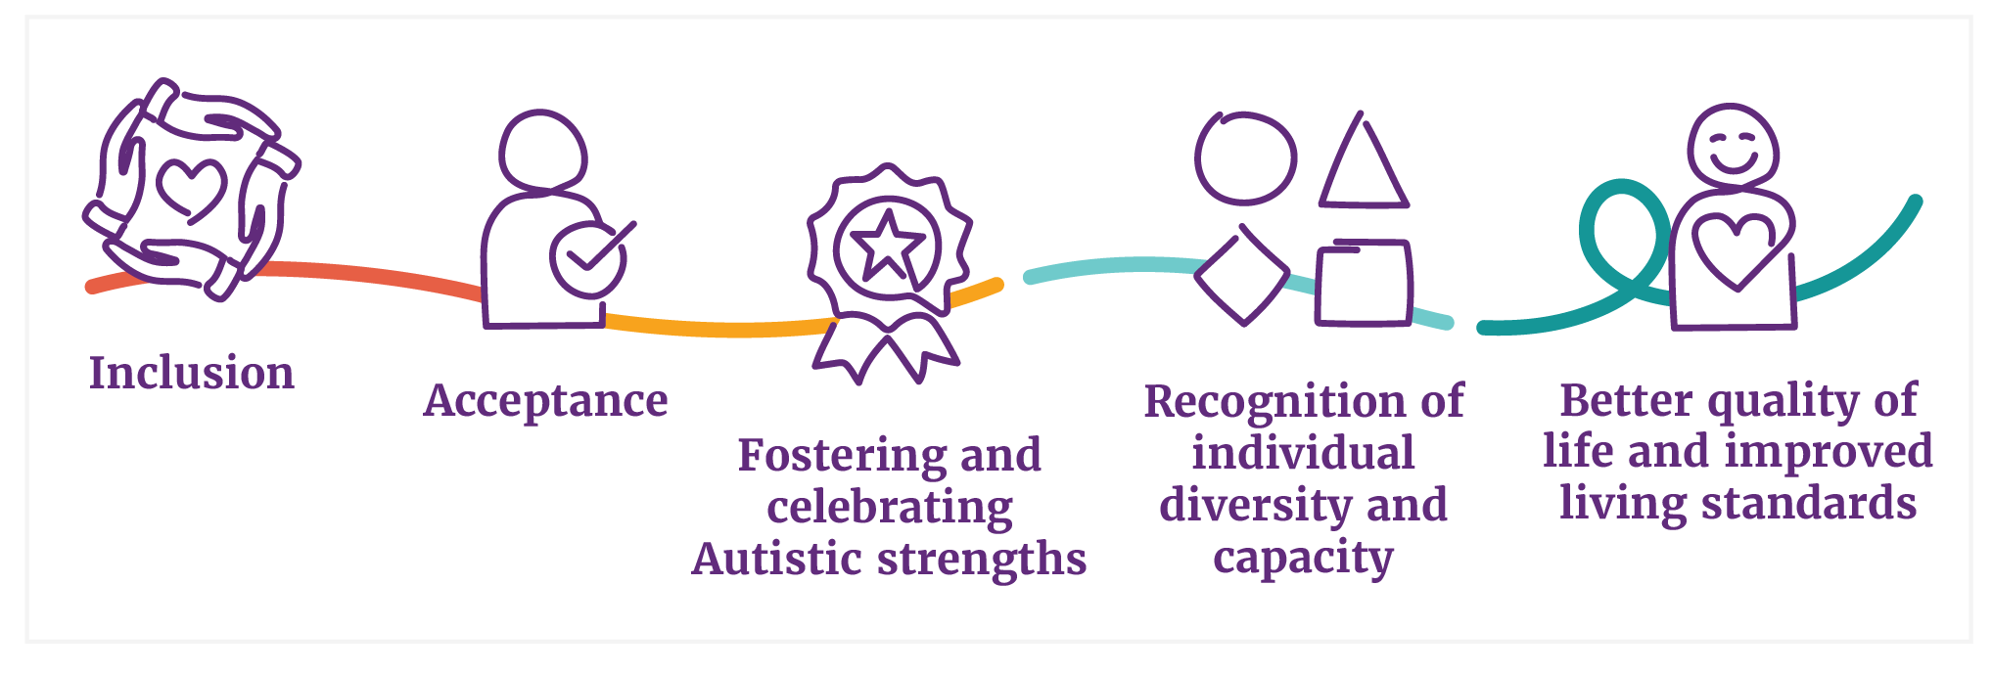

Main themes
The consultation covered vast areas of discussion, with important issues and ideas raised across all stages of a person’s life. These have been grouped into key themes. These themes are listed below and further explained throughout this report.
Rights, autonomy and safety | - Ensuring equal opportunities  - Promoting and supporting self-advocacy and decision-making  - Recognising and nurturing leadership of Autistic individuals
Understanding Autism | - Implement national awareness and public education campaigns  - Autism understanding training for consumer-facing services  - Support advocacy to challenge and reduce the stigma often faced by Autistic individuals  - Educate from a young age  - Ensure positive representation in media, and in sports and arts
Social inclusion | - Improving community understanding and acceptance of Autism  - Sensory-friendly public physical and online spaces  - Supporting social connections and peer support  - Improving access to legal support and a more inclusive justice system  - Improving and adapting communication and information  - Having access to accessible transport  - Neuro-affirming spaces and support systems
Education and learning | - Autism training for teachers and schools  - Pathways and transitions from schooling to further education and work  - More supports for Autistic students  - Inclusive higher education  - Inclusive educational practices
Employment and income support | - Employment support and training for Autistic people  - Autism-friendly workplaces  - Income support  - Removing hiring biases
Diagnosis, services and supports | - Issues with NDIS access and use  - Affordable, accessible and safe services  - Safe and inclusive diagnosis  - Support for Families and Caregivers  - Affordable and timely diagnosis  - Improved diagnostic tools and processes  - Continuity of support services  - Respite services for caregivers
Health and mental health | - Enhanced mental health care  - Autism-friendly healthcare  - Training for healthcare professionals  - Care for co-occurring conditions  - Addressing high rates of mental illness

Led and co-designed by Autistic people (and families and carers)
Autistic people should lead the design and implementation of the National Autism Strategy. This involvement will build on current Oversight Council and Working Group structures in place to design the National Autism Strategy.
Involving and co-designing with Autistic people may mean that some actions or initiatives need more time to get right. People commonly said that time must be given, and this is appropriate given the long term systems and societal change needed.

Implementation
A strong focus of the consultation feedback was how the Strategy would be implemented. Participants expressed concerns that it would just be a document on a shelf. They want to see real, tangible actions that are owned by the Commonwealth Government and others such as state and territories, non-government organisations and the corporate sector.
Autistic people need to have ownership of the Strategy, to guide it, work on it and deliver it. People suggested practical ways of ensuring that, including having Autistic led advisory groups and genuine co-design processes embedded across all parts of the Strategy’s implementation.
Parents and carers of Autistic people with high and complex needs reiterated the need to make sure the Strategy includes the voices of those who support and care for their loved ones, and to respect and support this role in ensuring that those they care for have a voice, and that their rights, choice and decision-making is supported.

Looking ahead
The next stage (Stage 3) of consultation includes the release of a draft National Autism Strategy. The public will be invited to provide feedback on the draft Strategy. It is intended that this would involve an online survey to test and validate the focus and priority areas of the Strategy, with feedback from Autistic people and a wide range of community and Autism sector representatives.

Participation and methods of engagement
In total, there were 2,039 participations that contributed to Stage 2 of the National Autism Strategy engagement process. More than 1,300 people were involved in qualitative discussions and 734 people provided written responses through submissions, the questionnaire and the online Ideas Wall.
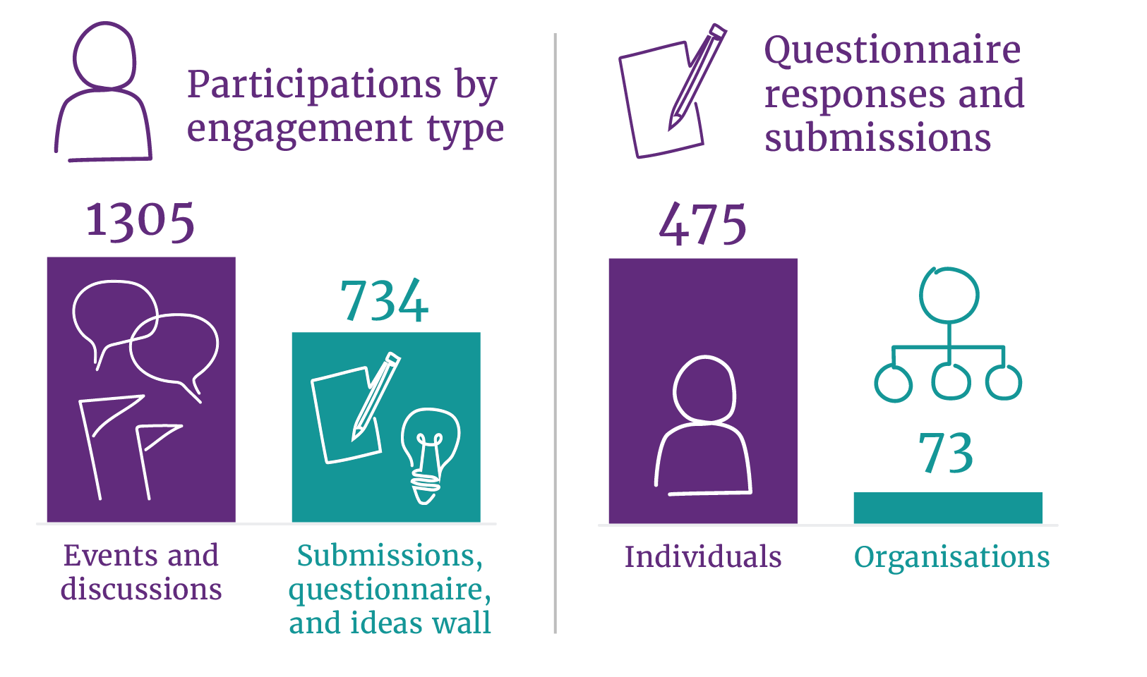
Figure 2. Participations by engagement type, and questionnaire responses and submissions between individuals and organisations
In total, 548 people made a submission by sending a written, audio or video file or by completing the guided questions online. Of those who made a submission including through the questionnaire, the large majority (475) were individuals and 73 were representing organisations.
In addition, 186 people contributed ideas to the open, online Ideas Wall.
In total, 101 engagement activities/events were held from September to November 2023, including:
- 18 open community forums and workshops (face-to-face and online)
- 21 targeted Autistic Voices forums (face-to-face and online)
- 45 focus groups and targeted discussion groups
- 14 interviews
- 3 other engagements

Figure 3. Participants by engagement type
Participation numbers by each of the open community forums and Autistic Voices forums is at Appendix B - Detailed participation.
Participation came from every state and territory and more than a third were from regional, rural and remote areas. Percentages are used to reflect a picture of participation by location; however, people’s state and territory and geographic location were not collected across all activities.
Figure 4. Participation by state | Figure 5. Participation by location
The largest number of participations (878) were Autistic people, followed by family members and informal carers (746). It should be noted that people do not fit into these cohorts exclusively—participants may be both an Autistic person and a family member/carer of Autistic people.
Figure 6. Participation by cohort | Figure 7. Identities of participants
Within the participation, just over 17% identified as having another disability and the proportion of people with co-occurring disability was higher (over one-third of the participants) in Autistic-only forums. About 14% identified as LGBTIQA+ and a smaller proportion of participants were CALD (6%) and First Nations (2%).
We did not collect additional demographic information for open community events and Autistic Voices forums, for example age and gender, to maintain privacy and reduce barriers to registration. As a result, the specific participation breakdown for additional demographics is only shown by event type.

Reaching targeted population and intersectional groups
The experiences and ideas of priority population and intersectional groups was a critical part of this engagement process. In addition to attendance at open community events, it was important to hold targeted events in safe and inclusive spaces to reach priority and intersectional groups.
Twenty-three (23) of the events or engagement activities were delivered with targeted populations including:
- First Nations Autistic people
- Autistic people from culturally and linguistically diverse (CALD)backgrounds
- Autistic people from the LGBTQIA+ community
- Autistic women and girls
- Young Autistic people (30 and under)
- Older Autistic people
- Autistic people who use augmentative communication or are non-verbal
A small number of these discussions were with:
- Autistic people with intellectual disability
- Autistic people with high and complex needs
- Autistic people living in segregated accommodation, group homes and institutions
In addition, 6 targeted sessions were held with parents, family members and carers of Autistic people with high and complex needs.
In total, 532 people participated across the 59 targeted discussion groups and interviews. Participation numbers by group are included at Appendix B - Detailed participation.
Further targeted engagement is continuing with people who have complex or higher support needs, and with First Nations people, given the timing of this phase of consultation limited the preparatory time required to engage with these audience groups.

Methods of engagement
Autistic people, families, carers, peers and organisations were able to contribute to the engagement process in a number of different ways.
All methods of engagement aimed to gain qualitative information on key barriers, experiences and ideas for the National Autism Strategy from a broad cross-section of the Autistic and Autism community. This was in line with the purpose of Stage 2— problem definition and solution ideation.
The multi-modal approach ensured that people could contribute in ways they wanted to and at times that would suit them. Submissions and input to the Ideas Wall could be made in varying formats including written text, video and audio files.
Within the engagement events, people were given a range of options for how they could contribute:
- Group discussion with input provided on posters
- Low key tables for individual inputs
- Conversation cards to support individual input and guided input about what was important to individuals
- Use of an accessible digital engagement tool, Mentimeter, to support:
- anonymous input
- preferences for use of digital tools, for example where people prefer not to or can’t write answers on paper
- screen reader accessibility.
Different types of events were used to make sure the engagements were accessible:
- Autistic-only forums ensured that Autistic people who find it challenging or uncomfortable to engage in a large, mixed group had the option to contribute in a safe space and in a tailored discussion format.
- Small discussion groups and recruited workshops were delivered by partners in the community for targeted groups.
- Attendance at existing events – For example, major conference and smaller regular gatherings and meetings.

Accessibility and accommodations
The Social Deck supported accessibility and accommodations, including having Auslan interpreters and live captioning available on request. The environments and venues chosen took account of considerations like light, sound and space, and participants were empowered to bring their own supports including people, tools and service animals.
Detailed participant packs gave participants advance notice about what to expect at events and how to participate, so that they had time to process content and prepare for the experience. People shared very positive feedback about the use of these packs to help them prepare for, and be reassured to attend, the face-to-face events.

Data analysis
Three types of data analysis processes were used.
Manual thematic analysis: All submissions (including all written, audio and video submissions received via email, in person at events, or as attachments to questionnaire responses) and responses to the guided questionnaire were analysed on an ongoing basis using manual thematic analysis and coding of content (Rapley, 2004). This thematic approach allowed The Social Deck to identify commonly occurring ideas, suggestions and concepts across all of the submissions (Auerbach and Silverstein, 2003), resulting in identification of key themes which have been summarised in the final report (Jensen, 2002). For the questionnaire, responses to each question were coded according to the key issues and themes raised by the respondent. Key themes for these responses were then summarised in a final ‘Submissions report’, with the most common themes (those with the highest percentage of mentions by respondents) presented first.
Qualitative thematic analysis with quantitative keyword frequency analysis: The analysis of the thousands of inputs received during face-to-face and online events involved collating all data into a single source (spreadsheet) where each distinct response or idea was allocated its own row. The ideas and responses in the Ideas Wall were also included with this dataset, along with raw notes of targeted discussions. Higher-level themes and subthemes were generated, allowing us to present these throughout this report, including having an understanding of the frequencies by which particular themes were raised. Due to the significant overlaps of responses across subthemes, the frequencies demonstrate prevalence and significance of each theme within the dataset, compared to other areas.
Manual review and summaries: Detailed notes were received for all targeted engagement sessions (e.g. discussion groups). These raw notes were reviewed by an Autistic research and data analyst within The Social Deck to discover themes that were prevalent to these targeted groups, particularly where themes or issues were not already presented in detail in the main body of this report. A summary of these issues is provided from Appendix A – Target audience and intersectional groups.

An ambitious National Autism Strategy
The Autistic and Autism community wants to see an ambitious national strategy for Australia. A Strategy that sees Autistic people have the same level of access as other people in the community and that ‘levels the playing field for Autistic people and their families’.
People said it needs action and must be upheld, with ‘measures that mean something to Autistic people’ and where there are ‘consequences for failures to uphold the Strategy’.

What should a National Autism Strategy achieve?
Five consistent themes emerged about what a National Autism Strategy should achieve
Inclusion: requiring systems, societal and attitudinal change across all four themes of the National Autism Strategy discussion paper.
Acceptance: supported by a better understanding of Autism across all parts of the community to create a more Autism-informed Australia, and a sense of belonging for all Autistic Australians.
Fostering and recognising Autistic strengths: strength-based and neuro-affirming practices to be the norm.
Recognition of individual diversity and capacity: acknowledgement that every Autistic adult and child has their own experiences and aspirations and can participate freely and equally in all areas of life.
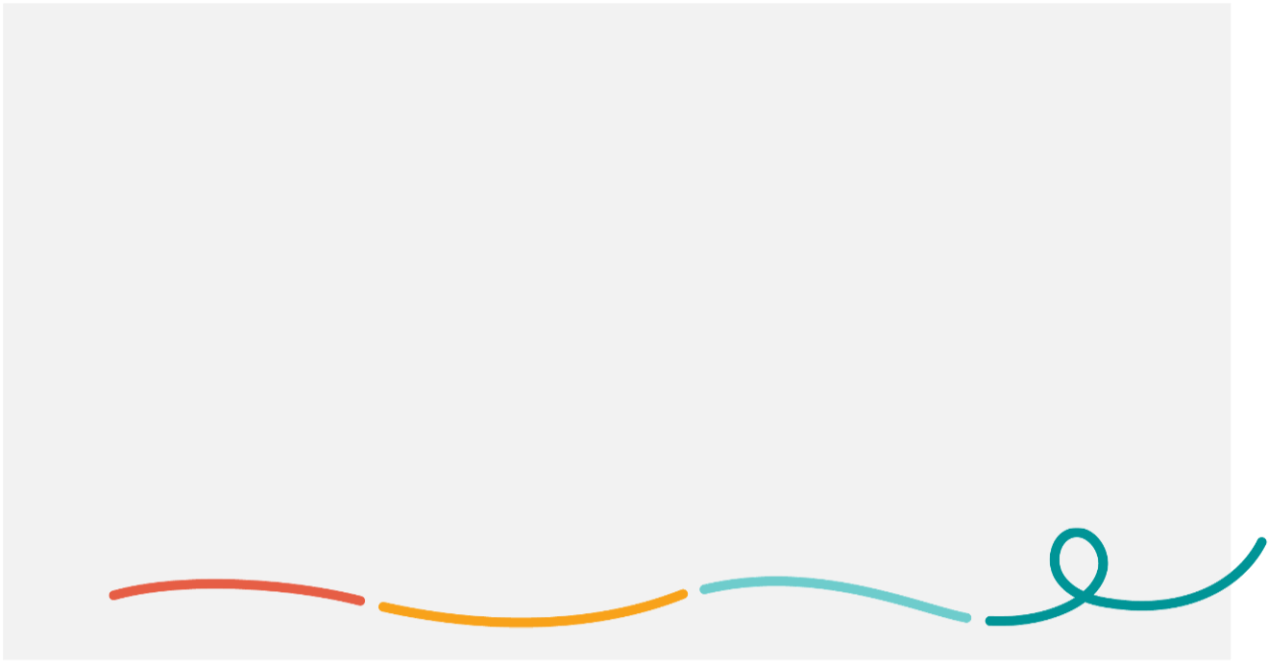
Better quality of life and improved living standards: systems and supports in place to provide for basic needs, to ensure access to health and mental health services to stay well, and equal opportunities for Autistic people to access and thrive in education and employment.
Many participants, especially young people, spoke about the importance of positive affirmation.
‘I want to see a change from ‘suffering Autism’ to a more positive way of looking at being Autistic.’
‘Remove pity, build understanding’.

What will help us get there?
The following feedback helps to inform the considerations, implementation and guiding principles for a National Autism Strategy.
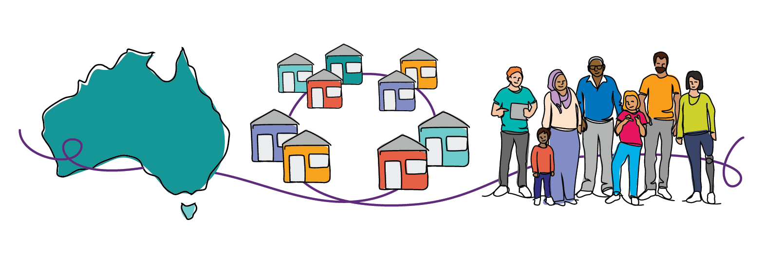

A unified national approach
Participants suggested a unified national approach is important to achieve positive outcomes from a National Autism Strategy. This referred to making sure that all levels of government are working together and there is cooperation and collaboration across different sectors, including mainstream services and supports, and with organisations led by and supporting Autistic people and their families.

Autistic led design and co-design
Participants highlighted co-design, continued engagement and consultation, flexibility, feedback mechanisms and Autistic leadership as crucial elements to implement a successful National Autism Strategy. Many people reflected that the engagement process to inform the National Autism Strategy should be something that continues or is done on a more regular basis, to make sure that the voices of Autistic people and their families are at the centre of the Strategy’s implementation. There is more about community involvement later in this report.
The feedback also highlighted the importance of making it easier for Autistic people to have leadership and decision-making roles in implementing the Strategy, and in society in general. A number of people said that more needs to be done to remove barriers for Autistic people to be in leadership roles including within the organisations (including government) and advocacy groups that will play a strong role in implementing the Strategy.

Person-centred and individualised
A large number of people, particularly questionnaire respondents, highlighted the importance of the Strategy being person-centred and individualised. This was particularly relevant when it comes to supporting the rights, autonomy and diversity of the Autistic community. People suggested that the Strategy needs to be reflective of the diverse range of experiences, skills and abilities of Autistic people.
Many participants commented that part of recognising diversity is better understanding the intersectionalities experienced by Autistic people. Autistic people are within every different community, faith, culture and language group present in Australia. Many Autistic people in the community have co-occurring disabilities or medical conditions. People want to see this represented and accounted for in the National Autism Strategy, so that services and supports are designed to improve outcomes for all Autistic people including those who may face multiple barriers due to intersecting considerations.

Rights and autonomy
One of the main themes from the consultations is about ensuring and upholding the rights of Autistic people. This includes their families and carers.
Rights and autonomy were mentioned across all areas of feedback. Consideration could be given to having a specific outcome area related to this theme. People spoke about feelings of being ignored and that society and government had not done enough to protect the rights of Autistic people.

Key themes
The following chart shows the order of key themes—areas mentioned most often—to improve rights and autonomy.
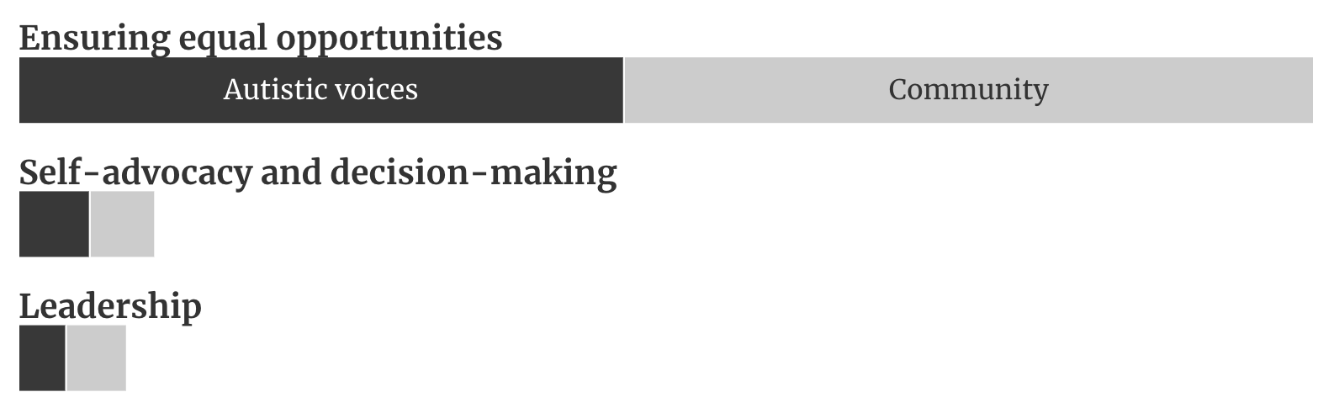
Figure 8. Comparative frequencies of key themes regarding rights and autonomy
In this area, participants said the focus of the Strategy should be on:
- Ensuring equal opportunities
- Promoting and supporting self-advocacy and decision-making
- Recognising and nurturing leadership of Autistic individuals

Ensuring equal opportunities
There is strong acknowledgement that Autistic people have the right to equal opportunity across all parts of society and at all stages of life. For example, being able to participate in education, have employment and income, have access to housing and be able to safely access the community are all basic needs that contribute to good life outcomes.
Equal opportunity is a right that needs to be supported by legislation and systems. Participants suggested the Strategy should help embed equity principles for Autistic people into legislation and policy, and that anti-discrimination protections should be better enforced.
‘The NAS needs to ensure that all Autistic Australians have all the same opportunities as the neurotypical mainstream, across social, economic and sexual domains. This should not be brought about by assimilating us into neurotypical cultures, but by making room for people who move, speak and behave differently from those who are traditionally taken seriously.’ - Individual submission - Autistic person
‘Inequitable access to diagnosis, supports, or services limits an Autistic person’s ability to be supported across their lifetime. It is imperative the Strategy provide approaches for improvement in equitable access to support across an Autistic person’s whole life regardless of socioeconomic status, diagnosis, or the ability to qualify for NDIS supports.’ - Life Without Barriers submission

Self-advocacy and decision-making
Autistic people should be supported to speak for themselves and make their own decisions.
Self-advocacy is crucial for Autistic people to have control over their lives and to ensure that their unique perspectives and experiences are heard, and respected, in both personal and public spheres.
Some participants suggested that a dedicated Autism strategy will empower Autistic people and will make sure they have the tools and ability to express their needs, preferences and rights.

Supported decision-making
Some Autistic people and family and carers spoke about how important it is to support decision-making to uphold the rights and dignity of Autistic individuals. This acknowledged that Autistic people with high and complex needs must have their own voice and be supported to make their own choices and exercise personal autonomy. A few participants mentioned the importance of frameworks like guardianship and trusteeship but making sure they are put in place with safeguards to protect individuals, especially those who are non-speaking or have complex needs. Some parents also noted rigid policies and systems in schools and other settings that limit their children or Autistic people they care for from being supported by parents and carers to make choices and decisions about their learning, environments and other things.
‘People such as our son do not have the intellectual ability or communication skills to express their experiences or needs. Their shared journey is with those who care for them. It is critical that their voice (through their carers) is included in decision-making bodies and specific consideration is given to the needs of people with Autism and intellectual impairment as a group when developing policy impacting their lives (early childhood education and what works, school, post school programs and services, housing, and health) so that they can enjoy their best lives’. - Individual submission - family member/care)

Recognising and nurturing leadership of Autistic individuals
Many participants suggested the National Autism Strategy should recognise and nurture the potential of Autistic individuals as leaders and change-makers. By promoting Autistic leadership, we can ensure that policies, programs and services are more reflective of the needs and strengths of Autistic people and the Autism community, including families and carers.
‘Resourcing needs to be directed to organisations, networks and groups run by and for Autistic people. Autistic people are skilled and we are diverse. We have the skills to be on Boards, to be CEO's, managers and workers at every level’. – Ideas Wall Participant
‘Many Autistic people have extraordinary leadership skills, are dedicated to integrity, transparency & social justice, communicate easily with other ND. Recruit Autistic staff to co-lead and deliver it’. – Online Autistic Voices Participant
Cultural safety and First Nations involvement
In relation to rights and autonomy, some participants noted that all aspects of the National Autism Strategy and implementation of actions must be designed and delivered in a way that is appropriate and safe for First Nations people. This included allowing First Nations communities to lead their change and to be involved in all aspects of designing First Nations-specific activities. It also included that any work to improve life outcomes of First Nations Autistic people should be done within the context of other First Nations-led strategies, especially Closing the Gap.

Understanding Autism
Across all consultation events, the issue raised most often was the lack of understanding of Autism. It was prevalent across all four areas of the discussion paper, as improved awareness and understanding were seen to be critical in all aspects of life—from accessing education and employment, to getting housing and having safe and appropriate health and mental healthcare. It was also one of the most common themes identified by people when asked what a National Autism Strategy should achieve.
Many participants observed that because Autism is an ‘invisible’ disability, specific focus and strategies are needed to increase understanding about how it presents in different people.
People said more work needs to be done to destigmatise Autism, particularly to actively change negative perceptions and stereotypes. This will help to ensure Autistic people can live without the burden of social stigma and discrimination.
‘The basic understanding of Autism has to be foundational to the NAS. Unless people can have a new/fuller understanding of the spectrum, we will continue to get cliches/scepticism/pushback.’ - Participant, online Autistic Voices forum
Due to misconceptions and stereotypes there are inherent biases against Autistic people. People suggested the National Autism Strategy should aim to combat bias that is detrimental to many Autistic people and actively challenge and reduce biases in areas of employment, education, justice and housing.
‘People make value judgements like ASD symptoms are a choice’- Participant, Darwin community forum
Understanding Autism was also a common theme among most of the targeted population groups. In particular, for First Nations and CALD communities, there is a need to increase awareness about what Autism is and to destigmatise Autism so it’s not seen as a ‘vulnerability’ or deficit. Some said this would help to improve diagnosis and then access to supports in these communities.

Key themes
The following chart shows the order of key themes—areas mentioned most often—to improve understanding of Autism.
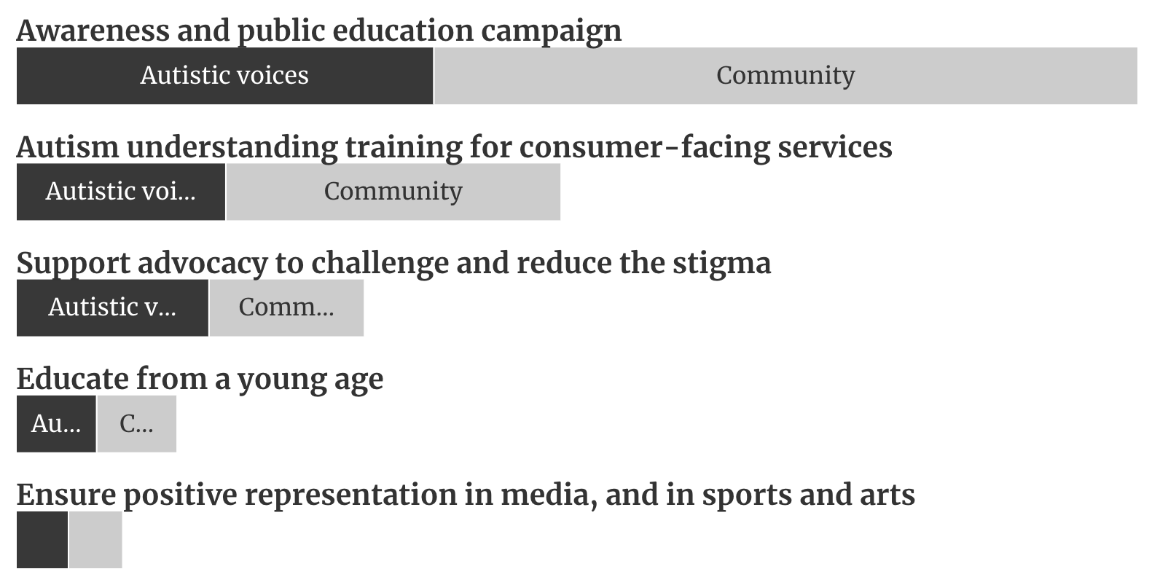
Figure 9. Comparative frequencies of key themes regarding understanding Autism
People consistently said the National Autism Strategy should:
- Implement awareness and public education campaigns
- Promote Autism understanding training for consumer-facing services
- Support advocacy to challenge and reduce the stigma often faced by Autistic individuals
- Educate from a young age
- Ensure positive representation in media, and in sports and arts

Implement awareness and public education campaigns
Public education campaigns are one of the most common ideas across all types of engagement activities and audience groups. Feedback focused on awareness campaigns and other community education initiatives (e.g. touring education stalls) to:
- reduce stigma
- debunk stereotypes
- address misconceptions about Autism.
People suggested these campaigns could feature:
- people with all different presentations of Autism and different representations
- a ‘day in the life’ to show how different Autistic people might navigate systems and places, to educate the community about how Autistic people communicate, why they might use different types of language, what they experience and how they may behave and why
- Autistic leaders and positive stories
- myth busting, with real situations, facts and information about Autism in Australia.

Autism understanding training for consumer-facing services and supports
Training to improve understanding of Autism was a very popular suggestion raised across all areas of feedback. It is important to promote both social and economic inclusion, and to improve access to services and supports and healthcare.
In particular, people suggested training for frontline services like retail, hospitality and transport and across sectors, such as healthcare, education, and law enforcement. Training would help people in consumer-facing and frontline roles to interact in a more sensitive, safe and effective way with Autistic individuals.

Support advocacy to challenge and reduce the stigma often faced by Autistic individuals, including from intersectional groups
Participants acknowledged the work of advocacy organisations in improving understanding of Autism and reducing stigma. Two specific types of advocacy were noted as particularly important in this area:
- Advocacy that supports people with complex communication and support needs to have a voice and to be able to challenge assumptions, noting that often people assume that people who are non-verbal are not capable or intelligent.
- Advocacy that improves awareness of the intersectional identities and barriers Autistic people face such as specific barriers for women and girls, First Nations people, people from CALD backgrounds and people who are LGBTIQA+.

Educate from a young age
Participants suggested that introducing Autism education from a young age is one of the most impactful ways governments can improve society’s understanding and awareness. Some suggested that schools introduce Autism education modules or programs to normalise neurodiversity from a young age. Educating students before they reach the middle years or high school will help with the bullying and abuse that are experienced at school and in adolescent years.
Some people also suggested more positive exposure and interactions for young children to understand Autism. Integrating Autistic and other neurodivergent children in mainstream schooling (instead of segregating in other settings or parts of the school) was raised as a way to help improve understanding and future inclusion.

Ensure positive representation in media, and in sports and arts
Many participants said it is still difficult to see Autistic people represented in media. This included entertainment and television programming. They said more needs to be done to improve the visibility of Autistic people, of all types, in the media.
‘When people think of Autistic people, they think of Sheldon Cooper or Rain Man. There are so rarely women, non-binary people, queer people’. - Participant, online LGBTIQA+ forum
Some people said it’s not often you hear about Autistic people in sports and the arts either. They suggested this is because people in those fields may not be disclosing Autism and talking about it.
Masking
Many Autistic people mask their characteristics and challenges to fit into neurotypical society. Masking can be detrimental and lead to poor mental health, trauma, burnout and feeling inauthentic.
Masking was raised as a particular concern for women, girls and other young people, including children. Many participants described that, for children and young people, masking can cause them to go through schooling without supports, and the stress of masking can cause significant childhood and later mental health issues including leading to harmful behaviours or ‘acting out’.
‘Looking at [Yellow Ladybugs] teens that I know our kids learn to mask their externalised behaviours but this is often harmful and feeds into internalised behaviours like self-harming and disordered eating and suicidal thinking. To external parties these kids might appear more compliant but they are on the edge of survival’. – Participant, Yellow Ladybugs focus group
Many women in the Autistic Voices forums talked about having to mask their Autism and Autistic traits given expectations of caring for others, such as their own Autistic children. Autistic women also particularly mentioned the impacts masking has on diagnosis and their overall health.
Many older Autistic people noted that late-diagnosed adults have often coped through masking their whole lives. They reported that the needs of ‘high masking’ individuals are often dismissed or doubted and then people struggle to access supports when they need it. Some specified that diagnosis can be even more challenging for individuals who have become accustomed to masking because diagnostic processes are not refined enough to pick up on that. They said greater recognition and supports to accommodate high masking are necessary.
People emphasised the Strategy should focus on reducing the need for masking. Autistic people said improving understanding of Autism will help to reduce masking (for some). Autistic people mentioned if employers, peers, and health and other frontline service staff were more understanding and accepting of Autism, they would likely mask less.
‘I would like to not have to mask my Autism in order to feel safe’. - Participant, online Autistic Voices forum

Feedback on the four themes of the National Autism Strategy discussion paper
The National Autism Strategy discussion paper provided four key areas for feedback. These were:
- Social inclusion
- Economic inclusion
- Diagnosis, supports and services
- Health and mental health
Throughout the consultations, participants noted there are many overlaps between these areas. As a result, the analysis and frequencies of themes raised by the public don’t sit neatly within them. However, to inform the drafting of the Strategy, this report groups key themes and ideas by these four main areas.

4.1 Social inclusion
The feedback about social inclusion was broad and covered many areas. Improving understanding and acceptance of Autistic people in the community was a very strong theme that is reflected in the previous section.
Participants highlighted the importance of fostering a deeper understanding of the principles of equity, in relation to Autism. This involves educating the public and professionals about the diverse needs and experiences of Autistic individuals and emphasising the importance of personalised, respectful approaches.
Some people spoke about the importance of adapting a social model of disability to promote inclusion, accessibility and acceptance rather than trying to 'fix' or 'cure' Autistic people. They said responsibility should be on society to remove barriers and accommodate the access needs of Autistic people.
‘Fix the system, not us’ – Autistic person, Adelaide Autistic Voices forum

Key themes
The following chart shows the order of key themes—areas mentioned most often—for Social Inclusion, based on the feedback received. A range of other issues were raised and presented using pull out boxes where they were considered to be particularly significant to the experiences of Autistic people including from priority and intersectional groups.
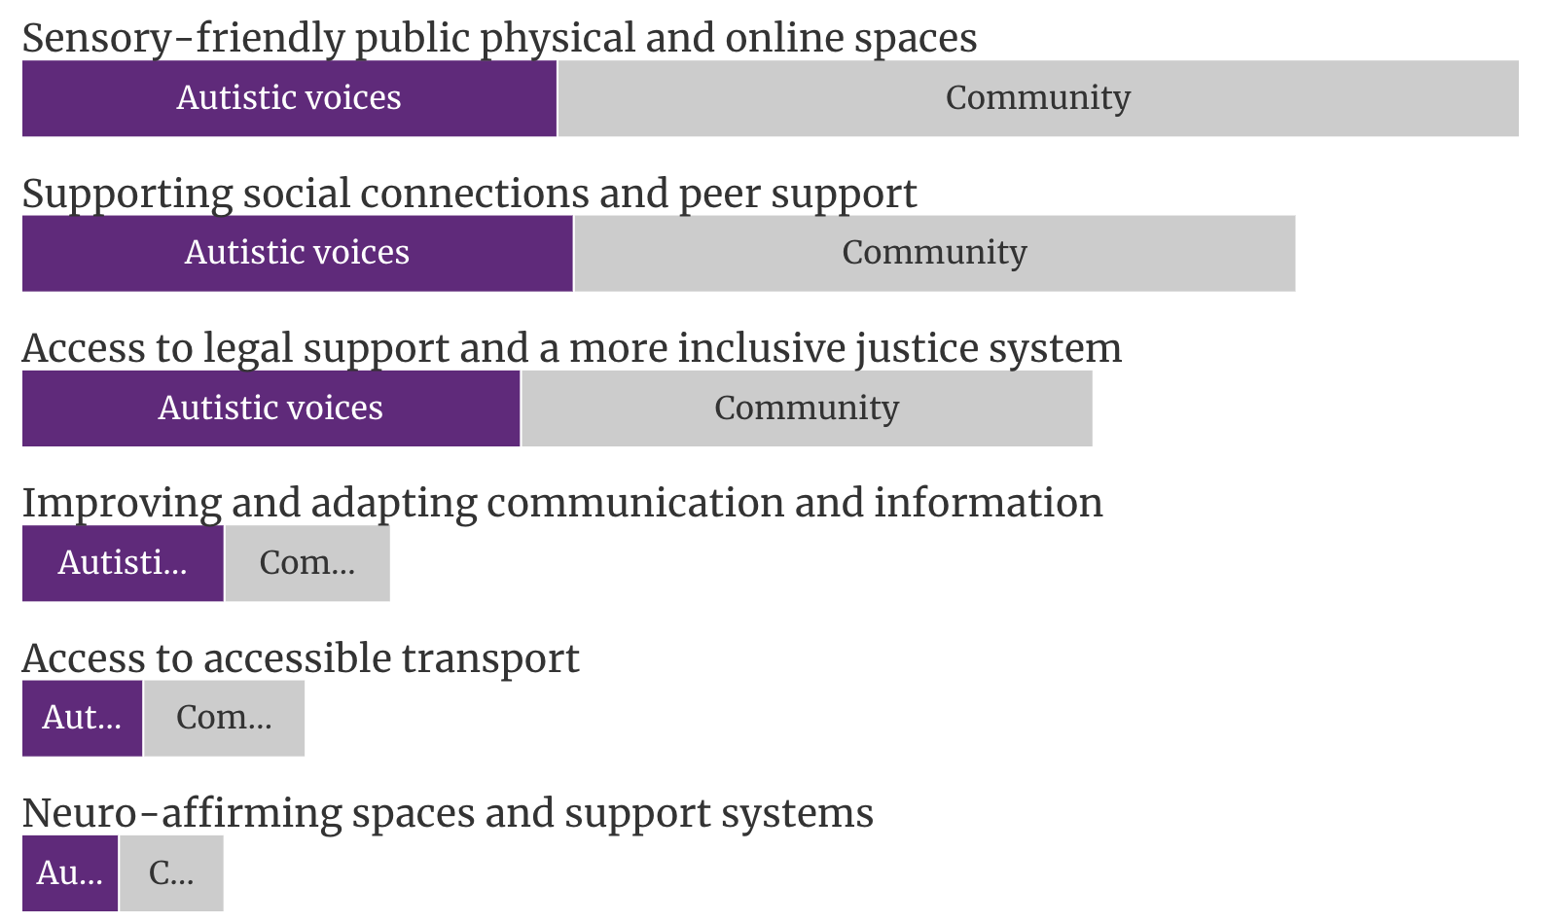
Figure 10. Comparative frequencies of key themes regarding social inclusion
The most common areas of feedback about social inclusion focused on:
- Sensory-friendly public physical and online spaces
- Supporting social connections and peer support
- Improving access to legal support and a more inclusive justice system
- Improving and adapting communication and information
- Accessible public transport
- Neuro-affirming spaces and support systems

Sensory-friendly public physical and online spaces
A common theme raised by Autistic people, families and carers was to make sure public spaces are sensory-friendly. There is a need to design and modify physical environments so they are accessible and comfortable for Autistic people. This includes creating sensory-friendly areas to reduce sensory overload, and designing inclusive environments in schools, workplaces, and community centres. People said these changes would let Autistic people, including children and their families, use these spaces without facing barriers, enhancing their ability to participate in everyday activities and social interactions.
Suggestions to improve public spaces included:
- incentives for venues to implement regular dedicated quiet hours
- having Autism and sensory-friendly certification for venues, established through setting up nationwide standards for sensory-friendly facilities
- designing competitions and initiatives to help rethink public spaces, schools, and workplaces.
In the digital age, ensuring virtual spaces are accessible to Autistic people is crucial. Some comments were about digital inclusivity, such as user-friendly website designs, accessible online platforms and considerate virtual communication methods.
‘Many public spaces and public infrastructure (e.g. transport) are inaccessible for Autistic people, both due to physical/environmental limitations (such as bright lighting, too much noise, overcrowding) and societal expectations (such as neurotypical communication norms). The recent increase in adapted environments, for example, quiet supermarkets, sensory concerts (having sensory-friendly sessions at concerts) has demonstrated how spaces can be made more accessible for Autistic people and the high value placed on these adapted and accessible environments.’ - Australian Music Therapy Association submission

Supporting social connections and peer support
‘The strategy could help [Autistic people] find their tribes - across Australia - the power in bringing us together and sharing and supporting will fundamentally change and improve things’. - Participant, Yellow Ladybugs focus group
A common theme raised by Autistic people is about doing more to facilitate social connections and peer support networks. Many participants said coming together with other Autistic people in safe and inclusive spaces, including in events like the Autistic Voices forums, is empowering and reassuring.
‘I find it easier to spend time with other people and make friends when I’m doing an activity’. - Autistic student, Giant Steps School, Tasmania
People said local peer support groups and social networks need more support through funding and tools that can make the set-up, promotion and running of events and networks easier. Lots of good examples of existing peer groups and networks were shared during consultations and this included groups who meet in person and who connect online. However, people consistently identified these networks generally rely on one or a few people who are volunteers, so they aren’t sustainable as a way to encourage social connection and inclusion on an ongoing basis.
‘As an Autistic individual the biggest barrier in society has been social inclusion and being able to maintain friendships because I am different. Throughout high school I was excluded during group work and bullied because I did not fit in with the norm. Post high school there are no social groups related to my interests for people like myself who never made friends during high school. NDIS only currently funds groups which are specific to people with a physical or intellectual disability which were not at my level of ability rather than giving us the opportunity to join groups for people of mixed abilities. Having Autism does not mean that I am intellectually disabled and cannot understand things and therefore there needs to be more social groups for adults who experience difficulty making friendships.’ - Autistic person, LGBTIQA+, CALD – questionnaire response
Support for this could include:
- small grant funding for peer support programs and specialised social groups for Autistic youth and adults
- developing a mentorship program that matches Autistic individuals for support, available nationally
- developing Autistic inclusion guidelines or similar tools to encourage mainstream social/community groups to actively welcome and include Autistic participants
- supporting targeted initiatives, such as arts, music and gaming programs, to reduce isolation and support connections to be built within the community.
Connecting with peers
When Autistic people came together at Autistic Voices forums to have their say on the National Autism Strategy it demonstrated the importance of peer connections and supports. Participants exchanged contact information, meet up invitations and service tips during the events. For example, in Cairns, participants coming from different parts of Far North Queensland had the opportunity to connect, relate and compare notes on local services. The group made a point of sharing contact information so they could continue to connect with one another and share information and resources.

Improving access to legal support and a more inclusive justice system
Issues and poor experiences with the justice system were raised across a number of discussions, particularly in Autistic Voices forums. Some Autistic parents also raised issues with interactions with the justice system they had experienced for themselves and their children.
Most often participants emphasised the need to improve understanding of Autism within the justice system, including police, courts, prisons, and legal professionals. Policing and security services were key sectors identified for more education and training. People said police often misinterpret Autistic behaviours like meltdowns, stimming or avoiding eye contact as suspicious, aggressive or intentionally disruptive.
‘Me being a person with Autism that is also Middle Eastern makes me a high target, and I’ve been subject to random pat-downs and bag checks just at the station… I get [an airport search] every time without fail, in every country I’ve been to’. - Participant, CALD online forum
There were significant concerns for young Autistic people ending up in trouble. It was suggested that Autistic children need to be supported from primary school years to break this cycle. An Autistic person who works in the justice system described ‘people are told they are bad and then we end up in a system of deficit all our lives’ and ‘we aren’t safely supported to be out of the situations and systems we are in’.
‘The school to prison pipeline is real for Autistic kids…We need to deal with it at both ends, we need to be there in crisis time but we also need to work with all children from primary school (including Autistic peers) to stop Autistic kids getting there in the first place’. – Participant, Ballarat Autistic Voices forum
Several participants called for increased legal protections for Autistic people. They emphasised the need for affordable, accessible legal services tailored for Autistic people. Autistic defendants may struggle to participate effectively in legal proceedings without support and accommodations. Some suggested that all facets of the legal system including lawyers, prosecutors, judges, courts, and correctional facilities, need to be better at understanding how to support Autistic people.
‘There's a huge need to do more work to make legal proceedings and the court process more accessible for neurodivergent folks and also recognise how processes for giving evidence, complying with court formality, etc. are framed on neurotypical expectations which all feeds into the disproportionate overrepresentation of disabled people in the legal system’. - Participant, WWDA online discussion group
‘The Strategy must engage with the experiences of Autistic people with an intellectual disability in the context of the justice system and put forward targeted strategies to increase peoples’ access to necessary supports when navigating the justice system.’ - Inclusion Australia submission
Child protection system issues
A few participants shared experiences with the child protection system and in particular, this system and the justice supports around it, need to be better tailored for Autistic parents and children. One person said the issues and misunderstandings in the system have caused children to be removed due to being judged and misunderstood. They said it’s difficult to be able to explain things and there aren’t properly trained people to help you explain it. People said trauma-informed responses are very important in these sorts of justice systems because many Autistic people will have past trauma which impacts their responses.

Suggestions to help improve Autistic people’s interactions with the justice system included:
- mandatory training for police on Autism, including on Autistic communication differences, managing meltdowns, avoiding escalation, and using non-lethal de-escalation tactics
- review prison procedures to better understand whether accommodations are in place and to put in measures that prevent discrimination and abuse
- developing targeted strategies to address issues that Autistic people are facing with the justice system that are co-designed with Autistic people from priority population groups who are at higher risk, such as Autistic people with intellectual disability and First Nations people.

Improving and adapting communication and information
The diverse communication styles of Autistic individuals need to be recognised and accommodated—including how people receive information and how they communicate themselves. Comments about this theme highlighted the importance of understanding and supporting both verbal and non-verbal forms of communication. Tailoring communication methods to suit individual preferences and needs is key, whether it involves using assistive technologies, visual aids, or alternative communication techniques. Embracing diverse communication styles enables effective interactions and empowers Autistic people to express themselves clearly and confidently. Many participants suggested more needs to be done to make information and communication more accessible for Autistic people.
‘Complex communication needs affect a person’s ability to understand and be understood by others. People with complex communication needs may not use speech, but may communicate in different ways, including using alternative and augmentative communication options. Statistical data suggests that half of the Autistic people in Australia have complex communication needs. Therefore, it is critical that this group of Autistic people are recognised in the National Autism Strategy, and that their needs are addressed.’ - Speech Pathology Australia submission
Participants also referenced the ‘double empathy problem’, where Autistic and non-Autistic people have different ways of expressing and interpreting things, which often don’t align but are equally valid. They suggested increasing awareness and understanding should include neurotypical people sharing equal responsibility for bridging this divide in communication and understanding.
‘Imagine if every [neurotypical] kid was taught how to speak [neurodivergent]?’ - Autistic person, online LGBTIQA+ forum
There was consistent feedback that information needs to be provided in clear, direct language that is easy to understand for Autistic individuals. Complex language, jargon, and confusing text should be avoided. Participants said that inaccessible information is a major barrier for Autistic individuals in understanding their rights, options for support, and how to self-advocate.
People suggested improving communication could include:
- using plain English and having Easy Read or Easy English information available about important things people in the community need to know
- tailoring resources with use of visual supports, videos, animations, social stories, communication boards, audio recordings, and plain language summaries
- establishing a website hub with accessible information
- co-designing resources, (e.g. have an advisory body of Autistic people, to guide information design to ensure accessibility).

Accessible public transport
Participants raised issues with public transport, most often in the context of social inclusion. They said issues with public transport stop them being able to access and move around their communities, including attending events and socialising. This was in addition to using public transport to get to work or study.
Priorities for improving accessibility on public transport included making sure people who operate transport have better awareness of what Autistic people might be experiencing. Participants mentioned there were some positive actions being taken, like quiet zones on trains and the hidden disabilities sunflower initiative to help people identify those with an invisible disability who need extra support. Other common suggestions included:
- mandate Autism training for all customer-facing transport roles
- require provision of clearly marked quiet zones on public transport, as well as having dedicated seats and clearly designated low-stimulus areas on public transport for people with sensory considerations
- develop Autism-tailored wayfinding tools for navigating transport hubs.

Neuro-affirming spaces and support systems
Neuro-affirming spaces, systems and approaches was a strong theme throughout the consultation and particularly in relation to improving social inclusion and acceptance. The feedback was about making sure environments and support systems in society recognise and affirm neurodiversity. Neuro-affirming support involves understanding and respecting the different ways Autistic individuals experience the world and adapting services and environments accordingly. This approach aims to provide care and support that is not only accepting but also embracing of neurodiversity, thus fostering a positive sense of identity and wellbeing for Autistic people.
‘Neuro-affirming to us is people have considered acknowledged and validated our Autistic identity and culture, and appreciating we do not want to be neurotypical passing but the best version of our Autistic self’. - Participant, Yellow Ladybugs focus group
People’s comments about the need for more neuro-affirming spaces and support was particularly common in regard to healthcare and educational practice.
‘Even if we can access things, are they actually affirming and safe? Are they the right fit for what we need? And all of that folding into health and mental health. And it's just such a compounding, interrelated thing, I think. It makes me so angry and so sad too because we all deserve so much better’. - Participant, online LGBTIQA+ forum
Neuro-affirming also means accounting for differences and intersectionalities. People said approaches need to be trauma-informed and appropriate for priority and intersectional groups who experience additional barriers for social inclusion and are at higher risk of trauma and discrimination.
Learning to drive
In addition to public transport, a number of participants, especially young people, talked about issues with learning to drive and getting their driver’s licence. They said they’d be good, safe drivers but the processes of getting a driver’s licence caused significant stress and accommodations were not made to account for Autistic needs.
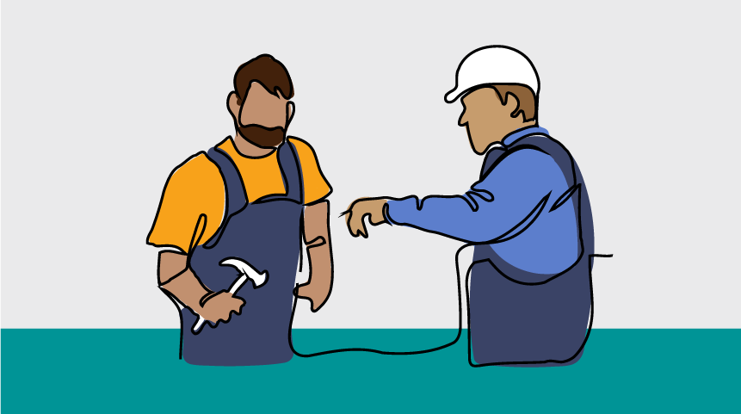

4.2 Economic inclusion
There was wide-ranging feedback on the area of economic inclusion. Most commonly participants noted significant barriers for Autistic children accessing education, and for Autistic adults to get and maintain meaningful employment. People raised concerns about the rates of poverty and financial insecurity among many Autistic people and families, with high costs of diagnosis and supports further impacting this.
Feedback on economic inclusion is grouped in two main areas:
- Education and learning
- Employment and business, and income support

Key themes - Education
The education system was a common focus, with many participants calling for improvements in how schools and higher education institutions support Autistic students. Enhanced training for teachers and implementation of more inclusive learning practices are seen as essential for meeting the needs of Autistic children to learn and grow.
The feedback indicates the National Autism Strategy should drive reforms across all levels and types of education—from schools to higher education and in vocational education and training. This will enable Autistic people to thrive in education.
The following chart shows the order of key themes—areas mentioned most often—for education, within the context of economic inclusion. Other issues were also raised and are presented in pull out boxes where they were considered to be particularly significant to the experiences of Autistic people including from priority and intersectional groups.
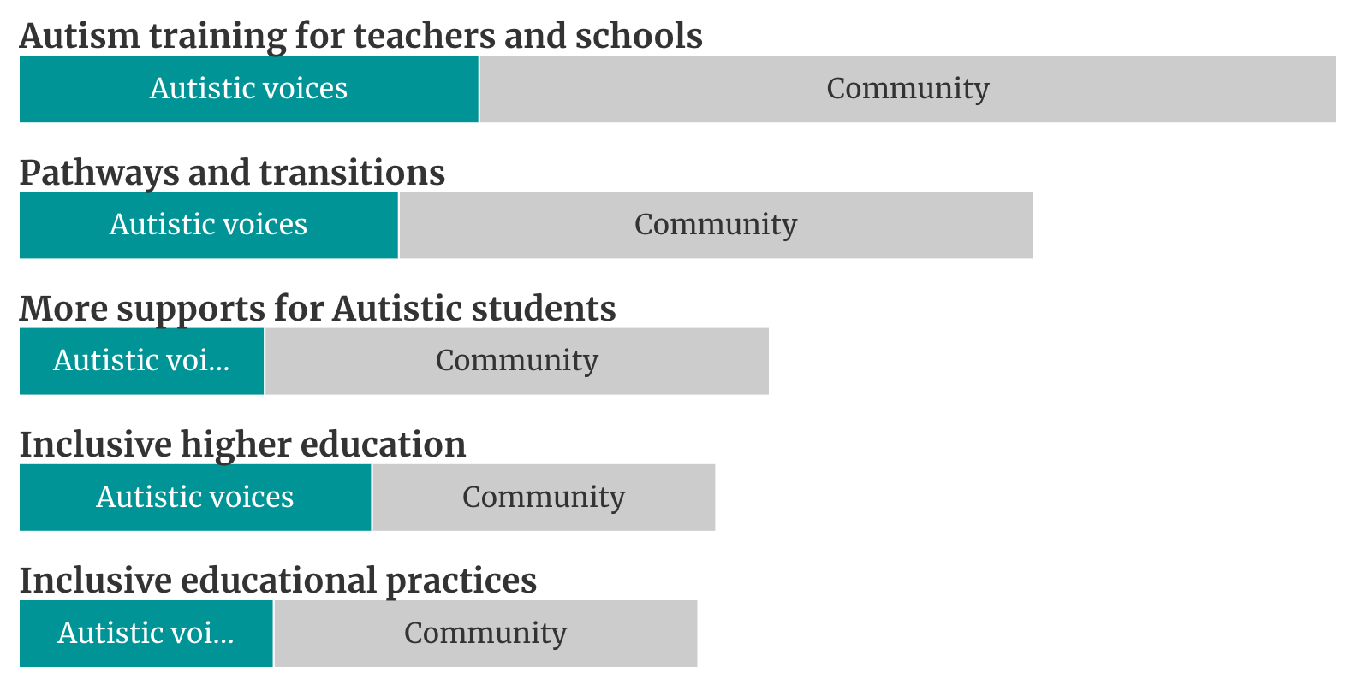
Figure 11. Comparative frequencies of key themes regarding education and learning
Common themes about education were:
- Autism training for teachers and schools
- Inclusive educational practices
- Inclusive higher education
- More supports for Autistic students
- Pathways from schooling to further education and work

Autism training for teachers and schools
Participants frequently spoke about the need to improve and mandate training for all education leaders, teachers and school staff on supporting Autistic students. This came up in comments related to both mainstream and specialist schooling.
‘At school I often shut down and don’t feel there’s an opportunity to ask questions. All teachers need to be educated, to have an understanding of Autism. That would make my life better right now.’ - Autistic young person, Devonport Autistic Voices forum
Parents and carers with children in specialist schools said that many staff, even in these settings, don’t have a thorough understanding of, or training in dealing with, the different presentations and behaviours that can occur.
Suggestions for Autism training and better Autism understanding in schools included:
- mandate dedicated Autism training for all teaching roles
- begin the delivery of training about Autism and working with Autistic students during university teaching degrees
- fund professional development scholarships focused on inclusive Autism practices for staff
- establish positions for Autism consultants/specialists within schools to support staff.
Autistic people reiterated that Autism awareness training should be designed and led by Autistic people, including young people, when it came to improving understanding in school environments.

Inclusive educational practices
There was a very strong emphasis on making mainstream classrooms and learning more inclusive for Autistic students. Many parents and carers said it is important to have choice in education and to make decisions about the sort of education environments their Autistic child/ren could attend.
School inclusion is critical for Autistic children and young adults. However, many participants shared experiences about extensive exclusion (suspensions and expulsions) from school and of school refusal by students. Some young Autistic adults reflected on experiences of exclusion, bullying and trauma when they were at school, which had a negative impact on their lives as they entered adulthood.
Participants said adapting educational environments and teaching methods to meet the needs of Autistic students should be the norm in all schools. This included ensuring there are appropriate classroom accommodations, tailored learning resources and assessments, and offering supportive educational practices. Some specified that a Universal Design for Learning (UDL) approach needs to be adopted in schools and universities.
‘Schools and educational institutions have been very rigid in their mode of delivery, expectations of attendance and behaviour, assignment requirements, time frames and modes of attendance. There have been some accommodations made but it has been largely dependent on who the individual teacher is. Schools have been more willing to make accommodations when we as parents have asked for them, but I often wonder if I didn’t ask, would they have been offered?’ – Submission - parent of Autistic person – Remote
Young people shared that simple accommodations in mainstream schools, like having fidgets and sensory-friendly rooms and spaces to go, make a big difference. However, they advised that all educators and support people in the school environment need to have a better understanding of inclusive practices.
‘The typical WA classroom environment is a sensory nightmare for neurodivergent students… with fluorescent lighting, lack of air conditioning (many neurodivergent students have difficulties with temperature regulation), group seating structures, background noise, preference for verbal communication and lack of sensory and movement breaks, the classroom environment is overwhelming and triggering for neurodivergent students. This results in reduced academic achievement, shutdowns / meltdowns, and behavioural difficulties. By ensuring that the classroom strategies utilised in all schools are neurodiversity-affirming, it’s clear that all students will benefit.’ - South West Autism Network submission
Common suggestions included:
- set national standards for required Autism accommodations in schools
- ensure funding and resources are available for schools to make adjustments and improve environments for Autistic students
- introduce flexible assessment options better suited to Autistic learning needs.
‘I want a new national curriculum that is inclusive of how the minds and ways of Autistic people work. This isn’t that hard to do if we can just adapt practices’. - Ballarat Autistic Voices forum
Bullying
Concerns about bullying targeting Autistic students was substantial. It was suggested schools should implement stronger anti-bullying rules specifically protecting Autistic students and make sure Autistic students are supported to report bullying in ways they are comfortable with. Several responses mentioned bullying can continue from childhood into adulthood for Autistic individuals, both in social relationships and workplaces. This highlights an ongoing issue across different life stages.

Inclusive higher education
Participants said more needs to be done to make universities and TAFEs more inclusive for Autistic students. This included ensuring mental health, social and academic support for Autistic students is available in those settings.
Current and recent university students talked about being scared to disclose their Autism as ‘they didn’t want to risk it’ and said that it can take time to trust lecturers and tutors to feel ready to disclose and ask for supports. Some also expressed concern about approaches to disclosure at university entrance being too simplistic, leading to presumptions about needs and abilities rather than considering individual presentation.
Autistic young people also said that universities could do a lot more to support student aspirations. For example, offering ‘more support to move into fields that we really want to study and work in’.
Common suggestions included:
- providing guidance to universities to support Autistic students in their learnings
- funding support services and dedicated scholarships at universities for Autistic students
- introducing Autism sensitivity training for academics and administrative staff
- promoting uptake of tools like lecture capture, note-taking supports and sensory rooms
- social inclusion programs to help Autistic students integrate into campus life, make friends and participate in activities.

More supports for Autistic students
Young Autistic people said that educators and school leaders need to listen to students about what they need, and students should not have to shoulder the burden of advocating for their needs to access and participate in education.
Participants suggested that providing more robust mental health, social and academic support tailored to neurodivergent students would better set young Autistic people up for success. They said a more open and supportive environment in schools, that aims to understand the things impacting Autistic students (e.g. experiences of trauma and bullying) rather than reacting to them, would help improve participation at school. Trauma impacts learning and behaviours at school, so tailored supports are needed to help with issues such as acting out or school refusal, and teachers need to know how to apply these supports.
Support in education settings is needed for families and carers. Parents talked about the value of supporting and involving the whole family. In particular, respecting and listening to parents of Autistic students where students have consented to this. There were a lot of comments about the burdens often placed on parents and carers to advocate and find supports for students to thrive in the education systems.
Specific suggestions included:
- additional counselling and support services to be made available for Autistic students in school settings
- better engagement between educators/schools and parents and carers to support students.

Pathways and transitions from schooling to further education and work
Young Autistic people and parents and carers highlighted the challenges and need for support during the transition from school to employment or further education. This transition phase often lacks adequate services and support. Some young Autistic people said entering university is a time where there should be more focus on support being available because it is ‘when you need to adjust to a lot of change at once’. However, they suggested that universities often expect they already have existing supports in place so it’s not a priority.
‘We need to have more support from secondary school into higher education. I did pretty well at school, but then went to Uni and everything started to fall apart. It’s a radically different style of learning and no one prepares you for that at all’. - Autistic person, VALID focus group
The types of supports needed include career and education transition supports, but also counselling and mental health supports during this critical and sometimes stressful period. Some Autistic people mentioned that they might be moving out of home during this time or going into completely new environments, so access to supports and services is critical. However, some participants said not all people have a formal diagnosis, so it’s important that any supports are Autistic-friendly but not restricted to those with a diagnosis.

Common suggestions:
- Support to help students explore career options suited to their strengths and providing vocational guidance, including dedicated employment counsellors and job coaches to guide and support Autistic individuals entering workplaces.
- Mentorship programs, apprenticeships, internships and other initiatives to support the transition into the workforce are needed. These can help Autistic individuals gain job skills, workplace experience and establish themselves in suitable careers.
- Vocational training programs tailored to Autistic people to equip them for employment.
- Life skills training programs to support the transition to independent living, including financial literacy, transportation, cooking, self-care etc. This promotes self-sufficiency in adulthood.

Key themes - Employment
Participants confirmed the National Autism Strategy must include tangible measures to help Autistic people find, secure and maintain appropriate employment. Many people commented that Autistic people are significantly underemployed in Australia, or they aren’t employed in jobs that utilise their full potential.
A lack of employment opportunity for Autistic people impacts all aspects of life
‘For me, I'm in my late 30s, and I look at my future and I will never be able to afford a house. I will never have the security of my own place to live. Because of lack of employment.’ - Participant, online Autistic Voices forum
The following chart shows the order of key themes—areas mentioned most often—to improve employment, within the context of economic inclusion. Other issues were also raised and are presented in pull out boxes where they were considered to be particularly significant to the experiences of Autistic people including from priority and intersectional groups.
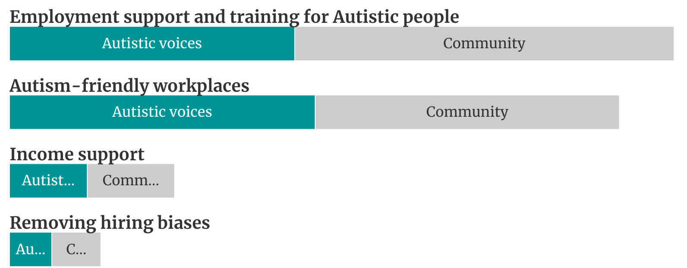
Figure 12. Comparative frequencies of key themes regarding employment and income support
Common themes about employment were:
- Employment support and training for Autistic people
- Autism-friendly workplaces
- Removing hiring biases
- Income supports

Employment support and training for Autistic people
Many participants said there needs to be more specialised employment pathways support and vocational training tailored to Autistic people. This support should also suit the strengths and needs of Autistic individuals.
Common suggestions included:
- funding Autism-specific school-to-work transition programs
- supporting Autism-specific employment services
- subsidising professional Autism job training courses and certificates
- funding for businesses to establish coaching programs for staff members who are neurodiverse
- providing traineeships and apprenticeships designed specifically for Autistic jobseekers.
‘HR departments have a significant role to play. They must facilitate education, support, and understanding among managers and peers, thereby fostering better working relationships. Businesses and HR teams should review every stage of the employment life cycle, from recruitment onwards, to ensure that internal practices and procedures do not discriminate against individuals based on their neurodiversity.’ - Individual submission - Autistic person

Autism-friendly workplaces
Participants said adjustments by employers to create more Autism-friendly work environments should be required and be the norm. People shared many experiences of discrimination in the workplace. Some specified that accommodations should not be dependent on disclosure of Autism.
While they acknowledged some services to support employers are available, participants generally said that adjustments are not often made due to cost or other limitations, and employers are sometimes not aware of discrimination laws and standards for disabilities like Autism and other hidden disabilities. Some suggested more needs to be done to showcase the benefits of making the workplace more inclusive for Autistic people, including how this can benefit all staff.
‘I’ve been told they love me for my analytic skills and attention to detail but it’s unfair that they get the benefit without accepting the struggles. So many organisations wanting the upsides of Autism without the downsides’. - Participant, WWDA online discussion group
People said that workplace inclusion needs to create supportive work environments for Autistic employees. Common suggestions included:
- offering funds and tax incentives to employers implementing Autism-friendly workplace initiatives
- increasing awareness, through training and resources, of large and smaller business on Autism awareness and disability discrimination
- introducing an Autism-friendly accreditation for organisations
- develop guidelines for workplaces on what good practice looks like
- celebrating and recognising employers who are implementing Autism-friendly practice
- better regulation of workplace adjustments in line with the Disability Discrimination Act.
Regulate some workplace adjustments so there becomes a level of compliance. - Online Ideas Wall participant
Support for Autistic businesses and entrepreneurs
Some participants suggested specific supports for Autistic people to start and grow their own businesses. They acknowledged many Autistic people start business due to barriers in workplaces and abilities to establish creative solutions and ideas. These are often microbusinesses, which may be able to access funding supports if government encouraged access to micro-business and entrepreneurship programs. Programs and supports need to be tailored and made inclusive for Autistic people.
Common suggestions included:
- providing specialised grants and funding schemes for Autistic entrepreneurs
- developing targeted mentoring and advisory initiatives for Autistic business founders
- offering tailored advice and training focused on Autistic people succeeding in business.
‘An entrepreneurship mentoring pathway would support those of us who are creative and passionate to earn a living and derive enjoyment and stimulation from our work while also having the scaffolding in place to navigate the unknowns which can send our executive functioning into shut down.’ - Online Ideas Wall participant
‘I really really support the concept of providing resourcing to support Autistic people to start up microenterprises. We have some amazing examples throughout Australia and would have more if there was better accessibility of expertise and support. The benefits are improved mental & physical health and wellbeing, improved social and economic participation and skill-building, entrepreneurship and innovation to benefit the community and Autistic people with purpose and pride.’ - Submission – Autistic person

Removing hiring biases
Addressing biases and barriers that disadvantage Autistic jobseekers was another important theme. In particular the comments focused on the inaccessibility of traditional interview processes. People noted that interviews are often used for hiring because that is what everyone has become used to doing, rather than because it demonstrates suitability for the job. Many Autistic people suggested changing or removing interview processes to be more inclusive. This will help make sure employers have the chance to see the benefits of employing an Autistic person who may not have otherwise successfully made it through a traditional interview process.
People also mentioned issues with wrongful assumptions that all or most Autistic people are inclined toward STEM skills and roles.
Common suggestions included:
- encouraging corporates and employers to change their hiring processes to be more inclusive and appropriate to the skills required for the job
- changing government interview and hiring processes to model inclusivity and responsiveness to actual role requirements
- developing standardised guidelines for Autism-inclusive hiring practices, including encouraging hiring focused on matching strengths to roles rather than arbitrary requirements
- funding programs to help Autistic people succeed in job applications and interviews.

Additional barriers in education and employment when people have co-occurring disabilities or conditions
There were lots of comments about the intersecting challenges of being able to earn and learn when a person has Autism and a co-occurring disability or physical or mental health condition. For example, people said educators and employers often don’t understand how co-occurring conditions might present and dismiss the need for different types of adjustments. This prevents people from being able to maintain employment or continue to access schooling and education and can lead to increased risk of poverty and homelessness.
Some participants suggested more education for teachers, school leaders, employers and policy makers about the additional barriers people with co-occurring conditions face in regard to economic participation. Some also suggested specific income supports, and ensuring the NDIS plans and funding takes better account of co-occurring disabilities and the costs within a person’s life.

Income supports
Some Autistic people said income supports aren’t adequate to ensure that Autistic people can access basic needs. Autistic people can experience higher costs of living due to barriers in accessing the community and services (e.g. having to get groceries delivered), and costs for medications or other needs.
There were calls for the Disability Support Pension (DSP) rate to be raised, as the current rate leaves many below the poverty line and unable to cover basic living costs, especially given the cost of healthcare and other supports an Autistic person may need. There were calls for subsidies, concessions and other financial supports to help cover costs of therapies, medication, transport etc.
In addition, several people said the DSP income and assets tests were too stringent, leaving many Autistic people unable to access it when needed. Participants suggested simplified applications for concession cards like healthcare cards to help with healthcare affordability. Participants said job hunting requirements for unemployment payments were also unrealistic, anxiety-provoking and not accessible for Autistic people.
Income support and relationships
Some participants raised concerns that if they enter into relationships, they will lose their DSP or other Centrelink supports. This potentially forces them to choose between relationships and income security. One discussion group participant explained that ‘when you get married your support and benefits are cut. This makes us worried because we don’t have our own income and it’s a fear for us that we won’t have our support anymore to live. It affects us from wanting to find love and date.’

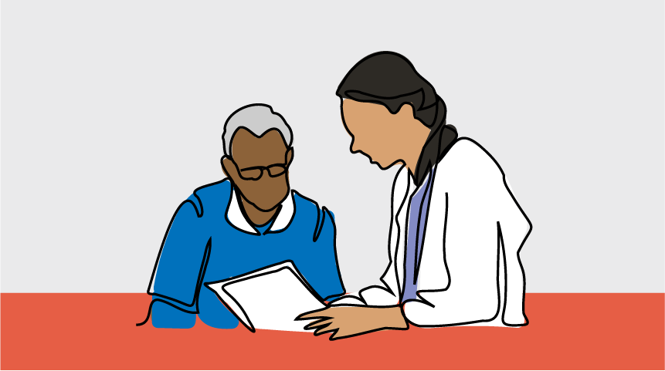

4.3 Diagnosis, services and support
Autistic people shared experiences about being unable to access or afford a diagnosis, and this has significant impacts in their lives, including their ability to get any supports.
A lot of the feedback within this area focused on the NDIS, with people particularly concerned that changes in the NDIS will result in less support for Autistic people. People want the Strategy to find ways of guaranteeing that supports and services will be accessible for Autistic people and children into the future. This includes the need to have increased respite services for caregivers.
The feedback also indicates the National Autism Strategy should focus on improving the current issues with diagnosis, especially for adults and in relation to costs and wait times for assessments and diagnosis of children.
The following chart shows the order of key themes—areas mentioned most often—to improve diagnosis and access to supports and services. Other issues were also raised and are presented in pull out boxes where they were considered to be particularly significant to the experiences of Autistic people including from priority and intersectional groups.
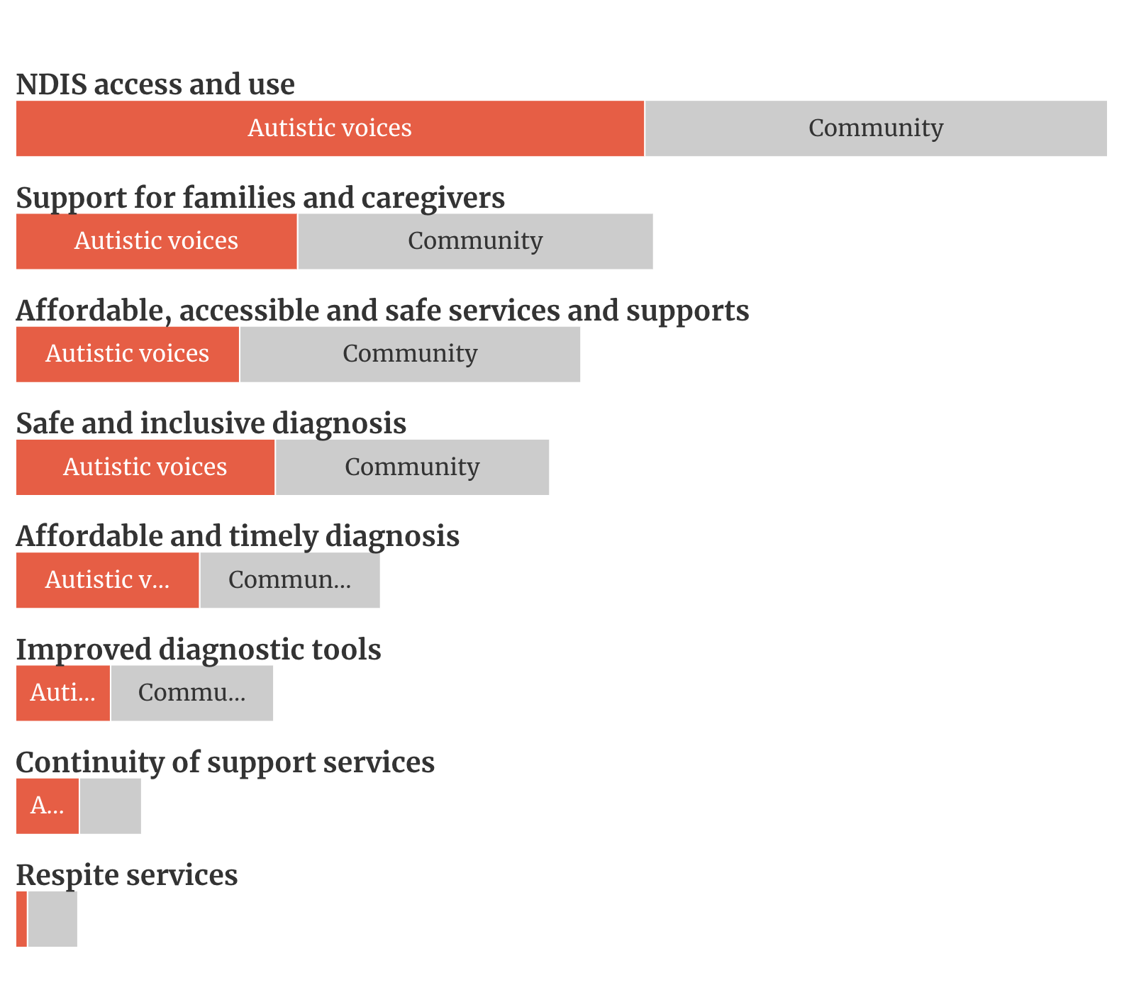
Figure 13. Comparative frequencies of key themes regarding diagnosis, services and support
Feedback on diagnosis, services and supports focused on:
- Affordable and timely diagnosis
- Safe and inclusive diagnosis
- Improved diagnostic tools and processes
- Affordable, accessible and safe services
- Issues with NDIS access and use
- Continuity of support services
- Respite services for caregivers
- Support for Families and Caregivers

Key themes - Diagnosis

Affordable and timely diagnosis
When Autistic adults have access to diagnoses, it can make a big difference across other parts of their life. The importance of accessing diagnoses that are affordable, timely and accessible was frequently raised by participants across all audience groups.
They consistently said that diagnosis is difficult, particularly due to very high costs and long wait lists. Specific suggestions to improve cost and wait periods of diagnosis included:
- expanding Medicare subsidies to cover assessments and related appointments
- implementing assessment quotas to reduce wait times
- training more diagnosticians or expanding the roles that can provide assessments and diagnosis
- easing GP referral requirements
- mobile Autism assessment and diagnosis services to visit regional areas
- continue to ensure diagnosis is supported in the early years.
A diagnosis makes a big difference in people’s lives
‘…being diagnosed was the final piece of a puzzle that allowed me to get employed because I understood what I needed’. - Autistic person, Adelaide Community forum
‘Basically if you are an adult, and don't have the money, then you don't get a diagnosis. Therefore you don't get NDIS, you don't get any supports.’ – Participant, Online Autistic Voices forum
Participants acknowledged these changes will require systemic change in the current diagnosis and health systems. They suggested GPs would play a significant role and government could better support the engagement and training of GPs.
It will require different settings and services to work together—for example:
- education and health professionals to enable a system promoting early Autism identification and diagnosis in children
- health and mental health systems working together to better support Autistic adults who have co-occurring conditions to be assessed and diagnosed with Autism.
Access to diagnosis was a particular concern for those in regional areas. People reported that there is a lack of services and professionals, and they’re often required to travel long distances with their Autistic children or for their own assessments and to access diagnosis. This causes delays with people in regional areas reporting that they wait more than two years to access the diagnosis process, and then more time to go through the process.
Affordability is also a central concern for families. Because of the tendency for high incidence of Autism within the same family, many families report being hit particularly hard by the cost of multiple assessments for different family members. Multiple self-identifying Autistic parents reported that they could not afford their own diagnosis because their children’s diagnoses took priority.

Safe and inclusive diagnosis
Participants said the diagnosis process for Autism needs to be more respectful, non-invasive and devoid of stigma. As well as being a factor in whether diagnosis is an accessible option for all Autistic people, a safe diagnosis experience can significantly impact the wellbeing of Autistic people and their families. Participants suggested diagnostic processes need to be neuro-affirming, trauma-informed, gender-affirming and culturally safe and responsive. Some participants reported that certain aspects of the current diagnosis process, particularly the reliance on input from parents even for adult diagnosis, are often not safe for people with certain cultural backgrounds, identities and/or trauma histories. People also commonly talked about the current pathologising nature of diagnosis and support, which positions Autistic traits as deficit or requiring corrective intervention.
Participants brought up considerations about whether it is safe to get a diagnosis given associated risks such as being targeted in immigration laws and facing biases when trying to access gender-affirming care.

Improved diagnostic tools
Many participants spoke about the need to fix the current diagnostic tools and processes, especially for diagnosing girls in the earlier years. Specific concerns were raised about gender and age biases in current diagnostic tools and processes. Participants also noted that diagnostic criteria and tools focus heavily on the outward presentation of Autistic traits as observed and experienced by others, rather than someone’s internal experience. A number of participants advised that the current diagnostic levels often do not match the reality of daily experiences and may result in inadequate support. The responses highlight the need to address assessment limitations and look for new opportunities for Autism diagnosis.
Suggestions to improve diagnostic tools included:
- fund research into improving diagnostic tools and addressing biases
- establish regular reviews of diagnostic processes by diverse experts
- improve diagnostician skills and knowledge on the differences in presentation
- co-design tools with Autistic people and invest in Autistic led tools and processes.
‘To suggest that the assessment tools don't meet any of the needs of women in my age bracket, is an understatement.’ - Participant, WWDA online discussion group
Autistic led and designed diagnostic tools and apps
In Autistic Voices forums a number of different people spoke about ideas to develop apps and other types of tools that could support the diagnosis of Autistic people. Important to this idea was that any apps and tools should be designed and led by Autistic people, with a variety of needs and presentations, who understand what diagnosticians and professionals (e.g. in health and education) should be looking for.

Key themes – Supports and services

Issues with NDIS access and use
Participants raised fears about what the current NDIS Review process would recommend about access to the NDIS for Autistic people. In particular, participants noted that state and territory government supports for disability had diminished since the introduction of the NDIS and this was having an impact of undiagnosed adults and would further be a significant issue for many children if NDIS access rules changed.
There were multiple issues raised about accessing and navigating the NDIS, and concerns that funds in plans had been reduced, especially for Autistic children.
In relation to navigating and using the NDIS, many Autistic people and parents and carers noted issues with being able to understand information and that the process is very complex. These issues were consistent with other feedback and research done as part of reviews into the NDIS.
Other specific issues for Autistic people and parents and carers:
- NDIS staff and planners are not well-trained to understand Autism.
- Autistic adults find it hard to get on the NDIS even when they have a diagnosis and need supports, due to the amount of assessment and paperwork required and due to perceived biases, that needs for Autistic adults are not as significant as physical or other types of disabilities.
- There are not enough advocates to support people through the system. Many parents and carers shared experiences that they are required to advocate for and manage plans on behalf of their children, often multiple children, and this can be a full time job.
Suggestions to address issues in the NDIS related to supporting Autistic people included:
- providing enhanced training for NDIA staff on Autism needs
- funding independent advocacy services for Autism families and Autistic adults to navigate NDIS and applications
- creating targeted resources explaining the NDIS tailored for Autistic users
- simplifying mechanisms for modifying NDIS plans as needs change.

Affordable, accessible and safe services and supports
Given the importance of ensuring continuity of services and smooth transition support for Autistic people and especially children, there are growing fears among Autistic people and the Autism community about the future of services and supports. Participants consistently said that specialist supports and services are expensive and not accessible in all areas. This was a particular issue for people in regional areas.
Many people also emphasised that Autism-related services and supports need to be available and accessible for Autistic adults, not only children.
People reiterated the importance of tailored, individualised supports with a shift away from ‘one-size-fits-all’ supports.

Suggestions to improve access to more tailored and affordable services included:
- improve service affordability through NDIS, Medicare and other subsidies to improve affordability and access for people especially on lower incomes
- address geographic inequities in access through outreach hubs and remote options
- simplify access through consolidated information portals and streamlined entry points
- needs assessments to comprehensively address individual circumstances
- funding should support needs, not just cover a pre-set list of services.
Accessible mainstream business and services
Participants spoke about the importance of having awareness programs extend to mainstream businesses and services, such as real estate, banking, telecommunication providers, and other sectors that Autistic people rely on using for their day-to-day living and financial independence. Some comments suggested that while the corporate sector are being engaged to employ more people with disability there’s still low awareness among their frontline employees to understand Autistic people’s needs or support Autistic people when they are using and interacting with their services.

Continuity of support services
Participants said there needs to be smoother transitions between different support systems. This was particularly important for parents and carers of Autistic people with high and complex support needs as changes to support workers, services and supports often causes significant disruption.
Participants also noted that finding and accessing new services, especially where this involves explaining their background and needs to each provider, requires a great deal of energy, which makes having to access new and discrete services and providers undesirable. It was mentioned that improved cross-sector service continuity is required.
Participants also spoke about the importance of having services work together.
‘Services are very fragmented. It would be good if the Strategy could have better integration of services, and more collaborative services for the child’.- Participant, Kindred online discussion group
‘Everything is compartmentalised and services aren’t working together. Formula of government isn’t supporting systems to talk to each other and therefore they’re not supporting us.’ - Participant, Perth Autistic Voices forum
Suggestions to achieve this included:
- establish consistent case coordination across different systems
- appoint transition coordinators to manage cross-sector change
- provide better transition information and preparatory support.

Respite services
The National Autism Strategy needs to support families and carers of Autistic people. One of the key things participants suggested was making sure there is appropriate and sufficient respite care available. Participants noted this improves the overall wellbeing of the whole family and the health and mental health of caregivers.
The feedback suggests the need for:
- more in-home and out-of-home respite options under the NDIS
- developing additional subsidies for non-NDIS carers, particularly for parents and carers where they have multiple Autistic children with varying needs in their care
- a dedicated national respite support helpline for caregivers or improve information on this in existing helplines such as Carer Gateway and Autism Connect.

Other support for families and caregivers
Family support focuses on providing resources, education and assistance to the families and caregivers of Autistic people. Participants said it was important that government and services recognise the vital role families and carers play in the lives of Autistic people especially where they are their primary carers and they have complex or high support needs.
Many participants suggested there’s a need to have accessible, comprehensive support systems that look at the whole family unit and how they can be supported, rather than only the individual. This also specifically applied to the way NDIS plans are done.
Participants suggested there could be more emphasis on supporting families and carers through:
- offering tailored and free or heavily subsidised counselling and emotional supports
- educational programs that help families understand Autism better and how to effectively support their Autistic family members

Applied Behaviour Analysis (ABA)
Participants commented on ABA with the majority of those who made comments raising concerns with it. They commented that it aims to make Autistic people appear “normal” and forces masking and compliance.
Multiple people raised concerns that families from CALD backgrounds are guided into ABA because of the stigma of having Autism, but often don’t have the language or other understandings of the practice to fully know what it involves.
Based on these views, numerous comments suggested ending the use of ABA as a support or service and particularly in care settings and schools. A few suggested that the correct use of ABA can have benefits for inclusion, and it should be regulated but not banned.

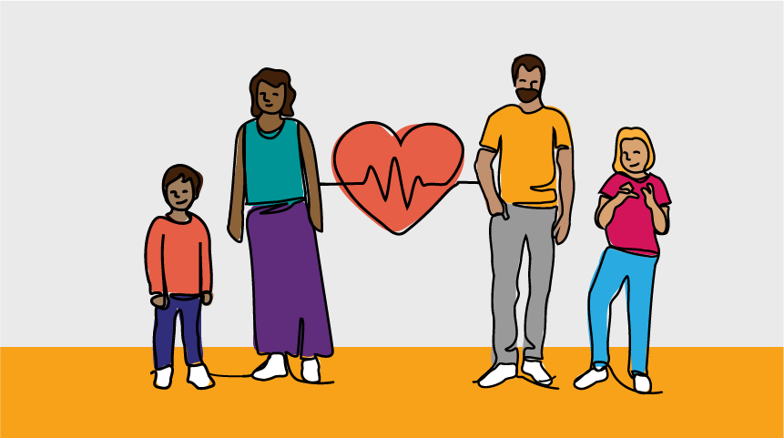

4.4 Health and mental health
As part of the National Autism Strategy, a separate National Roadmap to Improve the Health and Mental Health of Autistic People is being developed. This is led by Department of Health and Aged Care. A separate co-design and consultation process is underway to develop the roadmap.
However, during the National Autism Strategy consultations the community were given time to provide their thoughts and ideas about what is needed to improve health and mental health outcomes for Autistic people.

Key themes
The following chart shows the order of key themes—areas mentioned most often—to improve health and mental health outcomes for Autistic people. Other issues were also raised and are presented in pull out boxes where they were considered to be particularly significant to the experiences of Autistic people including from priority and intersectional groups.
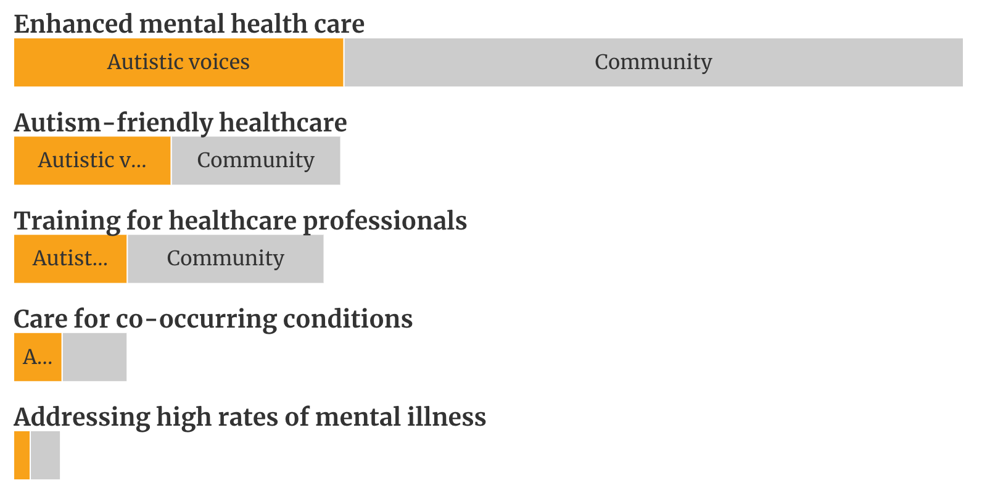
Figure 14 Comparative frequencies of key themes regarding health and mental health
Common themes raised were:
- Enhanced mental health care
- Addressing high rates of mental illness
- Autism-friendly healthcare
- Training for healthcare professionals
- Care for co-occurring conditions

Enhanced mental health care
More mental health services and supports are needed, particularly given the high and growing demand for services, and increasing wait times to get help. But many participants said that these mental health services and supports also need to be appropriate and tailored to safely support Autistic people in a neuro-affirming way, especially where people have other intersectional considerations to take into account. There is also a need to have more coordination between health and mental health services.
‘We are being moved between the acute and community health and mental health systems – one person says you’re too acute, the other says you’re not in crisis enough.’ - Autistic person, Cairns Autistic Voices forum
Participants commonly suggested:
- Funding more Autism-specialised psychiatric and psychology services. This included comments that more should be done to support Autistic people to become counsellors, psychologists and psychiatrists.
- The need for more preventative mental health care and different types of crisis care in place to avoid hospitalisation for Autistic people, including in-home crisis care. This suggestion was linked to issues raised about traumatic experiences and practices in hospitals which cause Autistic people to feel overwhelmed and sometimes unsafe.
- Expanding Medicare subsidies for mental health, particularly to increase the number of free mental health visits under a mental health plan (currently 10). Many participants said the system must acknowledge that many Autistic people need to access long term and regular mental health supports and the cost burden of this is a barrier to accessing care and is impacting many parts of their life.

Addressing high rates of mental illness
Participants highlighted the need to better understand and address the impacts of high rates of mental illness in the Autistic community. It was common for people who are Autistic with co-occurring mental health conditions to report that they didn’t receive correct or timely mental healthcare because medical professionals weren’t able to identify the illness or condition.
‘I was not diagnosed when I first sought it 15 years ago because according to the psych, I did not meet the criteria under DSM4. I have had 20 years of counselling with psychiatrists and psychologists and in patient stays in psych hospitals, suicide attempts and was only diagnosed with depression/anxiety.’- Participant, WWDA online discussion group
Late-diagnosed Autistic people especially noted that their mental health was negatively impacted by the time they spent without appropriate care or support or self-knowledge, including to the point of causing significant trauma.
Participants commonly suggested:
- increasing research into the rates and impacts of mental illness, as well as into effective treatment and management of co-occurring conditions
- improving screening and early intervention for mental health issues among Autistic people, including as they enter adolescence
- developing tailored mental healthcare approaches and specific training for mental health professionals that consider Autistic needs.

Autism-friendly healthcare
Participants said it was very important to improve healthcare environments for Autistic people, especially to make them more accessible with adjustments like quiet rooms, communication tools and reduced stimuli. Many participants reported that there’s no consistency for how healthcare settings, including hospitals and community health, were designed or would be able to respond to different people’s needs. Hospitals were considered to be unsafe and traumatic environments for people, and many participants said more could be done to make these settings more sensory-friendly, safer and responsive to different needs.
Participants reported that communicating in healthcare settings can be very difficult for some people, particularly those who have complex communication needs. Many had to rely on others to support them in these environments. Some participants suggested there’s a need for every hospital’s Emergency Department to have an ‘Autism nurse’ available to support people as they present to hospital.
Young Autistic people spoke about how important it is to have family and carers able to support them when accessing healthcare. They said this is critical to support communication and make sure the care and treatment they’re given is right.
‘When I’m at the hospital, I like it when my family is there to help, and when there is quiet spaces there’. - Young Autistic student, Giant Step School, Tasmania
A particular issue noted for Autistic children in healthcare settings was the significant psychological fear and physical pain responses to routine treatments or health interventions, such as vaccinations. Participants said there is limited guidance or awareness for nurses in GP clinics and other places to help manage these interactions. As a result, Autistic children often miss out on vaccinations which may cause serious and longer-term health problems.
Participants suggested:
- creating national standards or guidelines for more Autism-friendly healthcare facilities
- implementing dedicated quiet rooms in hospitals and clinics
- funding communication tools to support access to health services and medical needs
- dedicated staff in hospital and large healthcare settings to support Autistic people.
Better crisis care
Some participants spoke about issues with the crisis and acute health systems. Similar to feedback about other healthcare, they highlighted that psychiatric doctors, nurses and other professionals in the acute health system aren’t well-trained. They said that having specialist Autism liaison staff and better training in acute health settings would help to reduce suicide, as it’s people’s first contact with the acute health system that leads people from crisis to being isolated from the system.

Training for healthcare professionals
A very strong theme was the need for healthcare professionals, across a wide range of health professions, to have a better understanding of Autism. The lack of understanding of Autism within the healthcare sector, including how to engage and communicate with Autistic people, was reported as a significant barrier for Autistic people to access healthcare when they needed it and to prevent health problems.
‘I would love to see a national mandatory education program led by Autistic people and Autism-informed clinicians that educates GPs, psychiatrists, psychologists, NDIA staff, OTs, allied health and hospitals on issues such as new findings in Autism research, how Autism may present in girls and woman, masking, and the mental health impacts of masking, and potential neuro-affirming alternatives.’ - Individual submission – Autistic person
A particular area of training participants suggested was in pain management. Some reported that health care professionals have difficulties identifying and managing pain with Autistic patients, especially non-verbal people. Concerns were raised about healthcare professionals not believing Autistic people about their pain levels, due to not expressing the pain in neurotypical ways. Participants said this has resulted in major delays in responding to medical emergencies.
Participants suggested:
- mandatory Autism training for all medical, nursing and allied health qualifications, including in acute health care settings
- subsidising continued professional development on Autism best practice care
- appoint Autism care coordinators at major health facilities
- improving pain screening and management protocols, and more research into pain management, taking into account Autistic differences including for non-verbal Autistic patients
- more guidance for supporting Autistic children and adults during routine and specific healthcare, including for vaccinations.

Care for co-occurring conditions
Consultation participants often noted that co-occurring conditions (such as ADHD, OCD, epilepsy, eating disorders, mental health issues, chronic illness) can be common in Autistic people and that there was a need for greater recognition and support around assessing and managing co-occurring conditions.
Suggestions included:
- a more holistic, whole person approach taken when supporting Autistic people, considering both their Autism and any co-occurring conditions, including within NDIS and other disability supports
- diagnostic processes to better acknowledge and screen for co-occurring conditions, not just focus narrowly on an Autism assessment
- health professionals, including GPs, to have better education and training around Autism and commonly co-occurring conditions
- more research into Autism comorbidities to better understand correlations, develop appropriate treatments, and improve outcomes.

Considerations from Autistic health professionals and researchers
An online forum was held with Autistic health professionals and researchers to discuss the role of lived experience in delivering appropriate health and mental healthcare for Autistic people. It focused on the changes needed to better support Autistic health professionals and Autistic Autism researchers, knowing that this impacts Autistic people in the community and their opportunities to access supports and services they choose, and the scientific evidence that informs this.
Participants at the forum talked about the importance of Autistic led health services. But they said this is only possible if there is more targeted funding and investment to support Autistic people into health professional roles and research positions. They suggested:
- Autistic-identified positions and opportunities should be in place
- changes in workplaces (and society) to be able to safely disclose Autism without professional repercussions
- support to sustainably implement appropriate accommodations to avoid burnout, including managing workload given the high demand for clinicians with lived experience.
They also suggested there needs to be better awareness within the health sector and the broader community of the value of Autistic health professionals and especially how this can support neuro-affirming and trauma-informed care. They also noted, however, that it is not feasible for healthcare to always be delivered to Autistic people by Autistic professionals, so improvements in health and mental health outcomes need to include a focus on having non-Autistic health professionals be ‘allies’ in providing appropriate, neuro-affirming care and working complementarily with Autistic colleagues.
‘We actually can’t carry this load alone – we will break!’ - Autistic health professional
Participants noted that health professionals and researchers with lived experience can play a critical role in developing and delivering much-needed professional education and guidance around Autistic-appropriate practices. But this shouldn’t be an additional burden on Autistic professionals. They specifically suggested:
- more support is needed for Autistic clinicians working with Autistic clients to share best practice learnings and contribute to an evidence base
- investment in improving pathways for Autistic people into roles and mentorship programs.
Other suggestions included:
- funding for tailored healthcare spaces and services, such as specific ‘Autistic-friendly’ units in hospitals
- extensive use of multidisciplinary teams so that Autistic people can access timely, effective support across co-occurring conditions and needs.
‘A lot of the inequity that gets created for disabled people as a whole, and Autistics, is the amount of time that it takes for their conditions to be understood. That is both across mental health and physical health domains, which is contributing to the lifespan of Autistics’. - Autistic health professional

Involving Autistic people and the community in the National Autism Strategy
‘The development, implementation, evaluation and ongoing review of the Strategy must be undertaken in co-design with Autistic people, their families and representative organisations. The views, voices and aspirations of Autistic people should be at the centre of all government decisions, policy, projects and services that impact them.’ - Amaze submission
There should be continued involvement of Autistic people and the wider community in implementing the Strategy and designing initiatives and actions to improve life outcomes for Autistic people. To do this, participants suggested the focus be on:
Ongoing Autistic and community involvement: The lived experiences and perspectives of Autistic people are what the Strategy should represent. Participants consistently said Autistic people should continue to be involved to directly inform all aspects of the Strategy. A specific engagement plan could be included within the Strategy to embed the active, continual involvement of the Autistic and Autism community. Other specific suggestions for ongoing involvement included:
- frequent consultations, including through focus groups, surveys and other methods
- compensating Autistic people for their contributions
- funding Autistic led organisations to empower community voice and advocacy and to input to the Strategy’s implementation
- community involvement via inclusive community activities, events and programs that are welcoming to Autistic people.
Co-design with and led by Autistic people: Autistic people, and in some cases parents and carers, should lead and be the primary participants in co-designing policies, programs and services that affect them. Participants reiterated that Autistic voices should shape decision-making, not just provide input. Autistic co-designers should always be compensated for their expertise. Enshrining co-design and co-production within standard implementation processes will be important and require educating public servants about appropriate co-design methods to work with Autistic people and the Autism community.
Consultation at all stages: Consulting the community at all stages of Strategy implementation is critical. People said there should be mechanisms to allow Autistic people to collaboratively shape the Strategy over time, rather than seeking feedback on predetermined plans. People also mentioned that government should be required to update the community at each stage of involvement and demonstrate how their input was incorporated to have transparent and trusted engagement.
Mechanisms for continual feedback: Participants said there should be mechanisms for continual feedback to be provided about the Strategy. The purpose of this was to ensure the Strategy has the flexibility to adapt to changes as community expectations and needs change over time. It would involve establishing feedback channels that are always live and embedding key points in time to make iterative improvement into the program design.
Autistic people in leadership roles: In addition to involvement through engagement process, many people raised the importance of having Autistic people in lead roles to implement the Strategy. This extended beyond committee structures, to employing Autistic people within the Government sectors—social services, health, education—to lead policy design and implementation of the Strategy.
Research led by Autistic people: People suggested ongoing research is important and that this needs to be led or co-led by Autistic people, and with the involvement of families and carers.

Implementation and monitoring the National Autism Strategy
Based on feedback from the Stage 2 consultations, it is recommended the following is considered when implementing and monitoring the Strategy.
Make implementation of the Strategy person-centred and actively involve people with lived experience: A large number of participants said implementation needs to have the active involvement of Autistic people, as well as parents, carers and professionals within the Autism sector. This includes having Autistic representation on advisory groups overseeing implementation of the Strategy.
Communicate the Strategy's actions and outputs, and all associated information, in clear and accessible ways for all Autistic people: Accessible communication and information should be available for all Autistic people, including harder to reach cohorts and people with diverse communication needs. There should be regular updates on the implementation and evaluation of the Strategy, using accessible and easy to understand communication.
Have whole-of-government, cross-sectoral and coordinated approaches to implementation: This included ensuring there is active and cooperative involvement of sectors including health, education, employment, justice and housing. While the Strategy would be Commonwealth-led, many participants noted there needs to be buy-in from states and territories as they deliver majority of the mainstream services, and to have consistency in implementation across the country. It will be useful to have clearly defined roles and responsibilities across sectors and governments.
Make sure the Strategy aligns to other government strategies and work underway: Organisations who made submissions particularly highlighted the importance of aligning the Strategy to other highly relevant key government policies and all legislation impacting on the lives of Autistic people. Specific ones mentioned included Australia’s Disability Strategy, the National Plan to End Violence against Women and Children and Closing the Gap, and ensuring the Disability Discrimination Act and other Human Rights legislations apply.
Participants also acknowledged that the government’s response to the NDIS Review and the Disability Royal Commission are likely to have a significant impact, and potential benefits, for implementation of the National Autism Strategy.
Ongoing research that is targeted to the specific issues raised throughout consultations: Using the breadth of data and feedback gathered through the consultations, identify key areas where more research is needed to better design actions and programs that will be part of the Strategy. This should be ongoing to ensure the Strategy can respond to changes and have Autistic people and the Autism community leading research where possible.
Commit to adequate resourcing and funding for successful implementation of the Strategy: People were concerned the government would have a Strategy that ‘sits on the shelf’ and wanted to make sure there was adequate funding provided to implement the Strategy. People acknowledged not everything could be done at once but the Government should listen to people, including the results of the consultation, to focus on areas that are the highest priority. Participants noted that funding include ensuring organisations and service providers have the resources needed to effectively implement the various measures or actions outlined in the Strategy across settings, particularly in education, health, justice and housing.
There should be clear accountability and strong governance in implementing and monitoring the Strategy: People want to see measures in place to hold government and the sector to account to make the changes needed and so the Strategy is implemented fully and effectively. Establishing governance structures such as an independent Autistic led taskforce was suggested, along with developing clear penalties or consequences for agencies, organisations, schools and workplaces who fail to implement Strategy actions.
‘If the government made the suggested changes my life would improve and I would be happier. The strategies are not rocket science’. - Non-speaking Autistic young person (14) who uses alternative communication
There should be regular monitoring, evaluation and reporting of Strategy outcomes: There should be robust mechanisms (such as an outcomes framework) to track the progress of implementation of strategy actions, as well as setting clear milestones for reporting, with updates on implementation to be provided to the Autistic and Autism community. It was suggested that strategy evaluation and reporting processes should be led by and include Autistic people as well as government agencies. There should also be options available to rework and redirect Strategy actions where needed based on ongoing feedback and evaluation.

Appendix A: Specific focus areas for target audiences and intersectional groups
Targeted engagements, such as discussions groups and one-on-one interviews, were held with people from priority population and intersectional groups. These sessions allowed people to contribute to the Strategy in smaller group discussions with other people from the same intersectional or priority group to discuss specific barriers and needs relevant to the group.
Twenty-three (23) targeted engagements were delivered with targeted populations including:
- First Nations Autistic people
- Autistic people from culturally and linguistically diverse (CALD)backgrounds
- Young Autistic people (30 and under)
- Older Autistic people
- Autistic women and girls
- Autistic people from the LGBTQIA+ community
- Autistic people who use augmentative and alternative communication or are non-verbal
- Autistic people with high and complex needs, including with intellectual disability and Autistic people living in segregated accommodation, group homes and institutions
*It’s important to recognise the intersectionality across these audience groups. Autistic individuals will be in multiple categories.
In addition, 6 targeted sessions were held with parents, family members and carers of Autistic people with high and complex needs.
The following summaries by audience group are based on the insights from the targeted engagements.
It should be noted that the following population groups were also well represented in the main engagement activities, such as open community events and Autistic Voices forums, so many of the experiences and ideas of these groups featured heavily throughout the main parts of this report.
- Autistic people from the LGBTQIA+ community
- Autistic women and girls
- Young Autistic people (30 and under)
- Older Autistic people
- Parents, family members and carers

First Nations Autistic people

A First Nations perspective
The reflection of discussions with First Nations people are illustrated by First Nations artist and Autistic member of the National Autism Oversight Council, Renay Barker-Mulholland.
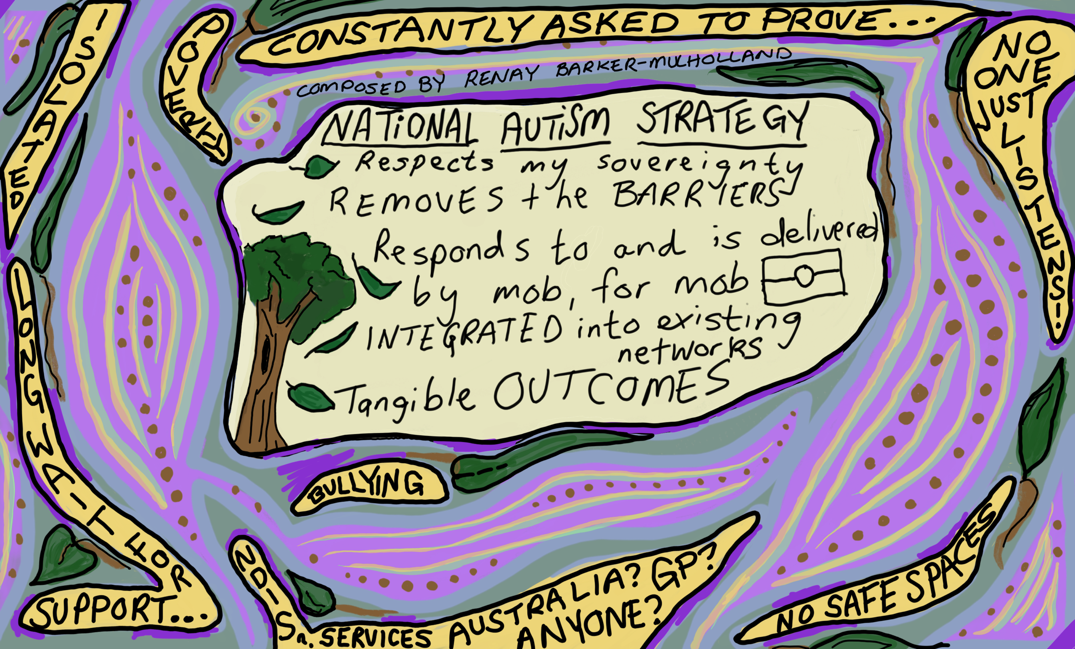
Figure 15 illustration of themes by First Nations artist and Autistic member of the National Autism Oversight Council, Renay Barker-Mulholland
More than 25 First Nations community members joined one-on-one discussions and provided comments in writing.
Renay Barker-Mulholland, First Nations Autistic representative on the National Autism Strategy Oversight Council, engaged in several discussions and consultations with First Nations Autistic, and/or neurodivergent people. Most respondents identified as Aboriginal, female, Autistic, average ages of 18-30 and in a caregiver role, whether formally or informally. The following areas were the focus of these discussions.
First Nations Autistic and neurodivergent individuals spoke about the intersectional discriminations and specific barriers that exist for many First Nations Autistic people in being diagnosed and accessing supports. Overwhelming the responses from these participants were about being under-resourced, and feelings of isolation.
Barriers in Diagnosis and Support: All respondents reported long waiting periods for diagnosis, most said the process was not at all accessible or safe. There were no reports of accessible supports available and a decline in seeking official recognition/diagnosis. Most often financial restraints were named as a reason for lack of diagnosis. Secondly, a lack of cultural awareness from organisations and health care providers was named as a barrier to diagnosis and supports.
This led to many respondents feeling invalidated and highlights why there is lack of recognition of the First Nations Autistic/neurodivergent communities as well as absent or severely delayed support.
Need for Emotional Support: Participants expressed a need for emotional support, from and for their community. This need was especially in evident when we discussed navigating the challenges faced being an Autistic/neurodivergent person and the lack of culturally appropriate, mob driven solutions to this deficit.
Challenges in Education and Work Environments: Incompatibility with the mainstream schooling and work structures mean that engagement within the First Nations community is low. This incompatibility is based on the colonial mindset and demands made by the existing societal structures. Engagement will only improve when the education and workplaces are developed and maintained to highlight the strengths and skills of the Autistic First Nations community.
Broken Support Systems: Family, particularly parents, were named a primary source of support for the people responding but most respondents were parents, who reported having little to no support. Given the significant and ongoing impact of colonisation on First Nations people, it is evident that the lack of community and extended family supports that are so often relied on by Autistic and neurodivergent people is not available to them. This has impacted on the capacity of many Autistic people, and their ability to make choices or access supports available to them and live lives of their choosing.
Social Impacts of Autism: Social anxiety, difficulties in connecting and communicating, and experiencing exclusion and bullying were significant challenges. Respondents all expressed a desire for better listening, understanding without assumptions, and more accessible information about available resources and support.
Other areas that First Nations people and organisations raised during consultations:
Better access to supports in regional and remote areas: A specific First Nations Autism workforce needs to be developed to improve options for culturally appropriate support. One suggestion was for this to be supported by a mobile team of Autism specialists who can come out and train local people in communities to support and provide services for Autistic people.
First Nations-led care focused on the whole person and family environment: This included funding First Nations organisations and community-based services to develop options for improved cultural support. First Nations families and carers said there also needs to be improved support and respite options as these are very limited (and often unsafe) for respite in First Nations communities.
Healthcare and support needs to consider the different needs and intersectional considerations of the whole person and their family and community environments. Stigma and the prevalence of a shame culture can prevent First Nations people from seeking and accessing help or services, especially where they’re not supported to do so by family and community.
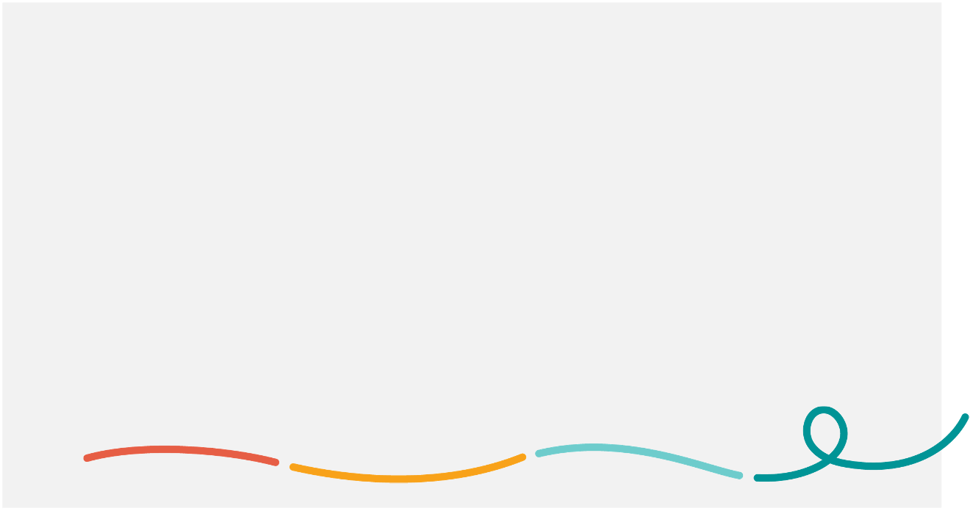
It was noted that First Nations Autistic people need specific support when transitioning to adulthood to ensure they retain cultural and community connection. It was suggested that young First Nations Autistic people are at high risk as they can become segregated at school and from their community.
Feelings of isolation and stigma were common among some First Nations Autistic people.
‘People in our community haven’t accepted Autism and don’t understand it’ - First Nations interviewee
‘We don’t want to talk to people about our vulnerabilities, because that comes with massive risk’ - First Nations interviewee
Based on this input, suggestions for the National Autism Strategy to focus on include:
Reducing diagnosis wait times: Implement streamlined processes to reduce waiting periods for diagnosis and ensure accessibility to diagnostic services for all First Nations people.
Diverse and tailored support programs: Develop and fund programs that offer diverse forms of support, including emotional assistance, educational accommodations, and employment support, addressing the individualised needs of Autistic/neurodivergent individuals.
Education and workplace accessibility: Create initiatives that encourage flexible learning and working environments, accommodating multiple learning styles and providing clear, accessible and culturally relevant information.
Community-based support networks: Establish community-driven support networks that integrate with existing structures, focusing on empowering and supporting First Nations individuals within their cultural contexts.
Cultural sensitivity and awareness: Training programs for service providers and educators to foster understanding and address the specific needs of First Nations Autistic and neurodivergent individuals.
Accessible information sharing: Develop easily accessible and culturally sensitive information resources that outline available support services and resources for individuals and their families.
Other specific suggestions included:
- improving awareness, understanding and acceptance of Autism, as Autism isn’t a term that’s well understood in First Nations communities
- prominent First Nations leadership in the Autistic community, and for this to be supported by government and the sector
- a specific First Nations Autism advisory group to help shape and implement the Strategy and to make sure that it directly links with Closing the Gap and its measures to improve life outcomes and acknowledges the intersectionality of First Nations people who are Autistic
- a dedicated support line for First Nations people with Autism or improved supports within existing helplines like 13 YARN
- improved early diagnosis and diagnosis that is accessible to the community. This will require more outreach services such as the idea for a mobile diagnostic and assessment multidisciplinary team which can travel to First Nations organisations and communities to improve access to diagnosis of adults and children.

Autistic people from culturally and linguistically diverse (CALD) backgrounds
Working with National Ethnic Disability Alliance, we held a targeted focus group discussion with Autistic people from different CALD communities.
During this discussions, Autistic people from CALD backgrounds emphasised the following themes:
Improving representation: There is not enough representation of Autistic people with diverse cultural identities, particularly Autistic people of colour, both within Autism policy spaces and in mainstream Australian culture. They suggested there needs to be more involvement and visibility in content creation and media. They observed that government and decision-making doesn’t seem to recognise intersectionality and diversity of Autistic and CALD populations, meaning the voices heard are not representative of the whole community.
Masking and discrimination: There is a compounded effort involved in trying to ‘fit in’ when you are Autistic and from a CALD community. Participants reported that Autistic people of colour can experience more pressure not to ‘slip up’, and discrimination means culture is sometimes ‘masked’ to be able to access opportunities. They noted that certain risks can be compounded, such as being targeted by police because of ethnic appearance and Autistic behaviours.
‘The strategy should focus on addressing how Autism in BIPOC communities results in higher interactions with police and criminal justice systems and often results in more violent and unmanageable labels being associated with BIPOC folks.’ - Autistic person, CALD discussion
Issues with diagnosis: There are obstacles to Autism diagnosis related to cultural diversity, such as:
- poor understanding leading to confusion between Autistic presentation and cultural norms (such as eye contact)
- reliance on input from parents in the diagnostic process (including where people are not comfortable discussing the subject with their parents)
- the impact of diagnosis on migration status and fear of deportation.
‘The Immigration Health Tests deport migrants with disability, parents can delay or avoid diagnosing their children for fear of being deported to countries where their kids will not get appropriate services and will be virtually locked up in the house along with their mothers. If these children don't get diagnosed until parents gain PR, these kids are being disadvantaged’ - Autistic person, CALD discussion
Low awareness and prejudice: There is low awareness and prejudice about Autism in some cultures and migrant communities, so Autistic people in those communities need safe spaces to disclose. Participants suggested awareness-building about Autism is needed in CALD communities, but this needs to come from within the community and have culturally specific and culturally sensitive messaging. They also suggested that professionals such as support workers need better training in how to engage with migrant families who have low awareness of Autism.
Accessible information and services: An important part of the implementing the National Autism Strategy is ensuring the accessibility of processes, information and services. For Autistic people from CALD backgrounds this included having translators available to access services and information, and including for people making complaints when services do the wrong thing.

Autistic young people
Six targeted events were held with young people:
- 2 sessions facilitated by Children and Young People with Disability (CYDA) with young people from 14-21 and 21-30
- online discussion forum with Autistic students from University of Tasmania
- a visit to Giant Steps School in Deloraine, Tasmania where we engaged with 10 Autistic students, many with high and complex needs, supported by Autism Tasmania
- two face-to-face engagement sessions conducted by Autism Queensland with Autistic students across two school campuses in Queensland.
The common issues that Autistic young people raised were consistent with the main themes of this report, however, during targeted discussions, they also raised:
Barriers to raising issues about education experiences and needs: There are power imbalances between young people and educators, as well as school and university administration, that can prevent Autistic students from speaking up about issues. Young people noted that experiences from early on in classrooms where teachers are dismissive of the needs of Autistic students can mean that Autistic children and young people don’t feel like they can speak their needs in future. Participants recommended that educators in all settings need to receive meaningful, evidence-based training in Autism and neuro-affirming practice.
‘If you can’t feel like you can speak about your needs as a university student, how can you speak about your needs as a worker?’ - Autistic young person, UTAS discussion
Bullying and isolation in education and other settings: Many Autistic young people reported being bullied and treated as different. Some participants said they find it hard to make friends and feel like an ‘outcast’. They commonly linked this to other children, and teachers, not understanding Autism. They suggested that the way teachers respond to and treat Autistic children at school, such as by treating behaviours as a problem, can establish a culture for other children of not being accepting of other ways of being.
Support for individual aspirations and needs: Young people spoke about the importance of being able to have their own aspirations and that supports would help with them achieving this. Young people on the NDIS often said this doesn’t work as well as it should now, and other Autistic young people commonly reported that schooling and other programs can be condescending and aren’t tailored to individual’s capabilities and needs. Some suggested there should be more focus on supporting young Autistic people to explore areas of interest or passions and pursue their goals, including in school subjects, extracurricular activities, sport and arts, and when transitioning to employment.
Ideas to improve experiences and lives of Autistic young people: Other specific comments and suggestions to improve experiences and outcomes for young Autistic people included:
- peer mentoring programs, such as between Autistic young people and children, to provide community connection and role models and so Autistic children and young people feel less isolated
- young Autistic people involved in policy design in education settings, both with government education departments and at universities
- more support for learning to drive and driving instructors trained to support Autistic learners
- youth mental health services to be more neuro-affirming
- all employment mentorship programs for young Autistic people to have links to actual job opportunities, as they have limited effectiveness when they do not.

Older Autistic people
Two targeted online events were held with Mature and Older Autistic people.
A lot of the feedback was consistent with the themes presented throughout this report, however, the online discussions with older Autistic people also emphasised the following areas:
Diverse representation: There should be more representation of older Autistic people within leadership, Autism organisations, media and other areas. While underdiagnosed or misdiagnosed, participants mentioned that Autism is as prevalent in the older population as it is in children and younger people. Participants advocated for older Autistic people to have an ongoing and active voice in the Strategy and Autism policy in Australia.
Participants also discussed the understanding of Autism among older people in their social and community networks. They reported that awareness is low, and that action is needed to address perceptions in these communities based on stigma and stereotypes.
More support for adults (with less exclusive focus on children): Many older people mentioned that the focus of supports seems to be on supporting parents and carers and Autistic children. However, Autistic older people are often isolated and require more supports, including support that is tailored to the needs of older people who aren’t as mobile or don’t use technologies. Some said there needs to be more acknowledgement that older Autistic people are dealing with the long term impacts of trauma from when they were younger and so specific supports that are trauma-informed are needed.
Participants also advised that tailored Aged Care supports and services are required. Specifically, they reported that My Aged Care needs to be more accessible for Autistic people to navigate and suggested that the Aged Care workforce needs training around understanding Autism.
Adopting strengths-based over deficit-based models: Consistent with feedback in the community sessions, older people wanted to see a Strategy that is strengths-based and neuro-affirming.
Addressing late diagnosis: Barriers to diagnosis as an adult and the issues that can present in late diagnosis need to be specifically considered for people who are over 50. Given issues with diagnosis and misdiagnosis of women and girls, some older Autistic people also raised specific concerns about the need for more support for Autistic women and girls to be diagnosed. They suggested this is to avoid having a population of older women who were not supported throughout their life.
‘A lot of us older people weren’t diagnosed as children. So, we were always led to believe that we were weird, or we were defective in some way. ‘- Autistic older person
Intersecting issues: Participants identified numerous intersecting issues for older Autistic people, for example, there are increased employment barriers for all people aged over 50 years and this is further enhanced when a person is older and Autistic. Some older people have cognitive impairments or lower literacy and when combined with Autism they can have significant difficulties understanding and processing information. Some said more needs to be done to tailor information to older Autistic people.

Autistic women and girls
Two targeted events were held with Autistic women and girls, feminine-identifying and gender-diverse (including non-binary) people:
- an online discussion group facilitated by Yellow Ladybugs
- an online discussion group facilitated by Women With Disabilities Australia (WWDA).

During these discussions, Autistic women and girls emphasised the following themes:
Understanding Autism in women and girls: Professionals, especially in health and mental health, need to better recognise and accept the ways Autism presents in women and girls. Supports from professionals needs to be more proactive, as girls tend to be more likely to mask than seek help.
‘Teachers need to be better educated on Autistic girls and their presentation. Just because they are following the rules and not making a fuss does not mean they are not struggling and need support/ modified environments.’ - Autistic person, Yellow Lady Bugs discussion
Masking and representation: More should be done to address the social pressures that lead girls and women to mask, including in workplace settings. Participants noted that community campaigns and media around Autism carry the bias of stereotypical male presentation and contribute to barriers for women to access employment, in particular. Some suggested there should be specific strategies to educate society—schools, workplaces etc.—on the ways Autism presents in women and girls and it will be important to make sure initiatives under the Strategy represent and include women and girls.
Issues and impacts of late diagnosis: The expense of diagnosis as adults unduly affects women because they are less likely to have accessed diagnosis as a child. Participants said a diagnosis is difficult to get as an adult. They highlighted that the cost associated with the diagnostic process is a greater risk for women and girls because the bias against women in the diagnostic criteria makes it more likely that spending money won’t result in a diagnosis. Several participants said growing up while heavily masking has meant that they are still figuring out their support needs later in life.
Social, economic and healthcare inequities: Gender biases and women’s health issues are often more prevalent in, and have a greater impact on, Autistic women, feminine-identifying and gender-diverse people. This includes higher risks of domestic and family violence and sexual violence, and greater housing insecurity. Because women are more likely to be the primary parental caregiver in families and Autistic women are more likely to have Autistic children, issues intensify for Autistic mothers as they enter parenthood. Participants recommended more research on these issues and into the intersections between Autism and gender.
‘Autistic women in particular have an unequal burden of unpaid work and face sexism at work which makes it harder to achieve professionally.’ - Autistic person, WWDA discussion
Menstruation and periods: There needs to be more consideration to how Autistic women experience menstruation and related health areas, pregnancy, childbirth and postnatal care, as well as puberty and menopause. Participants reported these can present differently and more intensely for Autistic women and girls, so they need access to appropriate and tailored care for these issues.
Peer support: More peer support would be particularly effective for supporting women and girls as they would have other Autistic women to discuss experiences and challenges with.
‘We need better education of midwifery and O&G teams so that Autistic mums can be better cared for and supported. If we feel safe to identify, make the sensory changes we need – don’t assume we are awful if we can’t breastfeed and don’t assume we are ok with being touched and prodded just because we are now a mother.’ - Autistic person, Yellow Lady Bugs discussion

Autistic people who are LGBTIQA+
One targeted online forum was held with Autistic people who identified as LGBTIQA+, facilitated by Autistic Self-advocacy Network of Australia and New Zealand (ASAN).
During the targeted and Autistic Voices forums, participants discussed different ways that their queer experience and Autistic experience can interrelate and build on one another. They reported:
- it tends to be very difficult to find support and care, including in areas of diagnosis, healthcare and social support, that is appropriate for their intersectional experience
- there is a gap in availability of services that are both suited to the needs of Autistic people as well as gender-affirming and safe.
A number of participants identified as working in mental health, allied health and social work and they reported that they’re in high demand among the LGBTIQA+ and Autistic community because their colleagues without lived experiences are not meeting this need. They noted that this places a high burden on professionals with lived experience of Autism and as an LGBTIQA+ person, including by limiting their ability to engage with their community in their personal life. They suggested that there should be more focus on upskilling professionals without lived experience to provide empathetic and affirming care to LGBTIQA+ Autistic clients.
Participants also spoke about the queer experience being heavily pathologised, especially among Autistic people. They reported that heteronormative expectations, stigma and other misinformation can have a very ‘disruptive’ impact, including manifesting in masking behaviour. They noted that in school and early childhood settings, children are given ‘narratives’ that can form the basis of a social script that Autistic children may pick up without completely relating to, and the fact that this is often done with materials exclusively representing cis, heteronormative experiences can do a great deal of harm. A participant also reported that some people hold off from seeking an Autism diagnosis if they are seeking Hormone Replacement Therapy due to transphobia in the diagnostic context.
Participants identified some actions and changes that would be important to improving the lives of LGBTIQA+ Autistic people, which included:
- having intersectional Autistic representation in leadership and the arts is critical and currently scarce
- establishing government-funded safe drop-in spaces for the queer neurodivergent community
- providing more support and safe opportunities that empower LGBTIQA+ Autistic people to advocate for their community, including in the implementation of the Strategy.
Support for intersectional identities
An Autistic person in the LGBTIQA+ forum shared: ‘Especially when we think about intersecting identities, something I’ve been thinking about for quite a while is there’s fantastic organisations that are doing great work but are still really binary. … Something that I am really wanting to do …is to start an organisation or a forum or a conference or something for queer Autistic folk to have that visibility, to break down those stereotypes and erasure, to have there be programs in workplaces, things like that, where there has to be training in inclusivity for folks with those intersecting identities, all of these things so that people can feel supported. … Having that thorough understanding and representation, because I think still so many of the things are quite cis heteronormative, or they’re moving towards inclusive but they’re not there.’

Autistic people who use augmentative and alternative communication or are non-verbal
Five one-on-one interviews and guided written responses were conducted with Autistic people who use Augmented and Alternative Communication (AAC) or are otherwise non-speaking, which were tailored to support participants’ particular communication needs. These were delivered by Scope Australia.
These participants identified several common themes for how the National Autism Strategy can best support non-speakers and AAC users:
Addressing perceptions and assumptions: The National Autism Strategy should help to change and improve perceptions of Autistic non-speakers and AAC users. These participants reported that people, including support workers, teachers and other professionals, tend to wrongly assume that Autistic non-speakers are not intelligent or that their disability is intellectual. They advised that it is important that people know to presume competence when they provide support or services or otherwise interact with non-speaking people.
Participants also indicated that this extends to understanding and accepting AAC as a valid means of communication through which people can self-advocate and have a say in decisions. This was further supported by organisations and other community members who contributed submissions.
Investments in supports and ensuring accommodations: Participants raised the support needs for Autistic non-speakers to be able to effectively participate in social and economic life. Some reported that, as AAC users, they do not feel included because people treat them differently and do not accommodate their needs. They suggested that more services and programs are needed that specifically support non-speakers. They advised that these services need to include workers and other professionals who are appropriately trained.
Access to sensory-friendly AAC technology: Participants noted that access to appropriate AAC technology is a necessity for self-advocacy and decision-making. They advised that devices need to be sensory-friendly and accessible with conditions such as apraxia, which they indicated has not always been their experience with the devices available to them.
Supports in schools and education: Participants specifically addressed how non-speakers can be better supported in school settings. They advised that it is important that non-speaking Autistic students are taught an age-appropriate curriculum, delivered by teachers trained in using alternative communication systems like Spelling to Communicate. One participant suggested that Autistic non-speakers who have missed out on regular curriculum when they were in school should have options available to complete formal educational qualifications later in life.
Empowered to advocate: Participants suggested that non-speakers should be supported and empowered to advocate for their community, as well as to develop social networks within their community. This included the consistent recommendation that non-speakers and AAC users be actively included in ongoing input to the National Autism Strategy.

Autistic people with high and complex needs (including with intellectual disability)
In-depth interviews and a small group session were held with Autistic people with intellectual disability and high and complex needs living in supported independent living (SIL). These discussions were facilitated by VALID and Autism Queensland.
Participants in these discussions spoke mainly about the following key areas:
Access in the community: In the VALID discussion group, participants mentioned there needs to be more focus on creating sensory-friendly environments and safe spaces to be out in the community. This would include having more quiet spaces, outside of only shopping centres.
The participants living in SIL spoke about how the NDIS could better support them to access the community. In particular, a participant said they’d like to go out in the community more but they don’t have enough funded supports individually. They’re often told either everyone needs to go or they have to wait and arrange special circumstances. This stops them from being able to choose when it’s a good time for them to go out. One person mentioned wanting to go out to see their mother but not having the sufficient funds for support to do so.
Access to transport: Participants in the VALID discussion mentioned that using public transport can be hard. They suggested more training is needed for people who run the transport to know about intellectual disability and Autism, because situations often present that cause problems, ‘like when you’re doing something strange like stimming the operators and people don’t understand that’. They also spoke about the need for more accommodations for hidden disabilities in the community including on public transport, such as spaces for invisible disabilities like Autism and also other co-occurring health issues that come with that.
Participants across the discussions mentioned public transport costs. They mentioned there can be extra costs with getting transport they can use, such as Ubers that are quiet.
Income and employment: Participants were concerned about having income to live the life they want. Those in employment said it had been difficult to find work and to know if a job is going to be accessible. Some mentioned it was difficult to coordinate their supports with work. Participants said that attitudes in the workplace need to improve, particularly to make it safer to tell people you have Autism and to acknowledge independence and agency. People had experienced significant burn out and exclusion as a result of workplaces not providing accommodations.
In the VALID discussion group, participants also spoke about how changes in income supports, like when you get married, can be a big concern for people. They suggested there needs to be changes so people don’t have to choose between income and relationships.
‘I have to constantly weigh up money, time and my wellbeing’ - Participant living in SIL
Quality of learning and education: Some participants in the VALID discussion spoke about experiences at specialist schools, and that these environments weren’t tailored to different students learning abilities. They suggested there are assumptions that Autistic children are all low functioning so ‘we’re still just taught our ABCs’. Participants suggested there should be more education options tailored to individuals and to meet their needs at different levels of learning even in specialist places.
Others spoke about bullying and exclusion in mainstream schooling. They also said it was hard to get support at school, especially until fully diagnosed. Participants reported moving between specialist and mainstream schooling due to challenges in both environments.
Services are hard to find and access: Participants consistently talked about issues with lack of availability of supports. In the VALID discussion group they talked about the need to widen support services and make sure people know about them. Some suggested that lots of services are marketed to parents, not Autistic adults.
‘Hard to find specific services for adults with Autism. When I do a google search most of the supports you first see are for parents, and then you have to weed through information that talks about us in the third person’ - Autistic person, VALID focus group
A participant in SIL spoke about issues with supports not being coordinated, such as the NDIS not funding required supports for psychiatrists because the systems are all different. There were major concerns with limited numbers of psychology sessions under the health system and participants suggested more is needed for Autistic people who often have co-occurring conditions.
Participants also spoke about high staff turnover (particularly in SIL) causing them to need to explain their needs lots of times. They said more needs to be done to train health and mental health professionals in Autism. They suggested the mental health helplines don’t often know about Autism and how this might be impacting mental health and there isn’t an Autism-specific mental health helpline to use.

Parents and carers of Autistic people with high and complex needs
Parent and carer discussion groups were facilitated with:
- Autism Community Network
- Autism Family Support Association (AFSA)
- Autism Queensland
- Inclusion Australia
- Kiind (Western Australia)
- Kindred (NSW)
During these discussions parents and carers emphasised the following themes:
Inclusion of Autistic people with high and complex needs: Autistic people with high and complex needs should be a primary focus of the National Autism Strategy as they are at risk of abuse, exploitation and/or marginalisation. It was noted that people with ‘profound or severe’ Autism are currently not directly referenced in the documents supporting the development of the Strategy, despite this cohort being highly vulnerable and representing a significant percentage of Autistic people. The Strategy should embrace what full inclusion looks like for each individual and their family members, recognising this can look different for all.
Related to this, many parents and carers highlighted the limited opportunities which exist for Autistic people with high and complex needs (or their parents and carers) to share their experiences and articulate their needs.
‘There are no governing bodies that are sensitive or compassionate, understanding of Autism or set up to hear our problems, issues and to take up issues in a formal manner.’ – Participant, parents and carers discussion group
Involving parents and carers: Parents and carers said it’s very important they are able to be actively involved in all elements of the life of their Autistic loved one when they have high and complex needs as they are not able to advocate for themselves. They said families should be “consulted and relied upon when anything is in doubt for their Autistic loved one, rather than being ridiculed, ignored and marginalised”.
‘Often we are pushed and bullied into remaining quiet because of fear that we will be persecuted for saying what we feel or what is needed for our children or adults.’ – Participant, parents and carers discussion group
‘People such as our son do not have the intellectual ability or communication skills to express their experiences or needs. Their shared journey is with those who care for them. It is critical that their voice (through their carers) is included in decision-making bodies and specific consideration is given to the needs of people with Autism and intellectual impairment as a group when developing policy impacting their lives (early childhood education and what works, school, post school programs and services, housing, and health) so that they can enjoy their best lives’. - Individual submission, family member/carer
Building connections and support for parents and carers: Parents and carers need support, education and networking, especially those who are burned out or experiencing ongoing financial, health and mental health issues. It was suggested that a specialist advocacy and support service is needed for families so they can have access to timely and much-needed support and respite. It was noted that an investment in supporting carers minimises potential trauma and family breakdowns.
Essential health and other services are difficult to access and use: Big changes need to be made to the health system, including in emergency departments and hospitals, to make them less traumatic for Autistic people with high and complex needs to use and access. Parents and carers wanted to see:
- better training and awareness of health workers
- safer spaces and specific, supported pathways for Autistic people with high and complex needs when using health services
- coordinated support for co-occurring health and mental health
- NDIS supports better cover mental health, social worker access and support for families
Improved supports for Autistic people with high and complex needs to improve daily life and life outcomes: This focused on:
- access to appropriate communications, making sure every child and adult who needs it has access to AAC devices and support, and are able to apply their preferred options for communication in education and all other settings
- more support to be included in school, including to prevent the current suspensions and expulsion (with parents sharing their children can often be sent home from schools for no good reason) including ed support for the Autistic person and requirements for teachers to be trained so they have have knowledge on the disabilities and what is and isn't allowed to happen to our children
- improved accountability and quality of support, along with the importance of addressing ongoing segregation and restrictive practices for people with high and complex needs and a better understanding of neuro-affirming options to support stress behaviour
- safer housing options for Autistic people with high or complex needs
- better education for the community around dysregulation, it’s causes and the reality that resultant behaviours are usually non-intentional and non-threatening, including education for police and services
- supported decision-making and the co-design of new policies, systems and environments with Autistic people with high and complex needs and their families and carers
- improved transitions for Autistic young people to adult life (with data collected on this).

Appendix B: Detailed participation

Targeted discussion groups, interviews and other engagement types
Engagement activity type | Activity name | Delivered with: | Participation
Targeted discussion group | School student engagement 1 (QLD) | Autism Queensland | 13
Targeted discussion group | School student engagement 2 (QLD) | Autism Queensland | (included in above)
Targeted discussion group | SIL participants | Autism Queensland | 3
Targeted discussion group | Young people (online) | Children and Young People with Disability Australia (CYDA) | 17
Targeted discussion group | Students (online) | University of Tasmania | 8
Targeted discussion group | Giant Steps School visit (students) | Autism Tasmania | 10
Interview | Giant Steps School visit (parents) | Autism Tasmania | 1
Targeted discussion group | Online session 1 | Autism Tasmania | 12
Targeted discussion group | Online session 2 | Autism Tasmania | 16
Targeted discussion / interviews | Series of interviews with Autistic people and people in Autism sector – Hobart | Autism Tasmania | 12
Targeted discussion group | Open community event/drop-in | Autism Tasmania | 15
Targeted discussion group | Regional and Remote online session | Autism Tasmania | 13
Targeted discussion group | Burnie community discussion | Autism Tasmania | 7
Targeted discussion group | Burnie community discussion 2 | Autism Tasmania | 12
Conference | ACND conference day | Autism Tasmania | 37
Targeted discussion group | LGBTIQA+ (online) | Autistic Self Advocacy Network (ASAN) | 13
Targeted discussion group | Women, girls and gender-diverse people (online) | Women with Disabilities Australia (WWDA) | 15
Targeted discussion group | Autistic women and girls (online) | Yellow Lady Bugs | 11
Targeted discussion group | Mature & Older Autistic persons (online) | Nick Glover | 12
Targeted discussion group | Mature & Older Autistic persons (online) | Nick Glover | 15
Targeted discussion group | Autistic people with intellectual disability, Autistic people | VALID | 4
In-depth interviews | Autistic people who are non-verbal or use augmentative communication | Scope | 5
Discussions and interviews | Submissions and conversations with Autistic First Nations people, families and carers | Renay Barker-Mulholland (Oversight Council) | 20
Interview | First Nations leader | Autism Tasmania | 1
Targeted discussion group | Families and carers of children with higher support needs (online) | Autism Family Support Association (AFSA) | 4
Targeted discussion group | Parents and carers (online) | Children and Young People with Disability Australia (CYDA) | 6
Targeted discussion group | Parents and carers (online) | Inclusion Australia | 8
Targeted discussion group | Families and carers of people with higher support needs | Jenny Karavolos (Oversight Council) | 8
Targeted discussion group | School parent discussion (QLD) | Autism Queensland | 2
Targeted discussion groups (x 8 sessions) | Families and carers (NSW) | Autism Community Network (ACN) | 52
Targeted discussion group | Families and carers (online) | Kiind, WA | 15
Targeted discussion group | Families and carers  (Face-to-face) | Kiind, WA | 12
Targeted discussion group | Families and carers of children with higher support needs (online) | Kindred | 7
Targeted discussion group | Warrnambool Autism parents group | Warrnambool Autism parents group | 5
Targeted discussion group | Autistic adults, families and carers (VIC) | Different Journeys Autism | 73
Targeted discussion group | Autistic teens, adults, families and carers (VIC) | Different Journeys Autism | 48
Targeted discussion group | Carers (VIC) | Different Journeys Autism | 13
Targeted discussion group | Autistic people from culturally and linguistically diverse backgrounds (online) | National Ethnic Disability Alliance (NEDA) | 7
Interview | Peer support, parent of Autistic person with high support needs (online) | Developmental Disability WA (DDWA) | 2
Targeted discussion group | Autistic health professionals and researchers (online) | Josephine Barbaro and Victoria Gottliebsen  (Oversight Council) | 26
Interview | Parent (Melbourne) |  | 1
Interview | Autistic person |  | 1
Interview | Autistic person |  | 1

Community forums, Autistic Voices forums and webinar
Engagement type | Event name/location | Participation
Community forum | Adelaide | 42
Autistic Voices forum | Adelaide (1) | 16
Autistic Voices forum | Adelaide (2) | 15
Community forum | Sydney | 20
Autistic Voices forum | Sydney | 13
Community forum | Mount Gambier | 15
Autistic Voices forum | Mount Gambier | 5
Community forum | Melbourne | 36
Autistic Voices forum | Melbourne (1) | 12
Autistic Voices forum | Melbourne (2) | 8
Community forum | Ballarat | 13
Autistic Voices forum | Ballarat | 10
Community forum | Canberra | 22
Autistic Voices forum | Canberra | 16
Community forum | Perth | 37
Autistic Voices forum | Perth (1) | 12
Autistic Voices forum | Perth (2) | 13
Community forum | Bunbury | 21
Autistic Voices forum | Bunbury | 6
Community forum | Katherine | 4
Community forum | Darwin | 22
Autistic Voices forum | Darwin | 9
Community forum | Cairns | 13
Autistic Voices forum | Cairns | 5
Community forum | Devonport | 12
Autistic Voices forum | Devonport | 6
Community forum | Brisbane | 28
Autistic Voices forum | Brisbane (1) | 9
Autistic Voices forum | Brisbane (2) | 10
Community forum | Hobart | 17
Autistic Voices forum | Hobart | 6
Community forum | Lismore | 12
Autistic Voices forum | Lismore | 5
Community forum | Online (1) | 39
Autistic Voices forum | Online (1) | 24
Community forum | Online (2) | 31
Autistic Voices forum | Online (2) | 27
Autistic Voices forum | Online (3) | 17
Community forum | Online (3) | 29

www.aph.gov.au/select_autism

