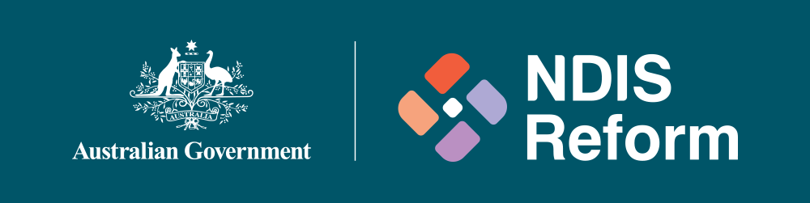

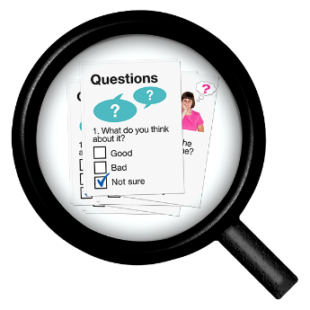 | We want to talk to you about the NDIS reforms.
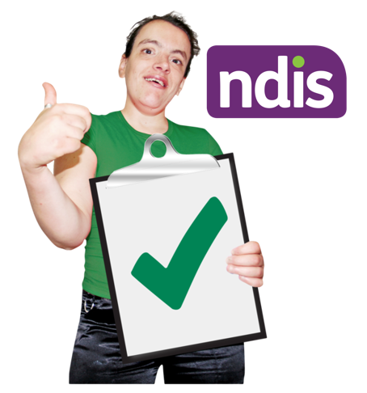 | We want to make sure the NDIS is working properly for people with disabilities.
 | It is important that we continue to talk to people with disability.
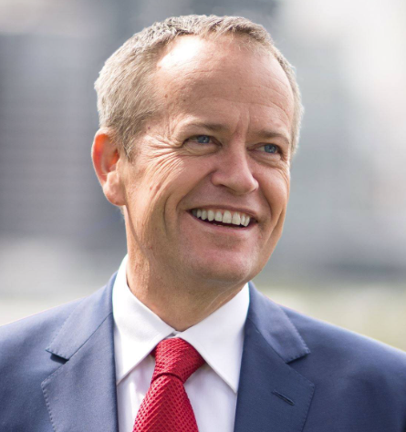 | There will be an online meeting, with Minister Shorten.
He will talk about some ideas for the future.
You will be able to ask questions.
The meeting is on Wednesday 5 June 2024.
It will start at 4pm and finish at 5pm.

For more information and to register please visit:
https://events.humanitix.com/ndis-reform-community-catch-up-online

