 | We want to talk to you about the NDIS reforms.
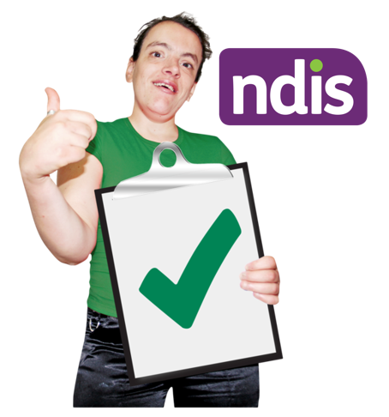 | We want to make sure the NDIS is working properly for people with disabilities.
 | It is important that the we continue to talk to people with disability.
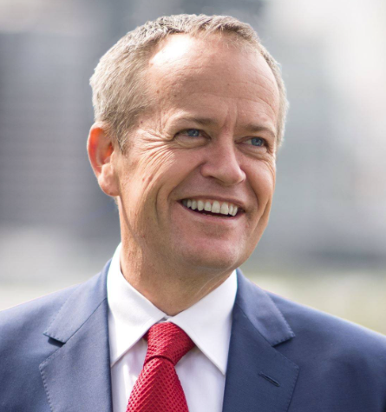 | There will be a meeting in Sydney, with Minister Shorten.
He will talk about some ideas for the future.
You will be able to ask questions.
The meeting is on Wednesday 8 May 2024.
It will start at 10:45am and finish at 11:45am.
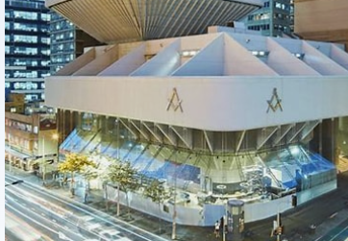 | The meeting is at Sydney Masonic Centre.  The address is 66 Goulbourn Street, Haymarket.
 | The meeting is free.
For more information and to register please visit:
NDIS Reform Town Hall event - Sydney | Humanitix

