Disability Employment Services (DES): Draft

Provider Performance Framework
April 2024
Draft for Consultation Purposes only – not for distribution

Disclaimer
This document is not a stand-alone document and does not contain the entirety of Disability Employment Services providers' obligations. It should be read in conjunction with the Disability Employment Services Grant Agreement and any relevant guidelines or reference material issued by the Department of Social Services under or in connection with the Disability Employment Services Grant Agreement. If there is any inconsistency between this document and the Disability Employment Services Grant Agreement, then the Disability Employment Services Grant Agreement will have precedence.

Copyright notice
This document Disability Employment Services: Draft Provider performance Framework is licensed under the Creative Commons Attribution 4.0 International Licence
Licence URL: https://creativecommons.org/licenses/by/4.0/legalcode
Please attribute: © Commonwealth of Australia (Department of Social Services) 2024
Notice:
- If you create a derivative of this document, the Department of Social Services requests the following notice be placed on your derivative: Based on Commonwealth of Australia (Department of Social Services) data.
- Inquiries regarding this licence or any other use of this document are welcome. Please contact: Branch Manager, Communication Services Branch, Department of Social Services. Phone: 1300 653 227. Email: communications@dss.gov.au
Notice identifying other material or rights in this publication:
- Australian Commonwealth Coat of Arms — not Licensed under Creative Commons, see https://www.itsanhonour.gov.au/coat-arms/index.cfm
- Certain images and photographs (as marked) — not licensed under Creative Commons

Table of contents
Disclaimer i
Table of contents i
Summary 2
1. Introduction 3
1.1. A new Provider Performance Framework 3
1.2. Designing a new DES Model 3
1.3. Consultation 4
2. Managing Provider Performance 4
2.1. Funding model 5
2.2. DES Grant Agreement 6
2.3. National Standards for Disability Services Certification 6
2.4. Provider Performance Framework 7
2.5. Scorecard report 7
3. Draft Provider Performance Framework 8
3.1. Objectives 8
3.2. Guiding principles 8
3.3. Key performance measures 9
3.3.1. Quality measures and indicators 10
3.3.2. Effectiveness measures and indicators 12
3.3.3. Efficiency measures and indicators 12
3.4. Scorecard report 13
3.5. Review 17
4. Next steps 17
Appendix A – Glossary 18

Summary
The Australian Government is committed to ensuring that Australians with disability have equal opportunities for inclusion and participation in the community, including in employment. The Disability Employment Service (DES) supports people with disability to find and maintain sustainable employment in the open labour market.
To measure provider performance following the cessation of the Star Ratings, the Department is developing a redesigned Provider Performance Framework (Performance Framework). This framework will be a foundation for the Disability Employment Services (DES) program in 2024-25 and is expected to continue to evolve in line with DES reforms.
The Performance Framework is intended to replace the DES 2018 Performance Framework, Star Ratings (2018) and Interim Performance Measures (2023). It aims to monitor and measure the performance of providers against an agreed set of key performance measures and work with them to continuously improve the overall performance of the program. This will assist in achieving meaningful and sustainable employment outcomes for participants.
The Performance Framework will include measures on achieving outcomes for participants and will also encompass the new Quality Framework which was implemented on 1 July 2023. The Performance Framework will provide an overarching framework to monitor, measure and drive continuous improvement in the performance of providers delivering the DES program.
The Performance Framework will be implemented on 1 July 2024, with the intention of publishing the finalised framework earlier.
The Performance Framework is supported by a new Scorecard, which will help to communicate provider performance against the agreed performance measures. The information will assist participants and employers to make an informed choice in choosing their preferred provider, assist providers to assess their performance and continuously improve the quality of their services.
This paper presents the draft Performance Framework and Scorecard for consultation and feedback. During April 2024, the Department will consult with providers, peak bodies and Disability Representative Organisations (DRO) on the draft Performance Framework and seek their feedback via interviews, a survey, and targeted workshops.
The Department values and will genuinely consider all feedback provided and the time commitment taken by providers to share their feedback on the draft Performance Framework. Feedback received will inform the final Performance Framework.

Introduction

A new Provider Performance Framework
To measure provider performance following the cessation of the Star Ratings and to support the design and implementation of a new specialist DES model, the Department is redesigning the Performance Framework.
The Performance Framework will replace the Star Ratings and Interim Measures and will be simple and accessible to participants, employers, providers, and Government. It will include measures on achieving outcomes for participants and will also encompass the new Quality Framework (implemented on 1 July 2023) to provide an overarching framework to monitor, measure and uplift the performance of providers and the program over time.
The Performance Framework has four key objectives:
- Empower participants, their families, and carers to make informed choices about providers with greater information about their performance.
- Enable employers to make informed choices on the providers they choose to work with.
- Enable Government to assess and manage the performance of providers and transparently communicate the quality of DES program.
- Drive continuous improvement in provider performance and service quality.
Performance will be monitored and assessed regularly, and information will be made available to participants, employers, and providers in a timely and frequent basis.
The Performance Framework will be implemented on 1 July 2024 with the intention of publishing the finalised framework earlier it will be informed by:
- Feedback received from people with disability, providers, employers and Disability Representative Organisations on the Star Ratings Performance Framework and Interim Performance Framework and what they would like in a new Performance Framework.
- A review of international best-practices and approaches to managing the performance of comparable disability employment programs.
- A review of the DES Star Ratings Performance Framework.

Designing a new DES Model
The Australian Government knows that people with disability and employers need a service that meets their needs and provides the right support. To ensure the future model is best placed to meet the needs of participants and employers the Government has committed to reforming Disability Employment Services.
The Department is working with people with disability, employers and providers on the design and implementation of a new DES model which is designed to:
- Continue the Government’s focus on program service quality, including formalising the Quality Framework and embedding it in overall performance.
- Enable greater transparency about the performance of services and process to monitor performance.
- Implement a redesigned Performance Framework that assesses the quality of services delivered and the successful achievement of education and employment outcomes for participants.
- Facilitate flexible supports which meets the needs of people with disability.
- Strive for greater alignment and interoperability with other programs and services, such as Workforce Australia and the National Disability Insurance Scheme.
- Revise the Funding Model to enable providers to invest in participants’, recognise and reward quality outcomes and maintain provider viability to deliver quality services.

Consultation
Throughout April 2024, the Department will consult with a broad range of stakeholders via interviews, a survey, and targeted workshops to seek feedback on the draft Performance Framework.
Providers, peak bodies and DRO’s will be engaged to seek feedback on the draft Performance Framework as outlined in this document, including objectives, principles, participant pathways, performance measures and reporting.
The Department values and will genuinely consider all feedback provided and the time commitment taken by providers to share their feedback on the draft Performance Framework. The Department will issue an invitation to providers for an all-provider feedback session on the framework, as well as holding group workshops on specific aspects of the framework.
Section 4 provides further information on the consultation process.

Managing Provider Performance
The objective of the DES program is to support people with disability to find and maintain sustainable employment in the open labour market. The DES program focuses on the needs of people with disability or injury to help them achieve greater social inclusion, boost employment participation, and better meet the needs of employers.
The DES program is delivered by a panel of approved providers who deliver services in line with the Grant Agreement. The Department has a key role in managing approved provider performance including:
- The management of service providers against the DES Performance Framework and Grant Agreement.
- Conducting program management, assurance, and compliance with the National Standards for Disability Services (NSDS).
Figure 1 provides an overview of the key components of the DES program managed by the Department. Together the Grant Agreement, NSDS, Funding Model, Performance Framework and Scorecard will assist the Department in managing provider performance, drive continuous improvement in performance and service quality. This will facilitate providers to better meet the needs of participants and employers and deliver on the program objectives.
This section provides an overview of how the Department proposes to manage performance in the DES program.
Figure 1: Overview of the DES Program
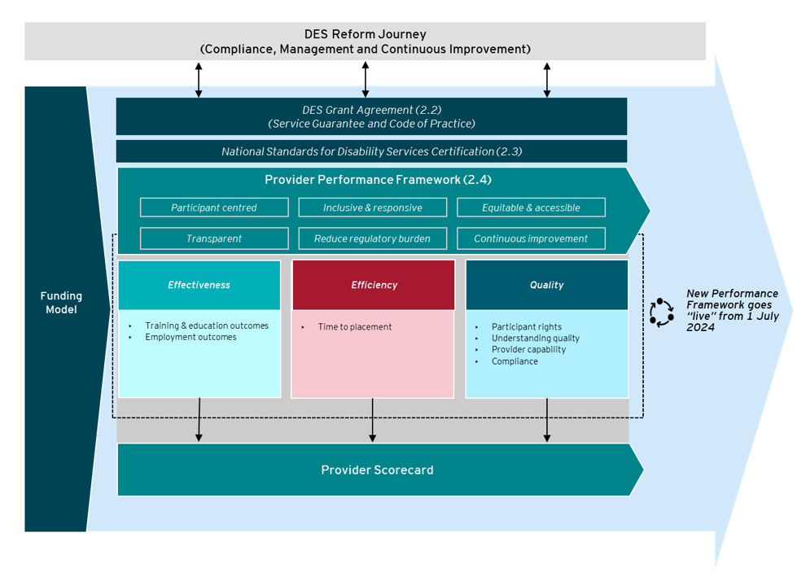

Funding model
The Department funds providers to deliver services to help participants gain education and meaningful and sustained employment. The risk-adjusted funding level (RAFL) model has been in place since 1 July 2018. The RAFL determines a differential fee to providers based on the likelihood of a participant to find employment. The key factors that influence the likelihood to find employment include:
- demographic characteristics
- duration variables
- labour market effects
- complexity of disability
- variables related to the Job Seeker Classification Instrument (JSCI)
- other barriers and condition flags.
It is recognised that the current RAFL model does not adequately account for the support needs of people with a moderate intellectual disability and a supplementary payment is available.

DES Grant Agreement
The DES Grant Agreement (2018) is a formal agreement between the Australian Government and service providers that deliver DES. The Grant Agreement outlines the terms, conditions, and expectations of providers in delivering services. This includes basic conditions, information and information management, administration services and fees.
The current Grant Agreement (Section 5Q) also states how the Department will monitor, measure, and evaluate a provider’s performance in accordance with Evaluation Activities and Key Performance Indicators: Efficiency, Effectiveness and Quality. The Department will also assess provider performance against a range of informal and formal assessments.
The Performance Framework has been developed to adhere to the current Grant Agreement. Future Grant Agreements will consider and align to the Performance Framework.

National Standards for Disability Services Certification
The National Standards for Disability Services (NSDS) outlines a set of standards that apply to disability service providers. It is intended to promote and drive a nationally consistent approach to improving service quality. They focus on rights and outcomes for people with disability.
There are six National Standards that apply to disability service providers:
- Rights: The service promotes individual rights to freedom of expression, self-determination and decision-making and actively prevents abuse, harm, neglect, and violence.
- Participation and Inclusion: The service works with individuals and families, friends, and carers to promote opportunities for meaningful participation and active inclusion in society.
- Individual Outcomes: Services and supports are assessed, planned, delivered, and reviewed to build on individual strengths and enable individuals to reach their goals.
- Feedback and Complaints: Regular feedback is sought and used to inform individual and organisation-wide service reviews and improvement.
- Service Access: The service manages access, commencement and leaving a service in a transparent, fair, equal, and responsive way.
- Service Management: The service has effective and accountable service management and leadership to maximise outcomes for individuals.
Providers undergo an initial certification process to confirm compliance with the National Standards, with periodic self-assessment and audit over the life of the certification (three-years). The Quality Framework was developed to align with the NSDS and reduce the administrative burden placed on providers by incorporating the audit results and data into the Quality Framework and its assessment of provider performance.

Provider Performance Framework
The new Performance Framework will replace the 2018 DES Performance Framework, Interim Measures and Star Ratings. It aims to monitor and measure the performance of providers against an agreed set of key performance measures and work with providers to continuously improve the overall performance of the program in achieving meaningful and sustainable employment outcomes for participants.
The domains of Efficiency, Effectiveness and Quality will remain in the Performance Framework. Each domain includes measures to reward and recognise quality services and employment outcomes. This will improve the consistency and quality of services delivered to enable meaningful and sustainable employment outcomes for participants.
The Department may consider adding or adjusting performance management activities and measures over time in line with the new DES model and broader reforms. These additional measures will assist in reporting the broader impact of the DES program. The Department will engage with providers at the appropriate time on any amendments to the Performance Framework.
A key principle underpinning the draft Performance Framework is collaborating with providers to improve compliance, monitor and measure performance and continuously improve performance to achieve outcomes. The key principles are defined as follows:
- Service Standard Compliance: Review and assess on a regular basis whether a provider is meeting the minimum requirements of the program such as the NSDS. Compliance is the minimum standard expected of providers with non-compliance potentially leading to further investigation, support, and potential exit from the program.
- Monitor: Assess the performance of providers against several measures to produce a ‘Scorecard.’ The results from the assessment of performance will assist the Department in understanding cohorts, regions and providers that are performing below or above expectations and where to provide additional focus or support.
- Continuous improvement: Develop and share case studies of best practice providers to lift the performance of the provider market over time, deliver improved outcomes for participants and employers and broader program level objectives.
Section 3 provides further detail on the draft Performance Framework.

Scorecard report
The Performance Framework would be supported by new Scorecards, which will help to report on provider performance against an agreed set of performance measures. The Scorecards will be tailored to meet the needs of participants, employers, and providers. The information will empower participants and employers with greater information to make informed choices about their DES provider. This will assist providers to assess their performance and continuously improve the quality of their services. For example:
- Participants and employers: a high-level Scorecard will be shared with participants and employers to assist them in selecting their provider and understanding their provider performance. These scorecards will be published and updated quarterly.
- Providers: a more detailed Scorecard will be shared with providers (and possibly published) to assist them in understanding, benchmarking, and improving their performance.
Data collected for the purposes of calculating the scorecard will be used to support Government’s understanding of the performance of providers and broader program performance.
Further detail on the Scorecard report, its application in practice and differences to the Star Ratings is outlined in Section 3.

Draft Provider Performance Framework
The draft Performance Framework has been designed to promote transparency and clarity in the way provider performance is assessed and communicated to stakeholders. It will drive the delivery of quality services to improve participant employment outcomes, social inclusion and independence.
This section provides further information on the draft Performance Framework including objectives, guiding principles, measures, scorecard, and implementation.

Objectives
The Performance Framework has four key objectives:
- Empower participants, their families, and carers to make informed choices about the providers with greater information about their performance.
- Enable employers to make informed choices on the providers they choose to work with.
- Enable Government to assess and manage the performance of providers and transparently communicate the quality of DES program.
- Drive continuous improvement in provider performance and service quality.

Guiding principles
In developing the draft Performance Framework, the Department has established nine guiding principles to assist in responding to the needs and priorities of program participants, employers, and providers to deliver on the broader program objectives.
The guiding principles for the Performance Framework align with the Quality Framework and have been informed by feedback from providers. They aim to provide a clear and concise direction for the design of the Performance Framework and reduce duplication.

Guiding principles
The draft Performance Framework is:
- Participant centred: Ensuring that participants are at the centre of service design, planning, procurement, delivery, monitoring and evaluation.
- Transparent: Is simple to understand for all stakeholders and in particular providers understand how performance is measured and assessed.
- Inclusive and responsive: Promotes Disability Employment Services that are inclusive and responsive.
- Equitable and accessible: Supports service provisions that are timely and accessible and is provided in a setting where supports are appropriate for meeting the needs and goals of people with disability.
- Outcomes focused: Focuses on outcomes and considers the activities and outputs that lead to sustained outcomes.
- Reduces administrative burden: Removes unnecessary administrative burden for providers, while still achieving its quality aims.
- Continuous improvement: Facilitates continuous improvement and innovation by promoting pathways to provide robust and timely feedback, including complements and complaints.
- Accountable: Promotes accountability by clearly defining roles, responsibilities, and expectations of participants, providers, and Government.
- Flexible: Enables the Performance Framework to evolve overtime in-line with DES and broader reforms.

Key performance measures
From 1 July 2024 the Performance Framework will include all three domains in the assessment of provider performance. These measures are consistent with what is included in the current Grant Agreement and what is currently measured. While the measures and indicators remain largely unchanged from Star Ratings, the methodology to calculate performance against measures and indicators will change to promote further transparency.
Together these measures are designed to provide a holistic view of provider performance and deliver insights that better match the needs of participants, employers, and Government.
The Draft Performance Framework (Figure 2) is comprised of Domains, Measures, and Indicators. These are further defined as follows:
- Domains: There are three Domains, Quality, Effectiveness and Efficiency (consistent with the current Grant Agreement). The aim of each domain is to:
- Quality: Assess the quality of services delivered by providers as outlined in the Quality Framework and include Participant rights, Understanding quality, Provider Capability and Compliance.
- Effectiveness: Assess the achievement of training, education and employment outcomes and the success in placing participants in sustainable employment.
- Efficiency: Assess the time taken to place participants into employment while taking into consideration their likelihood to find employment.
- Measures: Each Domain has one or more Measures that represent outcomes to be achieved including training and education outcomes, employment outcomes, speed to placement, participant rights, understanding quality, provider capability and compliance.
- Indicators: Each Measure has one or more Indicator which determine how performance will be assessed. This includes completion rates, placement rates, duration, time to placement, understanding participants’ needs, local labour market needs and expectations of employers, continuous improvement and compliance and assurance. The calculations that underpin each indicator are under development and will be published in a separate report.

Quality measures and indicators
Refer to the DES Quality Framework for further detail on the measures and indicators related to Quality.

Figure 2: Draft Provider Performance Framework
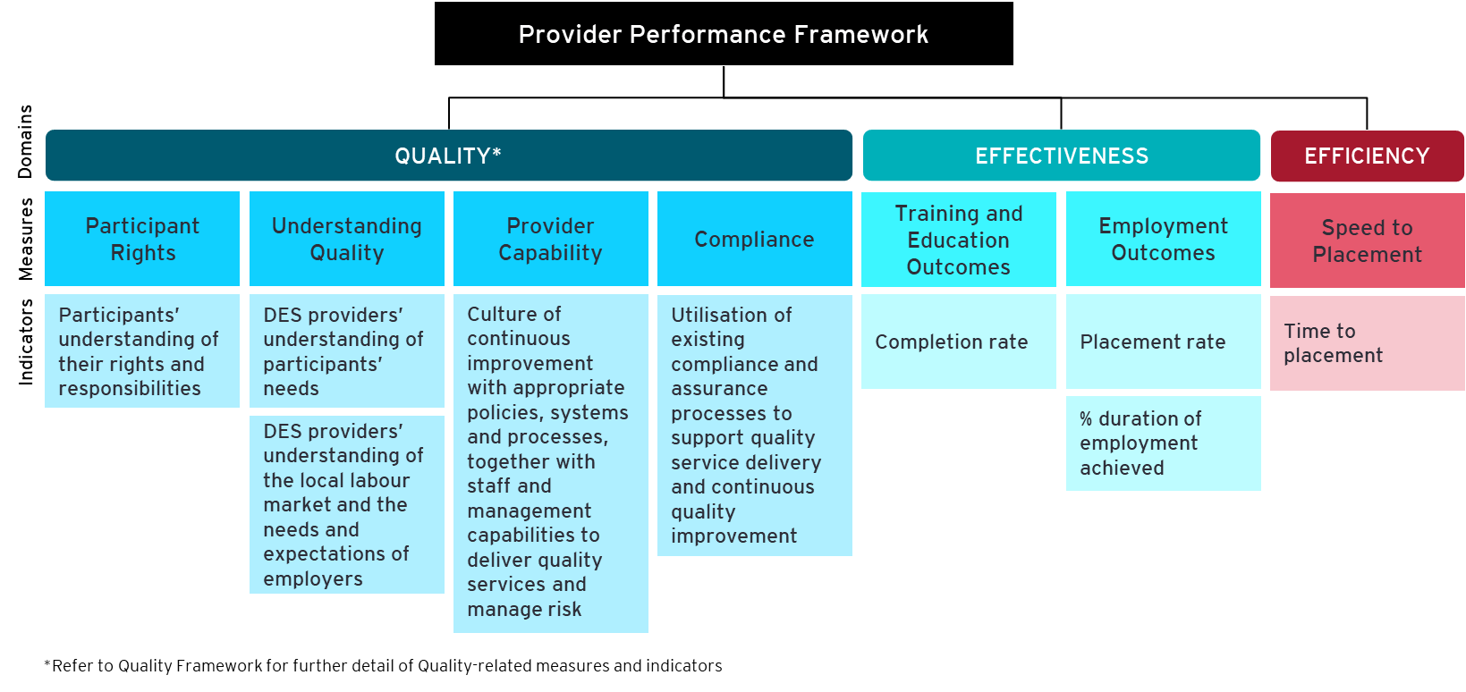

Effectiveness measures and indicators
Effectiveness is designed to measure the performance of providers related to the achievement of training, education and employment outcomes for participants. Of the three indicators, only duration of employment achieved was included in the Star Ratings. Two new measures have been included to take account of the achievement of training and education outcomes as well as 4-week employment outcomes (Table 1).
The Performance Framework explicitly recognises the achievement of training and education outcomes and 4-week employment outcomes, as well as the previously recognised 13-, 26- and 52-week employment outcomes. These indicators take into consideration a participant’s readiness for employment and the potential investment required by providers to get a participant work ready.
Table 1: Proposed Effectiveness measures and indicators
Measure | Indicator | Descriptions | New or existing indicator?
Training and Education Outcomes | Completion rate | Proportion of participants achieving education and training outcomes | New  (Measured by comparing Actual versus Expected Performance)
Employment Outcomes | Placement rate | Proportion of participants that achieve 4 weeks of employment | New  (Measured by comparing Actual versus Expected Performance)
 | Percent duration of employment achieved | Of the participants who reach 4 weeks of employment, proportion of participants that achieve:  - 13-week outcomes  - 26-week outcomes  - 52-week outcomes | Existing  (Measured by comparing Actual versus Expected Performance)

Efficiency measures and indicators
Efficiency is designed to measure the performance of a provider in relation to the speed by which participants are placed into employment (Table 2). This measure is the only measure that will be used to determine efficiency in the draft Performance Framework.
Initial feedback received through consultations with providers and peak bodies noted varied perspectives with regards to the inclusion of this measure in the draft Performance Framework. The rationale for inclusion is to address that timely help may not be provided to harder-to-place participants. However, some stakeholders have suggested the measure could drive providers to focus on speed to placement at the expense of quality service delivery and meaningful employment outcomes. In considering this measure, the Department will also consider the weighting applied in conjunction with the funding model to off-set the risk of potential perverse behaviour.
Table 2: Proposed Efficiency measures and indicators
Measure | Indicator | Descriptions | New or existing measure
Speed to placement | Time to placement | The time taken from commencement with provider to placement in employment or length of time looking for work if they are not in employment | Existing  (Measured by comparing Actual versus Expected Performance)

Scorecard report
The Scorecard aims to report on the performance of providers against an agreed set of key performance measures outlined in the draft Performance Framework. The Department proposes providing a tailored Scorecard for participants, employers and providers in-line with their information needs.

- Participants and Employers
A high-level Scorecard will be made available to participants and employers to assist them in selecting a provider and understanding their provider performance. A Scorecard will be made available to participants on entry into the program to help inform provider selection as well as an annual Scorecard to inform participants of their provider’s performance. A similar Scorecard will be made available to employers to assist them in choosing a provider to work with.
Figure 3 provides an example of the Scorecard that will be made available to participants and employers initially online and in future via Services Australia. The Scorecard will include:
- the name of the DES provider, and location
- the reporting period
- an overview of the provider’s performance in the reporting period, and the rating across each Domain
- a brief description of each Domain
- an explanation of the scoring including the definition of improvement required, meets expectations and exceeds expectations.

Figure 3: Example performance scorecard shared with participants and employers
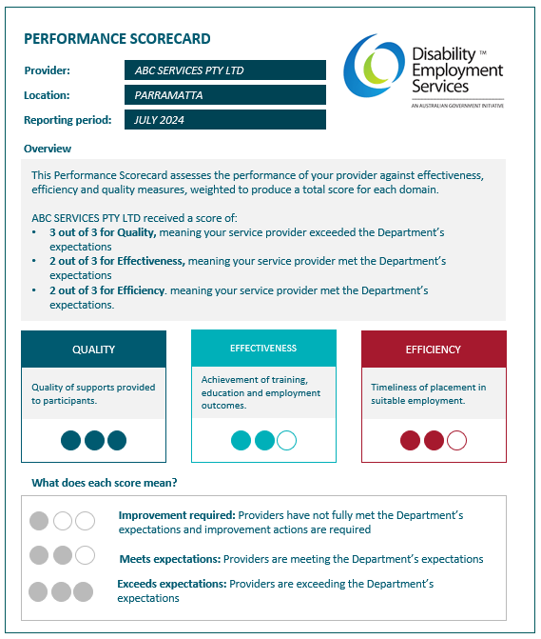

- Providers
A more detailed Scorecard will be shared with providers to assist them in understanding, benchmarking, and improving their performance. Information collected for the purpose of monitoring provider performance will also be used by Government to monitor overall program performance. Each quarter, the Department will share with providers their performance rating for each Domain and Measure by contract and organisation level.
Figure 4 provides an example of the Scorecard Report shared with providers on a quarterly basis. The scorecard will include:
- provider name and location
- reporting period such as quarterly timeframe
- an overview of the provider’s performance in the reporting period including a rating across each Domain
- a brief description of each Domain
- an explanation of the scoring including the definition of improvement required, meets expectations and exceeds expectations.
Providers will be given a score out of three for each Measure and Domain. The score for the Efficiency and Effectiveness Domains will be provided at contract and organisation level. The Quality Domain score will only be available at the organisation level. No overall score is proposed at this stage. The scoring aligns with the Quality Framework and is defined as follows:
- Improvement required: Providers have not fully met performance benchmarks set by the Department and improvement actions are required. They received a score of less than 1.
- Meets expectations: Providers are meeting the Department’s expectations and received a score of 1 or above but less than 2.
- Exceeds expectations: Providers are exceeding the Department’s expectations and received a score of 2 or above.
The Department is currently working on the development of a revised Performance Framework methodology and calculations for each Indicator and Measure. The detailed methodology and calculations will be published in a separate Performance Framework Methodology Report (Methodology Report). The Methodology Report aims to increase the transparency of how provider performance is calculated presenting all providers with the same information. For example, the Methodology Report will outline the calculations that underpin how actual performance is determined and compared to estimated performance to provide a score for each Domain, Measure and Indicator.
Figure 4: Example performance scorecard to be shared with providers
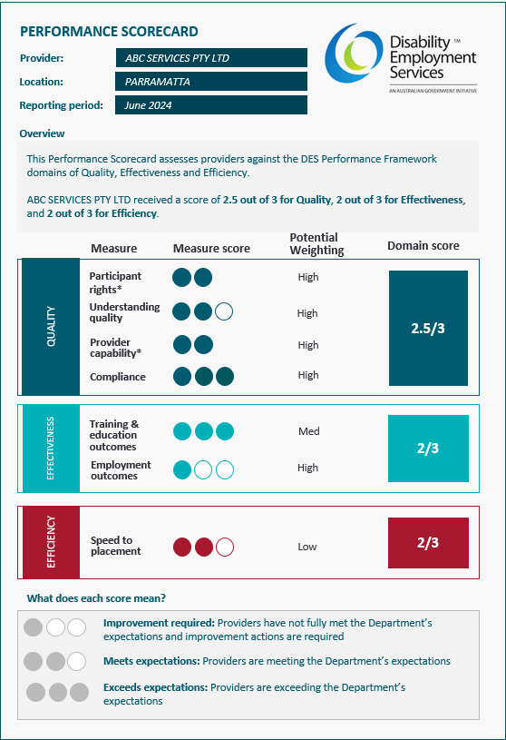
* Under the Quality Framework, the participant rights and provider capability measures are assessed based on improvement required or meets expectations. There is no assessment for exceeds expectations.

Review
The Department will periodically review the Performance Framework to ensure that:
- measures and indicators are fit for purpose
- calculations underpinning the Scorecard are robust and transparent
- the Performance Framework drives quality service delivery and continuous improvement
- changes to policy settings (for example the new DES model) are incorporated in the Performance Framework.

Next steps
Throughout April 2024, the Department will consult with a broad range of stakeholders via the Provider Reference Group, interviews, a survey, and targeted workshops to seek feedback on the draft Performance Framework (Figure 5).
There are three forums for providers, peak bodies and DROs give feedback and contribute to the development of the Performance Framework over the coming months. These are:
- All provider meeting: In May 2024, providers will be briefed on the Draft Performance Framework and have an opportunity to ask questions in the All-in Provider Workshop.

- Workshops: In late April 2024, providers will be asked to participate in a series of targeted workshops to give feedback on key aspects of the draft Performance Framework. Auslan assistants will be made available on request.

- Survey: From late April 2024, providers and peak bodies will have the opportunity to respond to an online survey to give written feedback on the draft Performance Framework. An accessible version of the survey can also be made available on request.

Appendix A – Glossary

Acronym | Definition
DES | Disability Employment Services
Department | Department of Social Services
Effectiveness | Refers to the effectiveness domain within the Performance Framework, which assesses the achievement of training, education and employment outcomes and the success in placing participants in sustainable employment
Efficiency | Refers to the efficiency domain within the Performance Framework, assesses the time taken to place participants taking into consideration their likelihood to find employment
Funding Model | Refers to the risk-adjusted funding model
JSCI | Job Seeker Classification Instrument is a tool used by employment companies to identify the required level of resources and support that are required for a job seeker
NDIS | National Disability Insurance Scheme
NSDS | National Standards for Disability Services
Participants | Individuals engaged in the DES program.
Performance Framework | The Disability Employment Services Performance Framework
Providers | An organisation that delivers Disability Employment Services
Quality | Refers to the Quality domain within the Performance Framework, which assesses the quality of services by considering participant rights, understanding quality, provider capability and compliance as stated in the DES Quality Framework
Quality Framework | Disability Employment Service Quality Framework
RAFL | The risk-adjusted funding level (RAFL) model has been in place since 1 July 2018 which pays a differential fee to providers based on the likelihood of a participant to find employment
Scorecard | A report for participants and providers outlining the performance of a provider against an agreed set of measures outlined in the draft Performance Framework
Star Ratings | Former DES performance monitoring and reporting approach. Star Ratings assessed against two key indicators: Effectiveness and Efficiency
VET | Vocational Education and Training
Work Assist | Work Assist is a service or program developed to provide support to individuals in the workplace, in particular those that have an injury or disability. Examples of services provided can include workplace adjustments and mental health support.
Workforce Australia | Workforce Australia is an Australian Government-funded network of organisations that are contracted by the Australian Government, through the Department of Employment and Workplace Relations, to deliver employment services to unemployed job seekers on Government income support payments and employers

¹ Further information on the measures and indicators and detailed calculations relating to the measurement of actual and expected performance will be provided in the technical methodology paper.
Further information on the measures and indicators and detailed calculations relating to the measurement of actual and expected performance will be provided in the technical methodology paper.

