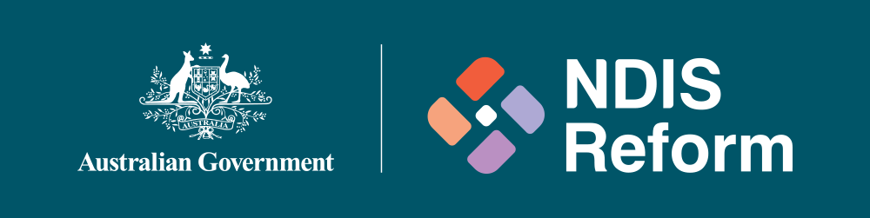

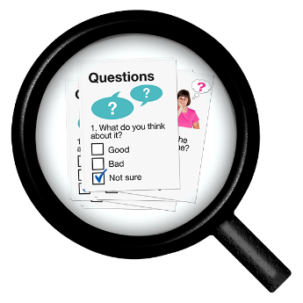 | We want to talk to you about the NDIS reforms.
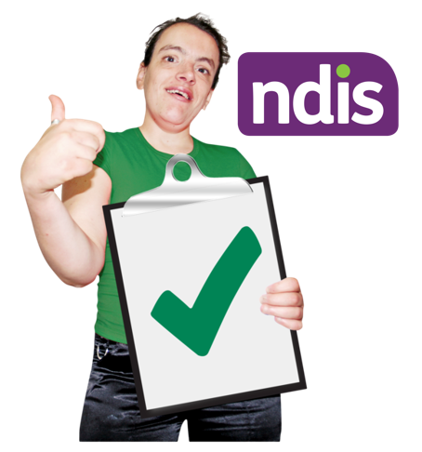 | We want to make sure the NDIS is working properly for people with disabilities.
 | It is important that we continue to talk to people with disability.
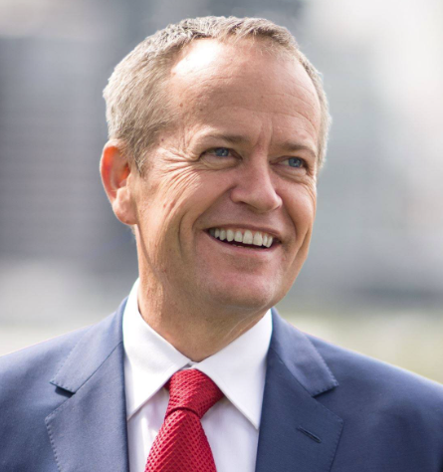 | There will be a meeting in Brisbane, with Minister Shorten.
He will talk about some ideas for the future.
You will be able to ask questions.
The meeting is on Friday 24 May 2024.
It will start at 10.45am and finish at 11:45am.
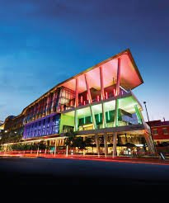 | The meeting is at Brisbane Convention Centre.  The address is Merivale St, South Brisbane QLD.
 | The meeting is free.
For more information and to register please visit:
https://events.humanitix.com/ndis-community-catch-up-brisbane

