 | We want to talk to you about the NDIS reforms.
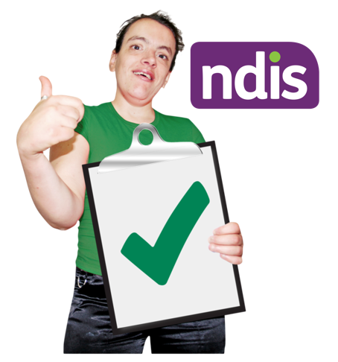 | We want to make sure the NDIS is working properly for people with disabilities.
 | It is important that we continue to talk to people with disability.
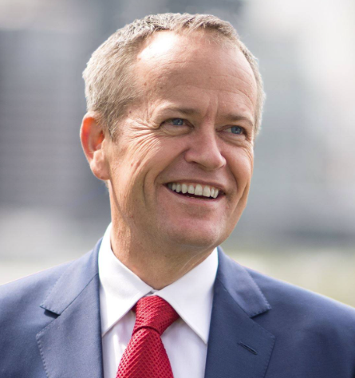 | There will be a meeting in Canberra, with Minister Shorten.
He will talk about some ideas for the future.
You will be able to ask questions.
The meeting is on Wednesday 15 May 2024.
It will start at 7:00pm and finish at 8:00pm.
The meeting is at QT Canberra.
The address is 1 London Cct, Canberra ACT

 | The meeting is free.
For more information and to register please visit:
https://events.humanitix.com/ndis-community-catch-up-canberra

