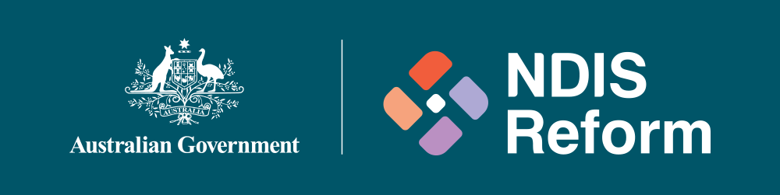

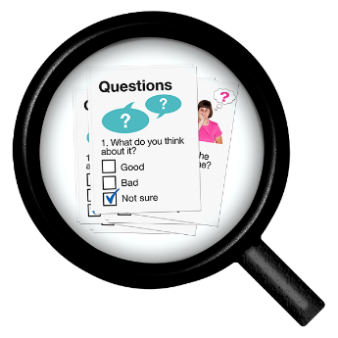 | We want to talk to you about the NDIS reforms.
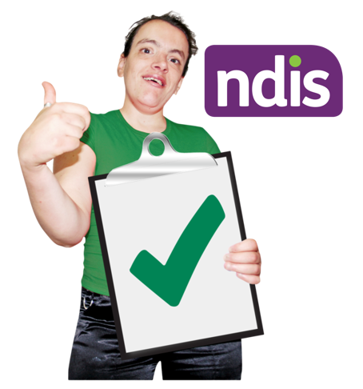 | We want to make sure the NDIS is working properly for people with disabilities.
 | It is important that we continue to talk to people with disability.
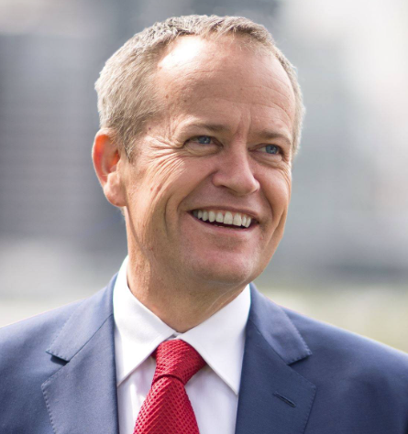 | There will be a meeting in Perth, with Minister Shorten.
He will talk about some ideas for the future.
You will be able to ask questions.
The meeting is on Tuesday 21 May 2024.
It will start at 10.45am and finish at 11:45am (AWT).
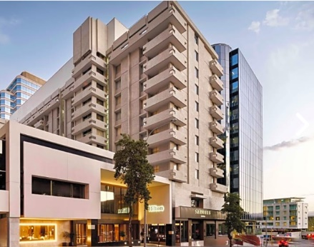 | The meeting is at Parmelia Hilton Motel  The address is 14 Mill Street, Perth WA
 | The meeting is free.
For more information and to register please visit:
https://events.humanitix.com/ndis-community-catch-up-perth

