Assistance Animal National Principles

Consultation Paper

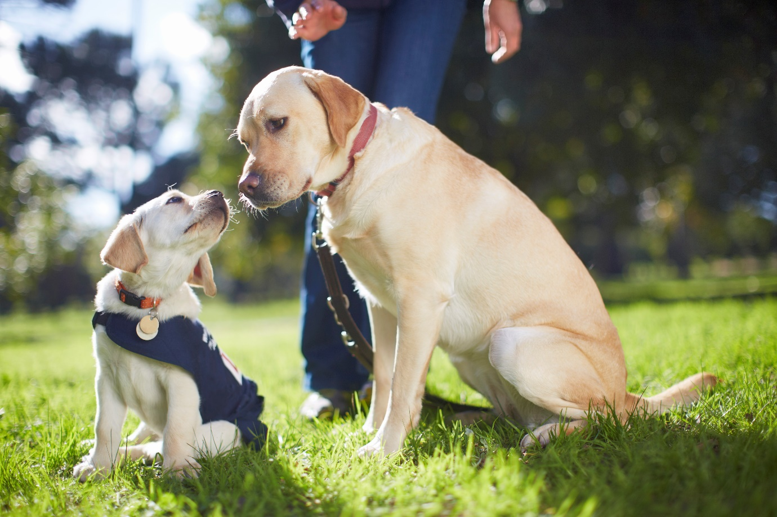

|  |  |
| --- | --- |
| Australian Government logo with Department of Social Services underneath | The Australian Government Department of Social Services wrote this.  We say **DSS** for short.  When you see the word **we** it means DSS. |
| A person holding a white book with easy read on the cover | We wrote this in an easy to read way.  We use pictures to explain some ideas. |
| The word bold is in bold and the words not bold are in plain text | We have some words in **bold**.  This means the letters are thicker and darker.  These are important words. |
| An easy read document with pictures and lines for text. | This is an Easy Read summary of another document.  This means it has the most important ideas. |
| teal envelope | We can answer any questions by email.  Email us  [sector.engagement@dss.gov.au](mailto:sector.engagement@dss.gov.au) |
| Two people with their arms around each other with thumbs up. | You can ask for help to read this document.  You can ask   * A friend * Family members * A support person. |
| image of Aboriginal and Torres Strait Islander people with the Aboriginal and Torres Strait Islander flags in the background | We recognise Aboriginal and Torres Strait Islander people as the **Traditional Owners** of the land we live on. |
| teal map of australia | They were the **first people** to live on and use the   * Land * Waters. |

Contents

|  |  |
| --- | --- |
| About Assistance Animals | 5 |
| How we made the Principles | 8 |
| The Principles | 9 |
| How we will work on the Principles | 11 |
| How to tell us your ideas | 13 |

About Assistance Animals

|  |  |
| --- | --- |
| Man in brown jacket and blue shirt standing with a guide dog in a yellow harness. | Assistance animals are animals that are trained to support people with disability to be   * **Independent** * Happy and healthy.   Independent means being able to do things on your own. |
| a cat and 2 dogs one wearing a vest | Assistance animals are usually dogs.  Sometimes other animals can be assistance animals. |
| a book with rules on the front and a green tick and red cross | There is a **law** that tells us how to know if an animal is an assistance animal.  Laws are **rules** for how we live. |
| a man with a clipboard looking at a guide dog with a vest sitting | The law says there are 2 ways to tell.   1. The animal is **accredited** to assist a person with disability   Accredited means someone has come to check that the rules have been followed.  This is done by someone in the state or territory you live in. |
| An assistance dog helping someone in a wheelchair to remove their jacket | 1. The animal  * Is trained to assist a person with disability * Has learned how to behave in public spaces * Is clean and looked after. |
| a teal map of Australia with white lines between the states | States and territories have different rules for assistance animals to be accredited.  Some states and territories do **not** have any rules. |
| Man in blue shirt giving thumbs-down next to a guide dog in a yellow harness. | This makes it hard for   * People with disability who use assistance animals |
| A person with a puzzled expression and open arms, standing next to a large question mark. | * Other people to know what animals may be assistance animals. |
| a black dog with a yellow harness on sitting on the side of the road with a person with a cane | We think if the rules were the same everywhere it would make it easier for   * People who use assistance animals |
| A guide dog laying on the grass | * Everyone to know what animals may be assistance animals. |

## How we made the Principles

|  |  |
| --- | --- |
| Woman with light brown hair wearing a black and white floral dress, holding her right hand to her ear. | In 2021 we talked with the community about assistance animals.  We wanted to hear from people who have assistance animals. |
| a silver puzzle piece with principles on it | That information helped us write the **Assistance Animal** **Principles**.  We call it the **Principles** for short.  Principles say how something **should work.** |
| teal icon of parliament house | We worked with   * State and territory governments * Other areas of the government.   This helped us come up with the Principles. |
| Teal icon of Australia with a book with rules on top | The Principles would be rules that states and territories follow. |

## The Principles

|  |  |
| --- | --- |
| Number 6 on a blue square background. | We have 6 Principles.  They are |
| A dog looking up at a person training them | 1. To have the same rules across Australia about  * How animals are trained * Who can train them. |
| A man in a blue suit sitting on a chair with a happy Labrador Retriever in front. | 1. To have the same rules across Australia for what training they need. |
| Man in brown jacket and blue shirt standing with a guide dog in a yellow harness. | 1. To have the same **Public Access Test** for all of Australia.   We call it **PAT** for short.  This makes sure they are safe to be in the community. |
| Person holding a clipboard with a green checkmark giving a thumbs-up. | 1. To have the same **evidence** needed for  * What disability you have * Why you need an assistance animal.   Evidence is proof that something is true. |
| A hand holding a blank white card with A Labrador Retriever wearing a yellow vest and sitting attentively. | 1. To have a card and logo for all of Australia.   This will make it easier to tell which animals are assistance animals. |
| a puppy with a vest on looking up at an older dog | 1. That the assistance animal is happy and healthy for their life. |

## How we will work on the Principles

|  |  |
| --- | --- |
| Person in a red shirt with an excited expression pointing upward, next to a glowing light bulb. | We want to hear what you think about the Principles.  This could be ideas about   * How we can make the Principles better |
| Elderly person in an orange jacket holding a clipboard and giving a thumbs-up. | * Information that will help make them work well in the community. |
| Cover of a spiral-bound report with the title 'Report' and an image of a person holding a paper that reads 'easy read.' | We will write a report about   * The things we have heard * How the ideas have helped. |
| Three people giving thumbs-up, wearing professional attire and ID badges. | When we have finished working on the Principles we will share them with the state and territory Disability **Ministers**.  Ministers are leaders in an area of the government. |
| 2 people shaking hands with a checklist behind them that says Principles | The Disability Ministers will be asked to agree to the Principles. |
| A diverse group of people interacting with speech bubbles overhead. | We will work with states and territories to help them follow the principles.  Some states will need to make more changes than others to follow the Principles. |

## How to tell us your ideas

|  |  |
| --- | --- |
| Person in a red shirt with an excited expression pointing upward, next to a glowing light bulb. | We want to hear your ideas about the Principles. |
| teal arrow with lines | You can go to our website to fill it out online.  [https://engage.dss.gov.au/assistance-animal-national-principles](https://engage.dss.gov.au/assistance-animals-national-principles) |
| Man scratching head while reading a booklet with a question mark above his head. | If you   * Can **not** fill it in online * Want to fill it in a different way   You can contact us. |
| teal envelope | You can send us an email.  [sector.engagement@dss.gov.au](mailto:sector.engagement@dss.gov.au) |
| Woman opening a yellow envelope at a white table. | Write us a letter.  Assistance Animal National Principles  Advocacy and Inclusion Programs Branch  Department of Social Services  GPO Box 9820  In your capital city |
| Person holding a sign with the word 'Name'. | We might share your ideas with the community.  When you write your ideas you will be asked if you would like your ideas   * To be shared with your name |
| A completely black rectangle with no distinguishable features. | * To be shared **without** your name   Sharing without your name is called being **anonymous**. |
| Man in an orange shirt holding up his hand in a stop gesture. | * **Not** to be shared. |
| Older woman making a 'shush' gesture with her finger over her lips and a 'CONFIDENTIAL' stamp overlay. | We will keep any information you share with us safe. |
| teal arrow with lines | You can go to our website to learn more about how we keep information safe.  It is **not** Easy Read.  [www.dss.gov.au/using-our-website/privacy-policy](http://www.dss.gov.au/using-our-website/privacy-policy) |

|  |  |
| --- | --- |
| Blue banner with 'made with photosymbols' text and checkmark logo.  easy read tech logo | This Easy Read document includes stock images and original illustrations created by [EasyRead.Tech](https://easyread.tech).  You must **not** reuse any of these images without permission. |