Next steps in

Supported Employment

Part 1

Questions

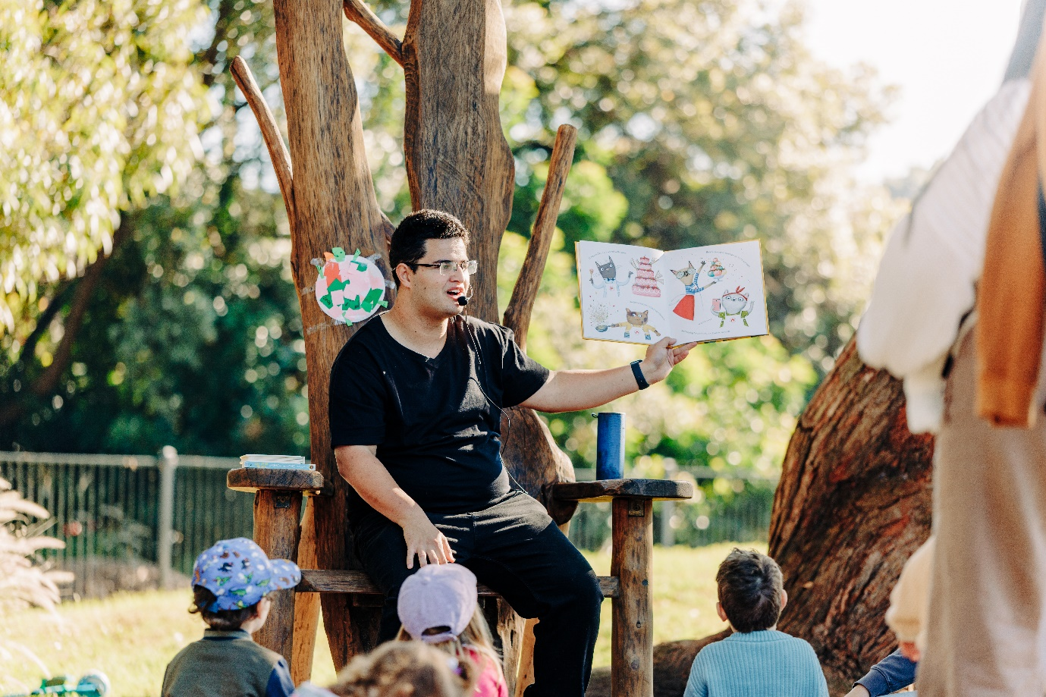

|  |  |
| --- | --- |
| Australian Government logo with Department of Social Services underneath | The Australian Government Department of Social Services wrote this.  We say **DSS** for short.  When you see the word **we** it means DSS. |
| A person holding a white book with easy read on the cover | We wrote this in an easy to read way.  We use pictures to explain some ideas. |
| The word bold is in bold and the words not bold are in plain text | We have some words in **bold**.  This means the letters are thicker and darker.  These are important words. |
| An easy read document with pictures and lines for text. | This is an Easy Read summary of another document.  This means it has the most important ideas. |
| teal envelope | We can answer any questions by email.  Email us [SEPolicy@dss.gov.au](mailto:SEPolicy@dss.gov.au) |
| Two people with their arms around each other with thumbs up. | You can ask for help to read this document.  You can ask   * A friend * Family members * A support person. |
| image of Aboriginal and Torres Strait Islander people with the Aboriginal and Torres Strait Islander flags in the background | We recognise Aboriginal and Torres Strait Islander people as the **Traditional Owners** of the land we live on. |
| teal map of australia | They were the **first people** to live on and use the   * Land * Waters. |

## Questions

|  |  |
| --- | --- |
| Two men holding signs with thumbs up and thumbs down gestures. | The government is working on lots of different things to improve inclusive jobs for people with disability. |
| A person in a striped shirt thinking with a checkmark and an 'X' in a thought bubble. | To help make supported employment better we want to hear your ideas.  We will ask some questions.  You can decide if you want to answer the questions.  You do **not** have to answer them all. |
| Man in a plaid shirt with a thoughtful expression, touching his chin. | You can take time to think about your ideas.  You can go to our website and read about what we are doing in Part 2.  This will help you answer our questions  It is in Easy Read  [engage.dss.gov.au/next-steps-in-supported-employment](https://engage.dss.gov.au/next-steps-in-supported-employment) |
| teal icon of computer mouse clicking | You can share your answers online.  [engage.dss.gov.au/next-steps-in-supported-employment](https://engage.dss.gov.au/next-steps-in-supported-employment) |
| A black inkjet printer printing a document with text and images.Person in a red beanie writing on a piece of paper at a table.Hands typing on a virtual keyboard composing a new email message. | You can write your answers.  You will need to   * Print this form * Write your answers in the boxes with a blue or black pen. * Scan the form * Email it to us.   You need to email your answers to  [SEPolicy@dss.gov.au](mailto:SEPolicy@dss.gov.au) |
| Calendar icon showing June 6 | This needs to be done before 5 at night  6 June 2025. |
| Three people collaborating over sketches on a notebook titled 'Plan'.Two men holding signs with thumbs up and thumbs down gestures. | We will use the ideas we get from everyone to make   * A plan * Supported employment better. |
| Two people sitting at a table, one writing and the other pointing at the paper. | We will put space for you to write your answers.  You can use more space if you need it.  You can ask for support to answer the questions. |
| Person smiling with eyes closed, wearing a red sweater and touching their head. | Question 1  Do you think we have forgotten some work that is happening? |
| Young boy in a red t-shirt pointing to a white rectangular space with A diverse group of people engaged in various workplace activities within a house-shaped frame labeled 'Workplace'. | Question 2  What would supported employment look like if it was perfect.   * Where would you work * What would you be doing * Who would you be working with? |
| A diverse group of people engaged in various workplace activities within a house-shaped frame labeled 'Workplace'. | Question 3  We want more people with high support needs to be working in **open employment**.  **Open employment** means anyone can get a job in that workplace.  How can we make this happen? |
| Three people collaborating over sketches on a notebook titled 'Plan'. | Question 4  The DRC thought we should make a plan to help us make supported employment better.  What ideas would you put in the plan? |
| Person in a gray suit reading a newspaper with the headline 'Jobs Available.'a yellow envelope with money coming out the top with an arrow pointing up next to it | Question 5  How can employers   * Keep all the jobs   And   * Pay people with disability more money? |
| Man in a navy blue shirt pointing with a thumbs-up icon in the background. | Question 6  What do you like most about supported employment? |

## Contact us

|  |  |
| --- | --- |
| teal circle with white i in the middle | You can contact us if you **need more information.** |
| teal envelope | You can send us an email.  [SEPolicy@dss.gov.au](mailto:SEPolicy@dss.gov.au) |

Product Number DSS3574.03.25

Images in this Easy Read must **not** be used or copied without permission.