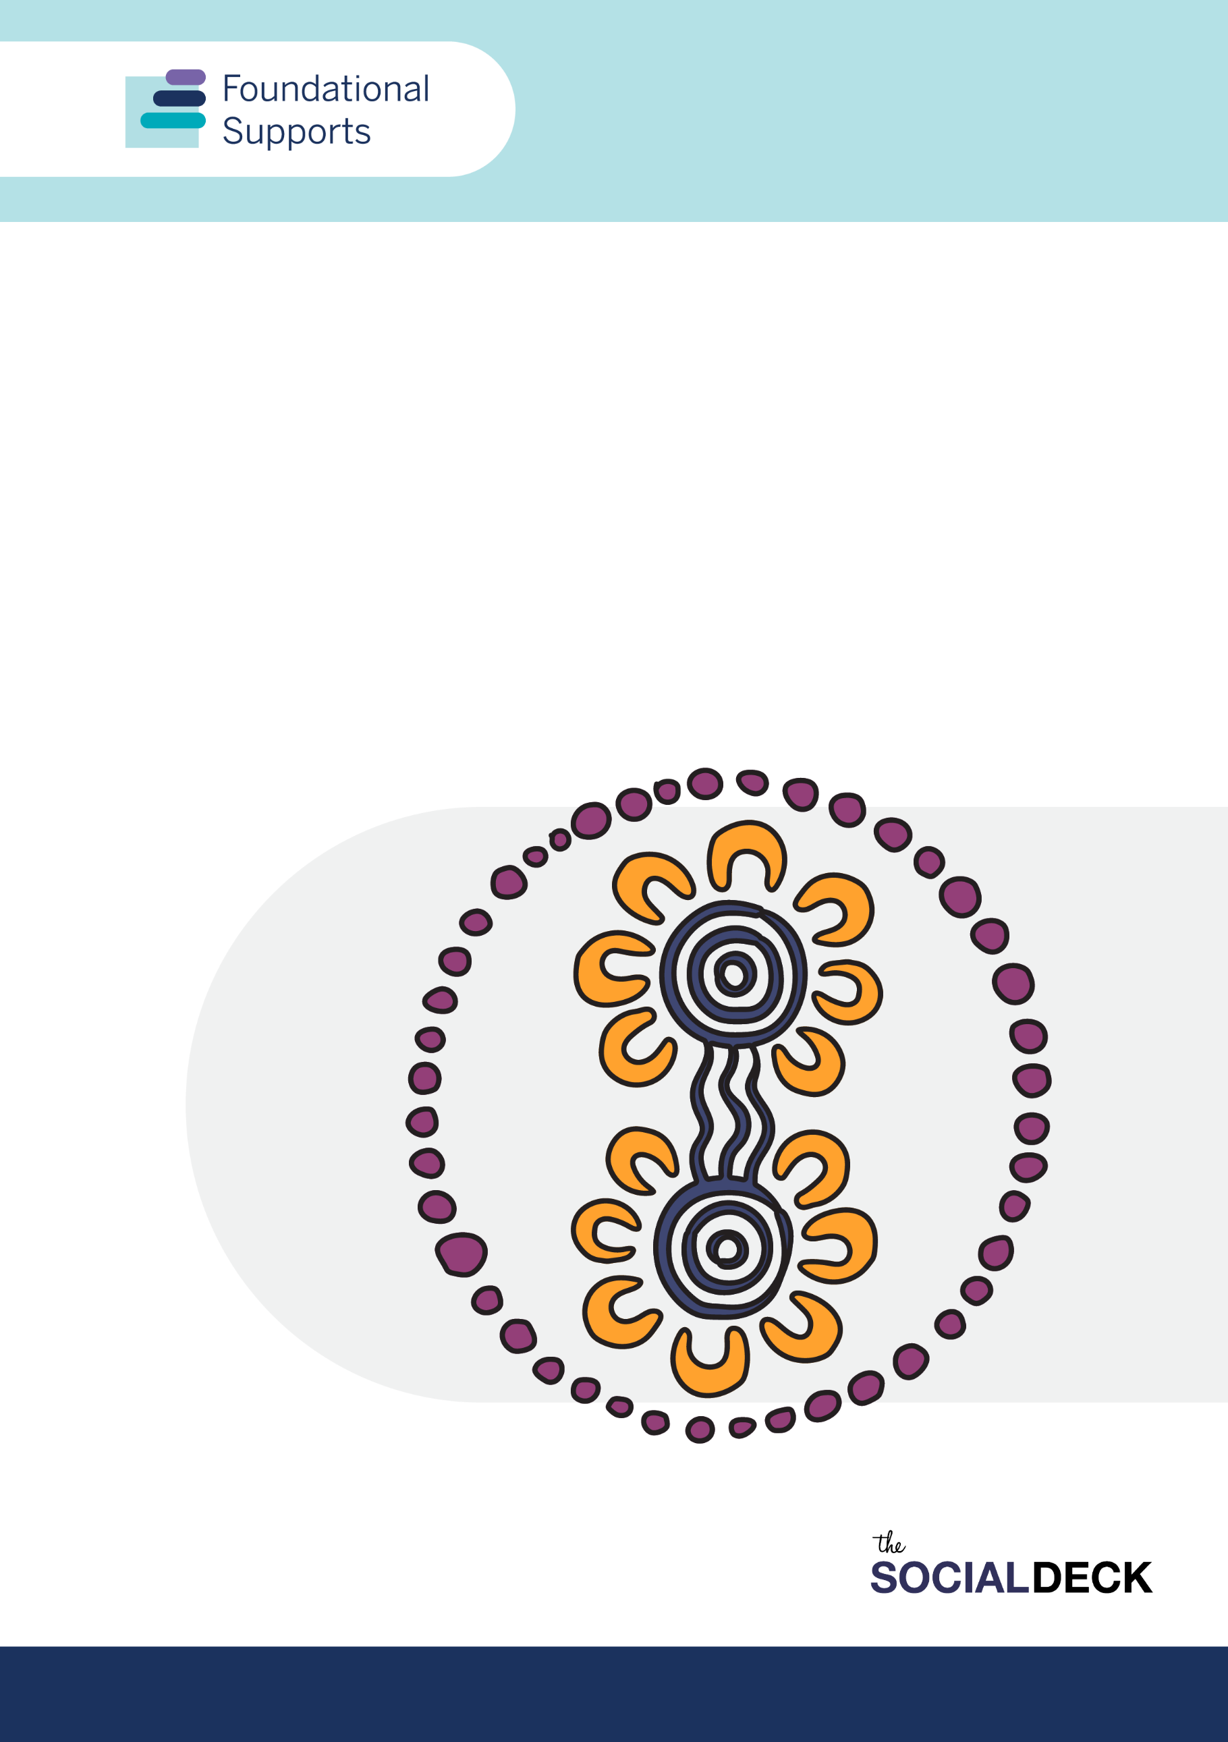
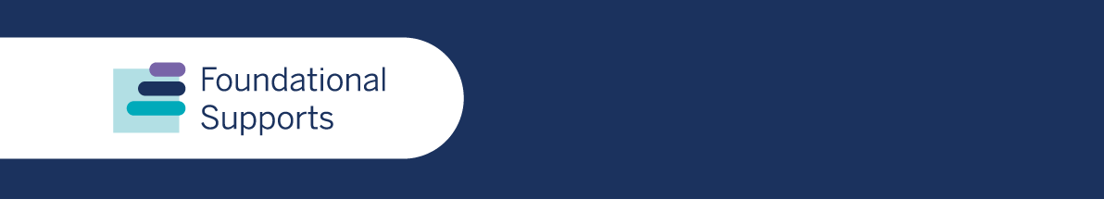
First Nations Consultation Report
Aboriginal and Torres Strait Islander community discussions on the design and delivery of foundational supports
Report produced by The Social Deck


This artwork was designed and produced by Gubbi Gubbi and Githabul artist, Shauna Hill for The Social Deck.

Acknowledgement of Country
The Social deck wrote this report on the unceded lands of First Nations peoples. We acknowledge the Traditional Custodians, who have lived on and cared for Country for thousands of generations, and recognise their continuing connection to land, waters and community. We pay our respects to them and their cultures, and to Elders past and present.

Language used in this report
We use the terms ‘First Nations people’, ‘Aboriginal and Torres Strait Islander peoples’ and ‘mob’ in this report. We understand that every mob is different and there are a range of nations, cultures and languages across mainland Australia and throughout the Torres Strait. We use these terms with respect.

Contents
Recognition 3
Introduction 4
Summary of identified themes 6
Engagement insights & findings 7
General supports 7
Targeted supports for children under 9 years 13
Implementation, quality and safety 14
Other considerations 15
Summary of community suggestions 16
Appendix A: Engagement methods 18
Yarning circles 18
Participants 18
Submissions and questionnaire data 18
Appendix B: Participation data 19
Face to face and online events 19
Submissions and questionnaire responses 19

Recognition
The Department of Social Services and The Social Deck would like to thank the following organisations and their staff for their help and support in bringing Mob together for yarning circles:
- East Arnhem Kids Hub
- SSI – First Nations Reference Group
- Far North Community Services
- Moonaboola Community Development Aboriginal and Torres Strait Islander Corporation
- Soward Consultancy
- Goorroomba Consultancy

Introduction
This report summarises consultations with First Nations communities about foundational supports for people with disability and their families. The feedback from yarning circles is mostly focused on general supports which include information, advice and referrals, and capacity building for individuals, families and community. Some conversations also included a focus on Targeted Supports for children with developmental delay, concern and/or disability and their families, carers and kin.
We drew the information contained in this report from what people told us at events and from submissions and questionnaire responses submitted by First Nations people and organisations.
These were initial consultations to help design general supports and supports for children with developmental delay, concern and/or disability. There is a need for co-design and additional engagement with First Nations people in communities to design the specific supports needed relevant to different cultures and locations. A community-led approach will help to support self-determination, and governance is in place for the delivery of foundational supports. It will allow mob to work WITH mob and FOR mob in an effort to address the National Agreement on Closing the Gap measures.
This report accompanies the full Consultation Report on General Supports and the Consultation Report on Targeted Supports for Children under 9, which include more detail.

Who and how we engaged
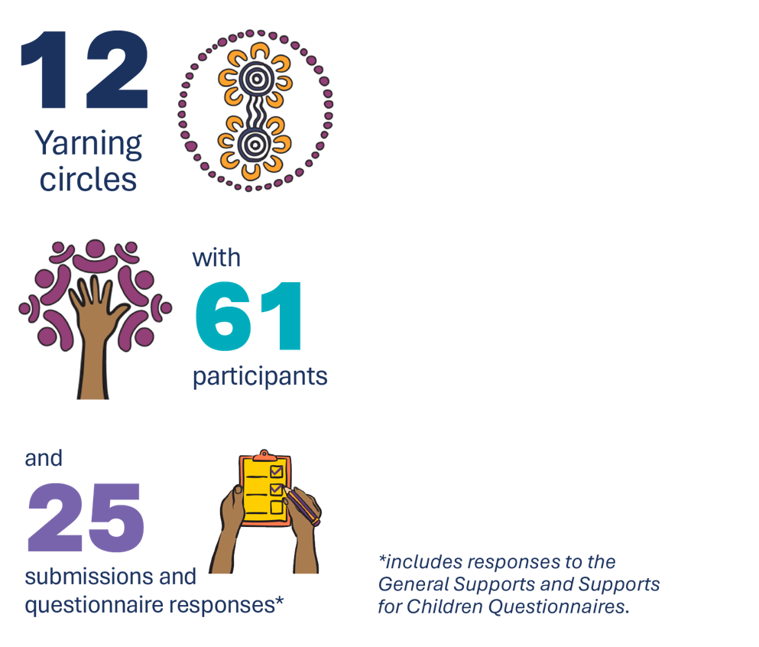
From September to November 2024, The Social Deck organised 12 yarning circles with Aboriginal and Torres Strait Islander peoples, and national, state and local organisations who support them. Yarning circles are the preferred method of engagement with communities and participants. Story-telling and truth-telling are important concepts in Aboriginal and Torres Strait Islander culture, so engaging with participants in this way encourages genuine and active engagement in a safe and trusted space.
Yarning circles occurred in both face to face and online settings and included representation from First Nations people in:
- Nhulunbuy – Gove Peninsular (Northern Territory)
- Alice Springs (Northern Territory)
- Campbelltown (New South Wales)
- Maryborough (Queensland)
- The Kimberley (Western Australia)
- Canberra (ACT)
Participants from different regions across the country took part in 3 of the online yarning circles. A breakdown of engagement in yarning circles is available at appendix B.
Wodi Wodi woman, Vikki McIntyre from The Social Deck, facilitated most of the yarns, with the active help and participation of Aboriginal and Torres Strait Islander organisations within the communities. Some discussions were led by local Aboriginal facilitators.

Areas of discussion
Participants yarned about:
- Existing Supports - supports that work well for mob, and what doesn’t work well.
- Information, advice and referral - getting good information and advice about disability and information on disability supports for mob and their families/carers and kin, including how to get help to find and connect with the right supports.
Individual and family capacity building – areas such as peer support and self-advocacy, education, rights awareness, decision making, leadership, relationship building and life skills.
- Community capacity building - building the capability of community and non-government organisations to deliver services that are inclusive and accessible. It included providing advice and resources that support equal access to good and inclusive community services for mob with disability.
Targeted supports for children 0-9 years, covering:
  - capacity building for families and caregivers of children with developmental concerns and disability
  - getting good information and advice
  - types of additional supports needed
  - trusted services
- Quality and safety - What we need to think about to make sure extra supports outside of the NDIS are good quality and keep our mob safe?
NB. Targeted supports and quality and safety were only included as topics in engagement depending on location and audience.


Summary of identified themes
This report highlights the urgent need for foundational supports tailored to the unique challenges experienced by First Nations people and communities. Supports must prioritise cultural safety, accessibility, and collaboration with First Nations organisations and communities. This will ensure better outcomes for mob with disability and their families. Participants called for urgent action to address existing gaps and empower communities to implement and lead solutions that are:
→ culturally appropriate
→ culturally safe
→ easily accessible
→ First Nations centred
In yarning about solutions for these challenges, Aboriginal and Torres Strait Islander peoples identified these key findings:
Limited effective supports:
→ Existing services are scattered and often inaccessible, especially in remote areas.
→ Long wait times and lack of culturally safe options deter mob from engaging with supports.
Access to information and advice
→ Communities face difficulty navigating fragmented systems.
→ Language and transport barriers exacerbate access challenges.
Individual and family capacity building
→ Individuals need peer support, life skills training, and advocacy resources.
→ Families require culturally relevant parenting workshops and leadership training.
Community capacity building
→ Services must integrate cultural competence and infrastructure upgrades.
→ Collaboration across service providers is essential to reduce fragmentation.
Targeted supports for children 0–9 years
→ Early intervention services are critically lacking in remote areas.
→ Tailored hubs could provide therapy, developmental monitoring, and parent training.
Quality and safety concerns
→ Workforce development is essential to ensure culturally safe and high-quality services.
→ Certification for accessible venues could improve trust and usability.
Other considerations
→ The need for self-determination
→ Changes to the justice system to account for disability and cultural needs.
→ The need for adequate funding, staffing and training for Aboriginal community controlled organisations to reach out directly into communities in ways that are culturally safe and effective.

Engagement insights & findings

General supports


Existing supports
There are broad systemic challenges faced by Aboriginal and Torres Strait Islander peoples in accessing existing supports, preventing them receiving timely and effective support.
Across all First Nations engagement, it was rare to get a positive response from participants when talking about current supports. When there was mention of a service or support that works well, this was generally followed by ‘however’ or ‘but’ and an existing drawback or challenge.
Participants specifically talked about:
long wait times
a lack of awareness of available supports
a lack of cultural sensitivity
insufficient funding
bureaucratic complexities
transport issues
‘There is not really anything that works WELL for mob now...’ – Participant, Alice Springs
Story
A participant in the Alice Springs yarning circle, came from a remote Homelands community and regularly travels over 400 kms to access his current disability support service face to face. He generally tries to tie these visits in with other medical appointments, but these can be few and far between and not necessarily in Alice Springs.
While there is a large Aboriginal Health Service (AHS) in his community and within the local Alice Springs area, these services focus on treating and supporting Aboriginal people with prevalent chronic diseases and illnesses like kidney disease, diabetes and rheumatic fever. This means there is a large gap in services for anyone who has other disabilities as the AHS are not funded, resourced or trained to support them.
Most existing services are not First Nations specific and mob are reluctant to ask for help from services they aren’t familiar with. In addition, existing services are often difficult to access, particularly for mob in rural and remote areas.
‘The lack of resources in rural areas means we have to travel great distances in order to access services. There is almost no public transport. So this is a big expense and burden.’ – Individual respondent, general support questionnaire
The lack of culturally safe options, together with long wait times, deter mob from engaging with supports. Many said they ‘gave up’ because they were frustrated, confused or felt disrespected.
Stakeholders also said barriers to accessing supports often stem from systemic racism and a general distrust of government and non-Indigenous organisations. Current disability and some community systems and supports are set up in a way which disadvantages First Nations people when their culture, language and connection to Country is not reflected.
Some stakeholders felt they were ‘set up to fail’ with a lack of sufficient funding and resourcing. They talked about the ‘inevitable change of government’, changing priorities and the withdrawal of existing funding being a consequence. In addition, the inability to adjust policy and processes to better address the needs of First Nations people with disability, and their families, is frustrating and unhelpful.
‘there needs to be committed and adequate funding provided to Aboriginal and Torres Strait Islander disability services to ensure they can meet demand in a culturally responsive and safe manner ‘– Submission
A lack of long-term funding also impacts local organisations’ abilities to engage and keep local workers. Some participants suggested funding be delivered differently in First Nations communities to increase supports and help strengthen local service delivery.
‘Put funding in to create businesses so there are workers to actually be had, instead of companies having not enough staff ‘ – Individual respondent, general supports questionnaire
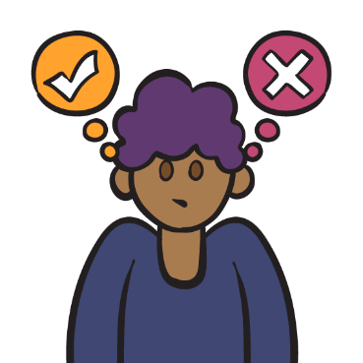

Information, advice and referral
Mob find it difficult to navigate what they see as the existing fragmented systems and bureaucratic processes in the disability support space. Often, the participants we spoke to were unfamiliar with the services and supports that may be available to them and, in some cases, are steered away from non-Indigenous supports to specific First Nations organisations.
Participants said this happened due to the misconception by non-Indigenous organisations that mob ‘get funding for everything’ so all Aboriginal and Torres Strait Islander organisations are able to help them. This is not often the case as these organisations are not resourced, funded or equipped to support people with disability.
‘These ways result in engagement and delivery disconnect when interacting with colonial systems as these systems are not designed to support Aboriginal and Torres Strait Islander people.’ – Submission
Language barriers exacerbate access challenges, especially in rural and remote areas. For those who don’t have English as their first language or with literacy challenges, the sometimes complex information around disability and available supports can be difficult to understand. In addition, existing information is rarely translated into Aboriginal languages, is not effectively shared or not disseminated at all.
‘…good information and advice from the government and service providers about what supports are available and how to access them are not disseminated effectively to the community, as information is being provided by multiple bodies, in multiple formats.’ – Submission
Mob can feel uncomfortable or fearful approaching non-Indigenous services, especially where they are not known. Culturally, ‘shame’ plays a big part in Aboriginal and Torres Strait Islander culture and prevents many from making an approach to ask for help. They want their information and advice to come from known and trusted sources within the community and prefer it delivered face to face. However, organisations trusted by mob do not necessarily have referral processes, information or advice for people with disability, within their remit.
‘I'd wanna [sic] have a place where I could go straight to. That's culturally safe. That's run by blackfellas that I can walk in and I can say I'm struggling. It's hard.’ – Participant, ACT
Story
A participant in the online yarns, from metro Sydney, related how he had taken some time to convince himself to call a non-Indigenous service and ask for help. He only did this because he was not aware of a specific Aboriginal service in his area that could help him with his issue. He had a long wait before being able to talk to someone on the phone and when he eventually spoke to a worker, he was told someone would get back to him about his particular issue. He never heard back from them and was ‘too shame’ to approach them again.
‘I’m not going to beg for their help if they don’t want to help me’ – Online participant

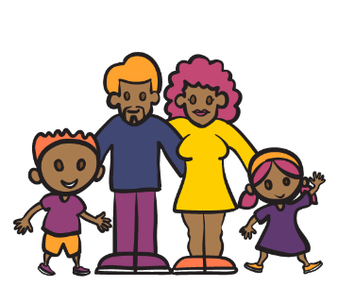

Individual and family capacity building
In every yarning circle there was a call for individual peer support, life skills training, and advocacy education and resources. Without exception, however, participants stressed the success of building capacity for both individuals and families would only be achieved if delivered ‘by mob for mob’. The need for cultural safety, awareness and for trust within the families and the community, is considered paramount, as the general consensus among mob is culture comes before disability.

For families
Participants said families require culturally relevant parenting workshops, peer support and leadership training. Having these types of supports would give families the tools they need to be more effective in managing the challenges they may encounter while supporting their loved ones with disability. Mob spoke about the need to have mentors, peers and leaders who understand the dynamics of First Nations communities and families to ensure effective outcomes.
The way these programs are delivered needs to meet the needs of families who are in different circumstances, including having options for one-to-one capacity building and access to group programs.
Some mob raised concerns about the ability of single parent families to access capacity building services due to their circumstances. There is a belief those who are less financially ‘well off’ and who may have more complex challenges, are missing out on supports in favour of those in better circumstances.
‘Mother capacity building - single parent disability families need A LOT more financial and social support - make an adversity scoring and triage via adversity. Those that are most disadvantaged are missing out to richer, easier families to support.’ – Individual response, general supports questionnaire

For individuals
For individuals, mob yarned about the lack of education around what is available in terms of supports and the lack of training around simple life skills or the support for families and communities to fill the roles of trainers and educators for people with disability, especially in rural and remote communities where services are almost non-existent.
‘Educating educators and having consistent guidelines on care and supports across the state and country.’ – Individual response, supports for children questionnaire

Advocacy and self-advocacy
There is a little awareness of advocacy services or what advocacy is or can achieve. The complex kinship systems in Aboriginal and Torres Strait Islander cultures also mean there can be many potential advocates who are not directly related to a person but are seen as the spokesperson for the family. Therefore, there is an urgent need for individuals and their families and carers to be educated about advocacy and self-advocacy services. Specifically:
what they are
how they can help
how to access them.
‘I think it's [advocacy] definitely a big area of need that's not well supported or not really known about in the region.’ – Participant, Nhulunbuy


Community capacity building
The most frequent response to questions asked about community capacity building was the need to institute cultural competence and awareness training for all staff and volunteers in community organisations who deal with First Nations people. Again, this was deemed a priority but should go hand in hand with more disability awareness training on a broad scale (include ALL forms of disability.)
Community organisations need to understand the intersectional challenges that mob with disability face. This could be achieved through more thorough cultural awareness training that encompasses truth-telling and focuses on the causes of intergenerational trauma, introduced diseases and systemic racism.
‘Outreach support, a lot of people we meet, a referral and information service isn’t what they need. They have broken relationships or fallen on hard times, information services just don’t really do much, but outreach programs like what TJ does meet the person where they’re at and follow up with them to help them continue to attend the services. Cross sectoral and holistic approach to helping people.’ – Participant, Kimberley
In addition, participants talked about non-Indigenous organisations often steering mob away from their services because they feel ill equipped, or they are ‘not inclined to help us’. In some circumstances, participants were aware of non-Indigenous services receiving a portion of their funding that is specifically meant to cover First Nations support but they do not see the organisations putting those funds to use in supporting Aboriginal and Torres Strait Islander peoples with disability.
‘Mainstream services need to be held accountable for the Aboriginal and Torres Strait Islander funding they receive. Better yet, this funding would be better suited going to Aboriginal services that are providing culturally responsive and safe support for our mob’. – Submission
Participants talked about accessibility issues when visiting community organisations and services and said infrastructure upgrades are needed to make all buildings physically accessible.
In addition, mob talked about the lack of cohesion between different services. There is frustration they have to ‘shop around’ service providers in order to find the correct supports for themselves or their family members. Collaboration across service providers would help to reduce this fragmentation.
‘We need blak fullas who understand us. And we need one place for everything. We need all the different things in one place instead of going to all different places.’ – Participant, Kimberley
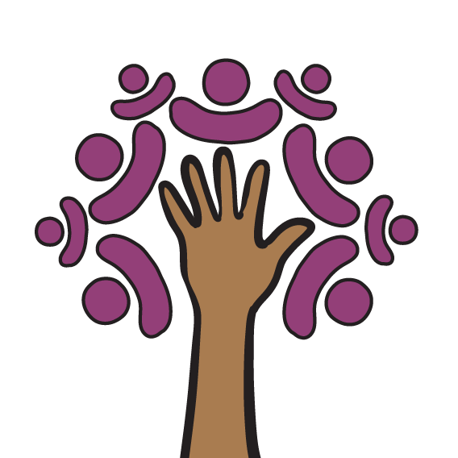

Targeted supports for children under 9 years
Governments are working on the design of targeted supports for children under 9 years old who have developmental delay or concern. Some of the yarns focused on the kinds of targeted supports that might be needed and what else should be considered about supports for young children and their families.
Many participants called for further detailed consultation and co-design to take place in relation to targeted supports for First Nations children, given the very real gaps that exist in the health and treatment options between them and the rest of the Australian population.

Early intervention
Participants talked about the importance of targeted supports so children with developmental delays or disability do not ‘fall through the gaps.’ This includes a focus on diagnostic, monitoring development, and therapies for identified conditions.
‘Our kids are falling through the gaps, and they’re not getting the help that they need. That early intervention process needs to happen.’ – Participant, Maryborough
Early intervention tailored to the needs of Aboriginal and Torres Strait Islander children was seen as a critical service that would have a major impact on reducing reliance on more intensive services being needed. But some community and other organisations suggested early intervention services are critically lacking in most areas, and specific disability services tailored for First Nations children are almost non-existent, despite the high rates of development delay and health conditions First Nations children experience.
‘the high rates of developmental vulnerability, preventable developmental conditions and disabilities among Aboriginal and Torres Strait Islander children and adults indicates decades of missed opportunities for early assessment, identification and provision of developmental supports. In many cases, this is the result of inaccessible or non-existent early years services where people live; [sic] market failures of universal service systems. It is essential that the foundational supports system does not mirror these failures.’ – Submission

Capacity building for parents and carers
In line with family capacity building, mob want to see programs to empower parents and caregivers with the knowledge and skills to identify and address developmental delays early. This would empower parents/carers with the knowledge and ability to identify development delay in their children before early learning commences.
As noted under family capacity building, the way these programs are delivered must suit the needs of different families. Many families will not have other care arrangements or respite options for their young children so they can attend parenting programs. One-to-one capacity building supports may be important to help address this but should be combined with local supports that help to build connections between parents and community.

Use of community controlled organisations in service delivery
Participants have suggested that local Aboriginal Medical Services (AMS) and other types of community controlled organisations be funded and resourced to deliver specific health and community services for children. Overwhelmingly, participants said the AMS was their preferred way to seek advice about any health issues and these organisations receive a high level of trust and respect in the community.
‘The aboriginal health service is a single point of contact for all services and supports but has resourcing issues resulting in huge waitlists.’ – Individual respondent, supports for children questionnaire
‘telling the aboriginal medical centre helps because they know our mob’ – Individual respondent, supports for children questionnaire
Participants also stressed the need for cultural exposure and connection to identity for children who live with, or are fostered by, non-Indigenous families. There is concern fostered Aboriginal and Torres Strait Islander children are losing touch with kin, culture and their country because non-Indigenous foster families don’t understand the need for children to have these connections. Mob want to see a holistic approach that prioritises cultural identity alongside developmental needs.
‘have family support workers and aboriginal health workers in mainstream general practice…. the town/area I live in has a [First Nations] population of 9.8%, however there is NOT ONE Aboriginal Health, Family Support or Occupational therapist accessible through GPs in the town.’ – Individual respondent, supports for children questionnaire
While in many comments block funding wasn’t preferred, (it was seen to preference larger organisations rather than community-controlled or local community organisations), a few stakeholders suggested it will be needed to sustain early intervention programs that are integrated with other types of services (e.g. through schools and early childhood), particularly in regional and rural areas.
‘some block funded supports is what is needed ……to support individuals to get that early intervention and then hopefully not need ongoing services’ – Participant, Nhulunbuy

Implementation, quality and safety
Ensuring quality and safety in foundational supports was a central concern, with a particular focus on workforce development and cultural competence.
Participants noted services must be delivered by staff who are both skilled in disability support and trained in cultural safety to build trust and confidence within the community. Certification processes, including cultural competence certifications for venues and staff, were suggested to guarantee consistent standards.
Participants also discussed the value of safe physical environments, including accessible venues that reflect cultural considerations. They highlighted the importance of services maintaining strict quality assurance frameworks so supports provided outside of the NDIS are reliable and deliver the desired outcomes.
When yarning with First Nations stakeholders, concerns were raised about how foundational supports will be implemented and whether it would be based on large grants or tenders. They noted that larger block funding can disadvantage smaller Aboriginal and Torres Strait Islander organisations who are unable to compete with the larger, mainstream services.
Stakeholders suggested that this may not support community-led and community-controlled approaches that are critical to effective service delivery in First Nations communities.

Other considerations

In the justice system
Concern was raised around the inability of the criminal justice system to evaluate and treat mob with disability or take these into account. This issue is one of many intersectional challenges that face mob with disability. This extends to child safety and the juvenile justice system where children with often undiagnosed disability, particularly with conditions like Foetal Alcohol Syndrome Disorder (FASD), are constantly shifted around locations, families and institutions without ever being given the treatment or support they require to become well-functioning members of the community.
‘Lack of culturally responsive and safe disability services and racist stereotypes are not acceptable reasons to incarcerate our mob.’ – Submission

Self-determination and community-controlled
The need for self-determination and making sure there is adequate funding, staffing and training for Aboriginal and Torres Strait Islander controlled organisations to reach out directly into communities in ways that are culturally safe and effective would enhance the effectiveness of foundational supports. Participants underlined how self-determination, advocating for increased funding and resources for Aboriginal and Torres Strait Islander controlled organisations could help in leading community-focused initiatives. Empowering First Nations organisations with adequate staffing and training was seen as a vital step to ensure culturally safe and effective outreach into communities.

Collaboration
Mob also spoke about the need for inter-agency collaboration. They called for improved integration between sectors such as justice, health, and education to address systemic gaps.
‘Government departments fight against each other… Education fights against health, saying, “It’s your problem.” Health fights against NDIS, saying, ‘‘That’s your problem’’ and then this child’s in the middle, not getting any services.’ – Participant, Nhulunbuy

Addressing intergenerational trauma and systemic racism through culturally grounded programs and outreach is essential, and this requires a whole of system response. Truth-telling, along with intersectional and cross-cultural training for all service providers would strengthen relationships and foster trust.

Summary of community suggestions

Disability hubs
Participants overwhelmingly supported a hub model, with a ‘no wrong door’ approach, to simplify access and reduce fragmentation of services. These hubs should provide a centralised space for disability support, education and advocacy, while also serving as a trusted point of contact for families and individuals. Tailored hubs could provide diagnosis, therapy, developmental monitoring, and parent training. A suggestion was made to base these hubs on the NT Disability Hub model that existed before the NDIS was implemented.
In the absence of a physical hub, mob called for a dedicated phone number where they could ring and speak to another Aboriginal and/or Torres Strait Islander person to give them the correct information and advice or refer them to a service. They suggested mob with disability could also staff this service as it would not be contingent on physical location and First Nations staff with lived experience of the intersectional challenges are best placed for these roles.
‘Rather than a hub being just a physical place, if that can’t be done, the next best option is to have a 1300 number staffed by First Nations people.’ – Participant, Maryborough

Workforce development
Employing and training mob with lived experience to deliver supports and provide mentoring. In addition, non-Indigenous services should be required to deliver and maintain training on cultural and intersectional competencies to ensure services are safe and responsive.
‘take some black people with disability on and skill them up. They've got lived experience. Who better to be the people that are then you know, talking to other mob with disability and you know, giving them advice, giving them referrals?’ – Participant, ACT
Suggestions also included developing a certification process to assure mob that organisations were Aboriginal and Torres Strait Islander friendly. This would allay fear and mistrust and give mob confidence to approach non-Indigenous services in the absence of First Nations specific services.
‘Service providers of foundational supports need to invest in cultural training so staff develop organisational and individual capacity to deliver culturally responsive and safe supports, and build community trust in services.’ – Submission

Holistic education for individuals and families
Supporting individuals and families with disability education programs that place cultural identity and connection at the forefront is vital for cultural and personal safety. Many First Nations families do not recognise disability in the same way as non-Indigenous families. This means those services are not fit for purpose when it comes to educating First Nations people with disability, their families and their communities.
‘In our communities, the concept of disability does not exist. Instead of stereotypically categorising people as different or disabled, our people are taken as they are.’ – Submission

Adequate funding
Dedicated and sustainable funding to enable Aboriginal and Torres Strait Islander-controlled organisations to meet demand in a culturally appropriate manner. Participants talked about the frustrations of having funding that is not sustained for any length of time and prevents real and successful outcomes.
‘Community are sceptical about the new foundational supports services being adequately funded due to previous experience with funding being pulled from the services providing the needed support to our mob’ – Submission

Cultural exposure
Providing cultural exposure and training for non-Indigenous foster carers, workers, and families engaging with First Nations children, would give children with disability and/or developmental delay, a connection to their heritage and enable them to feel included and safe in unfamiliar surroundings.
These recommendations reflect the priorities of Aboriginal and Torres Strait Islander communities to create a system of foundational supports that are culturally safe, accessible, and community-led.
‘For the new foundational supports to be culturally relevant, responsive, and safe for Aboriginal and Torres Strait Islander people, the supports must be infused with Aboriginal ways of knowing, being, and doing.’ – Submission
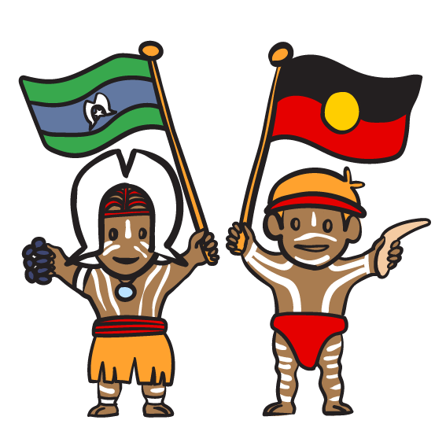

Appendix A: Engagement methods

Yarning circles
The Social Deck engaged with First Nations people through informal discussion groups in the form of yarning circles. Yarning circles are used to collect information through establishing a relationship with First Nations participants prior to gathering their stories through their own storytelling.
Yarning circles are a culturally appropriate and safe way to engage with Aboriginal and Torres Strait Islander peoples. They create a more comfortable space for people to be able to speak openly and honestly with those who are not from their community. This is especially relevant given the inherent lack of trust some people may feel towards government institutions and their agents.
Yarning has its own protocols that go hand in hand with other conventions and practices when engaging with First Nations people. For each yarning circle, our First Nations consultant reached out to trusted community members or local organisations to get advice on community protocols. We invited trusted community members or organisations to be present to help with the yarning circles.
Each yarning circle was different and developed with relevant local leaders and organisations. Based on their advice for each location, the consultation may have focused on particular topics or deliberately avoided certain areas of discussion.

Participants
The yarning circles drew participants directly from the community. Local Aboriginal organisations were instrumental in helping to distribute information about the yarns and provided advice and guidance on where and when the yarns should take place.
Participants included those with disability, carers and family of people with disability and stakeholders from within local Aboriginal organisations.
All states and territories were represented and included participants from metro, regional and remote areas.

Submissions and questionnaire data
Information in this report has also drawn from submission and questionnaire data submitted from various First Nations organisations and survey answers where the respondents identified themselves as being Aboriginal and/or Torres Strait Islander.

Appendix B: Participation data

Face to face and online events
State | Location | Event date | Partner | Attendees
NT | Alice Springs | 29/10/2024 | Disability Advocacy Service | 4
NSW | Online | 13/11/2024 | SSI – First Nations Reference Group | 5
NT | Nhulunbuy | 14/11/2024 | East Arnhem Kids Hub | 2
ACT | Weston | 19/11/2024 | Soward Consulting | 8
ACT | Ainslie | 19/11/2024 | Soward Consulting | 1
National | Online | 25/11/2024 | Recruited | 6
National | Online | 26/11/2024 | Recruited | 6
QLD | Maryborough | 27/11/2024 - AM | Moonaboola Aboriginal Corporation | 2
QLD | Maryborough | 27/11/2024 - PM | Moonaboola Aboriginal Corporation | 13
National | Online | 28/11/2024 | Recruited | 7
WA | Kimberley | November | Goorroomba | 7

Submissions and questionnaire responses
 | No.
Submissions and responses to the questionnaire | 25

