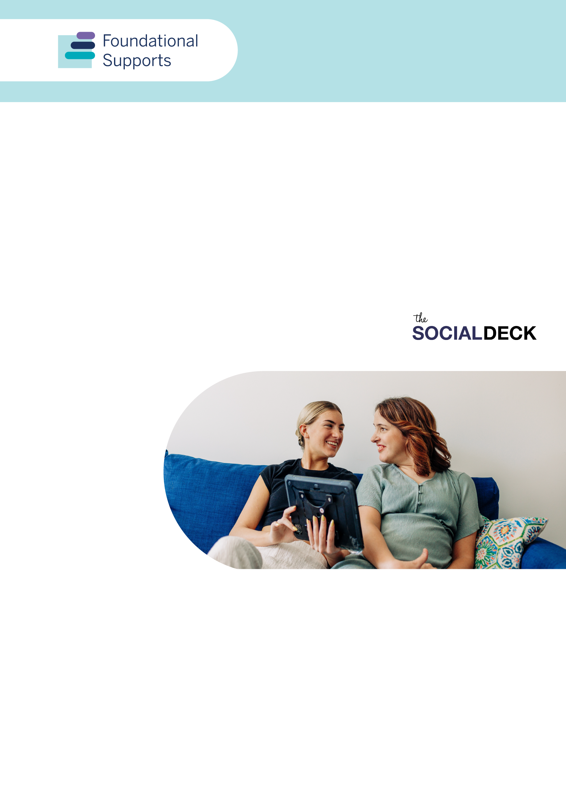

General Supports Summary Report
A summary of feedback from consultations for the design and delivery of additional supports for people with disability in the community.
Report produced by The Social Deck

Acknowledgement of Country
The Department of Social Services acknowledges the Traditional Owners of Country throughout Australia on which we gather, live and work. We acknowledge all Traditional Custodians, their Elders past, present and emerging and we pay our respects to their continuing connection to their culture, community, land, sea and water.
This is a summary of the more detailed General Supports Consultation Report.
Introduction
Governments are working together to design and deliver specific supports in the community. These are supports additional to mainstream services and supports people get through the National Disability Insurance Scheme (NDIS).
We call these foundational supports. They will help people with disability, and their families and carers in a number of important areas.
In September 2024, the Australian Government began consultations about foundational supports, starting with general supports. These consultations took place from 20 September to 5 December 2024.
The consultations followed the work of the NDIS Review panel. They suggested foundational supports are needed in the community.

Participation
More than 4,000 people gave feedback during the consultations on foundational supports.
People from all states and territories took part in the consultations. More than one-third were from regional, rural or remote areas.
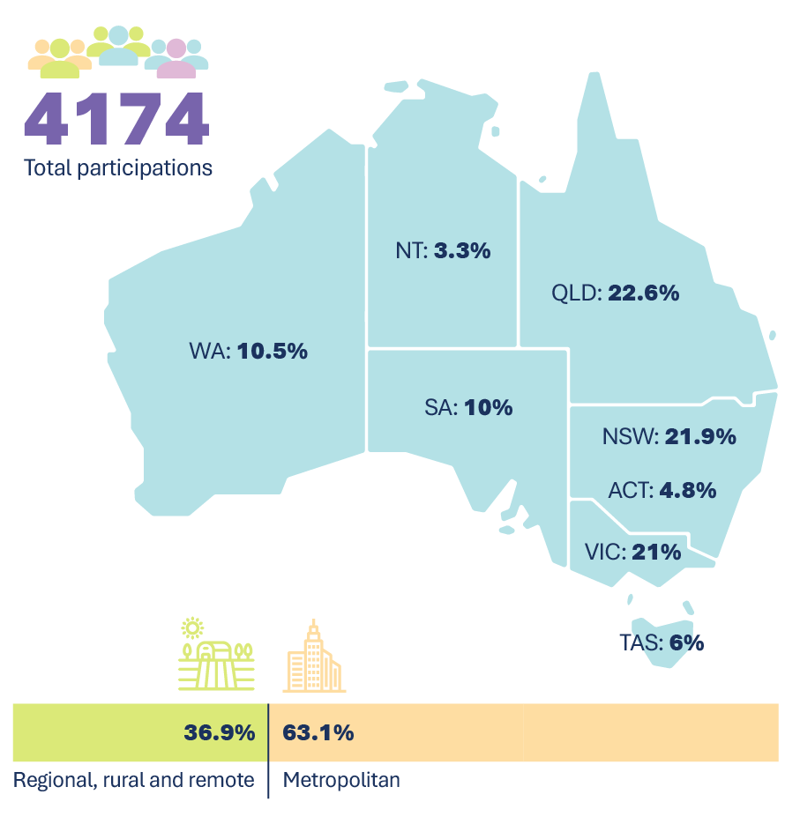
Figure 1: Total participations, and percentages across states and territories, and location.

Participation in general supports
People answered questions in the General Supports Consultation Paper. They also had other materials like information sheets, FAQs and translated materials. This helped them think about what general supports might look like in the future.
We held 78 events about general supports. We also had a questionnaire, submission process, and Ideas Wall. People gave feedback in lots of different ways.
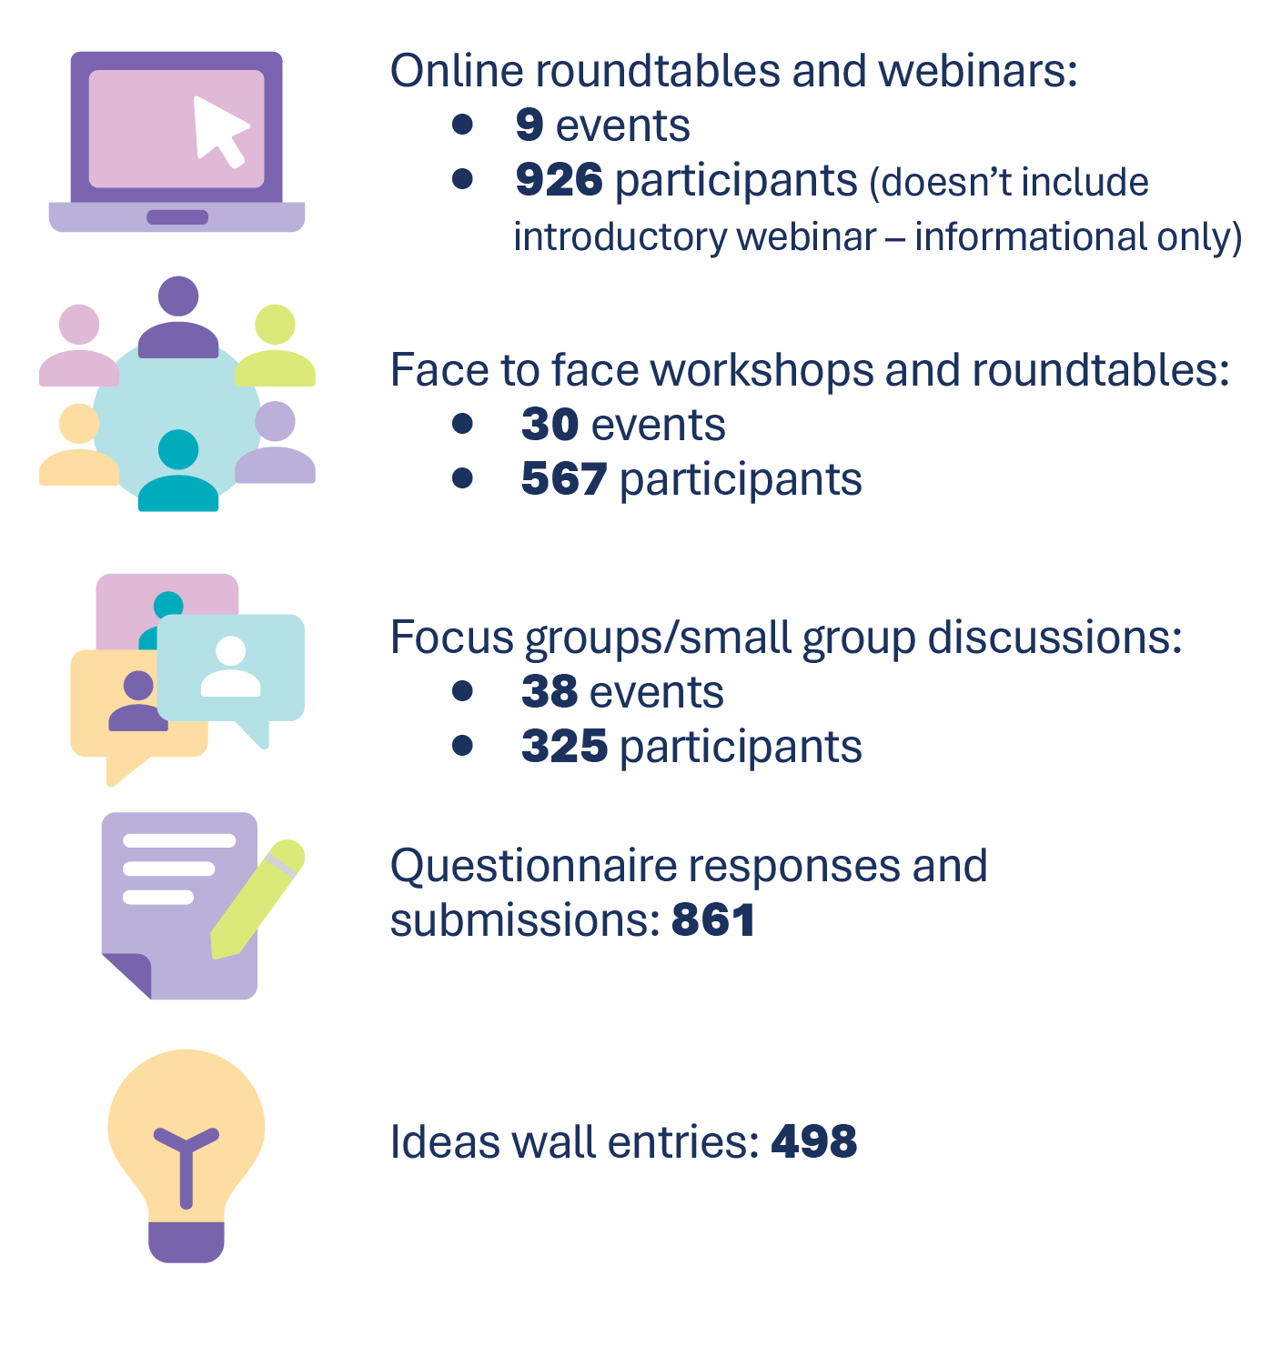
Figure 2: Consultation event types and participations
The largest group of people who took part in consultations about general supports were those with disability or mental/chronic health concerns (49.1%)*.
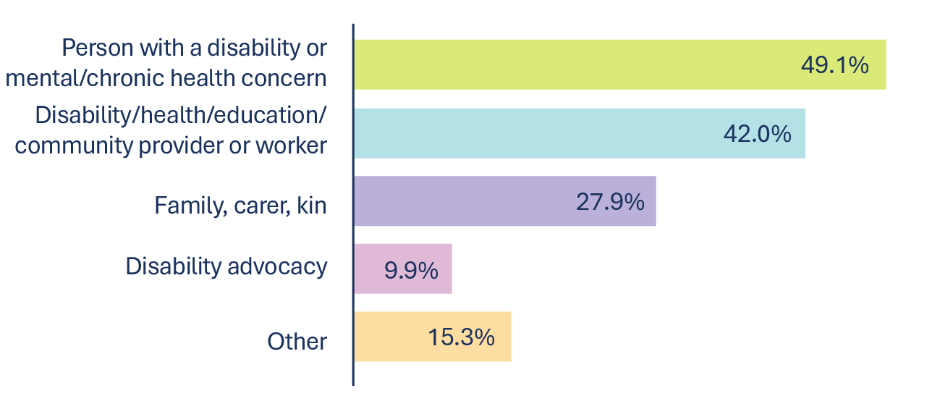
Figure 3: Participation percentages across interest groups *Note: Demographic data was not collected at all events, and participants could select multiple categories.

Main themes
There are 9 main areas that many people said would be most helpful in a general supports system.
 | - Trusted organisations in the community should give information, advice and capacity building. They should have enough long-term funding to deliver tailored supports and programs. This included local, state-based and national representative and advocacy organisations.  - They want more ways for organisations to work together. They need longer-term funding and flexible models. This will allow disability led peak bodies and grassroots groups to partner together. They could seek funding for vital local solutions, existing or needed, for:  - advocacy  - peer support  - capacity building.
 | - Deliver general supports in local settings with wraparound services. This included community hubs, neighbourhood centres, libraries and other community places.  - It is critical local supports for disability, health and mental health come together. They could offer programs tailored to different groups.  ‘…come to it as you wish, drop-in, you don’t ‘have to identify’ as a certain disability or with a group. It is for everyone’ – Person with disability, workshop event
 | - Invest in peer support networks. Make sure they are sustainable and available to more people. This included support for online, social media and in-person forums.  ‘Peer support creates natural learning environments where people feel safe to ask questions and share experiences. Through these connections, people gain real-world knowledge about navigating support systems and build confidence through shared experiences’. – Submission
 | - Support systemic advocacy as well as self-advocacy and family advocacy programs. This will drive long-term changes. In particular, access and inclusion to extra supports in community and mainstream services.

 | - Digital, centralised platforms and services for tailored, searchable and local information about supports.  - Most people suggested non-government, trusted and expert organisations deliver these platforms and services. They have the appropriate knowledge and resources. Many said governments should invest in a better centralised system for finding quality providers and supports.  ‘Having access to dedicated helplines with trained staff who can offer personalised guidance would make everything feel more manageable. It would be helpful to have more localised information that points to nearby services and support.’ – Submission
 | - Give effective information, advice and capacity building through other support systems. General supports must include GPs, allied health including social workers, schools and early childhood centres.  ‘I find it helpful to be able to access someone who is knowledgeable in the availability of services; this might be a wellbeing officer within a school, a local community health service or an experienced allied health professional’ - Individual respondent, general supports questionnaire
 | - Training and education programs for community supports, disability supports, mainstream services and public education.  ‘If we could shift community knowledge and service delivery knowledge, we would suddenly open doors.’ – Individual participant, targeted discussion
 | - Invest in a sustainable and trained workforce. This includes case management or navigator roles within general supports. Workforce needs often came up in feedback about services in regional, rural and remote areas.
 | - Improve communication and information about what foundational supports are. Include how they will be delivered alongside the NDIS and mainstream services and who will be eligible.

Designing and putting general supports in place

Quality, safety and accountability
People said we could deliver general supports with quality, safety, accountability and innovation if we make sure of the following:
- Strengthen and increase the workforce for foundational supports. Workforce shortages are a big issue in regional, rural and remote areas. It can be hard to attract and keep staff without job security or being able to match incentives or benefits given in other sectors or industries. For organisations to keep quality staff to provide supports, they will need:
- investment/funding for training and placement of the right people
- professional development opportunities for staff
- incentives for regional, rural and remote staff
- support for outreach activities
- to build a strong sense of team and connection with community.
- Have longer-term funding to deliver the ‘base’ of general supports with grants. Be flexible to encourage innovation. People said longer-term arrangements will:
- strengthen information systems and accuracy of information and advice
- make sure advice is based on evidence
- give time to build and sustain local and place-based initiatives
- increase collaboration
- lead to more reliable and ongoing capacity building supports
- better involve people with intersectional identities
- sustain self-advocacy and peer groups, including workforces and volunteers supporting these.
- Make sure there is quality and safety in services and programs through:
- registration and compliance
- a good complaints system
- investing in systemic advocacy
- involving all people with lived experience in monitoring and evaluation.
This includes those from diverse and marginalised groups.
- Progress and effectiveness of general supports must be measured and evaluated. This should be through defined outcomes and indicators Commonwealth and state and territory governments are accountable to. Co-designing these outcomes and measures is critical. Community and users of general supports MUST be included.
- Build on what’s working and make sure existing support systems are sustained. Participants stressed the need to:
- use existing trusted organisations and services to make sure quality and safety for people with disability
- have a fair and clear transition process and period for any changes in NDIS supports.

Supports tailored for people from specific and intersectional groups
There was very strong and consistent feedback saying we need fair supports meeting the needs of people from diverse and intersectional groups. This includes First Nations people, people from culturally and linguistically diverse backgrounds and people in the LGBTIQA+SB community.
People said we need specific supports tailored for young people and children. This is important, especially through key life transitions, and with different types of disability. Supports should be trauma-informed, accessible and neuro-affirming. This includes cultural safety and self-determination for First Nations people.

What needs to be considered when implementing general supports
Participants said these approaches would help guide how foundational supports are designed and implemented:
 | Human rights focus in the design and delivery of foundational supports. This included aligning with the Convention on the Rights of Persons with Disabilities
 | Co-design supports with people with disability, families and carers
 | Maintain choice, control and independence for people with disability
 | Self-determination for First Nations communities
 | Independence of organisations delivering information and advice is considered
 | Continuity of supports for people with disability whether they’re in the NDIS or not
 | Equity in eligibility and delivery of general supports. They must meet the needs of people from diverse and intersectional groups

Align with other strategies and reforms
We heard governments need to link foundational supports with other strategies. In particular, Australia’s Disability Strategy. General supports also need to be delivered alongside:
- possible reforms and updates to Australia’s Disability Discrimination Act
- other responses to the Disability Royal Commission
- Australia’s obligations under the United Nations Convention on the Rights of Persons with Disabilities (the UNCRPD)
- NDIS reforms based on recommendations of the NDIS Review. For example, legislative changes in the NDIS and provider and workforce registration
- state and territory disability plans
- the Australian Government’s gender equity, Closing the Gap and other related strategies.
Acknowledgement and thanks
The Social Deck thanks the thousands of people who contributed experiences, feedback and ideas to this consultation process. In particular, we acknowledge the strength and contributions of people with disability, and their families, carers and kin in sharing your stories.
A note on language
We acknowledge that people use different words to talk about disability and each person will have a way of talking about disability and about themselves they like best. Some people like to use ‘disabled person’ (identity-first language), while some like to use ‘person with disability’ (person-first language), and some are fine with using either.
We use person-first language to talk about disability. This means we usually use the term ‘person with disability’ in this Report. The language used in this Report is not intended to diminish an individual’s identity as a person with disability.
We recognise the appropriate use of language varies between individuals and disability communities. We acknowledge the importance of having conversations with individuals about their preferred language.

