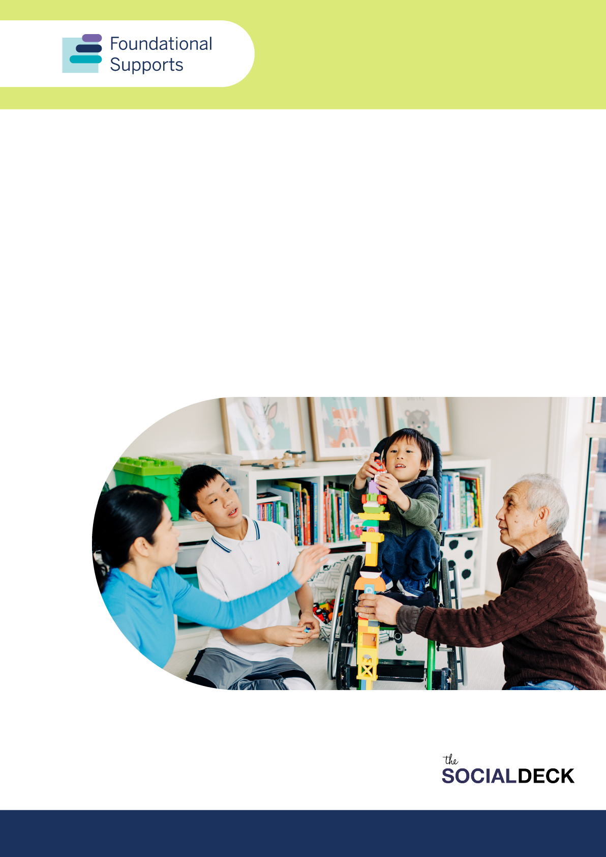

Supports for Children under 9 Consultation Report
Consolidated feedback from consultations for the design and delivery of foundational supports for children with developmental concern, delay and/or disability and their families, carers and kin

Report produced by The Social Deck

Contents

Acknowledgement of Country 4
Contributors 5
Foundational supports and scope of consultations 6
Scope of consultation and this report 6
Executive summary 7
How and who we engaged 10
Outcomes and considerations 12
Chapter 1: What is needed in general supports for children under 9 13
What we heard 14
Key issues and barriers 14
The solutions – what’s needed 16
Delivering general supports for children and families 23
Chapter 2: Targeted supports for children under 9 26
What we heard 27
Key issues and barriers 27
Building on what works 30
The solutions – what’s needed 31
Delivering targeted supports 37
Chapter 3: Implementation, workforce and integration with community and mainstream supports 41
Commissioning and funding 42
Workforce capacity and capability 44
Integrating with community and mainstream settings and services 45
Other considerations in the design and delivery of foundational supports for children 50
Appendix 1. Engagement methods and analysis 51

Acknowledgement of Country
The Department of Social Services acknowledges the Traditional Owners of Country throughout Australia on which we gather, live and work. We acknowledge all Traditional Custodians, their Elders past and present and we pay our respects to their continuing connection to their culture, community, land, sea and water.
The consultations informing this report took place on the unceded lands of First Nations peoples across Australia. The Social Deck acknowledges the Traditional Custodians who have lived on and cared for Country for thousands of generations, and recognises their continuing connection to land, waters and community. We pay our respects to them and their cultures, and to Elders past and present.
A note on language
Any reference to parents, carers and families in this report is intended to include the diversity of people who fulfil these important relationship roles for the children in their lives, including biological and adoptive mothers and fathers, LGBTIQA+ parents, kin / kinship systems, guardians and other carers, and extended family members (and many combinations of these).
When we refer to stakeholders, we are referring to the whole range of organisations, professionals and experts who contributed to the consultation process.
Throughout this report we use the term ‘developmental delay’ and ‘developmental concern’. When young children are slower to develop physical, emotional, social, communication or thinking skills than expected (beyond usual differences in development between children of the same age), it’s called developmental delay. Developmental delay can be identified in the way children move, communicate, think and learn, or behave with others. Developmental concern is where someone identifies there may be a difference in development and are not sure if it is significant and there is no diagnosis.
We know people use different words to talk about disability and each person has a way of talking about disability, and about themselves, they like best. Some people like to use ‘disabled person’ (identity-first language), while some like to use ‘person with disability’ (person-first language), and some are fine with using either.
We use person-first language to talk about disability. This means we usually use the term ‘person with disability’ in this report. The language used in this paper is not intended to diminish an individual’s identity as a person with disability. We recognise the appropriate use of language varies between individuals and disability communities. We acknowledge the importance of having conversations with individuals about their preferred language.

Contributors
The Social Deck wish to acknowledge the invaluable contributions of many people and groups as part of the consultations informing this report. Thank you to the hundreds of people with disability, their families and communities, as well as other stakeholders, who gave their time and shared their experiences and ideas.
A special thank you to the following partners who facilitated or coordinated events, and without whom the consultations would not be possible.
Partner organisations and individuals who led or coordinated engagement activity specific to the support for children consultations:
- Kindred
- Association for Children with a Disability (ACD)
- Kiind
- The Child and Family Disability Alliance (CAFDA)
- Soward Consultancy (First Nations engagement)
- Australian Autism Alliance
- Broome Youth and Families Hub (WA)
- East Arnhem Kids Hub (NT)
- National Ethnic Disability Alliance (NEDA)
- Different Journeys (VIC)
- Heidi La Paglia (Online workshop)

Foundational supports and scope of consultations
This report is about the design and delivery of foundational supports for children under 9 with developmental concern, delay and/or disability and their families, carers and kin.
Foundational supports are specific supports that are additional to mainstream services and supports accessed through the National Disability Insurance Scheme (NDIS). They will help people with disability, and their families and carers in a number of important areas.
Foundational supports were one of the key recommendations of the Independent Review into the NDIS (NDIS Review), which handed down its final report in December 2023. This consultation builds on the significant engagement the NDIS Review undertook with the disability community, to further understand what foundational supports may look like.
Governments are working together to design foundational supports. They would be jointly planned and funded by the Commonwealth and state and territory governments.

Scope of consultation and this report
This report includes consultation insights about both general and targeted supports for children under 9 and their families, carers and kin. It accompanies the General Supports Consultation Report. Feedback was provided in response to the Consultation Paper on foundational supports for children with developmental concern, delay and/or disability and their families, carers and kin.
It consolidates feedback from community members (mainly families and carers), disability advocates, allied health and other professionals who contributed to the supports for children questionnaire, or participated in dedicated online or in-person events about supports for children with disability, developmental delay and/or concern and their families and carers. Additional insights about general supports, for all people with disability and families and carers, can be found in the General Supports Consultation Report.
This report includes some feedback on areas that go beyond the scope of foundational supports, including the supports for children consultation paper. For example, feedback relating to education and schooling policies, health, mental health, employment and justice. Comments sometimes also focused on areas for change or improvement in the NDIS.
Feedback which is outside of the scope of the foundational supports consultations has been shared with governments but are not a focus of this report.
Throughout this report, we use examples and quotes to demonstrate more clearly some of the issues and ideas people spoke about. These are based on real contributions, however, they have been deidentified to protect the privacy of participants.

Executive summary
Governments are working together to design and deliver additional supports in the community. These are known as foundational supports. They are specific supports that are additional to mainstream services and supports accessed through the NDIS.
During October to December 2024, families, carers and stakeholders were asked to contribute their views on foundational supports for children with developmental concern, delay and/or disability and their families, carers and kin (supports for children).
There are different types of foundational supports. This report covers general supports (Chapter 1) and targeted supports (Chapter 2) for children, and their families, carers and kin. It also includes considerations about how they should be delivered (Chapter 3).
General supports would be for all children and families, regardless of whether they are in the NDIS. Targeted supports would be for children under 9 with developmental delay and their families who would not be in the NDIS, and need more assistance than mainstream services and general foundational supports.

What we heard
More than 1,000 people provided feedback as part of the consultation process on supports for children. This feedback is in addition to feedback received from families and carers during general supports consultations (refer General Supports Consultation Report).
Families and carers shared their experiences about supporting their children and family in accessing supports. They focused heavily on the need for foundational supports to:
- support existing programs that are working well
- be delivered in natural settings, trusted places and through trusted organisations
- prioritise family-centred practice and ensure supports focus on the whole child and whole family
- provide access to accessible and timely allied health supports, delivered by a strong allied health workforce.
Consultations took place at a time of uncertainty for many families. Due to this, feedback about supports focused a lot on issues about access, reassessments and eligibility for the NDIS. Parents and carers specifically shared concerns about losing NDIS supports for their children and wanted to better understand how the NDIS and targeted supports outside of the NDIS would work together. While we acknowledge this feedback, this report doesn’t cover many of the areas specific to concerns about eligibility or assessments for the NDIS.
The feedback has been shared with governments.

What will be most helpful
Common types of supports that families and carers said would be helpful in foundational supports for children and families, carers and kin included.
One-to-one advice and referrals through allied health and multidisciplinary teams  Allied health supports were the most common type of support families and carers mentioned their child and family would need to help them build skills and capacity, including to connect with other services and supports.  When it came to capacity building and providing direct supports to children, families reiterated the importance of integrated and multidisciplinary teams across allied health, other health and education. | Local peer, family and support groups  Families and carers spoke about the importance of having peer support groups to get advice from other parents and carers, particularly those who may be further ahead in their journey to access supports. This included playgroups which also provide children with direct supports and opportunities to build social connections and skills.  Families particularly focused on support groups being available in their state or region, as they understand what is available locally and can provide the most relevant information and advice.  Peer supports also referred to online networks and discussions on platforms such as Facebook.
Parenting programs and education  We heard programs that help to build skills and confidence of parents, families, carers and kin to support their child, and the whole family, are important.  These programs include training, mentoring and tailored resources to provide parents and carers with practical skills to support their children’s needs including in areas such as speech and language development and to better communicate with and understand their loved one’s experience. | Programs for children, and including families and siblings  We heard programs and services that provide different types of therapies should be an important part of targeted supports for children with developmental delay.  This included play, art, music and other therapies, as well as sports.  Consistently parents and carers suggested programs and supports be inclusive of the wider family, in particular siblings, where appropriate.
Culturally safe and relevant supports  Many participants reiterated the importance of having well-funded and sustainable organisations that are locally-based and provide relevant and culturally safe supports to families based on their needs. This included Aboriginal community controlled organisations, faith-based organisations (including churches), ethnic community councils and groups, and support services for people who are LGBTIQA+ are a central part of the foundational supports system for children and their families, carers and kin. | Digital directories of services, with regional networks  Families and carers said digital directories of disability services for young children are important to support foundational supports, including to get access to supports and to find out more information and advice.  There were strong views this should not be an information website, but a directory of what services are available to children, including at a regional level.

What is needed to make foundational supports for children under 9 and their families, carers and kin work
Stakeholders broadly supported the need for a redesigned system for general supports, particularly for improving the funding and commissioning of important disability and family-led advocacy organisations, and information, advice and capacity building programs in community.
Consistent with the General Supports Consultation Report, there was broad agreement family capacity building needs to include longer-term and sustained supports (rather than one-off) and be delivered through a range of ways including place-based and community-led programs.
The need for targeted supports for children with developmental concern, delay and/or disability is also strongly supported, noting there is a critical gap in the current service system providing supports for young children between the NDIS and mainstream services.
Representative organisations (including disability, early childhood, allied health and First Nations organisations) often highlighted the need for supports for children to:
- be transitional and universal, so no child falls through the cracks
- be designed and delivered with longer-term and more flexible funding arrangements to enable a national approach to sustain programs, while allowing for flexibility to address local community needs
- include multidisciplinary teams with key workers or similar models in place to improve the integration of supports across systems and reduce burden on families and carers
- be available to people locally and in regions
- allow for supports to be delivered through a range of natural settings, such as schools, early childhood settings and in the home.
Stakeholders also reiterated governments should focus on:
- better explaining foundational supports including clarifying eligibility
- reducing complexities and costs in the assessment processes
- invest to build a sustainable and diverse workforce, including in regional areas, to deliver supports for children and their families.
Note: There weren’t a lot of differences between states and territories in relation to general supports or targeted supports for children. Where there are differences between states and territories or geographic regions, these are highlighted in relevant sections of the report.

How and who we engaged

Participation
There were 1,020 participations in the specific consultations on supports for children. Of the total participations, 554 (or 54%) were family, carers or kin of children with disability.
Participations came from every state and territory with 32% from regional, rural and remote areas.
Families and carers, other community members and stakeholders provided feedback through workshops, targeted discussions, submissions and a questionnaire.
We held 21 events online and in-person as part of specific supports for children consultations. Online events were held for each state and territory. Four (4) of the events were yarning circles with Aboriginal and Torres Strait Islander families and stakeholders including in Nhulunbuy (NT), Kimberley (WA) and Canberra (ACT).
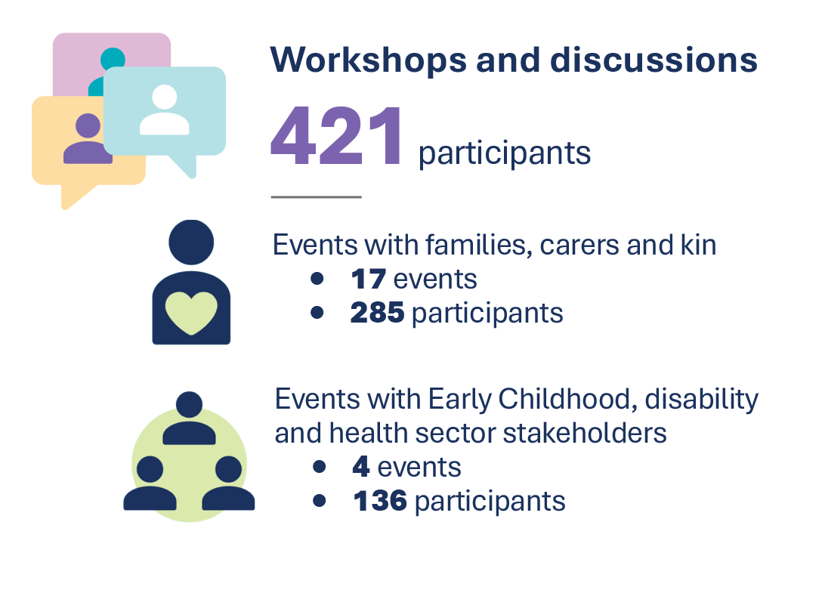
Figure 1: Number of events and participations across workshops and discussion
Some of the events with family, carers and kin were with specific population groups such as First Nations families, families from a culturally and linguistically diverse (CALD) background, families with autistic children, and parents of people (including children) with complex and high needs.

There were a total of 573 responses to the questionnaire, with families, carers and kin making up more than 64% of the responses*. An additional 26 respondents provided submissions by email specifically about supports for children.
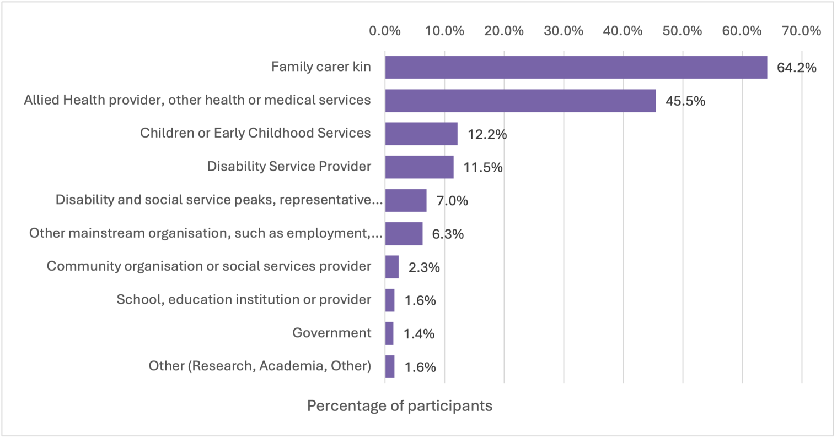
Figure 2: Participation percentages for the online questionnaire and submissions
*Note: Participants could select multiple options
In addition to the questionnaire and submissions, families, carers, people with disability and other stakeholders contributed to an online Ideas Wall.
This initial phase of consultation did not include specific engagement with children. However, this would be recommended as part of designing specific parts of foundational supports for children in the future.

Engagement content and activities
Methods of engagement were designed to gain qualitative information on key barriers, experiences and ideas to guide development of foundational supports. Engagement activities were focused around 3 areas of discussion:
- Information, advice and referral
- Children and family capacity building
- Targeted supports for children, including lower intensity or periodic child and family-centred allied health supports.
More information about how the engagements were delivered and analysed is at Appendix 1.

Outcomes and considerations

Focus and scope of supports for children
We heard the focus on targeted supports for children with developmental concern, delay and/or disability is a positive move, noting this is a critical gap in the current service system. It was noted a pathway to access such supports outside of the NDIS is needed, particularly given the importance of timely and early intervention for children.
Respondents broadly endorsed the focus on supporting families holistically and the vision of children thriving in their families and communities.
‘It is wonderful to see a focus on providing early childhood intervention to children with developmental delays recommended as part of targeted foundational supports for children and families. We see this as one of the biggest gaps for the existing system and observe this delaying timely intervention for children and families in need.’ – Submission

Outcomes
There wasn’t a lot of specific feedback about the intended outcomes, noting they are broad and cover the main areas mentioned by families, carers and stakeholders.
One outcome some people identified as missing was improved inclusion in early learning and education settings. They suggested:
- general supports should include further developing the capacity of education and other mainstream settings to be more inclusive of children with disability
- targeted supports for children should aim to ensure families have the necessary information and supports in place to support their children in mainstream schooling.
Additional outcomes for families, carers and kin have been listed in the full General Supports Consultation Report.
Considerations
Three key principles were commonly identified for the design and delivery of targeted supports:
- Design of supports are person-centred and consider the whole of child and should adopt a whole of family approach and family-centred practice.
- Models of supports are co-designed with families and carers, as well as children where it is appropriate.
- Early childhood supports, including targeted supports for children that sit alongside the NDIS, should be available to all children who need them—no matter where they live in Australia or what their circumstances are—to ensure all children have the opportunity for the best start in life. This included ensuring more equitable access to supports for children who may experience disadvantage or have additional barriers to accessing appropriate supports, such as children in rural and remote areas, who are First Nations, or from families who may not speak English as a first language.

Chapter 1: What is needed in general supports for children under 9
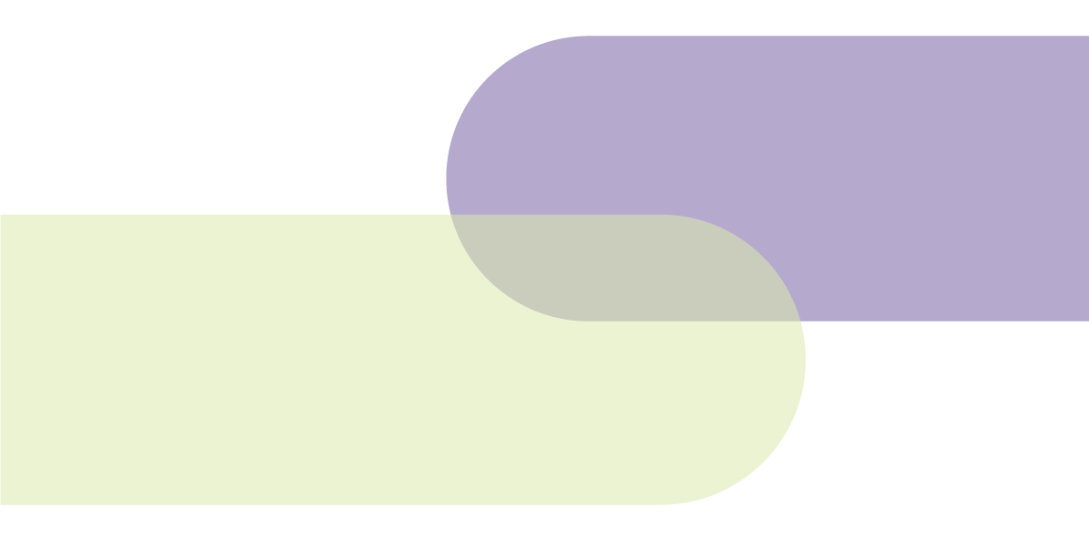

General supports:
Overview from consultation paper
General foundational supports are intended to support children with developmental concern, delay (including suspected delay) and/or disability and their family, carers and kin. Children getting the NDIS and children not getting the NDIS may be able to access general foundational supports relevant to their needs.
The consultation paper included the following examples of what these supports could look like:
- Information, resources and advice to help parents to understand their child’s needs, build their capacity and navigate service systems. This includes building knowledge about their child’s developmental milestones in terms of physical, emotional, social, communication and cognitive skills. Information may offer advice on how to set routines and to support a child with developmental concern, delay (ensuring information is neuro-affirming), disability and how to advocate for their child.
- Facilitated parenting groups/peer support groups to give general information and advice about parenting and delays in their child’s development. This includes social and emotional support for families and carers.
- Shorter or one-off courses or workshops on specific topics. For example, child development, supporting emotional regulation, how to prepare for important transition points in a child’s life.
- Evidence-based online and in-person programs on development to provide tools and practical ways to support parenting and child development.

What we heard

Key issues and barriers
Families and carers suggested information is currently difficult to find. Out of 268 families and carers who responded to this question, only 10% said they found it easy or very easy to find information about disability supports and 76% said it is hard or very hard to find information.
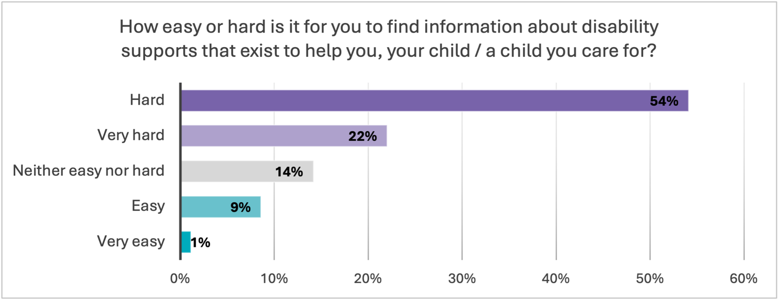
Figure 3: How easy or hard it is for people to find information about disability supports (percentage of respondents) (n=268)
The following specific issues and barriers were often raised about finding information and advice, or connecting with support groups and programs (capacity building).

Families are time poor and over-burdened
We heard many families are time poor and over-burdened with the amount of work, time and effort they need to put in to find and navigate services. This was particularly prevalent among single parents who described difficulties in having the mental capacity and time to find, navigate and access supports for their children. A number of single parents reiterated the importance of having people walk alongside them, such as case workers and in-home supports, to support the whole family.

Lack of information and confusion navigating systems
We heard many families find it hard to navigate different systems and to understand who to reach out to for supports for their children and families. This was particularly an issue for those with newly diagnosed children, and those who are not in the NDIS and so don’t have access to support coordinators and support workers.

Disconnected with early childhood and community supports
People suggested families who are not connected with any existing services in the community find it particularly hard to find supports when they identify their child may be experiencing developmental delay or concern.
Some communities are disconnected with early years supports so don’t receive early information and advice about their child’s development at all. One example of this was in relation to Aboriginal and Torres Strait Islander families in rural and remote areas where early childcare supports may be limited. It was noted supports need to be universal.
As noted in SNAICC’s submission ‘the high rates of developmental vulnerability, preventable developmental conditions and disabilities among Aboriginal and Torres Strait Islander children and adults indicates decades of missed opportunities for early assessment, identification and provision of developmental supports. In many cases, this is the result of inaccessible or
non-existent early years services where people live; market failures of universal service systems. It is essential the foundational supports system does not mirror these failures.’
Building on what works
There were many examples of existing programs people said are working well. These were most often family-led or peer-run programs or supports available in a family’s local area.
Families and stakeholders reiterated the need to build on what is already available. This included supporting existing family support groups and successful parenting skills and education programs in their regions. A few stakeholders suggested governments should ensure there is more awareness among the community of existing programs in place as part of building the foundational supports system.
Families, carers and stakeholders also said new programs and implementation of general supports for children and families must be co-designed with families, carers, children and siblings, so programs are informed by what has worked and helped in the past.

The solutions – what’s needed

Preferred sources for information and advice
Respondents were asked to choose their top 3 sources of trusted information and advice about supports and services. As shown in Figure 1, the most common 3 sources selected were:
- talking to other people with disability and/or carers (185)
- referrals from GPs or other health professionals (184)
- family peer or support groups (148)
The least commonly selected sources of trusted information were 1800 phone lines (7), the Disability Gateway (9) and the Carer Gateway (28).
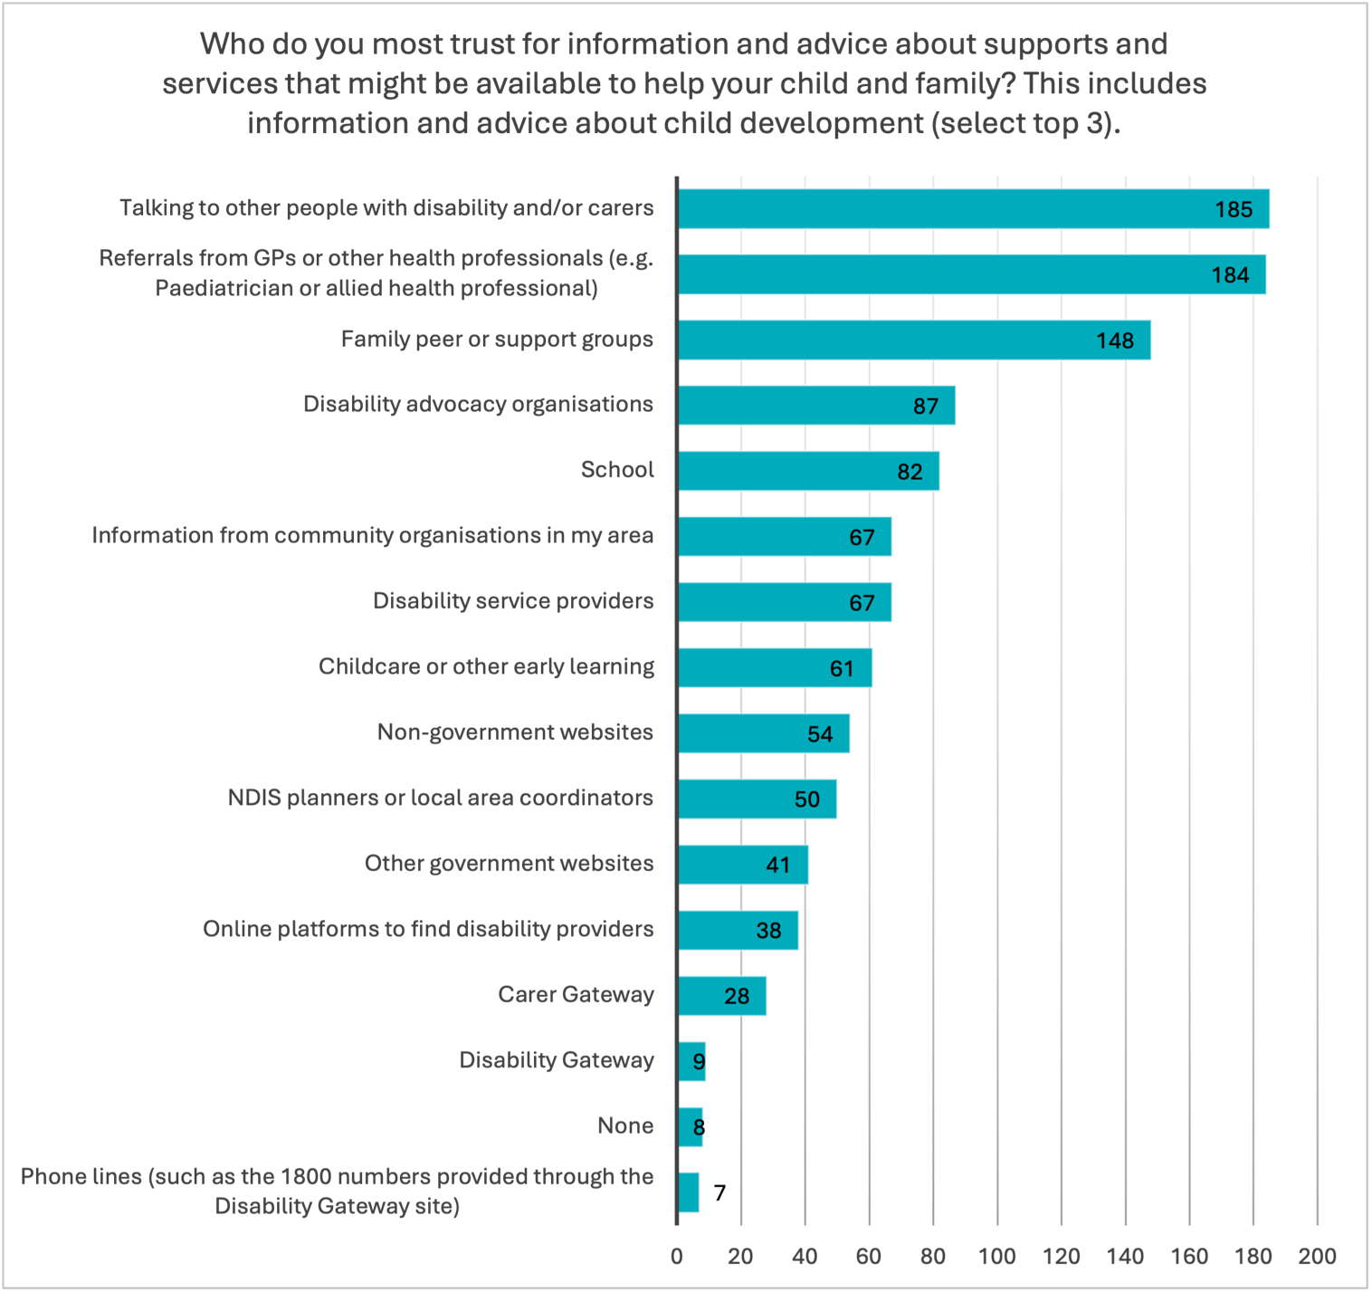
Figure 4: Sources of trusted information and advice (select top 3) (n=268)

People with lived experience and other families and carers
Overwhelmingly other parents, families, carers and people with lived experience of disability were named as the most trusted sources of information and advice. Parents often explained this is because information from other parents is credible and honest, whereas other sources of information about supports can be inaccurate or designed to ‘sell you a service’.
Parents, in particular, noted people with lived experience were the most helpful in providing advice about what supports their child can access or may need in the future. They often raised the importance of someone understanding their needs, but also being able to talk to them and their child in an empowered, informed and neuroaffirming way, and this often came from peers or organisations led by lived experience.
‘We prioritise engaging with disabled-led organisations (like Aspect or Reframing Autism) and value the advice of autistic adults and/or carers of children with similar profiles.’ - Individual respondent, supports for children questionnaire

Referrals from GPs and allied health professionals
We heard often that allied health and other health professionals, for example occupational therapists (OTs), speech pathologists, therapists, paediatricians and GPs, are key helpers in finding the right support for families. In addition to providing therapy, they point families to other services they might need, help them with NDIS paperwork, and recommend or connect them with trusted colleagues and other supports in the community.
For example, a number of families from the NT said their child’s OTs had been the best source of information and support, generally because they have the best knowledge about what a child needs and what supports exist in the system for them that are available in their region.

Peer and family support groups
Parents frequently mention word of mouth from other families has been more helpful than official channels, particularly for understanding what services are available locally, how to navigate the NDIS, and which approaches work best. Families and carers identified family-led peer groups and disability advocacy organisations are critical for connecting families with supports and running peer support and education programs.
‘We're now a part of a home education community and the support that we have found there… I have found out about other service providers, other peer support groups, other social skilling groups for my kids that were just not coming up in my online searches. That word of mouth has been crucial.’ – Participant, QLD family and carer online roundtable
Parents provided numerous examples of peer support groups and local organisations they connect with, which were frequently mentioned as being helpful for families to connect with other families and share resources and experiences.
‘Being able to be around peer-led, family-led and people with disability-led organisations that offer supports for families that are free, that are strength-based, that are family-centred, that are empowering and evidence-based, and really be able to build on my skills as a family leader.’ – Participant, ACT family and carer online roundtable

Networks supporting culturally diverse and migrant families
Peer and culturally specific networks emerged as being especially important in supporting people from CALD backgrounds with information and advice, in particular for engaging parents from migrant and refugee communities.
Staff supporting these communities suggested often people will only reach out to familiar networks and faith-based or religious leaders for advice because ‘a lot of time this is the only thing people know…they won’t trust the GPs, mental health nurses etc.’
They also suggested community hubs provide a more familiar space for people from CALD backgrounds to visit, which is important for ‘helping to create a socially safe model’. It allows families who frequent the area to ‘drop-in’ so when programs come and go, ‘the doors stay the same’.
In the focus group with parents and carers hosted by the National Ethnic Disability Alliance (NEDA), a number of parents suggested having culturally competent volunteers they can connect with can help to bridge gaps in understanding.

Playgroups supporting peer connections
Playgroups were a particular type of support parents and carers suggested need to be continued and, in some cases, better supported through foundational supports. These were particularly mentioned as being important for:
- connecting families and children with supports for the first time
- offering tailored and culturally safe spaces for parents and carers to find out about available supports in the community that suit their needs
- supporting children’s social and other developmental needs.
First Nations playgroups
Playgroups were often described as working well to support First Nations families, particularly in regional areas. Examples of playgroups that are culturally safe and responsive included those which:
- had routines and activities that are culturally-led so trust and relationships with families can develop
- embed evidence-based approaches such as the SWAY (Sounds, Words, Aboriginal Language and Yarning) model, an oral language and literacy program based on Aboriginal knowledge, culture and stories
- use the trusted space for staff to connect families with a wide range of services within a Hub, including health services (immunisation, developmental checks, allied health), housing, food bank, schools, counselling, family violence services and drug and alcohol services.

Online discussions
Parents often use Facebook groups and other social media platforms to find and access services, particularly groups run by other parents with similar experiences. These online communities are often seen as more helpful than official government sources or professionals for getting practical advice and service recommendations. However, many responses noted while these groups are valuable, relying on social media isn't ideal as information can be inaccurate and it takes significant time to find reliable information.
‘Most information is from online support groups, set up by other families. But it's been hard to access information from other sources, be they government agencies or other support organisations. Schools have little idea.’ – Individual respondent, supports for children questionnaire

Disability and family advocacy organisations
We heard existing disability and family advocacy organisations are very helpful in providing information, and need to be sustained. Parents and carers described support from advocacy organisations as being helpful and trusted because they ‘don’t have a hidden agenda’. People raised concerns organisations like this may be lost as they often only receive short-term, one-off funding for programs which end when funding runs out, even if they are working well. Many noted they should be better supported to meet the demand from families who need help, advice and support.

Information and resources through education settings

Schools
As expected, schools were identified as one of the most useful sources of information about supports for children, often because families are already engaging with teachers and other school staff about their child’s requirements and development. However, some also described experiences where schools had provided inaccurate information or dismissed the need for supports in the early years of a child’s life.
There were suggestions for:
- ensuring staff within schools have more information about how families and children with disability can access support
- schools to maintain a list of practitioners already working with kids in their community so this can be shared with parents, particularly parents and carers accessing supports for their child for the first time
- parents receive direct emails from schools with contact and localised support information for children with disability and developmental delay.
Further information about delivery of supports in education settings is discussed in Chapter 3.

Childcare and early education centres
We heard early childcare centres are often important sources of information and can support families to find supports for their child, including for finding allied health supports and connecting with families in similar situations. However, there were also mixed experiences about the availability and accuracy of information provided through childcare centres.
Parents and carers reiterated the importance of:
- training for childcare workers in disability so they can share the right type of information with parents
- having more information provided to and available at childcare centres
- possibility of using childcare centres as ‘hubs’ of information and advice
- having allied health and other professionals visiting centres to provide information to families.

Local government, community organisations and local places
Places and hubs in communities were identified as important sources of information, however, often aren’t equipped with the most up to date information about what supports are available for children with disability, developmental delay and/or concern. Some stakeholders, families and carers mentioned more needs to be done to improve the understanding of community organisations to ensure they are a useful part of a general supports system.
Many families and carers said they’d benefit from having more places in the community where they can come together to get advice and information. Some suggested parental supports groups and education could be run out of local community hubs. Noting the importance of allied health in providing trusted information to families, they also suggested it would be helpful to have permanent or visiting allied health professionals, supports or services available at community hubs or within existing community organisations, offered for free to families who need information, advice or referrals.
Some suggested local council support should be available for the family across the lifespan. This included offering things like social groups for parents, school holiday programs, playgroups, informal gatherings and cook ups.
Information and support through Aboriginal medical centres and community controlled health organisations
A number of stakeholders reiterated the importance of having information available at places where First Nations families already feel comfortable. An example of this was Aboriginal Medical Services and community controlled health organisations or local centres. Stakeholders noted this requires them to be supported and well-equipped to provide information and advice to parents, carers, families and kin about supports available for children and families.
A number of Aboriginal and Torres Strait Islander participants pointed out having advice and referrals available through trusted, local places helps to avoid asking families to retell their stories many times, or to share their family or child’s circumstances with people outside of community.
‘telling the aboriginal medical centre helps because they know our mob.’ – Individual respondent, supports for children questionnaire

Other trusted sources
Other trusted sources for information, advice and resources commonly identified were:
- disability providers, support coordinators and disability support workers, where families recognised these roles as working well for them
- NDIS planners and Local Area Coordinators, noting a relatively high number of parents and carers suggested they don’t get consistent information through these roles
- websites by community organisations, and some government-funded website and platforms.
‘Our disability support providers understand the needs of our children and target their advice to our specific needs. Our support providers have worked with our children since we first engaged with disability support, this provides them with a unique perspective that is essential to provide support to our ongoing information needs’. – Individual respondent, supports for children questionnaire
Sharing information at the right times and in different formats
Families and carers said it is important to receive information at the right time and there needs to be a mix of formats. They consistently mentioned 3 important considerations about this.
Information in range of ways to meet different needs. We heard information and advice needs to be delivered in a range of ways. Each family has different communication needs. For example, some families will not answer private numbers or open official looking mail. They suggested linkages with local trusted supports are often needed to ‘vouch for health professionals’ so a family can trust them and bring them into their support network.
Information tailored to children under 9. We heard there should be more information available to children under 9 and this needs to be tailored specifically for them. This might include, for example, interactive or visually engaging tools like social stories. A number of parents mentioned their child needs to feel comfortable with the supports they are accessing so better information about how services and supports work they can engage with is a critical part of general supports for children.
Information on a journey. Consistent with the General Supports Consultation Report, families and carers reiterated the need to have information relevant to each part of their and their child’s journey.
‘I’d have loved a journey planner- a step by step guide on what to do and where to find help. A list of services and how they help. A list of issues you might face and who can help you with them. You don’t know what you don’t know and I feel we missed out on a lot of help because I didn’t know it was available. Or I spent hours online researching to find services.’ – Individual respondent, supports for children questionnaire
‘The Government needs to provide a list of places and people to reach out to for newly diagnosed people. We had no idea what to do or where to start, it was sink or swim. There needs to be a clear and concise step by step guide of what to do, what you are entitled to, what to apply for e.g. NDIS, carers payment etc, who you can connect with for supports.’ – Individual respondent, supports for children questionnaire
Phone lines to direct and relevant information and advice
Parents and carers reiterated tailored phone lines and counselling services are important referral services for families. They shared that these services should be:
- specifically for parents and carers with information relevant to their state or region
- strength-based
- focused on the family and not clinical.
A common example of a support line working well to deliver specific information and advice was Parent Line NSW.
‘Parentline NSW is probably the absolute most help out of any service we access. The staff are amazing, they seem to have a lot of experience and give really respectful strengths-based, practical advice. … they listen first, and understand what you have already tried before they start giving you advice. That is so helpful, particularly for parents of older children/ teens who have already tried so many things. … you don’t have to wait a really long time when you call.’ – Individual respondent, supports for children questionnaire
‘Parent line New South Wales has given us direct advice but they always suggest other resources including websites and training so that we can continue to follow up after the phone call.’ – Individual respondent, supports for children questionnaire

Concerns with government sources and services
Consistent with feedback in the general supports report, families and carers also raised issues with the accuracy of information they receive when contacting government services, such as Carer Gateway and from NDIS planners. They mentioned government sources of information, such as websites, can be difficult to navigate with so much information on them.
There is also a feeling of distrust associated with accessing government services for information. A few parents and carers expressed concerns about relying on government information while there are risks their child’s funding and plans will be cut, or what they share might cause them to lose government supports. There was distrust of government among many families and carers of children with disability, including those who are in the NDIS.
Strengthening trust
Based on the feedback and fears raised by families and carers, work is needed to reset the relationships and trust between government and families in relation to supports for children with disability, and in the design and implementation of foundational supports. Families and carers raised concerns their children may lose supports from the NDIS prior to having other supports in the community in place.
Peak organisations such as Children and Young People with Disability Australia (CYDA) also highlighted the concerns of families about the foundational supports design. ‘Respondents to CYDA’s foundational support survey were overwhelmingly worried and confused about the introduction of foundational supports and believe they will be worse off in the short to medium term. Survey respondents also echoed a general lack of trust in government processes, voiced in several recent consultations across the disability community and sector, regarding recent changes to the NDIS and disability related programs and legislation’ (CYDA submission).

Delivering general supports for children and families

Types of models and settings
Refer to the full General Supports Consultation Report for more detailed feedback from community and stakeholders about models for delivering general supports.
The types of supports, models and settings for how and where general supports should be delivered was consistent with the feedback in the full general supports consultation report, with families, carers and organisations suggesting general supports for children be delivered through a mix of:
- place-based hubs and supports that come together in locations
- case workers, navigators or connectors
- digital platforms, directories and phone services
- existing family services.
These were in addition to suggestions to integrate general supports and targeted supports for children with schools and other mainstream settings, which is further discussed in the implementation section in Chapter 3.

Place-based and community hubs
We heard about the need for place-based hubs and supports that bring services and supports together in locations, to support children and their families and carers.
‘Hubs where child and family services and GPs are located, and where childcare, preschools, and schools are at the centre could be one way to create a community around the child and make it easier for families to find the right service for them. Where provider lists and registers within a hub area are collated for families to help access appropriate and relevant services.’ – Individual respondent, supports for children questionnaire
This included suggestions for hubs to be placed within or linked to schools, early childhood settings and local government settings where parents and children already interact. There were examples provided of existing early childhood hubs offering safe places for families to access quality services.
‘Early Childhood Hubs offer safe, welcoming, inclusive and high-quality services for children and families, relevant to community context. A multi-disciplinary ‘no-wrong-door’ approach and support for collaborative operation overcome barriers to access for families and provide an excellent platform for capacity building across the various mainstream and targeted services delivered from Hubs. Early Childhood Hubs are trusted by families, offering many soft entry points and create a space where families don’t need to ‘come looking’ for disability supports.’ – Submission

Case workers, navigators or connectors
Multiple comments suggested case workers in settings such as schools, community hubs or local government buildings. This also included having allied health or social workers within schools and childcare centres to provide guidance to families and carers.
Case management and key workers are further discussed in Chapter 2. Targeted Supports.
‘Bring back community support coordinators into community organisations like a case worker for each family.’ – Individual respondent, supports for children questionnaire
‘Early Childhood Education and Primary Schools having a dedicated Social Worker inhouse to support Educators and Families engage in services. Social workers are great at bringing families on a journey and taking steps to ensure the child is engaged. Many schools will not let Allied health into the school system - this is wrong and affects the outcomes.’ – Individual respondent, supports for children questionnaire
Programs for the whole family, including siblings
We heard about the importance of delivering high-quality family-centred practice. People said services need to prioritise family-centred approaches and be supported to deliver services in this way. Family-centred practice was considered to be ‘inherently inclusive, culturally safe and will better respond to families from diverse backgrounds and with diverse needs’.
‘All families need to be considered on an individual basis, time is required to invest in building a relationship with a family, developing mutual trust, exploring and understanding family routines, individual needs, hopes and dreams, and enabling provision of family centred practice.’ – Submission
During consultation events, parents often spoke about the importance of having access to programs that involve the whole family, in particular siblings. Some families and other stakeholders noted general supports are an opportunity to ensure outcomes are improved for the whole family, including siblings of children with disability.
‘The importance of giving siblings a chance to connect with each other and learn from each other, and just for them to have those kind of peer supports as well.’ – Participant, Tasmania family and carer online roundtable
‘We had a touch football program that was set up to for my son's gross motor skills, but his brother was encouraged to come along and participate. He was able to then support other kids that needed more support, so it was a really inclusive, lovely environment.’ – Participant, NSW family and carer online roundtable

Digital platforms, directories and phone services
It was common for people to suggest a central hub or directory of information that is accessible and welcoming for parents and carers to use would help to make it easier for families to find information. Most often families and carers said useful websites or platforms would:
- have a directory of disability-specific supports that can be searched by local areas, and not just general information
- provide the opportunity for families and carers to review, rate and comment on services that worked for them, and why
- include spaces for families to connect online.
‘A centralised register which includes real time information about availability, waiting times, method of service delivery (clinic, mobile), target group etc where users can leave reviews.’ – Individual respondent, supports for children questionnaire
It was often suggested these need to be staffed by allied health (e.g. social work or children’s development and allied health specialists) who can give parents accurate and useful information and refer them to the right places for supports based on their / their child’s needs.
Some stakeholders, including First Nations services, noted while existing websites such as Raising Children Website are useful at providing information for all developmental concerns, these could be ‘redesigned to be more easy read and culturally appropriate’.
While 1800 numbers were not generally selected as preferred sources of information, a number of comments from parents and carers suggested phone lines to provide tailored information, would be helpful.
‘A service I could call for advice that will answer and provide advice when I call.’ – Individual respondent, supports for children questionnaire
‘A phone service which families can ring to know what services are locally available. This service should have a “real time” understanding of wait times for services’. – Individual respondent, supports for children questionnaire

Existing family services
Stakeholders noted the important role existing services which support families experiencing vulnerability, complexity or trauma play in sharing information and advice. These should also be considered as part of the foundational supports service system, for example child protection, family violence services, and family and relationship services.

Chapter 2: Targeted supports for children under 9
When reading this section of the report, it is important to note people provided extensive feedback about areas of support they or their children need, which included through the NDIS and other mainstream systems. Some submissions also focused on the need for targeted supports for people aged 9 to 25. Only feedback related to the scope of targeted supports for children under 9 has been included in this section of the report.

Targeted supports for children under 9:
Overview from consultation paper
Targeted foundational supports are for children with developmental delay who need more support than (or in addition to) mainstream services and general foundational supports.
The consultation paper outlined the types of targeted supports for children with developmental delay and/or concern might include:
- Low intensity or periodic child and family-centred allied health supports. Dependent on the child this might include support from one or more of the following:
  - speech pathology
  - physiotherapy
  - psychology
  - occupational therapy or other allied health specialists (could in some cases include providing one-off/low-cost assistive technology to make everyday tasks easier and safer).
- One-on-one capacity building. Some families who need more support, may need more intensive, one-on-one capacity building. A suitably qualified and experienced worker could provide coordination and help families get appropriate supports.

Why are targeted supports for children under 9 needed
An independent review of the NDIS found current services and supports for children with developmental delay or concern and their families, need to be better. It also found the support system around the NDIS needs to be stronger.
The Review recommended the establishment of targeted supports for children with developmental delay to address gaps in access to necessary services and interventions.

What we heard

Key issues and barriers

Diagnosis, including costs of assessments
Families and carers reported they face significant barriers to having their child or children assessed and, where needed, diagnosed, due to long waitlists and difficulty in accessing supports at this early stage of a journey. This, combined with issues around perception, stigma and discrimination, mean many children with developmental delay and/or concerns are still not being assessed and therefore referred to the right supports.
Stakeholders highlighted the impacts poor diagnosis, or a lack of diagnosis, has on children in terms of accessing supports. Some suggested children are being removed from the NDIS for not having a diagnosis, and noted high costs for assessments to prove their child has a disability make them inaccessible. It was noted parents often share experiences about spending lots of money upfront for assessments and then being told their child isn’t eligible for supports. Some said many Medicare items cannot be used for assessments and diagnostic processes, and funds to support families with assessments are not readily available.
There were concerns, as a result of the barriers to assessments, the benefits of getting a child diagnosed early are not being realised. Some respondents raised concerns if families, particularly who are on low incomes, don’t think their child will get in the NDIS or get access to funded supports, they are less likely to bother getting an assessment for their child. As a result, it would be important to ensure targeted supports are available to children and families prior to a formal diagnosis.
Diagnosis for girls was also a particular issue raised, particularly in relation to not having early diagnosis and supports for young girls because they can present differently for autism, ADHD and/or developmental delay. Comments mentioned the need to ensure schools and health services better understand how disabilities or developmental delay may present in girls, including issues with masking, so girls are included and are equally eligible for supports.
‘My youngest child does not 'meet criteria' for autism and only has suspected ADHD until she reaches 6 and can be properly diagnosed. Girls present differently and their internalized [sic] presentations are not always recognized [sic] young. But the time for early intervention is now while she is young. With my son being diagnosed both ASD and ADHD there should be a program for siblings of children with ASD- who are much more likely to have autism as well. It could be play-based Floor time therapy or a group play group run by an OT or speechie’ – Individual respondent, supports for children questionnaire
Stakeholders also identified children living in communities with fewer available services (such as regional, rural and remote areas) generally have poorer access to early childhood services, which can result in delays to health and development checks and assessments, which subsequently postpones diagnosis and appropriate intervention.
‘Where services are available, families facing disadvantage experience barriers that others typically don’t – access to the current support options relies on families’ navigating multiple referrals with hidden costs and long wait lists, lack of culturally safe practices, long travel distances and limited transport options.’ – Submission
Streamlining assessments and eligibility
The way assessment processes work together between supports for children in the community and the NDIS needs to be considered in the design of foundational supports.
The Centre for Excellence in Child and Family Welfare suggested ‘Better service integration and coordination could be gained by streamlining assessments where appropriate and standardising the eligibility criteria for foundational supports and the NDIS.’
Some people noted the NDIS and foundational supports should be closely connected so that when children need to transition to NDIS support, they can do so easily without the need to resubmit diagnosis and documentation.

Availability of supports and wait times, particularly in rural and remote areas
Parents and carers reported they are being referred to supports that don’t exist or are often told there are no supports available for their children. This related mostly to:
- not having a diagnosis
- eligibility criteria
- services not taking on new clients or having very long waitlists.
This was particularly an issue in regional and remote areas. Where parents and carers have found available supports, they are often not able to access them immediately, with many reporting wait times are at least 6-12 months.
‘We live in the Territory and there is a shortage of health professionals so the waitlists are crazy and then when you get to see someone there’s never enough funding allocated to include the travel that we need’. – Individual respondent, supports for children questionnaire
Families and carers, and people who work in the disability and health sectors, all shared concerns that supports are often non-existent in rural and remote areas.
‘We can’t access Face to face support in the town I live in... Without high travel costs they make us pay. Like OT, SPEECH, psychology, community access programs, physio, and other services for people with disabilities.’ – Individual respondent, supports for children questionnaire

Confusion between disability and health systems
Parents and carers often described having a lack of clarity about which system they could use to get supports for their child. This mainly included confusion between whether something was a health-related support or a disability support. Some parents and carers also mentioned confusion about whether supports and assessments would be done through early childhood centres and schools in their early years. A few mentioned the need for a consistent policy about what schools and early childhood centres can offer in regard to assessments and supports.
Some people reported their child’s NDIS plans have been reduced for allied health supports, as these duplicate health system supports. However, they report there often isn’t a clear pathway to access those supports outside of the NDIS without significant costs, (e.g. paying for private providers).
‘I have been told by NDIS that my son could not access psychology as this could be accessed through medicare. Then the GP told me, his thinking and emotional needs were due to his disability so she wouldn't write a mental health care plan.’ – Individual respondent, supports for children questionnaire

Insufficient Medicare support for children with developmental concerns
Some parents and carers identified costs as a barrier to accessing supports. They, and many stakeholders, suggested there is not sufficient support for children with developmental concerns as part of Medicare. For example, having access to sufficient number of psychology or other specialist appointments.

Building on what works
Many saw the opportunity for targeted foundational supports to build on and upscale what is already working in various states and territories.

Mapping existing supports
Multiple stakeholders suggested, in designing foundational supports, governments should undertake detailed mapping to identify successful programs, supports and services, including those that require additional resources to meet community demand.

What families and carers find useful now
The consultation paper specifically asked families and carers what allied health or family services they have found useful.
Across the responses parents and carers listed the wide range of allied health services including OT, physiotherapy, psychology and speech pathology. They also sometimes mentioned social workers and peer support through family-led organisations who support their family to get support and connect with other services.
‘The best support we have had was finding the right psychologist and occupational therapist. Ones that have taught my child skills and techniques. She has finally finished year 12 this year, hasn't self injured in 4 years and is heading to uni. This would not have been possible without them. She would not have attended groups, would not have attended a school for support.’ – Individual respondent, supports for children questionnaire
They noted allied health supports and other services are most helpful when they are consistent and their child is able to build relationships with the supports over time. Related to this, parents and carers with children in the NDIS often said support coordinators and workers have been helpful as they provide one-to-one supports relevant to their child’s needs.
Families and carers also often mentioned the following types of supports are helpful:
- playgroups, particularly with an early intervention focus
- other therapies such as art and music therapy and equine therapy
- camps, sports programs and family day outs
- in-home help
- individualised parenting coaching
- family-led peer groups and education programs.
‘The most valuable supports for my child and family have been a combination of services that build a strong network around her. These include Art Therapy, Deaf Camps, Social Work, Occupational Therapy, Behavioral [sic] Support, Auslan and English tutors, and Support Workers. These services have been instrumental in helping her build skills, confidence, and connections.’ – Individual respondent, supports for children questionnaire

The solutions – what’s needed

Universal Early Childhood Education and Care system
Stakeholders including children and family peak bodies, such as CYDA and SNAICC, proposed ‘building an inclusive, universal, and high-quality Early Childhood Education and Care (ECEC) system that sits alongside NDIS’s Early Childhood Intervention program to cater to children with disability in partnership with the disability sector’. This included recommendations for the commissioning of supports and providing interim funding through the ECEC Inclusion Support Program.
Early childhood stakeholders supported targeted supports as a way of ensuring early childhood services and supports are enabled to be proactively set up to support children with disability, developmental delay and/or concern, rather than being delivered retrospectively.

Types of supports people need
The main types of targeted supports families and carers said are needed outside of the NDIS:
- Early intervention, including delivered through settings (e.g. hospitals, health centres, early childhood settings and schools) where young children are already interacting.
- Access to allied health, with the need to make these more available to children by reducing wait times to access assessments and supports.
- Play, art, music and other similar type of therapies.
- Practical supports, including in the home.
- Aids and equipment.
- Social workers.
There were also many mentions about having tailored targeted supports for:
- specific types of disability and learning difficulties
- for children and families who are from diverse backgrounds, for example First Nations and Culturally and Linguistically Diverse, and who are part of the LGBTIQA+ community.

Common areas for targeted supports

Early intervention
Early identification of disability (or change in a person’s condition) and intervention were seen as critical – particularly for children with developmental concern, delay or disability. This enables appropriate supports, therapies and management strategies to be put in place quickly, which can help to minimise stigma, address complex behavioural needs and enable the individual.
‘The quality of support received early in life has a direct impact on the amount of care and support a person with developmental disability or delay will require in adolescence and adulthood. It is therefore critically important to ensure these families receive the services and care they need.’ – Submission
‘With many systems and sectors now, there is too much focus on ‘proving’ eligibility which ties up an already strained and limited workforce in tasks associated with trying to get supports for children which are then even more limited.’ – Submission
Early intervention also focused on improving earlier diagnosis. Some parents and stakeholders suggested this is an opportunity for better supports to enable early diagnosis, including earlier screening for vision hearing and speech and upskilling of ECEC professionals and support staff.
‘If we had been referred to an early intervention partner instead of being told “the kids will grow out of it” then perhaps we could have engaged some supports. But no one knew or engaged with us.’ – Individual respondent, supports for children questionnaire
Families of autistic children very often raised the need for better access to early screening and early intervention supports. Many said not being able to get an early diagnosis for autism or ADHD, especially among girls, was causing them to not receive adequate supports in their early years.
It was also noted the earlier a developmental delay or concern in a child is identified, the more support parents and carers will have to understand what is happening with their child and to connect with supports. We heard from organisations who support families from CALD backgrounds that early intervention can be particularly important for first generation parents of children with disability who are isolated from support and resources.

Allied health
Parents and carers consistently said more allied health supports are needed to support children with disability, developmental delay and/or concern and families. This covered the range of allied health supports listed in the consultation paper, including speech pathology, physiotherapy, psychology, occupational therapy or other allied health specialists.
Families and allied health professionals also suggested dieticians be specially included in targeted supports for children, given ‘feeding milestones directly correlate to developmental milestones - therefore most children with developmental delays will be at nutrition risk.’
Many comments spoke about the importance of individualised one-on-one supports, with some suggesting it is most effectively delivered in the home in a child’s natural environment, but there should always be a mix of options.
In general, families, carers and sector stakeholders agreed allied health supports can be costly for families to access in private practice, and families need to be supported financially to access these services. A number of respondents highlighted, given the cost of living pressures many people and families with disability experience, it is important there is ongoing funding to provide access to essential allied health services for those who are not eligible for the NDIS. This was seen as particularly critical for children with disability or developmental delay as lack of access to required supports when a child is very young can have significant long-term consequences for the child and their family.

Allied health gaps in regional, rural and remote areas
There was a lot of feedback about the need to address gaps in specialist allied health supports in regional, rural and remote areas. Some suggested governments first need to invest in building the allied health workforce, particularly in these areas, and including to ensure there is a diversity of allied health workers trained to deliver culturally safe care to children and families.
Most often people said it can be hard to attract and retain allied health workers in regional areas and there are expectations on those who are there to service very large geographic regions, which contributes to these issues.
There were some other suggestions for improving access to allied health services, and increasing the diversity of providers, in regional, rural and remote areas including:
- place-based design of allied health support networks so gaps and needs specific to regional and rural areas are identified
- regional hubs and centres bring services together on certain days, including shared resources to help address unplanned shortages
- rural placements and internships
- outreach supports, such as mobile services and mobile playgroups ‘that visit remote communities and provide a playgroup to the community who would otherwise miss out’
- Telehealth, noting some respondents suggested telehealth had not worked well for their children (more feedback about telehealth is available on page 45).

Play, art and music therapies
We heard art, music and play therapies are important for many children and to support their development. Parents, in particular, said these types of programs need to be more accessible and offered to children with disability, developmental delay and/or concern, whether or not they’re in the NDIS.
Parents who raised these types of therapies often talked about the importance of them to ease anxiety when children are engaging with supports.
‘My son will not engage with OT or speech due to his anxiety- one on one equine therapy eases his anxiety and stress and allows him to find levels or calm where he has greater capacity to function and learn’. – Individual respondent, supports for children questionnaire
‘My toddler has always had a natural connection with music, making it the most effective tool for her learning and development. She has learned more words through singing than any other method, and the impact on her emotional regulation has been extraordinary.’ – Individual respondent, supports for children questionnaire
‘Children 9 and under often do not have the verbal language as yet to express what they need, or their psychosocial and emotional worries about disability experience. Increasing access to Arts therapies for non NDIS Clients helps express and find a language words of the Clients experience not a clinicians. Targeted help. Especially when non verbal, autism or language delay’. – Individual respondent, supports for children questionnaire

Practical supports, including in the home
Many families and carers said in-home supports and visits by allied health services to their homes was very helpful, for them and their child or children.
Some parents and carers suggested targeted supports outside the NDIS should include funding for support workers who can work directly with children and families in their home, particularly if children are going to be removed from the NDIS or not given access to it in the future.
Related to this, people noted many carers are overwhelmed by the day-to-day demands of their role. It is not enough to provide carers with theoretical tools and self-advocacy training without offering practical support to address the barriers they face. Some stakeholders suggested the focus of supports must, therefore, be on reducing the strain on carers by addressing their most urgent needs. This includes providing practical support that goes beyond workshops and training, such as improved access to respite, holistic planning or a professional to oversee the logistics of accessing supports and shoulder some of the administration burden.
Some parents and carers suggested in-home supports also help to remove specific barriers they face in accessing supports, particularly those barriers that can prevent them from taking children to clinics and other settings for supports, such as:
- having other siblings and children (including with disabilities) at home
- issues with transport
- not having internet or phone connectivity to call for services.
‘Them coming to me. Me not having to ring or email because sometimes I don't have credit on my phone.’ – Individual respondent, supports for children questionnaire

Aids and equipment
Multiple respondents to the questionnaire mentioned targeted supports should include support for aides, equipment and technologies as these allow children to participate in school and the community.
Aids and equipment was a particular focus for families and carers with autistic children, and children with learning or communication difficulties. Some noted when a child has an invisible disability they often miss out on having the same access to supports a child with a physical disability might have, most often because teachers, health professionals or others who make decisions about these supports don’t understand their needs.
The need to ensure Augmentative and Alternative Communication (AAC) devices are more available to children was a particular concern for some allied health professionals.
‘There seems to be a lot of misunderstanding about the types of children who require and can benefit from AAC. There appears to be a trend of AAC being considered as essential only for children who are non-speaking. It is essential that AAC is available to children where the speech does not fulfill all of their communication needs, not just for children who are non-speaking. Access to AAC assessment and prescription for AAC for children inside and outside of the NDIS is essential’. – Organisation representative, supports for children questionnaire

Social workers
People working in the allied health sector and a number of parents and carers said it will be important to include social work in general and targeted supports for children and their families and carers. Some suggested social workers play a key role in supporting families to find the right supports and might be best placed to be case managers/key workers within a multidisciplinary team.
Having neuroaffirming social workers was mentioned as particularly important. People also suggested having more training for social workers in understanding disabilities and child development to be able to support children and their families.

Targeted supports for the whole family
While a lot of feedback focused on the specific types of supports children need early in life, families and carers also described a need for specific supports that help them and the whole family. We heard from parents they need more supports to help them:
- navigate systems and be connected with the right services
- undertake the administrative work, such as organising reports and coordinating assessments, required to make sure children with disability or development delay are supported to get the supports they need
- in the home, such as with basic cleaning, maintenance, gardening and administration, acknowledging the significant time spent on caring for their child or children, especially where they have multiple children with disabilities.
A few people noted Carer Gateway support is currently not filling this gap for parents.
We also heard about the importance of having supports for siblings.
‘My other two kids have access psychology to help them understand their brother’s disability and why we have some of the challenges we face. Organisations like Siblings Australia are so valuable in building the capacity of families to support siblings too.’ – Participant, NSW family and carer online roundtable
‘I think siblings are often unsupported and a lot of supports don't stretch to siblings, and they are such a key relationship. I speak to so many families who, that is one of the biggest challenges that they're facing over anything else. And we need to make sure that not only the parents and carers are supported, but the siblings are supported as well, the entire family.’ – Participant, NSW family and carer online roundtable

Targeted supports for children in the NDIS
While governments have suggested targeted supports would be for children not in the NDIS, families, carers and stakeholders highlighted many children with disability who may be in the NDIS (or able to access it in future), will still require access to short-term early intervention support outside the NDIS. For example, children with vision and/or hearing impairment require supports to access early childhood, schools and places in the community that may not be fully funded in their plans. Some stakeholders also pointed out where supports are lacking, such as in regional, rural and remote areas, group programs for children that may come under targeted supports may be the best or only option for supports available.

Other needs to ensure children and families access targeted supports

Parents and carers noted specific things they need to make sure they and their children could access supports including:
- Having adequate information about supports available and these supports are promoted through campaigns and other awareness strategies.
- Respite supports which parents said makes a big difference to their ability to engage with capacity building programs. This was a very common thing parents and carers said they need but do not have access to. Respite was often linked to the need for time and opportunity for one-to-one capacity building.
- Transport to access services and supports, which was particularly an issue for families in regional and rural areas.
‘I think support in funding transport costs and/or having someone to drive us to access supports that are further away would be incredibly helpful. I have to spend hundreds of dollars each week on fuel because I have to travel so far for my children's therapies and it is increasing the stress on our already stressed family due to costs’. – Individual respondent, supports for children questionnaire
Delivering targeted supports through playgroups
Stakeholders shared different examples of how targeted supports could be delivered through family-centred initiatives to help to break down barriers to access.
This included examples where playgroups are delivered through mobile ‘play vans’.
The ‘play vans’ provide bespoke, place-based wraparound supports to families who face barriers to accessing services. These might include lack of access to transport, language barriers, lack of knowledge of services available and where to find them and distrust of government services. Playgroup sessions are led by experienced facilitators and respond to the needs of individual children and families who participate. The sessions are inclusive of children of all abilities.
These examples reiterated the importance of using playgroups as a soft entry point for families into other services. Facilitators engage with a range of community supports including the local health networks, dentists, Service NSW, Centrelink, allied health professionals and libraries to help families access crucial supports along with many other essential services families may not gain access to independently.

Delivering targeted supports

How should targeted supports be delivered
For families and carers, there were three common themes about how targeted supports should be delivered.
- The need for targeted supports to be delivered where children live, learn and play.
- The need to have supports delivered in different ways—such as one-on-one (in different environments and settings) and in group settings, so they meet the needs of the child and family.
- The need for governments to invest to make sure supports for children and their families are available and accessible. Limited availability of allied health and other types of supports, costs to access them in private practice and long wait times makes it difficult for families and children to access supports, especially if they’re not in the NDIS.
Choice and control
Having choice and control over the supports children and families access remained an important feature of how targeted supports should be delivered, noting even families not accessing supports in the NDIS should still be able to plan for and access supports to meet their child’s individual needs, goals and aspirations.
One key aspect of choice and control was to make sure there are different types of models of support available, from smaller local or specialised providers through to larger organisations.
Stakeholders noted it is important families receiving these services are enabled to access a variety of providers, including private practices, small businesses, and sole providers.
‘It is important that families are given choice and control in what supports they access as a parent or guardian knows first hand which supports have and have not been effective.’ – Individual respondent, supports for children questionnaire

Integrated support models

Care coordinators / key worker model
Case management and worker models were identified as critical for supporting families and children, particularly between the NDIS and mainstream services. This was consistent with the findings in the General Supports Consultation Report.
Families particularly suggested a single coordinating point would reduce burden and help to improve their child’s and family’s access to supports. This also provides a stronger person-centred and whole of family approach.
‘Having a care coordinator who is also a trained therapist to reduce the number of people in the care team. Occupational Therapists and Speech Therapists are great at care coordination and can use a therapeutic approach to support the family and the child together.’ – Individual respondent, supports for children questionnaire
In considering models of service delivery, many stakeholders commented specifically on the key worker model (variously referred to as lead clinician / practitioner model) – particularly in the context of supports for children with developmental concern, delay and/or disability and their families. While there were mixed views as to whether the model is appropriate in all circumstances and settings, those in support of the model noted the benefits as:
- families feeling more connected throughout their journey
- minimising the number of relationships families need to navigate
- improving collaboration across diverse teams of professionals
- supporting access for children and families in rural and remote settings to reduce the need to have all relevant allied health professionals available on site and they can be consulted with as needed.
Retelling stories
One of the main barriers to supports many families identified was having to share their story multiple times, and/or having to fill out many sets of paperwork and make appointments each time their child needed to re-engage with supports or access different types of supports.
Some families, and many of the organisations who support them, mentioned the key worker model or similar case management/coordination roles can reduce this burden. They often suggested a key worker facilitates sharing of information, knowledge and skills for a child and family across environments, reducing the need for a family to retell their story across stakeholders as their child transitions into a new environment.
‘The key worker model of care has been really helpful for my family, who has multiple neurodivergent children. Having one person I can speak to, instead of having to tell my story over and over again, and she just organises the therapies, has been the best.’ – Submission
It was noted these models required highly experienced professionals across the multidisciplinary team and, to be successful, the key worker must be determined based on the child’s needs. Others suggested the key worker model is not universally appropriate, particularly for children with invisible disabilities, developmental delays or complex needs.
These stakeholders suggested a wraparound allied health model, where families have access to discipline-specific expertise, is crucial for accurate assessment and targeted intervention.


Integrated, multidisciplinary teams and supports
Regardless of the specific model used, one of the main areas of feedback was the importance of having collaborative team approaches, such as transdisciplinary, multidisciplinary, key worker and interdisciplinary teams. This was seen as integral in early childhood intervention.
Many noted access to a multidisciplinary team was critical and children and families should have access to key workers with diverse skill sets. The discipline of a key worker should best suits their needs, while still ensuring access to other experienced professionals within the multidisciplinary team, and specialised, discipline-specific interventions are available.
It was also discussed these models should help to connect disability supports with early intervention, by being inclusive of early childhood intervention providers (e.g. allied health and qualified early childhood teachers), ECEC educators and schoolteachers, paediatricians, early childhood nurses etc.
Ideally, they would better integrate and leverage child and family needs across both targeted and general supports, with case managers/key workers being able to offer individualised supports and advice while also connecting families and children with programs and other opportunities happening in their community.
‘The key worker is supported by an active, wider ‘village’ of supports – a diverse team of professionals who collaborate closely with the keyworker, sharing their skills and knowledge and expanding the key worker’s capacity.’ – Submission

Supports delivered in group environments
Some families and carers described positive experiences with group programs and noted these are important in their child’s development. While supports delivered in group environments may not suit all children’s and families’ needs, many suggested having more of these available would be an effective way of delivering some supports to more children and may be more accessible for families considering supports for the first time.
Some families described benefits of group environments where there are children with mixed disabilities and disability/non disability groups, including those who involve siblings, as this can help to increase social skills and encourage a positive understanding of differences in children at an early age.

‘One-stop shop’ for services
A common idea from families and carers was to have a single hub or ‘one-stop shop’ where they could find and connect with services. This included:
- Place-based hubs where they could speak with similar services in the one location.
- Digital platforms or hubs, where they could search for local supports and services specific to their child’s needs. Respondents reiterated services listed need to be available or clearly list their wait times, to avoid them spending time contacting services that aren’t accepting new clients or have 12 month wait times.
‘Without clear and straightforward pathways, families may struggle to navigate the system. There is a pressing need for a streamlined, user-friendly online referral system and database that offers consistent information about available services, referral processes, eligibility criteria, and access points for families and professionals.’ – Individual respondent, supports for children questionnaire
Some stakeholders also agreed with this, suggesting a single point of entry for disability services is important. For example, the Centre for Excellence in Child and Family Welfare suggested ‘a platform linking all available service offerings together could be implemented to streamline access for families. Establishing a single point of entry for all disability services where families can access information, apply for support, and receive guidance on available resources could reduce the administrative burden on families. This could be a centralised online portal, complemented by regional service centres, that could act as a ‘one-stop shop’ for families—like the Child and Family Hubs that can provide families with access to a range of services and supports in one place.’

Chapter 3: Implementation, workforce and integration with community and mainstream supports

Commissioning and funding
Disability representative organisations (DROs) proposed there needs to be short, medium and long-term funding solutions for foundational supports, and these need to be co-designed with representative organisations. Transitional funding for general supports is important and covered in more detail in the full General Supports Consultation Report.
We heard strong commissioning and contracting arrangements are required for the successful implementation of foundational supports for children under 9 and their families, carers and kin, in order to build a stronger, more sustainable and equitable support system.
Many stakeholders recommended that commissioning and funding models for targeted supports for children need to be coordinated and have a national approach to sustain funding and programs, while allowing for flexibility to address local community needs, such as taking into account differences across regions and the need for tailored and culturally appropriate supports. Many said this would improve equity and ensure more consistency in available quality supports across states and territories.

Improved coordination in commissioning
Many stakeholders noted that foundational supports are an opportunity to improve coordination and streamline responsibilities for funding, to improve outcomes for children. Some suggested this include joint commissioning for programs and supports between Commonwealth and state and territory governments. CYDA, for example, recommended governments ‘coordinate the commissioning of inclusion support in ECEC and foundational supports to streamline responsibilities and funding’.

Flexible and longer-term funding models
A lot of families and carers, allied health workers and other stakeholders, spoke about the importance of having flexible funding models to access targeted supports for children. They explained that flexible funding helps to:
- have and adapt approaches to suit families and children, accounting for their specific circumstances (e.g. living in regional verse urban areas) and culture
- account for different stages of life and development
- improve integration between this and other supports, (e.g. if there are mainstream services—such as programs at a child’s school or local government program they can access for free, then funds could be spent on other areas of the child’s needs or development).
There were mixed views about block funding for foundational supports. While some stakeholders suggested that block funding models will be needed to implement foundational supports effectively, particularly to ensure programs for children and families are available in the community, many strongly disagreed with reintroducing block funding and instead suggested prioritising funding and investment in localised, community-driven programs.
In addition to flexible funding arrangements, we heard that long-term funding is important to sustain organisations who are delivering child and family programs, so they can sustain and build on models of supports over time. People identified that local organisations, especially regional disability and family advocacy organisations who are known in the community become the first point of contact for many families so it’s important they remain in place with sufficient funding to support all needs.

Flexible delivery
Having a variety of supports and programs delivered at different times and in a variety of ways was important to many families. This included having programs available out of hours and the ability for programs to do outreach into rural and remote areas.
To deliver this, there needs to be funding that accounts for the different modes of delivery, avoiding a ‘one-size-fits-all’ approach so travel, out of hours work, repeat visits and other factors are allowed for.
Some stakeholders suggested ‘rigid block funding isolated to a narrow range of commissioned services will restrict access and reduce service quality, which will impact on children’s developmental outcomes’.

Rural and remote delivery
As a result of workforce and service gaps, different types of funding and service models may be needed in rural and remote areas.
The design of these should be community-led so they are relevant to the context of a location and consider the environment, local community needs and the existing service footprint of the region.
First Nations delivery
Peak First Nations organisation and National Voice for Aboriginal and Torres Strait Islander children, SNAICC, recommended, to ensure no Aboriginal and Torres Strait Islander child misses out on foundational supports, governments should:
- provide funding to establish and sustain Aboriginal Controlled Community Organisations (ACCOs) integrated early years services empowered to provide general and targeted foundational supports in all communities, underpinned by the dedicated funding model
- prioritising ACCOs, provide interim funding through the ECEC Inclusion Support Program to provide foundational supports to all Aboriginal and Torres Strait Islander families in all communities, including funding for mobile provision of foundational supports in regional and remote locales
Furthermore, SNAICC recommended the design of foundational supports for children include a needs based, sustainable funding model for ACCOs and governments commit to commissioning foundational supports through building on and enhancing the early years ACCO funding model.

Workforce capacity and capability
Governments recognise, to make sure a foundational support system works well for children and their families, it will be important to build workforce capacity and capability. For some of the services described, the workforce and services already exist and might need to be expanded, for others emerging practice or new services will be required.

Workforce

Priority workforces
The consultation paper proposed foundational supports could look to be delivered through existing services where appropriate but would need to be phased in over time.
Families, carers and other stakeholders consistently raised concerns about not having a sufficient workforce to deliver foundational supports, if further investments are not made in new roles. This included in areas with longer waitlists, such as allied health and mental health supports, as well as putting in place roles to make it possible for families and carers to navigate a new foundational supports service system.
When it came to leveraging existing workforce and services, families, carers and other stakeholders most often mentioned workforces in early childhood development such as:
- early childhood education providers
- child and family support workers
- maternal and early childhood health professionals
- allied health workers
- supported playgroup facilitators
- sibling support workers

Workforce diversity
We also heard about the need to have diversity in the workforce so supports for children can be tailored and appropriate. It was noted some families may feel more comfortable accessing supports from workers and organisations who identify with their culture, disability or speak their language. Stakeholders suggested a focus on having a stronger workforce of people from First Nations and CALD backgrounds, as well as providers who have disabilities themselves.
In addition to having a diverse workforce, many stakeholders recommended that dedicated strategies should be in place to grow the workforce in specific areas of intersecting need. For example, to develop local Aboriginal and Torres Strait Islander early years workforces.

Workforce training
There was a strong focus on training for the workforces that may deliver foundational supports. Families and carers specifically mentioned more training to be given to allied health and early childhood education workers about different disabilities. Additional training was also suggested for teachers, and other roles in schools, to better understand disabilities and developmental delays in children, and how this presents. Some suggested teachers need more training and awareness of what disability and early childhood supports are available to help children and parents, so they can refer them to supports including in their local community.

Integrating with community and mainstream settings and services
Participants were asked for their ideas about how different sectors (e.g. disability, health, early childhood settings and education) can work together to better support children with developmental concern, delay and/or disability, and their families and carers.
Families noted the value of broader support systems working together. They often named mainstream settings such as kindergartens, playgroups, primary schools, local hospitals, health services and local governments as important for providing information, advice and programs. They suggested these services often have trusted existing relationships with families and offer appropriate, trustworthy capacity building resources and supports.
Families talked often about the need to have more coordinated care focused on the whole child and family, rather than having to negotiate between systems about who is responsible for what.
‘Parents shouldn’t have to negotiate the boundaries of the services and their child should always be seen as a whole child’. – Individual respondent, supports for children questionnaire
However, some people also highlighted risks with integrating foundational supports within health, medical and education settings, noting targeted supports should be strength-based and family focused. For example, the Private Practice Early Childhood Intervention (ECI) Community of Practice noted in their submission ‘foundational supports must remain distinct from health services to avoid reverting to a medical model of ECI’.

Health services

Community health
Many stakeholders, as well as families and carers, acknowledged health supports for children with developmental concerns are often delivered through different types of community health services, and this should be integrated with a targeted supports system.
The use of local Aboriginal community controlled health centres was particularly important in the context of services for First Nations children and families.
Local health networks were also identified as important for supporting collaboration between public and private providers and continuing education opportunities that would support a foundational supports system.
Example: Kimberley Aboriginal Medical Service
Kimberley Aboriginal Medical Service is an example of a community controlled health service already delivering programs that provide effective early childhood supports in a remote setting. Their Remote Early Childhood Supports Program is a blocked funded program that delivers occupational therapy and speech pathologists to the remote Kimberley and is free for families.

Maternal and child health services
Many noted existing services such as maternal and child health services play a significant role in providing reliable entry point for younger children with developmental concern, delay and/or disability. They noted these services are established, trusted sources of information and are well integrated with community-based services and networks.
Some stakeholders noted they provide an important touchpoint to families because they are already frequented and trusted by a broad section of the community and are able to provide an accessible, and supportive avenue to foundational supports, while ensuring the family and child remain connected to their existing community networks.
‘Existing services such as Maternal and Child Health services, early childhood education services, schools and Community Health Centres have already established reputations as trusted sources of information and have built connections to other community-based services and networks… this makes them invaluable as avenues through which families can connect easily with appropriate, trustworthy, resources and supports.’ – Submission
‘Local communities and systems can be an asset for a parent or carer, particularly when they first have a concern about their child’s development. It is often the maternal and child health nurse, GP, early childhood educator, friend or family member who is the first contact point responder and has the opportunity to provide information to link a parent/carer to the right supports.’ – Submission
Telehealth to address workforce, location gaps in services
The consultation paper specifically asked about opportunities for use of telehealth in rural and remote areas, noting the issues with availability of allied health and other health professionals in these areas. Stakeholders generally indicated telehealth is an appropriate service model in the context of children and families in rural and remote setting as in any other, to the extent that the appropriateness of telehealth remains dependent on the needs and capacity of the family and child, regardless of geographical location.
Some noted telehealth has proven to be a valuable tool for families, particularly those in rural and remote areas, by reducing the need to travel to access services. Some families and carers named telehealth as an important service in accessing support for their child.
Others noted telehealth has its limitations, and it should not become a replacement for face-to-face interactions. They expressed concern:
- it doesn’t become an excuse to drop the ball on providing staﬀ, and investing in services, to regional and rural areas
- some families within rural and remote areas do not have reliable access to internet, a suitable device, or do not have the skills with technology to access telehealth
- some individuals, particularly those with higher needs are not able to engage with telehealth
- some types of assessments or interventions are not suitable for telehealth (for example, equipment prescription).
Some also noted children with developmental delay are likely to have reduced verbal capacity and may prefer to communicate through drawings or play, which do not lend themselves to online communication.

Early childhood and school education
There was a significant focus on the role of schools, early childhood setting and teachers in being an integral part of the system that supports children with disability, developmental delay and/or concern and their families, carers and kin. As discussed throughout this report, the roles of schools and early childhood education is very important in children’s lives, and the lives of their families including siblings.
Many stakeholders, families and carers agreed embedding supports across environments, including early learning and school settings is critical. The benefits included:
- More collaborative and coordinated supports. We heard from families and carers about the importance of coordination and collaboration between their child’s allied health supports and the early learning environment. In addition, people suggested delivering targeted supports in schools and early childhood settings could help to increase collaboration between disability support providers and education providers, improving access to the specific supports a child needs.
- Reduced time and burden. Some families suggested supports delivered in a child’s school or education setting would support the whole family by reducing the need for parents and carers to move children between settings (e.g. school to clinics or community programs) on a regular basis.
- Natural setting. Some stakeholders suggested there are benefits in implementing therapy and strategies in the child’s natural environments, which includes there they learn and play, and this help to ensure a more seamless integration of support into their daily life.
- Improved inclusion. Some suggested embedding access to disability service practitioners where children learn creates opportunity for greater understanding among parents in the school community about the needs of children with disability, development delay and/or concern.
‘Having a therapist attend kinder has helped my child enormously! We have KIS funding but that is mostly to help all the children at kinder and ensure the children are safe. Having the therapist attend allows for any challenges in the mainstream setting to be immediately rectified or noted and worked on in therapy. My child can now actually engage in kinder not just attend’. – Individual respondent, supports for children questionnaire

Role of teachers and early childhood educators
People noted a strong relationship between teachers and parents is key in supporting children and building partnerships with families to ensure inclusivity and accessibility in education environments. Feedback from participants on the role of teachers and early childhood educators strongly supported their value as part of a multidisciplinary team. Comments, which often came from parents, representative organisations and allied health sector professionals, included:
- the teaching profession has specialist skills in early childhood development norms and the capacity to identify where children may have developmental differences outside of these norms across developmental domains
- teachers are essential members of multidisciplinary teams
- teachers are valuable in providing parent capacity building, information and training sessions, facilitation of group programs for children and young people and support for allied health staff to work with children and young people
- teachers are a particularly essential component of ECI teams in regional, rural and remote areas, where it is difficult to attract and retain allied health.
‘Early Childhood Teachers are a critical service and support to help support families and professionals to build knowledge, skills and abilities. They have extensive training in childhood development and are able to consider learning needs and strategies relevant to children and integrate this into interventions.’ – Submission
‘Foundational supports should reflect and leverage the important relationship that early childhood educators have with children and families, including their deep knowledge of behaviour, development and wellbeing of children in their care.’ – Submission
A small number of school sector stakeholders contributed to the consultation process. Further consultation with educators and schools would be needed to consider how targeted supports for children under 9 and the roles of teachers and early childhood educators might work together.
Roles within schools and school regions
Stakeholders and parents consistently raised a need for specific roles within schools or school regions to better support and coordinate access to targeted supports for children such as allied health supports.
Many noted access to and coordination of allied health professionals in schools varies greatly depending on the school and leaders, and this should be made more consistent with stronger national and state/territory policies to support the integration of additional supports that children need, and their early childhood education and schooling.
Both stakeholders and parents and carers, however, also noted schools have limited time and capacity to coordinate with many allied health and other support providers and so there needs to be a more coordinated system to support this.
Some stakeholders suggested a small panel of providers could be established to perform the role of a ‘Transdisciplinary ECI Provider’ for each school region. They suggested this would have the benefit of:
- facilitating and continuing to give families choice and control
- reducing the number of providers schools need to liaise with, thereby reducing administrative burden
- ensuring smooth transitions between early childhood education and primary school settings.

Notable issues or concern with the delivery of foundational supports in schools and early childhood settings
Some people raised issues or concerns about the delivery of capacity building supports in schools and early childhood settings. This included:
- Increasing expectation of teachers, noting there is a limit to what can be expected of teachers. Some noted while mainstream services should be inclusive, and teachers have a key role as a regular contact point for families in the provision of information, their primary role is the education of children.
- Potential to limit / reduce capacity building. Some noted while some parents may find it more convenient for therapy to take place at school, this can hinder the transfer of skills and capacity building where families are indirectly engaged.
- Inconsistent approaches to supports in schools, with a few responses noting some schools make a choice not to allow access for external service providers. Stakeholders Education services and settings must be designed with adequate resourcing and physical space to enable inclusive practices to be implemented.
- An over-reliance on early education settings can disadvantage some children and their families who may not engage in these systems early in a child’s life.

Mental health system and care
Families and carers raised the need for improved access to psychology and mental health services for children as part of targeted supports.
They shared experiences of not being able to get help through current mental health systems, and there are significant wait lists and costs associated with accessing services especially if they are required to go through the private system.
Families, carers and some stakeholders suggested targeted supports include access to mental health supports, such as through:
- better pathways and referrals between different health, education, early childhood and mental health supports—carers reported their children get lost between these systems when they are in crisis
- increasing Medicare access for children to get more support for mental health (without a formalised mental health care plan)
- providing wraparound family-centred supports in psychology, mental health and social work

Local government
Some families and carers suggested having supports available within local government settings, including recreation and community centres who already provide some therapies or programs to support different parts of the community. Some allied health and other professionals also suggested integrating supports with local government and local facilities.

Other considerations in the design and delivery of foundational supports for children

Community attitudes and awareness
Some feedback mentioned the need for improving community attitudes and awareness about disability and developmental delay in children. Some parents and carers said there are barriers to asking for help and accessing supports due to stigma and discrimination. This impacted supports for their children to participate in the community, in group programs and at school.

Working in partnership
It was particularly important to families, carers, and organisations who represent them, governments commit to working in partnership with them to make sure a foundational supports service system is safe for all types of children and families.
Some specific areas this was highlighted included for:
- parents with a disability, including intellectual disability, it’s important to work with them and representative organisations to tailor information and support, recognising where they may need extra support to engage and to ensure information and advice about their children is provided in accessible ways
- Aboriginal and Torres Strait Islander children and families, it is important governments co-design supports in line with agreed Closing the Gap frameworks and to ensure they experience cultural safety across all parts of the foundational supports system
- multicultural families, it’s important governments work closely with community, faith and cultural leaders and organisations to engage parents in language and culturally safe ways, particularly new and recent migrants who rely on these trusted community networks for support.

Best practice guidelines
Many stakeholders noted the intent of foundational supports must align with the approved Best Practice Guidelines for Early Childhood Intervention, and other strategies such as the Early Years Strategy and Australia’s Disability Strategy.
Data, measurement and reporting
Stakeholders recognised the importance of making sure the design of foundational supports includes appropriate monitoring and sharing of information across early childhood, disability, education and health to measure needs, progress and outcomes for children.
A specific data framework and outcomes measurement should be set up for the monitoring and evaluation of supports for children, particularly targeted supports which will have different inputs and outcomes to what is covered in the general supports service system. Stakeholders identified some additional accountability measures such as reporting regularly under the Early Years Strategy and to the Joint Council on Closing the Gap.

Appendix 1. Engagement methods and analysis
The following provides further information about engagement methods used during consultation events, and how data has been analysed.

Methods for data collection
During engagement events, a variety of activities and materials were used to facilitate input into consultation questions and prompt discussion. These included:
- Group discussion with posters – participants contributed ideas through discussions at their table and on sticky notes.
- Targeted discussions with stakeholders and priority groups. These were held with organisations and groups while on location.
- Use of an accessible digital engagement tool, Mentimeter, to support:
- anonymous input
- preferences for use of digital tools, for example where people prefer not to or can’t write answers on paper
- screen reader accessibility.
- Use of Chat within online events (Zoom and Teams).

Participant accessibility and wellbeing
Auslan interpretation and live captioning were available by request at all events. Larger community events and webinars included Auslan interpretation and live captioning by default. Other accessibility requests such as large print materials and seating preferences were accommodated.
Participants at online and face-to-face community workshops and roundtables received a participant pack up to one week in advance with information about accessing the event, a high-level agenda, and what to expect at the venue or in the video call environment.
Face-to-face and online community events included access to professional counselling services, with a wellbeing officer present at some events and/or available for post-event support and debriefing to support participants.

Data Analysis and presentation
Manual thematic analysis was undertaken for questionnaire responses and submissions. These were analysed for common themes and important differences before being consolidated with other findings in this report.
Data across all supports for children consultation events and written, audio and video feedback was then consolidated into this report.

