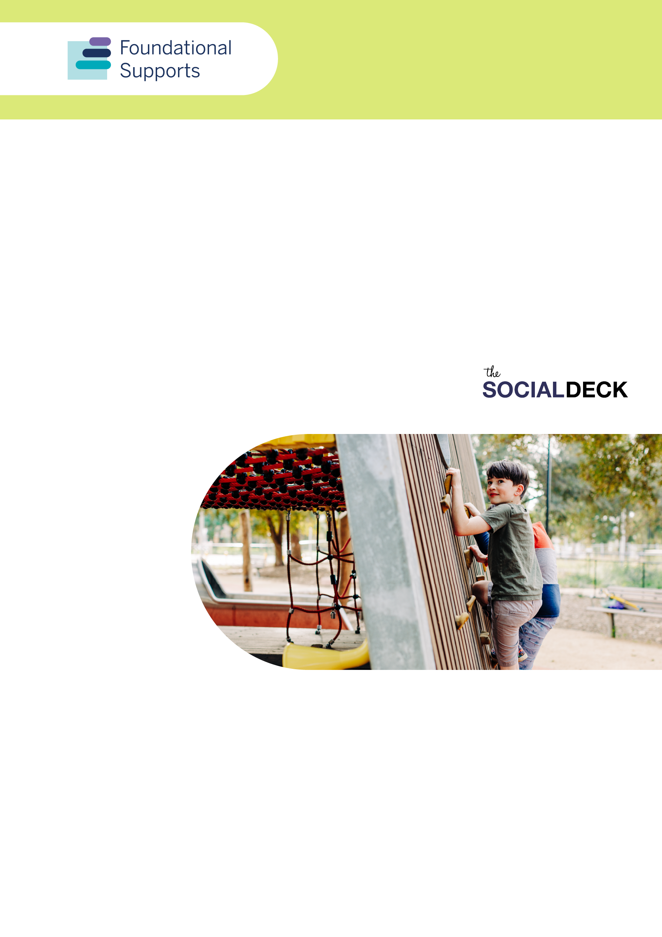

Supports for Children under 9 Summary Report
A summary of feedback from consultations for the design and delivery of foundational supports for children with developmental concern, delay and/or disability and their families, carers and kin
Report produced by The Social Deck

Acknowledgement of Country
The Department of Social Services acknowledges the Traditional Owners of Country throughout Australia on which we gather, live and work. We acknowledge all Traditional Custodians, their Elders past, present and emerging and we pay our respects to their continuing connection to their culture, community, land, sea and water.
This a summary of the more detailed Supports for Children under 9 Consultation Report.

Introduction
Governments are working together to design and deliver specific supports in the community. These are supports additional to mainstream services and supports people get through the National Disability Insurance Scheme (NDIS).
We call these foundational supports. Foundational supports were recommended by the NDIS Review panel.

Foundational supports for children
There are two types of foundational supports being designed for children with developmental delay, concern and/or disability and their families, carers and kin:
- General supports would be for all children and families. This is regardless of whether they are in the NDIS. It would include supports for information, advice and capacity building.
- Targeted supports would be for children with developmental delay, and their families. The supports would be for those not in the NDIS. They need more support than (or additional) mainstream services and general foundational supports. These supports may include:
- low intensity or periodic child and family-centred allied health supports
- one-on-one capacity building.
In this report we refer to these as ‘supports for children’.

Participation
From October to December 2024, we talked to families, carers and other stakeholders. We asked them what they need in foundational supports for children.
More than 1,000 people took part in the consultations on supports for children. 554 (or 54%) of the people who took part were family, carers or kin of children with disability.
People from every state and territory took part. 32% were from regional, rural and remote areas.
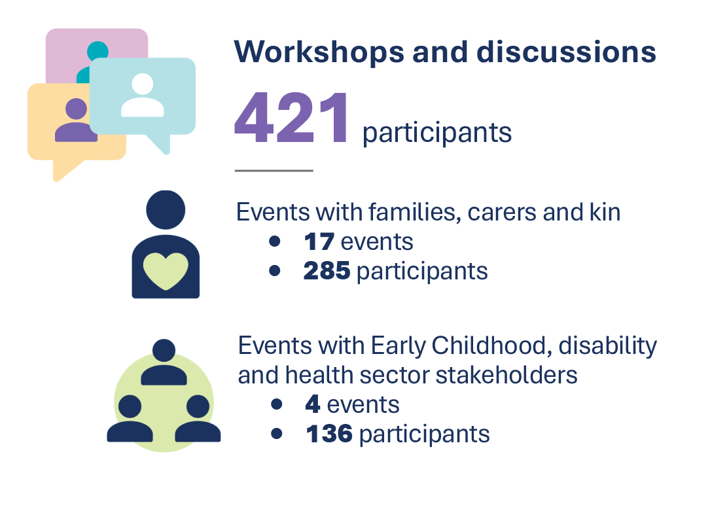
Figure 1: Number of events and participations across workshops and discussion
Some of the events were with specific population groups like:
- First Nations families
- families from a CALD background
- autistic parents and families with autistic children
- parents of people (including children) with complex and high needs.
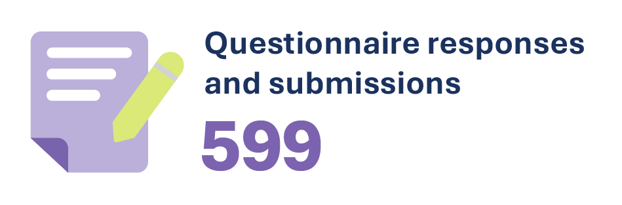
There were 573 responses to the online questionnaire about supports for children, and another 26 submissions. Families, carers and kin made up more than 64% of the responses*.

Figure 2: Participation percentages for the online questionnaire and submissions
*Note: Participants could select multiple options
People across Australia answered the questions in the consultation paper on foundational supports for children. We made this paper and other resources, like information sheets, available to everyone. They helped people think about what supports for children might look like now or in the future.

Main themes

Key issues and barriers

Information, advice and capacity building (general supports)
- Information is hard to find. Only 10% of 268 families and carers said it is easy or very easy to find information about supports. 76% said it is hard or very hard to find information.
- There isn’t enough information, and it is confusing to use the systems. This is especially so for children who were only just diagnosed and those who did not have NDIS access. Some people said disability supports and early childhood and community supports aren’t connected. Finding help is hard unless you’re already connected to a service or support system.
- Families are time-poor and have too much to do. There is too much work, time and effort to find and use services. They need more tailored information and one-to-one supports from existing and mainstream systems.
Preferred sources for information and advice
The 3 most trusted ways to get information and advice chosen by families and carers were:
- talking to other people with disability and/or carers
- referrals from GPs or other health professionals
- family peer or support groups.

Targeted supports for children
- Costs and wait times for diagnosis and assessments limit getting supports. Families and carers want to make sure getting targeted supports won’t rely on a diagnosis.
- Not enough supports and long wait times, especially in rural and remote areas. Parents and carers said they are often referred to supports that don’t exist. They are often told the supports are not available for their children if:
  - they’re not diagnosed
  - don’t have a specific type of disability or need (so not eligible)
  - aren’t existing clients.
- Confusion between the disability and health systems. Parents and carers get confused about which system to use to get supports for their child. They don’t know if supports should come through NDIS, Medicare, or other supports. They said supports they can get in early childhood care and schools, is not consistent or clear.
- Not enough Medicare support for children with developmental concerns. Some parents and carers said costs stop them from getting supports. There isn’t enough support for children with developmental concerns in Medicare. For example, getting the right number of psychology or other specialist appointments.

What we need to support children and their families, carers and kin
There are 6 main areas families and carers said would help in a foundational supports system. (This includes general supports and targeted supports.)
 | One-to-one advice and referrals through allied health and multidisciplinary teams  Allied health supports was the most common type of help families and carers said they need. It would help build skills and capacity and connect with other services and supports.  Families said it is important to have allied health teams working together. The teams could be made up of different kinds of allied health services. It should also include other health and education services. This would help for capacity building and providing direct supports to children.
 | Local peer, family and support groups  Families and carers said having peer support groups to get advice from other parents and carers is important. For those who were further ahead in their journey, this was especially important. For example, playgroups give children direct supports and ways to build social skills.  Families want support groups available in their state or region. Local groups understand what is available and give them relevant information and advice.  Peer supports also referred to online groups on platforms such as Facebook.
 | Parenting programs and education  People said building skills and confidence for the whole family are important.  Programs should include training, mentoring and tailored resources. This gives parents and carers practical skills to support their children’s needs. It includes areas like speech and language development. This would allow better communication and understanding of their loved one’s experience.
 | Programs for children, and including families and siblings  It's important for targeted supports for children with developmental delay to have different types of therapies. This includes play, art, music, sport and other therapies.  People said programs and supports should include the wider family, especially siblings.
 | Culturally safe and relevant supports  Many participants reiterated the importance of having well-funded and sustainable organisations. They should be local and give relevant and culturally safe supports to families. This included:  - Aboriginal community controlled organisations  - faith-based organisations (including churches)  - ethnic community councils and groups  - support services for people who are LGBTIQA+  These groups are a central part of the foundational supports system for children and their families, carers and kin.
 | Digital directories of services, with regional networks  People said online directories of disability services for young children are important. They help with accessing supports and finding more information and advice.  There were strong views this should not be an information website. It should be a directory of services available to children, including at a regional level.

Designing and implementing supports for children

Where supports should be delivered

Information, advice and capacity building (general supports)
Families, carers and organisations suggested general supports for children be delivered through a mix of:
- Place-based hubs and supports that come together in locations. Funding should be sustainable and supports designed so they work for the region/location.
- Case workers, navigators or connectors. Case management and worker models are critical for supporting families and children. In particular, between the NDIS and mainstream services. This included a key worker or care coordinator model so there is a single coordinating point.
- Digital platforms, directories and phone services are important for many families and carers. However, people said government sites need to be relevant and have improved navigation. Most families and carers get online information through non-government sources. For example, online parenting networks and social media.
- Existing family services. It is important to have sustained funding for advocacy and capacity building supports and programs. Especially those that are family-led.

Targeted supports
Families and carers said targeted supports should use the following areas for delivery:
- Focus on early intervention. Include delivery in places young children are already present. For example, hospitals, health centres, early childhood settings and schools.
- Access to allied health. Supports need better availability to reduce wait times and assessments. Include a wrap-around allied health model. Families could access experts to improve assessments. They would make sure supports are tailored to the child’s needs.
- Delivery supports where children live, learn and play. All stakeholders said services need to be in a range of locations and natural settings. For example, schools, early childhood settings and in the home. This would make them fit-for-purpose for family circumstances.
- Delivered in different ways. For example one-on-one (in different environments and settings) and group settings.

Supports in regional, rural and remote areas
In relation to regional, rural and remote areas, people suggested:
- Place-based design of allied health support networks.
- Regional hubs, centres and mobile outreach. Bring services together on certain days. Include shared resources that would help to address unplanned shortages.
- Rural placements and internships.
- Outreach supports, such as mobile services and mobile playgroups.
- Telehealth to be made more available to children in rural and remote areas. It was noted this may not work well for all children.
Working in partnership
Partnerships are important when designing and putting supports for children in place. For example, working in partnership with:
- Parents with disability - Design accessible information, advice and capacity building.
- Aboriginal and Torres Strait Islander children and families - Co-design supports in line with Closing the Gap measures and make sure they are culturally safe.
- Multicultural families - Work with community, faith and cultural organisations. This will help engage parents in language and culturally safe ways.



Designing and implementing supports for children
Supports for children need to be put in place with the following considerations.
- Person-centred practice
  - Design person-centred supports and think of the whole child. Adopt a whole of family approach and family-centred practice.
- Co-designed
  - Co-design supports with families, carers and children, where appropriate.
- Transitional and universal, so no child falls through the cracks
  - Targeted supports for children should sit alongside the NDIS.
  - They should be available to all children who need them.
  - It shouldn’t matter where they live in Australia or what their circumstances are.
  - Equal access for children with disadvantage or other barriers. (e.g. rural and remote, First Nations, families who don’t speak English as a first language.)
- Longer-term and more flexible funding arrangements
  - The foundational supports system should have a national approach to sustain programs. However, allow flexibility for local community needs.
- Delivered through multidisciplinary teams
  - Key workers or similar models to improve the integration across systems and reduce burden on families and carers.
- Better explain foundational supports
  - Make eligibility clear for children in relation to age and diagnosis.
  - Have clear definitions of developmental delay, concern and/or disability.
- Invest in building a sustainable and diverse workforce, including in regional areas. This would improve availability of supports and ensure they’re tailored and appropriate for children.
  - Extra training for allied health, early childhood workers, teachers and others in schools. This will allow them to better understand disabilities and developmental delays in children.
  - Invest in workforce placements and strategies. This will attract allied health and other workers to regional and rural areas.
Foundational supports must line up with approved Best Practice Guidelines for Early Childhood Intervention, and other strategies. For example, the Early Years Strategy and Australia’s Disability Strategy.
Acknowledgement and thanks
The Social Deck thanks people who contributed experiences, feedback and ideas to this consultation process. In particular, we acknowledge the strength and contributions of people with disability, and their families, carers and kin in sharing your stories.

