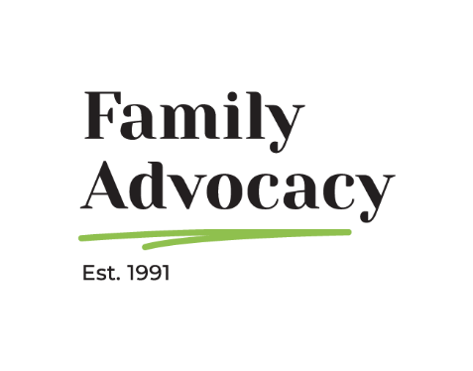

Submission to the Department of Social Services (DSS) on Next steps in Supported Employment: consultation on the way forward
June 2025

“I am learning about things I want to learn about… I love working with the boys because I am part of the team.
I really like talking to them about cars.”

Tyler, Year 10 student currently working part time at a local vehicle repair shop.

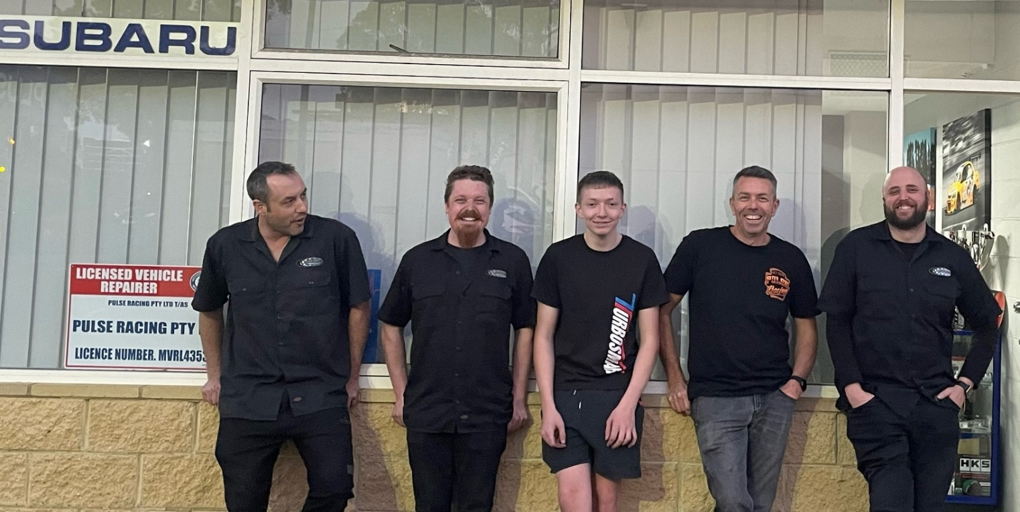

Cecile Sullivan Elder, Executive Officer, cecile@family-advocacy.com
Leanne Varga, Systemic Advocate and Campaigns Manager, leanne@family-advocacy.com
Family Advocacy (02) 9869 0866, Suite 704, 88-90 George Street, Hornsby, NSW 2077, Australia

Acknowledgement:
Family Advocacy would like to acknowledge the traditional custodians of the lands on which this report has been written, reviewed and produced, whose cultures and customs have nurtured and continue to nurture this land since the Dreamtime. We pay our respects to their Elders past, present and future. This is, was and always will be Aboriginal land.

Table of contents
Table of contents 1
Introduction 2
Increasing inclusive employment – Recommendation 7.30 3
Question 1. Is there any other existing work that is missing from the table at Appendix 3? 3
Question 2. What is your ideal future state for the supported employment sector and employment of people with disability with high support needs? 5
Question 3. What additional actions do you consider are necessary to increase employment of people with high support needs in open/inclusive settings? 7
Question 4. The Royal Commission recommended the development of a Plan or Roadmap to guide further reform in the supported employment sector. What would you like to see included in such a plan? 9
Raise subminimum wages – Recommendation 7.31 10
Question 5. How could the sector best increase wages for people with disability while avoiding job losses? a. Are there examples that currently exist that can be leveraged? b. Are there new approaches that could be tested? 10
Ending Segregated Employment – Recommendation 7.32 13
Question 6. Do you see a role for workplaces which provide specialised employment opportunities for people with disability in the future? If so, what should these workplaces look like? 13
Question 7. How could the benefits of supported employment settings be reflected in open employment settings? 13
Conclusion 13

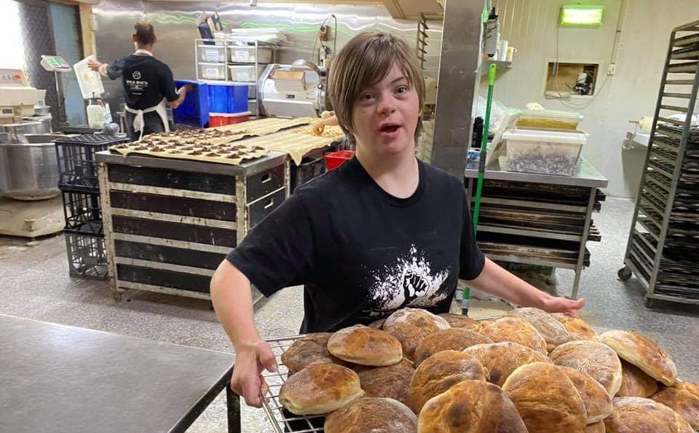

Introduction
Family Advocacy is a community based, state-wide disability advocacy agency, funded by state and federal funding programs to promote the rights and interests of people with developmental disability across NSW. The main objective of Family Advocacy over the last 34 years is to support families to advocate with, or at times, on behalf of the person with disability, with the goal to support people with disability to realise their goals, hold valued roles and lead lives embedded in the community to experience the same things that most Australians take for granted: an education alongside their same aged peer, a job and a home of their own. We continue to be governed and staffed by people with disability and families and provide services in the following ways:
  - Advocacy advice and advocacy information to individuals
  - Advocacy development for family members of a person with disability - Advocacy is often undertaken by families and can be required over the lifetime of their family member. Strengthening the advocacy capacity of families is essential to this.
  - Systemic Advocacy
We provide a visual illustration of the Model of Family Advocacy below, but for more information, it is discussed in much more detail in UNSW, Social Policy Research Centre’s (SPRC) report, Family Advocacy Model Research. 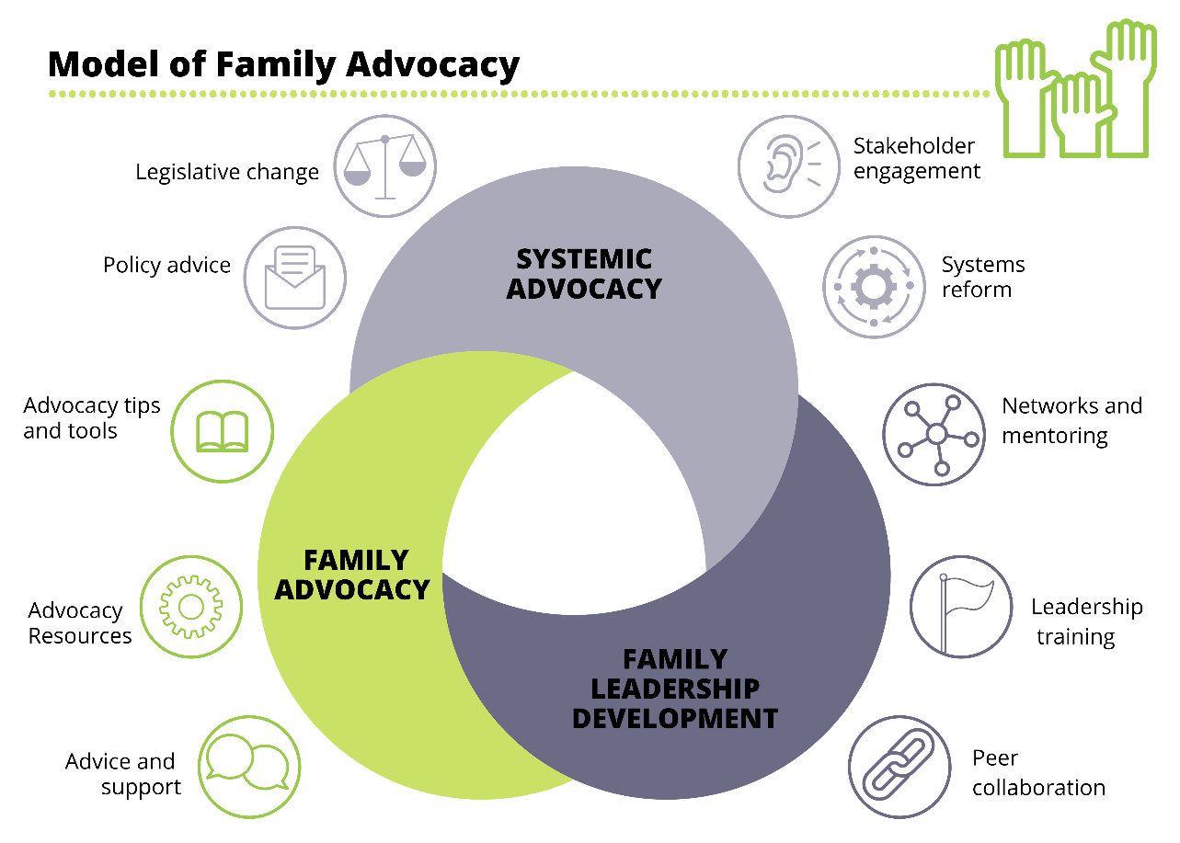
Family Advocacy also has an initiative, Resourcing Inclusive Communities, also working across NSW, and holds the philosophy that people with disability thrive in the heart of the community, sharing the same everyday experiences as their fellow Australians. It provides information and resources to assist people with disability to live meaningful lives, as valued members of their communities. We share our vision of social inclusion with the United Nations Convention on the Rights of Persons with Disabilities (CRPD). Resourcing Inclusive Communities works with many allies in the community to support this vision and of particular note, is part of the National Alliance of Capacity Building Organisations (NACBO).
In considering our advocacy efforts and capacity building efforts, both of which have a clear focus on the investment of families, we feel we are not only well positioned but also play a vital role in any work directed at supporting and building the capacities of families across NSW.
Family Advocacy appreciates the opportunity to provide a submission to the Department of Social Services (DSS) on the Next steps in Supported Employment: consultation on the way forward, Discussion Paper. We look forward to the recommendations of this Discussion Paper and to be meaningfully involved in the process of creating a society where people with disability, especially people with high or complex needs, can work in typical workplaces, with regular hours, have career progression and pathways, and earn the award wage or above.


Increasing inclusive employment – Recommendation 7.30

Question 1. Is there any other existing work that is missing from the table at Appendix 3?
We appreciate the appetite for change from DSS and its current reform efforts. However, from the perspective of Family Advocacy, we make the following points which should be acknowledged as essential components of a genuinely inclusive employment ecosystem—particularly for people with high or complex support needs.

School to Work and Investment in Families
There is a significant gap in recognising the work that targets families and students from Year 7 onwards to build expectations, knowledge, and a clear vision for open employment. Family Advocacy's School to Work project demonstrates how investment in families can shift expectations early and significantly improve transition outcomes. Families play a crucial role in influencing pathways; as such, their inclusion in capacity building, planning and policy is essential. Further this approach should be embedded in the current reform agenda as our view is without this reform efforts will be largely minimised.

Education Reform for Employment-Focused Transitions
The current education-to-employment pipeline continues to funnel students with disability—particularly those with high support needs—into Australian Disability Enterprises or non-work options. There needs to be a stronger recognition of reform initiatives that:
- Promote an Employment First approach in education.
- Integrate open employment outcomes into the curriculum, work experience, and transition planning processes.
- Prioritise Discovery-based approaches as part of planning in schools, building personalised pathways into real jobs and careers.
- Adopt School to Work Transition Pilots in each State/Territory, starting with NSW and build from there, see our proposal for NSW in the 2025-2026 NSW Pre-Budget Submission.

Use of Discovery in Transition and Support Planning
While Customised Employment (CE) is mentioned in the paper, the Discovery component is not sufficiently acknowledged as a planning tool beyond its use by employment providers. Discovery should be integrated within NDIS planning, school transitions, and inclusive employment program design. This approach has shown success in identifying individualised employment pathways, especially for people with high support needs. Further to this, when staff are trained and adopt the discovery process many current pitfalls and job matching failures can be avoided. This first step done well is key to how everything else will flow.

Need for Strong Parameters Around Major Initiatives
Current and emerging initiatives often lack clear guiding principles and accountability mechanisms to ensure they deliver on the intent of increasing access to jobs and careers (open employment). There is a risk that programs with broad scopes and no inclusion standards may fall short or reproduce exclusion. For example, initiatives should be guided by evidence-based practices, explicit commitments to supporting the attainment of jobs and careers, with clear targets for people with high and complex support needs.

Concerns Regarding Workability Expos, Structural Fund and Social Enterprises
While the Workability Expos are intended to support awareness and connection to employment opportunities, our insights suggest they have thus far missed the mark, failing to present genuine pathways into employment—particularly for people with high support needs. Retrofitting to an old model that was not successful will not work. These Expos risk reinforcing low expectations and segregated models. As regularly expo attendees across our organisation we have witnessed first hand the before and after effects of the ‘Workability Expo’s’ and post investment from the federal government there is little that has changed for expo attendee’s. These events had the opportunity to shift mindsets, open up possibilities and support access to good employment examples and support, however, this has not been delivered. This would beg the question of have the principles and aims been clear enough. We will not get different outcomes unless we do something different.

Regarding the Structural Adjustment Fund, we direct you to the Lane v. Brown Oregon case study and a report on many other U.S. states that have phased out sheltered workshops and eliminated or are on their way towards eliminating the subminimum wage: https://bit.ly/FinalReportToTheCourt_LaneVBrown2022, and also to Question 5 where this is discussed in more detail.

Additionally, we have deep concerns that this move to grow the Social Enterprise sector may unintentionally reinforce social enterprise models that replicate segregated employment, rather than supporting jobs and careers in the open market. Our contacts in the U.S., Dr David Manks, who has worked in transformation of supported employment for decades, has shared:

“If it is a group setting, you likely will be taking it apart in the years ahead. We believe the standard needs to be one person in one job in typical community companies, businesses and organisation. The same as any other citizen. The Social Enterprise and Workshop settings are often sustained when individuals work only a few hours a week in Open Employment and need "someplace to be" other hours in the week - or that is pressure we are seeing in the USA.

For maximum employment outcomes (wages, hours, integration) there are three main points:
- One person one typical job (no group settings).
- Always at full wage as any worker doing that kind of work.
- Maximum hours worked weekly yet individualised based on who the person is (don't settle for 6 or 8 or 10 hours weekly unless there are very good reasons).”

Omission of People with High Support Needs in Current Reform Focus
Current reform initiatives have yet to adequately address or prioritise the inclusion of people with high or complex support needs, many of whom are currently in day programs or non-work services. These individual’s risk being left behind entirely if they are not explicitly included in the scope and design of new programs. We urge stronger mechanisms to ensure these individuals are not siloed into recreational or passive day services, but are given equal access to tailored employment pathways. Employment for all or employment first should be critically clear narratives heard from government around this current reform agenda. We feel the government still has time to be agile in its reform offering to strengthen this shortfall.

Question 2. What is your ideal future state for the supported employment sector and employment of people with disability with high support needs?
Family Advocacy envisions a future where all people with disability, including those with high support needs, have genuine and equitable access to jobs and careers; not as an aspiration, but as the default and expected pathway.

Our ideal future does not focus on maintaining or expanding the current supported employment sector in its traditional, segregated form. Rather, it focuses on repurposing and upskilling this sector to enable people with disability to transition into meaningful, socially and economically beneficial jobs and careers. The supported employment workforce must be retrained to adopt models that encompass this believe and prioritise individual strengths and aspirations, not assumptions about capacity.

A powerful example of success is the experience in Oregon, USA, where the state did not begin with a mandate to close sheltered workshops or eliminate sub-minimum wages. See discussion in Question 5 and https://bit.ly/FinalReportToTheCourt_LaneVBrown2022. Instead, it invested in strengthening open market employment options—through strong discovery practices, sustained employment supports, and strategic systems reform. Over approximately 5 years, this shift made segregated options redundant. Importantly, Oregon’s approach recognised that transformation must occur one person at a time, with tailored support and community-based solutions.

To support people with complex support needs in particular, we strongly endorse the use of models such as Customised Employment (CE). CE offers a person-centred, strength-based framework for helping individuals with disability—including those with significant support needs—secure and maintain real jobs in the community whilst filling unmet needs of an employer. It’s a win: win situation for both the person and employer.

This model challenges outdated assumptions about who can work, and helps to ensure that employment is not reserved only for those perceived as "job ready." We reference regularly the use of this model for people with complex disability, people who are often not assumed to be able to work however this model works well for many people. For example, it would be compatible with people who have a psychosocial disability, a person who continues to move from job to job, or who is continually at risk of being fired or who experiences multiple barriers to employment. Although an extremely suitable model in the current supported employment sector, it can also reach and impact services within the Disability Employment Services (DES) and other programs of support focusing on securing paid jobs and careers alongside people with disability.

We also see significant promise in school-to-work transition models such with pathways and internships that begin in the final years of school and provide supported entry into open employment. These programs must be widely promoted and properly resourced as critical infrastructure for ensuring that young people with disability do not enter a pipeline leading into segregated settings, but instead move directly into inclusive workplaces with the right supports in place. When done well, any supports in place can generally be phased out over time.

We recommend a deeper exploration of the successful project in the U.S., Evaluation of the Pathways to Careers Program, a project spanning 10 years utilising Customised Employment model that connected people with significant disabilities to competitive integrated employment. The key service components were:

- Strength-based assessments of person
- Evidence-based
- Paid internships and work experiences
- Post-career employment support

We reference the report Pathways to Careers: A case study in Customised Employment (written by Source America, who have been a leading job creator for people with disabilities for more than 45 years), We share the executive summary of the lessons learned which can provide useful insights:

- Customised Employment offers one of the most promising paths for improving employment outcomes for people with significant disabilities.
- Matches the right person to the right job and provides the supports needed to succeed.
- There is no one-size-fits-all model. Flexibility is key.
- A sustainable funding stream is needed to expand offerings and maximise outcomes.
- Investments in Customised Employment have the potential to pay for themselves.

Importantly, there is a recommendation for their federal government to introduce a CAPABILITY Act as a demonstration of commitment to the millions of Americans with disabilities who are disconnected from the labour market, as well as those who are working but still in a state of poverty. Through a targeted focus on school leavers, it can create a new foundation for achieving open employment outcomes and economic and social mobility for people with disabilities.

Key components of the CAPABILITY Act, informed by Source America’s experiences with Pathways, included:

• The delivery of evidence-based services to transition-aged youth with disabilities;
• Dedicated funding to build capacity within provider organisations and promote long-term sustainability;
• Development of models for replication in other states; and
• Competition across states for funding based on their ability to steward resources to provider organisations and maintain high standards for outcome evaluation.

We also recommend the presentations/factsheets below:

Pathways to Careers Q & A (direct download, please check your downloads folder)

Pathways to Careers General Overview (direct download, please check your downloads folder)

A Framework for Achieving Competitive Integrated Employment: Findings from the SourceAmerica Pathways to Careers Evaluation (2017, 90 mins)

Expanding Integrated Employment: Lessons Learned from Scaling Up Pathways to Careers (2020, 90 mins)

We have previously recommended Marc Gold & Associates – The People who try another way, who provide performance-based certification in the areas of Discovery, Job Development and Systematic Instruction. There are entry level courses for 3 days on CE then more advanced leadership courses such as a 12-day course on CE and systemic instruction. This includes learning how to really get to know the person with disability, how do people perform tasks and how do they learn them.

Importantly, these courses also include learning how to get to know the employer such as learning to know how a company has tasks and how they are performed, what are the means for learning the tasks, who helps the person to learn the task within the company, how do staff interact, is there an unmet need in the business and how does it intersect with what the person with disability can offer, what is noticeable that could be improved in a business that the person with disability can offer, are there tasks performed by staff that are highly qualified that could be better performed by a others at an entry level of pay.
One example given here was of a welding job where the highly qualifies welders who were getting paid $35 were doing certain tasks that Michael could perform, who was getting paid $15 per hour. This gave the welders more time to focus on their highly skilled tasks and this gave Michael paid employment.

To recreate this Pathways to Careers project in Australia, purposeful action is required by federal and state governments, must include funding for Customised Employment capacity building and service delivery in disability employment policy, and potentially the creation of legislation such as the Capability Act, as suggested above. We work closely with Therese Fimian who had oversight of this project for its entirety and would be happy to connect her to you for further discussion.

In short, the future of supported employment must not be framed around the preservation of outdated models. Instead, it must focus on equipping the sector with the tools, frameworks, and cultural shift necessary to move people into and through open employment pathways—particularly the next generation coming through our schools. The narrative must be one of opportunity, inclusion, and evolution—where support is a bridge to inclusion, not a barrier to it.

Question 3. What additional actions do you consider are necessary to increase employment of people with high support needs in open/inclusive settings?
Family Advocacy believes that increasing employment outcomes for people with high support needs requires a fundamental shift—from a system that manages low expectations and segregated settings, to one that empowers individuals and families to pursue meaningful, inclusive employment from an early age.

We welcome the intent of the Supported Employment Next Steps Consultation Paper to move toward more inclusive settings. However, we caution that without concrete investment in early intervention, workforce transformation, and cultural change, people with high support needs will continue to be left behind and frankly all people with disability currently experiencing barriers to work. We recommend the following additional actions:

Early and Sustained Investment in Families
Families must be supported from Year 7 onwards to build a clear and confident vision that employment is not only possible but expected—regardless of the level of disability. Many families are still unaware that open employment is a viable pathway for their family member with high support needs. Clear messaging, peer support, and practical planning tools are needed to change the narrative and increase demand for inclusive outcomes. Our School to Work Project encompasses all of these aims.

Targeted Reform in the Mainstream and Special Education Sector
Intentional and system-wide work is required in the mainstream and special education sector to ensure that transition planning prioritises open employment as the default outcome. Currently, students with high support needs are too often directed into non-work options or segregated settings by default. Schools must be equipped and held accountable for implementing high-quality, inclusive transition-to-work practices, with open employment embedded as a standard expectation. Segregated workplaces will as a bi product dwindle in size and eventually be removed off the employment support landscape. This is another lever that needs rightful attention and the role of families to influence the need and expectation of this should not be underestimated as a change tactic.

Systemic Implementation of Customised Employment (CE)
The Customised Employment (CE) model, particularly the Discovery process, should be embedded as a national, evidence-based approach for supporting people with high support needs into open employment. Discovery is not just a job development tool—it is a holistic “no fail” planning process that supports identification of an individual’s strengths, interests, and ideal conditions for employment.
We recommend:
- National investment in CE training for employment providers.
- Establishment of accreditation standards for CE delivery.
- Development of evaluation and fidelity tools to ensure quality and consistency across providers.

This investment will help shift the supported employment sector from one focused on group-based or fixed employment options to one that enables one person at a time to pursue meaningful, individualised jobs in the open labour market. We would add that discovery should be embedded across the whole employment landscape and if by design a controlled approach to this could occur it could almost be seen as a ticket to work. Perhaps consideration should be given to specialist highly trained in this process being utilised to walk through the discovery process for all people with disability needing employment support and then that Discovery document could be transportable to the broader employment sector. Perhaps the starting point to this is school transitions.

Expansion of Inclusive Internship and Transition Pathways
The creation of transition pathways and internships are a valuable mechanism to bridge the gap between school and open employment. We refer to our discussion in Question 2 about the Pathways to Careers model. This model provides structured, real-world experience and demonstrate the capacity of people with high support needs to contribute meaningfully to inclusive workplaces. Greater support is needed to expand these initiatives and embed them within transition planning frameworks. Family Advocacy suggests DSS adopt School to Work Transition Pilots in each State/Territory, see our proposal for NSW in the 2025-2026 NSW Pre-Budget Submission , or at least start in NSW and build from there.

In conclusion, we urge DSS to frame the next steps in supported employment not merely as a pathway out of segregated settings, but as a framework to equip individuals and systems to confidently pursue open employment. This means early investment in families, reorienting the role of schools, building sector capacity through CE, and expanding practical, inclusive employment experiences. Without these additional actions, people with high support needs risk continued exclusion from the workforce, even in a reformed system.

Question 4. The Royal Commission recommended the development of a Plan or Roadmap to guide further reform in the supported employment sector. What would you like to see included in such a plan?
The supported employment roadmap must lead Australia toward a future where people with disability are not simply included in employment policy—but are expected, supported, and empowered to thrive in real jobs in their communities. This means investing in families, transforming schools, reorienting providers, and embedding CE system-wide. Only with a bold, practical, and rights-based plan can we ensure that people with disability are no longer segregated or sidelined, but fully included in the economic and social fabric of Australian life.

Family Advocacy stands ready to contribute to this process and support the design of a roadmap that delivers on the promise of genuine inclusion. We suggest the following to be included in the Roadmap:

A Clear Vision and Guiding Principles
The plan must be grounded in open employment as the default goal for all people with disability, regardless of perceived "job readiness" or support needs. A commitment to one person one typical job, not service-driven or group-based models.

A Strong Role for Families
Families are often the primary long-term advocates and decision-makers alongside people with disability. The plan must invest in early family engagement and capacity building (starting from Year 7) to raise expectations and build pathways to employment. Fund family-focused initiatives like peer support, planning workshops, and transition navigation that promote employment as a real and achievable goal. Utilising families as a safeguard against the systems as they are attempting to change.

Education Reform and Early Transition Support
The roadmap must prioritise reform within the education system to ensure genuine transition-to-work planning begins early and aligns with open employment outcomes. Embed CE principles, particularly Discovery, into schools and transition programs. Establish clear accountability measures for schools to prevent default transitions into day programs or segregated settings.

National Implementation of Customised Employment (CE)
CE is a proven, person-centred model that enables people with high support needs to gain and maintain meaningful employment. The roadmap should support national rollout and investment in CE training, including accredited qualifications and practice mentoring; integrate Discovery as a planning tool across NDIS, education, and employment services; develop a quality framework and evaluation mechanism to monitor fidelity of CE implementation.

Clear Timeline for Transition Away from Segregated Employment
While the goal is not to immediately close existing services, the roadmap must set a clear, staged timeline for phasing out sub-minimum wages and group-based employment models; ensure that all investments in “supported employment” models are tied to measurable progress toward open, inclusive employment; fund and support service providers to transition their models to open employment-focused supports.

Specific Inclusion of People with High and Complex Support Needs
People with high support needs must not be overlooked in reform efforts. The plan must require that all programs and policies include explicit targets and strategies to support this group; prevent the redirection of individuals into non-work day programs as a default; promote innovation and job customisation for individuals requiring significant support.

Accountability, Data, and Continuous Improvement
Include independent oversight and public reporting mechanisms; require disaggregated data on employment outcomes by support needs, type of employment, and hours worked; establish feedback loops with families and people with disability to inform continuous system improvement.

Raise subminimum wages – Recommendation 7.31

Question 5. How could the sector best increase wages for people with disability while avoiding job losses? a. Are there examples that currently exist that can be leveraged? b. Are there new approaches that could be tested?
Increasing wages for people with disability—particularly eliminating the use of sub-minimum wages—requires a deliberate, individualised, and well-supported transition process to avoid unintended consequences like job loss or displacement into non-work day services.
APSE (USA National Supported Employment Organisation) and ThinkWork (Institute for Community Inclusion, UMass Boston) both have national data and state by state data about Employment Outcomes and processes and information about eliminating sub-minimum wages.
We have previously referred DSS to Transformation to Competitive Employment Act Bill before U.S Congress awaiting to be passed, which aims to end subminimum wage employment for disabled individuals and advocates for competitive, integrated employment settings (similar to Australia’s open employment). Under Section 14(c) of the Fair Labor Standards Act, employers are allowed to pay disabled workers less than minimum wage. Section 201 of this Bill proposes a Transition to fair wages for individuals with disabilities by increasing wages by 10% each year. That is, a payment of 60% of the wage rate 3 months after the passing of the Act, then 70% in the first year, 80% in the second year, 90% in the third year, 100% in the fourth year. We have read some groups are urging Congress to pass the Bill and for the Department of Labor to finalise their proposed rule in 2025.
Despite the fact that this Federal Bill has not yet passed, there appears to be a dramatic shift away from subminimum wage employment, whereby 17 states have taken action to either eliminate or actively phase out the use of the subminimum wage. This includes Alaska, Maine, Maryland, New Hampshire, Oregon, Washington, Hawaii, Colorado, California, Delaware, Tennessee, South Carolina, and Rhode Island (State Legislative Watch – Association of People Supporting Employment First). These states have relatively high GDP per capita and are doing well, showing that phasing out Section 14(c) (the section under the Workplace Opportunity Innovation Act which allows for subminimum wages to be paid to people with disability) doesn’t negatively impact the economy.
We refer your Department to Pennies on the Dollar: The Use of Subminimum Wage for Disabled Workers across the United States (2024). This report examines, state by state, the policies that drive the use or elimination of subminimum wage, as well as the programs each state provides to more comprehensively support individuals with disabilities as they seek meaningful employment and fair wages. Analysing and comparing policies across all states allows for a national perspective on the drive to eliminate the subminimum wage. It also highlights other employment-related policies used to support individuals with disabilities. It shows that regardless of geographical location, political makeup, density, or other characteristics, many states have created lasting change for their workers with disabilities. The various approaches taken by states with high rankings provide a road map for Australia to consider, identifying multiple possible routes to take.
A CASE STUDY: OREGON (USA)
One compelling example is the state of Oregon (USA), which undertook a major systems transformation following a legal settlement addressing overreliance on sheltered workshops and poor transitions from school to open employment, see https://bit.ly/FinalReportToTheCourt_LaneVBrown2022, which provides the final report on Oregon’s progress in implementing the Settlement Agreement in Lane v. Brown, which came into effect on January 27, 2016. Without initially setting formal targets to eliminate sub-minimum wages or close workshops, Oregon achieved both outcomes by 2023 through a strategic focus on expanding access to Competitive Integrated Employment (CIE), enhancing transition services, and building the necessary infrastructure across state agencies. Key strategies included:
- Increasing investment in supported employment services and training for providers.
- Using discovery-based employment planning to align jobs with individual strengths and preferences.
- Offering technical assistance and incentives to service providers to support the shift to open employment.
- Expanding data systems and accountability frameworks to track progress.
During the course of the Settlement Agreement (2016-2022), the State has done the following:
- Closed all remaining sheltered workshops in Oregon.
- Totally eliminated the use of sub-minimum wages for people with IDD.
- Increased access to supported employment services and Competitive Integrated Employment for Oregonians with IDD, meeting and surpassing numerical goals for the sheltered workshop class and transition class in the Settlement Agreement.
- Expanded evidence-based transition practices, and ended the use of mock sheltered workshop activities.
- Developed the agency infrastructure across state agencies to support the Settlement Agreement and as required by Executive Order 15-01.
- Utilised enhanced federal and state funding to support access to CIE and create a statewide data system.
This approach demonstrates that sustainable wage increases are possible when employment support systems are strengthened, and person-centered planning is prioritised. Importantly, these changes occurred gradually, on a person-by-person basis, avoiding mass displacement or service gaps.
Centre for Public Representation
We draw your attention to the Centre for Public Representation, a law firm that has engaged in employment related litigation in the U.S. and in particular a four-part series created to help people with disabilities, families, professionals, providers, and stakeholders develop strategies to reduce reliance on sheltered workshops.
- Part 1 – Ending Segregated Workshops and Promoting Competitive Integrated Employment (CIE); Legal Foundations for Protection and Advocacy Entities, Part 1, Disability Employment Technical Assistance Center (July 15, 2021) by Steven J. Schwartz and Ruby Moore.
This first brief addresses the relevant laws, legal decisions, and legal strategies for challenging unnecessary segregation in sheltered workshop.
- Part 2 - Advancing Competitive Integrated Employment through Legal Advocacy Systems; Legal Foundations for Protection and Advocacy Entities, Part 2, Disability Employment Technical Assistance Center (September, 2021) by Steven J. Schwartz and Ruby Moore.
The second outlines the centrality of competitive, integrated employment (CIE) for people with disabilities, the importance of pursuing system reform initiatives that promote CIE, and suggestions for how to develop, implement, and manage these initiatives in legal rights organisations.
- Part 3 - Components of an Integrated Employment Service System, Part 3, Disability Employment Technical Assistance Center (March 2022) by Steven J. Schwartz and Ruby Moore
The third paper identifies the core components of an integrated employment system and methods for transforming state employment systems. It also discusses the remedies generated by litigation in Oregon and Rhode Island.
- Part 4 - Components of an Integrated Employment Service System, Part 4, Disability Employment Technical Assistance Center (June 2022) by Steven J. Schwartz and Ruby Moore
The final paper analyses how the Home and Community-based Services (HCBS) Settings Rule can be used to reduce reliance on sheltered workshops. This series is designed to provide people with disabilities and their advocates the information, tools, and strategies to end sheltered workshops as an acceptable work placement and to encourage the provision of supports that allow people with disabilities to obtain a real job, at real wages, in competitive employment.
We provide an extract from this final paper as does provide a time guideline for Australia to consider with our reform process.
“Oregon had an initial sheltered workshop census of approximately 2,750 people with intellectual and developmental disabilities (I/DD). States with a higher number of people working in sheltered workshops would need to adjust their annual goals upward. States with fewer people working in sheltered workshops should be able to transition all individuals into CIE in a shorter period and eventually eliminate sheltered workshops entirely. While provider capacity, available resources, and economic conditions will impact both the pace and duration of the transition process, closing all sheltered workshops and transitioning all people interested in working into CIE within eight years is demonstrably reasonable.”
New approaches worth testing could include:
- Wage subsidies tied to measurable employment outcomes in typical settings.
- Time-limited transition funding for providers moving from segregated to integrated models.
- Strengthened employer engagement initiatives to drive inclusive hiring.
- Peer mentoring and employee resource groups for workers with disability to support job retention and advancement.
- Ongoing investment in job customisation and flexible employment arrangements.
In summary, raising wages for people with disability must be done thoughtfully and with a focus on expanding quality employment options, not just removing outdated pay structures. With the right policy settings, service reform, and stakeholder commitment, inclusive employment and fair pay can be achieved without job loss or regression into non-work models such as Day Programs.

Ending Segregated Employment – Recommendation 7.32

Question 6. Do you see a role for workplaces which provide specialised employment opportunities for people with disability in the future? If so, what should these workplaces look like?

Question 7. How could the benefits of supported employment settings be reflected in open employment settings?
As outlined in our previous submissions, we do not support the continuation of segregated or specialised workplaces, such as sheltered workshops, for people with disability. These models are inherently exclusionary and reinforce the notion that people with disability are not capable of participating meaningfully in mainstream employment. This extends to many social enterprises as their structures, make up and assumptions surrounding their employees are often a mirror image to sheltered workshops.
We strongly believe that all people with disability have the right to access inclusive, open employment on an equal basis with others. The existence of segregated employment settings undermines efforts to transform the open employment landscape. As long as these separate pathways are maintained, there is limited incentive for employers, policymakers, or Disability Employment Services (DES) providers to innovate, adapt, or dismantle the systemic barriers that currently prevent people with disability from participating fully in the workforce.
Rather than investing in specialised, or sheltered workplaces, resources and policy efforts should focus on building inclusive employment environments, improving accessibility, strengthening supports within open employment, and holding employers accountable for inclusive hiring and retention practices.

Conclusion

For over 34 years, our work has been rooted in the belief that all people with developmental disability—regardless of the level of support they require—deserve the same opportunities as other Australians: to go to school alongside peers, to work in a regular job with fair pay and real career prospects, and to live a life embedded in the community.

From our perspective, the success of any reform in supported employment must be measured not by the maintenance of current structures, but by how effectively it leads to meaningful, inclusive, and award-waged employment for people with disability. That includes those who have historically been most excluded—people with high or complex support needs, who are too often directed into segregated or non-work options.

We urge the Department of Social Services to adopt a clear, values- based roadmap that sets open employment as the default goal; invests early in families, schools, and customised employment; ensures rigorous accountability; and ultimately eliminates the subminimum wage and segregated pathways.

We acknowledge the Department of Social Service’s efforts to date with this transformational opportunity. With bold leadership, collaboration, and investment in evidence-based practices such as customised employment, Australia can lead the way in demonstrating that all people with disability can and should be supported to contribute meaningfully in open, inclusive workplaces. Family Advocacy stands ready to assist in shaping and realising this future—for individuals, families, and communities across NSW and beyond.

Transformation to Competitive Integrated Employment, by Michelle Thomas, February 2025

