
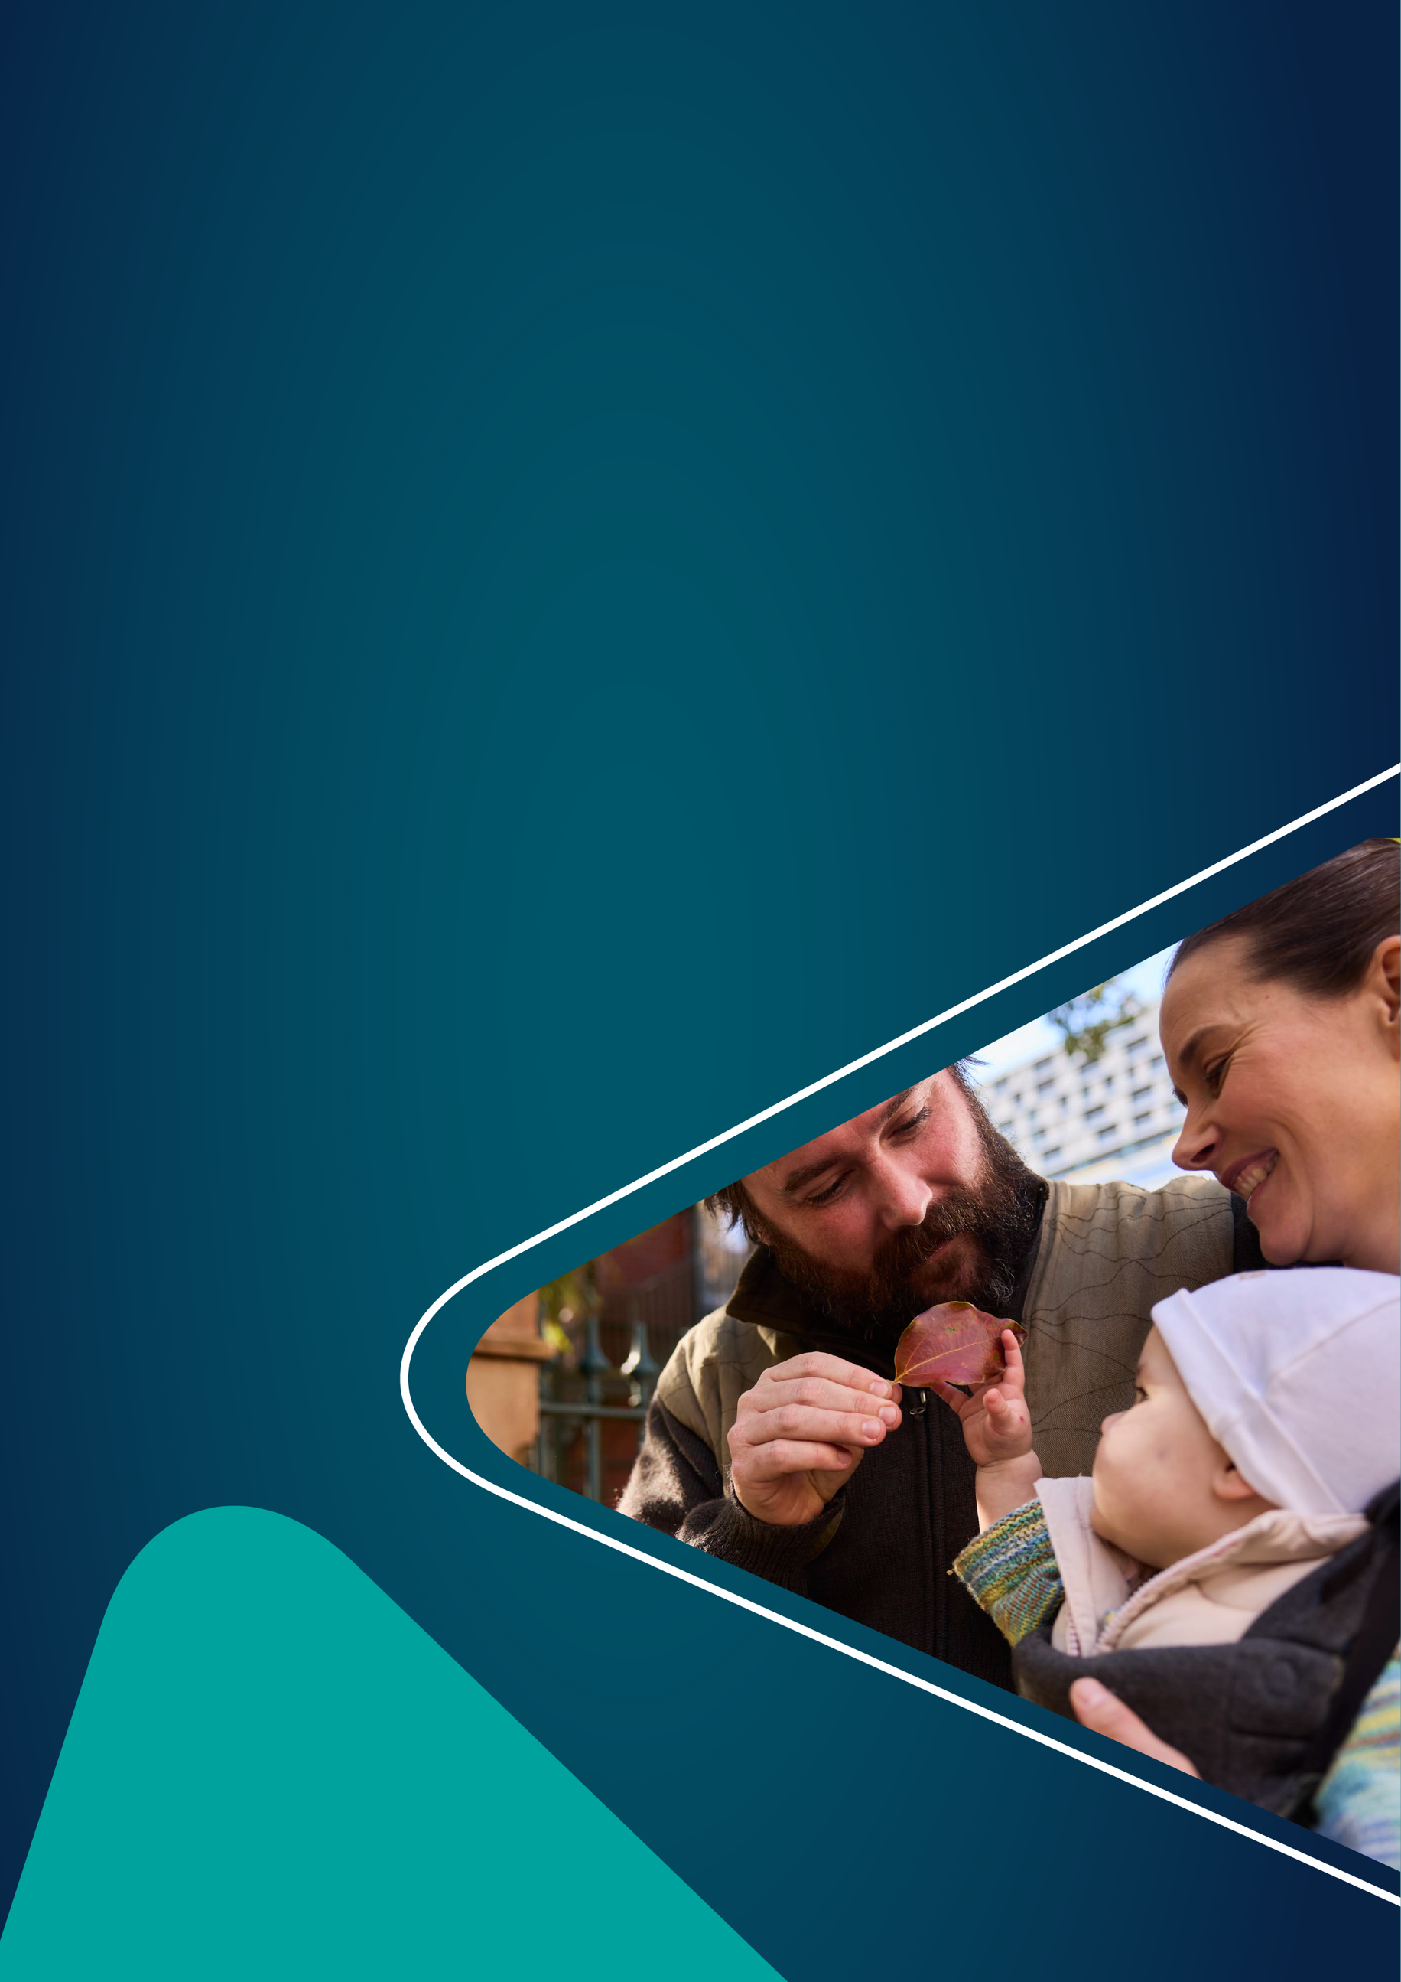

A new approach to children
and family programs
Factsheet for families, parents and caregivers

|DSS.gov.au

Proposed changes to children and family programs
The Department of Social Services (the department) is consulting on changes to ensure services for families, children and young people deliver better outcomes. This factsheet explains the key changes.

What are the proposed changes?
The proposed changes focus on four priorities to improve outcomes for families. These are:
- Ensuring supports and services improve the wellbeing of families and children.

- Making services easier and more convenient to use by locating child and family supports with other services you may already use, such as health or early learning services.

- Delivering services and supports in communities with the greatest need.

- Delivering more services that are culturally safe and inclusive for Aboriginal and Torres Strait Islander families.

We are also making it easier for providers to meet reporting requirements. This means that providers will be able to spend less time on administrative tasks and more time delivering services to you.

Why are we proposing changes?
We have heard suggestions from parents and providers about how we can improve services and supports for families, children and young people.
Parents have said that services should be more inclusive and better able to meet the needs of diverse children and families. They have also said that supports should be available in a range of delivery methods, such as online and after hours, to enable greater access.
From service providers, we heard that there should be more flexibility in how they deliver their services to allow them to better support families, children and young people.

Main points
- The main change is to establish a single national program to replace 5 existing programs:
  - Children and Parenting Support (CaPS). You may have accessed a support like playgroups, toy libraries, parenting classes or online information through CaPS.

  - Family Mental Health Supports and Services (FMHSS). You may have accessed counselling services or therapy groups through FMHSS.

  - Communities for Children Facilitating Partner (CfC FP). You may have accessed parenting programs, group peer support or life skills courses through CfC FP.

  - Family and Relationship Services (FaRS). You may have accessed a support like counselling for you and your family; practical assistance to access information; education and referrals to other services; or groups offering education and skills development.

  - Specialised Family Violence Services (SFVSS). You may have accessed a support like counselling for you and your family; a men’s behaviour change program; supports for your child/children such as play or art therapy, or youth activities and cooking workshops.

- The services and supports you currently use under these programs will still be available during consultation.

- If there are any changes, there will be a clear transition period to help you understand what supports are available and how to access them.

Who are we consulting?
We would like to hear from parents and caregivers, as well as feedback from service providers, peak bodies, academics and industry experts. There will be different ways to have your say - participate in an online round table event, make a written submission or answer a quick survey.
More information on ways to have your say is available at engage.dss.gov.au.

Next Steps
In 2026, we will provide an update on what we heard through this consultation and what changes will go ahead. Any changes to service delivery as a result of the changes would occur from early 2027.

