The DSS said they want to know:
- How well do you understand the NDIS Support rule?
There seems to be considerable variation in interpretation (e.g. providers, planners, support coordinators, participants) and therefore we are not confident that our interpretation is accurate.
Please refer to attached annotated ‘Supports that are NDIS supports’ and ‘Supports that are not NDIS supports’ documents for specific examples and comments to illustrate the situations where they are open to different interpretations, confusing or, in some cases, contradictory.
It is additionally challenging because application of the rules requires reference not just to one document, but others (PAPL, the 2 separate ‘Supports that are’ and ‘Supports that are not‘ documents, support catalogue, FAQs, etc).
No links in this consultation paper go to ‘the Rule’ – the links go to supports lists. Are the supports lists ‘the Rule’? Directed to Section 10 – the Rule is not mentioned in Section 10.

- What would help make the rule easier to understand?
Original document had a ‘What is an NDIS Support’ and a ‘What is not an NDIS support’ list – a single document would be easier to navigate.
Or one explicit ‘What is an NDIS Support’ document – if it’s not on this list then it is out.
Clear hierarchy of priority and cross referencing for application of support lists, PAPL, etc.
Currently the lists use a mix of generic descriptors and very specific descriptors – see annotated support lists attached for examples of this. This is confusing and would be preferable to go with one or the other.
Are the lists guides, or rules/a mandate? Rules imply strict black and white interpretation or a mandate, however, the provision of examples and some generic umbrella terms implies flexibility, interpretation and that it is to be used as a guideline. As an example, the list of therapies includes occupational and speech therapy but is not an exhaustive list of all evidence-based therapies.
An online decision tree that assists participants and providers to understand which supports are eligible based on the supports lists, impairment category, PAPL, etc.

- How have the lists of NDIS Supports helped you to know what the NDIS can and cannot fund?
The Support List has not given any further assistance in interpretation beyond what is in the PAPL.
The lists have been constructed in a way that requires multiple skills and abilities in order to access, read, interpret and apply them, which demands higher than minimum standards of both verbal and written literacy as well as computer literacy skills. The lists are also not constructed with cultural sensitivity in mind. Participants are required to access multiple documents in order to compare and transfer this information into their personal circumstances and settings.

The Easy read version is not an easier to understand option. They do not have hyperlinked contents and are double the page length. These easy read versions tend to oversimplify the lists which leads to misunderstanding and misinterpretation of information for participants.
These lists and the associated confusion, debate and disagreements have once again placed an enormous burden on the person with a disability, or their parent/carer, where the purpose of this should be to streamline / make the Scheme more accessible.

- What have you found hard about using or understanding the lists for:
  - supports that are NDIS supports
Please refer to attached appendix for annotated examples.

  - supports that are not NDIS supports?
Please refer to attached appendix for annotated examples.

- What are some examples of things in the NDIS Supports lists that aren’t clear?
Please refer to attached appendix for annotated examples.
There is a huge gap between the two lists – there are so many services and supports that are not listed on either document, therefore how is a participant or provider to know if it is acceptable or not?
Individual vs Group Therapy – double dipping interpretation at a planner / plan manager level – there have been some challenges with plan managers/support coordinators not allowing the use of therapeutic supports for group therapy or not allowing it to be used for a combination of individual and group therapy due to an interpretation that this is ‘double-dipping’. Does it need to be specifically noted that therapeutic supports can be provided through individual and/or group therapy?
As flagged earlier, some items in the lists include very specific examples, others are much more generic, seeming to indicate that it is open to interpretation. It would be much more helpful if the lists used one style or the other.
ECI section in the ‘Supports that are an NDIS support’ list references only SP and OT, not other professionals – should refer to professionals noted in the PAPL.
There is inconsistent use of the qualifier phrase ‘due to the participant’s disability’. This is included in some items but not others. For complete clarity, it should be made unmistakeable that an item is only eligible as an NDIS support if it relates to their disability. For example, in the ‘Supports that are NDIS supports’ list, under ‘Home modification, design & construction’, there are inclusions “installing equipment or changing a building’s structure, fixture or fittings” – this could be interpreted that any participant is able to use funding for such supports, when this is (presumably) not the case: it is only if the person’s disability prevents them from doing or organising these tasks themselves. By comparison, the next section ‘Household tasks’ does specify that it is when a participant is not able to do those tasks themselves because of their disability.

- Are there any areas of the NDIS Supports rule (or lists) you think need to be changed?”
Overwhelmingly, one of the biggest issues is the lack of interface between the two lists, and also between the lists and other NDIS documents, in particular the Pricing Arrangements and Price Limits (PAPL) document. The PAPL contains detailed information about many of the items listed in the ‘Supports that are NDIS Supports’ and ‘Supports that are not NDIS Supports’ lists.
It seems unhelpful that neither document makes reference to the other. All the documents provide valuable additional information which would be even more assistive if they referred to and interfaced with each other.
In some cases, the information in PAPL is in direct contradiction to the information in the lists.
Additionally, the PAPL includes a section on the Priority of Interpretation, which makes no reference to the Supports list – therefore it is unclear which should take precedence:
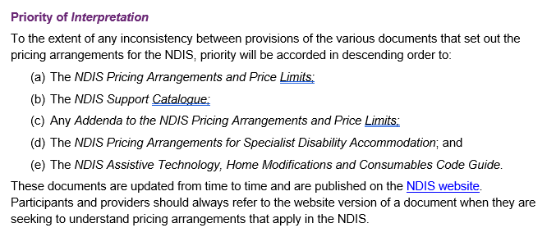Another hugely significant issue is that whether a support is or is not an NDIS support is not just determined by its presence on one list or the other; the participant’s impairment category will have a major impact. There is no reference to this in either document but is likely to be major point of contention between providers, plan managers and participants.
Our understanding is that the intention of the NDIS Support Rule is to ensure that participants are provided with evidence-based best practice, however there is no sign of consultation or research, nor is there clarification of what is deemed ‘evidence-based’.
Similarly, who determined what are the best supports for autism? There has been next to no consultation with peak providers.
Terminology and the use of the word ‘intervention’ – this term has been identified some time ago as undesirable, and responsive providers have ceased using this term. They are feeling pressure to use it again, in order to enable interpretation of their service against the Support lists, when evidence shows that it is not well-received by people with disability.
Gaps – lots of things are not mentioned or are not clearly stated in either the ‘in’ or ‘out’ list. Examples: art therapy, music therapy, school refusal programs are out – what about a psychologist treating for school refusal?

