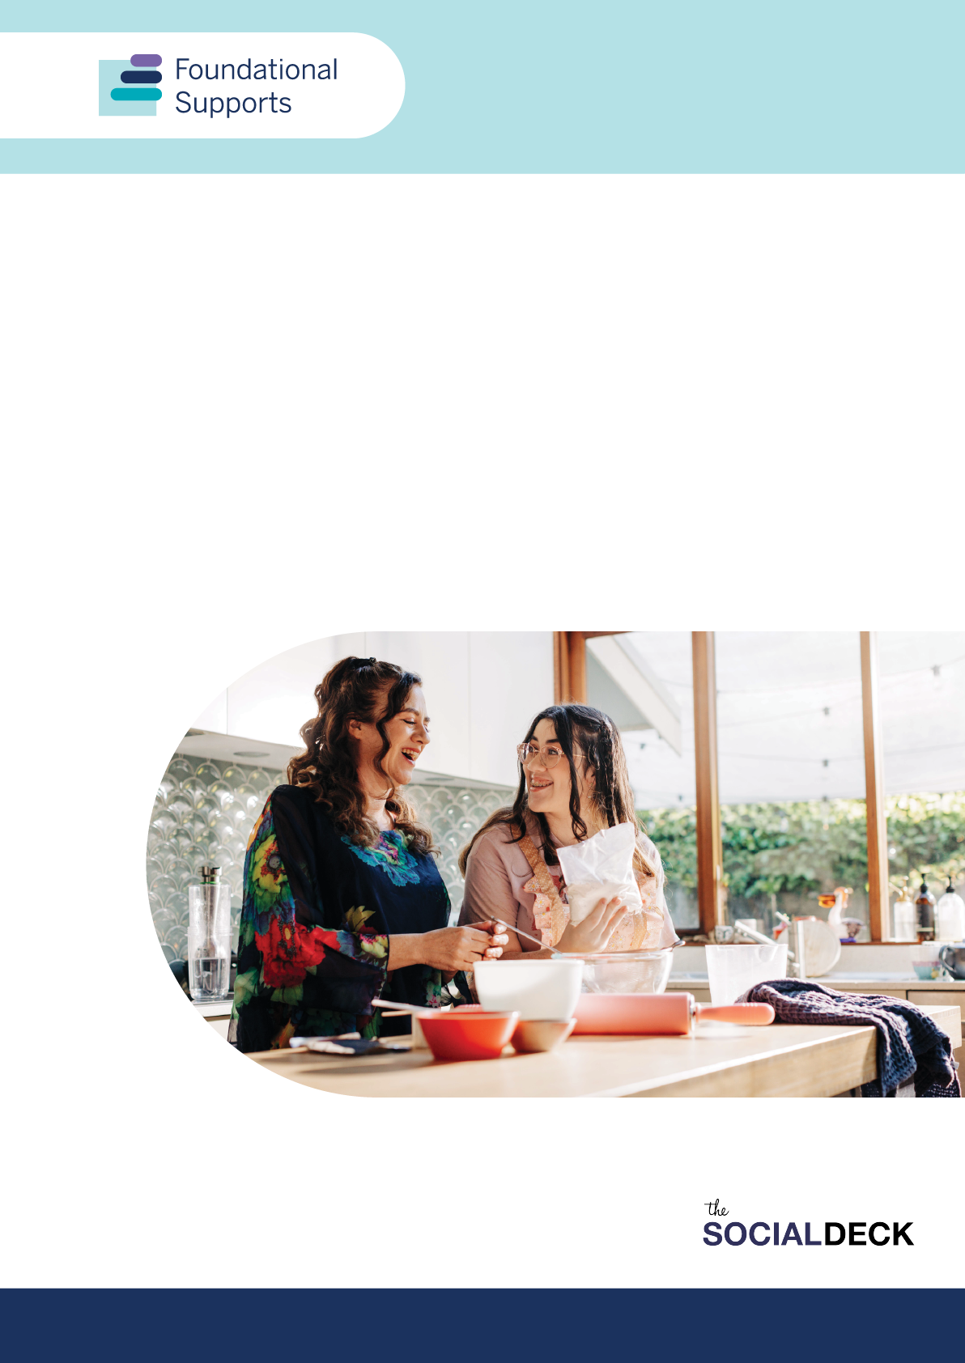

Foundational Supports Consultation Report
Feedback on disability advocacy from the foundational supports consultations
Report produced by The Social Deck

Contents
Contents 2
Acknowledgement of Country 3
Executive summary 4
Advocacy's role in information, advice and referrals 4
Advocacy's role in capacity building 5
Design, delivery and governance 5
Funding and independence 5
Meeting diverse needs 5
Opportunities for strengthening advocacy 6
Background 6
Types of disability advocacy and consultation themes 7
Advocacy’s role in information, advice and referrals 9
How advocacy supports information, advice, and referral 10
Barriers to accessing advocacy for information and referrals 11
Strengthening advocacy’s role in information, advice and referral 11
Advocacy’s role in capacity building supports 11
How advocacy supports capacity building 12
What’s working well to build capacity for families, carers and kin through advocacy 12
What’s working well in community to build capacity through advocacy 12
Barriers to advocacy-led capacity building 13
Strengthening advocacy in capacity building 13
Advocacy and the foundational supports system 14
Funding and independence for advocacy 14
Other feedback 15
Specific population needs 16
Meeting specific and intersectional needs 16
First Nations 16
Awareness and access 16
Culturally safe and appropriate support 17
Representation in systemic advocacy 17
Culturally and linguistically diverse 17
Cultural conventions and attitudes 17
Barriers to participating in advocacy 18
Regional, rural and remote 18
Specific types of disability 18

Acknowledgement of Country
The Department of Social Services acknowledges the Traditional Owners of Country throughout Australia on which we gather, live and work. We acknowledge all Traditional Custodians, their Elders past, present and emerging and we pay our respects to their continuing connection to their culture, community, land, sea and water.
The consultations informing this report took place on the unceded lands of First Nations peoples across Australia. The Social Deck acknowledges the Traditional Custodians who have lived on and cared for Country for thousands of generations, and recognises their continuing connection to land, waters and community. We pay our respects to them and their cultures, and to Elders past and present.
A note on language
We acknowledge people use different words to talk about disability and each person will have a way of talking about disability and about themselves they like best. Some people like to use ‘disabled person’ (identity-first language), while some like to use ‘person with disability’ (person-first language), and some are fine with using either.
We use person-first language to talk about disability. This means we usually use the term ‘person with disability’ in this report. The language used in this report is not intended to diminish an individual’s identity as a person with disability.
We recognise the appropriate use of language varies between individuals and disability communities. We acknowledge the importance of having conversations with individuals about their preferred language.

Executive summary
In 2024, The Social Deck consulted over 4,000 people across Australia about foundational disability supports. This report summarises key insights specifically on disability advocacy, highlighting its critical relationship with foundational supports.
Participants clearly indicated advocacy—people speaking up for themselves or others—is vital for foundational supports to be effective.
Disability advocacy and foundational supports are closely connected. Effective foundational supports help people engage in different types of advocacy, while advocacy improves the quality and relevance of supports. Consultation participants emphasised advocacy ensures people with disability can access services, uphold their rights, and participate fully in their communities.

Advocacy's role in information, advice and referrals
Disability advocacy organisations are trusted sources of information and were identified as the fifth most likely source people would use. They contribute by:
- providing accessible, tailored information
- offering personalised advice
- making appropriate referrals
- supporting communication for people who struggle with written materials
- acting as trusted sources of up-to-date information.
Key barriers include limited availability of advocacy services to address issues such as NDIS eligibility restrictions, and accessibility issues including a lack of advocacy access in regional, rural and remote areas. NDIS eligibility restrictions include people with disability who do not meet section 24 of the National Disability Insurance Scheme Act 2013 relating to eligibility and List A criterion, or section 25 relating to early intervention requirements. Advocates supporting people with disability with referrals to the NDIS have reported getting up-to-date supporting documentation, especially evidence addressing the exact criteria the NDIS needs, is a major issue. DANA advocated for minimal eligibility requirements for foundational supports, pointing to the issues already faced for advocates getting evidence for NDIS.
DANA noted in their submission ‘demand for advocacy sharply increased with the introduction of the NDIS, and funding injections have not effectively addressed this increase in need’ (p.16), including people who had been deemed ineligible for Scheme access. Family Advocacy suggested in their submission this spike in demand following NDIS introduction may be replicated when foundational supports are rolled out: ‘advocacy will be required to rectify individual and systemic issues caused by unintended consequences or the lack of clarity around roles and responsibilities’ (p.31).

Advocacy's role in capacity building
Advocacy plays an important role in building capacity for people with disability, their families, and communities by:
- providing information and education about rights and systems
- supporting skill development in communication and decision-making
- linking people with services and resources
- strengthening informal support networks
- identifying barriers and service gaps.
Participants valued peer-led advocacy organisations, community programs with lived experience involvement, and online groups who provide practical advice and emotional support.

Design, delivery and governance
Strong, independent advocacy is essential for the success of foundational supports. Participants suggested:
- advocacy must be considered in design, implementation and review
- people with lived experience and advocacy organisations should be involved in co-design
- advocacy organisations could form part of an oversight council for implementation of foundational supports.

Funding and independence
Participants frequently raised concerns about insufficient funding and unreliable funding cycles. Views were mixed on whether advocacy funding should be included in foundational supports or kept separate to maintain independence.

Meeting diverse needs
The consultations identified specific considerations for different populations:
- First Nations need culturally grounded advocacy, increased awareness of advocacy services, and representation in systemic advocacy.
- Culturally and Linguistically Diverse people need to navigate cultural conventions and attitudes, and address barriers to participation.
- Regional, rural and remote have significant gaps in service availability, with localised disability-led advocacy programs showing promise when adequately resourced.
- Specific disability groups have unique advocacy needs requiring targeted, lived experience-led approaches.
- People with disability who have intersectional identities need targeted supports that understand those intersecting needs.

Opportunities for strengthening advocacy
The report identifies several ways to strengthen advocacy's impact:
- Expand access to independent advocacy organisations, including for people not eligible for NDIS
- Provide long-term, reliable funding rather than short-term project funding
- Ensure advocacy services are accessible across all geographic regions
- Fund peer-led and disability-led advocacy programs based in lived experience
- Provide training for advocates to support people with diverse needs
- Recognise advocacy's role in working with families and informal supports
- Ensure advocates are trained in disability-specific needs, cultural safety, and trauma-informed approaches
- Include advocacy in the design, implementation and governance of foundational supports.

Background
In 2024, The Social Deck was engaged to undertake consultations to inform the design of foundational supports for people with disability. We held more than 78 consultation events and engaged with more than 4000 people.
The consultations focused on general supports and supports for children.
In this paper we have been asked to review the feedback we received through the general supports consultations to get an understanding of the perspectives shared on disability advocacy through this consultation process.
The purpose of the general supports consultations was to get feedback and ideas relating to the following key areas.
Information and advice: Access to quality information and advice on disability supports available to people and their families/carers and kin, and including help to find and connect with the right supports for their needs.
Capacity building for individuals: Improved access to peer support groups, support around self-advocacy, rights awareness, decision-making, leadership development, relationship building and life skills development.
Capacity building for families and carers: Peer support, parenting groups and workshops, education and training, building skills in advocacy and rights awareness, family leadership and development.
Capacity building for the community: Building the capability of community organisations (like sporting clubs, arts groups) and at the whole-of-sector or community level to deliver disability-inclusive and accessible services. Projects would focus on providing advice and resources to support equitable access to quality and inclusive community services for people with disability.
Other foundational supports consultation reports are available at: https://engage.dss.gov.au/foundational-supports/consultation-reports

Types of disability advocacy and consultation themes
Disability advocacy and foundational supports are closely linked. Effective foundational supports help individuals and groups undertake different types of advocacy. Similarly, advocacy activities improve the quality and relevance of foundational supports.
Feedback from the consultations emphasised advocacy ensures people with disability can access supports, uphold their rights, and participate fully in their communities. It plays a key role in making the foundational supports system accountable, inclusive, and effective. Many organisations provided feedback that advocacy must be involved from the outset — in design, governance, and delivery — to ensure the system works for everyone, especially people who have historically been underserved.
A number of key overarching themes from the foundational supports consultations are directly relevant to different types of advocacy.
Self-advocacy
Self-advocacy occurs when people with disability speak up for themselves about their rights and preferences. To support self-advocacy, foundational supports must provide clear information, training, and capacity building programs.
Key themes related to self-advocacy:
- Information and advice from trusted organisations: People emphasised the need for organisations to receive reliable, long-term funding to offer advice and education. These organisations empower individuals by helping them understand and communicate their needs and rights clearly.
- Local community delivery: Providing foundational supports in welcoming community settings (such as neighbourhood centres and libraries) enables people to learn self-advocacy skills and access resources.
It should be noted organisations had varying definitions of self-advocacy (some included representative organisations advocating on behalf of their members).
Peer advocacy
Peer advocacy is where people with disability support each other based on shared experiences. Foundational supports can help peer advocacy through sustainable networks and peer groups.
Key themes related to peer advocacy:
- Investing in peer support networks: People strongly supported peer networks, saying these groups help individuals share knowledge about navigating disability support systems. Peer groups build confidence and understanding in a natural, supportive environment.
It should be noted it is also common among some groups and individuals who participated in consultations to use the term ‘self-advocacy’ to refer to systemic and individual advocacy and support delivered by lived experience groups. For clarity, this report will refer to this as peer advocacy.
Individual advocacy
Individual advocacy involves providing personal support to help a person address specific issues such as housing, health care, or discrimination. Foundational supports are essential for individual advocacy, providing access to advocates and experts who can offer practical help.
Key themes related to individual advocacy:
- Digital and centralised platforms: People wanted reliable digital platforms where they can find advocates and tailored support information. They also emphasised the importance of trained staff who can provide individualised advice through dedicated helplines.
- Workforce training and sustainability: Respondents emphasised the importance of having a trained workforce, particularly case managers or navigators. These workers can assist people directly with personalised advocacy needs, especially in regional or remote areas.
Family advocacy
Family advocacy involves family members advocating on behalf of a relative with disability. Foundational supports can provide family members with essential resources, education, and training so they can advocate effectively.
Key themes related to family advocacy:
- Information and training programs: Families benefit greatly from programs which provide clear information about available supports. Respondents suggested foundational supports delivered through general community systems like schools, health services, and early childhood centres, will help families to learn effective advocacy for their family to get access to the most helpful support for their family.
Citizen advocacy
Citizen advocacy involves long-term voluntary relationships between individuals with disability and community members who advocate alongside them. Foundational supports can encourage citizen advocacy by investing in strong community connections and sustainable local initiatives.
Key themes related to citizen advocacy:
- Local community delivery: Community hubs and neighbourhood centres provide spaces where lasting relationships and networks can develop, creating opportunities for citizen advocacy.

Systemic advocacy
Systemic advocacy involves changing broader systems, policies, and laws to benefit people with disability. Strong foundational supports depend on effective systemic advocacy, as it ensures services remain relevant and accountable to the community's real needs.
Key themes related to systemic advocacy:
- Long-term and flexible funding: Participants stressed long-term funding models enable advocacy groups and grassroots organisations to collaborate on systemic changes.
- Quality, safety, and accountability: People said systemic advocacy organisations should play a key role in monitoring quality, improving complaints systems, and ensuring supports remain inclusive and accessible.
Legal advocacy
Legal advocacy provides formal, legal support to protect the rights of people with disability. Good foundational supports include clear pathways to legal advice and representation.
Key themes related to legal advocacy:
- Information about rights and legal protections: Participants emphasised foundational supports must include accurate, accessible information about rights and legal protections. Effective legal advocacy ensures individuals can challenge unfair decisions, discrimination, or poor-quality supports.

Advocacy’s role in information, advice and referrals
Many organisations said advocacy services are already trusted sources of information, advice and referral. These roles should be recognised and supported. Individual questionnaire respondents chose disability advocacy organisations as the fifth most likely source of information and advice they would use.
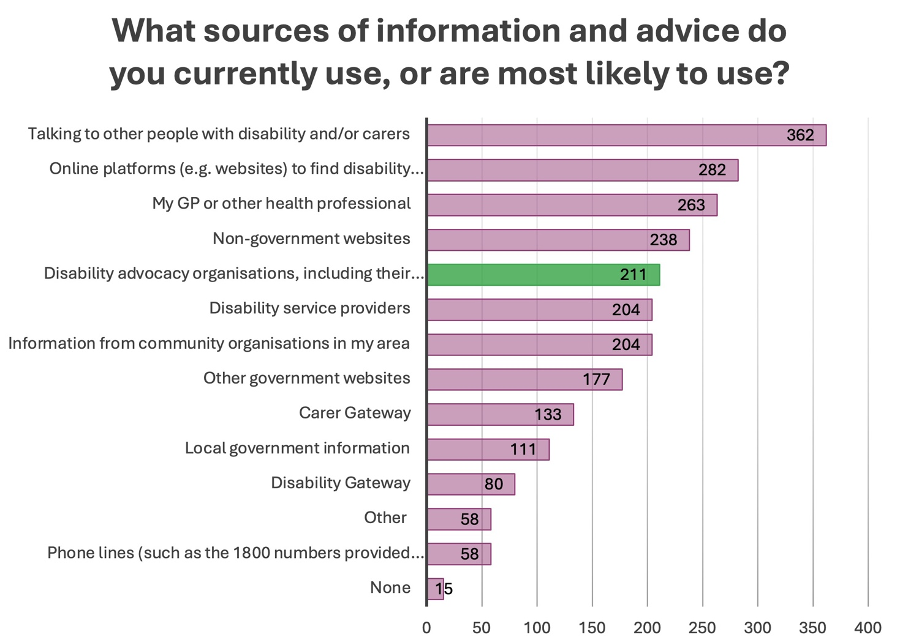
Figure 2: Sources of information with disability advocacy highlighted green (n=500)

How advocacy supports information, advice, and referral
Participants outlined several ways advocacy services and supports contribute to information, advice and referral:
- Advocacy services provide accessible, tailored information by explaining processes, eligibility, and entitlements in plain English or other formats such as Easy Read, videos, or with interpreters. This is especially important for people navigating systems like the NDIS, Centrelink, housing, health, or education.
- Advocates offer personalised advice helping people understand how general information relates to their own situation and figure out the best steps to take. This kind of support is especially helpful during stressful times or when someone doesn’t know where to begin.
- Advocacy organisations help people connect with the right services by making referrals to peer networks, allied health providers, legal services, and community programs. Their strong local networks make it easier to find and access the support people need.
- When written materials or websites are hard to use, advocacy organisations provide information over the phone, on video, or in person, making it easier to understand and ask questions.
- Participants said they trusted advocacy groups to provide up-to-date information, often finding them more reliable than government sources, especially when official information was confusing or inconsistent.

Barriers to accessing advocacy for information and referrals
Participants noted a number of barriers to accessing advocacy for information and referrals:
- Many people said they couldn’t access advocacy services due to long waitlists or because there were no services available in their area, especially in regional and remote communities.
- Some advocacy services only support people in the NDIS with legal advocacy which means others miss out on advice or help with referrals.
- When advocacy support isn’t available, people often rely on parents, peers, or GPs. While these sources can be helpful, they may not have the time or knowledge to give accurate or complete guidance.
- Government services like Local Area Coordinators (LACs) were often described as inconsistent or unhelpful, and many people said their needs weren’t being met.
- Some people found written materials and websites hard to use, especially if they had a cognitive disability, were neurodivergent, or had low digital literacy.

Strengthening advocacy’s role in information, advice and referral
Participants suggested a number of ways to strengthen advocacy’s role in information, advice and referral:
Expand access to independent advocacy organisations, including for people not eligible for the NDIS.
Fund ongoing, not just time-limited, advocacy, so people can receive help across multiple issues which is prohibiting advocates from being able to address issues inside the NDIS and in broader systems including education, employment and medical systems.
Provide centralised, easy-to-navigate referral points, such as a single contact number or local hub connecting to multiple services.
Ensure advocates are trained in disability-specific needs, cultural safety, trauma-informed approaches, and supported communication.
Recognise the role of peer-led and lived experience organisations in delivering advice and referrals, especially where mainstream services are inaccessible.

Advocacy’s role in capacity building supports
Consultation participants identified advocacy as playing an important role in building the capacity of people with disability, their families, and carers. Advocacy contributes to capacity building by supporting people to develop the knowledge, skills, and confidence to make decisions, access services, and participate in the community.

How advocacy supports capacity building
Participants described how advocates and advocacy services support capacity building:
Advocacy services help people understand their rights, what supports are available, and how to navigate different service systems. This often includes using plain language to explain things like NDIS processes, Centrelink, housing, health, and education systems.
Advocates support people to build skills in communication, self-advocacy, and decision-making. This might happen through one-on-one support, group workshops, or peer programs.
Advocacy organisations often connect people with services or support networks, which is especially important when systems are complex or hard to access.
Some advocacy organisations work with families, carers, and community members to help them better support people with disability in respectful and effective ways.
Through their individual work, advocacy services often uncover systemic barriers and speak up for changes to improve access and support for others in the community.

What’s working well to build capacity for families, carers and kin through advocacy
Participants outlined a number of ways advocacy was helping to build capacity for families, carers and kin:
Advocacy services and peer networks help families build confidence and knowledge about their rights, available supports, and how to navigate complex systems. This includes support from professionals as well as peers with lived experience.
Practical education and training such as workshops on disability rights, supported decision-making, and navigating services helps families better understand their role and equips them to support the person with disability.
Clear, accurate, disability-specific information supports families to advocate effectively and build daily care routines. Parents and partners benefit from help translating medical needs into day-to-day actions, especially when communication or health needs are complex.
Parent mentoring and emotional support help reduce isolation and burnout. Connecting with others who have similar experiences builds both knowledge and resilience.

What’s working well in community to build capacity through advocacy
Participants outlined a number of ways advocacy was helping to build capacity in communities:
Local and peer-led advocacy organisations (e.g. Rights in Action, Disability Advocacy and Complaints Service of South Australia, South West Autism Network, Consumers of Mental Health WA, Youth Disability Advocacy Network) have helped people connect with others in similar situations, understand available supports, and speak up for their needs.
Community programs that include peer support and people with lived experience are valued. These supports help people share information, reduce isolation, and learn from others.
Skilled professionals, such as allied health workers, social workers, and some support coordinators, have played a helpful role in connecting people to services and supporting advocacy.
Online groups and informal networks (e.g. Facebook, webinars, local events) have helped people find practical advice and emotional support from others in their community.

Barriers to advocacy-led capacity building
Participants noted several limitations in the current system reducing the effectiveness of advocacy in building capacity:
Short-term or project-based funding limits the ability of advocacy services to offer sustained support.
High demand and long waitlists mean many people cannot access advocacy when they need it.
Eligibility restrictions can prevent people with disability who are not in specific programs like the NDIS from receiving support. For example, some advocacy services only support NDIS participants or those seeking access to the NDIS, with specialist advocates who work in administrative law relating to the NDIS. Another example included a survey respondent sharing they use privately funded specialist advocacy which only supports advocacy in the education system.
Limited regional access to advocacy services affects people in rural and remote areas.
Inconsistent support coordination sometimes places the burden of capacity building on families and informal carers without professional assistance.
Families often feel alone in advocating for their family member and report a lack of access to coordinated practical information.

Strengthening advocacy in capacity building
Participants made a number of suggestions to strengthen advocacy in capacity building:
Increase investment in long-term, independent advocacy with a focus on building skills and confidence over time.
Ensure advocacy services are accessible across all geographic regions, and to people both in and outside the NDIS.
Include advocacy as part of the foundational supports system, with a clearly defined role in individual and community capacity building.
Fund peer-led and disability-led programs using lived experience to support capacity building.
Provide training for advocates to support people with diverse needs, including people with cognitive disability, mental health conditions, or communication barriers.
Recognise and support the role of advocacy in working with families and informal supports to build understanding and resilience.

Advocacy and the foundational supports system
In submissions, organisations said strong, independent advocacy is essential for the success of foundational supports. Advocacy helps make sure people with disability can access the right supports and have their rights upheld. Organisations suggested:
advocacy must be considered in the design, implementation and review of foundational supports
people with lived experience and advocacy organisations should be involved in co-design
advocacy helps ensure supports are responsive, trustworthy and uphold human rights – not just focused on independence.
In particular, disability organisations and other stakeholders noted self-advocacy must be accompanied by broader, systemic advocates to help raise larger and more complex advocacy matters. They reiterated advocacy, awareness and promotion of disability and inclusivity are critical to address systemic stigma and discrimination, which act as a key barrier to social, community and economic participation.
The group of Disability Representative Organisations (DROs) recommended a Commissioning Framework to allow disability-led peak bodies and grassroots groups to partner together and seek funding for the vital local solutions to advocacy, peer support and capacity building already existing or vitally needed. It was further suggested by the same group, advocacy organisations could form part of an oversight council to monitor the effectiveness of foundational supports and provide advice around any future expansion of supports.

Funding and independence for advocacy
Participants often mentioned the need for governments to continue to resource and fund advocacy organisations. This included both large, national organisations, and smaller community-based advocacy supports. Participants frequently raised lack of funding and short/unreliable funding cycles as a major barrier to sufficient and successful advocacy services. Many people reported advocacy services aren’t available when needed due to limited capacity.
It was also commonly noted the current demand for advocacy services was far more than the supply and the introduction of foundational supports will likely increase demand for advocacy, similar to what happened with the NDIS.
Views were mixed on whether funding for advocacy should be included in foundational supports or kept separate.

Some organisations argued advocacy should remain separate from foundational supports to protect its independence. They said when advocacy is tied to service delivery, it can create conflicts of interest and reduce trust. Keeping it separate helps ensure clarity about roles and responsibilities and allows advocates to act only in the interests of the person with disability. Independent advocacy is seen as most effective when it has its own structure and funding.
Other organisations said incorporating advocacy into foundational supports could make the system work better. They said it might reduce duplication, streamline service delivery, and make it easier for people to access the help they need. Some functions, like providing information or making referrals, already overlap with advocacy. Including these functions in foundational supports could offer more flexibility and help people receive more coordinated support.

Other feedback
Through submissions, questionnaire responses and consultation activities, participants also provided the following insights into advocacy and its relationship with foundational supports and the broader system.
Many organisations noted navigation and advocacy roles will have significant overlap with proposed general foundational supports. There is potential to strengthen advocacy/navigator roles for complex systems such as health, education, community supports, and legal services.
Advocacy services should help people with intellectual disability and their family and carers build capacity for Supported Decision Making alongside individual advocacy when needed. Supported decision-making training should be evidence-based, co-designed, and delivered with people with intellectual disability, including support for families and carers.

Specific population needs
A number of considerations specific to certain cohort groups within the disability community, as well as related to intersectional experiences in general, were identified during targeted consultations.

Meeting specific and intersectional needs
Participants in targeted sessions commonly emphasised the need for diverse options in advocacy supports and services, including targeted services and other appropriate choices and people with disability with intersectional identities and with different disability needs. Some suggested part of this involves improving connections between other targeted services, such as LGBTIQA+ services, and disability advocacy services. Participants explained having an appropriate range of options is important so people have access to advocates and advocacy services who understand needs, barriers and other considerations specific to the cohort, and so they have access to safe and accessible services. This was reiterated in organisation submissions.
Participants also emphasised the importance of intersectional lived experience being part of advocacy, both in terms of having input from different perspectives and in terms of delivering peer advocacy support.
In a focus group with members of Self-Advocacy Resource Unit (SARU), participants advised disability groups who commonly have others speak for them, specifically people with intellectual disability, brain injuries and complex communication needs, should have a greater voice in advocacy. They also advised LGBTQIA+ and CALD people with disability need better representation in advocacy.

First Nations
Input from First Nations people with disability and organisations who support and advocate for them raised the following matters.

Awareness and access
Consultation participants reported there is low awareness among First Nations communities, especially in regional and remote areas, of advocacy services and around the role advocates can perform.
They recommended education for First Nations people with disability and their families and carers about what advocacy and self-advocacy services are, how those services can help and how to access them. They noted this can include for less immediate or direct family members who are in a position of speaking and advocating for the family. They also supported a holistic, ‘no wrong door’ approach to service provision, through which people with disability in First Nations communities can access advocacy along with other disability and community supports and services under a hub model.

Culturally safe and appropriate support
In submissions, First Peoples Disability Network (FPDN) and the Institute for Urban Indigenous Health (IUIH) each emphasised the need for ‘culturally grounded’ advocacy services. National Advocacy Collective also echoed this specifically for First Nations parents with intellectual disability in their submission. The organisations noted a lack of culturally safe advocacy creates barriers for First Nations people with disability.
They explained community-driven and peer-led advocacy initiatives ‘offer vital emotional and practical support’ and facilitate trust and empowerment. They suggested ‘dedicated funding for community-controlled advocacy organisations’.

Representation in systemic advocacy
In the context of foundational supports development, FPDN recommended ‘a co-design process that centres First Nations communities as partners, rather than recipients’, in a way that incorporates localised representation. They advised this would promote better representation of First Nations people in decision-making and systemic advocacy, as well as promoting attention towards ‘jurisdictional specific issues’.

Culturally and linguistically diverse
Participants in targeted engagements with CALD communities identified some key considerations for providing advocacy support.

Cultural conventions and attitudes
Participants, including advocacy service providers, identified some common conventions and attitudes affecting how people with disability from certain cultural backgrounds are best supported with advocacy.
- Some cultural attitudes and stigma around disability can mean parents of a person with disability might believe the person is incapable of managing their own life or making their own decisions. This can be a key factor to navigate in advocating for the person’s rights.
- The nature of social systems within some cultures can determine who people with disabilities and their families, particularly in older generations, are willing to accept help from, including with people within their own cultural or ethnic group. This needs to be taken into account in ensuring there are culturally appropriate supports available to them.
- People with disability from some CALD backgrounds may have mindsets that discourage complaining or raising concerns.

Barriers to participating in advocacy
Advocacy service providers working in CALD communities identified some clients experience barriers to self-advocacy due to not being taken seriously when engaging with institutions and authorities, despite being fully informed and capable of advocating. This indicates supports designed to build capacity for self-advocacy need to be complemented by culture and practices in the systems people with disability engage with that are respectful to their voices and the voices of their family members.
Consultation participants also noted language barriers and cultural stigma can deter participation with peer advocacy groups.

Regional, rural and remote
Participants discussed some of the barriers and opportunities particular to supporting advocacy to people with disability in regional, rural and remote areas. Lack of availability of advocacy in regional, rural and particularly remote areas was a key barrier identified, which was often connected with lack of funding and resourcing.
Advocates servicing regional areas shared localised, disability-led advocacy programs have been effective while they have been able to run but noted these initiatives ‘only last as long as the funding’. Specifically, they referenced a program run in six regional WA communities through which groups of local people with disability actively advocated to local and state government about projects and changes to improve their town for residents with disability. They suggested if these programs could be supported over a longer time period, it could become a fixed group with cycling members who could serve as ‘the number one point of call for the local government’ on any disability matters.
In discussing what forms of disability advocacy are needed, some regional advocates noted building the capacity of towns to support residents with disability is very helpful but also requires more funding.

Specific types of disability
Targeted consultations also included discussions with people with specific disabilities and their carers, including intellectual disability, autism, psychosocial disability, deafblind, energy limiting conditions and complex needs communities. Input from these groups confirmed the need for intersectional and targeted advocacy support, led by people with lived experience, also relates to the diverse needs and experiences in different areas of disability.
Specific insights:
- People with intellectual disability and their families consistently identified advocacy services and programs as a key source of support, particularly in helping to understand services and supports.

‘Self-advocacy’ groups are a common form of peer support accessed by people with intellectual disability. In their submission, Our Voice SA also recommended provision of ongoing funding for peer network programs ‘empower individuals with intellectual disability to make their own decisions, providing them with accessible information, decision-making tools, and opportunities to participate in advocacy and leadership roles’.
Autistic people and their families identified a need for neuro-affirming advocates.
Parents of children with complex needs would find it helpful to be able to select an independent advocate, such as from a registry, from when their children’s disabilities are first identified, to be a primary touchpoint for assistance. They noted having someone available in this way would also be very valuable as a reliable source of support if the parents became unable to support their children.

