SUBMISSION ON THE S10 NDIS ACT SUPPORTS RULES - Shirley Humphris 27/7/25

Both Federal and State Governments must consider the unintended consequences of harm and more costs regarding these Rules.

This submission proposes that each of these questions have failed with the Transitional Rules considerations

- Was it needed in the current form (lists)to comply with s10?
- Has it saved cost both long and short term?
- Has it added clarity?
- Has it upheld the Objects and Principles of the Act?
- Has it incorporated the UNCRPD?
- Was the list without “principles decisions” (discretion is within the list eg for meals and substitutions, i.e. it can be done)

The unintended consequences

- Added costs both in the immediate and the future
- Killed innovation – “disability shop only” applies to 1&2
- Added confusion to participants and staff
- Flouted the Objects and Principles of the Act
- Flouted the UNCRPD
- Caused harm
- Caused greater poverty
- Caused exclusion and isolation
- Has been a failed pilot with no risk analysis

A Story of Harm
Harm Costs More

About young adult Sam (not their real name)

Sam is fortunate to have a post AAT plan for now, so some of these supports have still been possible. But the plan will soon end.
Sam has level 3 ASD Intellectual Disability CPTSD with flashbacks and nightmares, Behaviours of concern (BOC) and Severe longstanding anxiety. Sam also has a mobility impairment.
Dysregulation can result in harm to self and others and random children have been targeted in public by Sam (even an unknown kinder age), as well as informal supports, support workers and therapists.

Supports for Sam

Sam cannot attend a day programme or group STA due to past traumatic experiences. Support workers have been difficult to find despite 2:1 funding. Single mum on a pension is exhausted physically and emotionally from almost all the challenging care.
Very effective low-cost supports may soon to be banned. All have been recommended by OTs and the Behaviour Support Practitioner.
- Bubble Gum (biting is a BoC, including to random children)
- Weighted blanket
- Noise cancelling headphones
- Crafts and activities to distract as only home care is possible.
- Therapeutic massage, reducing mobility pain also mitigates BoC
- Mineral Bath Salts scented
- Activity books and scented textas in the car to keep the driver safe and avoid causing accidents.
To be honest it’s not certain these items are banned as there are grey areas and confusion.
Looking at the list many would presume anyone could self-fund these things, but that is not so through the lens of poverty. The bubble gum alone is costing $2 -3,000 a year due to intense use, two pieces at a time and replaced often.

It feels that the decision makers have no idea of disability cost of living. It is worse than general cost of living and usually lifetime long for those who cannot work.
Disability has many extra costs that have never been claimable such as medical care.
If the simple low-cost AT supports are not funded, Jane (Sam’s Mum) doesn’t know how she will manage Sam at home. She is worried that the tools will no longer be available for support workers to do their job and the workers will be even more difficult to find.
The alternative at far greater expense, is SDA both financial and as a cause of predicted regression from harm. Because harm costs.

For the many Sams - a New s10 Rules
principles-based approach to NDIS supports - From NDIS Supports (s10) consultation and engagement
  - Stakeholders have advocated for a principles-based approach to the NDIS supports rule, like section 34 of the NDIS Act. YES
  - The wording of the rule-making power in section 10 requires the rules to state what is, and is not, a NDIS support. it does not need to be a highly specific list to comply with s10. To claim a list is necessary is not lawful.
  - The use of principles would require participants, providers and others to make complex decisions which are not supported by the changes to the NDIS Act. This is actually patronising. However even “list” items still have to be decided disability needed otherwise anyone could buy anything on the list!
  - It is important the rules provide clarity about whether a person has a need for the support as a result of their disability, and whether the support is most appropriately funded by the NDIS. whether a person has a disability need is the antithesis of a restrictive list. It has not provided certainty.
I urge DSS/Health/NDIA to:

- Recognise the lawful use of disability principles in the finalisation of supports under section 10.
- Avoid imposing administrative limitations not found in the statute.
- Ensure that the implementation of section 10 mitigates harm and remains consistent with Australia’s obligations under the CRPD.
For the “IN” LIST
The new Rules, legislating “APTOS” would allow compliance with s10 without anything else (albeit lawyers were concerned that APTOS was not written in a legislative format). The APTOS type inclusion needs more in-depth consideration from States and Territories. There cannot be “gaps”.
This guidance (from the Explanatory Statement) MUST be included in the main Rules list (if such a list is a must). No list could include each and every support possible for the next 10 years.
“Column 2 of the table contains a description of the supports that fall within each category. Many of the descriptions include a list of included supports. These lists are not exhaustive so do not exclude an item that is not listed in the description. The purpose of the listed supports is to clarify the kinds of supports that fall within the overarching description.” Explanatory Statement
The “allowed list” in the Rules should have no reference to “disability specific” or “standard” because this restriction could be more costly, as participants search for “what fits” rather than best value. Therapists are already recommending a disability specific item when a mainstream item would do the job at a fraction of the price.
Furthermore, it causes “othering” of disabled people, is not inclusive, as well as resulting in restrictions to pursuing goals .

Two examples of costs (and there are many):
1.A Speech Pathologist reported that she requested an iPad for communication. It was refused. But was told she could order a $5000 device.
2. A severely disabled person with epilepsy and intellectual disability needed a simple $500 Apple watch for falls. The person has no capacity to use any other function of the watch. It was refused but offered a falls detection device for $1800

Failed supports not only cost more in the short term, but there are long-term implications of failed capacity building and cost shifting to health and justice that must be considered..

The Replacement support rule has been a complete failure. Participants and NDIA staff have failed to understand and apply it. It should not have restrictions or limitations imposed and should be appealable. Participants frequently have nothing available for the swap.

The below is all that is needed for principles-based purchases

Reasonable and Necessary Self-Assessment
SOURCE: https://www.ndis.gov.au/participants/assistive-technology-explained

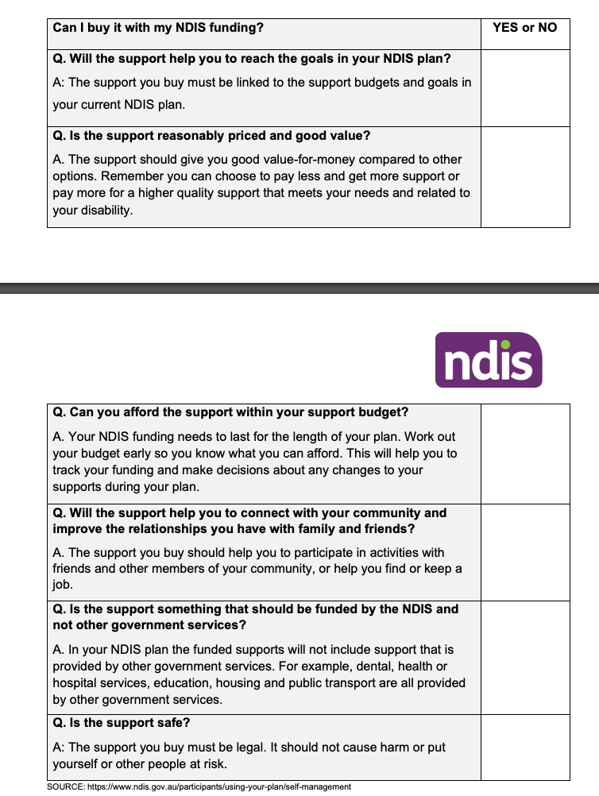

This is a brief overview from my (incomplete) perspective of the IN list: I do not have experience of many sections. This list is far more confusing than the above table based on Principles.
At 5 Assistance with daily life tasks in a group or shared living arrangement this part must be removed. Very many cannot partake in shared living for disability reasons and would be harmed or cause harm. Frankly this clause is highly offensive.
At (9 f) furniture and other products that are needed for disability adapted or specifically made to be placed in or added to a participant’s home (including indoor and outdoor areas) to help with movement, positioning and other safety needs, including entry and exit of the environment;
At 10 include AT recommended by BSP that assist in mitigating behaviours.
At 12 Supports that provide disability-related nursing care for participants with high care needs (not including high intensity daily personal activities), requiring a high level of clinical skill. Remove the strike through red.
· Not all high intensity daily personal activities are of equivalent care need and may need RN expertise. Just because the Commission has a standard fpr support workers on High Intensity doesn’t mean that support workers can be safe for a particular person if against professional advice.
· Note the non-exhaustive provision must allow for future provision for disability related nursing at home that in the long term prevent more expensive hospitalisation. The exclusion of high intensity daily personal activities MUST be removed from this section.
· APTOS only ever mention “suitably qualified” for care in the community and DSW may not be suitably qualified for some high intensity supports for some individuals. APTOS recognised the care required to live in the community not in hospital.
· The number of high intensity supports needed may combine to a cognitive and skilled load beyond the capability of even a trained disability support worker, who is likely managing other complex care beyond medical care. This is expressed by this comment:
“The practice standards document indicates that the described skills can be performed by a suitably trained support worker. There are two difficulties with this affirmation in the case of this applicant. Firstly, she has three different high intensity daily personal activities which significantly complicates the care.” From an IME paediatrician to ART

At 15 Include after school assistance where extra is needed due to disability. Allowing a child to fall behind year after year impact on future “life skills” with potential future costs of loss of capacity to work. Tutors should be allowed if needed for disability. The school does not provide this assistance. It finishes responsibility at 3:30pm

At 21 (a) “a suitably qualified worker” undertaking the activities;( see 12) this does not necessarily mean a disability support worker is suitably qualified.

The Rules, legislating APTOS would allow compliance with s10 without anything else (albeit lawyers were concerned that APTOS was not written in a legislative format and may need attending too). The APTOS type inclusion needs more in-depth consideration from States and Territories. There cannot be “gaps”.

The NO “LIST”

The following Rules are also clear on what are not NDIS supports. There is no reason that this couldn’t be replicated in s10 Rules to satisfy what is not a NDIS Support

Part 5 General criteria for supports, and supports that will not be funded or provided
5.1 A support will not be provided or funded under the NDIS if:
(a) it is likely to cause harm to the participant or pose a risk to others; or
(b) it is not related to the participant’s disability; or
(c) it duplicates other supports delivered under alternative funding through the NDIS; or
(d) it relates to day-to-day living costs (for example, rent, groceries and utility fees) that are not attributable to a participant’s disability support needs.
5.2 The day-to-day living costs referred to in paragraph 5.1(d) do not include the following (which may be funded under the NDIS if they relate to reasonable and necessary supports):
(a) additional living costs that are incurred by a participant solely and directly as a result of their disability support needs;
(b) costs that are ancillary to another support that is funded or provided under the participant’s plan, and which the participant would not otherwise incur.
Supports that will not be funded or provided - already legislated
5.3 The following supports will not be provided or funded under the NDIS:
(a) a support the provision of which would be contrary to:
(i) a law of the Commonwealth; or
(ii) a law of the State or Territory in which the support would be provided;
(b) a support that consists of income replacement.

This is a trawl through the muddle of the “NOT” lists to pick out those that were never supports that could be justified. if you really must have a list this should work . Anything not picked out here must be available as principles based for disability need.
A carefully considered and agreed APTOS could appear here.

Remove all references to day-to-day. It is an overreach and an insult to those who can barely afford basics. The shocking attitude of those with privilege, was exposed on a DSS webinar when the government representative stated that noise cancelling headphones were day-to-day because she uses them on a plan!

At 2 finance and payments
:
(a) donations, tithes, gifts, and political contributions;
(b) fines, penalties, and court-ordered amounts;
(c) travel insurance, life insurance, income protection insurance, home and contents insurance, car insurance and excess insurance for novated vehicles;
(d) health insurance, ambulance membership, gap payments for Medicare-funded services and private health insurance claims;
(e) superannuation for the participant, or a member of a self managed superannuation fund (within the meaning of the Superannuation Industry (Supervision) Act 1993) of which the participant is a member;
(f) fringe benefits for staff or contractors;
(i) child support fees and debt repayments;
(j) gift cards;
(l) debts, liabilities, loan repayments, buy now pay later payments, and taxes.

4 lifestyle:
(a) cigarettes, vapes and smoking paraphernalia, and legal cannabis;
(b) smoking cessation devices such nicotine replacement items;
(c) gambling;

clothing and beauty
(f) body art including body piercings, tattoo services, and henna.
6 travel and transport
(c) , devices, modifications or products that are not legal for use in the relevant state or territory;
e) vehicle registration
7 pets:
(a) animals, including pets and companion animals (other than eligible assistance animals);
(b) pet food for animals (other than eligible assistance animals
(c) veterinarian costs, pet boarding, pet grooming for animals (other than eligible assistance animals included in a participant’s plan); Nothing should be “named in the plan’ with now 3 year plans needing a crystal ball
(d) pet insurance;
(e) taxidermy and pet cremations, burials or funerals.
8 reproductive health and family related
Surrogacy and fertility treatments.
At 10 Not evidenced based—alternative and complementary therapies

Should not be excluded because they may be appropriate from a support worker but not at therapy rates. Again these may be 10 year Rules so who knows what is evidence based in 2035+
23 Unlawful goods and services
The following:
(a) supports the provision of which would be contrary to:
(i) a law of the Commonwealth; or
(ii) a law of the State or Territory in which the support would be provided;
(b) assistive products, vehicle modifications, or home modifications that do not comply with Commonwealth, State or Territory laws, the National Construction Code, or mandated Australian standards for the location and purpose the participant requires them;
(c) supports involving restrictive practices that are prohibited in the participant’s State or Territory of residence;
(d) consumable products that are against the law;
(e) firearms and weapons;
(f) seclusion rooms.
24 income replacement
(a) income support payments;
(b) rent subsidy; rent subsidy for disability support should be allowed. There could be cost savings in some situations eg SDA alternative. Finding an accessible rental costs more and the market is dire.
(c) income supplementation.

