Joint submission by ACWA and Fams to DSS discussion paper: A new approach to programs for families and children

December 2025

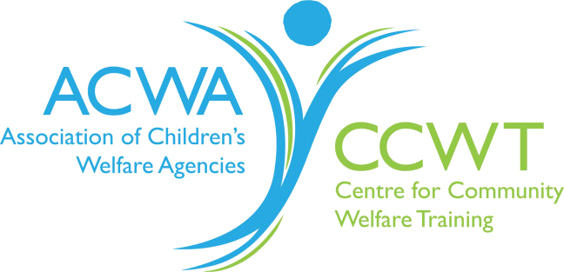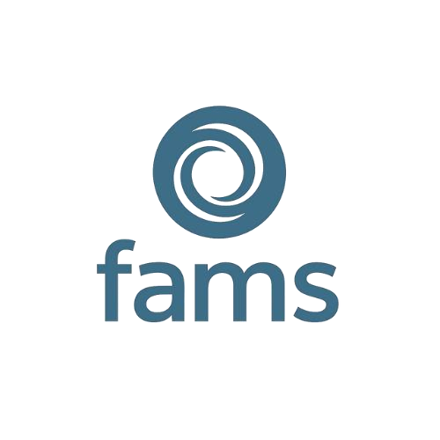

Table of Contents

Executive summary --------------------------------------------------------------------------- 3
1. Introduction 5
2. Response to the overall proposal 6
3. Proposed vision and outcomes 10
4. Program structure and activity streams 10
5. Proposed areas for priority investment 11
6. Key areas of interest proposed in the discussion paper 11
7. Different ways of working together 11
Conclusion 14
Contact Information 14

ACWA and Fams Joint Submission: 2
A new approach to programs for families and children

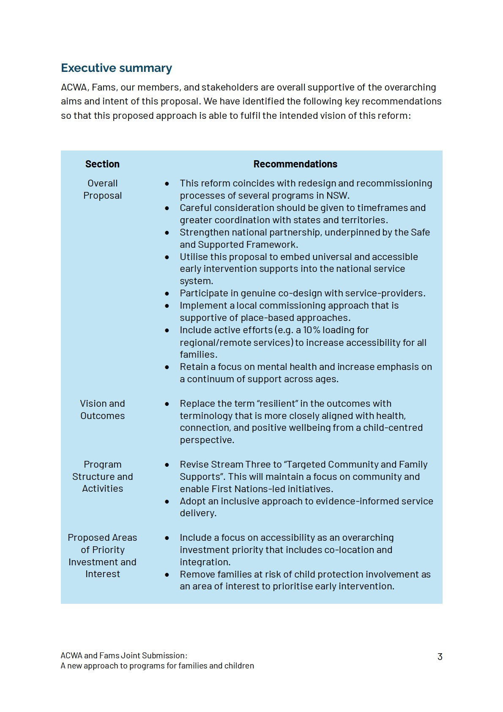
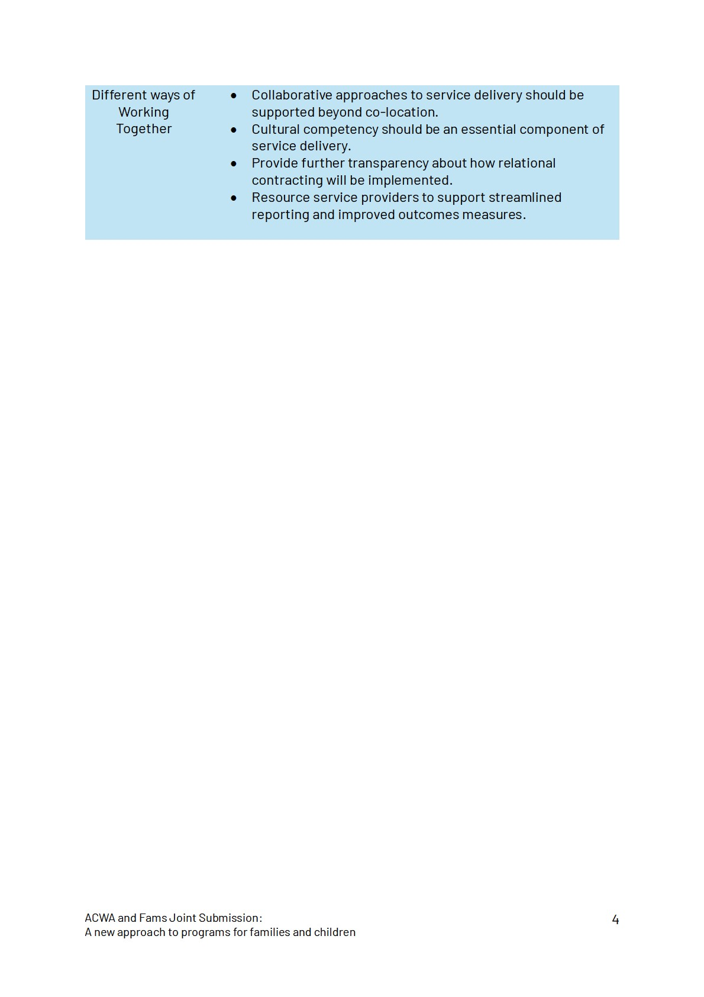

1. Introduction

About ACWA and Fams
The Association of Children's Welfare Agencies (ACWA) is the NSW peak body representing non-government organisations (NGOs) that deliver services to children, young people and their families in vulnerable circumstances including family preservation and out of home care services. Fams is the NSW peak body that represents the child protection NGO early intervention and prevention sector.
Together Fams and ACWA represent and advocate for organisations providing a spectrum of critically important services that work to improve children and young people’s safety and wellbeing and ensure they can thrive within their families and communities.
We welcome the opportunity to respond to the Commonwealth’s proposed reforms to programs for families and children. We strongly support the intent to reduce administrative burden, increase flexibility, and extend contract terms, and implement more relational approaches to commissioning. It is our shared opinion that reform of this magnitude requires a careful, staged approach to ensure service providers are appropriately resourced to provide a continuum of services to children, young people and families.

Our Consultation
ACWA and Fams consulted with our stakeholders in the NSW child and family sector to ensure that our recommendations are informed by service providers.
Many of our members and stakeholders provide services under the Australian Government’s existing child and family support programs including:
Children and Parenting Support (CaPS)
Communities for Children Facilitating Partners (CfC FP)
Family Mental Health Support Services (FMHSS)
Family and Relationship Services (FaRS)
Specialised Family Violence Services (SFVS)
Through these funding streams and state-based funding programs, our stakeholders provide vital services to families across metropolitan, regional, rural and remote communities in NSW. This reform presents an opportunity for services to be enabled and empowered to support families so that children and young people can grow and thrive in strong healthy families, connected to culture, community, and support.

2. Response to the overall proposal
Overall, our members and stakeholders broadly support the proposal to streamline the structure and ongoing administration of the above-mentioned programs into a single national program. They welcome the focus on flexibility and a reduction in administrative burden, and increased length of contracts. In our consultation we were also able to identify vital considerations for design and implementation of the new program to ensure that it is successful in achieving the desired outcomes.

Timing of reform
The proposed timing of the Australian Government’s new approach to programs for families and children, to take effect in June 2026 is unrealistic and coincides with a very significant program of state-based reform taking place in 2026. In NSW child and family programs are currently undergoing significant redesign and/or recommissioning, including:
- Prevention and Targeted Early Intervention programs currently being recommissioned into the Child and Family Support program
- Multiple family preservation programs being recommissioned into Families
Together and Aboriginal Family Preservation, and recommissioning of
Multisystemic Family Therapy – Child abuse and Neglect (MST-CAN) and
Functional Family Therapy - Child Welfare (FFT-CW)
- NSW Out of Home Care system reforms
- Specialist Homelessness Services • Domestic and Family Violence programs.
This range of programs includes almost every community service for families in NSW who need support, including newly commissioned programs in a rapidly expanding Aboriginal community-controlled sector. ACWA and Fams are working closely with
AbSec (the NSW Aboriginal Child and Family Peak) and the NSW Department of Communities and Justice to support reform, however we are deeply concerned about the level of change being asked of the family and community sector in the next year.
We note that the NSW Government is also extending forthcoming funding agreements to five years, and we are pleased to see five-year contracts are also proposed in the discussion paper. Should the start and end of state and commonwealth funding programs coincide this would mean disruption to almost every child and family program in NSW in 2026. This will have widespread impacts on children and families and the community sector workforce, with the same concern arising every five years.
We are also concerned by the intent to implement new contracts in June 2026.We are of the opinion this is insufficient time to consider submissions provided through the current process and undertake genuine co-design.

Consideration of state and territory contexts
In addition to the timing of these reforms, there is a critical need to consider how state and nationally funded programs are designed and commissioned to operate alongside one another. It is vital that there is a more seamless network of support for children and families, and in this reform process provides the opportunity for the Australian Government to make a positive contribution to the network of services, to prevent duplication and support greater collaboration for families in each community.
We call on the Commonwealth to directly engage with Aboriginal and NGO peak bodies and relevant state government agencies in each jurisdiction and ensure genuine codesign of system reform. This includes considering existing system strengths and gaps and working towards common overarching objectives, including the proposed program vision and outcomes and Closing the Gap outcomes.
Our members and stakeholders consider it vital that the approach take account of the development of Foundational supports, currently being negotiated between states and territories and the Commonwealth. It's essential that alignment between programs is considered to ensure seamless access to support for families with children with mild to moderate disability who are not accessing services under the National Disability Insurance Scheme.

Strengthening a national partnership agreement guided by the Safe and Supported Framework to coordinate state, territory, and federal priorities
While our members and stakeholders are supportive of the overarching vision, we identified opportunities to reduce duplication of state programs that service families at risk of contact with child protection services or facing multiple and complex challenges. Our proposed solutions to this are:
- Strengthening the implementation of the Safe and Supported Framework in state, territory and federal programs as an opportunity to develop a national partnership agreement with clear accountability measures.
- Enshrining shared accountability to adequately resource Action 1 of the Safe and Supported Framework so that early intervention approaches are better coordinated nationwide.
- Continue to support vital early intervention services that focus on early community support and targeted local programs such as Communities for Children and the Family Mental Health Support Services.

Prioritisation of prevention and early intervention
Our consultation process reinforced ACWA and Fams support for prevention and early intervention to remain the cornerstone of this reform. Given the clear economic costs of late intervention and the lifelong personal cost of childhood trauma, a focus on preventing harm, identifying need early, and supporting healthy development and wellbeing is imperative. We recommend:
- This program embeds the importance of universal and accessible early intervention supports.
- Clear program guidelines that ensure service delivery does not duplicate statebased intensive family support services.
- Inclusive eligibility criteria that is flexible and adaptable to community needs.

Retaining a focus on local commissioning to meet communities needs
Alongside a national approach, our members and stakeholders have made it clear that it is essential that programs support localisation of service commissioning.
The Communities for Children program is a successful example of how Commonwealth funding can be administered to ensure local services are tailored to local communities. The program’s federal funding is delivered through Facilitating Partners, who coordinate local activities and collaborate with Community Partners to provide services. Guided by a whole-of-community strategy, it operates on a national level while remaining flexible to meet each community’s needs. Stakeholders have noted the potential loss of this program and its commissioning approach as significant, given its flexibility, breadth and ability to respond to local needs and service gaps.

The need for place-based approaches to improve outcomes for families in targeted communities
Beyond local commissioning there is also a critical need to address a longstanding functional gap in place-based planning and dedicated resources that provide the infrastructure for complex, collaborative initiatives to succeed. Place-based strategies strengthen community and family safety by tailoring solutions to local needs, fostering collaboration, and addressing complex challenges in a holistic way. They empower communities to co-design initiatives with government and service providers, ensuring that interventions are relevant, culturally appropriate and sustainable. By focusing on a defined geographic area, these strategies build trust, relationships and shared

accountability among stakeholders, so children, young people and their families experience safer environments and stronger support networks.
Although there are examples in most Australian jurisdictions there is no consistent funding framework to support place-based strategies to improve outcomes for children and families in communities of significant need. ACWA and Fams see there is an important opportunity to embed this into the proposed program structure under stream 3, so that communities facing significant disadvantage can be supported and empowered to develop and implement effective solutions for their own contexts.

Accessibility to families in rural and remote communities
This approach presents an opportunity to support local connection and retention of small providers that are locally embedded. An example of was seen in the NSW recommissioning of Family Preservation services where small to medium service providers were granted a 10% loading in their tender applications. Our stakeholders are clear in their desire for funding approaches that consider the needs of the communities they support regardless of location. Our consultation process also identified the ongoing issue of the additional costs associated with regional/remote service delivery and the challenges of recruitment and retention of skilled staff in these areas. Therefore, we strongly recommend providing commensurate loading in the funding envelopes for regional/remote service delivery.
An important feature of current funding programs is their reach into smaller communities so that children and families in rural and remote regions can access vital programs and supports. It would be a significant loss to families to lose access to programs that nurture children and young people in their home communities. It is unrealistic to expect families in rural and remote areas to travel to access support under a hub and spoke style model. Resourcing and supporting regional and remote service providers is essential to increasing equitable access to services for all children, regardless of where they reside in Australia.

Ensuring a continuum of support across ages, and retention of focus on mental health
Our members and stakeholders are concerned that the discussion paper does not embrace services and supports along the continuum of infancy, childhood and youth. For example, there is a greater focus on the early years with little mention of children in the primary school or middle years group. These are times of significant developmental change and life transitions, when children and families often need support. We suggest the need for reconsideration of how the framework will reflect the needs and outcomes for infants, children and young people across the continuum.
Similarly, our members and stakeholders raised the need to retain a focus on children and young people's mental health and wellbeing. Inclusion of the Family Mental Health Support Services program in the scope of reform, without reference to clear outcomes in the proposed priority areas or program streams, suggests this important area is no longer considered a priority despite very significant need for children and young people to have access to mental health services.

3. Proposed vision and outcomes
Overall, ACWA and Fams and our members and stakeholders support the vision that All children and young people are supported by strong families who have the skills and confidence to nurture them.
Our stakeholders support the intent of the outcomes Parents and caregivers are empowered to raise healthy, resilient children and Children are supported to grow into healthy, resilient adults, but noted concern about the word resilient, which implies that children should be resilient after traumatic events rather than emphasising the importance of preventing trauma. We suggest reconsideration of outcomes with a greater focus on children and young people growing to adulthood within healthy, connected, supportive and safe families and communities.

4. Program structure and activity streams
To address the concerns raised above, we advocate that stream 3 be revised to Targeted Community and Family Supports. This elevates the focus on community and allows for targeted commissioning of First Nations-led initiatives, place-based programs that build community connectedness, and specialised programs for families facing complexity.
Participants in previous Fams consultations have identified that “evidence-informed services” as suggested in stream 2 should have provisions for locally designed programs and adaptation to meet community needs. This will help ensure that tailored solutions to complex issues are prioritised. We also recommend ensuring that the definition of evidence in this context is sufficiently inclusive to First Nations ways of doing and being. It is essential that this approach disincentivises prescriptive and inflexible approaches to service delivery that have often perpetuated barriers to support for families.

5. Proposed areas for priority investment
Overall, we support the proposed areas for priority investment and key areas of interest. During the joint consultation process, it was identified that for these proposed areas to be genuinely prioritised during the life of the contract period, genuine collaboration and locally based planning should occur. Our consultation identified several opportunities to better align these areas with their first-hand experiences of community need and address current service gaps:
- Making accessibility an essential structural design feature of these programs, of which co-location and integration are one of many options.
- Investment to remove participation barriers, such as transport, interpreters, digital access, child-minding, and discretionary brokerage.
- Incentivising service delivery models that outreach and engage marginalised populations and families that have been excluded by current service delivery models.

6. Key areas of interest proposed in the discussion paper
We recommend the removal of families at risk of child protection involvement as a key area of interest for this reform. Our consultation highlighted the disproportionate prioritisation of this cohort at a state level and expressed concerns that this will further divert resources towards more intensive and reactive service delivery. A genuinely accessible and inclusive approach to early intervention engages families prior to instances of identification of child protection risk. Therefore, we recommend that:
- Removal of families at risk of child protection involvement as an area of interest
- Service users should only be ineligible in exceptional circumstances in the spirit of a genuine early intervention and prevention approach.
- Community-led pathways of referral are preserved to ensure services fulfil their function of supporting children, young people, and families early.

7. Different ways of working together

We are pleased to see that the discussion paper indicates that the Commonwealth Government is open to new ways of working with communities and providers. The following are some aspects for enhancing service design that we would like to propose:

Better ways of supporting collaboration, beyond co-location
The discussion paper outlines that service providers will be encouraged to work together to meet community needs, and grant processes will prioritise applications that show strong local partnerships, co-location of services or genuine integration.
We strongly agree that collaboration is essential to achieve good outcomes for families and communities, but believe simple co-location is not sufficient to achieve a robust network of services that work together to meet families’ needs. We’re also cautious about hubs being a solution, if the expectation is that they will be in regional centres, requiring families to travel to access vital services.
Our experience is that building genuine and effective collaboration requires sustained effort, bringing services and community together to identify shared goals, and building shared commitment to resolve system disfunction and conflict and improve clients’ experiences and outcomes across a service ecosystem.
ACWA’s Family Safety Collaboration in Dubbo and Wellington NSW is one example of place-based work to build a more seamless response to family violence and child protection concerns. The Collaboration has engaged community and service users, strengthened local governance, built shared goals and identified actions to improve support to families in crisis. Services are now working together to address longstanding system challenges and build capability across the network.
We encourage the Department of Social Services to consider important aspects of commissioning that are needed to support greater collaboration, including requiring community co-design and interagency engagement, funding the backbone infrastructure for collaboration in communities, interrogating claims of collaboration in applications for funding, and establishing reporting requirements that reflect a sustained commitment to shared outcomes.

Improving outcomes for Aboriginal families and communities
We welcome the discussion paper’s support for increasing service delivery by ACCOs, and the improvement of outcomes for Aboriginal families. It is also vital that all services are culturally competent in their work with Aboriginal and Torres Strait Islander families (as well as those from refugee and migrant communities) and that First Nations families have choice about which services they access. We also consider it important that Aboriginal staff working in non-ACCO services are valued for the vital role they play in communities.

Proposed streamlined reporting
We are supportive of the intent to streamline reporting requirements and reduce reporting burden. We would like to ensure the following considerations are implemented so that this is achieved:
- Coordination with state and territories to streamline and align the minimum datasets required in DEX reporting
- Resourcing support systems for service providers to support quality data reporting. This is achievable through the reinstatement of the DEX helpline and increasing access to tailored support for reporting.
- Commitment to a regular consultation process with service providers to continually review and refine reporting requirements.
- Investing in DEX functionality to increase ease of integration with third-party databases and increased transparency of data to service providers. This will enable significant improvements to data quality across the sector.

Relational contracting
We welcome the opportunity to engage with the Commonwealth in relational contracting but see the need for this approach to be more carefully articulated and intentionally developed in consultation with the sector. Relational contracting requires capability to be developed on both sides of the commissioning equation to ensure this is well implemented. Transparency is also needed to ensure that there is equitable and sufficient access for all organisations who would want this.

Measuring outcomes
We support the proposal to acknowledge case studies and qualitative data as valid outcomes measures. To ensure that we are measuring the outcomes that matter most, we recommend:
- Ensuring that funding envelopes allocate and allow funding for data collection and outcomes measurement.
- Capacity building and resourcing service providers through templates, guidance, and funding to support the collection of quality qualitative data.
- Applying an early-intervention lens to qualitative data to ensure that preventative and strengths-based outcomes are prioritised rather than reactive ways of working.

Conclusion
ACWA and Fams thank the Australian Government and Department of Social Services for this positive proposal to refine and improve funding arrangements for critically important child and family programs. Our joint submission highlights areas where further thinking and refinement are needed, and aspects where benefits of the former programs and approached should be maintained. Most importantly we think it's vital that services are universally accessible to all children and families, and are codesigned and commissioned locally, so they are aligned with community priorities and needs.
We are eager to see close engagement with states and territories though the process of further design and implementation to enable careful transition, effective sector support, and investment in early intervention and prevention. This is ultimately needed so that children and young people can grow within strong, safe and connected families and communities, and parents are skilled and empowered to help their children thrive.

Contact Information

O’Connell, M. 2025, The Cost of Late Intervention 2024, The Front Project, Melbourne.
Muir, K., Katz, I., Edwards, B., Gray, M., Wise, S., Hayes AM, Professor A. & the Stronger Families and Communities Strategy evaluation team. (2010). The national evaluation of the Communities for Children initiative. Family Matters, 84, 35-42.
Scott, J. G., Malacova, E., Mathews, B., Haslam, D. M., Pacella, R. E., Higgins, D. J., Meinck, F., Dunne, M. P., Finkelhor, D., Erskine, H. E., Lawrence, D. M., & Thomas, H. J. (2023). The association between child maltreatment and mental disorders in the Australian Child Maltreatment Study. Medical Journal of Australia, 218 (6 Suppl): S26S33. http://dx.doi.org/10.5694/mja2.51870
Family Safety Collaboration Waluwin Wayadan, Place-Based Planning to Improve Child Safety and Domestic and Family Violence Responses. Association of Children’s Welfare Agencies. https://www.acwa.asn.au/wpcontent/uploads/2024/08/ACWA-Family-Safety-Collaboration-Report-WEB.pdf

