
4 December 2025

Department of Social Services Via email: families@dss.gov.au.

Dear Department of Social Services

Consultation - a new approach to programs for families and children
Thank you for the opportunity to respond to the consultation paper, A new approach to programs for families and children.
The Alcohol and Drug Foundation (ADF) is Australia’s leading alcohol and other drug (AOD) harm prevention organisation. We support Australians through delivering evidence-based AOD policy, education and community programs right across Australia.
ADF’s alignment with the program vision
ADF has reviewed the proposed new funding approach outlined in your consultation paper. We see strong alignment between AOD prevention and the vision expressed in the paper for an Australia where ‘all children and young people are supported by strong, healthy families who have the skills and confidence to nurture them’:
• Delaying, preventing and minimising AOD harms to young people
Adolescence, the period between 10 years and 24 years, is a time of physical, cognitive, social, and emotional development. Key formative social influences on health - peers, schools, communities, and workplaces - add to family life in shaping the individual.(1) Exposure to AOD use during this time can have lifelong implications, including through negative effects on brain development and attention, memory, and decision-making abilities, and increased likelihood of dependence later in life.(1-3)
A holistic approach to programs for children and young people needs to reach their parents as well. Research suggests parenting programs that strengthen the parent-child bond can positively affect a young person’s use of alcohol and other drugs.(4) These programs focus on communication, the child-parent connection, and problem-solving. Similarly, parental attitudes and behaviours around AOD use are a significant factor in children and young people’s health outcomes in relation to AOD.(5-7) That’s why the ADF has a focus on strengthening parenting skills including around AOD that aim to reduce a child’s lifetime risk of alcohol and other drug use and protect against AOD harms.



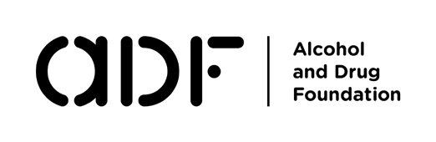

PG.2

Example – ADF’s Keep Their Future Bright: ‘Keep Their Future Bright' is an award-winning campaign that gives parents and caregivers the guidance they need to have open conversations with their kids about drinking. From conversation prompts and FAQs to videos and posters. The aim of the campaign is to stop parental supply of alcohol by changing parents’ attitudes about the risks of underage alcohol use. The program highlights that alcohol is harmful to the cells inside the developing brain. It provides parents the tools to talk to their kids about alcohol’s harms - and refuse to supply it when they’re under 18 - to give their developing brain the best possible start.
• Preventing and minimising parental and caregiver AOD use and harms
Parents’ and caregivers’ own AOD use can affect children and young people in a range of ways – from the impact of in-utero exposure to AOD, to the increased risks of poorer educational social and health outcomes associated with children’s exposure to parental harmful AOD use.(8)
Prevention of harmful AOD use among parents is an important protective factor for children and young people – and that can have positive effects over generations, breaking cycles of disadvantage. ADF supports prevention and early intervention for adults, including parents, in a range of ways – from information services to grassroots prevention services.
Example – Information services: The ADF has been delivering information and support to Australians since 2016 . We offer essential resources that enhance public knowledge of AOD-related risks, reduce harm and provide a digital service navigation tool and national directory connecting users with services matching their unique needs. One in three Australians are experiencing AOD-related harm: through educating the public on AOD risks, connecting people to services before issues escalate, and empowering concerned family and friends, we will alleviate pressure on healthcare systems.

Example – LDAT: For over eight years, the Local Drug Action Team (LDAT) program has been harnessing the power of local communities to make a difference in their own backyards. LDATs are partnerships between local organisations (like health services, councils, schools, and youth groups) who design and deliver practical, evidence-informed AOD prevention initiatives that are purposebuilt for their area. Some LDATs – like the Narrabri LDAT in NSW – prioritise working with parents on AOD knowledge.
More information on AOD prevention and parenting is available on ADF’s website: Preventing or delaying young people using alcohol and drugs - Alcohol and Drug Foundation.
• Holistic, health informed prevention for young people
Children and young people are vulnerable to stress and risk-seeking behaviors beyond AOD use.(9) Unsupervised leisure time,(10) a lack of positive role models, and fewer opportunities to connect to new social networks(11) are common challenges for other forms of risk taking among young people, including offending. Responding to these risks factors requires a holistic, social and health approach that includes equitable access to health literacy for all young people, and a creative approach that offers this access beyond mainstream institutions like secondary schooling.(11)
Example – ADF’s Stronger Through Sport (STS) program: STS works to build protective factors for young people who are in contact, or at risk of contact, with the criminal justice system, and who are not participating in or who are disengaged from sport. STS builds the capacity of local sports clubs to support young people – who are referred into the program through participating youth services

adf.org.au

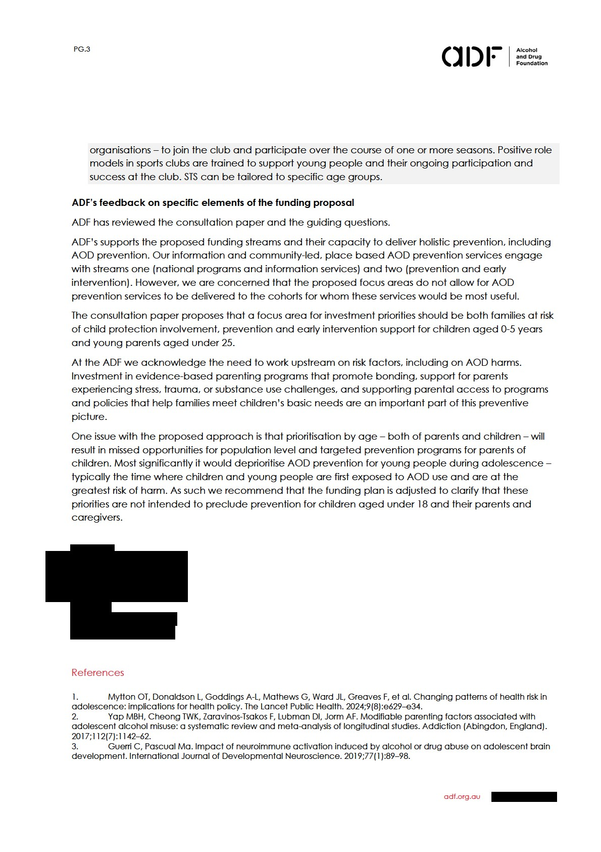

PG.4

- Thomas RE, Lorenzetti D, Spragins W. Mentoring adolescents to prevent drug and alcohol use. Cochrane Database Syst Rev. 2011(11):Cd007381.
- Pennay A, Caluzzi G, Fenton L, Holmes J, Livingston M, Raninen J, et al. Young People, Alcohol, and Risk : A Culture of Caution. Abingdon, Oxon: Routledge; 2025.
- Bowden JA, Bartram A, Harrison NJ, Norris CA, Kim S, Pettigrew S, et al. Australian parents’ attitudes, perceptions and supply of alcohol to adolescents: a national cross-sectional survey. Health Promotion International. 2024;39(6).
- Mehanović E, Vigna-Taglianti F, Faggiano F, Galanti MR. Does parental permissiveness toward cigarette smoking and alcohol use influence illicit drug use among adolescents? A longitudinal study in seven European countries. Soc Psychiatry Psychiatr Epidemiol. 2022;57(1):173–81.
- Leggat G, Kuntsche E, Kuntsche S, Atkins P, Laslett A-M. Substance misuse by birth parents: Outcomes for children and young people placed into out-of-home-care. International Journal of Drug Policy. 2024;132:104544.
- Rooney RM, Hopkins A, Peckover J, Coleman K, Sampson R, Alati R, et al. Protective factors, risk factors, and intervention strategies in the prevention and reduction of crime among adolescents and young adults aged 12-24 years: A scoping review protocol. PLoS One. 2024;19(11):e0312684.
- Tomé G, Guedes FB, Cerqueira A, Noronha C, de Freitas JC, Freire T, et al. How Is Leisure Related to Wellbeing and to Substance Use? The Probable Key Role of Autonomy and Supervision. Children (Basel). 2023;10(5).
- Deans E, Abdo J, Ravulo J, Conroy E. ‘I had nothing and drugs don't leave’: A qualitative study exploring the drug use trajectories of young people in contact with the justice system. Child Protection and Practice. 2024;3:100068.

adf.org.au

