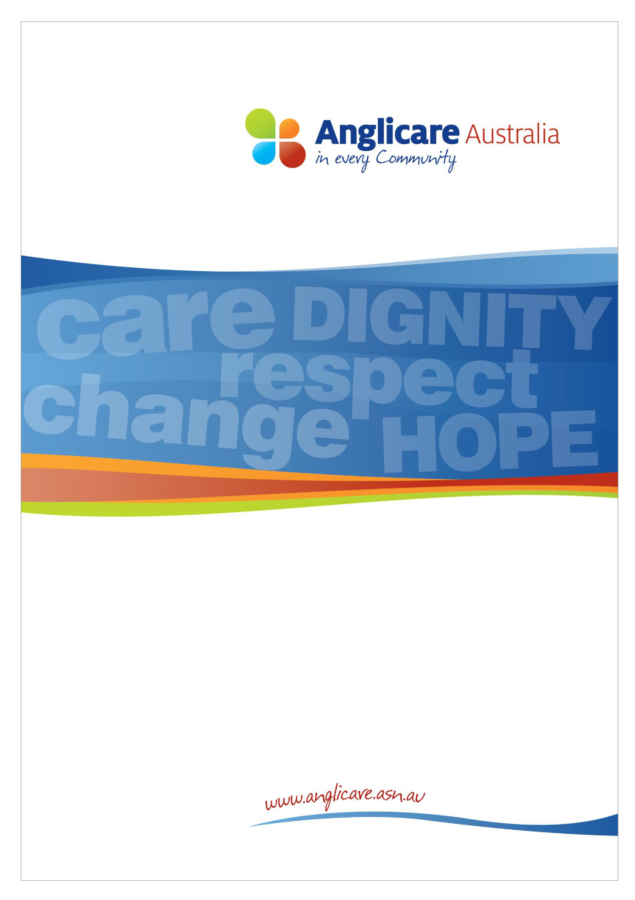

Submission
on

A New
Approach
to Programs for
Families and Children

December

20
2
5

About Anglicare Australia
Anglicare Australia is a network of independent local, state, national and international organisations that are linked to the Anglican Church and are joined by values of service, innovation, leadership and the Christian faith that every individual has intrinsic value. Our services are delivered in partnership with people, the communities in which they live, and other like-minded organisations in those areas. With a combined income of $2.94 billion, a workforce of over 24,000 staff and 6,000 volunteers, the Network delivers 37 different service types in the Australian community. Our services are delivered to over 500,000 people.

As part of its mission, the Anglicare Australia Network partners with people, families and communities to provide services and advocacy and build resilience, inclusion and justice. Our first strategic goal charges us with reaching this by influencing social and economic policy across Australia with a strong prophetic voice; informed by research and the practical experience of the Network.

Contact

Contents

About Anglicare Australia 2
Contents 3
Introduction 4
Vision and Outcomes 5
Inclusivity 5
Diversity 5
Rights of the Child 5
Program Structure 7
Clarifying funding adequacy and operational detail 7
Information-sharing and collaboration 7
Scale of reform and transition risks 8
Priority Investment Areas 9
Connected, co-located, and integrated services 9
Improving outcomes for First Nations children and families 10
Investing early to improve family wellbeing 10
Responding to community need 12
Working Together 13
Streamlined reporting arrangements 13
Alternative ways of commissioning 14
Conclusion 15

Introduction
Anglicare Australia welcomes the opportunity to provide feedback on the Department of Social Services’ proposed new approach to programs for families and children. As a national network that works alongside thousands of families every year, Anglicare Australia has a direct stake in how these reforms are shaped and implemented.

Anglicare Australia is a network of organisations linked to the Anglican Church of Australia. Anglicare Australia network members supported over 73,000 Australians through children, family and relationship services across all states and territories in the 2023-24 financial year. With the support of more than 1,500 staff and 154 volunteers, the Network delivers a range of programs that are captured under the proposed reforms. In addition, Network members support thousands of other families through emergency relief services, financial counselling, housing and homelessness support and community-based mental health programs. This experience has given us unique insights into what families and children need to thrive, and what many struggle with each day.

We believe that children and young people deserve to grow up in safe, stable and nurturing environments, and that the most effective way to achieve this is by supporting families and caregivers. We also recognise the vital role of government-funded programs in helping families at risk, and in supporting those already facing crisis or disadvantage.

Overall, Anglicare Australia supports the Government’s ambition to design a more coordinated, flexible and coherent system. However, we are concerned that several elements of the proposed model risk falling short of that ambition. Without a stronger focus on inclusion, diversity, local need, and the rights of children, and without clear transition planning, there is a risk that families will face disruption rather than improved support.

This submission highlights key areas for refinement in the program’s outcomes, structure, and investment priorities. It also outlines changes needed to ensure the reforms are achievable in practice and deliver the strongest outcomes for children, families and communities.

In the development of this submission Anglicare Australia consulted with Network members who provide family and children services, including programs that are captured under the proposed reform. The feedback and insight gained through this consultation has been used to inform our responses and recommendations.

Vision and Outcomes
Anglicare Australia supports the intent of the proposed vision and agrees that a national program should set clear expectations for how children and families can be supported to thrive. However, we believe the draft outcomes require refinement to ensure they are inclusive, reflect the diversity of Australian families, and recognise children’s inherent rights, as well as their future development into adulthood.

Inclusivity
The proposed outcomes emphasise two attributes they aspire children to achieve: health and resilience. For people living with disability, the term healthy can be prejudicial, and can be used to imply that people with disability are un-healthy or not “normal.” More than one in five Australians live with disability,^{i} and eight in ten people have at least one long-term health condition.^{ii} Framing outcomes around health risks overlooking the lived reality of a large proportion of the population.

Overall, Anglicare Australia does not support the use of ableist language and recommend the Department remove the term healthy.

Diversity
There is no one size, shape or composition that can describe every Australian family. The present day “typical” family looks vastly different to previous decades, with the 2021 Census revealing that 39 percent of Australian families consist of couples without children.^{iii} This is a ten percent increase from 1981.^{iv} Despite this, the Discussion Paper has proposed two outcomes for a national families and children program that do not actually include the term family. Instead, they reflect a typically ‘nuclear’ family type, families with children, ignoring the diversity in family forms that exist within the Australian community.

We recognise that improving outcomes for children will require delivering services to families with children, however it is important that all forms of family are recognised under the new program. This is of particular concern for Family and Relationship Services, whose clients include “family members with intact relationships, separated families, extended family members, individuals, children and young people, couples and significant others such as grandparents and kinship carers who have caring or other relationship responsibilities,”^{v} This is also the case for Specialised Family Violence
Services which provide support to eligible individuals, couples, children and families.^{vi}

Anglicare Australia recommends that the program outcomes include language that reflects diverse family composition, specifically those that are recognised and supported within the existing programs.

Rights of the Child
The current emphasis on the development of children to adults in the program outcomes fails to acknowledge a child’s inherent right to childhood. Childhood plays an invaluable role in development, and it should not simply be viewed as a preparation stage for adulthood. We believe that our focus should be on doing our utmost to afford every child with a full life which includes allowing them time to play, imagine, learn and simply be children. Providing this means children will have access to safe environments where they can not only make mistakes, but learn to recover from them, experience change and learn to adapt, and most importantly discover who they are and what they need to succeed. As a result, children will learn to thrive in every stage of life.

To ensure the program outcomes recognises that children are deserving of a full life in their own right, Anglicare Australia recommends that references to adulthood be removed from the program outcomes.

Overall, Anglicare Australia does not believe the two proposed outcomes capture what should be strived for under the new national program. We believe that the draft outcomes are insufficient measures of what we need to achieve to deliver on the programs vision and improve outcomes for all children and families. Further, the proposed outcomes fail to promote inclusivity, diversity or individual rights and risk excluding individuals currently eligible for children and family services from future programs.

Recommendations
Anglicare Australia recommends that the program outcomes be revised to better embrace diversity, be more inclusive and to recognise the value of childhood. Anglicare Australia proposes the following alternative outcomes:
▪ That families are empowered to build home environments that are safe, strong and nourishing ▪ That children are supported to grow up in safe and nurturing environments.

Program Structure
Anglicare Australia supports the Government’s intention to increase flexibility by consolidating services under a single contract model. This shift has the potential to reduce duplication, improve coordination and allow providers to respond more effectively to the needs of families. However, the Discussion Paper does not yet provide sufficient detail for the sector to understand how the new structure will operate in practice, nor how key risks will be managed during the transition.

Clarifying funding adequacy and operational detail
A consistent concern raised by Anglicare Australia members relates to funding adequacy across different service streams. A single contract model will only succeed if funding reflects the real costs of delivering each component within the program, including workforce, travel, supervision, compliance and cost-of-living pressures. Without mechanisms to recognise changes in service intensity and cost over time, organisations will face growing shortfalls and may be forced to redirect resources away from essential supports.

There is also a risk that services sitting across multiple streams, such as family relationship support, mental health interventions, and early intervention programs, will be underfunded if the financial model does not account for the different cost structures of each type of work. This could inadvertently weaken the continuum of supports the reform seeks to strengthen.

Recommendations
Anglicare Australia recommends that the Department:
- Provide detailed guidance on the proposed funding model, including how service costs, intensity, and workforce requirements will be recognised across different program streams.
- Develop mechanisms to regularly monitor changes in service demand and delivery cost, ensuring funding can be adjusted where necessary to maintain service quality and continuity.

Information-sharing and collaboration
The proposed structure assumes increased collaboration between providers, but collaboration depends on timely access to information. Under the current system, providers have limited visibility of other funded services in their region, making it difficult to coordinate referrals or identify service gaps.

The Department already collects extensive data. Making aggregated, de-identified information available to providers through a national funding map or regional program dashboards would support smoother coordination, reduce duplication, and allow scarce resources to be directed where they are most needed. Without improved information-sharing, the collaborative features of the new model will not be realised.

Recommendation
Anglicare Australia recommends that the Department:
▪ Improve information-sharing and transparency, including the creation of tools that allow providers to understand what is funded in their area and coordinate effectively.

Scale of reform and transition risks
The reforms represent the most significant restructuring of family and children’s programs in nearly a decade. Anglicare Australia members are preparing for tendering in 2026, but the scope of the change goes far beyond what the sector anticipated. Many providers have built deep local networks, employ specialised staff, and hold trusted relationships with communities. These relationships are not easily replaced and are at risk if transition processes are rushed or poorly resourced.

There is a clear opportunity cost if these reforms disrupt service continuity. Families experiencing vulnerability cannot absorb instability in essential supports, nor can organisations simply pause service delivery during transition. To mitigate this, the Government must invest in clear transition planning, adequate timeframes, and practical support for adaptation.

Strong transition arrangements are also needed to manage unintended consequences, including the risk of workforce displacement, the loss of community trust, and operational costs borne by organisations during the change.

Recommendation
Anglicare Australia recommends that the Department:
▪ Allocate adequate time, resources and support for transition, including early sector engagement, clear communication, realistic tender timeframes, and resourcing to address unintended costs or disruptions.

Priority Investment Areas
Anglicare Australia welcomes the Government’s commitment to prevention, early intervention, and the strengthening of the Aboriginal and Torres Strait Islander community-controlled sector. These priorities reflect long-standing feedback from service providers and evidence from recent reviews. However, several aspects of the priority investment areas require refinement to avoid unintended consequences and ensure they genuinely support the families and communities they aim to serve.

Connected, co-located, and integrated services
Anglicare Australia supports efforts to promote collaboration, co-location and service integration. These qualities can improve access, reduce duplication, and support more holistic responses for families. However, the priority area as currently drafted is overly prescriptive and does not acknowledge that these features vary in value depending on service type, community needs, and local context.

For example, co-location is not universally beneficial. Research has shown that co-locating family and domestic violence services with child protection agencies can heighten First Nations women’s fears of child removal, reducing their willingness to seek support.^{vii} Similarly, co-location often depends on factors outside a provider’s control, including workforce availability, local infrastructure, and the willingness of partner organisations to collaborate.

A broader, strengths-based understanding of “connected” and “integrated” practice would better reflect the diverse ways organisations build relationships and support communities. This includes outreach models, virtual service pathways, trauma-informed and culturally safe practices, and practical innovations that remove access barriers. Anglicare Australia members provide strong examples, such as ac.care’s free shuttle service in Mount Gambier, which was introduced in response to transport exclusion and has improved engagement and reduced missed appointments. ^{viii}

The grant assessment process should therefore recognise multiple forms of connection and integration, including partnerships with peak bodies, informal networks, volunteer engagement, and the use of lived experience in governance and service design.

Recommendation
Anglicare Australia recommends that:
▪ The integrated services priority be broadened to recognise diverse ways providers build strong relationships and improve access, including outreach, virtual models, culturally safe practice, and local innovations.

Improving outcomes for First Nations children and families
Anglicare Australia strongly supports the priority of expanding and strengthening the Aboriginal Community Controlled Organisation (ACCO) sector. First Nations organisations are best placed to design, govern and deliver services for their communities, and increasing their role is essential for achieving self-determination and improved outcomes.

However, this priority cannot be measured solely through the number of ACCOs funded. Sustainable growth requires equitable procurement processes and investment in core organisational functions. Findings from the Stronger ACCOs, Stronger Families report highlight how historical and ongoing discrimination has created structural disadvantages for ACCOs in competitive tendering.^{ix} Many lack the assets and administrative resources that mainstream organisations use to meet tender requirements, despite delivering high-quality, culturally grounded services.

To genuinely strengthen the sector, tender processes must be simplified, reporting requirements must be proportionate, and core operational funding must be built into contracts. The priority area should also recognise the value of meaningful partnerships between ACCOs and non-Indigenous organisations that build capacity, transfer knowledge, and support long-term sustainability without diluting ACCO leadership or control.

Recommendation
Anglicare Australia recommends that:
▪ The First Nations priority be strengthened by ensuring tender processes are not onerous, providing core operational funding for ACCOs, and recognising meaningful partnerships that build capacity and support self-determination.

Investing early to improve family wellbeing
Anglicare Australia welcomes the strong emphasis on prevention and early intervention. Targeted supports for families at risk of child protection involvement, for young parents, and for children aged under five are vital components of an effective national program. However, the priority area should be broadened to reflect other groups whose wellbeing has profound lifelong and intergenerational impacts.

Domestic and family violence
Domestic and family violence remains a pervasive driver of harm for individuals, families and communities. It contributes significantly to homelessness, mental health issues, disability, and intergenerational cycles of trauma. Children who witness or experience violence are at higher risk of future victimisation or perpetration. Given its prevalence and impact, eliminating violence should be explicitly included as an early-intervention priority within the program.

Culturally and linguistically diverse families and people with disability
Families from culturally and linguistically diverse backgrounds and families including people with disability often face unique barriers to accessing mainstream services, including language, unfamiliarity with systems, and accessibility constraints. Yet evidence shows they are significantly less likely to access children, youth and parenting programs despite having equal or greater need. Early intervention efforts must therefore include targeted, culturally informed approaches for these communities.

Addressing unmet need and providing wraparound support
Families frequently rely on a range of interconnected services, ranging from mental health, housing, disability support, and drug and alcohol treatment, to achieve stability and wellbeing. Long waits or service gaps in these adjacent systems can undermine the effectiveness of interventions funded through this program. While family and children’s program should not be expected to backfill other systems, it must recognise that families need support while waiting for essential services. A priority focus on addressing unmet need and facilitating wraparound responses is therefore critical.

Recommendations
Anglicare Australia recommends that:
- Eliminating domestic and family violence be included as a priority area given its profound intergenerational impacts on children and families.
- Culturally and linguistically diverse communities and people with disability be explicitly included within early-intervention priorities to address persistent inequities in access.
- The Government work across departments to reduce system silos, ensuring families can access essential mental health, housing and disability supports in a timely way, and that the family and children’s program can support families while they wait.

Responding to community need
Anglicare Australia welcomes the shift to merit-based grant applications that reflect local community needs rather than relying on population-based formulas. Disadvantage does not map neatly onto population size, and funding approaches must recognise where communities face higher levels of vulnerability or have distinct demographic profiles. For example, communities with concentrated asylum seeker populations or high proportions of older Australians will require different service approaches, staffing, and levels of cultural capability.

The cost of delivering services also varies significantly across regions. Providers in rural and remote communities face higher expenses for travel, fuel, insurance and compliance, yet these costs are rarely reflected in funding models. Without appropriate cost loadings, services in these areas are placed at risk and families in already under-resourced communities can face reduced access or long waiting times.

Finally, service delivery methods must be shaped by community preference and circumstance. Some communities value virtual delivery, while others, particularly those experiencing digital exclusion or complex need, rely on face-to-face or outreach models. The new program must therefore allow flexibility and provide adequate resourcing so services remain accessible and responsive.

Recommendation
Anglicare Australia recommends that:
▪ Assessments of community need include demographic profiles, regional delivery costs, and local preferences for service delivery, ensuring funding levels allow providers to meet community circumstances in a practical and responsive way.

Working Together

Streamlined reporting arrangements
Anglicare Australia welcomes the Government’s intention to reduce the long-standing reporting burden on community organisations. Streamlined processes, meaningful data use and reduced duplication are essential to freeing up resources for direct service delivery. However, the proposed arrangements still raise concerns about how collaboration, reporting expectations and data sharing will work in practice.

One of the major barriers to collaboration under the current models is the limited visibility of other services operating in each region. Although providers are required to report substantial information through the Data Exchange, this data is not made available in ways that support coordination or strategic planning. Improved access to aggregated, de-identified data, such as regional service maps or demand trends, would allow providers to reduce duplication, identify gaps, and direct scarce resources to areas of highest need. Without this visibility, the program’s aspiration for more collaborative service systems will not be realised.

We also note that while the intention to simplify reporting is welcome, high-quality outcomes measurement is inherently resource-intensive. Collecting, analysing and interpreting outcomes data requires staff skills and time, yet no additional funding is proposed to support this work. If reporting expectations increase without matching resources, providers will be forced to redirect funding away from core service delivery to meet compliance obligations. Contracts must therefore explicitly provide for the roles and time needed to undertake rigorous reporting.

Finally, we are concerned by the Discussion Paper’s emphasis on case studies and social media content as a routine reporting requirement. While storytelling can play a valuable role in policy and advocacy, it must be undertaken safely, ethically and with robust governance, particularly when children or vulnerable people are involved. Treating case studies as a compliance requirement risks normalising inappropriate consent practices, compromising client confidentiality and placing undue pressure on frontline staff. These forms of content should never be used as a formal measure of program performance.

Recommendations
Anglicare Australia recommends that the Government:
- Improve transparency and data sharing by giving providers access to aggregated, de-identified data insights to support collaboration and reduce duplication.
- Resource reporting requirements adequately, including explicit contract provisions for staff time and roles needed to deliver high-quality outcomes reporting.
- Remove case studies and social media content from formal reporting obligations, ensuring ethical storytelling remains separate from compliance requirements.

Alternative ways of commissioning
Anglicare Australia supports the introduction of relational contracting as an option within the new program. This approach reflects long-standing sector advocacy for more flexible, collaborative funding models and has the potential to strengthen service innovation and improve outcomes. However, relational contracting can only succeed if both Government and providers invest in the time, capability and trust required to make it work.

Our members’ experiences of past departmental engagement highlight key risks: high staff turnover, inconsistent communication, and uneven power dynamics. These key risks can undermine the stability and partnership required for relational contracting. For this approach to be effective, departmental staff must be supported to build sustained relationships, understand the broader policy and service context, and avoid requiring providers to repeatedly retell their story.

The trial of relational contracting should therefore be accompanied by clear expectations around communication, transparency and flexibility; investment in departmental capability; and safeguards that allow providers to innovate without fear of punitive consequences if a trial or initiative does not succeed. Eligibility for piloting relational contracting should consider not only an organisation’s willingness to participate, but also its demonstrated capacity for continuous improvement, its track record in supporting families and children, and the strength of its existing relationships with government.

Recommendations
Anglicare Australia recommends that the Government:
- Support the success of relational contracting by investing in departmental capability, ensuring consistent and transparent communication, and providing flexibility for innovation without sanctions.
- Select relational contracting pilots based on demonstrated organisational capability, including experience with continuous improvement, high-quality service delivery and effective partnership with government.

Conclusion
Anglicare Australia welcomes the opportunity to contribute to the development of a new national approach to programs for families and children. The proposed reforms reflect significant work to respond to long-standing issues in the current system, and we share the Government’s commitment to ensuring that all children and families can be safe, strong and thriving.

Throughout this submission, we have highlighted the changes needed to ensure the new program fulfils its vision. We have emphasised the importance of outcomes that genuinely reflect the diversity of Australian families; a funding and transition framework that gives providers the stability to plan and adapt; priority investment settings that address unmet need and support the growth of ACCO leadership; and program structures that enable genuine collaboration rather than adding additional administrative pressure.

We urge the Government to consider these recommendations closely as the model is finalised. Getting this reform right is critical, not only for the families who rely on these services today, but for the long-term strength and stability of the community service system and its ability to provide these services to families in need into the future.

Anglicare Australia and our members are ready to work with the Department throughout the design and transition process. We would welcome the opportunity to discuss these recommendations further or facilitate additional feedback from service providers across our Network.

- Australian Bureau of Statistics (2024) 5.5 million Australians have disability.
- Australian Bureau of Statistics (2023) Health conditions prevalence. ^{iii} Australian Institute of Family Studies (2023) Family and family composition. ^{iv} Ibid.
^{v} Department of Social Services (2025) Family and Relationship Services (FaRS) Operational Guidelines | Department of Social Services ^{vi} Department of Social Services (2024) Improving personal and family safety | Department of Social Services ^{vii} ANROWS (2020) Improving family violence legal and support services for Aboriginal and Torres Strait Islander Women.
^{viii} Anglicare Australia (2025) In Every Community. ^{ix} SNAICC (2023) Stronger ACCOs, Stronger Families Final Report.

