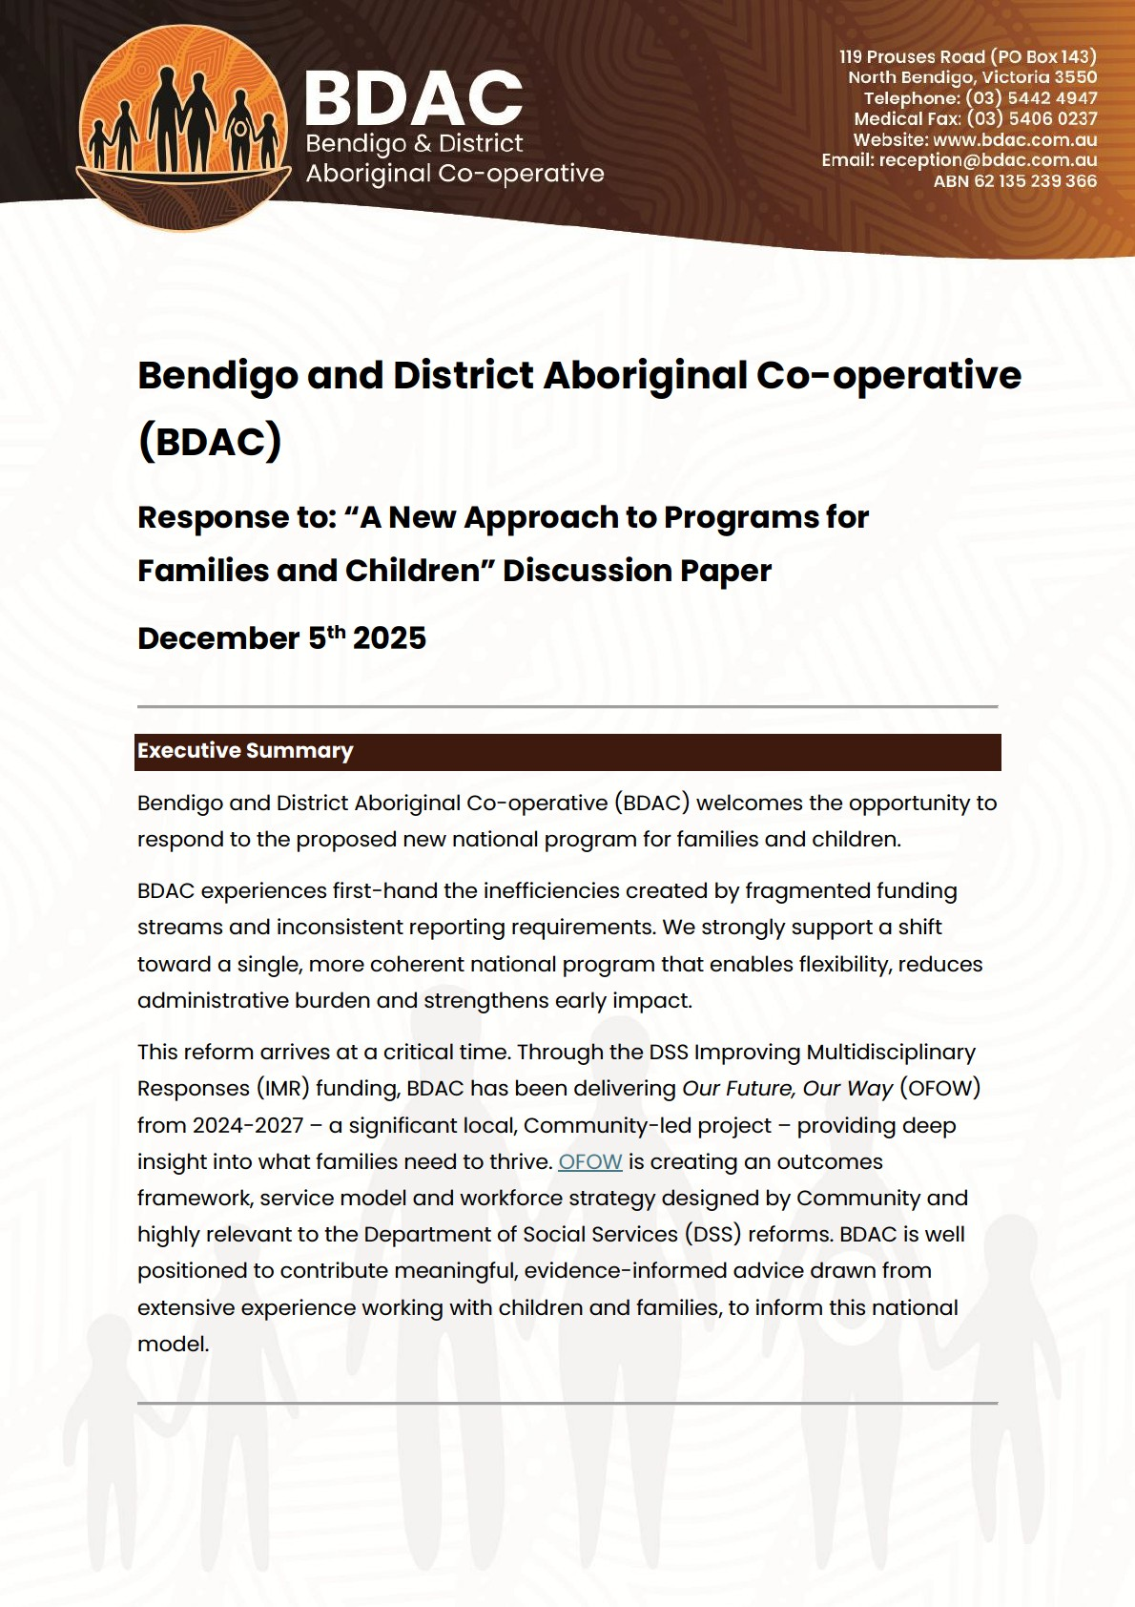

About BDAC
Established in 2001, BDAC is a proud Aboriginal Community-Controlled
Organisation (ACCO) delivering culturally safe, holistic and responsive services to Aboriginal and/or Torres Strait Islander people living on Dja Dja Wurrung Country. Our catchment in regional Victoria includes Bendigo and surrounding townships, serving an Aboriginal and Torres Strait Islander population of 4,477 (2022), projected to grow to over 7,200 by 2037.
BDAC delivers programs across health, wellbeing, early childhood, family services, justice, education, employment and community connection. Culture, selfdetermination and strengthening families guide our entire service model.

Our Future, Our Way (OFOW)
As Aboriginal Peoples, we know families and our Communities thrive when decisions affecting our lives are made by us.
BDAC currently manages more than 100 funding streams, each with its own objectives and reporting obligations. This fragmentation limits flexibility, restricts early impact, increases administrative time and makes services harder for families to navigate.
OFOW addresses these challenges by designing a unified, Community-led model of service delivery. OFOW involves:
- Deep community consultation using yarning circles, one-on-one yarns and other formats.
- A Community-led service model aiming for strong, community connected and culturally grounded individuals, families and Community.
- A Community-designed outcomes framework with indicators that are meaningful and matter locally, while meeting government accountability needs.
- A workforce strategy to support implementation and increase Aboriginal employment.
- Ongoing engagement with government and partners to ensure sustainability and alignment.
More than 180 Community members have already contributed to Our Future, Our Way, with analysis of their input underway to identify key themes and insights. This work establishes BDAC as a key strategic and service-level knowledge-holder, ideally positioned to inform and support these DSS reforms.

Responses to Discussion Paper Questions

1. Vision and Outcomes
Are the two main outcomes appropriate?
Yes. Empowering families and supporting children to grow into strong, healthy adults aligns directly with what Community has identified through OFOW. Families consistently emphasise culture, connection, confidence in parenting, and support for young people transitioning to adulthood.

2. Program Structure
Will a single national program provide flexibility?
A single national program has the potential to reduce silos, enable flexible and timely responses, and better support integrated, culturally grounded services. Local design remains essential, and the proposed structure appears to allow for this.
Do BDAC’s services fit the three funding streams?
Most BDAC family and children programs align with Streams 2 and 3, reflecting Community-identified need. However, current funding is heavily weighted to intensive support rather than early investment:
- 89% of current family/children funding = Stream 3: Intensive Support.
- Only 11% = Stream 2: Prevention and Early Impact.
- Just 4% is available for foundational Early Years and parenting programs.
- 63% of family/children funding supports statutory child protection pathways and care for Aboriginal children.
This imbalance does not reflect Community priorities or evidence about best practice in creating lasting change in Communities. BDAC strongly advocates for increased early investment and a shift toward prevention.

Case Study: BDAC Early Years Integration
BDAC’s Early Years work shows how flexible, integrated funding can significantly improve outcomes for families and children. Community consistently tells us that parenting confidence, social connection, cultural identity and support early in a child’s life are essential to keeping families strong. Over the past year, BDAC has worked to integrate several separately funded programs, including:
- balert gerrbik Parenting Program (0–5 years)
- BDAC Maternal and Child Health Nurse (MCHN) at djimbaya (our kindergarten)
- wonyotjarrapil Playgroup
- garinga bupup (expectant and new parents)
Despite being funded by different streams and operating in different areas of BDAC, staff have worked creatively to align these programs so families receive more cohesive early support. What We Are Seeing
- The Boorais Walk and Yarn Group for parents and babies under 12 months has quickly built strong peer networks and strengthened connection with BDAC’s MCH and early years services. Demand is so high that eligibility has had to be limited.
- Participation in wonyotjarrapil playgroup has increased, particularly among infants, with many families transitioning from garinga bupup and Boorais Walk and Yarn group. This increase has required BDAC to engage additional staffing to maintain appropriate ratios and support.
- Families are forming informal support networks where advice, cultural identity and connection are strengthened.
- MCHN registrations have increased by 40% in two years, showing

Current Limitations
- Programs are funded by four different funders, each with narrow objectives and small budgets, requiring staff to closely “braid” funding to integrate services.
- Many parenting supports are only available to families already at risk of child protection involvement, limiting true prevention.
- Staff spend significant time navigating administrative requirements instead of delivering early impact work.
Our aims:
A streamlined DSS model with broader, integrated funding would allow BDAC to:
- Expand parent–child groups like Boorais Walk and Yarns, and wonyotjarrapil Playgroup
- Offer universal early parenting support rather than limiting access to crisis-involved families
- Increase staffing to meet demand
- Reduce administrative burden
- Strengthen co-location across Early Years and family services
- Deepen the cultural and community connections that are proven protective factors.

3. Prioritising Investment
BDAC supports the four priorities outlined in the discussion paper. These align with community feedback from OFOW and BDAC’s strategic direction.

Priority 1: Early investment
Our funding profile shows heavy investment in late intervention. Community yarns emphasise the importance of early years supports, parenting skill development, peer networks and cultural connection. Recent BDAC initiatives such as Boorai’s Walk and Yarn, increased playgroup attendance and stronger Maternal Child Health engagement demonstrate the impact of early supports.
Long-term funding is essential to support the transition toward prioritising early years investment. Meaningful and evidence-based outcomes take time, which requires funders to be committed for the long term, and an organisation to be focused on this longer-term vision.

Priority 2: Connected, co-located and integrated services
BDAC strongly supports this. Community reports that integrated, culturally safe services reduce the burden of navigating multiple systems. BDAC’s Early Years model—where parenting support, playgroup and MCH operate side-by-side— illustrates the benefits.

Priority 3: Services responding to community needs
Over 180 Community members have contributed to OFOW. Their insights emphasise culture, identity, family connection and belonging. A flexible, outcomes-focused funding model would support meaningful local design.

Priority 4: Increased ACCO delivery
While choice remains critical, families consistently prefer ACCO services where possible, valuing the cultural safety, trust, community connections, and holistic approach to supporting children and families. Investment in ACCO capacity and workforce development is vital, and grant processes should recognise the additional cultural and partnership work ACCOs undertake.

4. Improving family wellbeing
The proposed focus areas—supporting families at risk of child protection involvement and young parents—align strongly with BDAC’s experience.
Community feedback also highlights the importance of:
- regular, informal activities such as playgroup, men’s and women’s groups, and community lunches
- building parenting confidence and peer networks
- strengthening relationships with extended family and Elders.
BDAC emphasises the need for broad eligibility criteria. Current constraints and funding requirements limit early years support primarily to families already identified as “at risk,” despite clear evidence that prevention and improved outcomes are most effective when implemented early for all children and families.

5. Connected and Integrated Services
Beyond co-location, what works?
- Strong relationships between workers
- Warm referrals
- Flexible eligibility
- Dedicated Support Worker/Navigator roles
- Culturally welcoming spaces
- Consistent, trusted staff
What shows a service is genuinely connected to its community?
Grant applicants should demonstrate:
- Evidence of meaningful, ongoing engagement—not one-off consultations • Community voice embedded across service design and practice • Transparent feedback mechanisms.

5. Ensuring Services Respond to Community Needs
Funding should consider:
- Regional diversity, population mobility and increased use of regional hubs like Bendigo.
- BDAC encourages investment in proactive programs that strengthen families and reduce reliance on statutory services.
- The need to resource both healing work and cultural connection.
- Avoiding replication of mainstream approaches within ACCOs.
- Capacity building and back-of-house support to deliver programs effectively.

6. Improving outcomes for First Nations children and families

1. Designing the grant process to support and increase the number of ACCOs delivering services
A layered grant approach is required to support ACCOs to meet short, medium and long-term goals for expanding children and family services. Short-term: Improve access and equity in the grant process
- Early engagement: Proactively notify ACCOs of upcoming grant opportunities and ensure information is accessible and culturally appropriate.
- Fair assessment: Recognise that smaller ACCOs may not have the same grant-writing resources as larger mainstream organisations, and take this into account during assessment.
- Resource ACCO ways of working: Provide funding for the additional and essential work ACCOs undertake, including relationship building, cultural safety, and holistic, community-centred practice.
- Partnership requirements: Where mainstream organisations apply, there should be clear evidence that they have genuinely sought, resourced, and established partnerships with ACCOs, and that partnerships have not solely been sought for the purpose of funding submissions, which often occurs. BDAC frequently provides cultural safety training and navigation support to external organisations—highly skilled work that should be funded and recognised within partnership arrangements.

Medium-term: Strengthen regional ACCO service reach
- Support ACCOs to deliver culturally safe services to smaller or more geographically dispersed Aboriginal and Torres Strait Islander communities.
- Many families prefer ACCO-delivered supports to mainstream services.
- BDAC welcomes the opportunity to work with the Department to develop approaches that enable regional ACCOs to better support families across large catchment areas.

Long-term: Build sustainable ACCO workforce and service capability
- Invest in the long-term development of the Aboriginal and Torres Strait Islander health and wellbeing workforce, including specialists such as paediatricians and psychologists.
- Prioritise development of culturally appropriate mental health services for children and young people—an urgent need identified by Elders, parents and young people.
- Support a stepped approach that builds ACCO capacity to independently deliver specialised services, reducing reliance on mainstream partnerships or subcontracting.

2. Additional program design elements to improve outcomes for Aboriginal and Torres Strait Islander children and families
Please see our feedback under section 9 – “Additional considerations” which capture our feedback for this section.

7 . Data, Measurement and Reporting

Qualitative data is essential for accurately measuring impact

Qualitative data captures the depth, context and lived experience that quantitative indicators alone cannot fully reflect. ACCOs work in ways that are relational, holistic and grounded in Culture, where the most meaningful indicators of progress often appear in trust, safety, belonging, healing and strengthened connection to Community. These outcomes are best understood through stories, yarning, case studies and community feedback. Incorporating qualitative insights offer government and funders a clearer understanding of what is working, why it is working, and how programs genuinely impact Aboriginal people and families. Embedding qualitative evidence in funding and reporting frameworks ensures that success is not reduced to narrow metrics, but assessed in culturally legitimate ways that align with Aboriginal ways of knowing, being and doing. Reform that recognises qualitative data as equal in value to quantitative measures will strengthen accountability, improve program design, and support ACCOs to demonstrate real community-led outcomes that matter.

We encourage guidelines that allow flexibility to tell stories in formats that make sense for Community. For example, through voice pops, brief videos or via staff. We take an intentional approach to the use of case studies, privileging privacy as well as people’s agency over their own stories and the ways they are represented. For appropriate services and activities, we use quotes, voice pops, short videos and PowerPoint presentations for reporting. This approach depends on the nature of services and would not be appropriate in some case management settings.

What data would help BDAC understand impact?
BDAC is developing a Community-designed Outcomes Framework through OFOW with local baseline measures (e.g. school attendance, child protection, health indicators). Support from government to access relevant datasets would strengthen this work and we would value working with DSS in coming months to identify specific datasets.

What data should BDAC share?
We are in the early stages of developing an outcomes framework and service design, to design a model that is meaningful, measures Community priorities, is appropriate in the ACCO context and also meets government (and our own to our Community) requirements around accountability.
We hope to work with funders to identify the most relevant indicators that align with our Community-led design and that will enable outcomes to be measured not at a service or program level but to consider the impact on families and children across the various services, community activities and programs. We have already commenced work on this which will continue into 2026. We would welcome further discussions on our findings and progress, as it’s critical to ensure the model works for both BDAC, our Community and government.

DEX and SCORE
BDAC uses several SCORE Circumstances domains across DSS programs but notes that capturing all domains is unrealistic and burdensome.
We welcome the DSS focus on outcomes, not outputs and finding the most appropriate ways and frequency of reporting. The use of a prescribed system like DEX data entry can be challenging and we would welcome the opportunity to explore what works best for an ACCO that operates across multiple funding jurisdictions and predisposed information management systems.

8. Working Together: Relational Contracting
We would strongly welcome the opportunity for relational contracting with DSS.
We have built strong relationships with key funders and have observed that it is only through relational contracting that meaningful funding reform is possible.
Case Study - Relational contracting in BDAC’s Aboriginal-led youth services
- We are working with the Victorian Department of Justice and Community Safety (DJCS) to expand opportunities for young people.
- This work has included the development of a program logic and codesigning services with the DJCS team and prioritises evidence of connection and engagement and the value of cultural practices.
- Our progress reporting, as discussed above includes hearing from young people and seeing the progress through photos, videos and quotes.
- DJCS contract manager has attended our youth activities and engaged directly with young people. We appreciate this must be carefully managed, but because of the relationship we have built, this has been effective in them understanding our work.
- DJCS is actively supportive of aligning outcome indicators with alike funding opportunities to avoid duplication of reporting and ensure that the broader aims of the youth program are prioritised.

Case study - Working with Victorian Government to increase funding impact
At a regional level we are building on the shared trust we have developed with our Victorian Department Families, Fairness and Housing (DFFH) contract managers to increase the impact of funding. This includes identifying the barriers and the reforms required of treasury and legislation to reduce funding restrictions and misalignment at the real world, operational level.
This has resulted in the adjustment of multiple funding streams, including the deliverables and reporting lines, to better meet the needs of our Community.
At a State level our CEO co-chairs, with the Deputy Secretary, a working group to address these barriers and consider the necessary policy changes. Locally, with our contract managers, we are identifying areas of opportunity for flexibility within the current funding system.
Our relational contract managers have observed that a relational contracting approach works well at BDAC because there is a strong, shared line of sight between Community priorities, BDAC’s strategic and innovative service models, and a workforce that is deeply connected to Community.
This type of contract management requires appropriate resourcing and our IMR project (Our Future, Our Way) has enabled both the necessary expertise and time required to deliver strong connections and measurable outcomes. In funding submissions we would encourage criteria that considers establishment time, flexibility to build systems, outcome readiness, evidence of strategy and community knowledge.
BDAC is moving toward outcomes-based funding and would welcome further discussions about applying relational contracting in a streamed model, especially in families and children services, where both Community and staff have consistently highlighted the need for better integration and funding amalgamation.

Direct funding
Direct funding to ACCOs is essential for both efficiency and accountability. When funding is routed through partner organisations, significant resources are lost to administrative layering, duplicated reporting, and misaligned priorities. This indirect model slows down implementation, weakens the direct relationship between ACCOs and the government, and risks diluting the community-led approach that makes ACCOs effective.
Direct investment enables ACCOs to work in genuine partnership with DSS, codesign solutions, and respond quickly to community needs without intermediary delays or interpretation. It also strengthens governance, transparency and cultural integrity by ensuring decisions are informed by those who are embedded in and accountable to Aboriginal communities.
Funding reform that prioritises direct contracting with ACCOs will deliver better value for money and more meaningful, measurable outcomes for Aboriginal people and families.

9. Additional Considerations

1. Cultural Wellbeing, Connection & Healing as Core Components
- The proposed outcomes emphasise “healthy, resilient children and adults,” but success for Aboriginal families also depends on identity, cultural connection, healing from intergenerational trauma, and community connection.
- Funding models rarely resource these activities. Any future program design should explicitly fund cultural practice and community connection as core components of service delivery.
- BDAC recommends explicitly recognising cultural wellbeing and community connection as core outcomes.

2. Ensure Flexibility in Eligibility and Service Design
• Eligibility rules often restrict early support to families already at risk of child protection involvement. Early intervention and prevention must be accessible to all families — not only those already identified as “at risk” — to truly reduce future child protection involvement.

3. Long-term, stable funding is critical for meaningful outcomes measurement of early investment
• It is essential that any new model is supported by long-term, stable funding. Early intervention and prevention outcomes cannot be meaningfully measured within short reporting cycles; they require sustained engagement, strong relationships and the ability to track progress over time. Long-term funding will enable BDAC to build an outcomes framework that reflects Community priorities, measure change across years rather than months, and demonstrate the true impact of early investment on keeping families strong and children safe.

4. Support for ACCO Workforce Development, Including Clinicians
• Long-term ACCO-led service delivery requires investment in building Aboriginal workforce — including clinical roles (mental health, paediatrics), cultural practitioners, and community navigators.

5. Balance Between Quantitative and Qualitative Reporting
• While DEX and outcome metrics are useful, the framework must allow space for community voice, cultural expression, stories of healing and resilience that do not fit neatly into numeric data.

6. Recognise integrated practice, not only referral metrics
- Standard outputs such as referral numbers do not adequately capture ACCO models of integrated and relationship-based care.
- BDAC’s warm, informal and embedded referral pathways across services are central to service coordination but are not easily reflected in traditional data.
- Funding for monitoring and evaluation would enable ACCOs to develop meaningful indicators of integration and track service use across multiple client systems.

7. Ensure a transition approach to early investment
• The shift from crisis response to early impact requires transition funding so ACCOs can meet immediate needs while building long-term capability.

8. Direct funding
• Direct funding to ACCOs is the most efficient and accountable model, removing unnecessary administrative layers and ensuring decisions are driven by those closest to Community. Prioritising direct contracting with ACCOs strengthens the relationship with DSS, protects cultural integrity, and delivers faster, more meaningful outcomes for Aboriginal people.

