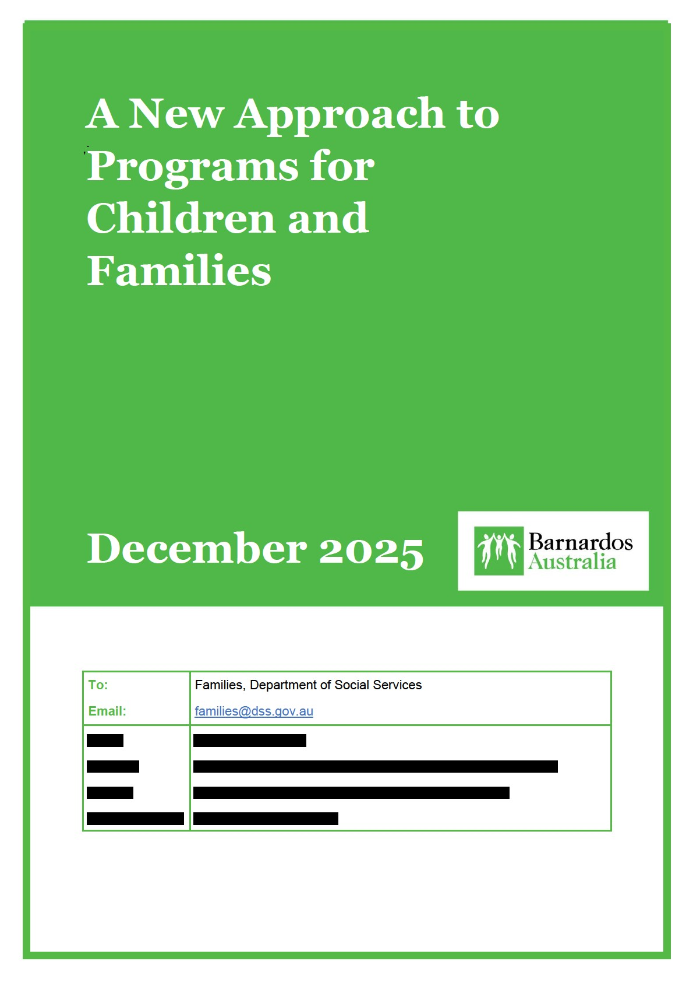

Barnardos Australia (Barnardos) is a major Australian charity and children’s social care provider, supporting approximately 15,000 children, young people and families each year. Our integrated Children’s Family Centres (CFCs) across the Australian Capital Territory (ACT) and New South Wales (NSW) provide a hub-and-spoke model of intervention that actively prevents the removal of children and young people into care and helps families stay safe.
Because poverty is a direct contributing factor to childhood neglect, Barnardos CFC teams are geographically located in, and targeted to reach, areas of socio-economic disadvantage.
Barnardos also provides a continuum of out-of-home care (OOHC) placements for around 1,200 children each year, including foster care, kinship care and open adoption. Our research shows that a child placed in foster care with Barnardos during Children’s Court action is almost three times more likely to exit care via restoration to family than children placed with other foster care providers.
We work in regions with significant Aboriginal populations, including Central West NSW, the South Coast, Western Sydney, Inner Sydney and the Queanbeyan-Palerang region. For nearly 100 years, we have worked alongside children, young people and families to break cycles of disadvantage and create safe, nurturing and stable homes connected to family and community.
Our vision is to empower every child in Australia to reach their full potential. Achieving this requires ensuring vulnerable children and young people are supported to recover and thrive despite the adversity they have experienced.

Barnardos knowledge of children and families
Poverty, housing instability and domestic and family violence (DFV) are deeply interconnected drivers of harm for children and young people. Barnardos prioritises reducing the impact of poverty, violence and homelessness on children, as outlined in our strategic plan A Brighter Barnardos 2025–2026. We support vulnerable children and families to recover and thrive, improve their development and wellbeing, and feel safe, connected and supported in the community. Through tailored, evidence-based services, Barnardos prevents problems early and helps keep children healthy, secure and safe.
To deliver these outcomes, Barnardos works with populations who experience disproportionate barriers to housing stability, financial security and safety, and who are at elevated risk of DFV, child protection involvement and intergenerational disadvantage.

Groups we work with
Barnardos provides specialist support to children, young people, families, kin and carers facing multiple and complex challenges. Many experience significant housing instability compounded by DFV, poverty, mental health conditions, disability, and systemic barriers.

Key groups include:
- children and their mothers involved with the child protection system (including non-offending parents receiving family preservation and support services)
- women, including Aboriginal women
- adults who have experienced childhood abuse
- young women and adolescents
- women with mental illness
- women in pregnancy and early motherhood
- women with disabilities
- LGBTQIA+ people
- migrants, refugees and people from culturally and linguistically diverse (CALD) backgrounds
- women in regional, rural and remote areas
- women who have experienced sexual assault at any point in their lives
Recognising the vulnerability of these cohorts, the Department of Social Services is a key funding partner for Barnardos services that support the safety, wellbeing and stability of children and families.
Funding from two Australian Government programs — Children and Parenting Support (CaPS) and Communities for Children Facilitating Partners (CfC FP) — enables Barnardos to deliver key integrated early intervention and family support services in Western NSW, Canberra and the South Coast.

Our Australian Government–funded programs

Gilgandra and Coonamble Children and Parenting Support (CaPS)

Funding source: Australian Government – Department of Social Services
Location: Gilgandra, Gulargambone and the Coonamble LGA (Western NSW)
Client group: Parents, caregivers and children aged 0–12 years (with flexibility up to 18 when required)
The Gilgandra and Coonamble CaPS program provides early-intervention supports designed to strengthen parenting confidence, family relationships and children’s development. Services include parenting skills development, school-readiness programs, peer support groups, supported playgroups, home visiting and supported referrals. Delivered by qualified child and family workers, the program operates as a soft-entry point for families and collaborates closely with local organisations to ensure coordinated, timely assistance.

Outcomes: Strengthens parenting capacity, builds family resilience, supports child development and prevents escalation of emerging concerns.

Kids in Focus (KIF) – Canberra (CaPS)
Funding source: Australian Government – Department of Social Services
Location: Canberra (ACT)
Client group: Families affected by parental alcohol and other drug use

Kids in Focus provides long-term, home-based case management for families where parental substance use affects children’s safety and wellbeing. Supports include assessment, goal planning, parenting education, practical household routines, strengthening family relationships and coordinating referrals to specialist AOD, mental health and community services. The program promotes stability and developmental opportunities for children, helping them maintain routines and build resilience.

Outcomes: Reduces risks associated with parental substance use, strengthens family functioning and supports children in experiencing safety, routine and improved wellbeing.

Communities for Children Facilitating Partner (CfC FP) – Shellharbour

Funding source: Australian Government – Department of Social Services
Role: Facilitating Partner
Location: Shellharbour LGA, South Coast NSW
Client group: Children aged 0–18 and families experiencing vulnerability, including
Aboriginal families, culturally diverse communities and families experiencing poverty, housing instability or domestic and family violence

Barnardos is the Facilitating Partner for Communities for Children Shellharbour, leading a place-based, community-led model that brings together services, local government, Aboriginal leaders, schools and community organisations to improve outcomes for children aged 0–18. The FP role provides the backbone infrastructure for a coordinated earlyintervention system that enables families to access soft-entry supports, culturally safe services and evidence-based programs close to home. Each year, Barnardos commissions and supports more than 10 Community Partner organisations to deliver targeted early-years activities across the Shellharbour region.
As Facilitating Partner, Barnardos commissions and supports Community Partners while also providing system-level leadership through governance, sector capacity building, datainformed planning and community engagement. The program delivers:
- sector capacity building and workforce development – including convening the South Coast Child Wellbeing Network (180-participant annual conference), coordinating training on trauma, neurobiology, cultural responsiveness and sustainability planning, and enabling workforce participation across the local early-years sector
- early literacy and local Aboriginal language initiatives – such as Paint Shellharbour REaD and the Dharawal Language Books project, supporting early learning, cultural revitalisation and community connection through joint literacy activities, book distribution and culturally grounded teaching resources
- strengthening community belonging and soft entry points – through major community events including KidsFest Play and Picnic Day (with approximately 700 attendees), NAIDOC events and Family Fun Day, creating safe, welcoming access points for families and strengthening networks of caring adults around children
- cultural engagement and partnerships with ACCOs – including participation in Aboriginal community working groups, mentoring emerging ACCOs, strengthening governance and providing access to Barnardos-funded training and development opportunities
- evidence-based program delivery – commissioning AIFS-approved programs such as TWEENS (social–emotional learning for children aged 9–12) and the Indigenous Network Program (supporting Aboriginal young people transitioning into high school through case management, cultural programming and skill-building)
- community consultation and evidence-informed planning – leading local data collection and engagement to inform the State of Shellharbour’s Children Report and the Community Strategic Plan, including annual review of child wellbeing indicators, children’s feedback collection and collaboration with the University of Wollongong
- governance and system stewardship – convening a diverse multi-agency Consultative Committee (government, NGOs, council, Elders, education, health, disability, early years) that provides strategic advice, supports decision-making, reviews partner reports and ensures shared accountability across the system

Through its stewardship role, Barnardos enables an integrated, responsive local service system that strengthens children’s social and emotional development, enhances parent and carer attunement, increases access to early supports and builds a stronger network of caring adults around children — key protective factors highlighted consistently through community consultation.

Outcomes: Increased community connection; improved child development and wellbeing; stronger service coordination; enhanced cultural identity and belonging; increased access to soft-entry supports; and a more skilled, connected early-years workforce.
Together, these programs place Barnardos in a strong position to understand the needs of children, families and communities across diverse contexts — from rural and regional areas to metropolitan and culturally diverse settings. The depth and breadth of this work give us clear insight into what helps children thrive, the barriers families continue to face, and the elements of the current system that enable or constrain effective early intervention.

Vision and outcomes
Barnardos strongly supports the proposed vision and the two core outcomes: parents and caregivers who are empowered to support their children, and children who are healthy, resilient and safe. Across our consultations, staff from Gilgandra, Coonamble, Canberra and Shellharbour consistently affirmed that these outcomes reflect what families value and what frontline early intervention aims to achieve.
Frontline teams across our CaPS, KIF and CfC programs highlighted that parents and carers thrive when supported by skilled practitioners who can strengthen attunement, build confidence, and create everyday safety and stability for children. Children thrive when they have predictable routines, trusted adults, and a sense of belonging and connection in their community. These insights reflect what our practitioners observe every day.
However, our experience delivering early intervention services — and facilitating Communities for Children in Shellharbour — highlights a third essential dimension:
communities that are equipped and empowered to provide environments where children and families can thrive. This reflects what families tell us matters most: belonging, safety, cultural connection and access to multiple caring adults across their everyday environments. It also aligns with emerging evidence on the protective effect of strong, relational, community environments.
A three-part outcomes framework would more accurately reflect how change occurs in practice. Empowered parents and resilient children do not exist in isolation; they are supported by the networks, institutions and informal relationships that surround them. As our Shellharbour consultations emphasised, outcomes improve when:
- families have soft-entry points such as playgroups, cultural events and school-readiness activities
- skilled staff can strengthen parent/carer attunement and emotional safety
- children experience a constellation of caring adults, not just a single primary caregiver
- local services work together through place-based structures such as the CfC Facilitating Partner model
Importantly, incorporating a community-level outcome does not add complexity; it reflects what frontline providers know makes prevention effective: trusted relationships, local adaptability and integrated responses rooted in community context.
To support DSS in operationalising this outcome through the Action Plan, Barnardos would welcome the opportunity to contribute our experience as both a direct service provider and a Facilitating Partner. We would be pleased to participate in any advisory or working group established to refine community-level indicators, soft-entry pathways or approaches to measuring collective impact.
Overall, we strongly endorse the vision and outcomes structure and recommend a modest refinement to fully capture the ecosystem that supports children to thrive.

Program structure
Barnardos supports the consolidation of existing programs where it reduces fragmentation and strengthens prevention. However, the structure of the new national program must preserve the features that make early intervention effective: flexibility, relational practice, and locally led responses.
Across all Barnardos sites—Gilgandra, Coonamble, Canberra and Shellharbour—the strongest message from staff and community partners is that program structure should enable practice rather than constrain it. The children and families we support do not present with neatly separated needs; they benefit when workers can respond holistically, draw on local partnerships, and tailor supports to cultural, developmental and community context.
A program structure built around a small number of high-level functions, rather than tightly defined “streams”, would better support this. Framing the structure around key prevention functions—such as family support, community development, soft-entry pathways, and integrated child and parent support—would allow providers to deliver what works locally without having to reclassify or fragment their practice.
Importantly, the new program can build on what is already working. The Communities for Children Facilitating Partner (CfC FP) model provides a set of enabling functions directly relevant to this reform’s goals. Shellharbour’s experience demonstrates the value of a locally anchored backbone role that convenes services, strengthens cultural partnerships, builds sector capability, and maintains safe, non-stigmatising soft-entry points for families. We are not suggesting replicating the CfC model in its entirety; instead, we recommend that the new program embed these enabling functions—place-based governance, community leadership, shared planning and coordinated service delivery. Incorporating these elements within a national program architecture would preserve local adaptability while giving communities the tools they need to plan and respond collaboratively.
As an organisation that delivers both Children and Parenting Support (CaPS) and Communities for Children (CfC) Facilitating Partner programs, Barnardos would be pleased to share practical insights on how these enabling functions could be implemented within a single national program.
Barnardos also notes that co-location can be beneficial, but integration should not be defined solely as physical proximity. In many rural and regional environments, outreach, warm referrals, community events, First Nations partnerships, and participation in interagency networks are often more effective than co-located hubs. The program structure should explicitly recognise these forms of integration as legitimate and central.
Finally, the structure must allow for multiple pathways of access, especially for families experiencing DFV, poverty, or stigma associated with formal services. Soft-entry points— supported playgroups, community events, school-link activities and peer-based programs— are essential to reaching families early. Restrictive program structures could unintentionally narrow access and undermine prevention.
Overall, we recommend a program structure that is:
- simple and high-level
- flexible enough to respond to local priorities
- grounded in relational integration
- protective of place-based governance
- designed around how families actually seek help
This approach balances the benefits of national consistency with the strengths of local adaptability, ensuring the new program enhances—not constrains—the capacity of communities to support children and families.

Prioritising investment
Barnardos supports investment that strengthens prevention, early intervention and community capability, particularly in areas experiencing high levels of disadvantage, rapid population growth, service gaps or intergenerational harm. Across our rural, regional and metropolitan sites, several investment priorities emerged consistently.

1. Communities experiencing entrenched or emerging disadvantage
Gilgandra, Coonamble and Shellharbour each emphasised the need for investment that reflects local realities—economic disadvantage, housing insecurity, DFV prevalence, food stress and limited service availability. Population growth in Shellharbour and parts of Western NSW is intensifying pressure on already stretched services. Investment should be targeted towards communities where multiple vulnerabilities intersect and where place-based responses can address early risk.

2. Soft-entry points and universal access pathways
Staff across all sites stressed the foundational role of soft-entry points—supported playgroups, community events, outreach, cultural activities and school-readiness programs. These activities create safe, non-stigmatising spaces for families to seek help early. They also enable skilled staff to identify developmental needs, strengthen parent/carer attunement, and offer timely support before issues escalate. Investment must protect these flexible, relational entry pathways.
3. Long-term, relationship-based work with families experiencing complexity Programs such as Kids in Focus (KIF) Canberra demonstrate that families facing substance misuse, DFV and acute adversity require sustained, relationship-based support. Short-term or narrowly defined investments do not match the realities of change for these families. Stable, multi-year funding enables the continuity and trust necessary to keep children safe and to support parents in stabilising, recovering and building capacity.

4. Strengthening Aboriginal community leadership and ACCO capability
Consistent with Shellharbour’s experience, investment should include dedicated funding to build governance, program development and workforce capability within Aboriginal Community Controlled Organisations (ACCOs). Many communities want ACCOs to lead or co-lead early intervention programs but require structured, long-term support to grow capacity. Supporting local Elders, cultural mentors and ACCO partnerships strengthens identity, belonging and improved outcomes for Aboriginal children.

5. Workforce capability in regional, rural and remote areas
Gilgandra and Coonamble highlighted challenges in recruiting and retaining skilled child and family practitioners. Investment should support professional development, supervision, travel costs, outreach capability and culturally safe practice. This is essential to ensure children and families in regional and remote areas receive the same quality of support as those in metropolitan contexts.

6. Community-level capability, leadership and backbone functions
Investment should strengthen the ecosystem around families, not only individual programs. Shellharbour’s Communities for Children Facilitating Partner experience shows the impact of backbone functions—local governance, shared planning, data-driven community assessments, partnerships with Elders, and coordination across agencies. These investments build durable community capability beyond the life of individual programs.

7. Access for families facing cultural, disability or literacy barriers
Sites identified the need for flexible access pathways for families from CALD communities, families with disability and families who face stigma or fear seeking help. This includes investment in translation, accessible materials, outreach and culturally safe engagement practices.

8. Holistic responses to cost-of-living pressures
Across all sites, staff reported increasing demand for practical support linked to food insecurity, transport costs and housing stress. While not the core purpose of early intervention programs, practical supports often enable engagement and stability. Investment should allow providers to respond flexibly to these emerging needs.

9. Data, quality and evidence — without excessive burden
Investment in evidence-based practice is welcomed, but it should not come at the cost of excessive administrative burden. Providers need streamlined reporting tools, support for mixed-methods evaluation, and access to local data to support community planning.
Overall, prioritising investment in communities of high disadvantage, soft-entry pathways, Aboriginal leadership, long-term family support and backbone place-based functions will deliver the greatest gains in prevention and early intervention. These investments align with the lived experience of families and the evidence emerging from frontline staff across Barnardos sites.

Improving family wellbeing
Improving family wellbeing requires approaches that strengthen the relationships, routines and supports around children. Across our CaPS, KIF and Communities for Children sites, several consistent themes emerged about what makes a meaningful difference for families.
First, wellbeing improves when families can access help early through soft, non-stigmatising entry points. Supported playgroups, school-readiness programs, cultural activities and outreach in community settings allow families to connect in ways that feel safe, respectful and voluntary. These environments give practitioners opportunities to observe children’s development, strengthen parent/carer attunement and offer tailored support before challenges escalate. Families repeatedly tell us that they value these early, relationshipbased pathways far more than formal referral-driven processes.
Second, wellbeing improves when support is holistic and relational, not fragmented. Families rely on routines, consistency and the sense that someone “walks alongside them.” Staff in Canberra, Shellharbour and Western NSW emphasised that progress is rarely linear for families facing cumulative adversity, particularly those living with DFV, mental health challenges, substance use or poverty. Sustained engagement over time—rather than shortterm, output-driven interventions—is what enables parents to rebuild confidence, regulate better and create secure environments for their children.
Third, wellbeing improves when services work together rather than in parallel. Meaningful integration occurs through trusted relationships between practitioners, local schools, health services, community organisations, Elders and ACCOs—not merely through co-location.
Warm referrals, joint outreach, shared planning and practical collaboration reduce duplication, increase engagement and ensure that families receive support that adapts as their circumstances change.
Fourth, wellbeing improves when families receive practical support that stabilises the basics. Sites reported increasing demand for food support, transport assistance and help navigating housing systems. While these supports are not the core purpose of prevention programs, addressing immediate barriers allows parents to participate, reduces stress and enables them to focus on their children’s wellbeing. Practical support is often the bridge into deeper engagement.
Fifth, wellbeing improves when families experience culturally safe and responsive practice. This includes Aboriginal families having genuine choice about where they seek support, families from CALD backgrounds accessing translated and accessible information, and families with disability being able to participate fully. ACCO leadership and partnership— combined with local cultural knowledge and community governance—create the conditions for trust and belonging. Shellharbour consultations underscored the importance of strengthening ACCO capability and partnerships as a driver of family wellbeing.
Finally, wellbeing improves when communities themselves are supported to thrive. Families in rural and regional communities repeatedly emphasised that wellbeing is shaped not only by parenting skills or access to services, but by the strength of informal relationships, local activities, safe community spaces and the number of caring adults surrounding a child. This has been particularly clear in Shellharbour’s CfC experience, where community-level work— building local leadership, supporting community organisations, strengthening partnerships with Elders and creating safe environments for children—has directly contributed to improved outcomes.
Overall, improving family wellbeing requires a combination of early access, relational practice, sustained engagement, practical supports, cultural safety and strong community environments. These insights reflect what families tell us and what frontline practitioners see daily across Barnardos sites. These foundations also shape how connected, co-located and integrated service models can be designed to genuinely meet families where they are and respond to their needs in coordinated, effective ways.

Connected, co-located and integrated services
Across all Barnardos sites, families consistently tell us that what matters most is not the location of services, but the quality of relationships and the ease with which they can move between different types of support. Effective integration is relational, flexible and grounded in the realities of local communities.
While co-location can be beneficial, our experience shows that integration succeeds when practitioners, organisations and communities build trust and shared ways of working — not merely when programs sit in the same building. The strongest examples come from placebased partnerships, warm referrals, joint outreach and collaborative planning with schools, ACCOs, health and community organisations.
Soft entry points play a crucial role in creating these connections. Playgroups, parenting groups, community events and cultural programs provide non-stigmatising settings where families feel safe and where practitioners can gently connect them with more targeted services. This is particularly important for families experiencing DFV, mental health challenges, social isolation or poverty, who may not access formal services without these low-pressure pathways.

Warm, trusted relationships between practitioners
Referrals work when families feel known and supported — not when they are directed to unfamiliar services. Practitioners who “walk alongside” families can introduce them to new supports in ways that feel safe, empowering and respectful.

Local coordination and strong partnerships
Shellharbour’s experience as a Communities for Children Facilitating Partner demonstrates the value of a backbone role supporting integration. Regular partnership meetings, shared training, community consultations and local governance structures help create a common vision and shared accountability across services.

Flexible, community-based locations
While co-location can work well, it is not always the best option for families who have limited transport, safety concerns or cultural preferences. Families in Gilgandra, Coonamble and Canberra often prefer outreach in schools, community halls, playgroups, parks or local health settings — places they already feel comfortable and connected.

Culturally safe and locally led approaches
For Aboriginal families, integration works best when services partner with ACCOs, Elders and community leaders, and when families have genuine choice about where and how they access support. Co-location in mainstream settings may not always be culturally safe or preferred.

Clear pathways and consistent communication
Parents and carers should be able to understand how services connect, and what support is available, without navigating a complex system on their own. Integrated practice requires shared language, shared planning and simple, supported pathways between programs.
Overall, families benefit most when integration is designed around how families live their lives, rather than around program structures or physical locations. A flexible approach allows services to meet families where they are — whether through co-location, outreach, partnership-based models or blended approaches tailored to local context.
These insights suggest that the new national program should define integration broadly, emphasising relationships, partnership and community-based pathways as much as colocation. This would ensure the model remains responsive to diverse communities, including rural and regional areas, rapidly growing suburbs and communities experiencing entrenched disadvantage.

Responding to community need
Barnardos strongly supports a program structure that is responsive to emerging community need and grounded in the lived realities of families. Across our sites in Shellharbour, Gilgandra, Coonamble and Canberra, staff consistently emphasised that need is highly localised, can shift rapidly, and is shaped by broader social determinants including housing instability, unemployment, transport barriers, food insecurity and limited service availability.
For many families, especially in regional and rural areas, early intervention works best when the program has the flexibility to respond to what the community is actually experiencing — not just what was predicted at contract commencement. Local adaptation enables providers to respond to population growth, school-identified priorities, changing demographics, community safety issues and local cultural expectations.
Soft entry points are essential. Playgroups, cultural activities, community picnics and schoolbased groups allow families to engage early and voluntarily, without stigma. These settings help practitioners identify emerging needs quickly, and they make it easier for families to access more targeted support if required.
Local workforce capability determines impact. Skilled practitioners who understand the local context can identify parent/carer attunement needs, pick up concerns early and work relationally with families in ways that build confidence and safety. Community partners emphasised that these skills matter as much as program design.
Demand patterns vary widely across communities. Gilgandra and Coonamble reported increasing needs relating to food security and social isolation; KIF emphasised the importance of practical, non-stigmatising supports for parents; and Shellharbour highlighted the value of community-wide literacy initiatives and culturally anchored activities. A one-sizefits-all model risks missing these nuances.
Community voice must shape planning. Our sites invest heavily in community consultation, children’s participation activities and local data collection (e.g., KidsFest feedback, school data, AEDC Champions work). Families consistently tell us that belonging, connection and safety across their daily environments shape their wellbeing as much as individual supports.
For the reform to succeed, providers will need both predictable funding and flexibility to adapt investment to shifting community needs. This should include the ability to:
- adjust activities in response to emerging local trends
- partner with culturally specific or emerging local organisations
- scale services up or down based on demand
- integrate community development initiatives where needed
- invest in outreach, transport solutions and small-scale practical supports
Barnardos also notes the significant value of place-based governance models, such as the Communities for Children Facilitating Partner role in Shellharbour. These structures enable nuanced local decision-making, shared responsibility and coordinated use of community insights. Expanding or adapting this model could strengthen the reform’s capacity to respond to community needs while preserving local autonomy.
We would welcome the opportunity to contribute our dual experience — as both a direct service provider and a place-based backbone organisation — to any future advisory work on how community needs assessment, local decision-making and adaptive investment could be operationalised within the Action Plan.

Improving outcomes for Aboriginal and Torres Strait Islander children and families
Barnardos strongly supports the reform’s emphasis on improving outcomes for Aboriginal and Torres Strait Islander children and families. Across our CaPS and CfC sites — including Gilgandra, Coonamble, Canberra and Shellharbour — our teams consistently highlight that culturally safe, trusted relationships and community-led responses are central to engagement, participation and sustained change for families.
Our experience confirms what Aboriginal leaders and ACCOs have long emphasised:
outcomes improve when families can choose from multiple culturally safe entry points, when community connections are strengthened, and when services work alongside — not in place of — Aboriginal organisations. Shellharbour consultations noted the limited availability of ACCOs locally and the importance of long-term capability building so that emerging
Aboriginal organisations are positioned to lead service delivery in future funding rounds. CfC Shellharbour is already contributing to this through mentoring, shared training, governance support and relationship-building with local Elders and community leaders.
To complement and support ACCO leadership, Barnardos works to build a culturally safe mainstream environment through our Aboriginal Cultural Unit, Gurung Wellama, meaning “child comes back.” Gurung Wellama supports Aboriginal children and young people across our services to remain connected to culture, kin, Country and community, while building cultural capability across our workforce and ensuring culturally safe practice in everyday service delivery. This work reinforces — rather than substitutes for — the central role of ACCOs in leading culturally embedded responses.
As a non-ACCO provider, Barnardos would welcome the opportunity to share learnings from Gurung Wellama — particularly around cultural capability development, culturally safe softentry pathways and partnership approaches — to assist DSS in designing program settings and capability requirements that lift the cultural safety of the broader mainstream system. We would be pleased to contribute to any DSS advisory or working group shaping cultural safety outcomes under the new program.
We support the reform’s direction and encourage the Department to ensure that:
- ACCOs are resourced and prioritised to lead
- mainstream services have explicit capability expectations and accountability mechanisms
- community-level outcomes include cultural connection, belonging and safety
- flexible funding enables Aboriginal families to access the services they choose, in the ways they choose
Barnardos is committed to working collaboratively, respectfully and in alignment with our Reconciliation Action Plan, ensuring that Aboriginal voices, leadership and community-driven priorities continue to guide the design and delivery of early intervention supports.

Measuring outcomes
Barnardos strongly supports an outcomes-based approach, provided it reflects the relational nature of prevention and early intervention work. Our CaPS and KIF teams in Gilgandra, Coonamble and Canberra, along with our Communities for Children Facilitating Partner in Shellharbour, consistently emphasise that meaningful change is best captured through a mix of quantitative indicators and rich qualitative evidence that shows how families are actually experiencing support.
Standardised tools are useful, but they cannot fully reflect shifts in parenting confidence, parent–child attunement, community connection or cultural belonging — all of which are core drivers of improved child outcomes. A mixed-methods approach allows DSS to understand not only whether change has occurred, but how and why, which is essential for learning and continuous improvement.
In regional and rural areas in particular, smaller sample sizes, fluctuating populations and variable service access make rigid or overly narrow outcomes frameworks difficult to apply. A degree of flexibility — with space for locally determined indicators, narrative evidence and community-level data — will ensure that the new program can demonstrate true impact while remaining workable for providers.
We strongly support the shift toward relational contracting, provided it enables the flexibility and trust required in prevention and early intervention work. When contracting frameworks encourage collaboration, shared learning and open communication, providers can identify emerging issues earlier, adapt responses, and work alongside government toward shared goals. This is especially important for place-based approaches such as Communities for Children, where community-level outcomes take time, coordination and relationship-building.
To support implementation, Barnardos would welcome the opportunity to collaborate with DSS — for example, through any advisory or consultation group — to help refine practical, culturally safe and locally workable approaches to outcomes measurement under the new single national program.

Other
Across all three Barnardos sites participating in the consultation, staff identified two additional design considerations that are important for the Department to take into account when shaping the new national program.

Transport and accessibility barriers
Transport limitations remain a significant challenge for families in regional, rural and outerurban communities. While integrated and co-located models can offer benefits, families with limited transport, shift work, safety concerns or caring responsibilities may struggle to attend centralised hubs. To avoid narrowing access, the new program will need to retain flexibility for outreach, satellite delivery and partnerships with trusted local organisations.

Continuity of relationships
Sustained, trusted relationships are essential to long-term outcomes. Families experiencing adversity often engage intermittently, influenced by housing instability, school transitions, mental health fluctuations or domestic and family violence. Programs that allow families to re-engage without penalty, maintain connection points across transitions and privilege relational practice are more effective in supporting continuity and progress.
Given Barnardos’ dual role as a direct service provider (CaPS and KIF) and as a Facilitating
Partner (CfC Shellharbour)—with established governance structures, community

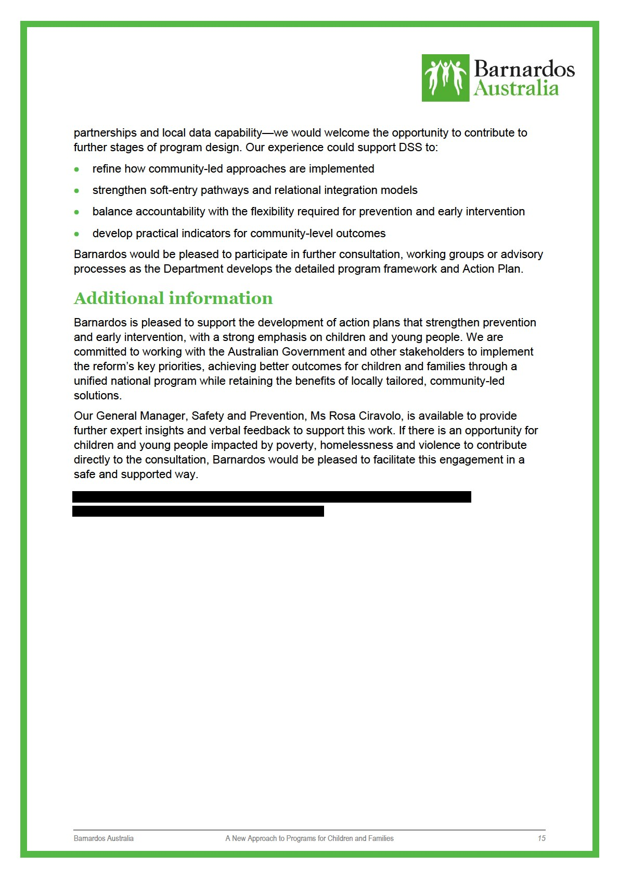

Moore, K. (2023). Barnardos Children’s Family Centres: Integrated local service delivery for vulnerable children and their families. Barnardos Australia: Sydney.
Barnardos Australia. (2024). A Brighter Barnardos: Barnardos Strategic Directions 2025-2026. Barnardos Australia. https://www.barnardos.org.au

