Friday 5 December 2025

To: The Hon Tanya Plibersek MP, Minister for Social Services By email: families@dss.gov.au

Dear Minister,

Response to the ‘new approach to programs for families and children’ Discussion Paper
We are pleased to provide Berry Steet Yooralla’s response to the Department of Social Services’ Discussion Paper ‘A new approach to programs for families and children’. We warmly welcome the Commonwealth Government’s commitment to addressing increasing rates of developmental vulnerability in children as well as increasing rates of children entering out-of-home care.
Berry Street Yooralla is a strategic merger bringing together two highly skilled specialist workforces to achieve better learning, wellbeing and safety outcomes for children and young people who are living in vulnerable circumstances, have experiences of trauma, or are living with a disability. Our multidisciplinary workforce of more than 3,300 staff deliver trauma-informed services that support over 38,000 people each year across Victoria, with services covering youth residential care and foster care, intensive family support and preservation, whole-of family therapy and mental health, specialist family violence, educational engagement, and NDIS-funded disability programming.
We make this submission as a trusted provider in Victoria for Children and Parenting Support (CAPS), Family and Relationships Services (FARS) and Communities for Children (C4C), including:
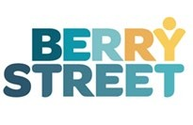

- Early Learning is Fun (CAPS): provides intensive supported playgroups for vulnerable families with children aged 0-5 years living in Whittlesea LGA. We deliver three weekly supported playgroups co-located at local primary schools and MCH services, offering a safe, familiar environment for parents and children to play and learn together. Activities are aimed at building the child’s school readiness, encouraging parents’ participation in their child’s learning, building parents’ and supporting the family’s engagement in the community. Families are also provided with information, advice and information to help access specialist services as well as to identify any early concerns for developmental delay. Our playgroups supported 119 children and caregivers last year, 39% identifying from CALD backgrounds.
- Family Therapy program ‘Family Matters’ (FARS): works with young people and their families living in four LGAs (Darebin, Banyule, Nillumbik and Whittlesea) who are experiencing challenges in the home, to strengthen family relationships, prevent family breakdown and prevent youth homelessness. Family Matters draws on evidence-based Family Therapy systemic theories and attachment-based interventions to help family members build safe, flexible and robust relationships. The service also equips parents with information, support and strategies to manage their child’s challenging and aggressive behaviour. The program provided therapeutic support for 43 families (148 individuals) last year.
- Hume Early Years Family Violence Project (C4C subcontract): provides an early intervention response for children aged 0-4 and caregivers who have experienced family violence. Our two specialist practitioners provide flexible 1-1 support for families including information and advice, referrals and service navigation, group activities, and longer-term case management, using the Safe and Together Framework and Circle of Security to place the child at the centre of the response. Our practitioners are also positioned at ‘outposts’ in the community and work closely in partnership with Maternal Child Health Nurses, early childhood services, women’s community house, and community legal services, to provide a mix of network capacity building, secondary consultations, and training workshops. The program directly supported around 180 victim survivors last year, plus 120 clients through secondary consultations.

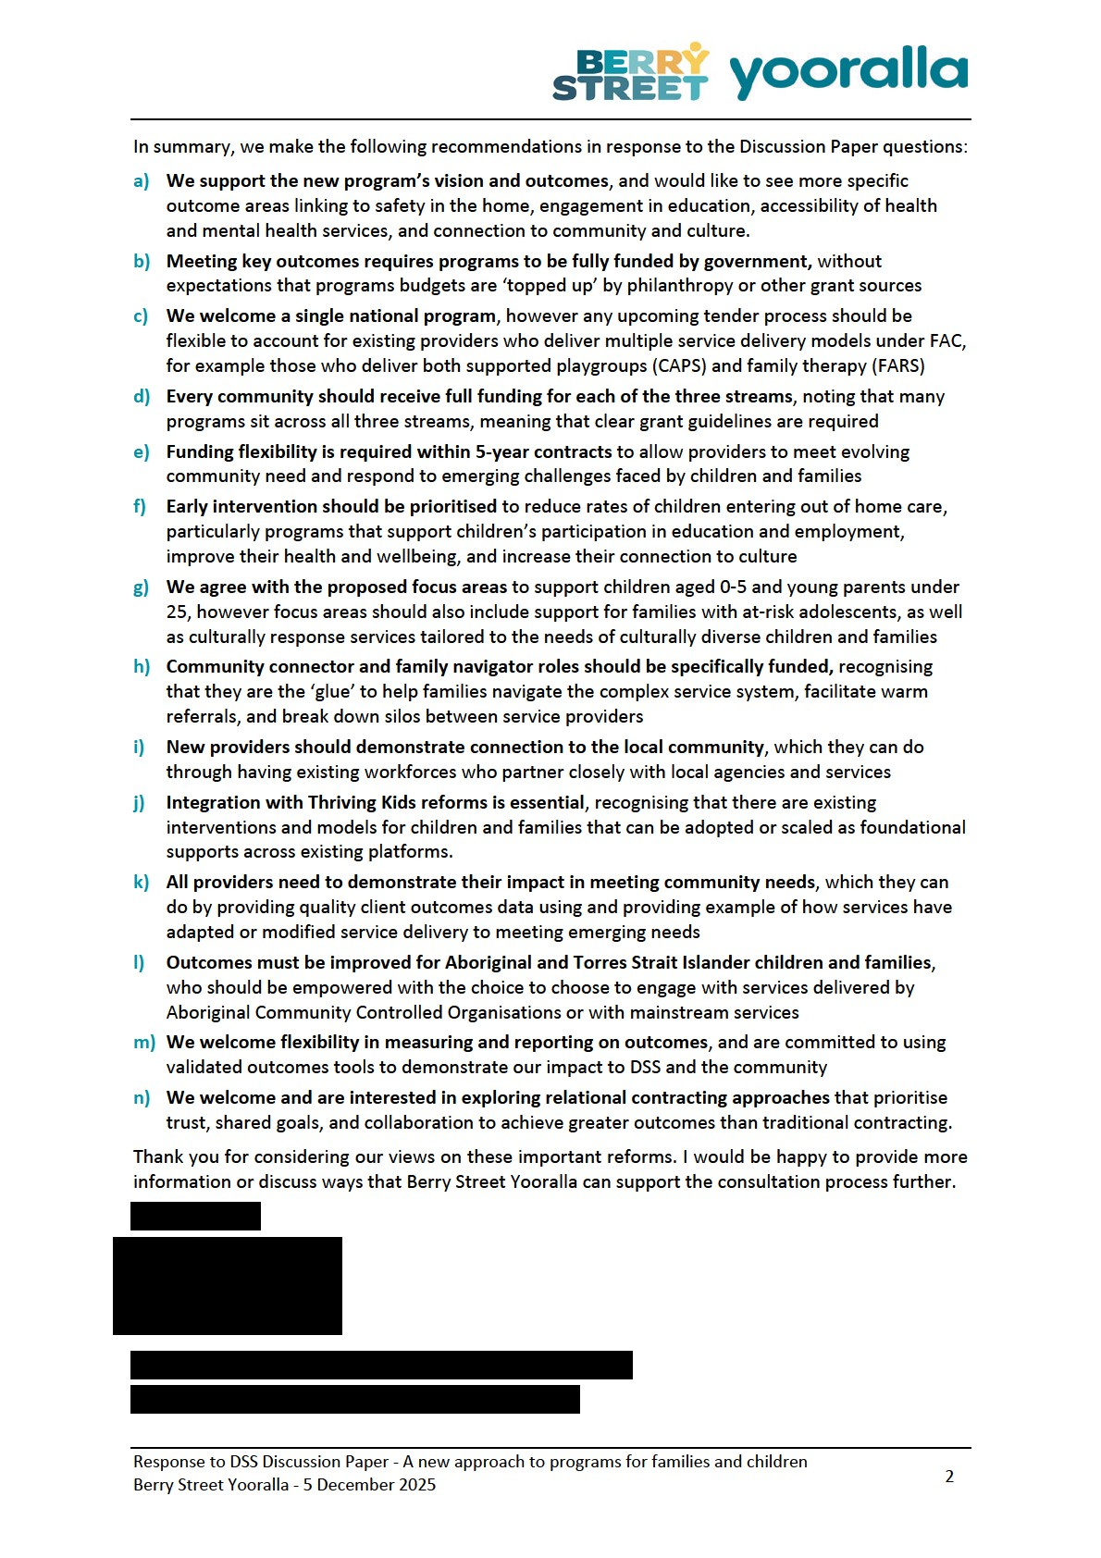

1. Vision and outcomes

a) Broad support for new vision and outcomes
We confirm our support for the new vision and two main outcomes. Theses outcomes are in line with the evidence which tells us that children achieve better outcomes when they are supported to engage in play and learning; when caregivers are supported to understand and engage in their child's development needs; and when families have access to health services and local support networks.
We would also like to see more specific outcome areas linking to safety in the home, engagement in education, accessibility of health and mental health services, and connection to community and culture. These are critical outcomes areas to ensure that children can thrive from their early years, as adolescents, and into adulthood.

b) Meeting key outcomes requires programs to be fully funded by government
We welcome long term, sustainable funding with 5-year contracts that account for annual indexation and award rises. We know that long term funding is critical to ensure continuity of quality care for clients, and to provide secure and stable jobs for our workforce
Programs under the FAC activity are core service delivery to achieve outcomes for vulnerable children and families, and therefore these programs should be fully funded as core service delivery.
Fully funding these programs means that:
- Administration and overhead costs should be appropriately funded. Quality service delivery relies on front-line practitioners being appropriately supported by ‘back-end’ functions including practice uplift, quality and compliance, people and culture, IT, data, and risk.
- Programs shouldn’t be required to combine multiple grant services to be financially viable. Too often, multiple grant sources are required to sustain a minimum workforce footprint which causes sustainability issues for our workers and clients if one source of funding ends.
- There shouldn’t be an expectation that under-funded program budgets can simply be ‘topped up’ by philanthropy or regular giving programs. This is particularly relevant in a cost-of-living crisis where giving is trending down across the not-for-profit sector.
This is confirmed by Social Ventures’ report ‘Paying What It Takes’ report which found that not-forprofits have an average indirect cost of 33% of their total expenses, which by far exceeds what is normally included in funding agreements.

2. Program structure

c) We welcome a single national program that accommodates multiple service delivery models
Broadly, we support a simplified recommissioning process for the FAC activity where there is only one tender process and one annual reporting process, rather than five individual ones. This will reduce administration time as we will only need to submit one annual Activity Work Plan and can report against streamlined outcome areas. This means our practitioners will get to spend more time directly supporting children and families.
However we note that any tender process needs to account for providers who deliver multiple service delivery models, as well as providers who deliver services across different communities. If there is only one tender that covers the entire FAC activity, then there should be enough space in the written responses section for providers to propose multiple service delivery models. For example, we have three programs currently funded under FAC (CAPS, FARS, C4C) and will require enough space to articulate our three service models and to demonstrate connections to each local community. Each service delivery model should be assessed by DSS separately based on its own merit and how it aligns to the new program guidelines and outcome areas.

d) Every community should receive full funding for each of the three streams
We believe the three service streams are appropriate (National programs and information services; Prevention and early intervention; and Intensive family supports) however we note that many services sit across two or three of these streams. For example, our existing services under FAC provide a mix of advice information and referral supports; early intervention activities to support families before their challenges escalate; as well as more intensive case management for the whole family when they are experiencing crises or are at risk of contact with the child protection system.
Flexibility should therefore be granted for services to provide support across the three streams, without being penalised during the commissioning process for not fitting neatly within one stream.
Further, it would be helpful to have clear guidelines for how funding will be distributed in each community across each of the three streams, so families do not miss out on receiving certain service types. Each community should be appropriately funded across each stream for the full range of services that are currently provided under the FAC stream, including but not limited to early years services, school engagement services, adolescent services, parenting programs, family counselling services, mental health services, and family violence prevention services.

e) Funding flexibility is required to allow providers to meet evolving community need
We support five-year contracts that ensure continuity of care for children and families while also providing secure jobs for our workforce.
However, community need and local challenges are always evolving and are never stagnant, so the way services are funded should reflect this. We would like to see flexibility mechanisms built into the long-term contracts to allow providers to adapt or modify service delivery to meet emerging challenges or changing community needs. Examples of this would include modifying or expanding a supported playgroup service’s catchment area to respond to changing community demographics; or scaling up the workforce of a family violence early intervention service to meet growing demand and shorten waitlists. This may require clear processes for contract variations that allow uplifts in funding as per agreement between the provider and DSS.

3. Prioritising investment
f) Early intervention should be prioritised to reduce rates of children entering out of home care Berry Street Yooralla agrees with the Australian Government’s priorities to:
- Invest early to improve family wellbeing, break cycles of disadvantage, and reduce the need for later interventions – like child protection.
- Prioritise connected, co-located, and integrated services that work together to meet family needs.
- Ensure services are informed by, and respond to, community needs.
- Improve outcomes for First Nations children and families by increasing the number of Aboriginal and Torres Strait Islander community-controlled organisations (also called ACCOs) delivering supports in locations with high First Nations populations.
We are supportive that the reforms are in response to increasing rates of developmental vulnerability in children as well as increasing rates of children entering out-of-home care.
Berry Street Yooralla is one of the largest providers of residential care, foster care and kinship care for Victorian young people; meaning that we have a deep understanding of the complex and overlapping challenges facing children and young people in contact with the child protection system. Our firsthand experience shows that these challenges are continuing to become more acute due to the long tail of the pandemic. Many at-risk children and young people’s formative years were severely disrupted which has affected their mental health, developmental stages and capacity to socially regulate. Parents are also struggling to support their children in an increasingly complex, financially precarious and socially isolated world.
We know that early intervention is the most effective way to respond to these challenges and to reduce the rates of children entering out of home care. In 2020, Berry Street commissioned Social Ventures to investigate the case for early intervention in the Victorian child protection system. The report found that sustained investment in culturally informed targeted early intervention will deliver broader social and economic impacts for children and families. The social benefits for children, young people and families include improved participation in education and employment, improved health and wellbeing, reduced risk of homelessness and involvement with the justice system and, for Aboriginal families, stronger cultural connection and cultural healing to address intergenerational experiences of racism, trauma and disadvantage. These are important contributors to ending the intergenerational cycle of adversity and disadvantage experienced by many families.

4. Improving family wellbeing
g) Berry Street Yooralla supports the proposed focus areas, including:
- Families at risk of child protection involvement.
- Prevention and early intervention support for children aged 0-5 years.
- Young parents aged under 25.
We know that focusing on children in their early years is critical to reducing the number of children entering out of home care. According to AIHW in 2023-24, 26.6% of children admitted to care and child protection orders were aged 1-4, while 20% were under 12 months old. In addition, 32% of children commencing intensive family support services were aged under 5 years. Data from NSW Department of Communities and Justice also shows a strong link between younger parents and child protection involvement, with a 2021 report finding that 18% of children in the NSW child protection system were born to mothers aged 20 or younger, compared to only 5% of the general population.
Our Early Learning is Fun supported playgroups (CAPS) and Hume Early Years Family Violence Project (C4C) are clearly aligned with these proposed focus areas, as they are designed to support children in their early years to thrive in their development and stay at home safely with their families. Our local teams see the following challenges experienced by families with children under 5 years:
- Increasing complexity of need: Families are presenting with overlapping challenges including risk of homelessness, experiences of family violence, financial stress and social isolation. This requires our team to provide a more holistic service, for example our teams are trained in the Safe and Together and MARAM family violence frameworks to help identify and respond to risk of family violence as well as to navigate difficult conversations with children and families about consent and safety in the home including with culturally diverse families. We also partner closely with local services like Maternal Child Health Nurses and family violence service navigators to ensure families are provided full wraparound support based on their needs.
- Developmental delay and neurodivergence: We estimate around 30% of our clients in our supported playgroups have either developmental delay or autism, which is placing pressures on families who can’t access the NDIS. Some families do not feel comfortable attending mainstream playgroups due to their children’s challenging behaviour, while other families can struggle to understand or acknowledge concerns around their child’s development needs. This is why supported playgroups are important to ensure the child’s individual needs can be met, and parents can be supported in a safe and non-judgmental environment.
- Younger children attending services: More children aged 18 months to 3 years are attending playgroups, due to introduction of universal 3- and 4-year-old kinder. This has required us to adapt our delivery model to best support this younger cohort’s development and build attachment with their parents. For example we use age and developmentally appropriate movement and arts activities to support young children’s development of fine motor skills. We also partner with mental health services and the local mother-baby unit to support young
parents who are having challenges adjusting to parenting, including post-natal depression.
In addition, service providers who are working in communities with a high proportion of culturally and linguistically diverse families should be providing culturally responsive services that meets the needs of local children and families. Providing tailored and culturally responsive service responses for CALD families is critical, for example partnering with parents to have strengths-based conversations about their child’s development, as well as having difficult conversations about respect and healthy relationships with families who view violence in the home as a taboo topic. 39% of the clients attending our supported playgroups identify as culturally and linguistically diverse, so we are deeply aware of the barriers to access and participation experienced by many CALD families.

h) Families with at-risk adolescents should continue to be a focus area for the new program
We also see the need for well-funded early intervention services to prevent adolescents from entering the child protection system. Almost 30% of children receiving child protection services are aged 1014, while 14% are aged 15-17. Early intervention programs for these families should be funded to strengthen family relationships, prevent family breakdown and prevent youth homelessness
Our FAC-funded ‘Family Matters’ (FARS) provides family therapy and counselling specifically for young people and their families. Every day, our Family Matters team see first-hand the following issues experienced by families with at-risk adolescents:
- Low confidence in parenting skills: parents feel ill-equipped to help their adolescent children deal with the contemporary challenges facing young people, and are feeling socially isolated due to rigid conceptions on authority in the home and their own experiences of childhood
- Mental health challenges: young people feel anxious about their futures, are having difficulties connecting socially with their peers and adults, have ongoing experiences of bullying at school or online, and are reporting that they can’t turn to their parents without being criticized
- Financial pressures: Housing shortages and the unaffordability of rental properties are putting pressure on family functioning, with some separated parents choosing to remain residing in same house resulting in family violence, and young people who do not feel safe in high-conflict households being unable to leave the home without risk of falling into homelessness
- Gaps in education: Young people are falling and staying behind in their education, with low school attendance rates and increasing rates of school refusal. We know that connection to education is a powerful protective factor for young people, but it often requires supportive parents who are engaged in the young person’s education and learning outcomes
- Distrust in information: Young people and parents are being overloaded with news and information from social media which is amplifying their anxiety about their futures. Families are also concerned about harmful stereotypes of gender and masculinity perpetuated by social media influencers, but are unsure of where they can get trustworthy information and support.

5. Connected, co-located, and integrated services

i) Community connector and family navigator roles should be specifically funded
There is general agreement by government and sector that new programs must be connected into local service systems, to avoid duplicating services or working in silos. Mapping need for new programs should also consider services funded by commonwealth, state and local government agencies.
An important way to ensure an integrated service system is to allocate funding specifically for community connector and family navigator roles. These roles are the ‘glue’ that:
- Provide outreach directly into the community in partnership with community centres, child and maternal health nurses, local schools, sporting clubs, and culturally diverse organisations
- Help caregivers navigate complex service systems, providing advice and information so that vulnerable children and caregivers can build trust and feel a sense of inclusion within the system
- Facilitate warm referrals to specialist services so that families get the right support when they need it, while holding partner organisations accountable to their obligations to the family
- Break down silos between service providers so that a holistic whole of family approach is used, rather than the family being treated primarily as a client to the first service they present to.
Community connector and family navigator roles are often underfunded and invisible in funding frameworks because it is expected that it is part of front-line service roles, however our experience shows that these roles need to be filled and fully funded with dedicated FTE.

j) New providers should demonstrate connection to the local community
The new program should prioritise service providers who have a connection to the community that they are proposing to deliver their service in. Examples of how providers can demonstrate this include:
- Having an existing workforce made up of local people who reflect the community they serve, for example having multilingual practitioners working in culturally diverse suburbs
- Letters of support from partner organisations or referral agencies such as local Council, schools, community groups, and specialist services
- Evidence of being an active member of local service networks and local level alliances etc.

k) Integration with Thriving Kids reforms is essential
Services under the new program should also consider integration with the upcoming Thriving Kids reforms to ensure coordinated service responses and wraparound support for children who have developmental delay or are living with autism.
As Berry Street Yooralla wrote in our October 2025 ‘Submission to the House Standing Committee on Health, Aged Care and Disability’, the Australian disability and early childhood sector currently provides existing interventions and supports for children with developmental delays or autism, but they are siloed and difficult to access for vulnerable families. We believe there are existing interventions and models for children and families that can be adopted or scaled as foundational supports across existing platforms.
Integrated foundational support models that should be piloted and scaled for Thriving Kids include:
- Early Childhood Hubs co-locating maternal and child health, allied health, and parenting programs in disadvantaged communities
- Trauma-Responsive School Entry Programs embedding trauma-informed specialists in schools to support transition for children with disability and adversity
- Family Violence-Disability Integrated Outreach Teams linking family violence services with NDIS early childhood partners to support at-risk families.

6. Responding to community need

l) All providers need to demonstrate their impact in meeting community needs
As described earlier, each community should be appropriately funded across each of the three streams and for the full range of services that are currently provided under the FAC stream. This means that every community should have funding across advice and information, early intervention, and intensive family supports. Every community should also have the appropriate funding to fill gaps in their early years services, school engagement services, adolescent services, parenting programs, family counselling services, family mental health services, and family violence prevention services.
We know there is limited funding available, which is why providers must demonstrate their ongoing impact in meeting the needs of their community. Providers can demonstrate their impact by detailing:
- Quality client data that shows sustained change for clients via pre and post assessments, including using validated outcomes tools to measure this change
- Examples of how they have adapted or modified service delivery to meet evolving community needs, ie refining target cohort, moving to different locations, or using new assessment tools
- How they have mapped their service against the local service system, confirming that their program is not duplicative of other nearby services funded by other government agencies
- Letters of support from other local services that highlight how they are embedded into the community and have contributed to joint problem solving initiatives.

m) Outcomes must be improved for Aboriginal and Torres Strait Islander children and families
The evidence shows that Aboriginal and Torres Strait Islander children and young people are significantly overrepresented in Australia’s child protection system. This over-representation is driven by intergenerational trauma, poverty, housing instability, and limited access to culturally safe support services. The lack of culturally responsive programs and the failure to uphold self-determination for Aboriginal communities further compounds the issue.
That’s why Berry Street Yooralla strongly advocates for the principles of self-determination, including the principle that services for Aboriginal children and families should be delivered by Aboriginal Community Controlled Organisations and led by and for First Nations people. Aboriginal children and families should also be empowered with the choice to choose which services they engage with, whether that is choosing to be supported by a local ACCO or by a mainstream service.
One way to ensure that ACCOs are appropriately funded and supported to deliver services specifically for Aboriginal children and families is to set a target for new investment into ACCOs. Examples of this include the NSW Department of Communities and Justice who has committed to a target of investing 30% of new early intervention program funds with ACCOs. In addition, the Victorian Government’s latest rolling action plan to prevent family violence has committed to allocate at least 10% of new funding to ACCOs to support services for Aboriginal people.

7. Measuring outcomes

n) We welcome flexibility in the way we can measure and report on outcomes
Berry Street Yooralla is currently developing an organisation-wide practice framework and accompanying outcomes framework which we have committed to delivering in 2026. Once adopted and implemented, we will have a standardised approach to collecting and measuring outcomes as well as to using outcomes data to inform our practice.
For the new FAC program, we support built-in flexibility in the use of tools to measure outcomes for children and families. A snapshot of our outcomes measurement includes:
- Early Learning is Fun (CAPS): Uses evidence-based pre and post survey tools including the Parent Empowerment and Efficacy Measure (PEEM) and Strengths and Difficulties
Questionnaire (SDQ) in the early stages of engagement and again when a family is exiting. Parent feedback may be given formally during biannual reviews and goal setting sessions, or informally during discussions with families, for example families reporting they have increased connection with local services such as the MCH Nurse or NDIS. Finally, group observations are recorded in individual notes for example observation of parents using parenting techniques introduced within group, or observed positive changes in children’s social skills.
- Hume Early Years Family Violence Project (C4C): Uses the DEX SCORE to report to the lead agency Uniting, however our experience shows that SCORE is limited to measuring client satisfaction levels rather than appropriately measuring the impact on our work which is focused on preventing family violence and supporting victim-survivors.
- ‘Family Matters’ (FARS): Uses Circumstances, Goals and Satisfaction domains in SCORE. The program has trialled tools like the SDQ however the nature of whole-of family therapy means that a single tool is difficult to measure the full impact of our work for each of the individual family members. The team are currently developing a questionnaire that reflects the DEX outcome scores and intends to apply this at commencement of therapy, during work to gauge need for ongoing work and at completion of the intervention. At present, families are interviewed following completion of service, and this has highlighted the impact of the work on the family and in particular high satisfaction with the service and their therapist.
Our practitioners would also benefit from a simple, standardised template to use for case studies that covers the voice of the child and family, the presenting issues, what our service response was including what goals were set with the family, what partners we worked with including referrals made, and how we measured our success using outcomes measurement tools.

8. Working together

o) We welcome and are interested in exploring relational contracting approaches
Berry Street Yooralla is open to relational contracting approaches with DSS and other government agencies, such as Social Impact Bonds or Payment By Outcomes contracting
We believe that if done right, relational contracting approaches that prioritise trust, shared goals, and collaboration can achieve greater outcomes than traditional contracting approaches by:
- Shifting the focus of buyer-supplier relationships to shared power and mutual understanding, reducing adversarial dynamics between government agencies and service providers
- Providing greater flexibility so that service providers can focus on outcomes and respond to emerging issues without being constrained by overly prescriptive contracted outputs
- Fostering shared responsibility and continuous learning, so that responsibility for solving systemic challenges such as rising rates of child protection is shared by both government and the social services sector.
We have experience in relational contracting approaches through our delivery of Australia’s first primary school based Social Impact Bond. The program ‘Side By Side’ is a partnership between Berry Street Yooralla and the Victorian Aboriginal Child and Community Agency (VACCA) designed to improve school attendance, engagement and learning outcomes for some of Victoria’s most vulnerable and disadvantaged children, particularly from First Nations backgrounds. Students receive an intensive 12 month program to help them re-engage with school and close gaps in their learning. Side by Side is delivering in partnership with the Victorian Government’s Partnerships Addressing Disadvantage initiative, and is supported by the Department of Treasury of Finance, Department of Education and Training, and investors who are managed by Social Ventures Australia.

