


VOICE / INFLUENCE / LEADERSHIP

D
epartment of Social Services
Reform of
Five

Funded
Families and Children Activity
Programs

December 5, 2025

SUBMISSION

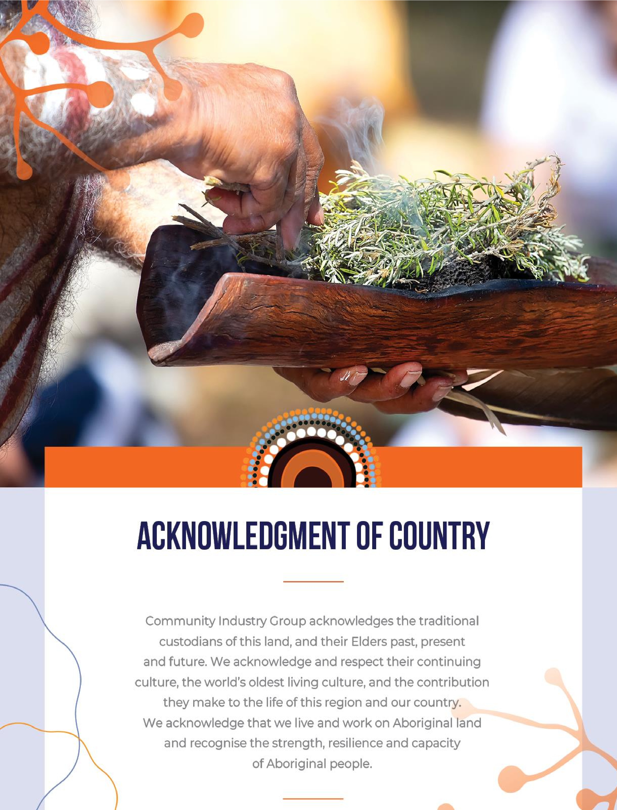

Executive Summary

Community Industry Group (CI Group) welcomes the opportunity to contribute to the Department of Social Services Reform of five funded Families and Children Activity Programs in Australia.
As the peak body representing not-for-profit human and community services across Southern New South Wales, our membership includes a wide range of services delivering homelessness support, family and domestic violence services, child and family support, youth work, aged care, disability services, and community centres. Many of these organisations deliver or partner closely with providers who are funded under the five affected Families and Children Activity programs.
For more than 30 years, CI Group has taken a leadership role in advocating for inclusive, evidence-based, and community-informed approaches to service delivery. We support community organisations by promoting expertise and innovation and fostering industry development. Our work is driven by a commitment to social justice and to ensuring positive outcomes for the sector and the region.
This submission is informed by the direct voices of our member organisations and service providers who work with children and families impacted by vulnerability, isolation, and systemic disadvantage in the Illawarra Shoalhaven region.
CI Group, our members and stakeholders are overall supportive of the Government’s commitment to streamlining programs, reducing administrative burden and improving cost-efficiency in service delivery, however, we are concerned that this efficiency will come at the expense of impact. Our members have identified significant risks that, if unaddressed, will undermine the very outcomes this reform seeks to achieve. Specifically:
- The gap between the reform’s vision and implementation threatens service continuity and community trust;
- Key priority groups are excluded from focus areas; and
- The competitive grant process proposed will create an environment of further inequities for smaller organisations.
As the Department advances toward a consolidated program structure, it is crucial to recognise the breadth and depth of the current service landscape. Any transition must ensure that the proven strengths, insights and achievements of existing programs are not lost but rather built upon.
As one member told us:
"Families rely on these programs." The proposed reforms risk disrupting trusted services that vulnerable families depend on.

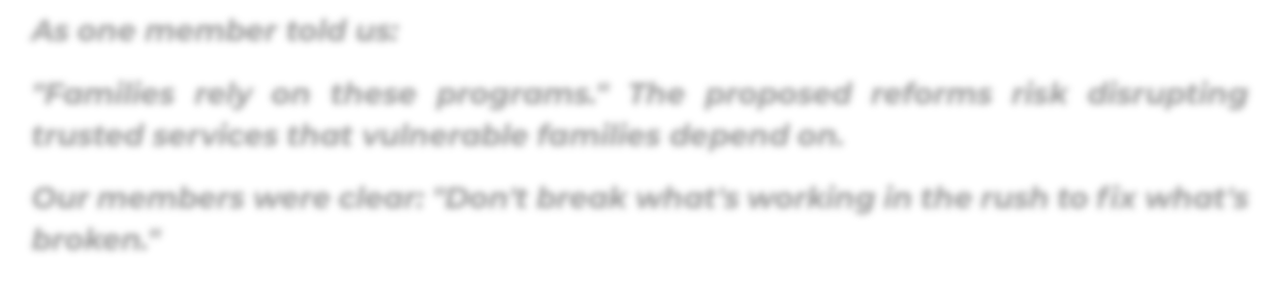

Our members were clear: "Don't break what's working in the rush to fix what's broken."
There is also a significant problem with the timing of this reform. It must be noted that this reform is occurring alongside a major program of state-based redesign and recommissioning across NSW, creating unprecedented levels of simultaneous change for the family and community services sector.

In New South Wales there is significant reform proposed in 2026:
- Prevention and Targeted Early Intervention programs being recommissioned into the Child and Family Support program
- Multiple family preservation programs being recommissioned into Families Together and Aboriginal Family Preservation, including multisystemic Family
Therapy – Child Abuse and Neglect (MST-CAN) and Functional Family Therapy - Child Welfare (FFT-CW)
- NSW Out of Home Care system reforms
- Specialist Homelessness Services redesign
- Domestic and Family Violence program reforms
These reforms impact almost every community service supporting vulnerable families in NSW. Our members—many of whom deliver services under both Commonwealth and NSW state funding—are facing the prospect of having every funding agreement, service model, and reporting requirement changing simultaneously.
This will have profound impacts on families, the workforce, service providers and community trust. To ensure this reform achieves its intended outcomes, it is essential the process is not rushed, and consultation is given sufficient time to be considered in order to undertake the genuine co-design these programs deserve.

Vision and Outcomes
Our members welcome and strongly appreciate the Department’s commitment to the proposed vision that All children and young people are supported by strong families who have the skills and confidence to nurture them. This vision aligns well with the outcomes we see every day in our communities and believe it provides an excellent foundation for the reform.
One concern raised by members, both in terms of the vision and the outcomes, was the definition of the family unit. We would be keen to ensure that the term ‘family’ is used inclusively to recognise diverse family structures including intergenerational families, families without formal caregiving roles, and siblings, extended family members or friends raising children.
The strong focus on family wellbeing in both vision and outcomes provides a solid platform which we believe could be enhanced by the inclusion of terminology such as “safe”, or “safety” within the outcomes. This enhancement would reinforce the program’s commitment to supporting services that work with families and children impacted by domestic and sexual violence. Safety is foundational to family wellbeing, and its inclusion would provide greater clarity and confidence both for service providers and the families they support.
As this reform takes shape, we encourage the Department to enhance the outcome language by explicitly including safety, and recognising the many diverse family structures our community is made up of to ensure that overall family wellbeing is embedded in community wellbeing.

Program Structure
Suggesting that service providers can fit within one of the three streams is unrealistic as this requires rigid service delivery which undermines the very nature of strength-based service delivery. The Department should instead be focusing on a program that is designed with enough flexibility to respond to the diverse and changing needs of families across many different communities.
Families present with complex, intersecting needs that require services to adapt and respond holistically. A rigid streaming approach risks fragmenting support and forcing families to navigate multiple services when integrated, flexible support would be far more effective.
The success of programs like Communities for Children Facilitating Partners has been built on their ability to be localised, unique, and responsive to community-determined priorities. This model recognises that communities themselves are best placed to identify their needs and design appropriate responses. Any reform must preserve this community-led flexibility rather than imposing standardised approaches that may not reflect local realities.

Prioritising investment
CI Group supports the four priorities:
- Investing early to improve family wellbeing and break cycles of disadvantage.
- Prioritising connected, co-located and integrated services.
- Ensuring services are informed by, and respond to, community needs.
- Improving outcomes for First Nations children and families by increasing ACCO-led service delivery.
Underpinning these priorities must be the principle of ‘local for local’, as a one-size fits-all approach will fail to address the uniqueness of our communities.
Aboriginal Community Controlled Organisations (ACCOs) must be situated in, and led by, the communities they work in. Authentic community control means trusting ACCOs to determine their own priorities and approaches, not imposing external frameworks onto their work.
When determining areas of investment, innovation and trusted successful programs and initiatives should be prioritised.
Funding should be allocated to be responsive to emerging community profiles, while also considering the reality of families not being able to realistically access services in hard to access areas.

Improving family wellbeing
Our members recognise that the proposed focus areas – such as supporting families at risk of child protection involvement and young parents - partly align with the needs and priorities of their service but stress these categories are too narrow, do not reflect the full spectrum of needs and risk excluding significant groups who are already falling through the cracks. For example, local communities are experiencing significant food insecurity at levels not previously seen.
These focus areas disproportionately impact families that do not meet formal risk thresholds but still require support.
It is crucial that groups already facing disadvantage must not be overlooked, including neurodivergent and gender-diverse individuals, CALD families, new and expecting families, intergenerational and extended family units and children living with a disability not covered by other funding.
To adequately support family wellbeing, we urge investment for:
- Models that support:
  - Broader areas of vulnerability o Holistic, whole of community approaches
  - Local grassroots organisations that can be flexible and creative in their delivery, adapting to community preferences and cultural contexts
  - Long term community development approaches that enable vulnerable communities the continuity that is needed to align with trust and consistency of service.
- Funding that captures the true cost associated with data collection and outcomes measurement.
- Long-term investment recognising that change takes time. Longer funding terms (5 to 10 years) and streamlined application and reporting mechanisms would certainly release important resources for more service delivery and promote security for long term staff retention and community trust as well as being able to demonstrate sustained outcomes.

Connected, co-located, and integrated services
The biggest challenge in framing a program around connected, co-located and integrated services is that it fails to recognise that effective coordination goes beyond physical colocation. True collaboration is born through informal and formal partnerships and communities of practice, professional and personal relationships, knowing the history of the community they service, and connecting people through events and opportunities to celebrate.
Of particular concern to our members is the reform’s proposal of community centres or hubs being integral to connected services. This hugely disadvantages communities which do not have such facilities, and families living in rural and remote areas.
Responding to community need and measuring outcomes.
Funding should not be allocated solely based on postcode. We recommend that additional factors be considered including demographic trends such as population growth and age distribution, service gaps, and barriers to accessing services such as isolation, digital exclusion, transport and language.
We strongly advocate for a ‘by the community – for the community’ model. Different communities will have different priorities and different ways of expressing and understanding their needs. There are families that desperately need support that don’t necessarily reside in at-risk areas or have disadvantage indices. Responding to community need means recognising the variance of this and enabling communities to have genuine input into how their need is defined and measured.
What’s the best way for organisations to show in grant applications, that their service is genuinely meeting the needs of the community?
Genuine connection with community in conjunction with data and statistics is needed to show organisations are meeting the needs of the community. This could be demonstrated through:
- Organisational feedback and practice demonstrations: Evidence of ongoing community engagement and feedback mechanisms.
- Data on service reach and outcomes, including wait-list data that demonstrates unmet demand and service gaps in specific communities
- Local impact stories and visual aids that capture the lived experience of services and community connection that statistics can’t.
A dataset that is functional, focuses on outcomes and incorporates both quantitative and qualitative information will ensure funding reflects actual need, and support equitable access to services and responds to raid changes in community conditions. It is no surprise that feedback from our members highlighted that the Data Exchange (DEX) alone cannot adequately capture this. We strongly advocate for flexible tools and greater accessibility to datasets that provide transparency to the sector.
Furthermore, the recent removal of the DEX helpline disadvantages services already at maximum capacity. A system is only as effective as the quality of data that is captured and reinstating this helpline would be one measure to support this.

Improving outcomes for Aboriginal and Torres Strait Islander Children and Families
Programs need to be designed to recognise that First Nations families need choice over the services they want to access – both ACCO and non-ACCO services. This ensures services are accessible regardless of where families live, and reduces barriers to access services including transport, service hours and cultural safety. Genuine commitment to improving outcomes requires direct commissioning of ACCOs with adequate long-term funding, cultural competency for all services, and genuine self-determination in program design and delivery.

Relational and Competitive Contracting
As one member told us:

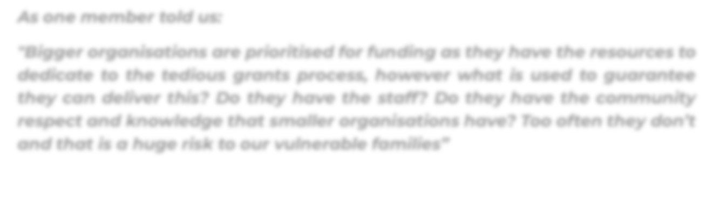

"Bigger organisations are prioritised for funding as they have the resources to dedicate to the tedious grants process, however what is used to guarantee they can deliver this? Do they have the staff? Do they have the community respect and knowledge that smaller organisations have? Too often they don’t and that is a huge risk to our vulnerable families”

We support the relational contracting approach in principle as members have significant concerns that a fully competitive grants process will disadvantage smaller, locally- embedded organisations that do not have the administrative resources or dedicated tender-writing staff of the larger providers. These smaller organisations are often the most trusted in their communities yet face the greatest barriers in navigating complex application and reporting requirements.
To ensure the proposed relational contracting process meets its intent of shared goals, clear governance and accountability we urge the Department to provide more clarity around how the relational contracting process will be applied and implemented to ensure service providers are best placed to determine if this would suit their service. Collaboration with the sector to develop the framework that supports who should apply for this as opposed to who should be offered this.
Members strongly encourage DSS to adopt a commissioning approach that removes unnecessary competition, reduces administrative burden, and actively supports smaller organisations to participate on equal footing.
Thank you again for the opportunity to shape these essential programs. In closing, we respectfully suggest the following:

Key Recommendations
Timing and Implementation:
- Extend implementation beyond June 2026 to enable genuine co-design and avoid compounding NSW state reform disruption
- Coordinate with state/territory governments to sequence reforms
Vision and Outcomes:
Revise vision and outcome terminology to:
- Explicitly recognise safety, including DFV impacts, and the diversity of family structures
- Acknowledge family wellbeing is embedded in community wellbeing
Program Structure:
- Design with flexibility over rigid streaming to enable holistic, responsive service delivery that recognises diverse family needs
Priority Groups:
- Expand beyond child protection risk and young parents to include families experiencing food insecurity, neurodivergent and gender-diverse individuals, CALD families, new and expecting families, children with disabilities, fathers, visalimited families, children impacted by domestic and family violence, and families needing general support
- Support families across the full childhood/adolescence continuum, not just 0-5 years
Funding:
- Implement 5-10 year funding agreements
- Retain proven community-led models such as Communities for Children
- Apply a minimum 10% loading for regional/remote service delivery
- Allocate funding based on multiple factors beyond postcode
- Prioritise innovation and proven community-trusted programs
- Fully fund data collection and outcomes measurement, including qualitative methods
Aboriginal and Torres Strait Islander Communities:
- Directly commission ACCOs with long-term funding and capacity building investment
- Require cultural competencies for all services, not just ACCOs
- Enable genuine self-determination in program design and delivery
Collaboration:
- Support collaboration beyond co-location through partnerships, communities of practice, and relationship infrastructure
- Fund backbone infrastructure for collective impact
- Ensure accessibility is an essential design feature, with investment to remove barriers such as transport, digital and language barriers
Commissioning:
- Move away from competitive grants that disadvantage smaller, locallyembedded organisations
- Provide transparency on relational contracting implementation
- Streamline application and reporting requirements
Data and Measurement:
- Use multiple data sources and community input, not just postcode allocation
- Reinstate the DEX helpline and improve system functionality
- Value qualitative data, case studies, and children's voices alongside metrics
- Enable "By the community – for the community" approach to defining and measuring need.
Essential Principle:

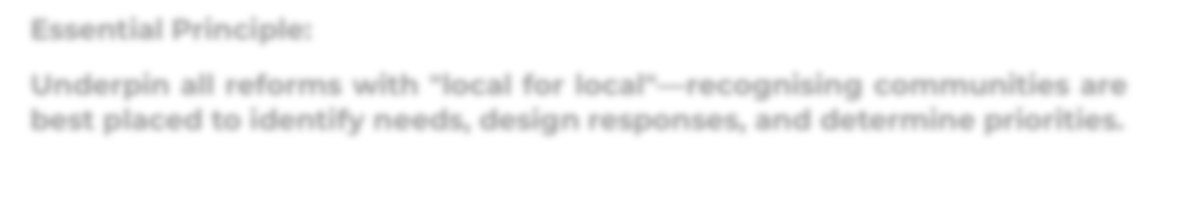

Underpin all reforms with "local for local"—recognising communities are best placed to identify needs, design responses, and determine priorities.

