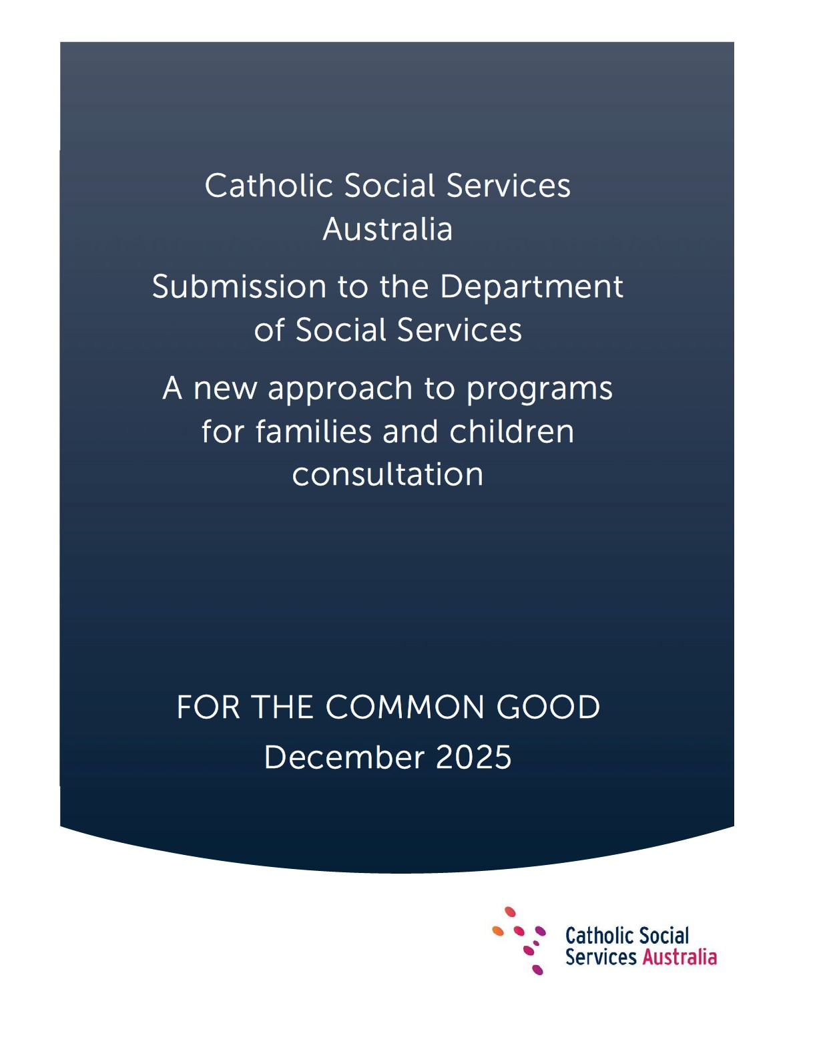

About CSSA
Our 41 member agencies, with an annual revenue of over $1.4 billion, provide a diverse range of services to about half a million people annually. These services include children’s and family services, early childhood education and care, youth work, family and relationship support, domestic and family services, aged care, NDIS services, financial counselling, homelessness services and emergency relief, all aimed at helping the vulnerable and impoverished. Our network operates across more than 900 sites in Australia, employs over 10,000 staff members, and is supported by around 3,000 volunteers.
Overview
CSSA welcomes the opportunity to respond to the Department of Social Services’ (the department’s) consultation on ‘A new approach to programs for families and children’.
Our member organisations deliver vital services and programs to those in our communities experiencing the most disadvantage and vulnerability, often in challenging circumstances. CSSA estimates that at least 20 of our 41 members deliver one or more of the five in-scope programs through the department’s child and family programs.
CSSA’s interest in this consultation stems from our commitment to a fairer, more inclusive Australian society that reflects and supports the dignity, equality, safety and participation of all people. Our rich network of member agencies are embedded in their local communities delivering services that help all people to thrive, flourish and develop to their full potential. Our significant national network and knowledge of our local communities leaves our members well placed to support the department in working alongside the sector towards transitioning to the new national program.
In preparing this submission, we have consulted with our member organisations across Australia. We acknowledge that our members have varying perspectives on some aspects of the proposed changes, reflecting the diversity of services they provide and the communities they serve. Where relevant, we have highlighted these different viewpoints to provide the department with a more detailed understanding of how in-scope programs under the proposed reform will be affected on the ground.
CSSA thanks our member organisations for their insight and contributions in preparing this submission. A full list of CSSA member agencies is listed at
Attachment A.

Executive Summary

Catholic Social Services Australia (CSSA) welcomes the opportunity to contribute to the Department of Social Services’ (the department’s) consultation on ‘A new approach to programs for families and children’.

CSSA acknowledges the department’s genuine efforts to respond to long-standing calls from the sector to improve investment in families and children programs through longer-term grant agreements, greater focus on outcomes (not outputs) and simpler administrative and reporting arrangements. CSSA also commends the reform’s commitment toward the shared realisation of Priority Reform 2 under the National Agreement on Closing the Gap - to build the Aboriginal and Torres Strait Islander community-controlled sector. CSSA shares this commitment to journey with Aboriginal and Torres Strait Islander people and the community organisations that represent their interests and aspirations to explore culturally appropriate approaches to supporting self-determination and building meaningful relationships.
While CSSA and our member organisations broadly support the intent of the proposed reforms and the department’s investment priorities for children and families, we have a number of concerns and queries about aspects of the proposed reform.
These concerns and queries are presented in response to questions raised at Appendix A in the department’s Discussion Paper dated 4 November 2025 and are summarised below. Regarding the consultation process itself, some general feedback from our members includes:
- Preference for a longer consultation period outside of the busy preChristmas period to allow more considered and fulsome engagement with the sector on the proposed reform.
- Concern over the lack of detail in the Discussion Paper on key definitions, and lack of specificity regarding the design, grant agreement administration and service delivery implementation of the proposed new national program across the three proposed activity streams, including ambiguity in reference to relational contracting.

Through consultation with our member organisations, we have developed this submission which seeks to balance the aspirations of the proposed reform with practical implementation considerations. Importantly, the views in the submission aim to ensure that essential services and programs currently delivered by member organisations will not be disrupted or compromised as part of the transition to the new arrangements, and that good practice with trusted providers that are achieving positive outcomes in the lives of children and families continue to be recognised and valued.
We look forward to constructive engagement with the department and the children and family services sector to co-design, develop, test and implement the reforms arising from this consultation process. CSSA would be pleased to facilitate a face-to-face delegation representing our 41 member agencies to further engage with government architects of this reform.
Response to Discussion Questions

Vision and Outcomes
Does the new vision reflect what we all want for children and families?
- While CSSA generally supports the reform proposal’s vision that ‘all children and young people are supported by strong families who have the skills and confidence to nurture them’, we encourage the department to include ‘community’ in the vision. This is important in recognising the new program’s investment priority to respond to community-level need, especially in the context of the Communities for Children Facilitating Partner program. An example of a more inclusive vision could be:
‘all children and young people are supported by strong families and communities who have the skills and confidence to nurture them’.
- The two main outcomes proposed exclusively emphasise children and parents/caregivers. The main outcomes should encompass broader concepts of ‘family’ including grandparents and other extended family, kin and networks of support. Existing family and relationship services (FaRS) that support and strengthen relationships between couples with no children or who are yet to have children should also be considered under a broader definition of ‘family’.

- As the department moves toward implementation, concepts of ‘healthy’, ‘resilient’ and ‘early intervention’ will need clear and shared definitions, as well as clarity on indicators to measure outcomes. For example, does the department prefer providers to measure outcomes for ‘healthy children’ primarily in alignment with the Australian Early Development Census (AEDC) mental health, wellbeing and educational domains?
- We support the department embracing measurement of ‘healthy’ outcomes consistent with First Nations conceptions of child development including connection to county and cultural identity, cultural resilience, storying and other oral traditions.

Program Structure
Will a single national program provide more flexibility for your organisation? Does the service or activity you deliver fit within one of the three funding streams?
- In principle, the three new activity streams seem sensible as they cater for all in-scope programs within a continuum of supports from prevention to early intervention and intensive support services. There is opportunity as part of this reform for the Commonwealth to act as a market steward in ensuring the right ‘service mix’ in terms of equity and investment across the three streams.
- The Discussion Paper does not clarify whether service providers are required to establish entirely new service models under the three proposed streams. Many services and models have been operating for a long period of time and are well-established and valued in their communities. The 52 Communities for Children Facilitating Partner (CfC-FP) sites for example are a proven, two-decades long, place-based model with ‘brand’ recognition within Australia’s most disadvantaged communities. It is unclear in the Discussion Paper whether the model would require dismantling of if individual Facilitating Partners could negotiate to continue to deliver the model.
- FaRS and Specialised Family Violence Services (SFVS) do not seem to fit easily within the two main proposed outcomes centred on children and parents. A broader definition of ‘family’ to include all FaRS and SFVS client types would overcome this issue.

The streamlining of one grant application and one grant agreement for multiple services with one set of reporting requirements is consistent with
Pillar 3 – reduce administrative burden - under the Community Sector Grants Engagement Framework. With regard to DEX reporting, work underway to develop a DEX Standard Data Set with the sector through the Community Sector Advisory Group (CSAG) should ensure no additional reporting burden ‘creep’ under new in-scope grant agreements.
- The Discussion Paper and Evidence Summary tend to focus too narrowly on ages 0-5 (the Early Years). Children between the ages 6-18+ risk being overlooked despite some member agencies reporting that this age group represents a large proportion of Family Mental Health Support Services (FMHSS) clients, in particular. Program outcomes and Streams 2 and 3 should be sufficiently flexible to respond to needs of the local population including the 6-18+ year age group.
Alignment with related reforms and programs across governments
- The program could be strengthened through linkages with relevant systemlevel reforms and programs across governments. This would ensure enabling conditions for Commonwealth-State coordination, place-based collaboration and a coordinated national approach to workforce development, supporting sustainable and integrated service delivery for children, young people and families.
- Effective implementation of this reform will require the Commonwealth to effectively coordinate with states to ensure that efforts are complementary in nature and not duplicative or contrary. We note that the Commonwealth holds greater policy levers to invest in universal support and early prevention and intervention. Coordination with the states is required to ensure that all children, young people and families are supported effectively across the continuum. Key opportunities for alignment include:
  - Alignment of grant extensions for FaRS and SFVS (currently proposed until 31 January 2027) which currently do not align with extensions to related programs funded by the Federal Attorney-General’s Department under its Family Relationships Services Program (FRSP). The FRSP suite of programs, which support separated and separating families, are contracted until June 2028. There is significant interdependence between these programs.

  - Alignment of the FaRS and SFVS grant timelines with the FRSP suite of programs (as per previous practice) would harmonise service delivery for those organisations providing both FRSP services and FaRS and achieve the type of connected and integrated service delivery the reform proposal prioritises. This is especially important where an employee within an organisation delivers services across both programs.
  - The first services under the $2 billion Thriving Kids Initiative are due to roll out from 1 July 2026. Thriving Kids seeks to support children aged 8 and under, and their families, with developmental concerns earlier through mainstream and community settings, including within some FaC Activity service settings that are already known and trusted by children and families. There is an opportunity to align the FaC Activity reform with the Thriving Kids initiative. Transitional arrangements under the FaC Activity could also include funded capacity building for service providers to help ensure their mainstream services, where appropriate, are accessible and can participate in the Thriving Kids Initiative.

Prioritising Investment
Improving Family Wellbeing
Do the proposed focus areas – i.e. supporting families at risk of child protection involvement, prevention and early intervention support for children aged 0-5 and young parents – match the needs and priorities of your service?
- Focus on the three key areas (or groups) of interest to support priority investment in family wellbeing is understandable given these groups tend to show signs of being at risk of poor outcomes or are at life stages where strategic intervention can have the greatest impact. The proposed focus areas for investment reflect the sector’s commitment to meeting the real and pressing needs of families and young people. Services consistently identify early and proactive support as critical to preventing harm and child protection involvement, alongside integrated and connected pathways that respond to complex needs.

As Stream 1 and some activities under Stream 2 seem targeted at universal services - that is services that are designed to be accessible to all members of a population - tender applications should not be inequitably weighted based on attention to these focus areas/groups alone. This is unnecessarily limiting.
- The department should consider other high needs areas/groups that may struggle to receive other funding including: children aged 6 and above; children showing early signs of poor mental wellbeing; young people; families impacted by trauma; parents with experiences of mental illness or psychological distress or those involved in the out-of-home care and justice systems.
- CSSA also encourages greater consideration of client intersectionalities including First Nations children and families, those from culturally and linguistically diverse (CALD) backgrounds, LGBTQIA+ identities and individuals living with disability.
Connected, Co-located and Integrated Services
What are the other effective ways, beyond co-location, that you’ve seen work well to connect and coordinate services for families?
- CSSA appreciates the department’s preference for more integrated services to help ensure children and families in need do not fall through service gaps. Co-location of services, including community hubs, are proven models fostering connections and building social and economic capital in communities. It is important to consider that in some locations, co-location is not always possible or preferable and does not always equate with integration. For example, in regional/rural areas, and/or where only one service exists, co-location is not implementable. Where specialised services operate, there may also be sensitivities or risks in physically co-locating with other services, particularly where an individual’s privacy and safety may be diminished (for example, for those engaged in SFVS). In such circumstances, safeguards around co-location should be the priority.

- Some of our member agencies have cautioned that additional administrative, logistical and contractual burdens can be incurred in seeking physical co-location arrangements between providers. Service providers should not be penalised in tender applications for preferences not to colocate, or to delay this action, if it creates unreasonable burdens such as breaking leasing/rental agreements.
- Integration of services does not need to equate with ‘bricks and mortar’ colocation. For example, a particular strength of CSSA’s member agencies is our established network of providers who regularly share knowledge and have can collectively coordinate on issues or opportunities. Some of our member agencies emphasise the effectiveness of interagency networks in recognising and leveraging each organisation’s strengths, including enjoying well established warm referral pathways and shared care planning, service coordination functions, shared network meetings, formalised partnerships and MoU arrangements across the service continuum and in line with client needs, goals, risk factors and circumstances.
Responding to community need
Beyond locational disadvantage, what other factors should the department consider to make sure funding reflects the needs of communities?
- The Discussion Paper notes that community need will be determined through a variety of data sources (SEIFA, AEDC, child protection engagement data). CSSA joins strong calls from the sector for the department to take a lead role in releasing relevant and comprehensive data assets to support tender applications better evidence community need. This will help reduce the impost on the sector to source and analyse this data, especially smaller organisations with limited capacity to do so.
- CSSA notes that the Evidence Summary document provided as part of the consultation recognises that child protection engagement data is available at only the state and territory level. Further guidance should be provided to service providers on accessing appropriate child protection data at the community-level if this data is to inform tender assessments. Provision of qualitative, anecdotal or other data from providers engaging with children and families at risk of, or already engaged in the child protection system, may be a suitable de facto measure of need for this priority group in some locations.

CSSA-commissioned research ‘Real Costs, Real Impacts: A Path to Social Services Sustainability’ also emphasises the need for governments to adopt funding frameworks that include empirical evidence of service mix gaps that exist in Australian communities in order to drive sustainable and effective service delivery. Such information would further assist the quality of tender applications under the reform.
- Other needs-based factors to consider include:
  - Access Barriers: Availability and capacity of local services, transport limitations, digital connectivity and workforce shortages.
  - Community Complexity and Risk: Areas with high intergenerational disadvantage, systemic discrimination, or compounding issues such as mental health and substance misuse.
  - Social Isolation: Especially among regional and newly arrived families.
  - Changes in Population Demographics and emerging need which changes over time, particularly in growth corridors of major capital cities.
What’s the best way for organisations to show in grant applications that their service is meeting the needs of the community?
- Several CSSA member organisation cite the following ways for organisations to demonstrate that their service is meeting the needs of the community: o Examples of regular community consultations and codesign approaches and highlight evidence of collaboration and community engagement, including through case studies. o For ACCOs without prior experience in this space, consider alternative measures such as cultural competence, community trust, and partnerships to demonstrate readiness and connection.

  - Community Leadership and Networks: Existing local leadership, trusted organisations, and strong social capital that can drive collaboration and innovation.
  - Cultural Strengths: Rich cultural heritage, language diversity, and community-led practices that support resilience and wellbeing. This is particularly important in remote or very rural communities with high First Nations populations.
  - Readiness and Capacity for Change: Ability to demonstrate a strong track record or evidence of community willingness and capability to engage in place-based approaches and co-design solutions.
  - Existing Partnerships and Collaboration: Established cross-sector relationships that can be leveraged for integrated service delivery.
  - Youth and Family Engagement: Active participation of children, young people and families in shaping priorities and solutions.
- One member agency suggested that grant applications could include a Program Plan through which the applicant could demonstrate how their service responds to local community data and community-identified priorities. The Plan could include a statement as to how the service complements existing services and avoids duplication, including partnerships with health, education and housing sectors.
Improving outcomes for Aboriginal and Torres Strait Islander children and families
How could the grant process be designed to support and increase the number of ACCOs delivering services to families and children?
- Strengthening of the ACCO sector is vital. CSSA supports the achievement of Priority 2 under the Closing the Gap National Agreement in recognising that better outcomes are achieved for Aboriginal and Torres Strait Islander children and families through a strong and sustainable ACCO sector that can deliver high-quality services to meet the needs and aspirations of Aboriginal and Torres Strait Islander people.
- Alongside this journey is sits broader sector strengthening to ensure that non-ACCO organisations are able to support culturally safe, high-quality service options within mainstream settings, where appropriate.

Greater investment in ACCOs should be underpinned by a sector capability-building and change management process that builds the cultural capacity of the sector to support this journey. ACCOs and nonIndigenous organisations can play a valuable role in supporting each other through capacity building and partnerships. Non-Indigenous organisations can support less experienced or small ACCOs with tendering processes, and training and mentoring on compliance and reporting.
- ACCOs can support non-Indigenous organisations to increase their ability to deliver services in a culturally safe way and to understand diverse family dynamics and structures. Both ACCOs and non-ACCOs can share their mentoring, governance and evaluation expertise.
- The department is well placed to promote greater awareness of successful collaborative and commercial partnership options between ACCOs and non-ACCOs. Low integration examples include informal networking and supplier relationships. Higher level integration examples include consortia arrangements, auspicing and grandfathering arrangements. SNAICC has developed several helpful and practical resources to support ACCOs and non-ACCOs support genuine inter-agency partnership that could be promoted on under the reform journey including the ‘Creating Change through Partnerships Training Manual’ and ‘Applying for Funding – a guide to best practice partnerships between Aboriginal and Torres Strait Islander and non-Indigenous organisations’.

Measuring Outcomes
What types of data would help your organisation better understand its impact and continuously improve its services?
- Linkages to longitudinal studies administered by the department such as Growing Up in Australia and Footprints in Time.
- Access to trend data that shows long-term outcomes for families and children.
- Journey mapping to illustrate client experiences and progress.
- Direct service user/client feedback and outcomes as demonstrated through internal and DEX data.
- Internal and external evaluation reports that demonstrate measurable outcomes.

Working Together (Relational Contracting)
What does a relational contracting approach mean to you in practice? What criteria would you like to see included in a relational contract?
- Feedback from CSSA member agencies generally supports relational contracting in principle however some member agencies are concerned by the lack of shared understanding of the term ‘relational contracting’.
- As the nature of relational contracting relies on mature, trusted relationships, greater collaboration between parties and the creation of shared goals, governance structures and outcomes, CSSA supports codevelopment of a relational commissioning model with the sector and assurance of sufficient time for this process to occur. One CSSA member suggests the department engage in joint readiness assessments to determine if both the provider and the department have the structures and skills to sustain a relational approach effectively.
- CSSA notes that the Minister for Social Services previously commented on ‘trialling’ relational contracting. An iterative or piloted approach within a particular region, service type or among a select group of willing service providers has merit as this allows time for the department and the sector to observe the model in action and adapt to new ways of working that support the model before expanding uptake of the model across the entire national program.
- The department could support further clarity on relational contracting by sourcing examples where this commissioning approach is working well in practice such as within the National Indigenous Australians Agency (NIAA) or relevant overseas examples. CSSA considers there may be valuable lessons to be taken in developing this commissioning approach from the department’s implementation of the Social Impact Investment (SII) program suite, particularly Commonwealth Outcomes Fund - Focus Area 1:
supporting families and children which shares similar objectives to the FaC Activity programs, albeit on a payment by outcomes basis.

Recognising existing relationships that have demonstrated success, strong community connections, the ability to deliver outcomes in partnership and strong governance frameworks will also be important considerations in the department’s consideration of a relational contracting offer.
- Relational contacts should prioritise continuity with Funding Agreement Managers and service providers to ensure corporate memory within the department is not lost over time. Brief tenures of key grants administration (Community Grants Hub) and policy roles can undermine building strong and agile relationships under this commissioning model.
- Mechanisms for ongoing discussion on relational contracting between the department and the sector should be established, including at least annual forums to discuss how unforeseen issues or unintended consequences are experienced on the ground and how they are best addressed.

Working Together (non-competitive contracting)
- CSSA understands that all five in-scope programs will be subject to competitive re-tendering processes in 2026. CSSA encourages the department to consider whether competitive tendering is necessary and appropriate in some areas and programs, for example where thin markets exist in some regional, rural and remote areas. A mix of competitive and non-competitive contracting would also help to ensure service continuity where services are more scarce and less resourced.
- One member organisation strongly recommends the department consider a modified approach to tendering in very rural and remote areas whereby providers would be asked to indicate their interest to tender as a first phase. Where providers are able to demonstrate their credentials such as an existing and trusted physical presence, partnerships in the location, strong governance structures, etc., first-round eligible candidates would be invited to respond to final round tender applications.
- CSSA notes the re-commissioning of services example under the NSW Targeted Early Intervention (TEI) program and associated Family Connect and Support program (now merged under the Community and Family Support program) was not predominantly run as a standard competitive tender in its latest round. Rather, this process was successfully managed through a negotiation-based contracting approach with most existing providers.

Reform Timeline
- The proposed six-month notification period of outcome (from August 2026 for new agreements to be in place no later than January 2027) means that new grants will commence in the middle of the financial year. This means that service providers under current grant agreements will have to manage two budgets, including forecasting in the event that funding is not renewed. Agencies need to adequately plan their budgets before the end of the 2025-26 financial year. Retaining qualified, skilled personnel will be a key risk factor under the proposed reform timeframe as personnel may seek more certain and secure employment elsewhere in advance of tender decisions.
- Given that notification of tender outcomes will be known from August 2026, there is a very limited period of time for the department to collate the consultation feedback, make necessary amendments to the proposed reforms, communicate the consultation outcomes to the sector, (co)design new national program structures and guidelines, draft, finalise and process tender applications and commence assessment processes for a large number of inscope programs over the January-July 2026 period.
- A longer lead-in period (that is, offering extensions until the end of June 2027) would allow considered development of new agreements with the sector and time to address risks that would otherwise arise in a shortened transition timeframe, and with funding uncertainty. This includes:
  - Capital costs and losses, particularly in rural and remote areas where service providers have thin margins and serve geographically dispersed populations. Capital investments, including vehicles, building leases and workforce investments, may be unrecoverable if a tender outcome is known too late, creating a direct financial loss.
  - Loss of social capital due to de-stabilised relationships and trusted community networks. Social capital is the ‘glue’ that enables service providers and communities to work together. When local service capacity declines due to funding uncertainly, it can be slow to rebuild.
- A longer extension period to June 2027 would also help to avoid the real risk of service disruption or failure in rural and remote areas during the transition period to the new program. Rushing the consultation and re-contracting process to meet an arbitrary deadline undermines the successful outcomes the reform is attempting to achieve.

CONCLUSION
CSSA thanks the Department of Social Services for the opportunity to contribute to this consultation.
CSSA and its members would welcome the opportunity to discuss the content of this submission should any further information be of assistance. We reiterate our invitation to facilitate a face-to-face delegation representing our 41 member agencies to further engage with government architects of this reform. Further information can be sought from:

ATTACHMENT A CSSA Member Agencies
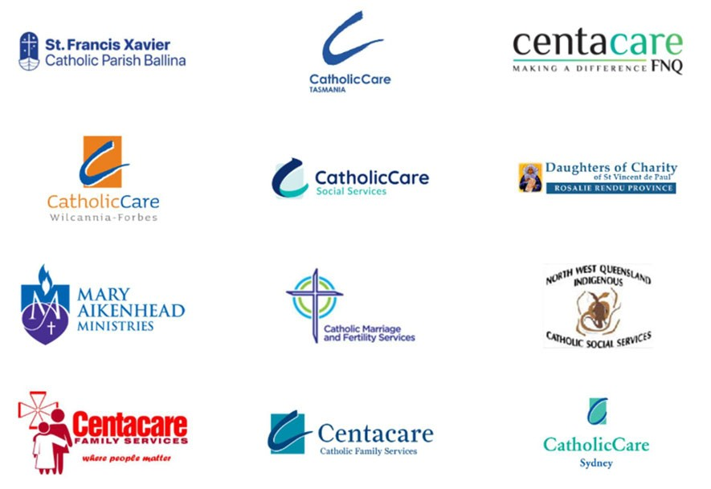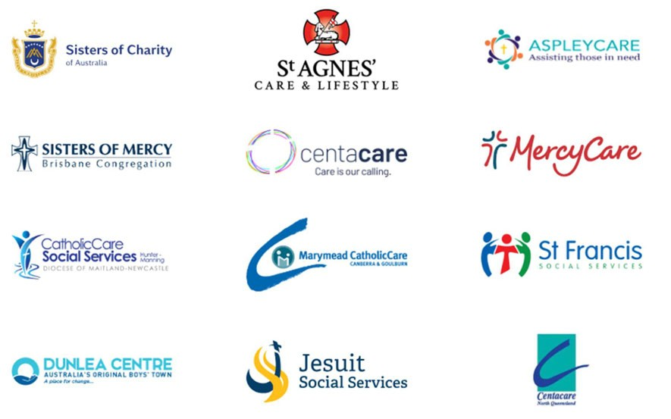

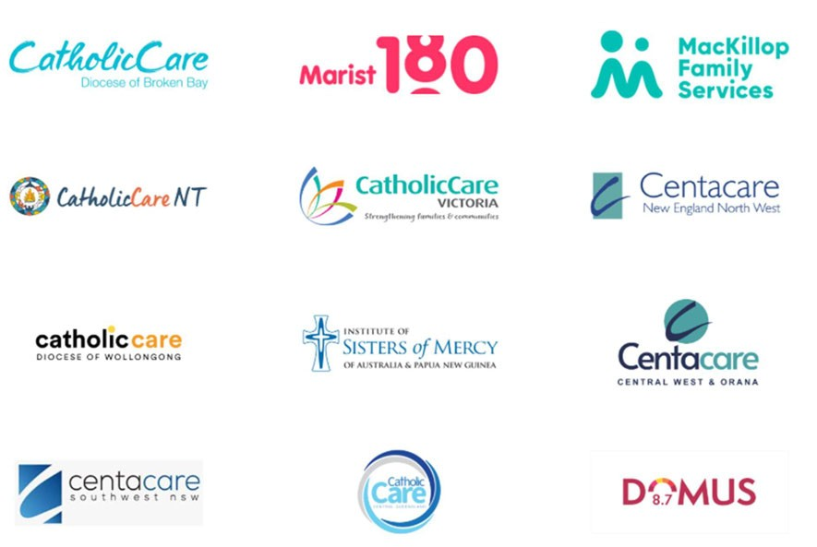

See: The Senate Community A airs Reference Committee Report on the ‘Impact on service quality, e iciency and sustainability of recent Commonwealth community service tendering processes by the Department of Social Services’, (September 2015).
See: Gilchrist, D.J., & B. Perks. ‘Real Costs, Real Impacts: A Path to Social Services Sustainability’. Centre for Public Value, UWA Business School, for Catholic Social Services (Australia) Ltd, Canberra, Australia (March 2025).
See: Mark Considine, Bruce Bonyhady, Sue Olney and Kirsten Deane. ‘Formal Relational Contracts and the Commissioning of Complex Public Services: Position Paper’. (October 2024).

