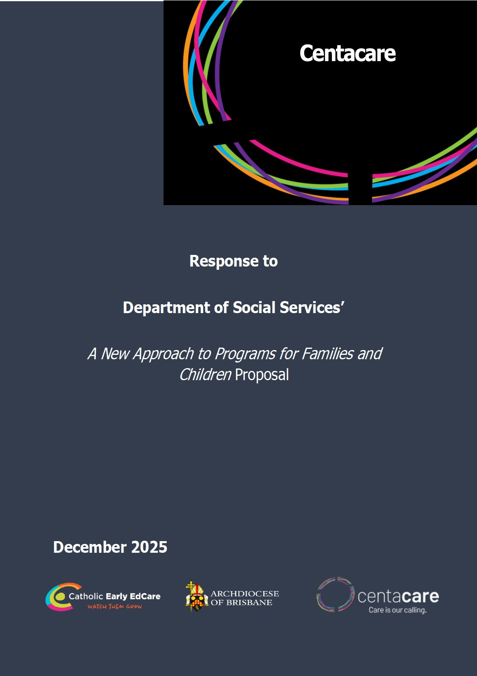

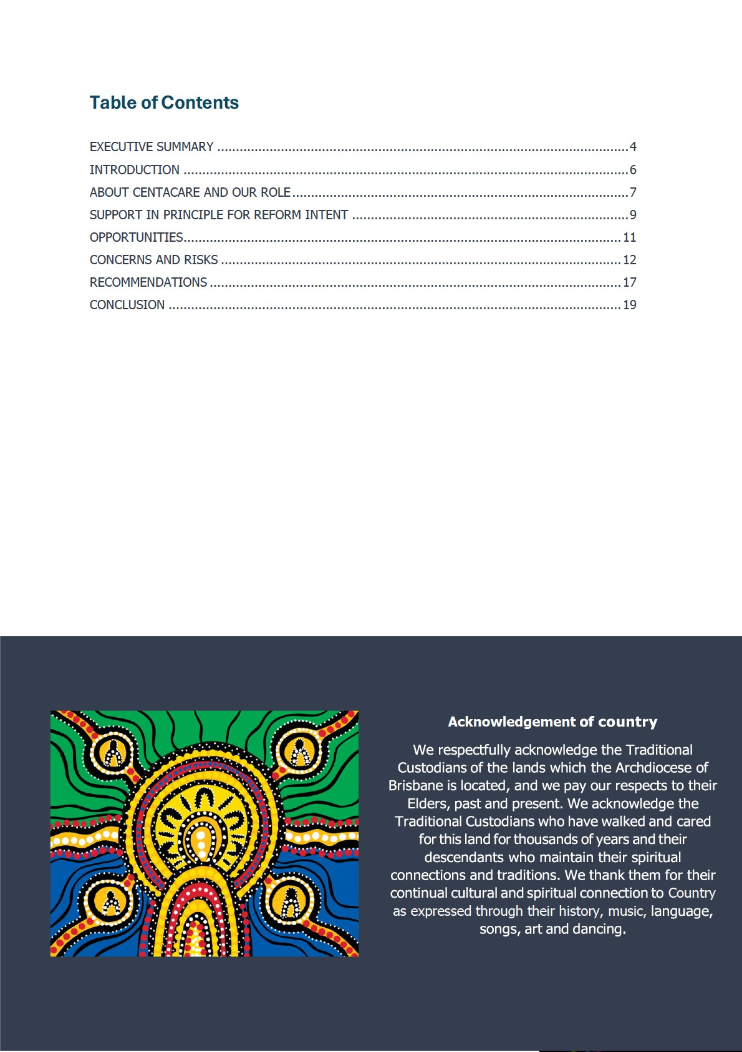

E
XECUTIVE SUMMARY

Centacare welcomes the reform of the Commonwealth’s Families and Children Activity and supports
the Department of Social Services’ intention to simplify program structures, strengthen early
intervention and deliver a more coherent, flexible national framew
ork. The consolidation of five
existing programs into a single outcomes
-
focused model presents a significant opportunity to
improve service integration, reduce administrative burden and ensure that families receive timely,
appropriate and holistic support.

Centacare agrees in principle with the direction of the reform. The organisation sees strong potential
for the proposed model to address longstanding inefficiencies in the current system, particularly the
fragmentation created by multiple contracts, incons
istent performance requirements and rigid
program boundaries. Centacare also supports the move toward longer
-
term funding, the aspiration
for greater flexibility across activity streams and the conceptual shift toward relational contracting,
provided these

mechanisms are implemented with clarity, co
-
design and strong operational
safeguards.

However, Centacare identifies several critical risks that must be addressed. The proposed outcomes
framework is too narrow and does not recognise the essential role of adult relationships, extended
family systems or specialist therapeutic interventions in
preventing harm and building long
-
term
family stability. The reform is heavily child
-
centric, and does not adequately reflect the diversity of
contemporary families, including childless couples, older couples, blended families, kinship carers
and adult chi
ldren with ageing parents. These groups form a substantial proportion of Centacare’s
client base and play a critical role in prevention and early intervention.

Centacare is also concerned that system fragmentation remains a significant risk. The FaC reform is
occurring alongside major, unaligned reforms across the Attorney
-
General’s Department, State
domestic and family violence systems and early childhood policy
. Without strong coordination,
vulnerable families may experience duplicated reporting, contradictory pathways and service gaps.

While Centacare supports the strengthening of Aboriginal Community Controlled Organisations, the
proposed prioritisation may unintentionally limit client choice for First Nations families who prefer
mainstream services for privacy or safety reasons. Genuin
e self
-
determination requires the freedom
to choose a trusted provider.

Centacare also remains cautious about relational contracting without clear definition. Without
boundaries and collaborative design, relational contracting could increase administrative burden and
blur the distinction between government and provider roles.


Centacare therefore makes seven key recommendations: the addition of a third outcome recognising relationships and family wellbeing; broader definitions of family; preservation of First Nations client choice; clear boundaries for relational contracting; government-provided community-level data; strengthened cross-agency coordination; and explicit protection of specialist services including domestic and family violence therapeutic work and relationship counselling.
Centacare stands ready to work collaboratively with the Department to refine and strengthen the proposed model.

INTRODUCTION

1.

Centacare welcomes the opportunity to respond to the Department of Social Services’
consultation on reforms to Commonwealth
-
funded programs for families and children. This
reform is one of the most significant shifts in national family support policy in mo
re than a
decade. It represents an ambitious attempt to redesign a system that has become increasingly
fragmented and difficult for both families and providers to navigate. Centacare provides this
submission to support the development of a model that is st
reamlined, outcomes
-
oriented and
capable of addressing the real needs of contemporary families.

2.

Centacare operates as one of Queensland’s largest and longest
-
standing providers of family and
relationship services. Across metropolitan, regional and rural communities, Centacare supports
individuals, couples, kinship networks and extended families. Thes
e supports include relationship
counselling, domestic and family violence intervention, mental health responses, pre
-
marriage
and early relationship education, intergenerational family work and crisis interventions. Families
present in a variety of circums
tances, from early relationship stress through to complex trauma.
This breadth of practice provides Centacare with a deep understanding of the full spectrum of
family needs, including those not readily captured in a child
-
centred framework.

3.

The reform also occurs in a broader policy environment where multiple Commonwealth and
State initiatives are being redesigned simultaneously. These include the Attorney
-
General’s
Department’s family law reform process, the Commonwealth’s Thriving Kids init
iative and major
State
-
led reforms in domestic and family violence. Without strong coordination, these
overlapping reforms risk creating duplication and confusion for families. Centacare believes this
context makes it even more important that the new Famil
ies and Children model is designed
with clarity, flexibility and inclusiveness.

4.

Centacare supports the intent of the reform and shares the Department’s commitment to early
intervention, prevention, cultural safety and improved outcomes for children and families. At the
same time, Centacare considers it essential that the new program r
eflects the diversity of family
structures, protects access to specialist services and incorporates practical safeguards to ensure
that relational contracting and commissioning arrangements are implemented in a way that
supports, rather than complicates, s
ervice delivery.

5.

This submission outlines the opportunities presented by the reform and the amendments
required to ensure the program strengthens, rather than narrows, the support available to
families

ABOUT CENTACARE AND OUR ROLE
- Centacare is one of Queensland’s largest and most established providers of family, relationship, mental health and community support services. Operating within the mission and values of the Catholic Archdiocese of Brisbane, Centacare has delivered social services for more than sixty years and continues to play a central role in supporting individuals and families across metropolitan, regional and rural communities. Guided by a commitment to dignity, inclusion and social justice, Centacare’s work is grounded in the belief that strong, safe and healthy relationships are foundational to personal wellbeing and community resilience.
- Centacare delivers a broad suite of programs that directly align with the objectives of the Families and Children Activity. These include Family and Relationship Services (FaRS), Family Mental Health Support Services (FMHSS) and Specialised Family Violence Services (SFVS). Through these programs, Centacare provides support to families at every stage of life and across a wide range of presenting concerns, from early relationship education to complex therapeutic responses for families experiencing crisis, trauma or domestic and family violence. Centacare’s services extend beyond traditional family structures and encompass individuals, couples, kinship groups, extended families and intergenerational networks.
- The organisation’s Family and Relationship Services portfolio provides counselling and therapeutic interventions to couples and families seeking support for relationship breakdown, conflict resolution, communication difficulties, separation, co-parenting, grief, trauma and significant life transitions. These services include specialised interventions for couples in the early stages of their relationship, including pre-marriage and relationship education programs that support long-term relational stability. Centacare also works with older couples, childless couples, families navigating blended or non-traditional structures and adult children with ageing parents, ensuring that all family relationships are recognised and supported.
- Centacare’s Family Mental Health Support Services program provides early intervention support for children, young people and families experiencing mental health challenges. This work includes individual assistance, group programs, school-based interventions and coordinated responses for families navigating complex social, emotional and developmental concerns. These supports are delivered in close collaboration with local schools, health services, community organisations and family networks, reflecting Centacare’s commitment to holistic, communitycentred care.

10.

Centacare also delivers specialist Domestic and Family Violence services, with a focus on trauma
-
informed therapeutic support, safety planning, risk assessment and support for rebuilding
healthy and safe relationships. These services assist adults experien
cing violence, couples
navigating DFV dynamics and families affected by intergenerational trauma. Centacare’s DFV
practitioners work closely with local community agencies, housing providers, legal services and
child protection systems to ensure coordinated

and culturally responsive support.

11.

The breadth of Centacare’s service delivery provides the organisation with a unique
understanding of the complexity of family life and the importance of supporting adults, couples
and extended families as part of long
-
term prevention and wellbeing strategi
es. Centacare’s
practice demonstrates that relationship support, even in the absence of children, can play a
critical role in preventing future harm, reducing DFV risk, strengthening community cohesion
and fostering stability for families who may become ca
regivers or parents in the future.

12.

Centacare employs a multidisciplinary workforce of counsellors, psychologists, social workers,
family therapists, case managers and DFV specialists. Staff receive ongoing training in trauma
-
informed practice, cultural capability, child and family wellbeing
, and evidence
-
informed
therapeutic approaches. Centacare maintains strong relationships with regional and local service
networks, Aboriginal and Torres Strait Islander communities, schools, parishes and specialist
services across Queensland.

13.

Centacare’s experience across multiple domains of family support positions the organisation as
a credible and informed contributor to the future design of Commonwealth family services. Its
operational footprint, strong community presence and deep understan
ding of diverse family
presentations ensure that Centacare is well placed to identify both the opportunities and the
risks inherent in the proposed reforms and to offer constructive recommendations for shaping a
system that supports all families to thrive.

SUPPORT IN PRINCIPLE FOR REFORM INTENT
- Centacare supports the overarching intent of the Commonwealth’s proposed reform to create a single, streamlined program for families and children. The consolidation of five existing program streams into a unified national framework represents an important opportunity to reduce fragmentation, improve simplicity and consistency for providers and enable families to navigate services with greater ease. Centacare acknowledges that the existing program architecture has, over many years, evolved into a complex mix of funding arrangements, reporting mechanisms and eligibility rules that do not always align with the way families experience challenges or seek support. The reform proposal provides a necessary platform for addressing these longstanding structural issues.
- Centacare supports the reform’s explicit focus on prevention and early intervention. Families often present for support only when difficulties have escalated or when they are already in crisis. Centacare welcomes the Commonwealth’s shift toward earlier, more proactive forms of support that can strengthen relationships, improve family functioning, reduce risk and prevent the need for more intensive and costly interventions down the track. The organisation also supports the intention to invest more consistently in evidence-informed practice and to strengthen capability across the sector.
- Centacare endorses the emphasis on integrated and holistic service delivery. Families rarely present with a single, isolated issue; rather, the concerns raised in counselling, DFV services, mental health support and family relationship programs are deeply interconnected. The reform’s vision to promote more connected, co-located and integrated services aligns closely with Centacare’s existing service model, where multidisciplinary teams work together to support families across multiple domains. The organisation is encouraged by the Commonwealth’s recognition that better outcomes require systems that reflect the complexity of family life rather than siloed programs.
- Centacare strongly supports the proposed move toward longer-term funding arrangements. Multi-year contracts improve workforce stability, strengthen practitioner capability, reduce administrative turnover and promote long-term planning. Short-term contracts and frequent recommissioning cycles have historically made it difficult for organisations to retain skilled staff, invest in innovative practice and build sustained relationships with local communities. Five-year funding arrangements will enable greater consistency in service delivery and allow for more strategic, evidence-based improvements.

18.

Centacare also supports, in principle, the conceptual shift toward more flexible contracting
mechanisms, including relational contracting. The organisation acknowledges that the
Commonwealth’s intent is to allow for greater adaptability, more collaborative

problem
-
solving
and a stronger focus on outcomes rather than activity
-
based compliance. While Centacare has
identified operational risks that must be addressed, the organisation recognises the potential for
a more dynamic partnership between government an
d providers if relational contracting is
implemented with clear boundaries and strong sector engagement.

19.

More broadly, Centacare supports the reform’s alignment with national commitments to cultural
safety, Closing the Gap and improved outcomes for First Nations families. The organisation
shares the goal of ensuring all families have access to culturally safe
, responsive and community
-
led supports and acknowledges the vital role of Aboriginal Community Controlled Organisations
in achieving this.

20.

In summary, Centacare supports the direction and intent of the reform. The organisation
believes the Commonwealth has taken a necessary and positive step toward designing a more
coherent, flexible and outcome
-
focused system for families and children. The r
emaining sections
of this submission outline the specific opportunities, risks and recommendations that Centacare
considers essential for ensuring that the reform’s potential is fully realised without unintended
negative consequences.

OPPORTUNITIES
21. Centacare recognises that the reform presents several significant opportunities to strengthen service delivery, enhance system cohesion and improve outcomes for families and communities. These opportunities are contingent on the reform being implemented in a manner that is both principled and practical, with clear attention to the realities of service delivery across metropolitan, regional and rural contexts. The subsections below outline the key opportunities the organisation has identified.

Reduced Administrative Burden
- The consolidation of multiple program streams into a single national program offers a meaningful opportunity to reduce the administrative burden currently placed on providers. Under the existing framework, Centacare manages separate funding agreements, distinct performance measures and multiple reporting cycles, even when services operate within the same team or support the same client group. These administrative complexities divert time and resources away from frontline work and create inefficiencies within program management.
- A unified contract structure, coupled with simplified reporting requirements, would allow providers to focus more heavily on service quality and client engagement. Centacare anticipates that one contract, one set of performance requirements and one reporting framework will enable a more efficient allocation of staff time, reduce duplication across internal systems and ultimately strengthen the responsiveness and capacity of frontline services. The organisation supports DSS’s stated intention to streamline grant requirements and reduce unnecessary administrative processes, noting that simplicity in contracting is essential to achieving the overarching goals of the reform.

Flexibility Across Program Buckets
24. The reform’s shift toward a more flexible funding model represents a significant improvement over the current system, which often restricts providers from transferring resources between program areas even when emerging need is clear. Centacare frequently encounters scenarios where demand in one area of service exceeds available capacity, while another program has underutilised funding tied to overly prescriptive contractual rules.

25.

Greater flexibility across program buckets would allow providers to adjust service profiles in real
time, responding to the patterns of demand
actually

presenting in communities. This flexibility
would allow Centacare to strengthen support for families experiencing sudden or acute need,
for example, surges in domestic and family violence, shifts in local economic conditions or
increased demand for counse
lling following community trauma. A flexible model would also
support the design of more tailored respons
es in rural and remote areas where small population
sizes require adaptable approaches. Centacare sees this as one of the most promising aspects
of the reform.

Holistic
S
ervice
M
odels

26.

The proposed reform offers Centacare a valuable opportunity to strengthen holistic service
delivery. Families do not experience challenges in isolation; relationship conflict, parenting
stress, mental health concerns and domestic and family violence freque
ntly intersect and require
coordinated, multifaceted responses. The current program structure, which separates funding
streams according to service type, can unintentionally fragment support and complicate
pathways for families seeking help.

27.

A unified program, built around prevention and early intervention, provides the foundations for
more integrated care. Centacare already operates multidisciplinary teams in many locations,
where DFV practitioners, relationship counsellors, mental health wor
kers and family therapists
collaborate to meet the needs of families as a whole. The reform’s structure would support and
expand this approach, enabling smoother transitions between service types and reducing the
burden on families to navigate multiple sys
tems. In Centacare’s experience, holistic models
significantly increase engagement, reduce drop
-
out rates and improve long
-
term outcomes.

Relational
C
ontracting could
A
llow
D
ynamic
A
daptation

28.

Centacare acknowledges the significant potential of relational contracting to create a more
collaborative and adaptive relationship between government and service providers. In principle,
relational contracting aligns with contemporary best practice in pub
lic administration, where
funders and providers jointly identify emerging needs, agree on adjustments and respond
flexibly to changing community conditions. This dynamic approach contrasts favourably with
traditional contracting models that lock service pa
rameters in place for the life of the agreement.

- If implemented effectively, relational contracting could allow Centacare and DSS to co-design service responses when unforeseen pressures arise, avoid service delivery gaps, and refine program settings without the need for renegotiating contracts or waiting for recommissioning cycles. The approach could also support innovation by removing the constraints that currently prevent providers from trialling new methods or responding swiftly to local challenges.
- Centacare’s support for relational contracting is contingent on the model being clearly defined, collaboratively developed and grounded in mutual respect for the roles of government and providers. With strong safeguards and clear boundaries, relational contracting could become a central mechanism for driving continuous improvement and enhancing the quality of support available to families.

CONCERNS AND RISKS

31.

While Centacare supports the overall direction of the reform, the organisation has identified
several substantial concerns that must be addressed to ensure the new program is equitable,
effective and sustainable. These concerns are grounded in Centacare’s
extensive practice
experience and reflect similar issues raised across the sector. If these risks are not carefully
managed, the reform may inadvertently undermine core elements of family support, reduce
access for some groups and increase system complexit
y.

Outcomes
F
ramework is
T
oo
N
arrow

32.

Centacare is concerned that the outcomes framework, as currently proposed, is too narrow to
capture the full scope of family support needs. The two outcomes focus exclusively on child
wellbeing and parental capability. This leaves no space for recognising
the critical role of adult
relationships, relational health or broader family functioning. A significant portion of Centacare’s
service delivery

–

including relationship counselling, pre
-
marriage education, adult
-
to
-
adult
conflict resolution, and domestic
and family violence therapeutic work

–

cannot be meaningfully
mapped against solely child
-
focused outcomes.

33.

If the outcomes framework remains limited to child
-
centred constructs, these essential services
risk becoming invisible within the new program structure. Over time, this could lead to reduced
funding, loss of specialist workforce capability and diminished
capacity to undertake preventative
work that stabilises families long before children are present or involved.

O
verly

C
hild
-
C
entric

34.

The reform’s conceptual framing assumes that families seeking support will have children in their
care. However, Centacare’s client base reflects a far broader and more complex reality. Families
frequently present without children, including older couples
seeking support after decades of
partnership, couples preparing for future parenting, adult children and ageing parents navigating
relational conflict and kinship structures that do not involve dependent children.

35.

A model that defines family outcomes solely through the lens of child wellbeing risks excluding
these cohorts entirely. The narrow focus fails to acknowledge that strengthening adult
relationships is itself a critical form of early intervention that preven
ts domestic and family
violence, supports future child safety, and contributes to healthier community functioning.
Centacare urges DSS to recognise the diversity of contemporary families and avoid designing a
system that unintentionally sidelines adults wh
ose relational wellbeing is central to long
-
term
family health.

Specialist Service Integrity
- Centacare is concerned that the reform may unintentionally marginalise specialist services that fall outside a strict child-focused framing. These include relationship counselling, pre-marriage and early relationship education, post-separation counselling, intergenerational family work and therapeutic domestic and family violence services for adults. These programs play a critical preventative role and often form the first point of intervention before more severe issues escalate into child protection, homelessness or DFV crisis responses.
- Without explicit recognition of specialist adult services within the program design, there is a substantive risk that these offerings will be deprioritised or rendered ineligible under the new funding model. Loss of these services would not only reduce support options for families but would also undermine the Commonwealth’s objectives of prevention, early intervention and long-term family resilience.

System Fragmentation
- Centacare notes that the FaC reform is occurring concurrently with multiple other major reforms across Commonwealth and State portfolios, including the Attorney-General’s Department’s redesign of family law services, national DFV reform initiatives and the Thriving Kids developmental support program. These reforms are not currently aligned, and there is no clear mechanism for ensuring consistency across them.
- This fragmentation risks creating overlapping pathways, contradictory reporting requirements and confusion for clients who already struggle to navigate a complex service environment. Vulnerable families may fall through gaps created by the misalignment of program objectives, commissioning cycles and outcomes frameworks. Centacare emphasises that system integration must be a deliberate design feature of the reform, not an assumed by-product.

ACCO prioritisation risks reducing client choice
40. Centacare fully supports the strengthening of Aboriginal and Torres Strait Islander Community Controlled Organisations (ACCO) and the Commonwealth’s commitment to Closing the Gap. However, the reform’s current framing, which prioritises ACCO-led delivery in areas with significant First Nations populations, raises concerns about client choice and service access.

41.

Many First Nations clients accessing Centacare services opt to do so because they prefer the
privacy, confidentiality and neutrality offered by a mainstream provider, particularly in small or
closely connected communities. Funding arrangements that strongl
y favour ACCO
-
only delivery
may unintentionally restrict access for clients who, for reasons of safety or personal preference,
do not wish to engage with local community
-
controlled organisations. Centacare believes that
genuine self
-
determination includes
the right to choose the provider that feels most culturally,
emotionally and personally safe.

Relational
C
ontracting is
U
nder
-
S
pecified

42.

Centacare is supportive of relational contracting in principle but is concerned that the model
remains significantly under
-
specified. The reform proposal provides limited detail on the
boundaries, governance structures or decision
-
making mechanisms that wi
ll underpin these
contracts. Without clarity, relational contracting risks blurring the distinction between the roles
of funder and provider.

43.

There is a real risk that relational contracting may inadvertently enable government overreach
into service design, operational decision
-
making and therapeutic practice. Ensuring that
relational contracting enhances flexibility without increasing administr
ative burden will require
explicit co
-
design with the sector and the establishment of safeguards that preserve provider
autonomy and professional expertise.

RECOMMENDATIONS

Introduce a third outcome recognising relationships, family wellbeing and adult-focused interventions
Centacare recommends the inclusion of a third core outcome focused on relational health, family functioning and adult wellbeing. This outcome should explicitly recognise the role of adult relationships, extended family systems and non-child-related interventions in preventing harm and building long-term family stability.
A third outcome would ensure that relationship counselling, pre-marriage education, adult domestic and family violence therapeutic work and intergenerational family support remain eligible within the new program. Without this, essential preventative services may become marginalised or unfunded due to their indirect relationship with child-focused measures.

Adopt Flexible Definitions of Family
Centacare recommends that the program adopt a broad and inclusive definition of “family” that reflects the diversity of contemporary Australian households. This definition should recognise:
- couples without children
- older couples
- blended and non-nuclear family structures
- kinship care arrangements
- adult children and ageing parents
- intergenerational households
- extended family networks
A flexible definition will ensure that the program does not inadvertently exclude families who rely heavily on relationship support, conflict resolution and therapeutic intervention, even when children are not directly involved.

Preserve Client Choice for First Nations Families
Centacare strongly supports the growth and leadership of Aboriginal Community Controlled Organisations. However, genuine self-determination requires that First Nations families retain the right to choose the provider they feel safest with.
Centacare recommends that commissioning guidelines:
- explicitly preserve client choice
- encourage collaborative partnership models between ACCOs and mainstream providers

•

avoid hard tender boundaries that restrict Aboriginal and Torres Strait Islander families from
accessing mainstream services when they prefer them

•

recognise privacy and confidentiality needs in small or closely
-
connected communities

This approach supports ACCO leadership while preserving equitable access to trusted, culturally safe
service options.

Establish

C
lear
B
oundaries for
R
elational
C
ontracting

Centacare recommends that relational contracting be co
-
designed with the sector and supported by
explicit guidelines that delineate the respective roles of government and providers. This should
include:

•

clear boundaries preventing government overreach into therapeutic practice or operational
decision
-
making

•

governance structures that promote shared problem
-
solving without compromising provider
autonomy

•

transparent change processes that ensure adaptations are jointly agreed

•

proportionate reporting requirements that do not increase administrative burden

These safeguards are essential to ensure relational contracting strengthens, rather than complicates,
service delivery.

Provide
G
overnment
-
O
wned
C
ommunity
D
ata

Centacare recommends that DSS commit to collecting, analysing and distributing key community
-
level data sets
,
including demographic, socio
-
economic and child protection indicators
,
rather than
placing this responsibility on providers. Community
-
level data is not consistently accessible,
particularly in regional and remote areas, and requiring providers to supply such data disadvantages
smaller organisations.

Government
-
provided data would ensure equity in the tender process, improve consistency in needs
assessment and reduce duplication across the sector.

Strengthen
C
ross
-
A
gency
C
oordination

Centacare recommends that the Commonwealth establish structured coordination mechanisms to
align DSS reforms with parallel initiatives across the Attorney
-
General’s Department, State domestic
and family violence systems and the Thriving Kids initiative.

A coordinated approach would reduce fragmentation, limit conflicting reporting requirements and ensure more coherent pathways for families navigating multiple systems. Centacare urges DSS to work collaboratively across portfolios to ensure consistent outcomes frameworks, complementary commissioning timelines and integrated service expectations.

Protect Specialist Services
Centacare recommends that the new program explicitly recognise and protect specialist services that are currently funded within the FaRS and SFVS programs. These include:
- relationship counselling
- premarriage and early relationship education
- adult domestic and family violence therapeutic services
- intergenerational relationship interventions
- complex family systems work
These services underpin long-term prevention, reduce future DFV and child protection involvement and support family resilience. Explicit recognition within guidelines and contracts is essential to ensure their continued availability under the consolidated program.

CONCLUSION

44.

Centacare welcomes the opportunity to contribute to the reform of Commonwealth
-
funded
family and children’s services and acknowledges the ambition underpinning the Department’s
proposed new program. The intent to simplify program architecture, strengthen e
arly
intervention and create more coherent pathways for families represents an important step
toward a more effective national system. Centacare supports this direction and recognises the
considerable potential for improvement if the reform is implemented
with clarity, balance and a
realistic appreciation of service delivery environments.

45.

At the same time, Centacare emphasises that the success of the reform will depend on the
Department’s willingness to address several foundational issues identified in this submission.
The proposed outcomes framework must be broadened so that it reflects th
e full reality of family
life, including the vital role of adult relationships, extended kinship networks and specialist
interventions that are essential to long
-
term prevention. Without this adjustment, the new model
risks narrowing its focus to only one
dimension of family wellbeing and excluding adults whose
relational stability has direct implications for community safety and child outcomes.

46.

Centacare also urges the Department to ensure that commissioning settings do not inadvertently
reduce service access or client choice, particularly for First Nations families who may choose to
engage with mainstream services for reasons of privacy, safety
or personal preference. A
genuinely inclusive system must preserve this freedom while continuing to strengthen Aboriginal
Community Controlled Organisations where they are best placed to lead.

47.

More broadly, the reform will only achieve its full potential if it is designed with a clear
understanding of the wider policy landscape. With significant reforms underway across the
Attorney
-
General’s Department, State domestic and family violence systems

and early childhood
initiatives, there is a pressing need for intentional coordination. Alignment across portfolios is
critical to avoiding fragmentation, preventing duplication and ensuring that families can move
through support systems without encounter
ing conflicting expectations or gaps in care.

48.

Centacare recognises the promise of relational contracting but emphasises the need for clear
role delineation, co
-
design and safeguards that protect provider autonomy. Flexibility must not
come at the cost of increased administrative oversight or blurred o
perational boundaries. If
relational contracting is to become a central feature of the new program, it must be implemented
in a way that builds trust, supports innovation and respects the professional expertise of service
providers.

49. Centacare stands ready to work collaboratively with the Department as the reform progresses. The organisation is committed to contributing constructively to the refinement of program guidelines, the development of commissioning processes and the design of implementation arrangements. With the refinements recommended in this submission, the new national program has the potential to deliver lasting benefits for children, adults, families and communities across Australia. Centacare looks forward to ongoing dialogue and partnership as the Department moves toward finalising the model and preparing for its transition.

[
This page is intentionally kept blank
]

CONTACT



