

Department of Social Services: A new approach to programs for families and children Submission - December 2025

The opportunity of reform
These proposed reforms are a bold step for Australia’s child and family sector by recognising that how services are procured and contracted directly impacts the individual children and families they support.
However, even the best intent at a policy level can be derailed by the challenges of implementation on the ground. With over 13 years of experience in family-centred integration – starting from Doveton College in 2012 – we would like to share our thoughts on how to set these reforms up for success.
Who we are
Our Place is an initiative of the Colman Education Foundation – working in partnership with the Victorian Government to demonstrate the impact of providing integrated services for families. We bring together everything a family needs to thrive, at their local school. This breaks the cycle of disadvantage by connecting families to the right support at the right time and enabling services to work better together.
Our Place sites are currently located in 11 schools in nine highly disadvantaged communities for a period of ten years. Our teams provide fidelity to an evidence-based model – the Our Place approach – but each site’s implementation is place based, adapted to the unique needs of each community and local service system.
It is important to note that Our Place is not a service provider. Our work takes place through partnerships with over 110 service providers, who together deliver an average of 26 services and activities at each school site. These providers are funded by Federal, State and Local Governments and include early education, health care, child and family support, schooling, adult education and employment pathways. Our 2025 Evaluation found that 83% of providers reported that the quality of their service has improved by being on an Our Place site and there are year-on-year increases in the number of children and families accessing services.
It is from this deep experience of multi sector integration that we are sharing our perspectives, particularly regarding your ambition to prioritise connected, co-located and integrated services and to ensure that services are informed by community needs, are working together and measuring outcomes that matter.
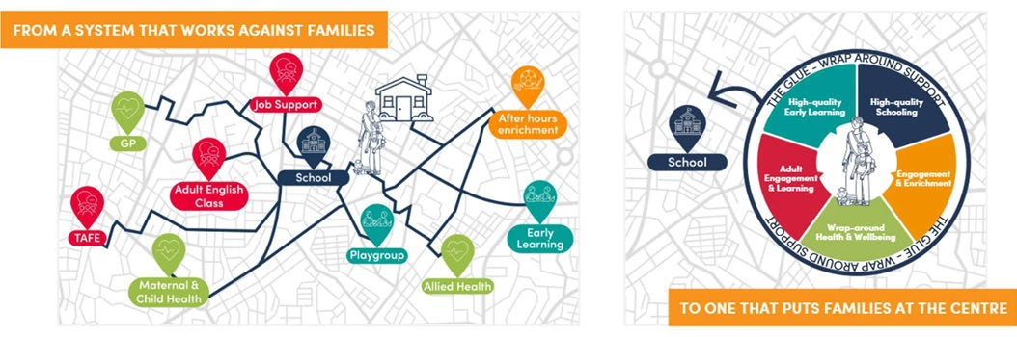

This submission
We’ve seen it more than once: reform with strong intent fails because it can’t get traction on the ground due to gaps in authority, misaligned incentives and unintended inflexibility. So instead of offering a typical policy response, we’re sharing a few practical lessons from our work - things that either unlock or block effective service integration in communities.
This submission is for the people designing commissioning approaches, drafting contracts, writing guidance for DSS teams. It’s something we wish more departments asked about, before launching into delivery.
What we’ve learned: practical lessons for making integration work
- Where co-location and integration happens matters: If early intervention and long-term trust with families is the goal, then co-locating services within universal, non-stigmatising settings – such as schools – should be prioritised. It’s vital that the trust and collaboration are built in a setting where families are already present and where we want families to engage long term. For this to be successful, best practice guidance on how to effectively engage in a school or universal environments should be developed for services.

- Integration isn’t free – even in universal settings: There’s a frequent assumption that universal locations such as schools and early years hubs are ‘free’ for services to use for room hire, but they aren’t. They are low-cost and accessible but still require funding to be welcoming and sustainable. If you want services to co-locate, contracts must explicitly allow funding for room hire or infrastructure costs.

- Collaboration takes time and resources: Integrated services contracts should funding for staff to attend shared planning, training and governance and have clear performance metrics for collaboration. This can’t just be for managers – frontline workers should also be resourced to participate in joint work and/or funding should enable dedicated roles to support and activate connection between services and with families. Otherwise, collaboration becomes an add-on that leads to burnout.

- Structured governance authorises new work: Co-located and integrated services are deeply impactful but do create complexity that can require escalation and careful stewardship. Investing in structured governance at a local and cross-portfolio level is essential to provide authorised channels to share lessons and navigate cross-silo tensions such as data sharing and shared planning (see below). Further detail on Our Place’s lessons from creating shared governance across jurisdictions can be found here.

- Understanding community need takes time – and must be shared: When providers say they’re part of a place-based collaboration, part of the test should be whether they have a shared vision for their work. This means bringing together multiple forms of data and lived experience and using it to create shared goals that stretch across service boundaries and over multiple years. There should be a plan in place for local service leaders to review progress, share learning, and adapt their approach as needs change.

- Information sharing should be enabled, not avoided: Information sharing is essential for effective integration – both deidentified service data and consent-based information about individuals. Services should be required and supported to develop local protocols that enable proactive sharing of relevant information to support families more holistically. Clear authorisation to do so needs to come from the top and be frequently reiterated.

- Measuring impact needs multiple angles: At Our Place, we’ve learned that evaluating integration requires multiple partners and community bringing their ‘piece of the puzzle’ to provide a holistic view of progress. One method of monitoring impact is through nested annual surveys which track, among other things: service leaders views on the quality of the partnership; front line staff’s ability to refer between services; and, parent and carer confidence in accessing services. Details of this methodology are captured in our Emerging Findings report (2024) and our upcoming 2025 Annual Evaluation.

- Relational contracting enables locally-informed outcomes: We’ve seen first-hand how relational contracting – such as the early Jobs Victoria model and Communities for Children – allows services to respond more flexibly to local needs and achieve outcomes. Services operating under that model were more collaborative and more focused on long-term success for families, not just outputs – but this requires capability both from the service and the funder to do so effectively (see below).

- DSS needs to support its own staff to manage differently: The reforms won’t succeed unless the department adapts how it manages contracts. We’ve seen strong central policy intent fall over when contract managers aren’t resourced or empowered to do things differently. Part of the reform investment needs to go into enabling DSS’s own teams and systems to commission work in line with the reform directions and to be supported through a long-term change process.

- Integration isn’t about services, it’s about children and families: Finally, while we have much to share about the ‘how’ of integrating services, it should always be clear that integration is not an outcome. It is merely a method to improving access and support for children and families so that they can thrive. Putting the family’s needs at the centre of local decision making, resourcing the building of trust and committing to being present and persistent for the long haul are the foundations for success.

An invitation to see this in action
Integration and place-based work is always challenging to capture on paper. We welcome DSS staff to come and visit any one of our nine Our Place communities to hear directly from the local staff and families about how co-location and integration flies or flails based on the operating conditions. In addition to universal lessons, our sites can speak directly to the experience of collaborating successfully with existing Australian Government-funded services, including:
- Family Mental Health Support Services in Frankston North
- Family and Relationship Support in Carlton
- Communities for Children playgroups in Robinvale
- Communities for Children-led NDIS assessments in Mooroopna.
- Parent Pathways (DEWR) in Corio

