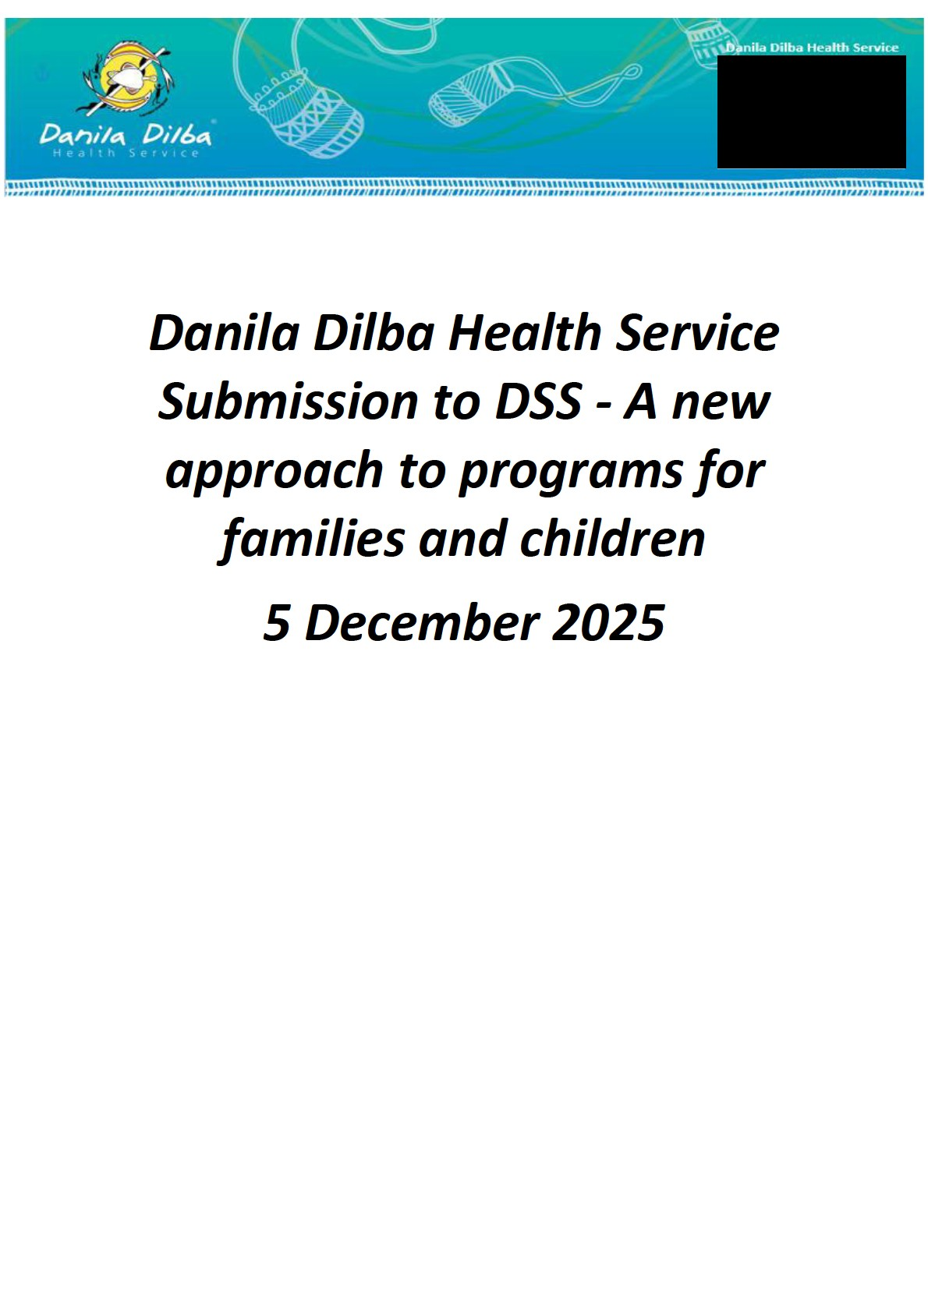

Contents
1. About Danila Dilba 3
2. Danila Dilba Services Related to Families and Children 3
3. Overall Comments 3
4. Impact for DDHS existing DSS funded services 4
5. Procurement and Transition 4

About Danila Dilba

Danila Dilba Health Service (DDHS) is the only Aboriginal Community Controlled Health
Service for the Darwin region. DDHS was established in 1991 with a single clinic in the Darwin CBD. DDHS now operates a network of seven clinics, plus a mobile outreach clinic, and employs more than 250 multidisciplinary staff across the region – delivering high quality, integrated health services that include a range of specialist and allied health, social and emotional wellbeing, child and family and aged care services, as well as health promotion and education. More than 13,000 people use our services each year which is made up of around 5,500 families.

Danila Dilba Services Related to Families and Children

DDHS provides a range of care and services with families and children through a variety of funding streams including DSS. The services provided are:
- Midwifery service (DDHS Core funding)
- Maternal and child primary health care for children (DDHS core funding)
- The Australian Family Partnership Program (Commonwealth Department of Health, Disability and Ageing)
- Intensive Family Support Service (NT Department of Families and Children)
- Early Steps Together – early intervention family support (DSS Outcomes and Evidence Fund)
- Danggal Dalby (Strong Kids) (DSS Improving Multidisciplinary Responses.
Both the DSS grants received by DDHS for family and child related services are short term in nature with no certainty about future funding.

Overall Comments

Overall this new approach is positive and DDHS supports it. In particular, we support:
- The combination of multiple programs into a single, flexible, outcomes focussed funding stream.
- Streamlined reporting.
- The commitment to increasing the number of Aboriginal and Torres Strait Islander community-controlled organisations delivering supports in locations with high First Nations populations.
- Recognises that challenges and the need for family support extend well beyond early childhood and continue throughout adolescence.
- Encourages collaboration and integration.
The parameters set out in the aims and scope of the new approach are appropriate.

Impact for DDHS existing DSS funded services
For us, it is unclear what impact, if any, the proposed change will have for services that are funded outside the main programs listed for this approach. Both the IMR and the Outcomes and Evidence Fund are short term funding programs with no clarity about future funding arrangements. IMR is currently funded through to 30 June 2027 and Outcomes and Evidence (Early Steps Together) to 30 June 2026. The take up of these services if very strong and the need for both services is high. There is a wait list for access to Danggal Dalby.
DDHS is seeking greater certainty and clarity about the future arrangements for these family and children programs that sit outside the proposed approach.

Procurement and Transition

The new approach appears to continue to rely on competitive grant funding which works against the collaboration and integration that is an aim of the approach. DDHS suggests that DSS should consider collaborative procurement processes and give detailed consideration to the learnings from the processes employed in the DSS Outcomes and Evidence Fund approach which employed a place based collaborative service development approach. As a participant in the Outcomes and Evidence Fund process, DDHS makes the following observations:
- The process can be lengthy but a detailed analysis of the projects developed will show aspects of the process that could speed up the process without losing the benefits. For example, a clearer definition of the parameters of the funding and its purposes.
- Collaborative procurement ensured that service models were developed from a position of knowledge of direct service delivery and an understanding of community needs.
- The collaborative process has resulted in a stronger relationship between Aboriginal controlled organisations in the families and childrens sector and has provided a basis for further funding applications. For example, the Darwin group has successfully obtained funding as an established collaborative from the Paul Ramsay Foundation.
While the discussion paper makes a broad commitment to increasing the number of ACCOs among providers in areas with a significant Aboriginal population, there is no detail of how this will be achieved. DDHS makes the following suggestions in this area:
- It will be critical to avoid a tokenistic approach as seen in the past where mainstream providers continue to win the lion’s share of funding on the basis of partnerships where the ACCO is very much the junior partner with little real influence.
- We would support requirements for a preference for Aboriginal lead organisations, and transition to the ACCO within a set timeframe where the mainstream organisation is the lead initially.
It will be critical that DSS ensure that procurement is undertaken in timeframes that allow for the time needed to form collaborations and to properly consider how best to structure service proposals that are able to realise the potential benefits of the new approach.

