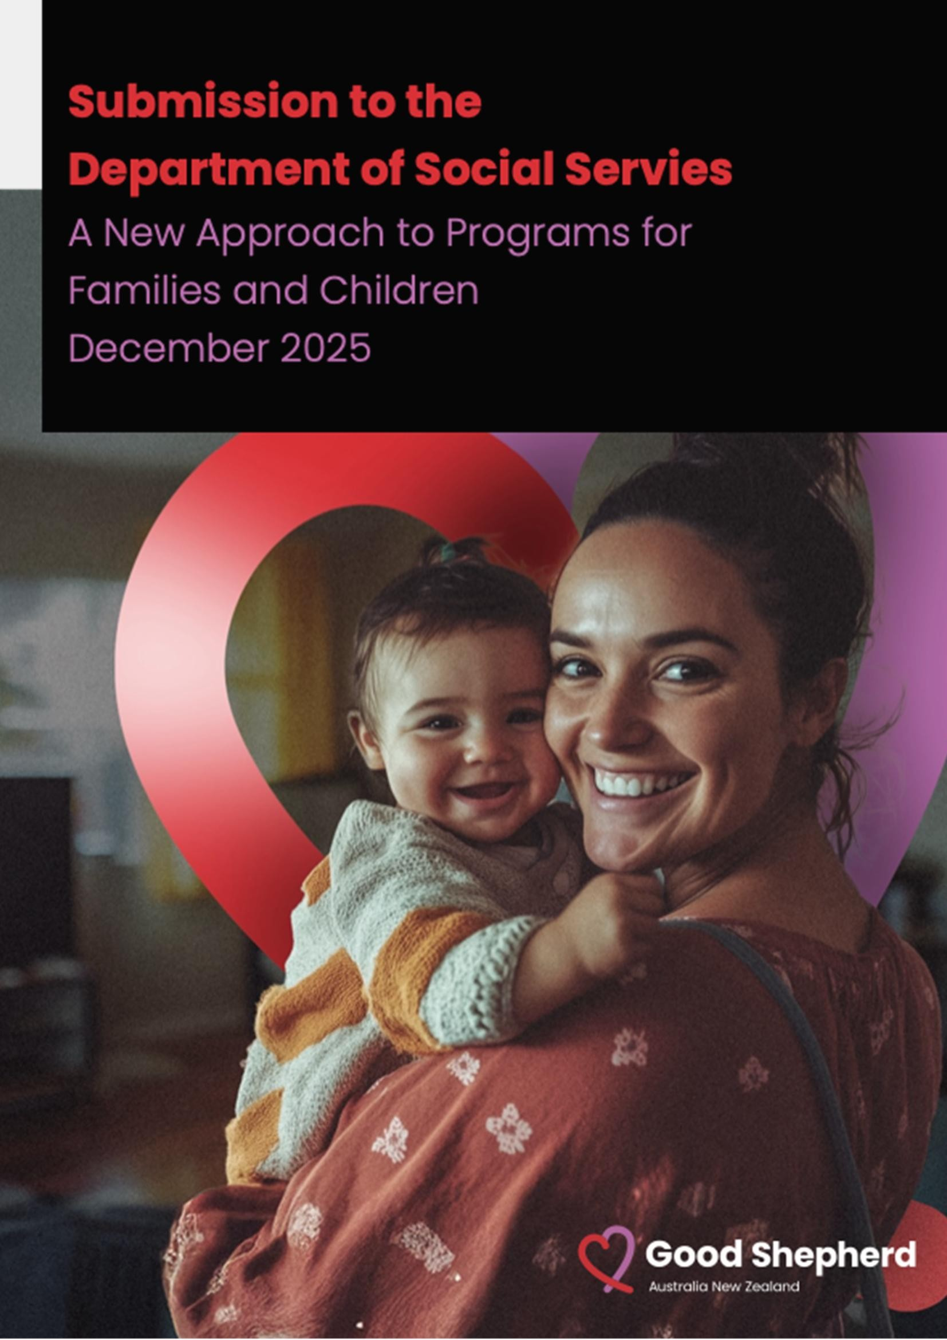

Statement of Recognition
Good Shepherd Australia New Zealand acknowledges the Traditional Custodians of the lands and waters throughout Australia. We pay our respect to Elders, past and present, acknowledging their continuing relationship to land and the ongoing living cultures of Aboriginal and Torres Strait Islander Peoples across Australia.

About Good Shepherd Australia New Zealand
The Sisters of Good Shepherd was established in France over 400 years ago to respond to the needs of women and girls. The first program was a refuge that offered new possibilities for women and girls who were trapped in situations of poverty and exploitation who wanted to change their lives. Saint Mary Euphrasia Pelletier carried forward this mission, expanding internationally. We are now the largest, longest running organisation supporting women and girls, located in 73 countries, and with consultative status on women and girls at the UN. Good Shepherd has worked in Australia and New Zealand since 1863.
We provide programs and services that support women, girls, and their families to be safe, well, strong and connected. Our clients are at the centre of what we do. We are focused on responding to their emerging needs and on providing innovative, locally-tailored responses. Our services are complemented by research, advocacy, and policy development that address the underlying structural causes of injustice and inequality to pave a way for a better tomorrow.

Submission to the Department of Social Services A New Approach to Programs for Families and Children

Inquiries
This submission was endorsed by .
We welcome the opportunity to elaborate on the points raised in this submission and encourage you to contact us for further discussion.
Contact:

Monday 8 December 2025

Contents
Introduction 5
Vision and Outcomes 6
Program Structure 7
Prioritising investment 8
Improving family wellbeing 9
Connected, co-located, and integrated services 9
Measuring Outcomes 10
Working Together 11

Introduction
Good Shepherd Australia New Zealand (GSANZ) welcomes the opportunity to contribute to the Department of Social Services proposed changes to child and family programs. We strongly support the vision for a single national program that prioritises prevention, early intervention, intensive family support and integrated service delivery.
The proposed single national program presents a pivotal opportunity to bridge systemic gaps by prioritising early intervention, place-based service integration, and culturally responsive practices. This, teamed with authentic engagement with children and families as key stakeholders in place in the design and delivery of the national program, represents an opportunity for place-based scale at a national level.
Streamlining program delivery and reducing red tape will ensure resources are effectively allocated to those most in need. Additionally, commitment to funding reforms, including 5-year contract periods, will encourage workforce stability and service continuity, ultimately achieving more sustainable outcomes for children and families.
Good Shepherd has responded to the questions raised in the Discussion Paper Appendix A and provided recommendations in each section.

Vision and Outcomes
Vision: All children and young people are supported by strong families who have the skills and confidence to nurture them.
Does the new vision reflect what we all want for children and families?
Outcome 1: Parents and caregivers are empowered to raise healthy, resilient children.
Outcome 2: Children are supported to grow into healthy, resilient adults.
Are the two main outcomes what we should be working towards for children and families? Why/why not?
(from survey) Do you think there would be a more appropriate outcome/s for the single national program?
Good Shepherd applauds the new vision of supporting all children and young people through strong, capable and confident families. This aligns with the Good Shepherd vision for all women, girls and families to be safe, well, strong and connected.
We strongly agree with the two outcomes proposed. These outcomes are also aligned with the Good Shepherd mission – striving for dignity and social justice so that no family should face systemic barriers in supporting their children. The outcomes, empowering caregivers and supporting children’s life-long resilience, capture critical stages of family and childhood development.
Not only should families be ‘empowered’ but systemic barriers often prevent families and caregivers from being able to take control of their lives, make their own choices and determine their needs. Systems and services need to be in place that also meet the needs of those who are vulnerable or otherwise excluded from being ‘empowered’ to access these services. Hence, we reiterate the importance of ensuring the vision and outcomes are explicitly inclusive of marginalised communities and in particular families in poverty.
Good Shepherd Australia New Zealand supports women, girls, and families through a range of services including child, youth, and family programs, financial wellbeing initiatives, and specialist family violence support.
We believe that should DSS consider other outcomes, they should ensure that children do not live in poverty and are free from all forms of violence and abuse. This is more than ‘support’ and more than ‘empowerment’. It implies a commitment to these two additional fundamental outcomes (alongside health and educational outcomes) to create environments where children and families can thrive.

Program Structure
Will a single national program provide more flexibility for your organisation?
Does the service or activity you deliver fit within one of the three funding streams?
Do these streams reflect what children and families in your community need now – and what they might need in the future?
Are there other changes we could make to the program to help your organisation or community overcome current challenges?

Ensure flexibility of funding and contracts across streams
Good Shepherd strongly supports the three streams and further advocates for the ability to reallocate funding in response to the changing needs of children and families, in consultation with funding agencies. Organisational contracts that allow movement across funding streams will promote flexibility. Conversely, tying funding to a single stream limits adaptability, particularly when client and community circumstances change.

Include other DSS funded programs administered by other facilitating partners including state governments
Good Shepherd receives funding from the Communities for Children Facilitating Partners (CCFP) programme and partners with the Smith Family to deliver the evidence-based supported playgroup ‘Building Blocks’. Currently, our contract is with the Smith Family, who facilitates this partnership.
In addition, Good Shepherd delivers other Department of Social Services (DSS) funded programmes that support children and families, which are not included in the five program streams outlined in the Discussion Paper.
We recommend that DSS consider including all programmes for children and families within this framework, rather than limiting it to the five specified streams. DSS funds additional programmes for families and children that fall outside these areas.
Some of these programmes are funded by DSS but administered through State governments. For example, under the Family and Domestic Violence National Partnerships Agreement, we provide Firmer Foundations (a financial coaching programme for victim-survivors of financial abuse) administered by the Government of NSW, Bridget House (emergency accommodation for multicultural women and their children escaping family and domestic violence), and the Personal Safety Initiative (administered by the State Government of Victoria).
We also receive NPAR funding for case management for CALD victim-survivors, directly supporting women and children who have experienced family and domestic violence, administered by the State Government of Victoria.
In all these cases, NPAR requires us to report to both the relevant state government and DSS.
Good Shepherd seeks clarification on whether these family violence programmes funded through
NPAR will be included in the proposed single programme. If not, we recommend that all
programmes serving the needs of women and children be brought under one funding umbrella. Without this integration, the complexity and rigidity of multiple funding sources, contracts, and reporting requirements will persist.
Streamlining and consolidating all funding sources would improve efficiency and reduce the burden of multiple reporting, thereby alleviating current challenges.

Prioritising investment
Do you agree that the four priorities listed on page 4 are the right areas for investment to improve outcomes for children and families?
Are there any other priorities or issues you think the department should be focussing on?
- Invest early to improve family wellbeing, break cycles of disadvantage, and reduce the need for later interventions – like child protection.
- Prioritise connected, co-located, and integrated services that work together to meet family needs.
- Ensure services are informed by, and respond to, community needs.
- Improve outcomes for First Nations children and families by increasing the number of Aboriginal and Torres Strait Islander community-controlled organisations (also called ACCOs) delivering supports in locations with high First Nations populations.
Good Shepherd strongly supports all four priority areas, with particular focus on priorities one and two. However, we advocate for greater emphasis on ensuring that children’s needs and voices are explicitly included in investment priority area three, rather than focusing solely on broader community needs.
Additionally, we believe there should be stronger investment in long-term healing and recovery, recognising the profound effects of intergenerational poverty and trauma.
We also recommend integrating DSS-funded family, domestic, and sexual violence programmes with Families and Children Funding to provide more cohesive and effective support.

Improving family wellbeing
Do the proposed focus areas – like supporting families at risk of child protection involvement and young parents – match the needs or priorities of your service?
Key areas of interest will be:
- Families at risk of child protection involvement.
- Prevention and early intervention support for children aged 0-5 years.
- Young parents aged under 25.
Are there other groups in your community, or different approaches, that you think the department should consider to better support family wellbeing?
Good Shepherd currently delivers services to families, children, and young people across the three proposed focus areas, ensuring alignment with both client needs and organisational priorities. Across all programmes and focus areas, it is essential to adopt an intersectional lens—particularly considering culturally and linguistically diverse (CALD) communities—in the planning, development, and implementation of services. Greater priority should be given to children and families at high risk of homelessness, and we remain especially concerned about the wellbeing of families living in poverty.

Connected, co-located, and integrated services
What are other effective ways, beyond co-location, that you’ve seen work well to connect and coordinate services for families?
What would you highlight in a grant application to demonstrate a service is connected to the community it serves? What should applicants be assessed on?

A model for enhancing connection
Good Shepherd’s strategy embraces connected, co-located and integrated services. For example, Good Shepherd services are co-located with other services at the Brimbank Aquatic and Leisure Centre. But co-location is not enough.
We have developed a partnership program called ‘Inclusive Communities Program’ to foster social connection, improve mental health and link participants to local services. The program is codesigned with local communities to meet emerging needs. The program is delivered through a collaborative partnership involving Good Shepherd, Brimbank Aquatic & Wellness Centre, Brimbank City Council, Distinctive Options (a disability service provider) and CommUnity+ (an adult education provider and community legal service). The partners meet fortnightly to identify emerging issues, develop and refine sessions and services, and share data and feedback for continuous improvement.
The program activities are then tailored to community needs, informed by Brimbank City Council data. Based on the partnership meetings and identified areas of need, new programs and information sessions were developed that included social engagement, skill-building, and pathways to local resources.
For example, based on the partnership findings, a program was developed for young people aged
18 to 25. The aim of this program was to build confidence, social connections and raise awareness of local resources. Eight sessions were delivered to young people in the area. Topics included wellbeing sessions (mental health, resilience strategies), financial literacy workshops, community engagement (introducing local services and opportunities) and skill-building exercises
(encouraging participants to try new activities). Participants valued meeting new people, exposure to community resources they “may never have come across otherwise”, and the support needed to try new things.
The Inclusive Communities Program demonstrates a sustainable model for ensuring that colocated services work collaboratively to meet the needs of local communities and cohorts by harnessing expertise across organisations.
When evaluating such programmes, it is important to include stories and examples of partnership outcomes, as well as metrics that go beyond simple ‘client numbers’, to show how services are connected to the communities they serve and to each other. Quantitative outcome measures should be shared across partnering organisations, rather than being confined to individual organisations, and may include tools such as rubrics to assess the level of community engagement and partnership development.

Measuring Outcomes
What types of data would help your organisation better understand its impact and continuously improve its services?
What kinds of data or information would be most valuable for you to share, to show how your service is positively impacting children and families?
If your organisation currently reports in the Data Exchange (DEX), what SCORE Circumstances domain is most relevant to the service you deliver?
What kinds of templates or guidance would help you prepare strong case studies that show the impact of your service?
To reinforce accountability and foster continuous improvement, collecting disaggregated longitudinal data on family outcomes is essential. We also advocate for capturing qualitative livedexperience insights from families, accounting for social and economic contexts and cultural considerations.
Beyond DEX, Good Shepherd delivers an evidence-based program for pre-school aged children at risk of entering the child protection system. This program was developed by Griffith University. As part of ongoing monitoring, we use standardised measures to show how the program is impacting parents and children. The measures used with parents include The Depression Anxiety and Stress Scale, Cognitive and Effective Mindfulness Scale Revised, Interpersonal Mindfulness in Parenting Scale, Confusion Hubbub and Order Scale, and the Strengths and Difficulties Questionnaire. These measures enhance the ongoing insights and evidence base for this program.
While a general minimum set of metrics across all programs is beneficial (such as DEX), it should not supplant the need for program and goal specific measurement scales. Good Shepherd recommends assessing the review and adoption of the Marmot Indicators and having a broad range of indicators relevant to families and children – both quantitative and qualitative.
Good Shepherd further recommends:
- The enhanced use of narratives to demonstrate change and impact also support program monitoring and improvement (such as the Most Significant Change method).
- Leveraging and building on learnings and infrastructure (for example data linkage) from jurisdictions that have successfully piloted outcome measurement approaches and triangulated this with system-wide linked data.

Working Together
What does a relational contracting approach mean to you in practice? What criteria would you like to see included in a relational contract?
What’s the best way for the department to decide which organisations should be offered a relational contract?
Is your organisation interested in a relational contracting approach? Why/why not?
Relational contracting signifies a partnership built on trust, shared goals, and co-design, including lived experience. This approach facilitates sustained, flexible responses to unique community requirements and should be prioritised to avoid rigid compliance burdens for service providers.
Good Shepherd has extensive experience with relational contracts, and we strongly support this approach. Relational contracts allow for the proactive management of services which provide better outcomes for clients, agencies and the department. This approach allows both the department and contracted agency to have confidence in one another as the contract progresses.
Good Shepherd is committed to delivering its new approach to funding programs for families and children.

