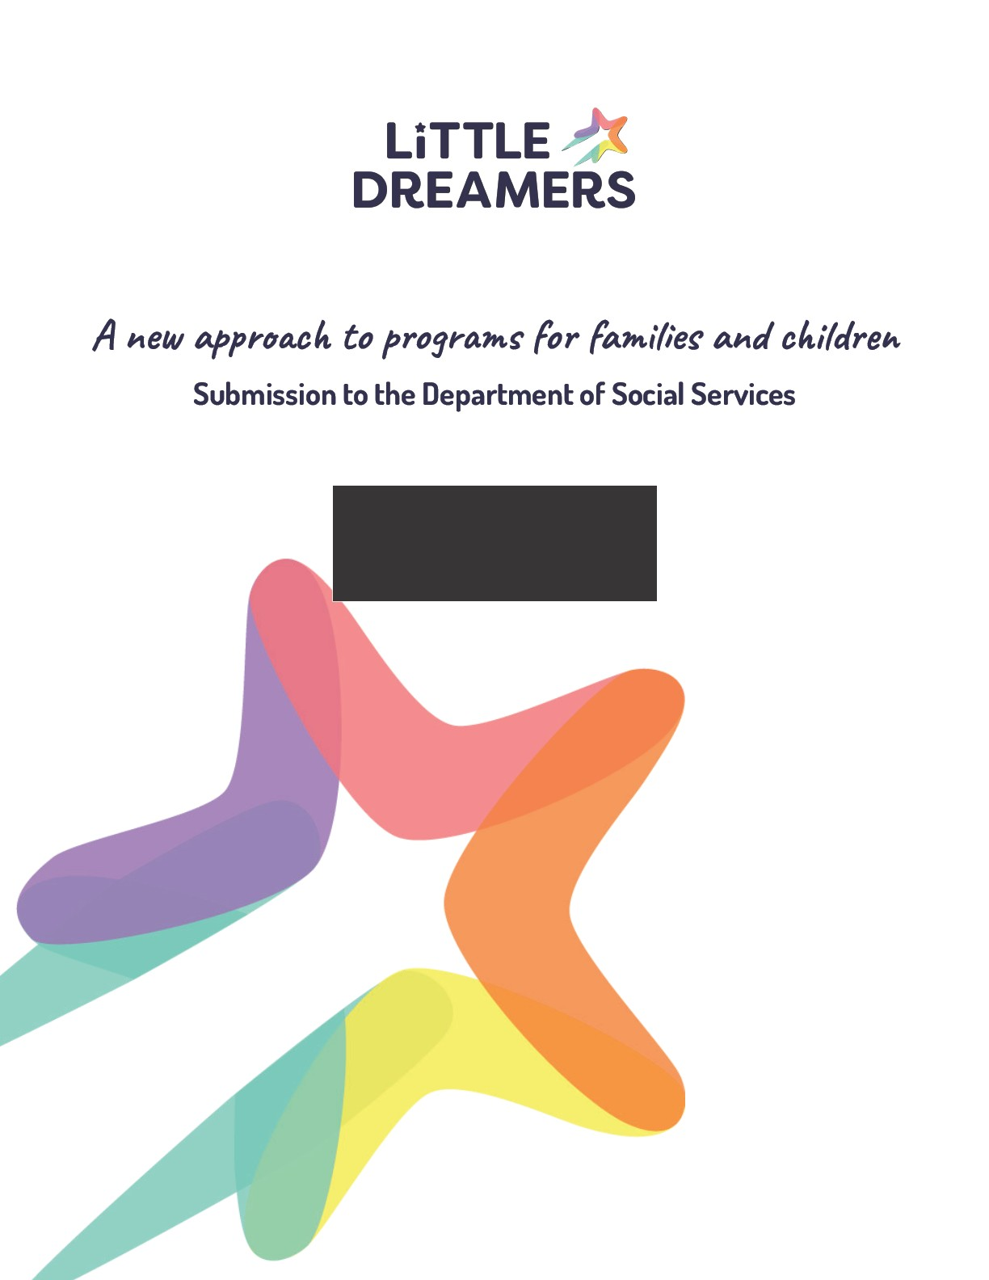

Acknowledgment of Country and Cultural Governance
We acknowledge the Traditional Custodians of the lands on which we work, learn, and live across Australia, and pay our respects to Elders past and present. We recognise that Aboriginal and Torres Strait Islander peoples
have cared for children, families, Country and culture for more than 65,000 years, and continue to do so today.
We acknowledge that Aboriginal and Torres Strait Islander children and families experience the impacts of colonisation, removal, discrimination, and intergenerational trauma in ways that intersect with and compound other systemic barriers. We recognise the resilience, strength, and self-determination of First Nations communities and the leadership of Aboriginal Community-Controlled Organisations (ACCOs) in supporting families and children.
Little Dreamers is not an Aboriginal Community-Controlled Organisation, and we do not speak on behalf of
Aboriginal and Torres Strait Islander peoples. We are committed to listening deeply, working in partnership, and working towards any support provided to Aboriginal and Torres Strait Islander Young Carers being culturally governed, community led, and grounded in respect, healing, and self-determination.



Introduction
We welcome the opportunity to provide feedback on the Australian Governmentʼs proposed reforms to supports and services for families, children, and young people. We strongly support the intention behind this reform: reducing fragmentation; streamlining administration; and shifting toward outcomes-based reporting that reflects the real-life pathways of families and children, not program categories.
Little Dreamers Australia is the nationʼs leading organisation dedicated to supporting Young Carers - children and young people who currently provide care, or intend to provide care, to a family member with a disability, chronic or mental illness, substance dependency, or frailty due to aging. Founded from lived experience, our work, our research, and our advocacy are led by young people who have grown up in caring roles.
Our submission responds to the Discussion Paper from the perspective of a cohort that remains largely absent in national frameworks, despite being one of the most at-risk groups of children and young people in Australia. While Young Carers sit at the intersection of disability, mental health, family services, child wellbeing and youth development, they are rarely explicitly recognised within program design, reporting requirements, or data systems. The absence of recognition results in program exclusion, missed early intervention opportunities, and long-term disadvantage.
We bring insights not only from service delivery, but from the findings of a 2024 Churchill Fellowship examining international best practice for supporting Young Carers across the United States, United Kingdom, and Australia. The Fellowship highlighted the critical need to move from siloed service responses toward mainstreaming Young Carers across health, education, social services, and families and children policy.
This submission outlines why the Families and Children reform presents a defining opportunity to embed Young Carers in a national framework and how models such as the Empowered Care Model can provide a scalable, evidence-informed blueprint for achieving outcomes that align with the Departmentʼs vision.

About Little Dreamers
Established in 2009 from lived experience, we have grown from a grassroots initiative into a national organisation delivering programs across the eastern seaboard focussing on early intervention, peer support, service navigation, education engagement, and mental health and wellbeing. Central to this is the Young Carer Wellbeing Hub - the clinical mental health services arm of Little Dreamers - delivering psychology, art therapy, play therapy and cognitive assessments offered alongside our broader programs to ensure Young Carers receive integrated clinical and non-clinical supports that respond to their caring role, their wellbeing, and their life opportunities, whilst advocating alongside Young Carers nationally.
Each year, we work with thousands of Young Carers through programs co-designed and developed in consultation with young people and informed by best practice in youth work, family systems, and
trauma-informed approaches. Our vision is that all Young Carers have the same opportunities as their peers, in education, employment, mental health, and social connection, regardless of the caring responsibilities they hold.
We advocate for visibility, recognition, and systemic reform to ensure Young Carers no longer fall between the gaps of fragmented service systems.

Vision and Outcomes
Discussion Questions:
- Does the new vision reflect what we all want for children and families?
- Are the two main outcomes what we should be working towards?
- Why/why not?

We support the Governmentʼs proposed vision and outcomes as a foundation for reform. We strongly agree that the role of parents and adult caregivers in raising healthy, resilient children should be recognised and supported.
A necessary nuance: families and caregiving structures vary
While the term “parents and caregivers” ordinarily refers to adults, we recognise, and the Discussion Paper acknowledges, that families do not always reflect conventional nuclear arrangements. In some households, due to disability, chronic illness, mental illness, substance dependency, or other circumstances, children and young people assume significant caring responsibilities, often unintentionally and without formal recognition.
We are not proposing that Young Carers be conceptualised as parents. Rather, we recommend that the new framework explicitly acknowledge that children and young people with caring responsibilities face distinct risks and service needs, which are best recognised under Outcome 2.
Outcome 1: Parents and caregivers are empowered to raise healthy, resilient children
We support this outcome and agree it appropriately centres adult responsibility for care and child safety. Our recommendation is that Outcome 1 be accompanied by guidance that recognises the diversity of family caregiving networks, including households where adult caregiving capacity is reduced due to illness, accommodation instability, mental health challenges, or disability.
Outcome 2: Children are supported to grow into healthy, resilient adults
We strongly support this outcome and view this as the most appropriate place to recognise and respond to children and young people with caring responsibilities. When the caring role is visible and supported, Young Carers demonstrate leadership, maturity, empathy, and problem-solving. When unrecognised and unsupported, they face increased risks of school disengagement, anxiety and depression, financial hardship, and reduced long-term life opportunities.
“I wasnʼt a parent - but I was doing parent things. I helped raise my siblings because someone had to. I just needed someone to notice and understand.” - Young Carer, age 14
Explicitly acknowledging Young Carers under Outcome 2 strengthens the framework by ensuring:
- Early identification
- Tailored supports without stigma
- Recognition that responsibility without choice can be harmful in some circumstances ● Focus on enabling equal life opportunities
This approach aligns with current DSS priorities around early intervention, place-based responses, and improving long-term outcomes.

Program Structure
Discussion Questions:
- Will a single national program provide more flexibility for your organisation?
- Do the three funding streams reflect what children and families need?
- Are there other changes that would improve outcomes and delivery?

We agree that a single national program has the potential to reduce fragmentation, duplication, and the administrative burden experienced by service providers and families. For children and families navigating multiple systems simultaneously - particularly those impacted by disability, mental illness, intergenerational trauma, and/or family violence - integrated program structures can be transformational.
However, structure alone does not prevent siloed delivery. A single program risks functioning as three siloed streams unless the design, funding conditions, and outcomes measurement reinforce integration.
Our concern
Young Carers are often engaged across multiple service needs simultaneously, yet assessment, referral and reporting frequently separate:
- The childʼs wellbeing;
- The wellbeing of the person they care for;
- The capacity of the household; and
- The supports needed for the caring role.
This fragmentation leads to repeated intake processes, lack of coordination, and significant “story fatigue,” which is a deeply common experience among Young Carers and their families.
Aligning Young Carer support with the three proposed funding streams
We believe the proposed streams offer a meaningful opportunity to address Young Carer needs across the program structure:
- Stream 2 (Prevention and Early Intervention) provides the most appropriate mechanism for early identification of Young Carers and support that prevents escalation - including education engagement, peer connection, and mental health support that recognises the caring context.
- Stream 3 (Intensive Family Supports) can enable integrated navigation and intensive case coordination, particularly for households where caring responsibilities arise from complex circumstances including mental illness, disability, or family violence.
Recognising Young Carers across Streams 2 and 3 maintains the intent of the reform - supporting children and young people early, and avoiding the cost and human impact associated with late intervention. Little Dreamers and the Young Carer Wellbeing Hub
The Young Carer Wellbeing Hub, delivered by Little Dreamers, currently operating in Victoria, provides a practical example of how integrated, early intervention supports can meet the needs of children and young people with caring responsibilities.
Through the Hub and other Little Dreamers services, Young Carers can access: ● Wellbeing support
- Clinical mental health services including psychology, art and play therapy, and cognitive assessments ● Service navigation
Early data and demand demonstrate that a single entry point improves access, reduces repeated assessments, and ensures that children are not navigating complex service systems alone.
The Hub and Little Dreamers illustrate how Stream 2 and Stream 3 investment could work together - offering early intervention while also supporting families experiencing complexity and crisis.
The Empowered Care Model as a solution pathway
We support the direction of program consolidation and recommend enabling models that provide integrated responses. The Empowered Care Model, currently being developed and piloted in components through Little Dreamers and our Young Carer Wellbeing Hub, demonstrates a framework that:
- Supports both the child and caregiving environment;
- Blends navigation, mental health, social connection and practical supports;
- Is informed by lived experience and international evidence; and
- Is adaptable for regional, diverse cultural, and place-based contexts.
This model is designed to scale progressively - from innovation to pilot to blueprint - aligning with the structure of the proposed reform.

Suggested adjustment to the program structure
To ensure the new structure does not unintentionally replicate existing blind spots, we recommend embedding Young Carers within program guidelines and outcomes as a priority group whose needs cross funding streams.
This creates:
- Flexibility for integrated delivery
- Clarity for providers
- Explicit recognition that care roles held by children require purposeful support

Prioritising Investment
Discussion Questions:
- Do you agree the four priorities listed are the right areas for investment?
Are there other priorities or issues that should be considered?

We agree that the four proposed priority areas are central to improving outcomes for families and children in Australia. Addressing intergenerational trauma, family mental health, financial hardship and place-based disadvantage is essential. We believe these priorities will be strengthened by explicitly recognising children and young people with caring responsibilities as a group who both experience, and are deeply impacted by, these priority issues.
Young Carers often live in households experiencing multiple and intersecting forms of disadvantage. Research and firsthand experience demonstrate that when a child is caring for a parent or sibling experiencing ill health, disability, or substance use:
- Mental health support becomes a household need, not an individual one
- Financial hardship is often amplified by reduced work capacity or increased care costs
- Caring responsibilities can affect school attendance, social development, and long-term opportunity
- Early intervention is frequently missed because the caring role is not recognised as a risk factor
Strengthening the priorities with one additional clarification
We recommend a refinement to the investment priorities that identifies children and young people in caring roles as a priority population for early intervention. This acknowledges the growing evidence that: ● The caring role itself can be a predictor of increased risk
- Early support mitigates long-term cost and harm
- Young Carers are disproportionately represented among children affected by mental illness, disability, and family violence
- Visibility and data are prerequisites for improved outcome.
We support DSSʼs direction toward coordinated, flexible investment. We believe the inclusion of Young Carers strengthens the reform intent by ensuring support flows not only to families in crisis, but also to children and young people who are quietly carrying caring responsibilities that shape their future.

Improving Family Wellbeing
Discussion Questions:
- Do the proposed focus areas match the needs or priorities of your service?
- Are there other groups or approaches the department should consider?

We support the proposed focus areas, particularly the emphasis on households affected by mental illness, parents experiencing distress, and those at risk of involvement with child protection. These settings are where Young Carers are most concentrated.
Young Carers frequently step into caring roles in response to:
- Parental mental illness
Family substance use issues
- Disability or chronic illness
- Family violence or instability
- Absences of other adult supports where medical diagnoses are involved
Where adult capacity is compromised, the system often responds to the adult condition, but not its impact on the childʼs life, identity, education, and developing mental health.
A strengths and wellbeing approach for Young Carers
We believe the new framework should recognise Young Carers as children with strengths, agency and lived expertise, not solely as dependents affected by adversity. Supporting family wellbeing therefore requires: ● Wraparound navigation for the household
- Targeted mental health support for young people with caring loads
- Respite that strengthens education and social connection
- Co-designed support planning involving the young person where appropriate
The Empowered Care Model aligns with this vision by building protective factors - confidence, connection, coping strategies and financial literacy - alongside addressing household risks.
A lived experience narrative
“When Mum wasnʼt well, I didnʼt need someone to fix her - I needed someone to check in on me. I needed help with school, someone to explain what was happening, and to know I wasnʼt alone.” - Young Carer, age 17
Improving family wellbeing is most effective when children in caring roles are recognised as part of the picture, not an afterthought.

Connected, Co-located and Integrated Services
Discussion Questions:
- Beyond co-location, what works to coordinate services?
- What should demonstrate a service is connected to community?

We support the direction toward improved service integration, however integration is relational, not simply geographical. Co-location alone does not resolve duplication, repeated trauma through retelling, or the absence of a single lead point of navigation for families.
Approaches that demonstrate effective integration
Models that support families and Young Carers effectively include:
- Dedicated navigation roles
- Shared intake and information pathways
- Warm referrals supported by data sharing (with consent)
Co-designed pathways and transition planning
- Trusted relationships with schools, youth services and ACCOs Integration is strengthened when:
- Services share outcomes, not just referrals
- Reporting frameworks acknowledge shared impact across organisations
- Contracts allow flexible collaboration rather than compliance-driven delivery
Demonstrating connection to community in grant assessment
If grant applicants are required to demonstrate community connection, criteria could include:
- Lived experience involvement in design and governance
- Participation structures for children and young people
- Locally developed referral pathways
- Evidence of collaboration with ACCOs, schools, youth services and health services
- Workforce training in cultural safety, trauma-informed practice and Young Carer identification
These criteria recognise that integration is demonstrated through relationships and outcomes - not branding, proximity, or assumptions about community reach.

Responding to Community Need
Discussion Questions:
- Beyond locational disadvantage, what other factors should the department consider?
- Whatʼs the best way for organisations to demonstrate their service is meeting genuine community need?

We agree that place-based disadvantage remains a critical factor in determining where and how service investment should occur. However, disadvantage is not only geographical. For many children and young people, need is shaped by their caring role, an often hidden dynamic within households that may otherwise appear stable.
For Young Carers, community need is defined by:
- The capacity of adults in the household to provide care
- Episodic or fluctuating need due to mental illness, chronic illness, or relapse
- Cultural, linguistic, or generational expectations around care
- The absence of extended family supports or formal systems stepping in
These factors do not map neatly to postcode disadvantage and are frequently under-reported in data sets, including service intake forms, school attendance data, and child wellbeing assessments.

Demonstrating community need: what matters

Organisations should be supported to demonstrate need using:
- Qualitative and narrative data, not only quantitative metrics
- Evidence of family systems impact, not individualised episodes
- Local knowledge and relationships with schools, ACCOs, youth services and mental health providers ● Lived experience participation and governance
We recommend grant assessment frameworks explicitly recognise community-defined need, including need identified by children and young people themselves.

Improving Outcomes for Aboriginal and Torres Strait Islander Children and Families
Discussion Questions:
- How could the grant process support and increase the number of ACCOs delivering services?
- What else should be built into program design?

We strongly support the intent to increase Aboriginal Community-Controlled Organisationsʼ leadership in supporting Aboriginal and Torres Strait Islander children and families. ACCOs are best placed to design, govern, and deliver culturally grounded, strengths-based supports - including those for Aboriginal and Torres Strait Islander Young Carers.
Many First Nations young people provide care within kinship structures that hold cultural meaning, responsibility, and identity. Ensuring culturally governed support for Young Carers requires investment that:
- Enables ACCOs to design and lead Young Carer responses
- Builds workforce capability and lived experience leadership within ACCOs
- Ensures non-ACCO organisations partner, not prescribe
- Recognises kinship care within outcomes frameworks
- Supports community-led development of tools, language, and models
For non-ACCO organisations like ours, this means working in genuine partnership - listening, improving cultural safety, sharing insights when invited, and ensuring that our role supports, rather than replicates or displaces, ACCO leadership.
Program design should also:
- Allow for shared delivery models between ACCOs and non-ACCOs where appropriate
- Include flexible contracting that enables ACCO-led place-based innovation
- More opportunities for consortiums where ACCOs are the lead organisation
- Ensure that reporting frameworks do not place unrealistic administrative burdens on small or emerging ACCOs
Improving outcomes for Aboriginal and Torres Strait Islander Young Carers must be led by Aboriginal and Torres Strait Islander communities, with government enabling, resourcing and embedding cultural governance, not simply cultural adaptation.

Measuring Outcomes
Discussion Questions:
- What types of data would help your organisation understand impact?
- What data is most valuable to share?
- Templates needed for case studies?

We welcome the shift to meaningful outcomes-based reporting and agree that data should improve services, not distract from them. For Young Carers, outcomes measurement must reflect the unique impact of caring responsibility on life opportunities across childhood and adolescence.
Data that would strengthen service improvement We recommend a combination of:
- Baseline and follow-up wellbeing measures
- Education engagement and attendance data
- Confidence, agency, and self-advocacy indicators
- Social connection and peer belonging
- Mental health outcomes
- Navigation success and reduction in system duplication Crucially, data should also include caring context, such as:
- Hours of care
- Type of support provided
- Breadth of tasks
- Fluctuations in household need
Data valuable to share externally We would share:
- Changes to mental wellbeing and coping
- Case study narratives (with consent and guidance)
- Themes emerging from intake and exit interviews
- Insights on navigation, not only service delivery volume
Guidance and templates
We strongly support DSS developing:
- Trauma-informed case study guidance
- Safeguards for consent and dignity
- Templates that centre strengths, achievements, and voice
- Reporting that accommodates co-authored or co-presented lived experience stories
Meaningful outcomes reporting must reflect the strengths, aspirations, and agency of children and young people - not only their risk.

Working Together - Relational Contracting
Discussion Questions:
- What does relational contracting mean in practice?
- What criteria should be included?
- How should organisations be selected?
- Is Little Dreamers interested, and why?

We strongly support the direction toward relational contracting and view it as a critical component in enabling early intervention, innovation, and integration across services. For Young Carers in particular, relational contracting offers the opportunity to move beyond referral-based coordination to shared outcomes, shared learning, and shared responsibility.
What relational contracting looks like in practice Relational contracting means:
- Partnership rather than procurement
- Transparency in challenges and achievements
- Flexibility to adapt delivery in response to community feedback
- Co-design and lived experience embedded from inception to evaluation
- Funding certainty that enables workforce stability and skill development
It also requires a cultural shift away from compliance-led reporting toward relational accountability, accountability driven by outcomes, evidence, trust, and community voice.
Criteria that could guide relational contracting Contracts should consider:
- Demonstrated trust and relationships with the community served
- Lived experience governance and participation structures
- Collaboration with ACCOs, schools, mental health and youth services
- Ability to deliver integrated service pathways
- Ethical use of data, storytelling and outcomes reporting
- Commitment to cultural safety and workforce capability
Selection for relational contracting
We recommend DSS consider relational contracting for organisations that:
- Have strong local partnerships and referral networks
- Deliver early intervention or integrated models
- Demonstrate evidence of impact and continuous improvement
- Work with priority cohorts whose needs cross multiple systems (including Young Carers)
Little Dreamers would welcome a relational contracting approach, as it aligns with our commitment to co-design, integration, innovation, and evidence-led service improvement.

Other Considerations - Mainstreaming Young Carer Support
The Discussion Paper recognises the limitations of siloed programs and the need for integrated, outcomes-focused design. The experience of Young Carers illustrates this challenge clearly.
Young Carers are not a small niche group, with 1 in 10 young people growing up with caring responsibilities they represent a significant and growing proportion of children and young people, present in every school, community, culture, and postcode. Yet services, data systems, and governance structures often overlook the caring role itself.
Drawing from international research undertaken through the Churchill Fellowship, we recommend that DSS consider a Young Carer mainstreaming approach, similar in principle to gender mainstreaming, where every policy, program guideline, needs assessment and reporting framework asks:
“How does this decision impact children and young people with caring responsibilities?” This does not require a standalone program; rather, it is a lens embedded across the system.
Mainstreaming ensures:
- Early visibility and identification
- Reduced duplication and retelling of traumatic stories
- Prioritisation of equal life opportunity, not just crisis response
- Integrated support aligned with how families actually experience need
The Families and Children reform presents a historic opportunity to embed this lens at every level of system design.

Closing Position and Recommendations
We welcome the Governmentʼs commitment to improving outcomes for families and children and commend DSS for placing integration, flexibility, and outcomes at the centre of its reform agenda.

