

A New Approach to
Programs for Families and
Children

Submission to the Department of
Social Services – Consultation
Response

December 2025

Executive Summary

Mallee Family Care (MFC) strongly supports the Australian Government’s commitment to reforming programs for families and children. The proposed shift toward longer-term funding, reduced administrative burden, streamlined reporting, and relational contracting represents a significant opportunity to strengthen the community sector and improve outcomes for children and families nationwide.
However, the design and commissioning approach will ultimately determine whether this reform strengthens—or inadvertently undermines—the place-based service systems that regional communities rely on. An open competitive grant process that treats all applicants as equivalent, regardless of their history, relationships or community embeddedness, risks displacing the very organisations best positioned to deliver trusted, culturally safe and locally responsive support. This concern is grounded in evidence: across multiple Commonwealth program areas, competitive commissioning has led to contract consolidation toward large national providers, with reduced accessibility in regional areas, loss of local workforce, and erosion of the community trust that effective service delivery depends on.
MFC is a leading place-based community service organisation with more than 45 years' continuous operation in the Mallee region. As the long-standing Communities for Children (CfC), CfC Facilitating Partner, Children and Parenting Support (CaPS) and Family and Relationship Services (FaRS) provider in our region, MFC has direct experience delivering most of the programs being consolidated. We operate across a vast cross-border catchment spanning Victoria, New South Wales and South Australia, covering more than 160,000 square kilometres and navigating three sets of legislation, service systems and funding frameworks. Each year, our 300-strong workforce delivers more than 70 programs to over 7,900 individuals and families, travelling more than 693,000 kilometres to do so. Our governance is locally accountable, our workforce lives in the community, and our relationships with families often span generations. This is what genuine place-based practice looks like, and it cannot be replicated by organisations whose regional presence is limited to a satellite office, a subcontracting arrangement or a line in a tender submission.
This submission is offered in a constructive spirit, but with an urgent message:
The new national program must protect and strengthen genuinely place-based organisations if it is to deliver equitable outcomes across Australia.
As a multidisciplinary provider operating across early childhood, parenting support, family violence, mental health, disability, community legal services and whole-of-family early intervention, MFC brings a system-wide perspective on what works and what is needed for this reform to succeed in rural and regional communities.
In this submission, we identify structural risks that must be addressed, including over-reliance on metropolitan datasets (such as SEIFA and AEDC), the potential consolidation of contracts into fewer national providers, and implementation models that assume proximity of services, digital connectivity, or workforce availability that do not exist outside metropolitan areas.

We also propose detailed recommendations to ensure the new program strengthens, rather than erodes, place-based service systems. These include embedding place-based commissioning principles, introducing a rural and remote adjustment factor, strengthening ACCO–mainstream

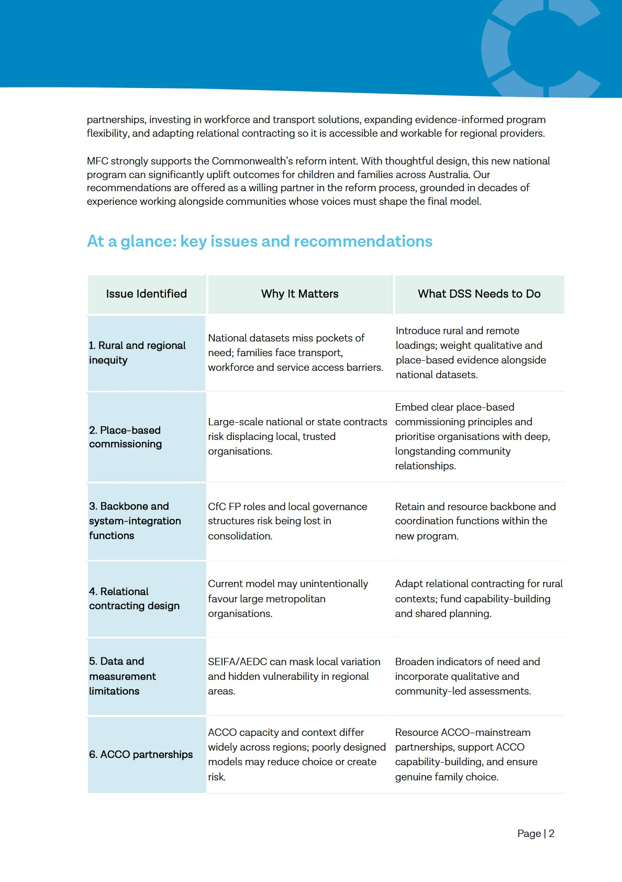

About Mallee Family Care: Place-based leadership and regional expertise

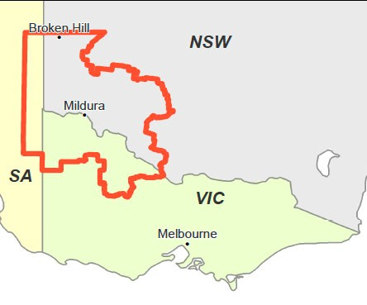
Mallee Family Care is a leading place-based community service organisation operating across a vast crossborder region spanning Victoria, New South Wales and South Australia—more than 160,000 square kilometres. For over four decades, we have been a cornerstone of the regional service system, supporting children, families and communities living in some of the most complex circumstances in Australia.

Our region experiences entrenched socio-economic disadvantage, including high rates of family violence, intergenerational poverty, youth disengagement, digital exclusion, limited transport options, and severe shortages of specialist health and allied services. These challenges are compounded by sparse population distribution, long travel distances, seasonal workforce variability and systemic service inequities that disproportionately impact rural and regional communities.

Against this backdrop, MFC delivers more than 70 programs through a workforce of over 300 staff, supporting more than 7,900 individuals and families each year. Our deep regional presence enables us to create and lead local solutions that are targeted to the specific needs, cultural context and lived experience of our communities. Our multidisciplinary portfolio spans early childhood and parenting support, youth programs, family violence and trauma-informed services, disability and developmental supports, family relationship services, migrant and refugee settlement, community legal services and whole-of-family early intervention. As an integrated provider, we offer the pathways, soft entry points and local infrastructure that families in the Mallee depend on.

MFC also plays a key leadership role in the regional service system. As the long-established Communities for Children Facilitating Partner, we provide backbone coordination, community governance leadership and subcontractor capacity building across the region. Our place-based approach strengthens local capability, deepens partnerships with ACCOs and community organisations, and ensures that services are culturally safe, community-led and responsive to emerging needs.

Our long-standing presence, multidisciplinary capability and deep relationships with families, ACCOs, culturally diverse communities and local partners give us a unique perspective on how national program reforms land in high-needs, geographically dispersed communities. We offer this submission from that vantage point—seeking to ensure that the new national program delivers equitable and effective outcomes for all Australian children and families.

Feedback on proposed reform

The reform’s potential
Mallee Family Care strongly supports the Australian Government’s commitment to strengthening outcomes for children and families through a more integrated, flexible and sustainable national

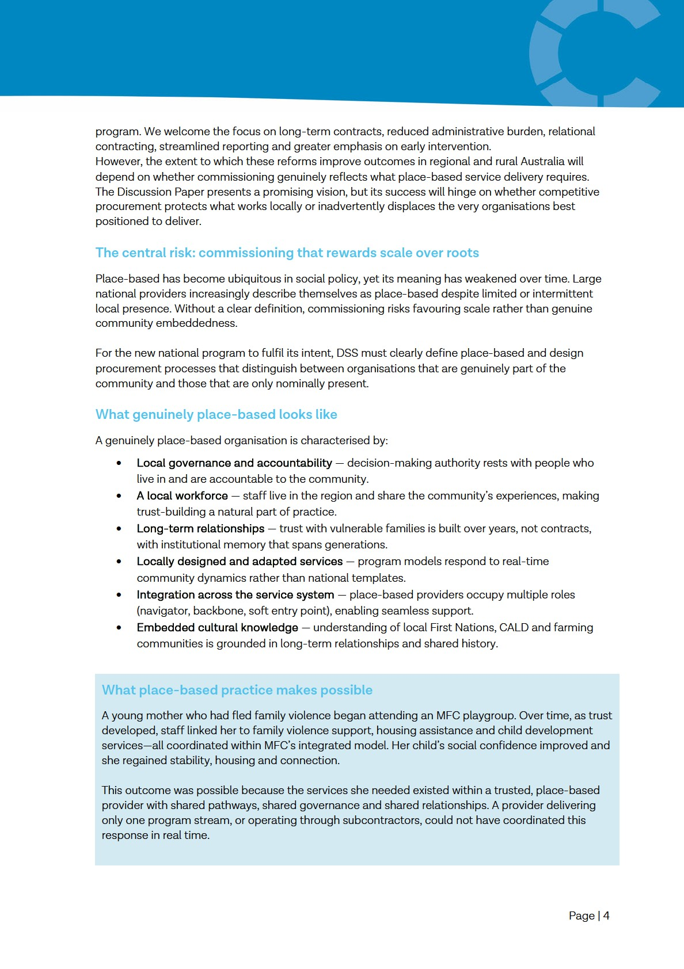

What place-based is not
An organisation is not place-based simply because it:
- has an office in a regional town
- employs a small number of local staff while retaining accountability elsewhere
- subcontracts delivery while managing funding and reporting centrally
- provides outreach from a metropolitan base
- lists regional locations in a national footprint
These models may meet contractual definitions of “coverage” but do not build the capability, trust or integration that regional communities rely on.

Why this matters for the reform
Competitive tendering in employment services, aged care, mental health and out-of-home care has repeatedly led to contract consolidation, reduced regional accessibility, loss of local workforce and weakened community governance. The same risks apply here unless commissioning explicitly safeguards place-based capability.

The consequences for regional communities include:
- Loss of trusted relationships with familiar providers—particularly devastating for families with trauma histories.
- Reduced service integration, as single-stream providers cannot replicate warm referrals and whole-of-family responses.
- Erosion of local capability, with job losses and diminished expertise when contracts shift to external organisations.
- Weakened community governance, undermining networks that take years to build. Responding to “any organisation can apply”
Open competition is not neutral when applicants start from vastly different positions.
A provider that has spent 45 years building trust, employing local staff and refining practice is not equivalent to a new entrant proposing to establish a presence. Families do not experience a change of provider as a neutral administrative event; it disrupts relationships that are central to safety, engagement and outcomes.

True equity in commissioning requires recognising community embeddedness as evidence of capability—not an incidental feature. Incumbency, where it has delivered strong outcomes, should be weighted as an asset.

MFC supports competition where it identifies the provider best placed to deliver, but in regional areas this must include explicit weighting for local relationships, sustained presence and proven community trust.

Recommendations for place-based commissioning
To protect the integrity of the reform, MFC recommends that DSS:
- Publish clear criteria for assessing genuine place-based capability, including local workforce, years of continuous operation, strength of partnerships, community governance structures and demonstrated history of culturally safe practice. Require applicants claiming place-based status to provide verifiable evidence.

- Weight demonstrated local track record in assessment, recognising proven local performance and community trust as critical indicators of capability.

- Avoid criteria that privilege scale, such as requirements for national coverage or high organisational turnover, which disadvantage regional organisations. Treat incumbency— where outcomes are strong—as an asset rather than a barrier to fair competition. Getting the implementation settings right
The reform’s success will rely on several technical and operational settings:
- Data and needs assessment. National datasets (SEIFA, AEDC, NEET, child protection) are unreliable for small populations and often mask high local need. Funding decisions must incorporate local qualitative evidence, lived experience, community insight and place-based assessments co-developed with regional providers.

- Relational contracting. Strongly supported, but resource intensive. Without capability funding and simplified governance, relational contracting may favour large metropolitan organisations. It should explicitly prioritise place-based organisations, support shared governance with ACCOs and reduce administrative burden—not add to it.

- ACCO partnerships. Priority Reform 2 is strongly supported, but implementation must ensure families retain genuine choice; ACCOs are not set up with unfunded expectations; partnership work is resourced; mainstream providers develop cultural capability; and regional variations in ACCO capacity are recognised.

- System alignment. The model must clearly articulate how the program aligns with early intervention systems, mental health reforms, the National Framework for Protecting Australia’s Children and state systems. Families in regional areas often navigate multiple disconnected systems simultaneously. DSS should invest in place-based service system mapping to support integrated implementation across jurisdictions.
Detailed discussion of rural implementation realities is included in Section 6.

Responses to Discussion Paper questions
The following responses address the questions in Appendix A of the Discussion Paper and should be read alongside the overarching policy considerations in Section 3 and the rural implementation realities in Section 6.

Vision, Outcomes and Program Structure
Is the proposed vision appropriate?
Yes. The vision aligns with MFC’s purpose and with the evidence about what families need to thrive. To be meaningful in rural and regional contexts, the vision must explicitly recognise place-based decision-making, regional and rural equity, and the capability of local organisations to shape and deliver supports.

Are the proposed outcomes appropriate?
The outcomes are directionally sound, particularly the emphasis on safety, connection and prevention. Two additions would strengthen the framework:
- Connected Communities, recognising the importance of local social infrastructure; and
- A Sustainable and Locally Relevant Service System, acknowledging workforce, access and integration.
The outcomes framework must also recognise the diversity of family and caregiving arrangements in regional communities. The current framing risks defaulting to nuclear, Anglocentric models. Effective service delivery in the Mallee requires recognition of extended kinship networks, grandparent-led households, multi-generational arrangements, blended families, chosen families and culturally specific caregiving structures. For First Nations families, kinship obligations extend well beyond the nuclear unit. Program design, eligibility and measurement must treat these as common and legitimate family forms.

Is a single national program with three streams appropriate?
Potentially. Consolidation could reduce fragmentation, but providers cannot meaningfully assess the implications without:
- a mapping of current programs into the new streams;
- clarity on how continuity for families will be ensured; and
- guidance on the future backbone functions such as Communities for Children Facilitating Partners (CfC FP).

Investment Priorities and Assessment of Need
Are the investment priorities appropriate?
Yes. MFC supports focusing on early intervention, local responsiveness and First Nations leadership.

Are the data indicators adequate for identifying need?
Not for regional and rural communities. As outlined in Section 6, SEIFA and AEDC are unreliable for small populations, mask intra-regional variation and pockets of high need, and fail to account for access barriers, service gaps and hidden vulnerability. CALD families and children with disability are consistently under-represented in datasets, increasing the risk of under-funding in high-need regions.

What should be considered in addition? Funding decisions must incorporate:
- local qualitative evidence;
- transport and digital access indicators;
- workforce data;
- local service availability; and
- place-based assessments co-developed with regional providers.
To reflect the higher cost and complexity of delivery, DSS should introduce a Rural and Remote Adjustment Factor.

Supporting Family Wellbeing and Early Intervention
Are the proposed focus areas appropriate?
Yes, but two critical gaps remain:
- Supports for children aged 6–18. Early intervention must extend beyond the early years. Middle childhood and adolescence are key periods for preventing escalation.
- Access barriers, particularly transport, stigma, workforce shortages and lack of specialist services. These factors determine whether families in the Mallee can meaningfully engage. Recommendations
- Expand early intervention supports to include school-aged children and adolescents.
- Fund transport, outreach, after-hours sessions and mobile delivery models.
- Adopt an evidence-informed approach that values practice wisdom, community knowledge and cultural adaptation alongside formal evaluation, particularly for First Nations families and culturally diverse communities.

Integrated and Connected Service Delivery
Is co-location essential?
Co-location can be highly effective and should be supported where feasible. MFC operates colocated models successfully, particularly within our Family and Relationship Services programs, where having multiple supports under one roof enables seamless referrals, coordinated responses, and families sharing their story only once.

However, co-location should not be mandated or treated as the only legitimate model of integration. In smaller communities with limited service infrastructure, co-location may not be practical or costeffective. In these contexts, integration is achieved through long-standing relationships, shared governance, coordinated referral pathways and backbone functions—not physical proximity. The new program should recognise both models as valid expressions of integration, each suited to different contexts.

Effective integration, whether co-located or relational, is driven by:
- strong local governance;
- consistent leadership and shared purpose;
- coordinated referral pathways;
- backbone functions such as CfC Facilitating Partners; and
- trust built through sustained local presence. Recommendations
- Support and fund co-location where communities have sufficient service density and infrastructure to make it viable.
- Equally support and fund relational integration models in smaller communities and dispersed regional areas where co-location is not feasible.
- Define integration by outcomes and practice quality—not by physical arrangement—and fund the coordination work that makes integration effective regardless of location.

Responding to Community Need
Responsiveness requires flexibility, shared decision-making, genuine engagement and the ability to tailor supports to local context. These principles must be embedded in commissioning and contract management.

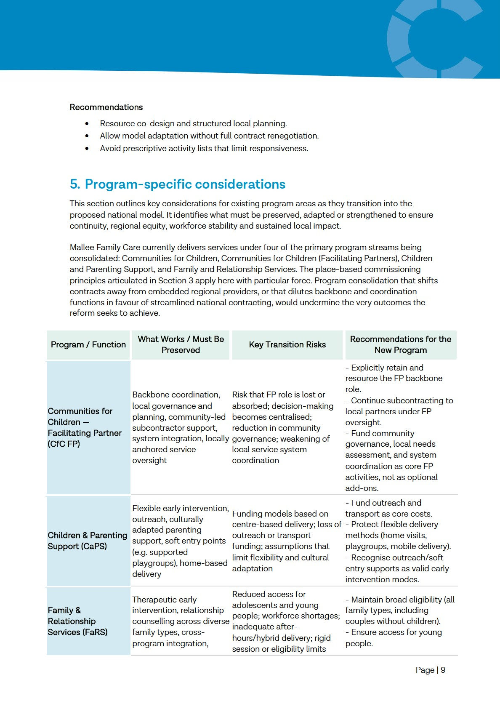
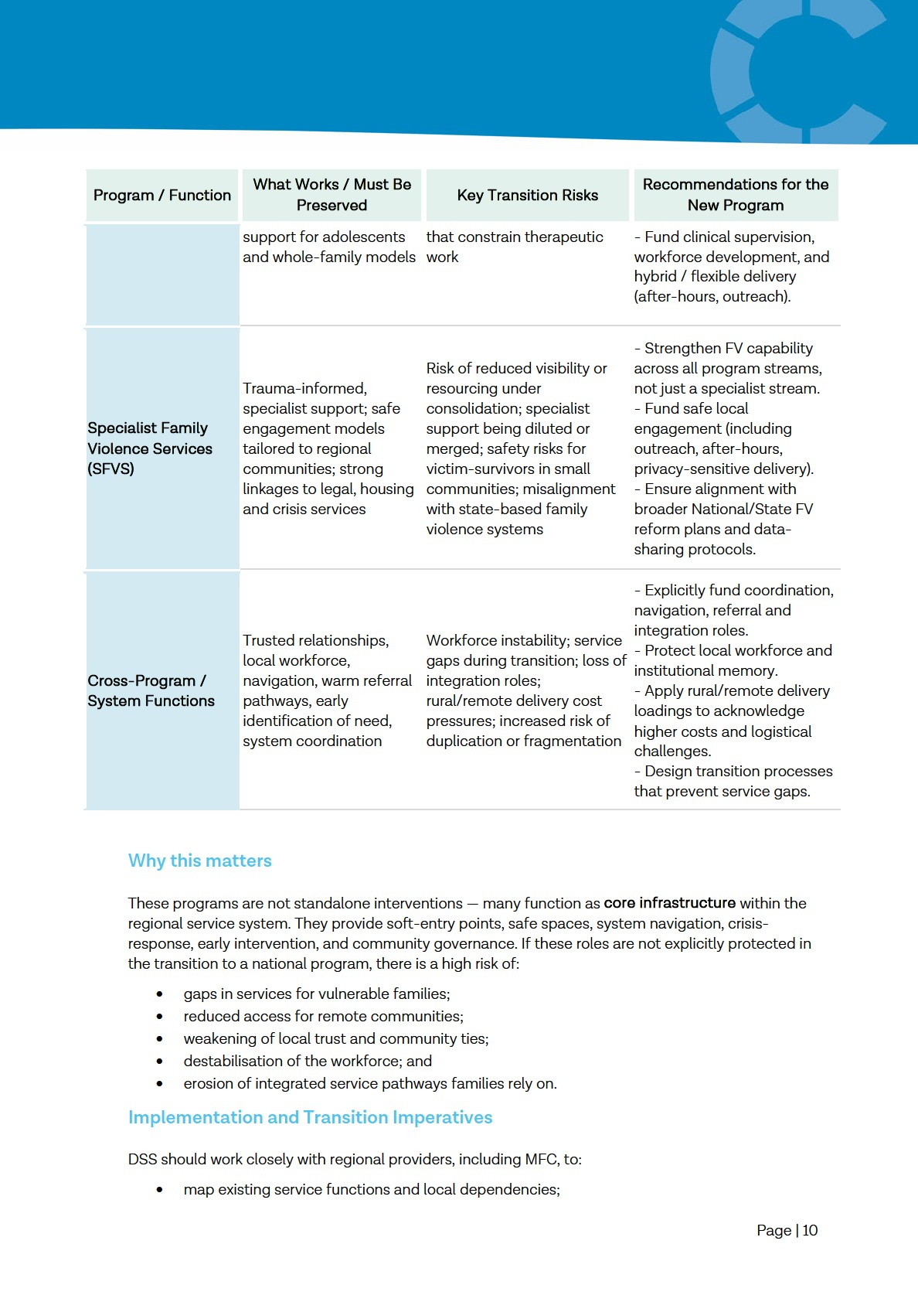
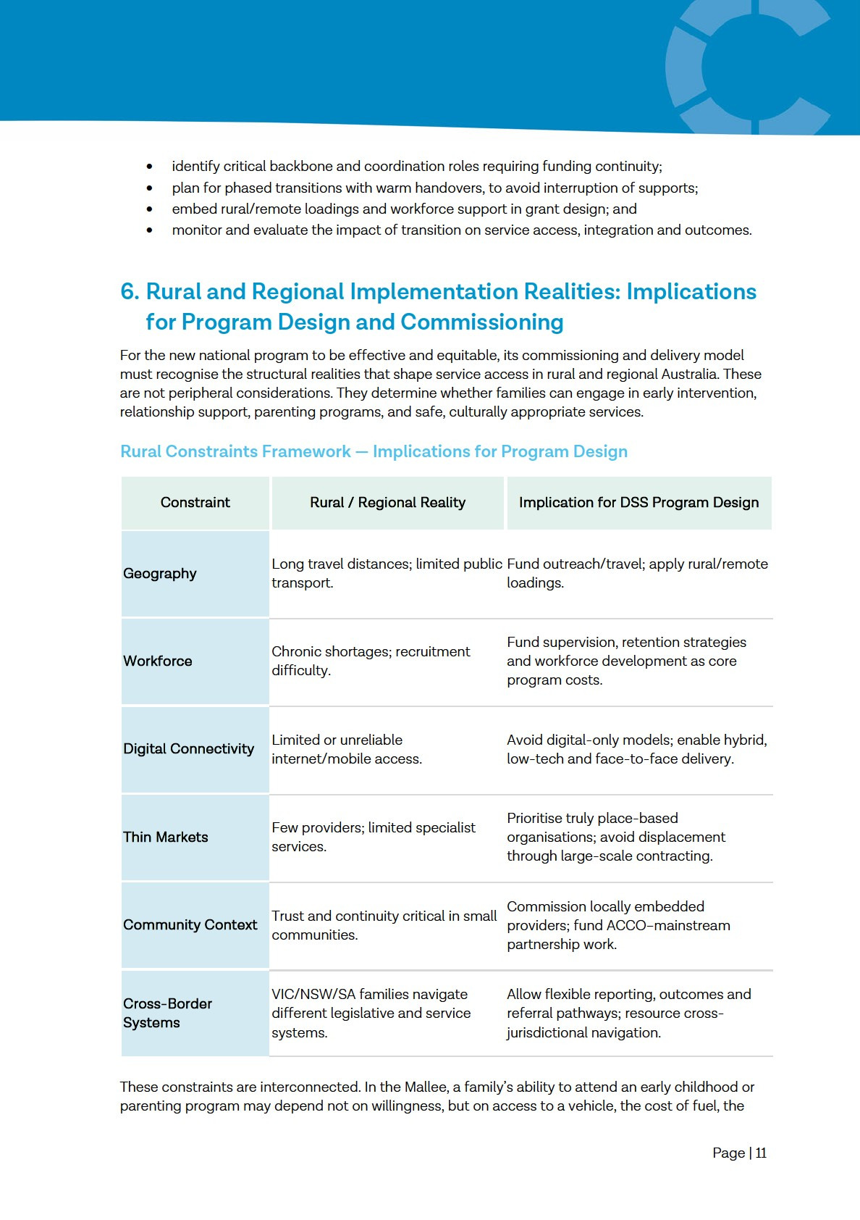
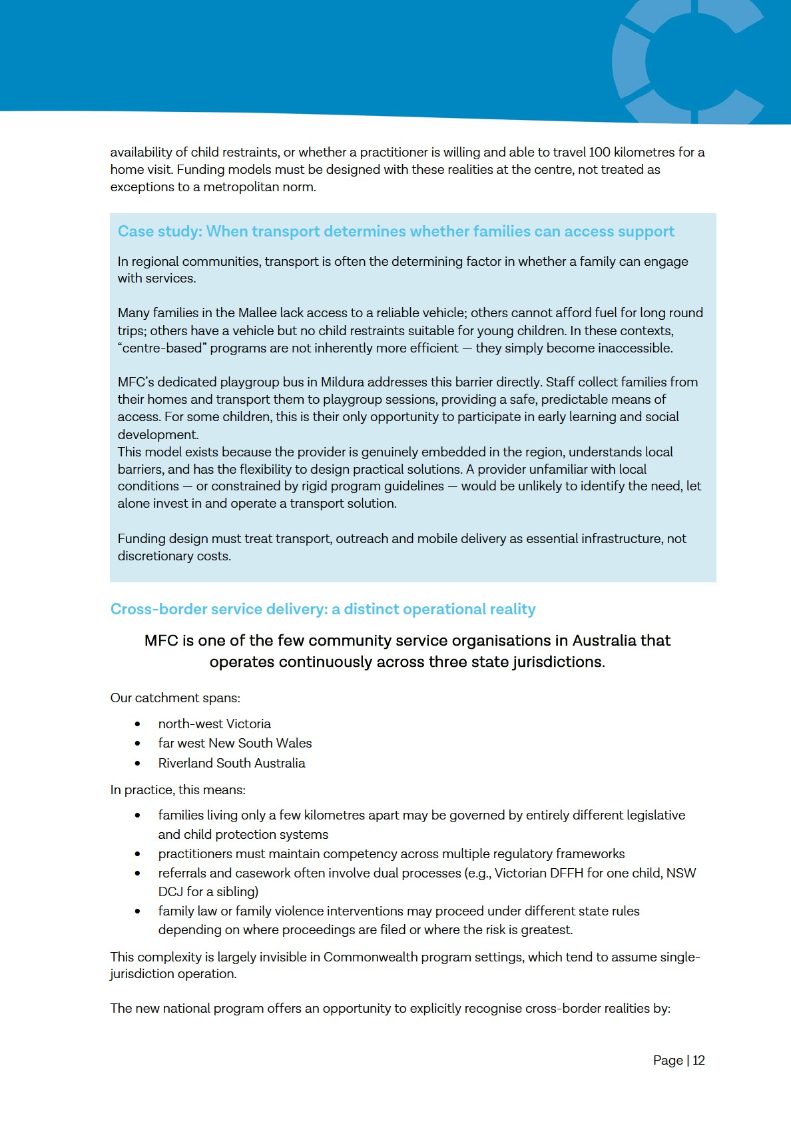

- allowing flexible reporting arrangements
- enabling dual-framework practice where required
- funding the additional coordination and compliance burden inherent in cross-jurisdictional service delivery

Programs designed without acknowledging cross-border operating realities risk undermining continuity, safety and compliance in regions like the Mallee.

Implications for Commissioning
To operate effectively across regions like the Mallee, commissioning must:
- prioritise organisations with demonstrated local presence and long-standing community trust
- apply rural and remote cost and workforce loadings
- enable adaptive, context-specific delivery models rather than prescriptive activity lists
- resource outreach, mobile, after-hours and home-based delivery
- preserve backbone functions (e.g., CfC FP) that hold regional systems together
- design relational contracting to be proportionate and feasible for regional providers
- fund ACCO–mainstream partnerships, recognising variability in ACCO capacity and local context.
Two cost categories warrant specific attention in funding models.

- Workforce development, clinical supervision, and staff retention measures must be funded as core program costs, not absorbed by providers. Recruitment and retention are significantly more challenging in rural areas, and providers who invest in workforce quality should not be competitively disadvantaged.

- Venue and operating costs must be recognised as a legitimate and necessary expense in regional service delivery. In many regional areas, providers lack purpose-built facilities and rely on hiring community halls, church spaces or other local venues. These costs are not discretionary overheads; they are the infrastructure required for service delivery in dispersed communities. Why This Matters
Without explicit rural adaptation, the reform risks unintentionally:
- reducing service availability
- privileging large national organisations over local providers
- disrupting systems that currently perform well
- increasing access inequity
- weakening ACCO-mainstream partnerships
- eroding the trusted relationships that underpin effective engagement.
Embedding rural commissioning principles will ensure the new national program works in practice, not just in design, and delivers equitable outcomes across all communities.

Page | 13

