SUBMISSION TO THE DEPARTMENT OF SOCIAL SERVICES – A new approach to programs for families and children

Introduction
Ngaanyatjarra Pitjantjatjara Yankunytjatjara Women’s Council (NPYWC) is a member-led,
Aboriginal Community Controlled Organisation (ACCO), governed and directed by Ngaanyatjarra Pitjantjatjara Yankunytjatjara (NPY) women from 26 remote desert communities across the cross-border regions of Western Australia, South Australia, and the Northern Territory — an area covering over 350,000 square kilometres and a population of approximately 6,000 Anangu. Guided by women’s law, authority, and culture, NPYWC delivers a wide range of health, social, and cultural services, and social enterprise opportunities, that promote safety, wellbeing, and empowerment for Anangu women, children, and families in the NPY Lands. Annexed and labelled “A” is a map of the region.
Embedded in NPYWC’s history is the gathering and strategic organisation of NPY women who wanted to be seen and heard during the Pitjantjatjara Land Rights movement. Annexed and labelled “B” is a painting by M.W (deceased) that tells the story of the time Anangu women came together to form their own Women’s Council. NPYWC’s theory of change and service provision is deeply rooted in local strengths-based, trauma-informed and healing practices that champion Anangu as being best placed to articulate and determine their own needs. Self-determination is the catalyst for transforming communities with the intention of every person fulfilling their right to full emotional, social, physical and spiritual wellbeing.

SUBMISSION

“They give us the money and we should be able to spend the money the way we want to. We want it to work on the ground.”

As a leading provider of human services in remote Aboriginal communities, NPYWC strongly supports the department and Minister Plibersek’s commitment to finding better ways to build more sustainable and collaborative relationships with ACCOs. As a recipient of direct and indirect Department of Social Services (the department) funding, NPYWC would like to express appreciation for the ongoing relationship we hold with the department, and we welcome the opportunity to provide input to the consultation for a new funding approach to programs for families and children.

1. Key impacts for NPYWC under existing framework

Our experience under the existing model is detailed below and highlights the key challenges and barriers faced by our staff, the communities we work within and our challenges in service provision as a whole:

- Monthly reporting meetings with the department, across our different services, are considered too frequent and teams have suggested that transitioning to bi-monthly meetings which would be more supportive.
- Feedback from services reveals that approval to roll over underspend is often delayed, which impacts operations, particularly when occurring late in the financial year.
- NPYWC expresses frustration at the incredibly detailed Activity Work Plans required under existing grants, which don’t reflect the true value of the work. The additional ‘back and forth’ in relation to the Activity Work Plans and Activity Work Plan Reports (performance reports) between the department and the services during a reporting period adds unnecessary strain on capacity and detracts from direct service provision.
- Meaningful collaboration with ACCOs who have a legacy and direct knowledge of how and what services to provide in community should be reflected through a more trusting relationship. For example, reporting against some of our projects, such as the MalpararaMalparara (MM) Lived Experience Women’s Group that informs the work of the DFVS, can be difficult. This project is Anangu led, innovative and organic and does not fit into Western metrics or frameworks for interpreting DFV prevention. In the past, it has been challenging for NPYWC to settle on an Activity Work Plan that satisfies the department’s need for quantifiable metrics.
- The department’s privileging of quantitative data over qualitative or other types of data relevant to the organisation doesn’t tell the true story of change and ultimately reflects a lack of trust in ACCOs who understand what matters in telling the story of transformation for Anangu. This dynamic can ultimately reinforce colonial power dynamics between the sector and Government and fails to respect the legacy of NPYWC – the oldest continuing Aboriginal Women’s organisation in Australia.
- With a strong focus on compliance and oversight, NPYWC experiences a further reporting burden via the department’s Data Exchange (DEX). DEX requires significant manual input that often requires support from other NPYWC teams - such as our IT Department - who are not resourced to produce this work in funding grants.
- SCORE data doesn’t accurately reflect the services we provide or the changes being made in communities. Upon completing requirements, NPYWC satisfies the reporting standard, but it does little to create value. NPYWC supports the need for evidencedbased policy which requires various forms of data being collected and monitored. Only then can we triage evidence to capture the full and critical spectrum of our comprehensive services. This helps shape a true, collective narrative around the families and communities we work with.
- Further, collected data isn’t meaningfully fed back to the organisation to contribute to benchmarking change and allowing the information to be used for other purposes like seeking alternate funding.

2. What NPYWC requires for the new approach to be successful

“Data offers one way to reflect on improvement. Using a narrative, storytelling or art, are approaches very helpful for reflection. It is the authority that First Nations people have used for thousands of years, the oral authority”

The success of the new approach will depend on its ability to privilege cultural safety and authority and embed genuine partnership and collaboration with ACCOs. The ways in which the department can achieve this is detailed below.

- Introduce weighted factors that privilege ACCOs in the tender process. Increase the value placed on organisations like NPYWC with strong cultural governance, authority and a deep history in, and understanding of, the region in which they are directly delivering services.
- Urgently consider reinstating the ability to apply brokerage as a meaningful activity that deeply impacts the lives of the clients and communities we service.
- Detail the provision of clear transitional arrangements or replacements for the supplementary funding ending the financial year 2025-26.
- Grants need to incorporate the full cost of service delivery, including resourcing administrative and technical support for reporting requirements. In doing so the department would be acknowledging ACCOs as the experts in delivering services for their own remote Indigenous communities.
- Meaningfully invest in workforce capability to recognise and respond to the needs of the community in culturally appropriate ways. This would include funding for cultural guidance, recognition of local authority structures as well as the ongoing resourcing of translation and interpreting. Annexed and labelled “C” highlights the importance of resourcing language as it depicts the high percentage of Western Desert language speakers in the NPY Lands.
- Resourcing data experts in the cost-of-service delivery would also acknowledge the limited workforce of data professionals in our region. The data load for ACCOs has become increasingly resource intensive. Co-design of data collection with ACCOs would enable a better understanding of the data load and potentially embed more strategic ways of working.
- Improve transparency from Government on what actions it is currently undertaking this parliamentary term, or planning to undertake, on sector policy.
- NPYWC requests transparency around the allocation of funding for the NPY region. It is difficult to advocate for our services when there is no clear information about the current level of investment in the region across all governments (state, territory and federal). Transparency is lost when funding for programs in the region is allocated to generalist notfor-profit organisations who deliver services in partnership with ACCOs. This funding model means organisations like NPYWC have reduced capacity to properly monitor and deliver services. NPYWC support any reforms that centre a commitment to shared data – this is includes national, regional and localised data.
- Genuinely commit to working with ACCOs servicing Aboriginal and Torres Strait Islander communities directly by allowing them to flexibly design Activity Work Plans and reporting requirements that reflect the value of the work and the needs of clients. For example, this type of flexibility applied to reporting against the MM Lived Experience Group would allow NPYWC to showcase the efficacy of the work in a more culturally relevant way. It also offers a strengths-based approach to telling the story of outcomes and transformation.
- Commit to genuine shared decision making to produce genuine, alternative results. Shared decision making is structural, not symbolic, and there should be decision makers on both sides of the partnership. Shared decision making should be at the heart of any relationship with the department and ACCOs.
- NPYWC have long advocated for block funding, with a minimum contract length of five years to provide services that contribute to long-term transformation. Change takes time
in complex, multi-lingual and cross-cultural contexts. The relationships underpinning change require meaningful investment. The department must comit to consolidating and extending contracts to address this.
- Privilege qualitative data (such as art and storytelling) over quantitative data where relevant and seek culturally grounded forms of knowledge-sharing and evidence, such as lived experience, to ensure it reflects the needs of the communities we represent. Reporting should prioritise what meaningfully changed for people, following the right cultural protocols, not just how many people interacted with a service. In doing this, we urge the department to also acknowledge the capacity and resource burden of collecting qualitative data which takes trust and time to collect.
- Ensure maximum flexibility relating to geographical spending. For NPYWC, we are rarely funded for communities in the Ngaanyatjarra (NG) lands in Western Australia which discriminate against Anangu as a highly mobile and relational population frequently travelling across the NPY Lands for cultural and familial obligations. Anangu cultural movement is not dictated by state and territory boundaries; it is dictated by cultural, linguistic and kinship lines that determine how people live, move, marry and maintain Law. Flexibility in reporting will also minimise underspend by allowing NPYWC to help resource programs innovatively and strategically.
- Streamline processes and reduce red tape. Members from our Palywanungku Palyantjaku Core Group noted that each year new government funding programs are introduced into communities, often with different rules and requirements that must be followed. While adapting to these systems, young people are missing opportunities to learn cultural ways, as community members spend more time trying to navigate government processes. This has led to feelings of being lost within the system.
- Ensure cultural safety is embedded at every stage of the tender and implementation process of the new approach. In doing so, the approach will acknowledge our need to prioritise connection to Country, kinship and collective wellbeing in service provision.

3. Items NPYWC needs more clarity on regarding the new approach

- The intended outcomes in the discussion paper are focused on children and young people and don’t acknowledge the complex family and kinship networks that underpin service delivery in our region. Will the department allow flexibility by factoring in the diversity and interconnected clients and communities we work with?
- The intended outcomes lack detail around how the new approach will structurally address raising people out of systemic disadvantage. The two outcomes are broad and don’t provide an indication of how they will be measured. How will the department translate their intended outcomes into practical activities?
- More detail is required about what types of activities will be included under the new approach and whether items like salaries and administrative levies, as well as capital infrastructure, will be included.
- Identify whether the tender process will be commissioned or competitive and provide enough consultation and time for NPYWC to resource the application process.

4. Future hopes for our relationship with the department

“We under tri-state and the only state we're funded in is NT and SA. Western
Australians missing out and they [Anangu] always complain in AGM and Director’s meetings. They're [the Government] telling, ‘not going to give you any support’. Well, we need to roll that money over to them to help them.” - NPYWC Chairperson, Mrs Smith

It’s important to highlight that the department fund the only family support service in our region. The lack of service support in our communities means that without the ongoing commitment from the department to invest this vital funding in the NPY lands, NPYWC’s ability to support Anangu families and communities will be critically disenfranchised.

- Monitor and evaluate the success of these proposed reforms to translate the model across a variety of department funding streams. Track this progress against the priority reform areas of Closing the Gap to reflect the Government’s commitment to changing the way they work with the ACCO sector.
- Consider how else the department can listen to and engage with the needs of the clients and communities we work with through stronger relationships with ACCOs under this new model. Addressing structural barriers like housing and income support will play a significant role in determining the success of the outcomes in the new approach to working with children and families.
- Consider the strength of foundational supports and further invest in community development programs. Organisations like NPYWC are well placed to provide this specific and tailored work to communities but are rarely funded adequately to do so.
- Commit to strengthening communication between state, territory and federal governments and the ACCO sector. Improved communication between departments and funding bodies, as well as shared accountability across Ministerial portfolios, will help secure equitable and sustainable funding for service delivery in our tri-state communities.

NPYWC Priorities
The tri-state complexity in which Anangu live, in the remote and very remote NPY region, is central to understanding how families and communities access opportunities, all while facing poverty, domestic and family violence and the clutch of the indiscriminate criminal justice and child protection system. While legislative borders mark the state and territory boundaries, these borders bear little significance to Anangu from the NPY Lands. Acknowledging the unique context of the cross-border region is particularly relevant to the Government’s commitment to Closing the Gap and Safe and Supported. Honouring this deeply held priority and history is critical for meaningful engagement and transformation to occur in the lives of the people we work with.

Further, NPYWC has observed how structural changes - such as raising income support payments and improving access to affordable culturally relevant and holistic services - positively impact participation in social, educational and employment opportunities. Annexed and labelled “D” graphs the total personal weekly income on the NPY Lands and annexed and labelled “E” depicts comparative grocery process between the APY Lands and Alice Springs to highlight the specific remote and very remote discrepancy in the cost of living.
Addressing underlying determinants of low engagement - such as poverty and the impact of colonisation - will have lasting positive effects for Anangu.

Conclusion
As a leading provider of human services in remote Aboriginal communities, NPYWC strongly supports the department and Minister Plibersek’s commitment to finding better ways to build more collaborative, and thus sustainable, relationships with ACCOs. The new approach is highly promising and a welcome response to NPYWC’s advocacy in our sector and region. This transition represents a genuine commitment from Government in centring the voices of Anangu, and ACCOs across the country, who know what’s best for their communities.
However, alongside greater transparency, decreased reporting requirements and more flexible relational contracts, NPYWC is seeking longer term investment strategies. Coupled with shared decision-making, co-design and Anangu leadership, longer term investment creates the foundation for community outcomes to flourish. This must be prioritised above all else.
Thank you for providing NPYWC with the opportunity to comment on this important initiative, and please do not hesitate to contact us if there are any further questions about what we have raised in this submission.

NPYWC Annual Report 2023-24
NPYWC Strategic Plan 2024-2029

Annexure A:
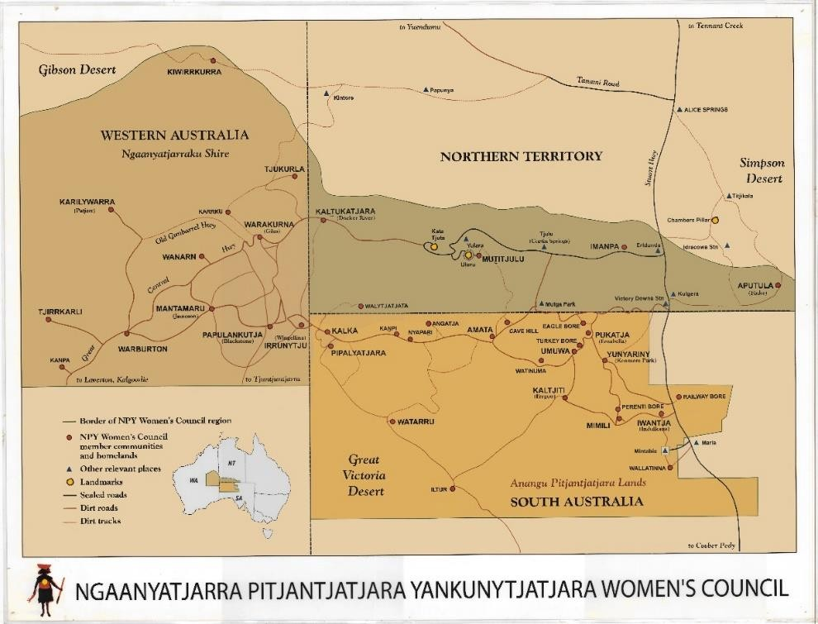

Annexure B:

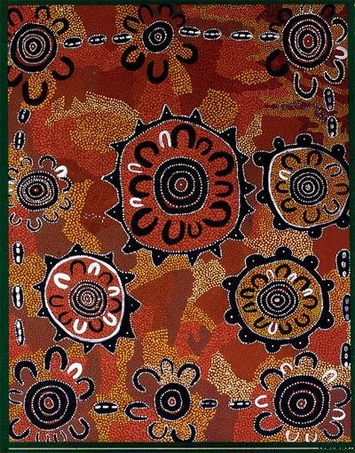
“This painting tells the story of how the NPY Women’s Council was started in 1980. I made a cassette tape and sent it around to all the communities for women to listen to. The black line going around the painting with the white marks is the cassette travelling around to all the women in communities. All the women listened to that cassette about the idea of starting up a Women’s Council. They sat down and talked together. Then we all came together at Kanpi to have our first meeting together. That is the big circle in the middle with all us women sitting around. This was the first time we came together, all us Pitjantjatjara, Ngaanyatjarra,
Yankunytjatjara women.” - Mantatjara Wilson
(deceased)

Annexure C:
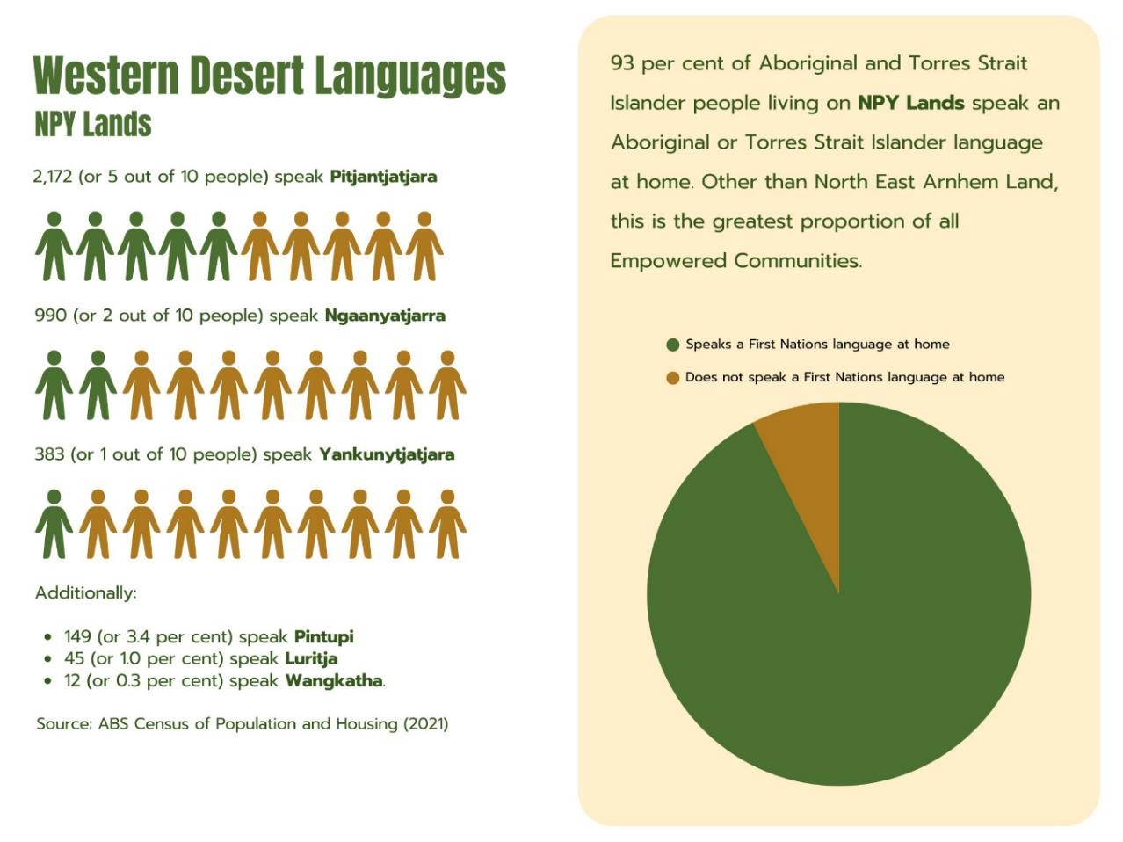
Annexure D:
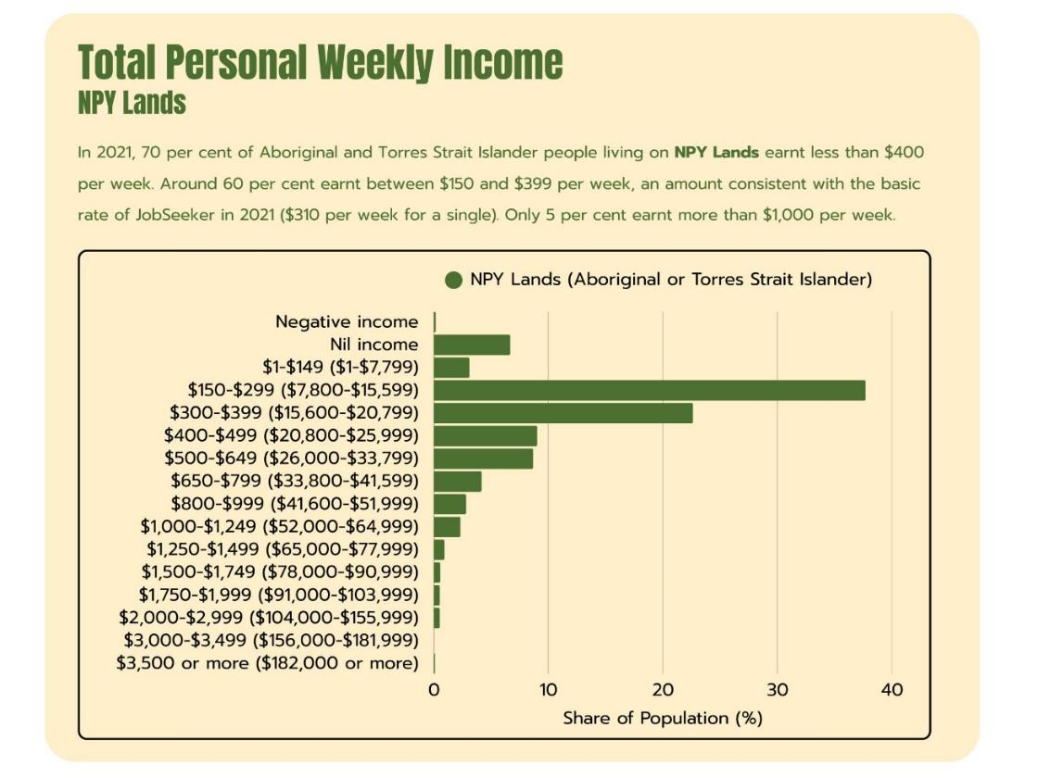

Annexure E:
