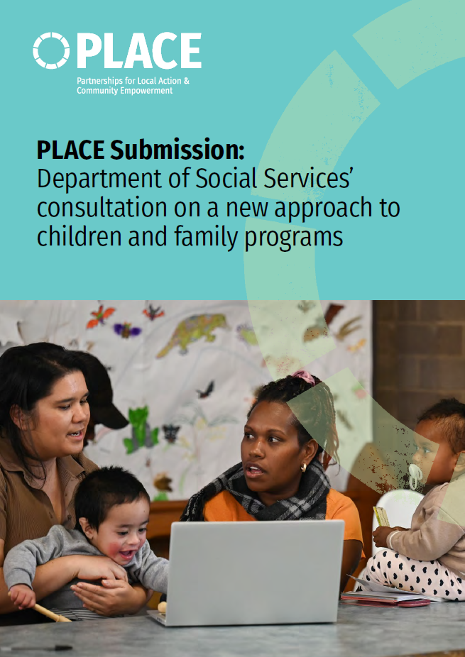
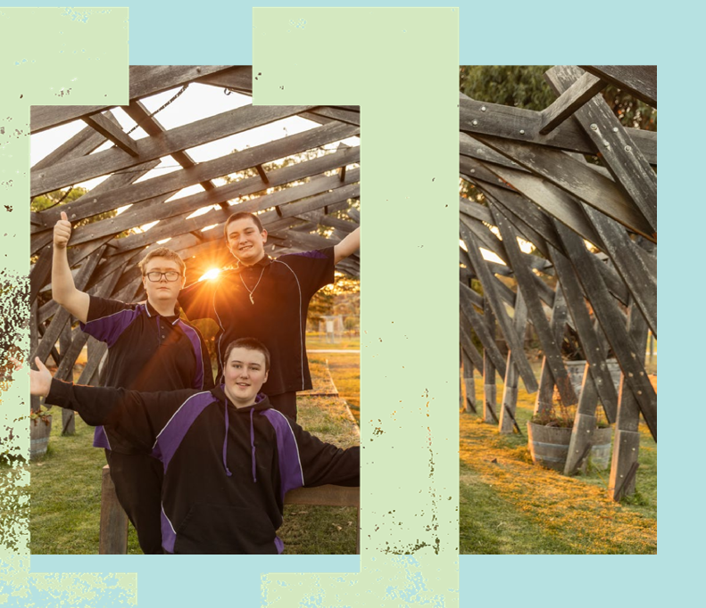
About PLACE
Partnerships for Local Action and Community
Empowerment (PLACE) is a national organisation that
champions and supports community-led approaches
to social and economic challenges.
We are a support system – a hub for shared learning,
partnership and policy innovation. Our work is
underpinned by a belief that communities know best
what matters to them, and that long-term change
starts with shared decision-making and strong local
leadership.
We exist because top-down, one-size-fits-all
approaches have consistently failed to meet the needs
of diverse communities. Despite decades of effort,
persistent disadvantage remains entrenched in many
parts of Australia. Meanwhile, communities across
the country are leading place-based initiatives that
demonstrate different approaches built on genuine
partnership and local ownership.
What’s missing is the infrastructure to connect this
work, elevate it in policy discussions, and remove the
structural barriers that constrain it.

Executive summary
Communities know best what their families and children need to thrive. Flexible, place-based and community-led programs and services that meet local needs are key to creating good outcomes, particularly for families that face complex challenges. There is strong evidence that, without community involvement and leadership, outcomes for children will continue to decline.¹
The new approach to children and family programs presents an enormous opportunity to improve outcomes for children and families across Australia. The new program, if implemented with community and with a focus on prevention and response, can deliver on the reforms flagged in the Early years strategy, Targeting entrenched disadvantage, and Community Sector Grants Engagement Framework. This could lead to a child and family service system where communities are engaged and empowered, providers work collaboratively to meet community needs, and different levels of government provide integrated governance and oversight.
This requires significantly more change than recommissioning existing programs. It requires a reshaping of the ecosystem in which service design, delivery and accountability occurs. This will involve a new approach from government to authorise and create the conditions to work with communities and providers across Australia. This will enable them to respond to local challenges and needs through collaborative commissioning, relational contracting and shared decision-making. Without this investment and effort, there are significant risks that the reforms could make outcomes worse by driving competition over collaboration, disrupting existing relationships between communities and providers, ignoring local community leadership and knowledge, increasing fragmentation by not integrating with other programs, or introducing relational contracting without the required capacity or capability.
Three horizons is a useful frame to consider these reforms²:

Horizon 1:  Current system |  | Horizon 2:  Building the foundations for our  desired future |  | Horizon 3:  Our desired future system
Where we are now |  | Focus of reforms |  | Where we want to be
Our recommendations focus on horizon 2, the actions necessary to transition from the current system to the desired future system. They complement other submissions, which focus on the full ecosystem required in horizon 3.

Executive summary
Recommendations
- Build on the strengths of existing programs by running a collaborative rather than competitive commissioning process, tailoring approaches to different places and leveraging existing, established relationships between service providers and communities.
- Ensure funding to support place-based community leadership. This recognises that sustained outcomes will only be achieved with the ongoing engagement of community at the centre of local service design, commissioning and delivery.
- Ensure that program performance and learning frameworks value the role of community within design, delivery and commissioning.
- Use relational approaches – including collaborative commissioning, relational contracting and shared decision-making – to deliver value for the communities in most need. This can be achieved by drawing on organisations with existing capability and actively learning to build national capability over time.
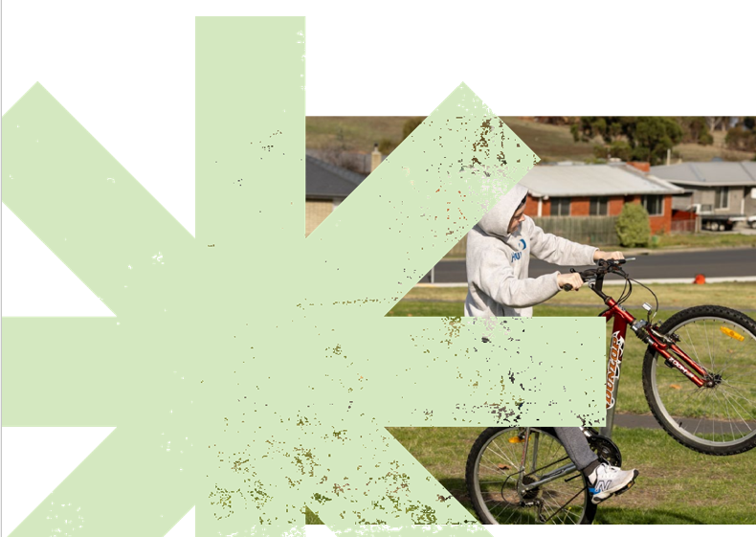
- Extending the implementation timeframe by 6-12 months to enable investment in building DSS’s core function and capability to act as system steward, to work with commissioning bodies, and to support relational contracting.

Strengths of place-based approaches used in current programs
Case study: Communities for Children
Facilitating Partners
The Communities for Children Facilitating Partners (CfC FP) program has been shown from both program-wide and providerspecific evaluations to be cost effective and to contribute to improved child, youth, parenting and community outcomes³, with a community focus and flexible service delivery to meet local needs.
Program evaluations highlight that there is variability in community engagement between Facilitating Partners: the best outcomes are generally achieved in communities where Facilitating Partners are well-known to community, have administrative support and can build on pre-existing interagency collaboration. Without these factors, Facilitating Partners struggle to build good momentum in community.
During consultation, Facilitating Partners highlighted that despite a high reporting burden, the work of collaborating with communities and coordinating services is not valued within program performance frameworks. This is a critical issue, as this qualitative data is a critical element within any relational contracting model and has primary relevance to the delivery and impact of programs.
In the context of these reforms, there is an opportunity to build on the strength of existing, well-established Facilitating Partners with strong connections to community, and support
capability-building for others. Better reporting and data management systems should be considered. This will allow providers to share successes that are important to communities and inform program-wide iterations and policy development.
The five programs that are proposed to be included in these reforms have demonstrated significant strengths and success in supporting families and children, and any large-scale program reform needs to build off these strengths or risk losing the progress that has been made. Many service providers delivering these programs have built strong relationships with communities and use a partnership approach to planning and delivering services. Some also play a crucial role in integrating Commonwealth, State and local government-funded programs, making it easier for communities to access the services they need in a fragmented system.
This community-led, place-based approach to service delivery is key to improving outcomes for children and families and needs to be built into any program reform. The relationships and social infrastructure that support this cannot be built overnight, particularly with families that may have a historical distrust of government and service providers. Significant alterations to how these programs are delivered needs to be done in partnership with community or it risks damaging the social infrastructure and community leadership that has been critical to success.
Some particular strengths of the current approach that should be built into program reform include:
- Strong community engagement, with some sites maturing to community leadership.
- Flexible, local commissioning of services.
- Coordination of state and federally funded services to meet community needs and drive service system integration.
- Tailoring approaches to different communities: some communities may be best served by one provider delivering multiple programs, others by a range of providers.
- Targeting demand to communities in most need.
Community-led approaches to supporting

children and families
Community-led program and service design and delivery is the key to sustainably delivering better outcomes for vulnerable children, families and the communities that support them. Communities bring knowledge about local priorities, service gaps and barriers to access, as well as trusted relationships, that are all critical to deliver the intended outcomes. The program budget must include dedicated funding for community engagement and capability building to participate as required.
The new program should place community leadership at the centre and support communities to build their leadership capacity. This will look different in different communities, depending on the maturity of existing initiatives:
- Communities with mature place-based initiatives
(including Stronger Places Stronger People and Empowered Communities) and CfC FP sites with strong community leadership should lead and own local program design and delivery in partnership with local providers.
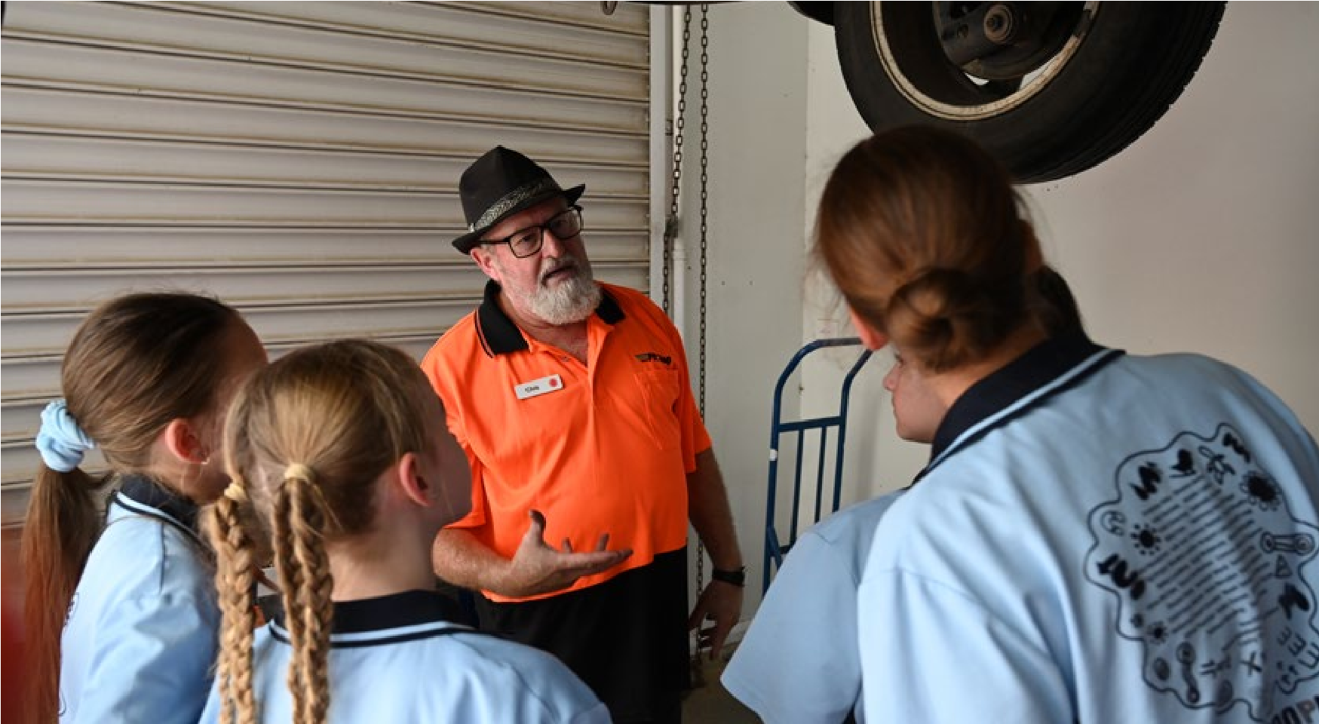


- Communities with emerging place-based initiatives and some community governance and integration, such as CfC FP sites with less established community partnership models, should be engaged on local co-design of program delivery and supported to continue to build their capacity and governance.
- Communities without place-based initiatives should be consulted on service design and supported to build capability and organise community-led governance, with providers adopting place-focused approaches to delivery.
Community leadership can also drive local service system integration across the large number of mainstream and specialist services funded by different levels of government working to support children and families. This is already happening across Australia, with many place-based organisations, CFC FPs and backbone organisations working to coordinate funding from multiple sources and make it easier for families and children to navigate a complex and fragmented system. This includes working collaboratively to highlight and respond to local workforce challenges. While government can and should improve service coordination between portfolios and levels of government, it is important to acknowledge that this work is already happening at the community level and is driven by local leadership and relationships.

Relational commissioning, contracting and

shared decision-making
Traditional approaches to awarding and managing grants rely on competitive markets, individual agency and a high degree of trust in government and providers. These approaches will not deliver enough flexibility to adapt program design and delivery to local contexts for many communities. Instead, more relational approaches are needed, such as local collaborative commissioning, formal relational contracting and shared decision-making.

For providers, this means having sufficient data collection and transparency and accountability processes in place to share detailed progress against outcomes, as well as resources to allocate to regular contract management discussions.
Shared decision-making: when communities have real authority over decisions that affect them, not just input or consultation⁶.
For example, the community of Millgrove in the Yarra Valley in Victoria identified the need for a community resilience plan due to the risk from both fire and floods. The Millgrove Residents Action Group (MRAG) partnered with experts and philanthropists to work together with the Millgrove community over 14 months to identify and prioritise actions that the community could take. As the resulting resilience plan was generated through shared decision-making, it has strong community and stakeholder endorsement and MRAG have already delivered projects to increase Millgrove’s resilience to natural disasters.
Relational Approaches
Collaborative commissioning: the practice of organisations working in partnership to plan, procure, coordinate and evaluate services for their local communities.
For example, Birthing in Our Communities (BiOC) provides culturally informed maternal and infant health services for Aboriginal and Torres Strait Islander families in Brisbane. It is a partnership between an Aboriginal Community Controlled Health Service and public and private health services, featuring Aboriginal and Torres Strait Islander governance and oversight and integrated service delivery. By working together to plan, design, coordinate and evaluate services, BiOC performs better on a range of indicators at a lower cost than standard care.
Formal relational contracting: legal agreements with governance rules prioritising flexibility to achieve outcomes and promoting cooperation between purchasers and service providers⁵.
Relational contracting is beneficial when significant flexibility is needed to meet community needs. It does, however, require specific capacity and capabilities from both the purchaser and provider. This includes additional time and a willingness to build in greater accountability and transparency by both the purchaser and the provider. For purchasers, this means having sufficient resources to allocate to contract management, as well as an authorising environment that enables the shared governance structures that underpin relational contracting.
These relational approaches are mutually reinforcing. While they can be beneficial on their own, together they have the potential to be transformative for communities, families and children by creating and leveraging long-term, trusted relationships to deliver outcomes with openness and provide flexibility to adapt as conditions change.
These approaches require significant time and investment to develop capability in new ways of working. Across Australia, experience in collaborative commissioning and relational contracting is still growing and is mostly informal. Organisations that have this experience include:
• Primary Health Networks (PHNs), who have expertise working with communities to commission and coordinate place-based integrated service responses, and who are increasingly investing in initiatives that tackle social determinants of health and disadvantage, including for children and families.

Relational commissioning, contracting and shared decision-making
- National Indigenous Australians Agency (NIAA), who share decision-making with Indigenous communities, especially through Empowered Communities partnerships.
- Some local governments and state and territory government departments, noting the large diversity in capability and approaches, with informal relational approaches often being used as part of managing traditional contracts.
- Some community sector organisations that support placed-based initiatives or deliver strong community-informed Facilitating Partner roles, noting that relational commissioning and contracting is best performed by an organisation not delivering services in a local community.
By working collaboratively with these organisations, DSS can help grow national capability for formal collaborative commissioning and relational contracting, while leveraging and strengthening local relationships.
Providers may also need support to build their capability to participate in relational approaches, especially smaller organisations and Aboriginal Community Controlled Organisations (ACCOs).
Relational contracting makes sense where there are complex issues and factors impacting on program delivery, and where service providers, funders and community need to work together to amplify what is working well and make changes where impact is not being achieved. Relational contracting is common in the private sector for complex projects, including multi-party contracts. In the context of the children and family program reforms, these models are most appropriate where there are significant challenges, such as entrenched disadvantage, inequality and low participation. Communities with these factors should be prioritised for commissioning and relational approaches while national capability is being grown, ensuring value for the extra investment required in these approaches.
Relational approaches need to start with commissioning, ideally building on trusted relationships with the local community. Prior to being selected for funding for the new program, providers should demonstrate genuine relationships with the local community and other service providers as well as a commitment to strengthen local community leadership, ideally with a range of evidence including community referees. While this may favour existing providers with strong local relationships, this reflects the value for money available by building from a position of community trust rather than having to build it from scratch. This is consistent with the newly released Commonwealth Procurement Rules⁷, which include requirements for ethical behaviour for both government and potential suppliers (noting that while these rules may not apply to grant processes, they represent best practice).
To be most effective, formal relational contracts should include the parties accountable for an outcome. For outcomes for vulnerable children and families, this would usually include DSS, other Australian Government departments, and could include state and local governments, and providers.
A relational contract between DSS and one provider will need to account for how each party will reasonably influence the broader ecosystem associated with the complexity of the outcome area. For example, DSS may commit to using cross-portfolio and cross-jurisdiction relationships to influence factors impacting the outcomes being targeted through the relational contract. The Department’s role could include coordinating with other Australian Government departments to bring additional investment, adjustments to policy and related program structures, and gathering and sharing the data and evidence needed to understand the range of factors impacting on the outcome area being targeted.
Relational contracts also need to explicitly require and support the role of community as central to the ability to generate significant and lasting impact in complex areas. While a formal relational contract would not usually have a community as a party, it should include requirements for providers and government such as:
- Accountability to, and engagement with, community leadership based on local maturity (as above).
- An explicit focus on building community capacity.
- A focus on coordinating and integrating local service systems to meet community needs.
- A commitment to shared decision-making with community, including building or supporting local structures and processes.
Relational approaches need to be supported with data that is meaningful to the local community, including national, state and local government data, community data, and data on relational outcomes, trends and indicators, such as families feeling safe, respected and involved in their community. Building data systems and capability along with shared understanding and interpretation is critical to successful relational approaches.
Building on the longer funding already identified, extending funding to 5 + 5 year funding (subject to satisfactory performance and community endorsement) would give community assurance of consistency, and support providers to invest and respond with flexibility to changing contexts with a relational focus on continuously improving performance.
Governance and implementation
For a reformed system delivering outcomes for children and families, based on the strengths, needs and priorities of local communities, the ideal governance would involve a network of cross-portfolio regional commissioners. They would require the capability to work in relational ways with communities, providers and all levels of government. This horizon 3 will take years to develop and should adapt and respond as capability is built across the system.
A pragmatic approach to beginning this reform journey (horizon 2) would involve DSS:
- Ensuring enough time to implement well, build stronger relationships and avoid unnecessary disruption for children, families and communities.
- Focussing on system-stewardship, including highlevel policy, funding, coordination and capabilitybuilding.
- Leveraging existing relational commissioning and contracting capability for the communities where it will add the most value and provide lessons to inform scaling across the system.
This approach would provide support across Australia based on the current capability – including strong community leadership – while also setting up a system than can learn, build capability and improve outcomes for children and families over time. A potential phased implementation plan is included in the story of Wattlestone.

1. Timeframes
It is strongly recommended that the implementation timeframe is extended by 6-12 months to:
- Develop more clarity on the high-level program design in consultation with communities, providers and experts.
- Better coordinate with other reforms including in early childhood education and care, Thriving Kids, and state and territory initiatives.
- Allow for collaborative commissioning rather than a competitive grants process.
- Support a transition that build on and strengthens existing relationships with communities rather than disrupts them.
The timeframe and grant process announced requires providers to compete rather than collaborate, will generate proposals focussed on achieving financial and workforce sustainability rather than meeting community need, and will favour large providers with dedicated proposal-writing staff. A shift to relational ways of working requires a tailored selection process that recognises the outcomes, outputs, accountability and governance frameworks are fundamentally different in a relational model compared to the existing grants or procurement models.
Without that shift, the announced process runs counter to the aims of the reforms, any potential benefits of relational contracting and the Community Sector Grants Engagement Framework.

2. DSS as system steward
As the leading Australian government department, DSS should focus on system-level policy, funding, coordination, capability-building and data. This should be done in partnership with state and territory governments, who also invest significantly in services and supports for families and children.
Investment decisions should be based on community need and priorities as well as an understanding of existing services and supports, to avoid duplication and service gaps, noting that the current funding allocation isn’t sufficient to provide support to every community across Australia. The proposed datainformed approach to prioritisation, based on SocioEconomic Indexes for Areas (SEIFA), the Australia Early Development Census, national census data and child protection engagement rates is sound, but also needs to include insights from communities and providers. Services need to be made available to all families experiencing disadvantage, noting that up to 40% of Australia’s disadvantaged children living outside lowincome areas⁸.
DSS should be an enabler in program design. That means service design ‘with’ rather than ‘for’ communities. This looks like: supporting capability building, embedding flexibility into the program to meet community needs, ensuring timeframes and processes allow for sufficient community engagement, ensuring relevant data is available for communities and supporting learning and innovation between communities on different approaches. Some considerations for high-level program design include:
- Expanding the outcomes to reference the critical role that strong communities play in supporting children, parents and families.
- Recognising the difference between prevention and early intervention and ensuring that there is sufficient investment in prevention, noting the challenge of demonstrating improvements in outcomes.
- Identifying and addressing workforce challenges at national, state and local levels, building on local community knowledge and approaches.
In supporting the capability shifts required across the system to work more relationally, empower communities, and share decision-making, DSS can draw on expertise in organisations such as NIAA, PLACE, the Investment Dialogue for Australia’s Children (IDAC), Thriving Queensland Kids Partnership, the Australian Research Alliance for Children and Youth, the Strengthening Communities Alliance, the Possibility Partnership and member organisations who are actively working to support systemic reform and place-based approaches.

3. Priority communities for relational approaches
For streams 2 and 3 of the new program, DSS should work collaboratively with stakeholders across the system to identify the communities where relational approaches will add the most value, given the new ways of working this approach needs. This would primarily be communities experiencing significant challenges, such as entrenched disadvantage, inequality, low participation or service gaps, and is likely to include the current CfC FP communities and communities identified by IDAC.
It could also include communities where relational capability is already high due to an existing commissioner or place-based initiative.
For priority communities where there is a commissioner with relational capability, including strong community relationships, they should be allocated funding to design, commission and coordinate services, working with and building on local community leadership. There should be a balance between continuity of existing services and supports while transforming to a more community-led, integrated service system over time. Commissioners should enter formal relational contracts with providers where outcome complexity is high. As system steward, DSS should play an active role overseeing the work of these commissioners, ensuring they are engaging with community leadership and supporting them to generate lessons and evidence on relational approaches that can be shared to build capability across the system.
For priority communities where no commissioner is identified, DSS should commission services, working with local community leadership where this exists. These communities should also have explicit plans in place to build capability of both community leadership and collaborative commissioning. The contracts with providers should be for 5 years with an additional 5 years available depending on performance and community engagement but should also have flexibility to be transferred to a collaborative commissioner during the life of the contract. While DSS could enter into formal relational contracts with providers for these communities, this needs to be balanced against DSS’s capability and capacity for relational contracting.

Providing support across Australia
Following this model, support across Australia would involve:
- DSS working with state and territory governments on system leadership, policy, funding, coordination and capability building, especially identifying and supporting collaborative commissioners across the country.
- DSS commissioning stream 1 services.



Governance and implementation
services.
• DSS commissioning stream 2 and 3 services for
priority communities, with the aim to transition
to a commissioner once this capability has been
developed.
• DSS commissioning stream 2 and 3 services for
other communities across Australia, noting that
some vulnerable children and families may be best
supported by providers working across multiple
communities (eg. children and families living in less
disadvantaged communities).
This is likely to reduce the number of grants that DSS
is managing, as some commissioning organisations
would likely support more than one community.
Over time, grants would be transitioned from DSS to
commissioners as capability grows across the system.
• Commissioners working with priority communities to deliver community-led, place-based support to children and families across streams 2 and 3

Bringing program reform to life: a story from one place with phased implementation

To understand how phased implementation of a place-based approach to a new program for families and children could work in practice, let’s consider Wattlestone, a fictional regional town. It has pockets of deep disadvantage, a large First Nations population, and a growing number of young families. The town is home to several local service providers delivering DSS, state and locally funded programs. Providers have good community relationships who work together through a local working group to coordinate services, but there is no backbone place-based initiative or CfC FP. The PHN for the region has some experience commissioning place-based approaches for other communities and coordinating health services in Wattlestone. Many families are getting support, but others face barriers to access. There are service gaps and coordination could be improved.
Under the announced reforms the following scenario is likely in Wattlestone and similar communities:
- Current providers of DSS services begin preparing for a competitive grant and for the likelihood that only one provider per region will be funded by DSS from 2027, possibly a large provider not currently delivering services. Engagement with community and collaboration grind to halt as services focus on the grant application, and business contingencies like workforce and leases. Some of the best staff, recognising this familiar cycle, leave Wattlestone for larger providers with more certain funding. This impacts local services and the trust of the Wattlestone community declines.
- One of the existing local providers wins the DSS contract for family and child services in Wattlestone from 2027. While this provides some continuity, it also causes disruption. Other providers are no longer financially viable without DSS funding. As there is a limited workforce in Wattlestone, staff move from one provider to another or leave the community altogether, causing disruption due to different cultures and conditions.
- While some Wattlestone families like the successful provider, other people prefer the cultural approach of the unsuccessful providers and consider withdrawing from services altogether.
- Through the formal relational contract, the provider considers that it does not receive sufficient funding to invest in the training, systems and support needed to achieve the desired outcomes. They approach their relational manager in DSS to share additional information about how they resource and invest in their services, their approaches to managing operational challenges and engaging the community. While this gives DSS an insight into the challenges the provider is facing, the resourcing issues sit within the state government’s responsibilities. The impact of the relational model is limited because it does not draw in other critical stakeholders, including other providers, state and local government.
- The transition disrupts community engagement and service coordination during 2027, and outcomes for children and families worsen over several key indicators. This begins to improve in 2028 as new arrangements are established and stabilise.
- The long-term impact of the reform is to maintain outcomes, with gaps in services and coordination remaining and marginal improvements for families facing barriers to access. The community’s trust in the successful provider is slowly improving from a low point following the disruption in 2026 and 2027. DSS and the successful provider have more streamlined reporting with greater effort spent on relational contracting rather than compliance, while other providers, state and local governments have reduced their efficiency.
Bringing program reform to life: a story from one place with phased implementation
A different approach is possible for communities like Wattlestone through a phased implementation of collaborative commissioning and place-based approaches.
Phase 1. Prioritisation and governance: February – April 2026.
DSS announces a further 6-month extension of current arrangements and a collaborative commissioning approach for priority communities. Appropriate commissioners for the priority communities are identified, including a mix of PHNs, state and territory governments, local governments, and NIAA for some indigenous communities. DSS also sets up a governance group with the state government and community, to provide joined-up guidance to commissioners and support local service coordination and integration.
Wattlestone is identified as a priority community. The local PHN (the commissioner) agrees to collaboratively commission services for three local communities, including Wattlestone. DSS allocates funding to the PHN for services, commissioning and building community capability and leadership.
The commissioner starts work to engage with community on the need, understand the existing services landscape and demographics.
Phase 2. Preparation: May 2026 – August 2026
DSS works with the state government and commissioner to develop the parameters and outcomes of the services they are commissioning, while they also develop the reporting and data governance frameworks and systems.
In Wattlestone, the PHN works with the community to build their capacity to engage in co-design of services. This includes working with diverse community members, including local Aboriginal Elders, to build their trust in the PHN, between each other, as well as their understanding of the scope of DSS services being commissioned. At the conclusion, the PHN has established a community advisory board with broad representation from across the community and mechanisms to hear from everybody. The PHN provides a small amount of backbone funding to support the board.
The PHN also works with existing providers to understand the current services, while drawing on their knowledge from working with health providers in Wattlestone and other providers in the region.
Phase 3. Co-design: September – December 2026
In Wattlestone, the PHN lead co-design of the new services with the community and local providers, including providers of related services not funded by DSS (including education, employment and health services). In addition to designing the DSS-funded services, by drawing on the community knowledge, lived experience, broader expertise and consolidated data, the co-design process also:
- Identifies that some of the barriers to access for Wattlestone families include lack of transport options, lack of trust in service cultures, and lack of awareness of childhood development indicators.
- Plans to address these barriers through a mix of the services to be commissioned, changes to practice in other services, and community-led initiatives including volunteer-run carpooling and community visiting programs.
- Identifies that Wattlestone families have different cultural preferences for services and would prefer a choice of service providers rather than fully integrated services.
- Identifies duplication in services funded by different governments and opportunities for improved coordination with information-sharing based on consent.
The end result of the co-design process is a mix of current and new services from providers and the community, improved coordination, and agreements to new ways of working. The PHN supports the group to reach consensus on the service design as well as how they will hold each other to account not just for services but for practice and behaviour commitments.
This co-design process is supported by DSS and the state and local governments, which allow their funded services to fully participate and share data and insights with the PHN in the interests of the best outcomes for the Wattlestone community.
Phase 4. Commissioning: January – June 2027
In Wattlestone, the PHN commissions services according to the agreed service design, which includes:
- Extending funding for existing services, where it is clear that the current providers are the only ones who can effectively deliver (e.g. where the co-design valued existing relationships).
- A competitive process for newly identified services and some existing services to ensure the best providers are delivering for Wattlestone.
- Entering into formal relational contracts for all providers, aligned to the outcomes and accountability measures agreed to in co-design.
- Coordinating services across providers.
- Continuing to support the community advisory board and backbone as they establish communityled services and recruit and support volunteers.
Phase 5. Implement and deliver: July 2027 – June 2032
In Wattlestone, providers deliver existing and new services as well as making the practice and behaviour changes needed to support the community codesigned model. Following the co-design process, community trust in services has increased, leading to more people accessing services as well as an increase in volunteering.
The PHN brings the community advisory board and providers together regularly to monitor progress and track agreed outcomes, while building capability in evaluation and data analysis so that all can participate equitably.
It is not all smooth sailing. Some state-funded providers commit to changing practice and behaviours as part of the co-design process, but do not allocate any funding for developing new processes or training staff. A new provider does not deliver the services at the quality intended because they underestimated how much it would cost. All providers continue to have workforce challenges. After an initial burst of enthusiasm, volunteer numbers drop off. These issues are discussed by the group and the PHN leads strategies to address them through the relational contracts, backbone support, and where necessary escalating to the state government and DSS.

Overall, though, outcomes are positive, both in state and commonwealth government data, in community access and participation, and in community satisfaction. Over the next 5 years, relationships deepen in the community and between providers, enabling more transformative change as the system matures. The PHN shares the lesson delivering this approach across three different communities with DSS and the state government, building the capability of the entire system.

- Geatches, L., Preston, C., and Putnis, A. for Equity Economics and Development Partners, 2023, Where are we? Place-based approaches to tackling community challenges in Australia. Where are we? Place-based approaches to tackling community challenges
in Australia
- NPC, 2025, The Three Horizons Framework. The Three Horizons Framework - NPC
- Department of Social Services, 2024, Families and Children Activity: Review of Children, Youth and Parenting Programs. https:// engage.dss.gov.au/wp-content/uploads/2024/11/families-and-children-activity-review-children-youth-and-parenting-programsevidence-paper.pdf
- Productivity Commission, 2025, Interim report – Delivering quality care more effectively. Interim report - Delivering quality care more efficiently | Productivity Commission
- The University of Melbourne, 2025, Collaborative Commissioning & Formal Relational Contracting – What’s the difference and what are the likely benefits? Item - Collaborative Commissioning & Formal Relational Contracting – What’s the difference and what are the
likely benefits? - figshare - Figshare
- PLACE, 2025, Sharing the power to make change: A guide to shared decision-making, to be available at www.placeaustralia.org 7. Commonwealth Procurement Rules 2025
8. https://www.theguardian.com/australia-news/article/2024/jul/13/up-to-40-per-cent-of-australia-disadvantaged-children-liveoutside-low-income-areas-study-finds and Measuring vulnerability and disadvantage in early childhood data collections phase two


PLACE Submission:
Department of Social Services’
consultation on a new approach to
children and family programs
Acknowledgement of Country
PLACE acknowledges Traditional Owners of Country throughout
Australia and recognises their continuing connection to lands,
skies, waters and communities. We pay our deepest respects
to Elders past and present and extend that respect to all
Aboriginal and Torres Strait Islander peoples.
We acknowledge that systemic inequities continue to impact
First Nations communities disproportionately, and that these
are the result of colonisation, dispossession and historical
injustice that persist in current systems.
The work of PLACE is grounded in a belief that those closest
to the challenges must be central to the solutions. In this, we
recognise that Aboriginal and Torres Strait Islander peoples have
long practised community-led, place-based governance and
decision-making.
We are committed to walking alongside First Nations
communities in a spirit of respect, learning and shared
leadership, amplifying their voices, supporting self-
determination, and embedding equity in all we do.

