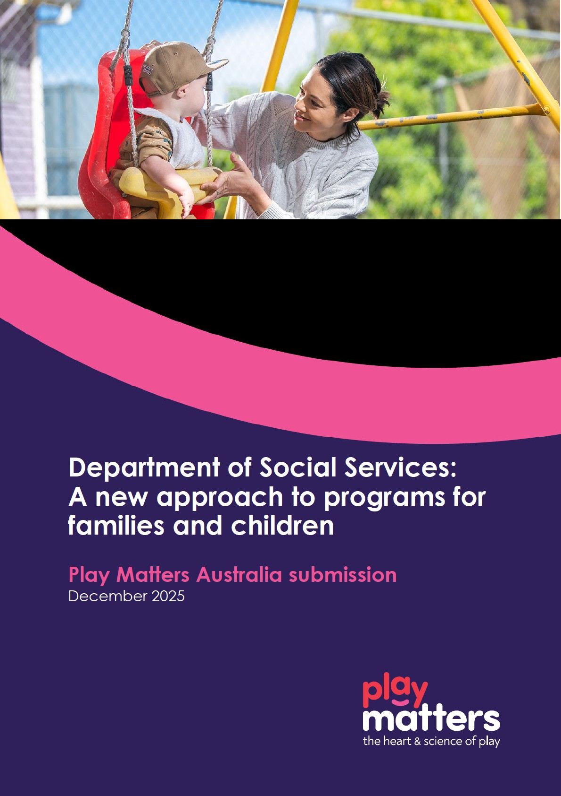

Executive Summary

Play Matters Australia welcomes the opportunity to contribute to the discussion on reforming investment in family and community services. Our submission reflects insights from extensive service delivery experience and engagement with families across diverse communities in Australia.
We strongly support the principle that all children and young people deserve equitable access to high-quality play and connection opportunities, as these are foundational to wellbeing and resilience. Play Matters’ evidence-based programs adopt a whole-of-family approach, building protective factors and strengthening relationships to mitigate disadvantage.
In response to the discussion paper A new approach to programs for families and children, Play Matters offers the following feedback:
- Equity through early investment: Investment strategies ensure all children have equitable access to high-quality play, place-based, multi-generational interventions that strengthen family wellbeing and break cycles of disadvantage.
- Community-centric outcomes: Current frameworks emphasise individual outcomes; Play Matters advocates for a stronger focus on community capacity building and integrated service models that foster safe, resilient communities.
- Genuine partnerships with Aboriginal and Torres Strait Islander communities: Partnerships that enable shared decision-making with Aboriginal and Torres Strait Islander communities, and accountability to Closing the Gap reforms must guide funding and service implementation.
- Service integration and streamlining: While the proposed three-stream reform offers potential for simplification, alignment with other early years initiatives and careful management of administrative burden are essential.
- Sector sustainability: Workforce development, access to community infrastructure, adequate time for relationship-building and service integration require dedicated funding and longer-term contracts to ensure continuity and quality.
- Flexible funding models: Relational contracting and extended funding periods will enable services to adapt to evolving community needs and maintain trust with families and communities.
- Meaningful outcomes measurement: Current quantitative metrics do not fully capture impact. Play Matters recommend incorporating qualitative approaches to reflect real outcomes for families and communities.
Play Matters urges that reforms prioritise collaboration, flexibility, and sustainability, ensuring families can access the right supports at the right time through a cohesive and connected service system.

Play Matters Australia
Operating for over 50 years, Play Matters was founded in Brisbane, Queensland, and now operates nationally as a not-for-profit organisation with a vision for Playful Connected Communities.
At Play Matters, we recognise families as their child’s first teacher and focus on enhancing parent-child relationships by building family capabilities and confidence. Our programs and services are designed with this foundational principle in mind, delivering both universal and targeted support that is place-based, culturally responsive, and grounded in evidence-based methodologies.
Our comprehensive suite of services ranges from universal volunteer-led playgroups, supported playgroups, peer parenting support, early years navigation, inclusion programs, and specialist therapeutic services. Play Matters also deliver the evidence-based Sing&Grow program, with a team of dedicated Registered Music Therapists across every State and Territory in Australia.
In 2024-2025, Play Matters:
- Operated in over 403 postcodes across Australia
- Actively engaged more than 15,000 Queensland families through playgroups and online resources
- Supported over 300 active volunteer playgroup facilitators
- Delivered over 320 Sing&Grow programs to over 8,200 families and workers, including in some of Australia’s most culturally diverse communities in Mirrabooka (WA), Miller in (NSW) and Inala (Qld).
- Delivered and supported playgroups across Queensland with a wide range of communities, including inclusion-focused, intergenerational, LGBTIQ+, culturally and linguistically diverse (CALD), First Nations and rural and remote groups. In communities from as far north as Horn Island in the Torres Strait to Coolangatta on the NSW border.

Response to A new approach to programs for families and children.
Play Matters appreciates the opportunity to provide feedback on the Department of Social Services’ (DSS) discussion paper A new approach to programs for families and children.
Our feedback is focused on seven areas for priority:

Priority 1 : Equity though early investment

- All children and young people should have equitable access to high quality play and opportunities for social connection.
- Play Matters’ programs and services strengthen protective factors and resilience through a place-based, multi-generational approach that works with both the child and their family, including parents, carers and grandparents.
- Equitable access is provided through proportionate universalism, whereby families can be supported by interventions that are scaled and intensified as their needs change (upward and downward).
- Early intervention is critical to improving family wellbeing and breaking cycles of disadvantage.
- Place and intersectionality must be considered when responding to the needs of contemporary families.
- Families require timely access to appropriate supports through a cohesive and connected service system, that is easy to navigate.
- CALD families are acknowledged to be less likely to access services than the general population as articulated in the DSS 2024 “Evidence paper”. Despite this, the proposed outcomes do not speak to improving outcomes for CALD families.

Priority 2: Community-centric outcomes

- As currently framed, the two stated outcomes lean toward individualistic outcomes. Community-level outcomes such a capacity building and social connectedness must also be explicitly embedded and prioritised.
- Safe and resilient communities are essential, supported by peer networks for children and their families.
- Wellbeing should be considered holistically, referencing research such as ARACY’s The Nest.
- Integrated service models should focus on layered, evidence based supports rather than solely physical hubs. The integration of services and ensuring families can access the right supports at the right time is crucial in meeting the needs of children and families.
- Funded activities need adequate time during business-as-usual and throughout the length of contracts to do the deep work to understand the communities they work with, and the changing needs of communities. It takes time to build relationships and trust. The cost of service integration and relationship building must be recognised as a foundational part of funded practice.
- Strategic coordination across regions and systems is vital to avoiding siloed service delivery, and to ensure sector cohesion. Consideration needs to be given as to how services will work together across regional areas to ensure a cohesive connected service system for families. Without this strategic oversight there is a risk of further perpetuating and exacerbating the siloed nature of services and not building a coordinated connected system response.

Priority 3: Genuine partnerships with Aboriginal and Torres Strait Islander communities:

- A commitment to genuine partnership by listening and walking alongside Aboriginal and Torres Strait Islander communities are vital in ensuring the needs of organisations and communities are understood and a funding process can support their success.
- Meaningful partnerships that enable shared decision making with Aboriginal and Torres Strait Islander families, Elders and communities takes time, and it may take longer to implement services in some communities.
- Implementation and accountability of to the Closing the Gap priority reforms, including building the ACCO sector and improving data sovereignty at a local and regional level, should inform the investment and contracting process.

Priority 4: Service integration and streamlining

- The current reform into three streams offers potential for flexibility and process simplification; however, further detail is needed. For example, reporting under one stream may simplify some processes (such as child safety compliance statements), however increased DEX reporting requirements risk adding administrative burden. This may have a net impact on increasing time on administrative tasks, when coupled with the increased child safety compliance obligations.
- Alignment with other early years reforms, such as Thriving Kids, must be clarified to ensure seamless family access to supports. The discussion paper does not fully articulate how it will be integrated within the broader social service-system and policy landscape.

Priority 5: Sector sustainability

- There is limited access to appropriate physical infrastructure within the community which restricts service delivery and engagement opportunities.
- Capturing impact data for community engagement activities is challenging under the current DEX reporting frameworks. Community engagement is foundational to establishing rapport and trust in a service, however effectively measuring and reporting on these activities with the existing DEX protocols is complex and doesn’t represent the time and effort required, nor the impact or value of these activities.
- Workforce development requires dedicated funding for training and resources. Workforce development must also include adequate time and resourcing for mandatory child safety training, consistent with State and Territory Child Safe Standards and the National Principles for Child Safe Organisations. Embedding this training into funded practice is essential to ensure compliance and safeguard children.
- In addition, workplace health and safety obligations require ongoing training and risk management, which must be recognised as part of business-as-usual service delivery costs. Dedicated funding and realistic timelines are critical to enabling organisations to meet these compliance requirements while maintaining continuity and quality of services.
- Volunteers are an incredible untapped resource for the social service sector that require investment in their support, recognition and management. Volunteers are also required to meet child safeguarding and workplace health and safety obligations.
- There is widespread sector concern about the timeline of implementation for the reformed program. The current stated extension to 31 January 2027 is impractical. With the majority of organisations developing budgets by financial year, having funding certainty only partway through a financial year does not support sector sustainability. Moreover, the short implementation timelines and ongoing funding uncertainty may negatively impact workforce retention and service continuity for children and families. More time for a change or winddown of services is required to best support families accessing services. We recommend extending current contractual arrangements to 30 June 2027 to better support families and sector sustainability, and to better support the implementation of the reformed DSS approach.
- The discussion paper lacks operational detail, limiting the sector’s ability to provide informed feedback on the proposed changes. Moreover, the tender process must support the continuity of service, particularly in communities with embedded and trusted providers. Unnecessary service disruption must be avoided.

Priority 6: Flexible funding models

- Relational contracting approaches are promising, and would enable responsiveness to evolving community needs including adjustments to service mix and location.
- Longer term funding arrangements are essential for building and sustaining relationships in the community. It is important to note that the longer the grant agreement, the more critical it is for annual indexation to be applied to appropriately reflect the increased costs of service delivery.
- The cost of service delivery in rural, regional and remote locations is significantly higher than metro locations. Relational contracting as a concept is promising for organisations to flex funding allocations to be appropriately funded for service delivering in these locations.
- Consideration must also be given to the needs of remote and regional workers, who often face higher service delivery costs, longer travel times, and travel expenses. Limited access to physical infrastructure and connectivity challenges further add to these pressures, making recruitment and retention sometimes difficult in these areas. Flexible funding and longer-term contracts are important to support workforce stability and ensure service continuity in rural and remote communities.

Priority 7: Meaningful outcomes measurement

- DEX SCORE outcomes are limited in their ability to fully capture the impact on an individual and at a community level.
- We recommend impactful qualitative approaches such a Most Significant Change, or Stories of Change, to demonstrate the meaningful impacts services have on families and to supplement the quantitative nature of DEX reporting.
- Consider the importance and value of quality over quantity. For example, small communities where you can have a big impact on outcomes are an important consideration. It isn’t always about numbers.

To deliver meaningful investment reform for families and children, the approach must prioritise equity through early investment, embed community-centric outcomes, genuine partnerships with Aboriginal and Torres Strait Islander communities, streamline service integration, ensure sector sustainability, and adopt flexible funding models. These actions will create a connected, responsive social service system that strengthens family wellbeing, supports resilient communities, and delivers lasting impact for children and families.

For further information please contact:

