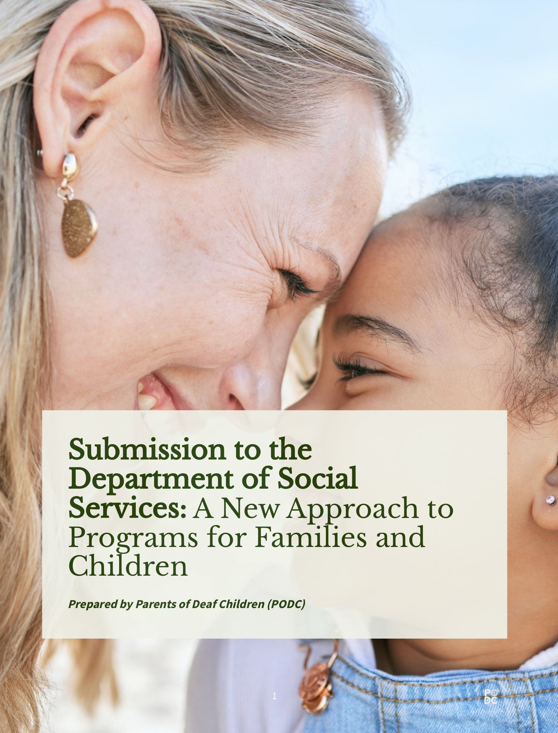

Table of Contents
- Introduction: Building a Child and Family System That Works for Everyone 3
- Response to the Consultation: Key Themes and System Opportunities 7
- Equity and Inclusion Across the New Program Structure 12

- Priority Populations: Ensuring No Child Is Left Behind 19
- Designing Services That Work: A Solutions-Focused Response 23
- Measuring What Matters: Outcomes and Evaluation 26
- Recommendations 29
- Conclusion: A Future Built on Equity, Dignity and Access for All Families 34
9.Key References 36
- Introduction: Building a Child and Family System That Works for Everyone

Australia has the opportunity—through this consultation—to strengthen a child and family system that genuinely supports every child's development, wellbeing and full participation in community life. For Deaf/ deaf children, this means ensuring the foundations are in place early: access to language, access to communication, and access to inclusive environments that enable them to thrive. For their families, it means having clear pathways, timely support, and services designed with accessibility and equality at their core.
The experiences of families demonstrate that when systems are responsive, coordinated and inclusive, children flourish. This submission brings a constructive lens to the consultation, highlighting practical opportunities to build on what is already working well, address gaps, and ensure that reforms uplift rather than fragment the supports available to families.
  - About Parents of Deaf Children (PODC)
Parents of Deaf Children (PODC) is a long-standing, parent-led organisation supporting families of Deaf/ deaf children in NSW and the ACT for more than sixty years. We work with families who use Auslan, spoken English, and bimodal-bilingual approaches—supporting each child's and family's communication choices with respect and openness.
PODC is funded through the NSW Disability Advocacy Futures Program (DAFP), which enables us to provide independent, community-based advocacy that is grounded in lived experience and informed by strong evidence. This positioning gives us unique insight into both the challenges families face and the solutions that consistently make a positive difference.
Our work spans:
    - family capacity-building, peer education and support navigation assistance across health, early intervention, education and NDIS systems information provision tailored to diverse communication needs
    - systemic advocacy and policy contributions, shaped by real-world experience. We approach this consultation with a strong commitment to collaboration. Families, practitioners and policymakers all share a common goal: ensuring that Deaf/ deaf children have every opportunity to learn, participate and succeed. PODC offers this submission in that spirit—highlighting effective pathways, amplifying lived experience, and identifying where system design can evolve to better support children and families.
  - Purpose of This Submission
The purpose of this submission is to contribute constructively to the redesign of Australia's child and family system, ensuring it is inclusive, responsive and capable of meeting the needs of all children—including those who are Deaf/ deaf. Our recommendations focus on practical enhancements that strengthen early support, reduce avoidable barriers, and ensure families can access services that reflect contemporary evidence and human rights principles.
4

  - Our Commitment to Child Rights, Equality and Accessible Family Support
PODC is guided by the belief that children thrive when systems protect their rights, respect their identities and uphold their access to language and communication. We recognise that families are central to children's wellbeing, and that accessible, culturally safe and timely services play a decisive role in shaping developmental outcomes.
Our approach is strengths-based: we highlight opportunities, encourage collaboration and seek to reinforce the positive outcomes already demonstrated in Deaf-inclusive practice across Australia.
  - Why This Consultation Matters for Deaf/ deaf Children and Their Families
This consultation is significant because it allows for a more coordinated, equitable and future-focused approach to supporting children and families. For Deaf/ deaf children, early access to communication and connection is critical. Families often navigate multiple systems at once, and small improvements in design can have substantial positive impacts.
Through this process, there is an opportunity to:
    - strengthen early and ongoing access to language ensure parenting and family support programs are accessible from the outset improve coordination between health, early childhood, education and disability sectors promote consistent, evidence-informed pathways for families embed lived experience insights into ongoing system design
These are practical, achievable shifts that build on existing strengths and help ensure all children can participate on an equal basis with their peers.
  - Alignment With Australia's Human Rights Obligations (CRPD, CROC, NDS)
This submission aligns with Australia's commitments to:
    - the Convention on the Rights of Persons with Disabilities (CRPD) the Convention on the Rights of the Child (CROC)
    - Australia's Disability Strategy (N DS)
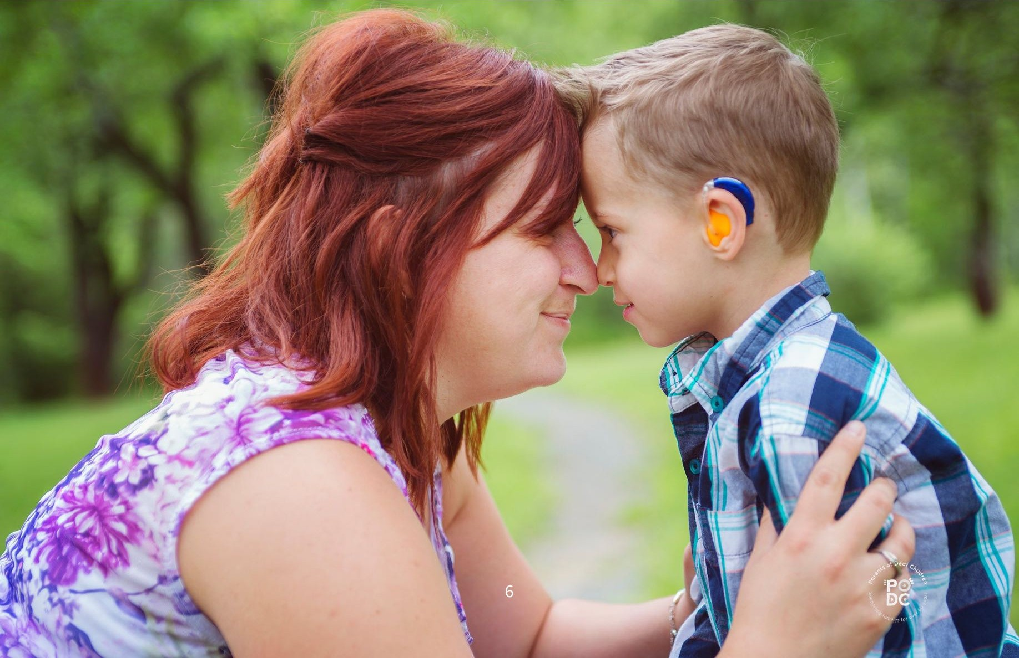
These frameworks emphasise accessibility, early support, inclusion and the right of every child to develop their full potential. They guide our solutions and reinforce the shared responsibility across government and community to build a system where children and families are supported early, consistently and with dignity.
This submission aligns with the Department's system design principles of prevention, accessibility, integration, and meaningful partnership with communities, and proposes practical measures to embed these principles for deaf and hard-of-hearing children and their families.

2, Response to the Consultation: Key Themes and System Opportunities
This consultation invites a national conversation on how we can build a child and family system that is more accessible, preventative, coordinated and responsive to the diverse needs of children and families. The experiences of Deaf/ deaf children and their families provide clear insights into what strengthens systems—and where achievable improvements can create significant, long-term benefits.

2.1 Summary of Consultation Aims
The consultation asks how the child and family system can be redesigned to deliver:
earlier and more effective support stronger coordination across sectors equitable and accessible services for all families a workforce with the capability to meet diverse needs improved accountability, evidence and outcomes
For families of Deaf/ deaf children, these aims closely align with everyday realities. Early and reliable access to communication, timely support, and clear pathways across systems are central to positive outcomes. This submission offers constructive, evidence-informed opportunities for reform that reflect those aims.

2.2 The Need for a Coherent, Accessible, and Preventative System
A preventative system ensures children and families receive support early, consistently and in ways that uphold their dignity and autonomy. For Deaf/ deaf children, prevention is deeply tied to language access, communication choices, and timely, coordinated pathways.
Coherence
Families engage with multiple systems—health, early childhood, education and disability supports. A coherent system:
- reduces duplication, provides consistent information, enables warm referrals, and
- allows families to move seamlessly between services without needing to retell their story.
Accessibility
Accessibility must be embedded into service design. For Deaf/ deaf families, this includes:
- Auslan-accessible parenting and family programs,
- Assistive Technology Solutions interpreters and captioning as standard supports, materials in plain language and visual formats, and culturally informed practice that respects communication diversity.
Prevention
Prevention means ensuring every child has immediate access to a natural language, whether spoken, signed or both. Preventative system design reduces avoidable developmental delays and aligns with Australia's commitments under the CRPD, CROC and Australia's Disability Strategy.
A preventative, coherent, accessible child and family system benefits all families—not only those with disability.
2.3 What Families Tell Us: Barriers, Strengths, and Opportunities for Reform
Across decades of engagement, families consistently show strength, resilience and deep commitment to their children's development. Their experiences illustrate both what is working and where targeted improvements can meaningfully enhance the child and family system.
Barriers Identified by Families
Families report several recurring challenges:
  - Limited access to clear, timely information following identification of hearing loss, especially in accessible formats.
  - Parenting programs and family services that are not consistently Auslan-accessible, limiting participation.
  - Fragmented pathways across health, early intervention, education and NDIS systems, creating a high coordination burden on parents.
  - Inconsistent professional understanding of hearing loss, communication diversity and the importance of early language acquisition.
  - Limited access to Deaf mentors, Auslan-fluent staff and culturally safe supports, especially in regional areas.
Lack of Structured Bimodal/Bilingual Programs
A significant and consistent barrier for families is the absence of structured, evidencebased bimodal/bilingual pathways (spoken English + Auslan) from the point of diagnosis.
Families often express a desire to support both modalities so their child has the broadest possible communication access. However:
- programs offering structured bilingual approaches are scarce, pathways are unclear or vary by region,
- few early childhood services are equipped to support Auslan alongside spoken language, and families are left to navigate bilingual development without guidance.
This gap persists despite strong evidence showing that:
- access to a natural signed language supports cognitive and socio-emotional development, signing enhances—not hinders—spoken language outcomes for children with cochlear implants, and bilingual pathways reduce the risk of language deprivation.
Families are not choosing "more support"; they are seeking structured pathways that reflect best practice and protect their child's right to language access.
Strengths Families Identify
Families also highlight what is currently working well:
- practitioners who demonstrate cultural humility and confidence in Deaf-inclusive practice early intervention and health professionals who prioritise timely language access
- community-based organisations, like PODC, who provide trusted navigation support, evidence-informed guidance and peer connection
- coordinated planning across sectors, which families describe as "transformative" in reducing stress services that embed accessibility and inclusion as core elements, not add-ons
These strengths show what is possible when systems work intentionally and collaboratively.
Opportunities for Reform
Families consistently identify constructive, achievable changes that align strongly with the consultation's aims:
Improving Access and Navigation
- Clear pathways from hearing screening into early intervention, Auslan supports, and family education.
- Accessible resources in multiple languages and formats, including Auslan and visual media.

Embedding Accessibility
- Auslan-accessible parenting programs and family supports across all service settings.
- Interpreters, captioning, and culturally informed practice as standard—not by exception.
Building Workforce Capability
- Training that equips practitioners to understand communication diversity and the developmental importance of language access.
- Expansion of the Deaf mentor workforce and Auslan-fluent professionals.
Developing Structured Bimodal/Bilingual Pathways

- Early intervention services offering integrated Bimodal/bilingual programs aligned with international best practice.
- Co-designed models developed in partnership with Deaf-led and parent-led organisations.
- Clear information to support informed family choice—not to steer families toward one modality or another.
Strengthening System Coordination
- Shared planning across health, early childhood, education and disability systems.
- Warm referrals and continuity of support that reduce the load on families.
These insights directly frame the opportunities outlined in Sections 3 and 4, including the need for structured bimodal/bilingual early intervention pathways, communication access guarantees, and cross-sector accountability mechanisms.

3, Equity and Inclusion Across the New Program Structure
This section responds directly to the consultation questions regarding the design of the three-stream program structure, and outlines how universal, early and intensive supports can meet DSS principles of prevention, timely support, accessibility and integration.

The proposed three-stream model offers a valuable opportunity to embed equity and accessibility across all levels of the child and family system. For Deaf/ deaf children, this structure can strengthen early communication access, reduce preventable developmental risks, and ensure families receive support that is respectful, inclusive and responsive to their needs. The following section outlines how each stream can meaningfully contribute to a more inclusive future.

Understanding Intersectionality in the Child and Family System
Achieving equity also requires recognising the intersectional factors that shape children's and families' experiences. Many Deaf/ deaf children live at the intersection of multiple identities—disability, culture, language, socioeconomic status, trauma histories or geographic isolation. Parents may themselves be Deaf, rely on Auslan, come from culturally and linguistically diverse backgrounds, or experience their own access barriers.
These intersections do not make a family vulnerable; they highlight where systems must be intentionally designed to ensure fair access. When services recognise intersectionality:
- information becomes meaningfully accessible to families who use Auslan or visual communication
- supports reflect the needs of children with multiple disabilities or diverse developmental pathways
- families from migrant, refugee or First Nations backgrounds receive culturally and linguistically aligned services rural and regional families can participate without disadvantage
- Deaf parents and caregivers are respected as parents first, not seen through a deficit lens
Embedding intersectionality across all three streams ensures the system responds to realworld diversity, aligning with the consultation's goals of inclusion, prevention and early support.
3.1 Ensuring Universal Access Under Stream 1: National Programs & Information
Stream 1 establishes the system's universal foundation. For information to be genuinely universal, it must be accessible to families with diverse communication needs and delivered in ways that promote confident engagement.
3.1.1 Accessible Parenting and Child Development Information
Families report that early, accessible information builds confidence and supports informed decision-making. Universal access can be strengthened by:
- providing parenting and developmental information in Auslan, with captioning and tra nscri pts offering plain language and visual formats for ease of understanding
- ensuring national materials reflect diverse developmental pathways, including Deaf / deaf children
High-quality, accessible national information reduces later confusion and supports families to engage early.
National guidance is required to ensure that bimodal/bilingual (Auslan + spoken language) pathways are delivered consistently and according to evidence. This includes defining core components, expected developmental benchmarks, and minimum workforce competencies in bilingual practice
3.1.2 National Standards for Communication Access (Auslan, Captioning)
Embedding consistent communication access standards across Stream 1 activities ensures services are inclusive from the start. Standards may include:
- guaranteed Auslan interpreter access for national programs and webinars assistive technology solutions mandatory captioning across all digital and video materials accessibility guidelines co-designed with Deaf-led and parent-led organisations
These standards reflect Australia's CRPD obligations and promote equitable participation nationally.
Interpreter and captioning access should be embedded as core infrastructure across all universally available parenting and family programs, supported through national procurement and streamlined booking systems.
3.1.3 Removing Hidden Participation Barriers
Some barriers are subtle but have significant impact, such as:
- spoken-only program delivery phone-based service models group programs with limited visual support inaccessible registration or communication systems
Removing these barriers strengthens universal access and ensures no family is unintentionally excluded.
3.2 Strengthening Early Support Under Stream 2: Prevention and Early Intervention Stream 2 focuses on early identification, timely support and prevention of avoidable developmental risks. For Deaf/ deaf children, early access to communication and culturally aligned guidance is central to wellbeing.
3.2.1 Evidence-Based Supports That Promote Child Development
Early intervention can be strengthened by:
- recognising early access to language—spoken, signed or both—as foundational
- providing consistent pathways into Auslan, oral communication and bimodal/bilingual supports
- ensuring families receive balanced, evidence-informed information at key decision points
National guidance is required to ensure that bimodal/bilingual (Auslan + spoken language) pathways are delivered consistently and according to evidence. This includes defining core components, expected developmental benchmarks, and minimum workforce competencies in bilingual practice.
Quality in early support must be defined not only by model fidelity, but by whether a child can fully access the information, relationships and learning opportunities.
3.2.2 Meeting the Needs of Children With Diverse Developmental Pathways
Children who are Deaf/ deaf often have developmental trajectories that differ from mainstream expectations due to communication environments—not deficits.
Stream 2 programs can meet diverse needs by:
- expanding structured bimodal/bilingual early intervention programs incorporating Deaf mentors and Auslan-fluent practitioners
- supporting early childhood professionals to understand functional listening, sensory needs and communication diversity
These reforms respect each child's identity and provide families with genuinely informed choice.
3.2.3 Ensuring Interpreter Access and Culturally/Linguistically Inclusive Practice
Effective early support depends on communication access. Stream 2 programs can strengthen inclusion by:
- guaranteeing interpreter access offering linguistically inclusive program models incorporating Auslan developing resources in partnership with Deaf and parent-led organisations supporting regional families through hybrid, outreach and telepractice models These steps ensure early supports are not only available but also usable.
3.2.4 A National Language Access and Development Monitoring Framework
(Preventing and protecting children from language deprivation)
Language deprivation is a preventable developmental harm. Early childhood presents a unique window to identify risks and take action before delays occur. Stream 2 is the most appropriate place to embed a national approach.
We propose a National Language Access and Development Monitoring Framework, including:
A national data program
Tracking language access outcomes for Deaf/ deaf children across early childhood to:
identify emerging risks early guide timely supports inform national planning and resource allocation
A Language Deprivation Risk Assessment Tool
A validated tool used by early childhood practitioners to:
    - assess whether a child has consistent access to an accessible first language flag potential risks in communication environments
    - guide referrals to Auslan supports, assistive technology mentors, bilingual programs or Deaf mentors
Targeted supports when risk is identified
    - early access to family Auslan classes bilingual resources and modelling referral to Deaf /langugae Specialist parental coaching and community connections
This framework ensures no child falls through preventable gaps and supports Australia's obligations under CRPD and CROC.
3.3 Supporting Vulnerable Families Under Stream 3: Intensive Family Support
Stream 3 supports families experiencing compounding pressures. For some Deaf/ deaf families, vulnerability is increased when communication barriers intersect with trauma, isolation or disadvantage.3.3.1 Designing Supports That Uphold Dignity, Choice and Cultural Safety
Intensive supports should:
respect communication preferences use trauma-informed, culturally safe approaches uphold families as partners in decision-making build on strengths rather than emphasising deficits
Families engage more confidently when their dignity and autonomy are recognised.
3.3.2 Intensive Supports for Families Facing Communication Barriers
Stream 3 programs can strengthen inclusion by:
    - providing interpreter access for all contacts, planned or crisis-driven
    - offering home-visiting and hybrid programs delivered by Auslan-fluent practitioners where possible developing information in Auslan, visual formats and Easy Read supporting Deaf parents and hearing parents of Deaf children with tailored navigation
This reduces risk and ensures communication never becomes a barrier to safety or support.
3.3.3 Embedding Accountability to Prevent Exclusion
To prevent families from falling through gaps, Stream 3 programs should incorporate:

systematic monitoring of communication accessibility outcome tracking for families with disability-related needs lived-experience-guided evaluation requirements for services to demonstrate how they respond to identified barriers
Accountability ensures inclusion is consistent, not optional.

4. Priority Populations: Ensuring Every Child Has an Equal Chance to Thrive
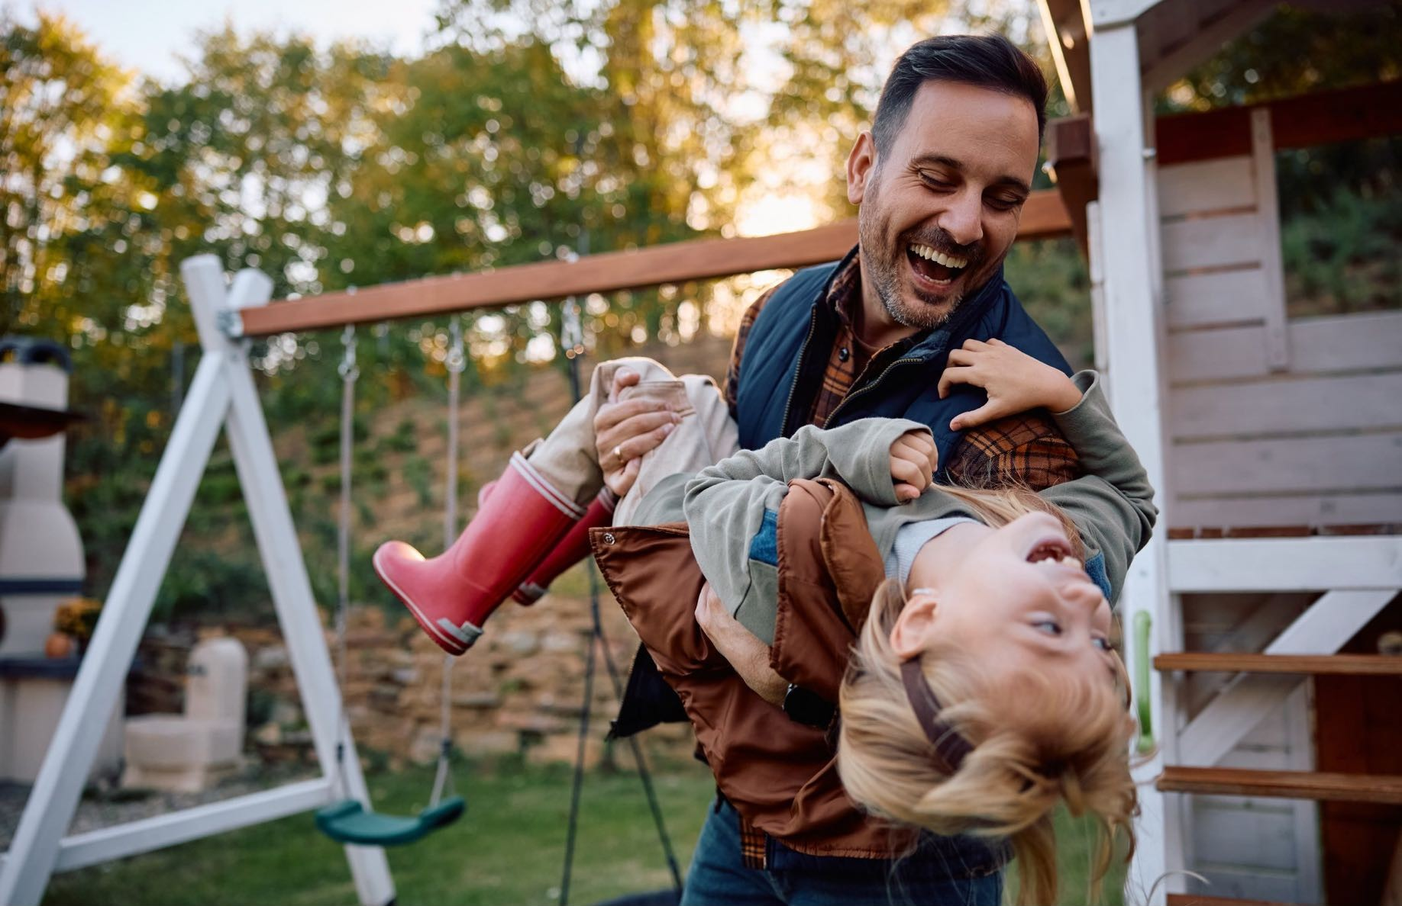
A truly inclusive child and family system must recognise that some children face structural barriers that can limit their opportunity to participate on an equal basis with others. Identifying priority populations is not about creating categories of vulnerability; it is about ensuring the system meets its responsibility to uphold the rights, dignity, and potential of every child.
For Deaf/ deaf children and their families, many of the barriers they encounter arise not from disability itself, but from environments that are not designed to be accessible. Similar patterns are experienced by First Nations families, CALD families, those living in rural and remote communities, and families experiencing socioeconomic pressures. A system committed to equity must consciously recognise these barriers and respond to them in a coordinated and rights-affirming way. Oea'
4.1 Deaf/ deaf Children
Deaf/deaf children should be recognised as a priority population because their developmental opportunities depend directly on the accessibility of the environments around them. When communication access is inconsistent or unavailable, children may be excluded from the everyday interactions that shape early learning, belonging, and wellbeing. Ensuring that Deaf/deaf children are fully included in the new program structure affirms their right to develop, participate, and thrive on an equal basis with their hearing peers.
4.2 Deaf Parents and Parents with Disabilities
Parents with disabilities, including Deaf parents, bring strengths, insight, and resilience to their families. Yet many encounter barriers when parenting supports are not accessible.
These barriers do not reflect a lack of capacity; they reflect a lack of equitable access. Recognising Deaf parents as a priority group ensures that parenting programs uphold the fundamental principle that all parents have the right to receive information, guidance and support in ways that respect their communication needs and their dignity.
4.3 First Nations Children and Families
For First Nations children who are also Deaf/deaf, the intersection of culture, language and communication access is central to identity and wellbeing. These children often face unique barriers due to geography, service gaps, and a lack of culturally grounded support.
Recognising them as a distinct priority population affirms the importance of upholding both cultural rights and communication rights, and of ensuring supports are connected to Country, community and culture.
4.4 Culturally and Linguistically Diverse (CALD) Families
CALD families of Deaf/deaf children often navigate multiple language environments at once. When information, services or programs are not accessible in ways that reflect this diversity, families can be unintentionally excluded. Recognising CALD families as a priority population acknowledges the importance of equitable access to information, communication, and support—delivered in ways that are culturally informed and linguistically appropriate.
4.5 Rural and Remote Families
Children living in rural and remote communities have the same rights to early support as any other child. However, distance, workforce shortages and limited service availability can create structural barriers that delay identification and early help. Recognising these families as a priority group affirms the principle that geography should not determine a child's developmental opportunities or their access to support.
4.6 Families Experiencing Socioeconomic Disadvantage
Socioeconomic pressures can make it harder for families to engage with early supports, even when those supports exist. These pressures do not diminish a family's strengths; rather, they highlight the importance of designing a system that does not inadvertently require financial resources, time availability or advocacy capacity to access what should be universal supports. Recognising socioeconomic disadvantage as a priority factor ensu res that the new system remains anchored in fairness, accessibility, and the right of every child to an ordinary life.
4.7 DeafPlus Children (Deaf/deaf Children with Additional Disabilities)
Many Deaf / deaf children also have additional developmental, cognitive, physical or health needs. These DeafPlus children frequently engage with several service systems at once, yet too often encounter fragmentation rather than coordinated support.
Recognising DeafPlus children as a priority population underscores three key principles:
  - every child has the right to participate and develop on an equal basis with others
  - communication access remains foundational, regardless of the number of systems involved
  - coordinated, relational support is essential to prevent children from being lost between programs
This recognition reflects a commitment to fairness, dignity and the inherent value of every child.
4.8 Children and Young People in Out-of-Home Care (OOHC)
Deaf/ deaf children in OOHC experience compounded developmental risk when communication access is not guaranteed across placements, school environments, or care team interactions.
Lack of Auslan-proficient carers, absence of language-rich environments, and inconsistent interpreter access can lead to delayed language acquisition, social isolation, and increased vulnerability within the OOHC system.
Care planning must therefore include mandatory communication access assessments, stable language environments, and Deaf-aware support teams to ensure the child's rights and developmental needs are upheld.

4.9 LGBTQIA+ Families
- Parenting programs must be explicitly inclusive of LGBTQIA+ parents, ensuring nondiscriminatory materials, examples and service models.
- For LGBTQIA+ parents who are Deaf or raising Deaf/deaf children, intersectional practice must include affirming language, Auslan-accessible resources, and Deaf-aware competency within programs.
4.10 Families Experiencing Family Violence
- Communication access is a core safety requirement; without interpreters or captioned service options, disclosures may be missed or misinterpreted.
- Programs must provide confidential, trauma-informed pathways that ensure safe communication for Deaf parents and Deaf/deaf children, with clear protocols for interpreter engagement in crisis contexts.
5, Designing Services That Work:
A Solutions-Focused Response

A child and family system grounded in human rights must not only remove barriers—it must be intentionally designed to uphold dignity, strengthen inclusion, and ensure every child can participate on an equal basis with others. Creating such a system requires listening to the expertise of those who live with its impacts every day, embedding cultural and communication accessibility from the outset, and building a workforce and service environment capable of meeting children's rights to development, belonging and safety. The consultation provides an opportunity to shape services that reflect the lived realities of families, respond to structural inequities, and ensure that prevention and early support are not aspirations but everyday practice.
5.1 The Importance of Lived Experience in Service Design
Lived experience is central to designing services that truly work. Families understand the practical conditions that enable participation, the barriers that restrict access, and the supports that genuinely enhance a child's development. Their insights do not supplement evidence—they strengthen it.
A national Deaf Mentor Workforce Strategy should be established to train, accredit and support Deaf adults in delivering early language, identity, and communication support to families.
When lived experience is positioned as expertise, service systems become more transparent, more responsive and more aligned with the rights and needs of the children they are intended to serve. This approach supports early identification of barriers, encourages trust between families and providers, and ensures that reform efforts do not overlook the realities of people who use the system every day.
5.2 Co-Design With Deaf-Led, Disability-Led and Parent-Led Organisations
Co-design is most effective when the organisations closest to community experience are partners at every stage. Deaf-led and disability-led organisations bring cultural, linguistic and experiential knowledge that cannot be replicated through formal training or administrative data alone.
Parent-led organisations, including Parents of Deaf Children (PODC), also play an essential role. With more than sixty years of continuous connection to families, PODC carries deep generational knowledge about what helps, what harms, and what families need to thrive. This history gives parent-led organisations a unique understanding of long-term trends— insights into systemic gaps, emerging pressures, and the practical supports that genuinely strengthen family capability.
Engaging these organisations as equal partners honours both the expertise of lived experience and the principle that communities are best placed to identify solutions that reflect their own needs. Co-design is not an optional feature; it is a cornerstone of building a fair, rights-respecting system.
5.3 Building a Skilled, Inclusive Workforce
A prevention-focused system relies on a workforce that understands the importance of communication access, cultural safety and early identification of structural barriers. This is not about creating a specialised workforce for certain groups—it is about ensuring all practitioners have the confidence and capability to support diverse families respectfully and effectively.
A national Deaf Mentor Workforce Strategy should be established to train, accredit and support Deaf adults in delivering early language, identity, and communication support to families.
An inclusive workforce:
recognises when communication is not accessible and takes steps to address it values cultural and linguistic diversity as strengths responds early to emerging concerns rather than waiting for crises works collaboratively across sectors to reduce fragmentation
By building confidence, rather than relying on complexity or specialisation, workforce development becomes an enabler of inclusion rather than an administrative requirement.
5.4 Reducing Administrative Burdens While Strengthening Accountability
Families consistently describe administrative complexity as a barrier to accessing early support. Simplifying processes respects families' time, reduces stress and ensures that access to support is not determined by a parent's advocacy capacity or familiarity with bureaucracy.
At the same time, a prevention-based system requires clear accountability so that responsibilities are understood and children do not fall between service boundaries. Clarity of pathways, transparent decision-making and consistent communication across sectors all contribute to a system where families can engage confidently and practitioners can work cohesively.
Relational contracting should ensure stability for Deaf-led, disability-led and parent-led organisations, enabling long-term investment in workforce capability, interpreter partnerships and bilingual/bimodal resources.
A well-designed system can balance both aims—minimising unnecessary burden while upholding strong, rights-focused accountability.
6. Measuring What Matters: Outcomes and Evaluation

A child and family system grounded in human rights must be accountable for the outcomes it delivers. This means moving beyond administrative reporting or service utilisation data, toward measures that genuinely reflect whether children are developing, participating and being supported on an equal basis with others.
For Deaf/ deaf children, and for all priority populations identified throughout this submission, meaningful evaluation must capture the extent to which the system provides access, inclusion, and the conditions necessary for children's rights to be realised. The consultation's emphasis on prevention and early support offers a valuable opportunity to define outcomes in ways that are principled, transparent and grounded in lived experience.
6.1 A Rights-Based Outcomes Framework
A rights-based outcomes framework ensu res that the new system measures what truly matters: each child's opportunity to grow, learn, and belong. This approach aligns with international obligations under the CRPD and CROC, and with Australia's commitment to systems that uphold dignity, equity, and participation.
Such a framework shifts the focus from "service delivery" to whether supports create the conditions in which children can thrive. It places children's rights — including the right to language, identity, safety, connection and development — at the centre of evaluation, ensuring every measure reflects these foundational principles.
6.2 Measuring Accessibility and Inclusion Across All Three Streams
Accessibility must be visible within evaluation, not treated as a procedural detail. Whether a family can meaningfully participate in a program is a core indicator of the program's quality.
Across the three streams, evaluation should consider:
whether information was accessible in communication formats that met the family's needs whether programs removed, rather than created, participation barriers whether families experienced cultural and linguistic safety whether children were able to engage fully with peers and practitioners whether inclusion was embedded as a standard expectation, not an adaptation
These are not "additional considerations"; they are fundamental measures of whether the system is delivering equitable outcomes.
6.3 Language Access and Communication Indicators for Early Childhood
For Deaf/ deaf children, the quality and consistency of language access is one of the strongest predictors of later developmental outcomes. Yet this dimension is rarely measured within early childhood frameworks.
Introducing language access indicators allows the system to identify whether:
children have full and reliable access to communication in everyday environments families receive information in formats that enable informed decision-making programs support multimodal communication, including Auslan early identification processes lead to timely, appropriate intervention risks of language deprivation are recognised early and acted upon
By measuring communication access directly, the system acknowledges that language is not a service — it is a right. These indicators also provide government with the tools to monitor developmental equity and intervene early when gaps emerge.6.4 Partnering With Families to Monitor Impact Across the Lifespan
Families are essential partners in evaluating impact. Their insights reflect day-to-day experiences that cannot be captured through administrative records alone. When families are invited to contribute to evaluation, the process becomes more transparent, more grounded in lived experience, and more aligned with children's rights.
A partnership approach to monitoring impact means:
families help define what meaningful outcomes look like evaluation tools reflect real-world conditions, not idealised assumptions children's progress is understood in context, not in isolation feedback loops strengthen services over time accountability is shared respectfully between government, providers, and communities
Crucially, this approach supports continuity across the child's lifespan. Families' experiences during the early years often shape later outcomes in school, health and participation, making their involvement essential for monitoring long-term equity.

7. Recommendations

The new child and family system presents a defining opportunity to strengthen equality, prevent harm, and ensure that every child — including Deaf/ deaf children — grows up with full access to language, connection, and developmental opportunity. The recommendations below are grounded in human rights obligations, aligned with the Disability Discrimination Act 1992 (DDA) and Australia's Disability Strategy 2021-2031, and informed by six decades of lived experience within Deaf communities and families.
These recommendations do not seek to recreate existing systems, but to refine them so they uphold dignity, participation and fairness for all children.
7.1 System-Level Recommendations
- Embed a Rights-Based Framework Across All System Design and Delivery
All reforms should uphold children's rights to language, identity, accessible environments and equal participation — consistent with obligations under the CRPD, CROC and the DDA.
- Align the New System With Australia's Disability Strategy 2021-2031
The Strategy emphasises accessible communication, early support, safety, and inclusion. Embedding these pillars ensures coherence across national reforms and strengthens the system's preventative approach.
- Establish National Language and Communication Access Standards
These should set clear expectations for Auslan, captioning, visual supports, multilingual resources, and accessible formats — ensuring families do not rely on advocacy capacity or discretionary decision-making.
- Introduce a National Language Deprivation Prevention Framework
Develop a consistent, evidence-informed tool to identify early risk of language deprivation. Support this with pathways and resources enabling families, practitioners, and services to respond swiftly and appropriately.
- Build a National Resource Hub for Accessible Parenting Information
Ensure information is provided in Auslan, captioned video, plain English, Easy Read, and community languages. This aligns with DDA requirements for equal access to information and the Disability Strategy's commitment to inclusive communication.
- Establish a Coordinated Cross-Sector Pathway
Health, Early Intervention, NDIS, education and family services must share responsibility for supporting communication access. This reduces fragmentation and ensures children are supported consistently across developmental stages.
- Engage Lived-Experience Organisations as Equal Partners
Deaf-led, disability-led and parent-led organisations — including PODC with its 60-year history — must be structurally embedded into design, governance, evaluation and system improvement cycles. Their expertise reflects real-world needs and safeguards fairness.
- Establish a national Language Deprivation Prevention Framework, including mandatory screening, referral pathways, bilingual supports, and annual reporting requirements.
7.2 Stream-Specific Recommendations
The following recommendations map directly to DSS program streams, specifying which reforms should occur nationally, which should be community-delivered, and where minimum access requirements must apply.
Stream 1: Universal Information and National Programs
    - Ensure all national parenting information is accessible, multilingual and multimodal (Auslan, captioning, Easy Read and more).
    - Include lived-experience leadership in resource development to ensure accuracy, cultural safety and community relevance.
    - Actively identify and remove participation barriers such as literacy, technology access or lack of qualified Auslan interpreters.
Stream 2: Prevention and Early Support
    - Recognise communication access as a foundational developmental need, not a specialised intervention.
    - Integrate language access indicators into early developmental monitoring to ensure timely responses when communication barriers are identified.
    - Provide clear, accessible information to families following newborn screening and during key early childhood transitions.
Stream 3: Intensive and Targeted Family Support
    - Guarantee access to Auslan interpreters and culturally safe communication supports in crisis, home-visiting and family preservation programs.
    - Ensure continuity of relationships, recognising that trust and consistency are protective factors for families.
    - Embed cultural competence for working with Deaf families and Deaf adults within program requirements.
7.3 Recommendations for Priority Populations
Deaf/ deaf Children
    - Formally recognise Deaf/deaf children as a priority population in the new system.
    - Implement national language access indicators and the language deprivation prevention tool across all early childhood settings.
    - Ensure no child is denied access to information or communication due to system gaps.
Deaf Parents and Parents with Disabilities
    - Guaranteed access to accredited Auslan interpreters, Deaf interpreters, captioning and other communication supports across all parenting programs.
    - Parenting information provided in accessible formats (Auslan, Easy Read, plain English, audio/visual, tactile).
    - A workforce trained to support Deaf parents and parents with disability with dignity, cultural competence and linguistic respect.
    - Services designed to avoid discriminatory assumptions and uphold the rights and strengths of parents with disability.
    - Genuine involvement of Deaf-led, disability-led and parent-led organisations (including PODC) in designing and reviewing supports.
First Nations Deaf/deaf Children and Families
    - Support community-controlled, culturally grounded, language-strong approaches that honour both cultural identity and communication rights.
    - Recognise First Nations Deaf/deaf children as a distinct population requiring tailored, culturally safe support pathways.
CALD Families
    - Provide multilingual information, qualified interpreters and culturally responsive supports, especially where families are navigating multiple language contexts.
Rural and Remote Families
    - Ensure programs incorporate high-quality telepractice, interpreter access, outreach models and flexible service delivery.
Families Experiencing Socioeconomic Disadvantage
    - Remove financial, technological and administrative barriers that limit participation.
    - Ensure universal programs are truly universal, regardless of income or advocacy capacity.
DeafPlus Children
    - Embed coordinated pathways across health, disability, education and mental health systems.
    - Ensure communication access remains central even when multiple disabilities are present.
7.4 Governance, Funding and Accountability Recommendations
- Establish a National Data and Outcomes Program Develop a cross-sector data system tracking:
communication access interpreter utilisation participation equity language deprivation risk outcomes across priority groups
This ensures transparency, informs continuous improvement and aligns with the Disability Strategy's outcome measurement goals.
- Integrate DDA Compliance Into Governance and Reporting
Public reporting should track how programs uphold the DDA's requirements for nondiscriminatory access — including communication supports, accessible environments and information equity.
- Embed Lived-Experience Expertise Into Governance Structures
Create formal advisory and evaluation roles for Deaf-led, disability-led and parent-led organisations. This ensures accountability rests with those who understand the real-world impacts of system decisions.
- Prioritise Funding for Prevention
Invest in early, accessible, culturally safe support rather than crisis-driven models.
Prevention reduces long-term service demand and upholds children's rights from the outset.
- Build Clear Lines of Accountability Across Sectors
Define responsibilities across health, El, NDIS and education so children are not lost between systems. Regular, transparent reporting supports public confidence in reform.
- Promote Workforce Capability and Cultural Safety
Require training in Auslan awareness, disability rights, culturally safe practice and communication access. A skilled workforce is essential for delivering equitable support.
8. Conclusion: Building a System That Realises Every Child's Right to Thrive

This consultation marks an important opportunity to reshape Australia's child and family support system into one that is equitable, accessible and capable of uplifting every child and every family. For Deaf/ deaf children — and for parents, including those with disability — the early years are a critical period where reliable access to communication, connection and development sets the trajectory for lifelong wellbeing. When these foundations are strong, children thrive. When they are compromised, the impact can echo across education, health, employment and community participation.
Across this submission, PODC has outlined practical, human-rights-aligned pathways for reform. Central to our recommendations is a core principle: all children and all parents — including parents with disability — are entitled to full access, dignity, support and inclusion from the earliest stages of life. This aligns with Australia's obligations under the CRPD, CROC, the Disability Discrimination Act, and Australia's Disability Strategy 2021-2031, each of which affirms the right to accessible environments, inclusive services, and equitable participation.
For the new system to deliver on its promise, it must achieve three outcomes:
- Prevent harm through early, accessible support.
This includes ensuring that families receive clear, timely information; that communication barriers are identified and addressed early; and that parents — including those with disability — can access support in the formats and languages they need to pa rticipate fu lly.
- Enable participation by design, not by exception.
Universal programs must be inclusive in practice, not just in policy. For Deaf/ deaf children, for CALD families, for rural and remote communities, and for parents with disability, participation must be supported through accessible communication, flexible service models and culturally informed practice.
- Embed accountability that reflects lived experience.
A strong system is one shaped with, not just for, the communities it serves. This includes

Deaf-led organisations, disability-led organisations, and parent-led organisations like PODC, which bring over sixty years of collective knowledge and trusted support to the sector. Their genuine engagement strengthens transparency, data quality and the longterm success of reforms.
PODC remains committed to working in partnership with government and sector partners to ensure these reforms deliver practical, measurable improvements for families. A responsive, preventative and inclusive system would transform the experiences of countless children and parents — including parents with disability — who currently face avoidable barriers to access and support.
We welcome the opportunity to work collaboratively with DSS and sector partners to ensure the reformed system delivers the accessible, equitable and preventative supports that all children—including Deaf and hard-of-hearing children—have a right to expect.
9. Key References

Foundational Rights & Policy Frameworks
- United Nations. (2006). Convention on the Rights ofPersons with Disabilities (CRPD). United Nations. (1989). Convention on the Rights of the Child (CROC).
- Australian Department of Social Services. (2021). Australia's Disability Strategy 20212031.
- Disability Standards for Education. (2005).
- Royal Commission into Violence, Abuse, Neglect and Exploitation of People with Disability. (2023). Final Report.

DSS Consultation Documents
- Department of Social Services. (2024). Consultation Summary: A Strengthened Child and Family Support System.
- Department of Social Services. (2024). Evidence Summary.
- Department of Social Services. (2024). Discussion Paper: Reform Directions for Child and Family Supports.

Language Access, Early Intervention & Language Deprivation
- Murray, J. J., Hall, W. C. , & Snoddon, K. (2019). Education and health ofchildren with hearing loss: Necessity ofsigned languages. WHO Bulletin.
- Hall, W. C. , Levin, L. L. , & Anderson, M. L. (2017). Language deprivation syndrome: Sociocultural and neurodevelopmental risk.
- Humphries, T., Kushalnagar, P. , Mathur, G., et al. (2016). Language choices for deaf infants.
- Family-Centred Early Intervention (FCEI). (2019). Best Practice Guidelines.
- Davidson, K. , Lillo-Martin, D., & Chen Pichler, D. (2014). Spoken English outcomes among native signing children with cochlear implants.
- Geers, A. E., et al. (2017). Early sign language exposure and cochlear implantation benefits. Pediatrics.

Cognitive, Mental Health & Developmental Evidence
- Glickman, N. S. , & Hall, W. C. (2018). Language deprivation and Deafmental health.
- Fellinger, J., Holzinger, D. , & Pollard, R. (2012). Mental health ofdeafpeople. The Lancet.
- Schick, B., de Villiers, J., de Villiers, P., & Hoffmeister, R. (2007). Language and Theory of Mind in Deafchildren.

Australian Sector Evidence
- Deaf Australia. (2023). DeafCensus Snapshot.
- National Association of Australian Teachers of the Deaf (NAATD). (2016). Teacher of the DeafElaborations.
- Roadmap for Hearing Health. (2019).
- Hearing Services Program Review. (2023). Final Report.
Parent, Community & Lived Experience Evidence
- Parents of Deaf Children (PODC). Consultation insights and system navigation evidence (1960-2024).
- The Disparity in Access to Parenting Supports for Deaf Parents.


- Parenting Supports Advocacy Paper.
- Australian Journal of Rural Health (2024). Service leads' perspectives on lack ofservices.
Priority Populations
- World Federation of the Deaf. (2016). Position Paper on the Language Rights ofDeaf Children.
- WHO. (2011). World Report on Disability.
- WHO. (2012). Global Estimates ofHearing Loss.
- MHFA (2022). Deaf-to-DeafMental Health First Aid Guidelines.
www.podc.org.au www.instagram.com/podcnsw www.facebook.com/podcnsw

