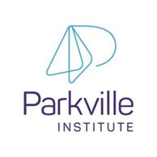

Submission on the Australian Government’s new approach to programs for Families and Children

Parkville Institute

December 2025

© Parkville Institute (2025). Submission on the Australian Government’s new approach to
programs for families and children



Introduction
Parkville Institute (PI) welcomes the opportunity to provide a submission on the Australian Government’s proposed new approach to programs for Families and Children.
PI is an innovative research and practice institute established by Associate Professor Brigid Jordan AM and Dr Anne Kennedy as a not-for-profit organisation in 2021. PI’s purpose is to improve the life trajectories of young children living with significant social disadvantage and family stress. PI is achieving this by working with providers to oversee delivery of an intensive model of high-quality early education and care across three sites, underpinned by evidence and evaluation. This model emphasises ethical, equitable and collaborative partnerships with families as their child’s first educator.
PI supports the Australian Government’s Early Years Strategy, and its agenda to create a highquality universal early education and care (ECEC) system and to tackle entrenched intergenerational disadvantage. PI strongly endorses the goal expressed by the Minister for Social Services, Tania Plibersek MP, at the National Early Years Policy Summit in June 2025, to “ensure every Australian child is happy, healthy, safe, and able to learn and develop, no matter where they live or what their background is”.
We know that children who encounter extreme adversity in the early years are at risk of compromised learning, wellbeing and developmental outcomes. Deficiencies in cognitive and social skills before the age of five are likely to persist into later life and become the basis of problems such as low educational attainment, unemployment, teenage pregnancy, homelessness, involvement in crime and an increased risk of physical and mental health problems (Shonkoff, 2012; Campbell et al., 2014).
At the same time, we know that the best approach is to prevent problems early; helping young children experiencing socioeconomic adversity and exposure to trauma, abuse and neglect to enjoy the same life trajectories as their peers. To achieve this, interventions and prevention need to offer targeted, intensive support for young children with acute needs, best delivered through universal service systems.
For children living with significant and multiple vulnerabilities and risk factors, there is powerful evidence of the need for a targeted ‘intensive care’ ECEC model nested within universal provision. This approach has been proven to redress harms, overcome the effects of trauma and reduce toxic stress levels, enabling children to learn in partnership with their families and communities (Shonkoff, 2012). Programs that are designed to provide for the specific needs of this cohort of children and families may prevent and reverse children’s compromised learning and development in addition to addressing barriers to their engagement with universal services (Leseman & Slot, 2020; Lord, Southcott, & Sharp, 2011).

© Parkville Institute 2025 ²

The Early Years Education Program
The Australian ECEC program with the highest quality evidence and most positive outcomes to date, is the Early Years Education Program (the Program). The Program, commencing in 2011 and concluding in 2018, was undertaken as a multi-disciplinary Randomised Control Trial by a team from The University of Melbourne’s Departments of Economics, Paediatrics and Education and the Melbourne Institute (Jordan et al., 2014; Tseng et al., 2019). The Program was initiated by Kids First, previously the Children’s Protection Society (CPS), an independent not-for-profit child and family services organisation based in the north-east of Melbourne which was founded in 1896. The Program was designed and implemented by CPS in collaboration with Associate Professor Brigid Jordan and Dr Anne Kennedy.
The Program, delivered by a multidisciplinary team (including an Infant Mental Health
Consultant, Family Practice Consultant, and Early Years Pedagogy Lead) was the first of its kind in Australia, achieving remarkable developmental and learning outcomes for children who received the intervention in the trial. The RCT found an average 7-point increase in IQ scores after three year’s participation, with the effect being concentrated on children whose initial IQ was below 90, who improved on average by 14 points, as well as significant and sustained increases in children’s social and emotional development and fewer behavioural problems. Improvement in children’s IQ and language development was sufficient for participants to be developmentally equal to their peers (Tseng et al., 2022).
PI is currently funded by the Australian Government, Victorian Government and philanthropy to replicate the Program with service partners (including C&K, the City of Ballarat, and Uniting until December 2025) in three centres, with two now operating in Victoria and one in Queensland. The aims of the replication phase include applying the model in different contexts to test the original findings and providing data to inform recommendations for stepped scaling up.
The current cohort across PI’s replication sites is experiencing significant social disadvantage and family stress, aligned with the needs the new national program for families and children seeks to meet (see Table 1).
PI is also partnering with Cullunghutti Aboriginal Child and Family Services, NSW, SNAICC - National Voice for our Children and Social Ventures Australia to co-develop, trial and evaluate an evidence-informed intensive early childhood education and care program, for Aboriginal and Torres Strait Islander children.

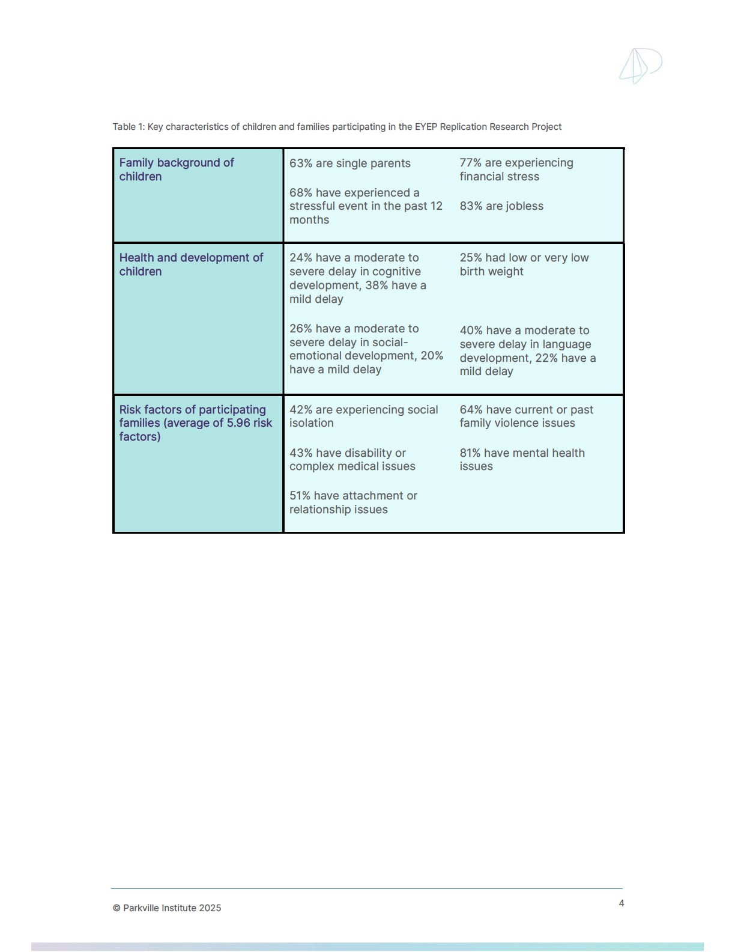

Proposed Design of a Single National Program – PI’s insights and advice
PI supports the intent of the Australian Government’s proposed new approach to programs for Families and Children, which will better enable the delivery of evidence-based, integrated services and supports, helping people earlier and preventing the escalation of risk and need.
With its experience in evidence-based, multidisciplinary early childhood education and care for young children living with significant social disadvantage and family stress, PI offers the following insights and advice
- Targeted support nested within universal systems – targeted and effective supports can be successfully integrated into universal service platforms. The aim of PI’s Program is to improve children's learning and development by 1) redressing impacts of trauma on children and 2) providing an enriched early learning and care environment. This is achieved through a program design which combines in each service, elements of high quality ECEC (such as a full time Pedagogical Leader, higher staff to child ratios, more highly qualified educators, small group and centre sizes, and dedicated planning time) with the expertise needed to address the underlying challenges faced by this cohort (such as an Infant Mental Health Consultant, a Family Practice Consultant, and a dedicated cook delivering 75% of children’s daily nutritional requirements). The process components include relational pedagogy, attachment theory, play and relationshipbased curriculum and pedagogy, family partnerships and referral pathways. The service is delivered by high quality ECEC providers within the National Quality Framework, working in close partnership with PI.
- Effective early intervention for children aged under 3 – the services delivering the Program undertake intensive work with families and children referred to them in order to engage them and build their trust. This provides the foundation for enrolment and attendance. In a typical universal ECEC setting, children from complex and challenging family backgrounds often find it difficult to sustain engagement or instead access lower quality ECEC, having been turned away from higher-quality services. In addition, PI’s Program has an explicit focus on education and learning for children under the age of 3, enabled through the delivery of other required supports that redress the impacts of trauma.
- A family-centric approach – the Program is designed to maximise family participation. Parental engagement and the development of sustained, ethical partnerships are a core principle. Trauma-informed practice, and the infusion of infant mental health knowledge and skills, means that educators are equipped and supported to work with parents presenting with issues that would often prevent their children attending early education services. The model recognises that if educators’ relationships with parents can build parents’ emotional resources and provide them with support, this will increase the emotional resources parents have available to meet their children’s needs and to be effective as the child’s most important educator (Jordan & Kennedy, 2019).
- Research and evaluation informing the development of best practice – The RCT has demonstrated the importance of robust research in developing best practice early interventions for children and families. Research and evaluation are also key features of the current Research Replication Project, testing whether the Program can be implemented in different settings, and of the Co-development Project, assessing the impact of the First Nations-led program at Cullunghutti. Research is essential in program design and in demonstrating value for Government’s investment.
- A capacity to scale PI’s Program and reach more families with young children who need intensive support – PI anticipates that positive outcomes will be achieved through the current Research Replication Project. PI will receive a 12-month Outcomes Report in late January 2026 and a 24-month Outcomes Report in December 2026. This will inform PI’s plan to scale its impact, including by expanding the delivery of the Program over time to other communities across Australia experiencing a significant concentration of disadvantage.
- A re-designed DSS program for families and children will support integrated early intervention, prevention and better outcomes – the redesign of current DSS programs to support families and children is very welcome. The establishment of one new program (to replace five) will create more flexibility for service deliverers and make it easier to secure funding for effectively integrated interventions that meet multiple needs. For PI, this means the potential to attract funding from multiple sources (for example, the Child Care Subsidy, DSS, State Governments etc.) to achieve its purpose.
PI encourages DSS to explore the potential of high-quality, evidence informed, early childhood education and care services with an embedded multidisciplinary team - who are involved in the leadership of the service as well as direct work with children and families - as an innovative, very accessible channel for supporting and funding services for children and families living with significant adversity. The PI model crosses the usual sector divisions of child protection, child and family services, and education and care.

Responses to Questions in the Discussion Paper

Vision and Outcomes
Does the new vision reflect what we all want for children and families?
Are the two main outcomes what we should be working towards for children and families? Why/why not?
PI supports the creation of a single program (rather than five more narrowly framed programs) with a broader vision of outcomes for families and children.
PI commends DSS for including a separate outcome focused on children, rather than presuming that supporting parents will lead to a positive change for children. PI further notes that evidence-based ECEC programs focused on children that support parents to improve their confidence in using and advocating for access to required services over time at their pace (through a relational, rather than a transactional approach) can achieve outstanding outcomes.
PI notes that the proposed outcome 2 could be strengthened by aligning it to Minister Plibersek’s aspiration that “every Australian child is happy, healthy, safe, and able to learn and develop, no matter where they live or what their background is” (2025), specifically that it more explicitly reflect the need to enable children to learn and develop. To achieve this, PI proposes that outcome 2 be expanded to read: “children are supported to grow into healthy, resilient and capable adults”. This would capture the sense that children’s learning and development contribute to their capability as employees and citizens when adults.

Program Structure
Will a single national program provide more flexibility for your organisation?
Does the service or activity you deliver fit within one of the three funding streams? Do these streams reflect what children and families in your community need now – and what they might need in the future?
Are there other changes we could make to the program to help your organisation or community overcome current challenges?
The proposed new national program structure is a major step forward, making it easier to deliver high-quality, integrated services which achieve significant outcomes for children and families.
PI’s program fits within two funding streams, prevention and early intervention, and intensive family supports.
PI highlights the following opportunities to strengthen the descriptors of streams 2 and 3:
- PI requests that the descriptor for stream 2 be broadened to include learning (programs that support children and young people’s development, learning and wellbeing), consistent with the Minister’s aspiration and the need to support children to grow into capable adults.
- PI also requests that the descriptor for stream 3 be broadened to include support for families already engaged with child protection services, not just those at risk of contact with it. This is essential for early intervention to occur. The duration of PI’s Program means that children who move in and out of child protection processes (notification/investigation/case management) and families who have to navigate changing personnel in child protection services can build a trusting relationship with PI services and use it as a safe base which then supports them engaging properly with community based preventative services.
This program structure should enable:
- PI to sustainably build intensive support for families and children through an ECEC platform, with particular significance afforded to the multidisciplinary expertise embedded in each service (for example, the Infant Mental Health Consultant and Family Practice Consultant roles).
- integration of different funding streams from different levels of government, different departments and philanthropy – and at different funding levels over time.
- gradual scale-up of service delivery, and evidence of impact, so increased funding is made available through the program when new sites are opened as part of an agreed long-term growth plan.

Prioritising Investment
Do you agree that the four priorities listed on page 4 are the right areas for investment to improve outcomes for children and families?
Are there any other priorities or issues you think the department should be focussing on?
PI supports the four priorities for investment listed in the Discussion Paper.
Consistent with comments above, priority 1 should include families and children who have already had contact with child protection, noting they may have since been diverted to a family violence service or intensive family support.
Early intervention at this point can prevent further child protection involvement, improve outcomes for children, reduce parental stress and lessen the risk of child involvement with out of home care, youth justice and other tertiary services.

Improving Family Wellbeing
Do the proposed focus areas – like supporting families at risk of child protection involvement and young parents – match the needs or priorities of your service?
Are there other groups in your community, or different approaches, that you think the department should consider to better support family wellbeing?
Consistent with the point made earlier, the first ‘key area of interest’ should include families and children who have already had contact with child protection. PI proposes that this be reframed as “Families who have engaged with or who are at risk of child protection involvement”.
PI strongly endorses the proposed ‘key area of interest’ of prevention and early intervention support for children aged 0-5. This is a critical period of early intervention for young children living with significant social disadvantage and family stress. PI highlights the opportunity to improve support for young children under the age of 3 by redressing the impacts of trauma, enabling brain development and learning, and to build the capacity of families as their child’s first and most enduring educator. This includes mental health support for children under the age of 3 and parent-child relationship counselling - not just for family violence exposure but also for families where:
- parents grew up in child protection
- parents don’t feel connected to children
- children show signs of learning compromise
PI further highlights the opportunity to build these targeted supports on a universal ECEC platform, reaching the children who need it when they need it most.

Connected, Co-located, and Integrated Services
What are other effective ways, beyond co-location, that you’ve seen work well to connect and coordinate services for families?
What would you highlight in a grant application to demonstrate a service is connected to the community it serves? What should applicants be assessed on?
Families and children benefit from the delivery of integrated services which are tailored and responsive to community needs. Co-location can assist in this but is not the only way to achieve it.
PI’s Program:
- Incorporates significant outreach to engage the most vulnerable families in any service, using skilled, non-judgemental and inclusive approaches
- Forms individualised engagement plans including soft entry strategies such as play and stay, play and yarn which are paced to families’ needs and capacity
- Integrates essential supports within one service, providing a more joined-up service response
- Connects families and children to any additional supports required, including through the Family Practice Consultant
- Provides relational support over a three-year period to engage parents and build their trust (this is in contrast to system navigators which often fail to provide continuing relational support)
- Incorporates a focus on quality ECEC delivery, enabling the provision of multidisciplinary support.
PI would highlight the following in a grant application to demonstrate its connection to the community:
- Evidence of the engagement that a PI service undertakes across local community networks to function as part of the eco-system
- Strong referral networks to identify children and families eligible for the Program
- Evidence of a PI service’s reputation as a trusted provider of child and family services (including ECEC) in the community
- Local government connections and engagement
- Use of data to understand community need and best target its support
Grant applications should be assessed on:
- Achievement of positive outcomes for both children and parents, measured through robust research
- Quality of evidence-based interventions
- Capability to deliver the service
- A demonstrated record of working with the target cohort and achieving the required outcomes and impact
- Demonstrated partnerships with service providers and local community networks

Responding to Community Need
Beyond locational disadvantage, what other factors should the department consider to make sure funding reflects the needs of communities?
What’s the best way for organisations to show in grant applications, that their service is genuinely meeting the needs of the community?
Beyond measures of locational disadvantage, the department should also consider data which indicates the level of risk a child or children in a family may face. For example, under current program arrangements with the Commonwealth Department of Education, a child must be assessed as being at risk to be referred to a PI service and to be eligible for the Additional Child Care Subsidy (ACCS). Targeting of the intervention to children at greatest risk clearly has merit but there may be better ways of doing so in the future.
Another factor for the Department to consider would be evidence of support from communitybased agencies that provide referrals to PI services. Organisations could show that their service is meeting community needs by:
- In PI’s case, using evidence from trials or programs that show the link between community needs and the specific ways in which the program elements address or mitigate those needs, for example food insecurity or child health data
- Testimonials from community members and agencies
- Community celebrations that families and children participate in
- Evidence that elements of the program/model are being used or adopted in wider community services context
- Increasing the numbers of children and family participating in the service over time

Improving Outcomes for Aboriginal and Torres Strait Islander Children and Families
How could the grant process be designed to support and increase the number of ACCOs delivering services to children and families?
What else should be built into the program design to help improve outcomes for Aboriginal and Torres Strait Islander children and families?
Opportunities to design the grant process to increase the number of ACCOs delivering services to families and children include:
- Providing time and funding upfront to enable ACCOs to develop service models with their local communities
- Enabling partnership models which bring technical experts together with First Nations communities to design and deliver a service which meets local need
- Demonstrating an evidence-based program-design, demonstrating strong outcomes
- Commitment to and actions for capacity building the Aboriginal and Torres Strait Islander workforce - to support self-determination principles and actions
- Data sovereignty principles informing evaluation frameworks, evidence gathering and dissemination.
As outlined above, PI is a partner with Cullunghutti Aboriginal Child and Family Services, NSW, SNAICC - National Voice for our Children and Social Ventures Australia in a co-developed model of intensive ECEC for First Nations children in Nowra, NSW. The model being implemented, Boori Milumba, is built on the Program, is responsive to community strengths, aspirations and needs, and also includes a number of additional elements, for example a cultural framework, a cultural leader role, cultural plans for children and staff, play and yarn orientation sessions, and regular cultural supervision for staff.
Three Reports have been produced to date on Boori Milumba (available at Parkville Institute - Reports & Updates).

Measuring Outcomes
What types of data would help your organisation better understand its impact and continuously improve its services?
What kinds of data or information would be most valuable for you to share, to show how your service is positively impacting children and families?
If your organisation currently reports in the Data Exchange (DEX), what SCORE Circumstances domain is most relevant to the service you deliver?
What kinds of templates or guidance would help you prepare strong case studies that show the impact of your service?
As a research and practice institute, PI supports a rigorous approach to research design, data collection, reporting and analysis. In particular, PI would recommend:
- A research design which enables a robust level of causality to be established
- Baseline data (which, in PI’s case, measures IQ, language, and social and emotional development), followed by data at agreed points during and after the intervention
- A capacity for the data set or evidence to be ‘tested’ or compared with other national data, for example, the Longitudinal Study of Australia’s Children
- A potential for data linkage
- Qualitative (e.g. case examples) and quantitative data demonstrating impact
- A measure of workforce development demonstrating the increased expertise of educators working with children
PI would welcome the sharing of data held by different levels of government which would assist in determining risk and community need for intensive support.

Working Together
What does a relational contracting approach mean to you in practice?
What criteria would you like to see included in a relational contract?
What’s the best way for the department to decide which organisations should be offered a relational contract?
Is your organisation interested in a relational contracting approach? Why/why not?
PI wishes to be considered for relational contracting when the new national program is implemented.
The work of PI and its service delivery partners in changing the life trajectories of young children experiencing social disadvantage and family stress is challenging and requires a shared commitment to agreed outcomes, clear roles and responsibilities, and close collaboration in practice. The opportunity for positive ‘spillover’ effects for family members (increased sense of efficacy and reduced parenting stress) through their child’s improved emotional and behavioural

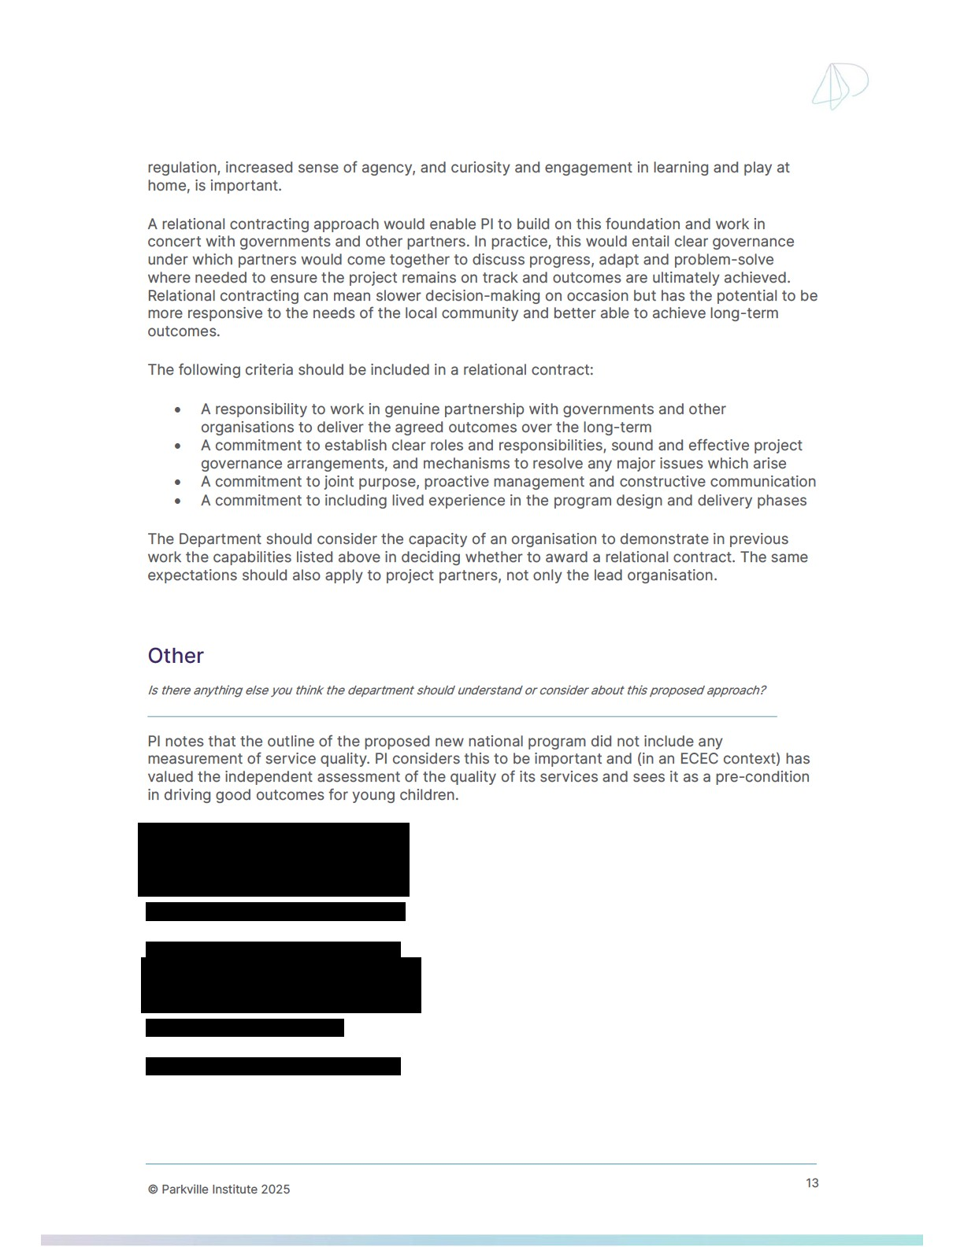

References

Australian Government Department of Education [DE] (2024). The Boori Milumba Model: An Aboriginal and Torres Strait Islander specific service-led intensive Early Childhood Education and Care (ECEC) model. Australian Government Department of Education.
Australian Government Department of Education [DE] (2024). A Journey of Co-Development: The Boori Milumba Model. Australian Government Department of Education.
Australian Government Department of Education [DE] (2024). Co-Development Framework: For developing an intensive early childhood education and care program for Aboriginal and Torres Strait Islander children, Version 2. Australian Government Department of Education.
Campbell, Frances & Conti, Gabriella & Heckman, James & Moon, Seong & Pinto, Rodrigo & Pungello, Elizabeth & Pan, Yi. (2014). Early Childhood Investments Substantially Boost Adult Health. Science (New York, N.Y.). 343. 1478-85. 10.1126/science.1248429.
Jordan, B., Tseng, Y., Coombs, N., Kennedy, A., & Borland, J. (2014). Improving lifetime trajectories for vulnerable young children and families living with significant stress and social disadvantage: The Early Years Education Program. BMC Public Health, 14, 965.
Jordan, B. & Kennedy, A., (2019). The Early Years Education Program (EYEP) Model. Changing the Trajectories of Australia's Most Vulnerable Children Report No. 3. Melbourne Institute of Applied Economic and Social Research, University of Melbourne and Kids First.
Leseman, P.P.M., Slot, P.L. (2020) Universal versus targeted approaches to prevent early education gaps. The Netherlands as case in point. Z Erziehungswiss 23, 485–507 (2020)
Lord, R., Southcott, C., & Sharp, C. (2011). Targeting Children’s Centre Services on the Most Needy. Slough: National Foundation for Educational Research.
Plibersek, T. (2025, June 18). National Early Years Policy Summit. Tanya Plibersek.
https://www.tanyaplibersek.com/media/speeches/national-early-years-policy-summit18-6-25/
Shonkoff JP; Garner AS; Committee on Psychosocial Aspects of Child and Family Health; Committee on Early Childhood, Adoption, and Dependent Care; Section on Developmental and Behavioral Pediatrics. The lifelong effects of early childhood adversity and toxic stress. Pediatrics. 2012 Jan;129(1):e232-46. Doi: 10.1542/peds.20112663. Epub 2011 Dec 26. PMID: 22201156.
Tseng, Y., Jordan, B., Borland, J., Coombs, N., Cotter, K., Guillou, M., Hill, A., Kennedy, A., & Sheehan, J. (2019). 24 months in the Early Years Education Program: Assessment of the

© Parkville Institute 2025 ¹⁴

impact on children and their primary caregivers. Changing the Trajectories of Australia's Most Vulnerable Children Report No. 4. Melbourne Institute of Applied Economic and Social Research, University of Melbourne.
Tseng, Y., Jordan, B., Borland, J., Clark, M., Coombs, N., Cotter, K., Guillou, M., Hill, A., A. Kennedy and J. Sheehan (2022), Changing the Life Trajectories of Australia’s Most Vulnerable Children – Report no.5: 36 months in the Early Years Education Program: An assessment of the impact on children and their primary caregivers; accessed at: https://fbe.unimelb.edu.au/__data/assets/pdf_file/0006/4360173/9597-MU-EYEPReport-5-WEB52.pdf
Tseng, Y., Coombs, N., Fraser, S., and Taylor, Ey (2025), EYEP Trial Replication Research Report: Understanding the Trial Participants, Melbourne Institute of Applied Economic and Social Research.

© Parkville Institute 2025 ¹⁵

