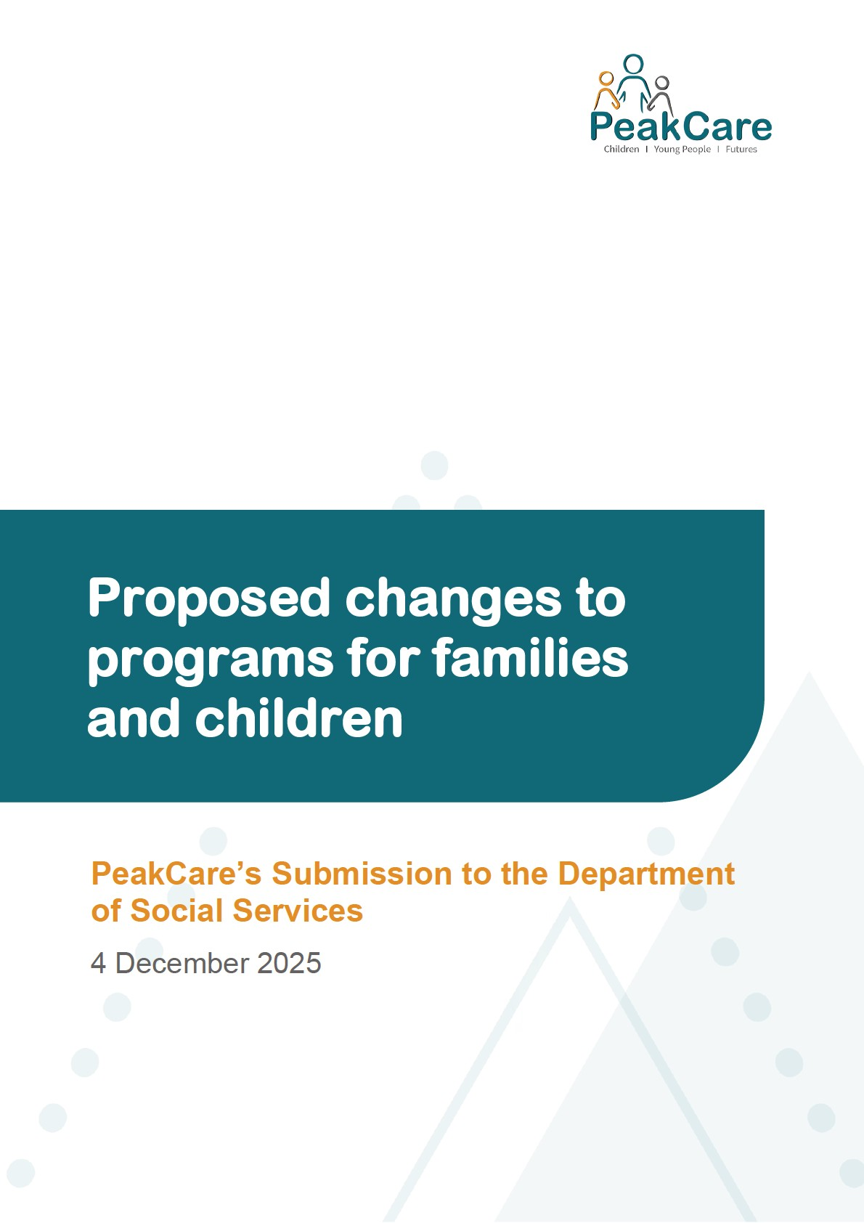

Contents

Introduction 3
About Peakcare 3
Peakcare’s Submission 3

Conclusion ......................................................................................................................................... 4


Page 2 of 4

Introduction
PeakCare welcomes the opportunity to provide feedback to the Department of Social Services (DSS) on the proposed changes to programs for families and children. PeakCare supports the response made by Families Australia on these changes as the national body representing the views of member organisations working with children, young people and families. We support the intent of the proposed reforms to prioritise investment in prevention, early intervention and targeted supports that are informed by and responsive to community needs. Where the sector is adequately supported to transition, PeakCare supports an approach that strengthens long term funding security, simplifies grant processes and enhances services for Aboriginal and Torres Strait Islander families. PeakCare also supports Families Australia in calling for further detail on the proposed reforms design and implementation as well as strong and carefully considered transition arrangements.
Given the significant, system-wide impacts of the proposed changes, PeakCare also supports Families Australia’s offer to play a coordinating role alongside government throughout implementation. As the trusted national peak body, this coordinated leadership approach would help create the conditions for a smoother transition, strengthen sector capability across jurisdictions, and assist in early realisation of the reform’s intended benefits. PeakCare encourages DSS to give strong consideration to this proposal to minimise disruption for organisations and, most importantly, for the children, young people, families, and communities they support.

About PeakCare
PeakCare is a not-for-profit peak body for child and family services in Queensland, providing an independent voice representing and promoting matters of interest to the non-government sector. Across Queensland, PeakCare represents small, medium, and large local, state-wide and national nongovernment organisations which provide prevention and early intervention, generic, targeted, and intensive family support to children, young people, families, and communities. Member organisations also provide child protection services, foster care, kinship care and residential care for children and young people who are at risk of entry to, or who are in the statutory child protection system and youth justice systems.
A large network of associate members and supporters also subscribe to PeakCare. This includes individuals with an interest in child protection, youth justice and related services, and who are supportive of PeakCare’s policy platform around the rights and entitlements of children, young people and their families to safety, wellbeing, and equitable access to life opportunities.

PeakCare’s Submission
PeakCare supports the intent of new funding approaches which aim to provide children with the supports they need, when and where they need them. The Australian Childhood Maltreatment Study (ACMS) found that, 62.2 per cent of the Australian population has experienced at least one type of childhood maltreatment. This highlights the widespread nature of childhood maltreatment and

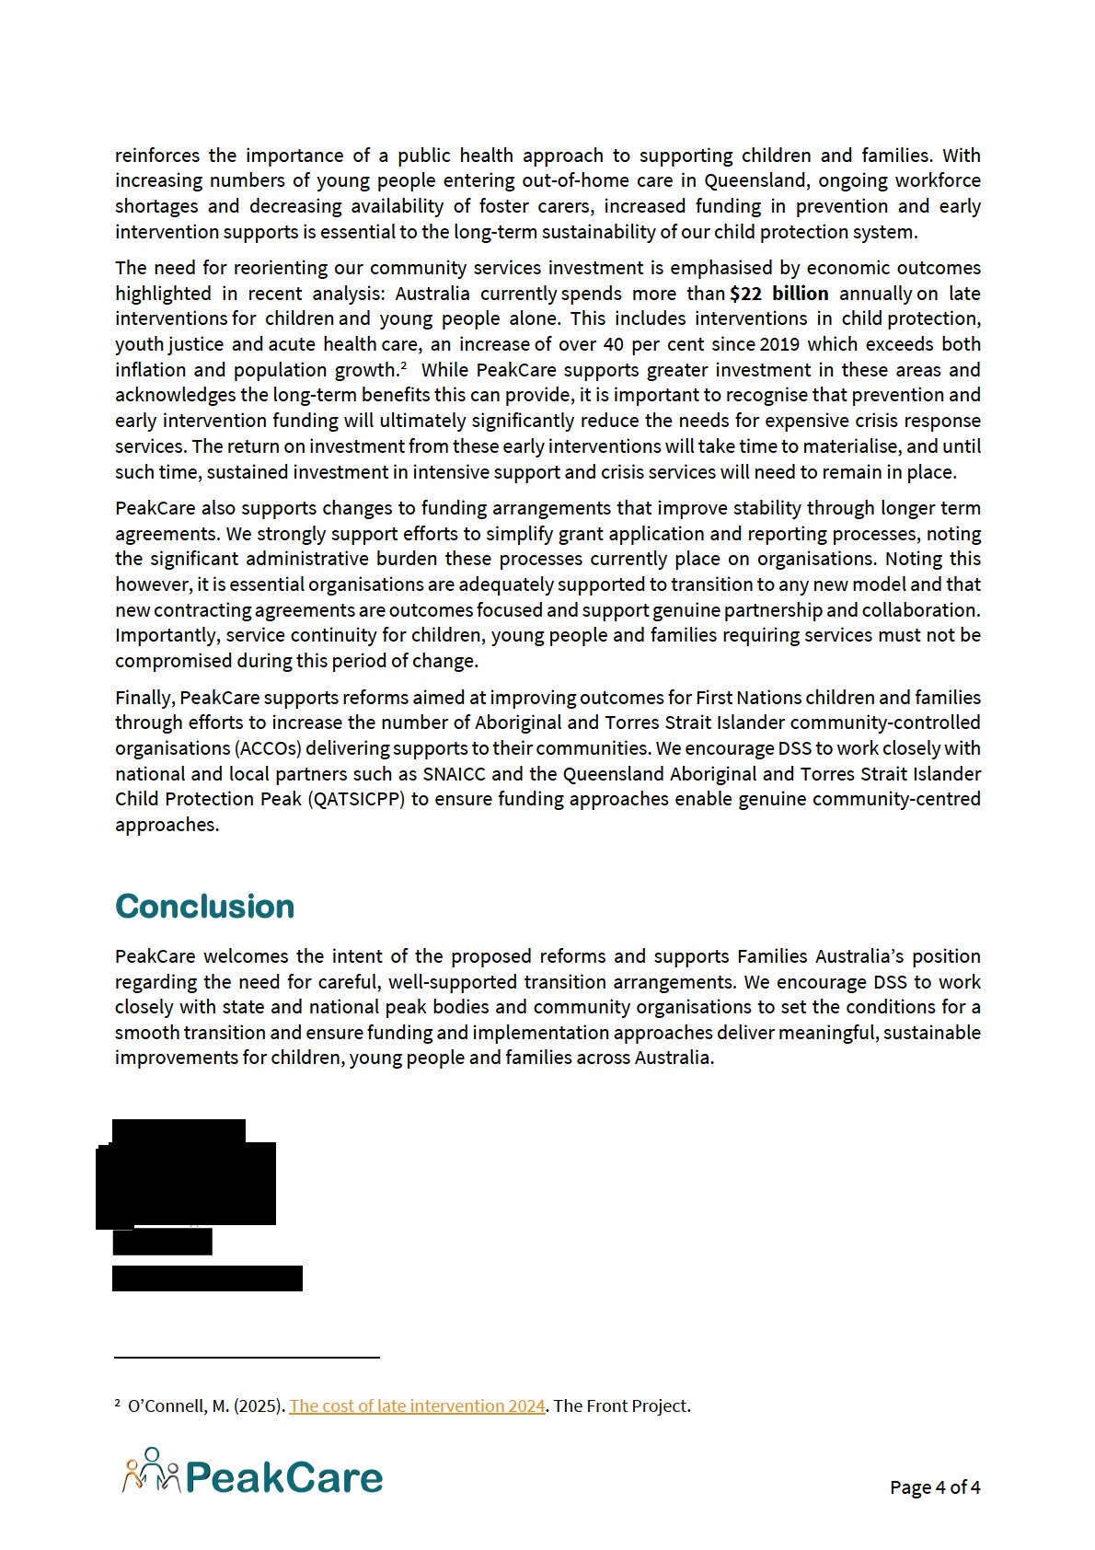

Haslam D, Mathews B, Pacella R, Scott JG, Finkelhor D, Higgins DJ, Meinck F, Erskine HE, Thomas HJ, Lawrence D, Malacova E. (2023). The prevalence and impact of child maltreatment in Australia: Findings from the Australian Child Maltreatment Study: Brief Report. Australian Child Maltreatment Study, Queensland University of Technology. Page 3 of 4

