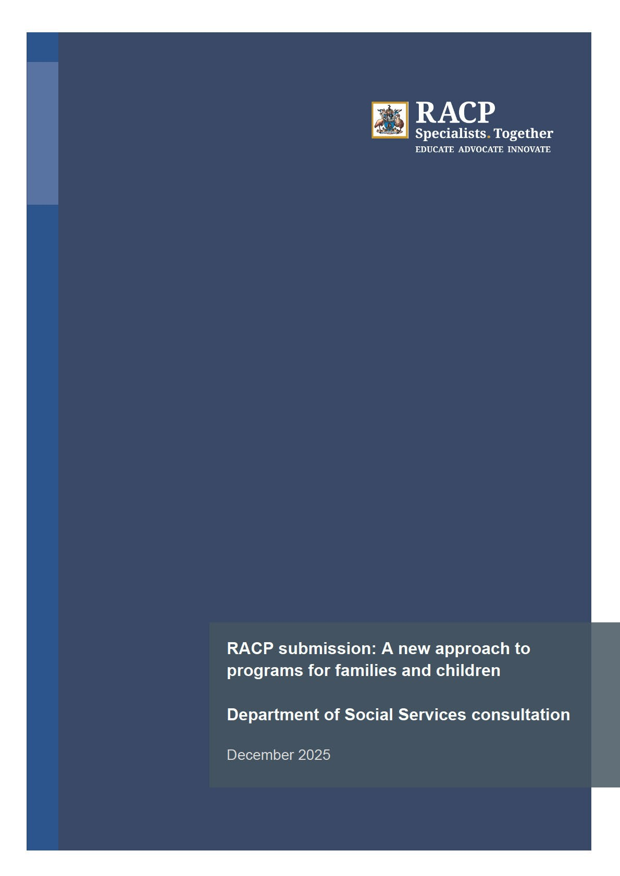

About The Royal Australasian College of Physicians (RACP)

The RACP trains, educates and advocates on behalf of over 23,800 physicians and 9,500 trainee physicians, across Australia and Aotearoa New Zealand. The RACP represents a broad range of medical specialties, including paediatrics and child health, public health and rehabilitation medicine.

Beyond the drive for medical excellence, the RACP is committed to developing health and social policies which bring vital improvements to the wellbeing of patients, the medical profession and the community.

Contact -


We acknowledge and pay respect to the Traditional Custodians and Elders – past, present and emerging – of the lands and waters on which RACP members and staff live, learn and work. The RACP acknowledges Māori as tangata whenua and Te Tiriti o Waitangi partners in Aotearoa New Zealand.

Role of the RACP

The Royal Australasian College of Physicians (RACP) welcomes the opportunity to provide feedback on the Department of Social Services ‘A new approach to programs for families and children’ consultation, as part of the Families and Children (FaC) Activity Review. We recognise the importance of this work and are pleased to contribute to the consultation process.

Representing over 33,000 physicians and trainees across Australia and Aotearoa New Zealand, including over 7,100 paediatric and child health members, the RACP brings extensive expertise in child health and developmental care. Our members work daily at the interface of health, disability, education, and social services, and are uniquely placed to inform the design, implementation, and evaluation of reforms under the FaC Activity Review.

The RACP would welcome further discussion with the Department and looks forward to working closely with the Minister for Social Services, her office and the Department to ensure the reforms deliver meaningful outcomes for children, young people, and their families/carers.

Key Comments

The RACP broadly supports the decision to strengthen integration across child and family services.

The RACP has previously highlighted the need for more coordinated, multidisciplinary approaches to child and family health, and commends the Australian Government’s commitment to advancing reforms that strengthen integration across services.

In our submission to the Inquiry into Thriving Kids, the RACP emphasised that improving outcomes for children requires integration of sectors: health, disability, education, and social services. Our members noted that timely detection and early family-centred interventions improve developmental outcomes (language, social skills, and cognition) compared with delayed care. Interventions that are integrated, multidisciplinary, and that involve parents, offer the best support.
In our submission to the draft Thrive By Five Early Childhood Guarantee Bill 2024, the RACP noted the importance of investment in the early years of children’s health, development, and wellbeing, as the most cost-effective means of tackling long term health conditions and health inequities. Investing in the early years of a child’s life offers the opportunity to shift the trajectory of their health and wellbeing over the course of their life and disrupt intergenerational cycles of disadvantage.

The RACP position statement on the Health Care of Children in Care and Protection Services highlights that children with disability and children in out-of-home care, together with their families and carers, are particularly at risk of poor outcomes when services are fragmented. Both groups experience greater health needs and face significant challenges navigating systems and accessing supports. Strengthening integration across sectors is therefore critical to ensuring equitable access, timely interventions, and culturally safe, trauma-informed care for vulnerable cohorts.

Discussion paper comments

The following points represent a summary of feedback received from our RACP members on the Discussion Paper, consolidated for consideration:

- Integration and Implementation: The intention to improve the presently “rigid, fragmented and bureaucratic system” by bridging five (5) key child and family services together has considerable merit and is much needed in the community. However, the proposal lacks sufficient details regarding how these goals will
be achieved in practice, and the specifics of how consolidation will be undertaken, implemented and evaluated should be mapped.
- Prevention and Early Intervention: Funding streams should clearly distinguish between prevention and early intervention. Prevention must be recognised as a distinct, universal, population-level program type, operationalised differently to early intervention programs that target children and families/carers with identified vulnerabilities.
- Age Inclusivity: Supports for adolescents and young adults are not explicitly addressed. Extending the framework to cover pregnancy, infancy, childhood, and adolescents would ensure continuity of care across all developmental phases.
- At-Risk Groups: While the discussion paper identifies some priority groups, our RACP members recommend broadening these to include culturally and linguistically diverse families, LGBTIQA+ families, families caring for children with disability, and fathers. Tailored supports for these groups are important.
- Data and Reporting: Data collection must be standardised across jurisdictions when capturing the complexities of family/carer circumstances. Data infrastructure must reflect the complex challenges facing families/carers. Clarity is needed on the administrative burden and how this will be reduced, with a minimum core outcome measure set for all programs reporting through appropriate data exchange, supported by a governance framework.
- Workforce and Service Design: Employment of a workforce that embraces diversity, equity and inclusion is essential. Also, providing information in multiple languages, is critical to the framework’s success. Services must be developed and led by First Nations and culturally and linguistically diverse communities with lived experience to achieve improvements in health outcomes for children and families.

Beyond these points, members of the RACP Adolescent and Young Adult Medicine (AYAM) Committee and the broader Paediatrics and Child Health Division (PCHD) are generally supportive of the decision to bring together and replace the Children and Parenting Support (CaPS), Communities for Children Facilitating Partners (CfC FP), Family Mental Health Support Services (FMHSS), Family and Relationship Services (FaRS), and Specialised Family Violence Services (SFVS) with a unified program.

Drawing on its Early Childhood: The Importance of the Early Years position statement, the RACP recommends Government:
- Strengthen integrated child and family healthcare services within primary care, and within public healthcare services.
- Ensure universal access to preventive and developmental supports in the early years, but also across childhood and adolescence.
- Embed trauma-informed, culturally safe approaches across systems, and
- Support local leadership and sustained early intervention programs for vulnerable families.

Next steps

The RACP greatly appreciates the opportunity to provide input into the FaC Activity Review and welcomes the initiative to support children to grow into healthy, resilient, adults.

The RACP reaffirms the importance of a comprehensive, coordinated, and long-term strategic approach to identifying, addressing, and supporting disadvantage and vulnerability in children and families.

We look forward to continued engagement as the reforms progress. In particular, we would welcome arranging a discussion with our physicians (specifically our paediatricians and adolescent and young adult medicine physicians) to explore further proposals under the FaC Activity Review.

For further information or to engage further with us, please contact

RACP Early Childhood: The Importance of the Early Years position statement

