
FAO: Letitia Hope
Deputy Secretary
Families and Communities
Department of Social Services

Sent by email to: families@dss.gov.au

5 December 2025
Subject: Social Ventures Australia Submission to families and children’s programs proposed reform consultation

Dear Ms Hope,

Social Ventures Australia (SVA) welcomes the opportunity to respond to the proposed changes to the families and children’s programs outlined in the Department of Social Services’ (the department) discussion paper, ‘A new approach to programs for families and children.’
SVA, a not-for-profit social impact organisation, was created to solve challenging social problems. We influence systems to deliver better social outcomes for people by learning what works in communities, helping organisations be more effective, sharing our perspectives and advocating for change. Our vision is for an Australia where all people and communities can thrive.
We welcome the overall intention of the proposed changes, which recognise and value the importance of the early years, the role of families and communities, and the benefits of streamlining program administration requirements so that service providers can focus on highquality delivery. We particularly welcome the prioritisation of Aboriginal Community Controlled Organisations (ACCOs) and the trial of relational contracting, which respond directly to sectoridentified challenges.
Above all, the reform must keep children and families at the centre. Across our early years work we have strong insights into what drives better outcomes, and how services can meet needs in a more joined-up, coherent way – directly supporting the objectives of this program.
SVA’s work with not-for-profit sector partners has provided insight into how uncertain, short-term funding and the administrative load of managing multiple grants create financial precarity and can undermine organisational effectiveness. Longer-term, stable and better-aligned funding is essential for capability, workforce stability and community impact.

Shifting to new funding and delivery approaches is challenging and requires intentional investment in capability across government and across the program delivery sector, alongside mechanisms that ensure responsible stewardship of public funds towards activities that deliver social value.
This response builds on Restacking the Odds submission to the 2024 Family and Child Activity consultation, highlighting the important impact parenting programs have for children and families and the program design, data, evidence and contracting settings that would equip them to improve community outcomes. We highlight four areas for the department’s consideration, including recommendations for each, that represent the most significant themes across our responses to the consultation questions:
- Support and incentivise integrated early years services
- Strengthen the meaningful use of the right data for learning and accountability
- Support the effective transition to relational contracting
- Balance evidence with innovation and community-led responses

Support and incentivise integrated early years services
We strongly support the programs’ focus on connected, co-located and integrated service models. Although co-location of services can be an effective precondition for integration, deliberate supporting conditions are required to enable integration in practice.

Effective integrated models incorporate these intentional conditions for integration. These conditions, also referred to as the ‘glue’, include people, systems and structures that hold services together with a shared purpose to reduce complexity for families and improve outcomes for children. Integrated models support staff to take on a broader lens beyond their professional discipline and collaborate in multidisciplinary environments. Early childhood hubs are one promising integrated model, bringing together services in trusted community settings and responding to local needs.

Integration looks different in each community, but evidence (outlined in SVA’s report ‘Sticking points: why the ‘glue’ helps Early Childhood Hubs thrive’) shows it consistently relies on strong relationships, cross-sector leadership, coordinated systems, supportive physical environments and a shared culture of collective care (see figure 1). Together, these elements create the relational, structural, and cultural conditions needed to align services, strengthen collaboration, and improve outcomes.

Integration requires dedicated funding and sustained investment to realise the benefits of this approach, to create a service system that really wraps around children and families.
2

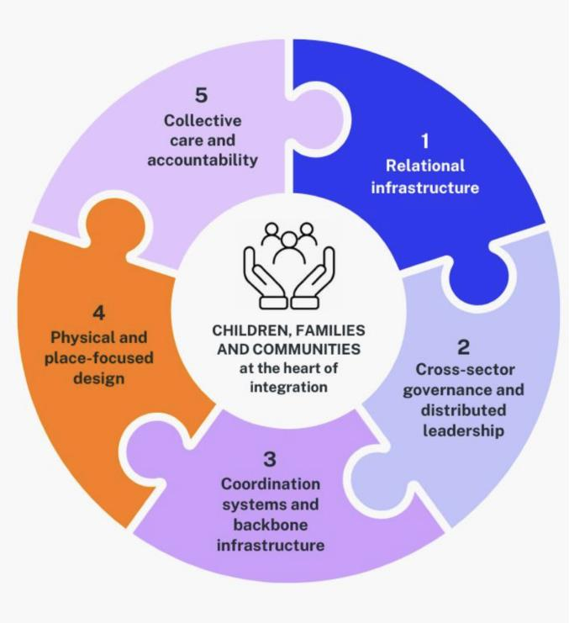
Figure 1 Key domains of the ‘glue', from 'Sticking points: why the ‘glue' helps Early Childhood Hubs thrive.

When appropriately funded, integrated early years models not only influence how services are delivered, but how government works – increasing efficiency, strengthening accountability to community, and shifting whole-of-system behaviour toward shared responsibility for children and families. Further details, including funding requirements for integration, are outlined in
‘Approaches to integration in the early years: learnings for impact’, and the substantial benefits of funding integration in early childhood hubs are discussed in From vision to viability: funding requirements for effective Early Childhood Hubs.
It is essential that integration is enabled across systems, as many co-located and integrated models deliver services funded through other federal departments, through state/territory or local governments and philanthropic sources. The department can facilitate service-level integration by ensuring consistent expectations and support for integration.
There is significant investment and reform in early childhood services including early childhood education and care, in Thriving Kids, place-based approaches and child safety and protection. Cross-system collaboration has benefits beyond enabling service-level integration.
Our work exploring the features of trauma-informed early childhood systems¹ found that government system structures can create or perpetuate trauma and can act as barriers to healing and recovery – including ‘single-issue’ systems that don’t effectively account for the whole context of the child, miss opportunities for strengths-based support and limit access to the

¹ SVA (2024) ‘Towards a trauma-informed Australian ECEC system: considerations for system change’
https://www.socialventures.org.au/about/publications/towards-a-trauma-informed-australian-early-childhood-education-and-caresystem-ecec/
3

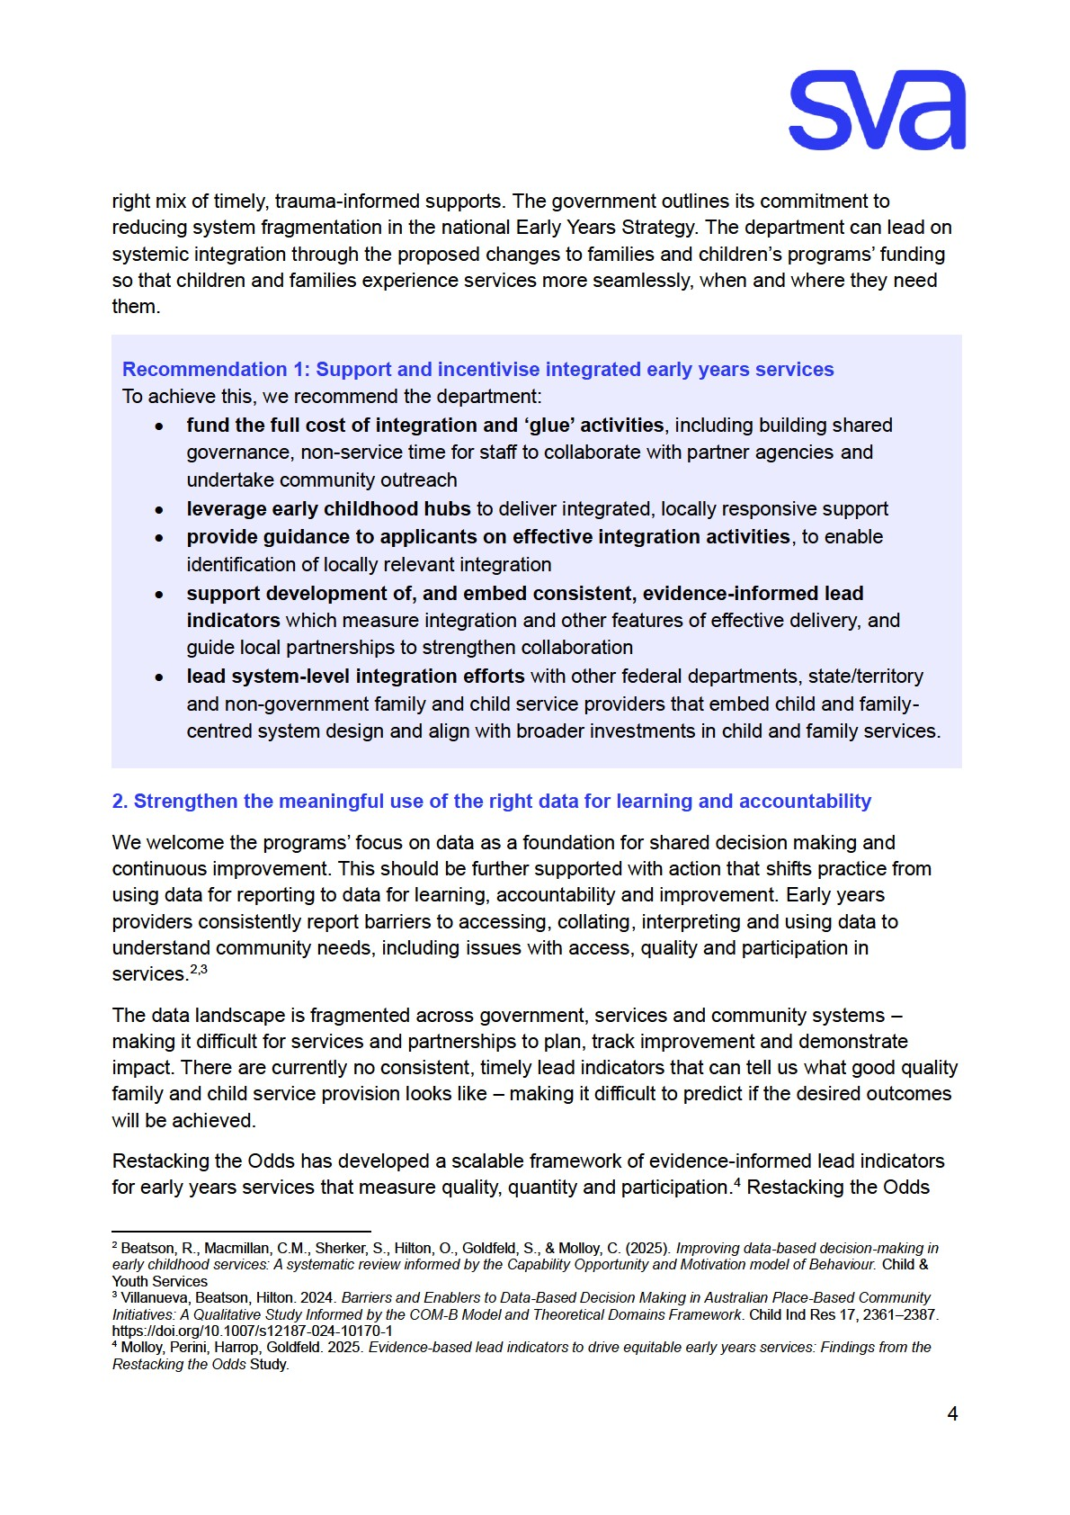
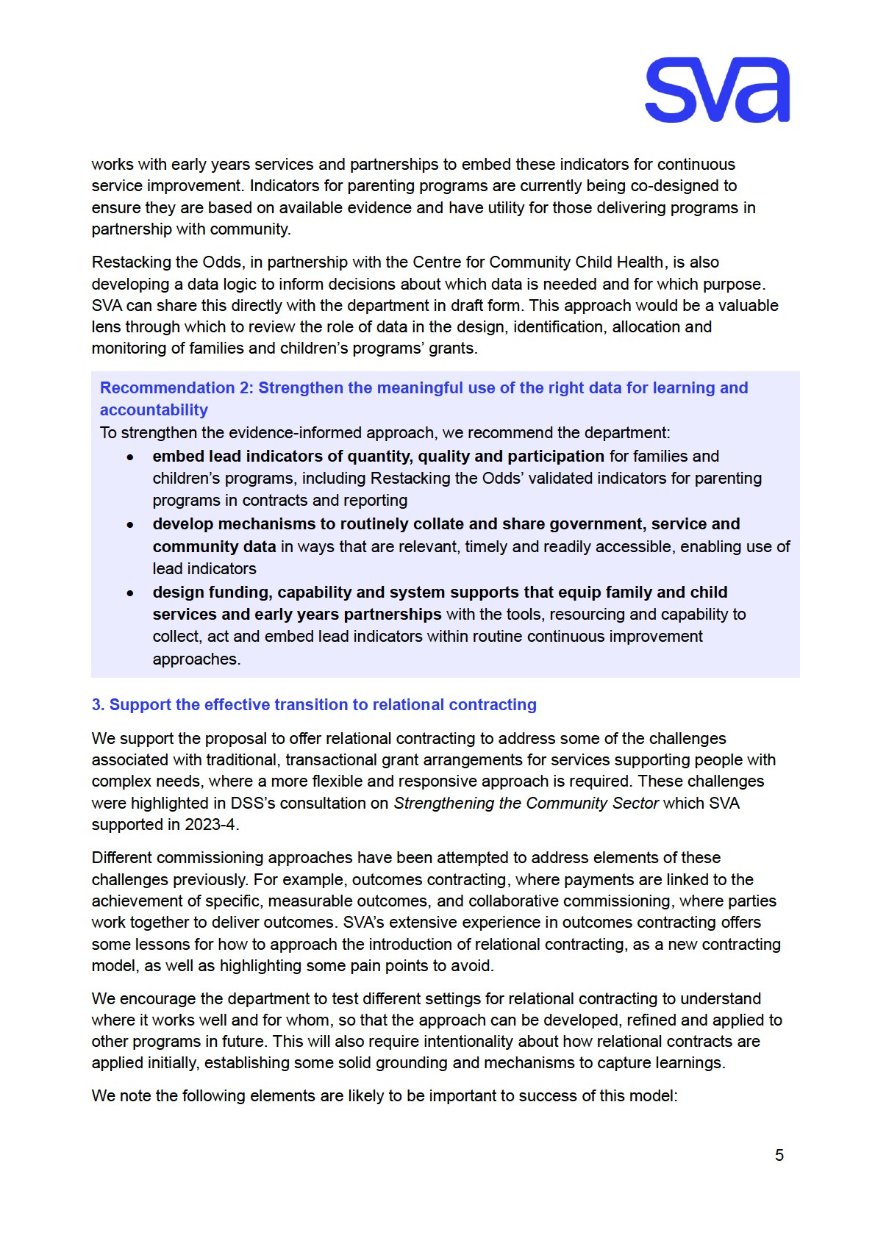
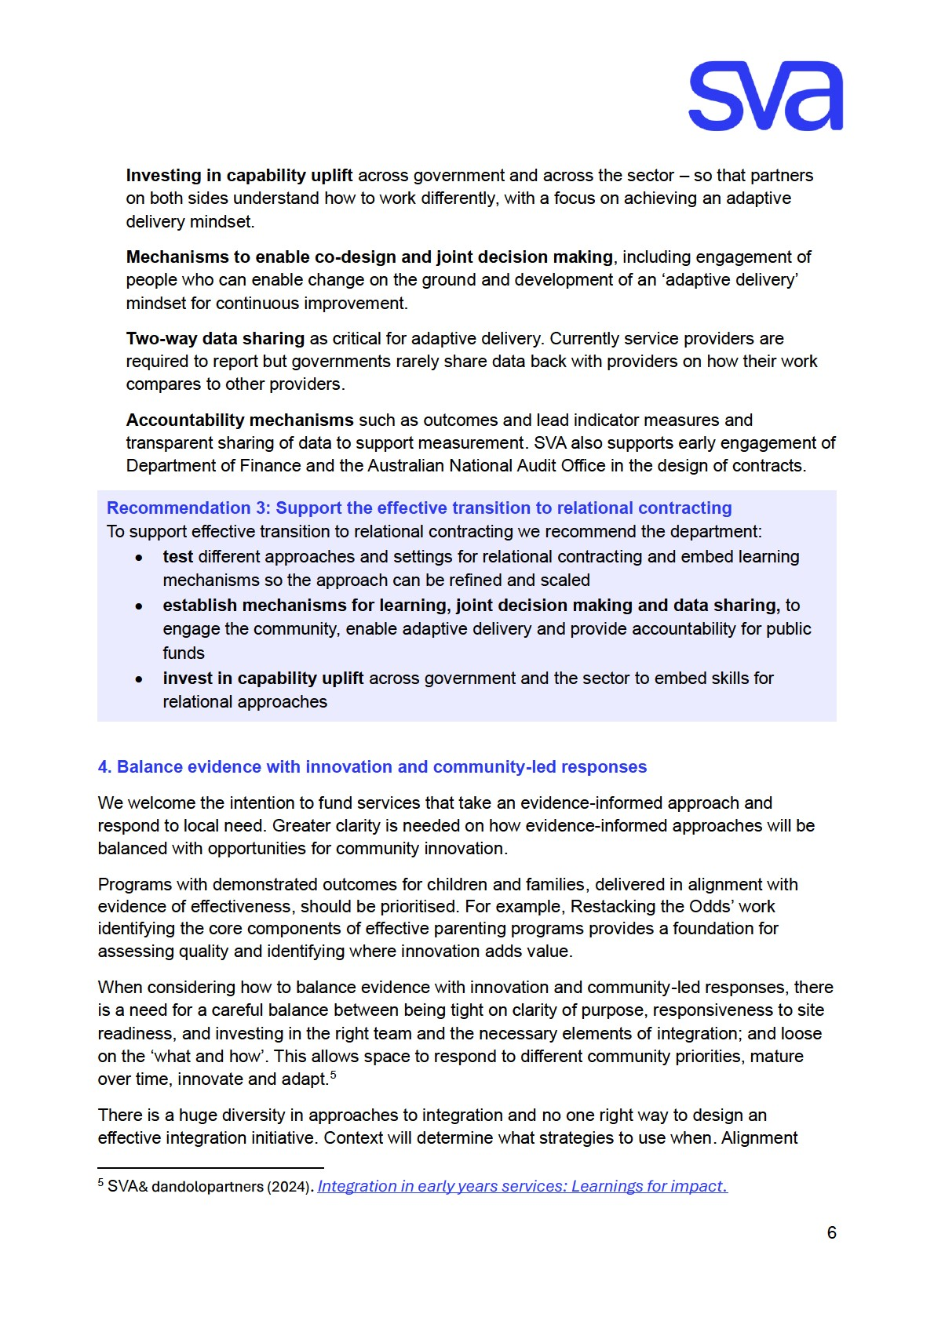
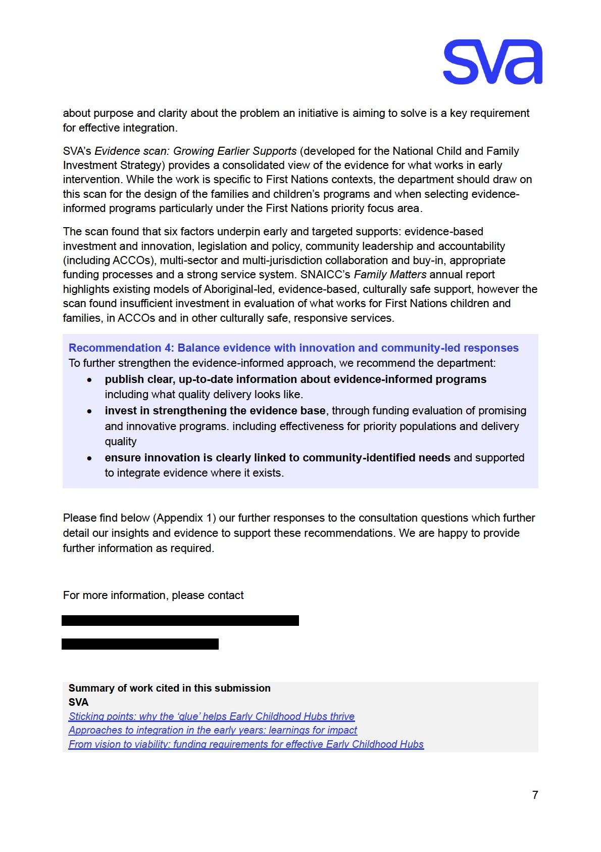
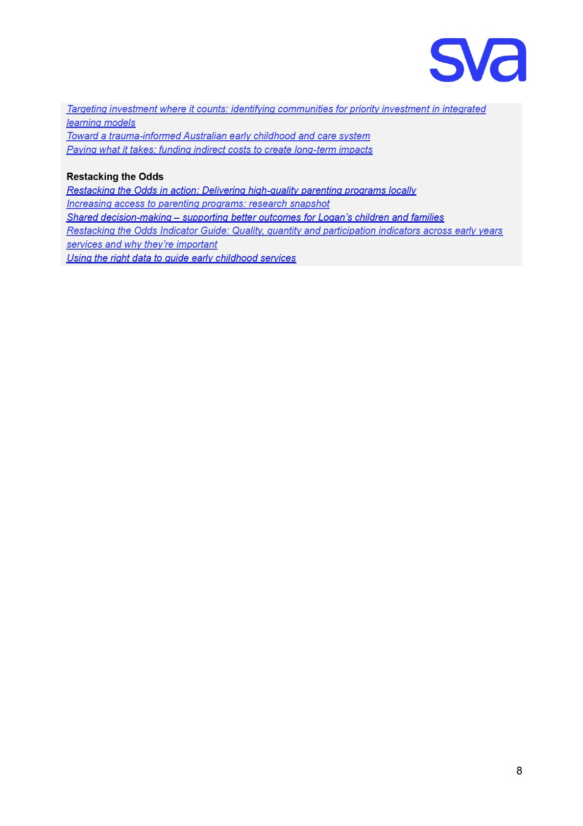

Appendix 1 – Response to select consultation questions

SVA’s expertise
SVA is a leader in outcomes contracting and impact investing, and has over 20 years’ experience working with partners in Australia for a strong charitable sector. Our response draws insights from this work and our internal expertise, including with relational commissioning approaches in the UK.
SVA has developed a strong body of evidence of what children need to thrive in early childhood, recognising this critical window to change trajectories and alleviate disadvantage. Our work includes Nurture Together, building momentum to scale integrated early childhood models. This includes early childhood hubs that provide access to a range of key services and wrap-around supports (including food relief) as well as a safe space for families to build connections and social networks.

SVA is part of Restacking the Odds, in collaboration with the Centre for Community Child Health at the Murdoch Children’s Research Institute and Bain & Company. Restacking the Odds’ mission is to ensure all children can access and participate in high-quality early childhood services. Restacking the Odds enables early years partnerships and services to use evidenceinformed lead indicators (timely data which show if programs are on track to achieve their goals) to drive continuous, locally-led improvement.

Program structure
6. Does the service or activity you deliver fit within one of the three funding streams? Do these streams reflect what children and families in your community need now – and what they might need in the future?
Restacking the Odds supports service providers that deliver programs under stream 2:
prevention and early intervention by providing tools and capacity building to enable evidenceinformed, quality delivery and continuous improvement. This includes targeted programs: parenting programs (included in this funding program), and sustained nurse home visiting, as well as universal services: antenatal care, early childhood education and care and early years of school (prep to year 3). When children access a combination of high-quality services over time– known as ‘stacking’ – evidence shows it significantly boosts developmental outcomes and reduces inequities.

While some services are not within the remit of the department, the department should consider how the families and children’s programs’ funding fits with other early years services to support complementary delivery to children and families who stand to benefit most.

To ensure the streams reflect what families need, the department should provide clear, up-todate information on which programs are evidence-informed, which priority groups they are designed to benefit, and what quality delivery looks like. For example, in response to the gap in consistent quality frameworks for parenting programs, Restacking the Odds has reviewed existing parenting programs supported by the strongest levels of evidence, identified core components linked to more effective programs, and is developing indicators to support consistent, evidence-informed implementation.
A parenting program advisory group (including researchers, providers, First Nations and government representatives) has also been established to further guide the development of consistent evidence informed approach to measuring parenting program quality. The objectives are to confirm the evidence base, identify the core components that underpin effective parenting support beyond reliance on named programs, and develop and refine lead indicators to assess and validate program quality.

7. Are there other changes we could make to the program to help your organisation or community overcome current challenges?
We support the move to streamlined, single contracts. This should be combined with support to help grant applicants understand available program options and implement them with fidelity. Assessment criteria and weighting should be designed to favour evidence-based approaches, while also supporting innovation and community-identified needs so the intention is clearly signalled to applicants.

Prioritising investment
- Do you agree that the four priorities listed on page 4 are the right areas for investment to improve outcomes for children and families?
We support these priorities, and particularly welcome the emphasis on coordination and integration, and on ACCOs.
- Are there any other priorities or issues you think the department should be focussing on?
Ensure early intervention does not exclude children and families who have already had contact with the child protection system – they are still early in life, and early in need. Investment in pathways, such as stepping down from residential care, or supporting safe reunification delivers meaningful benefits for children immediately and long-term. A child-centred approach is needed to avoid rigid program boundaries between federal and state systems. Hard edges in eligibility can leave children falling between programs, creating unnecessary navigation hurdles and limiting access to support.
- Do the proposed focus areas – like supporting families at risk of child protection involvement and young parents – match the needs or priorities of your service?
These focus areas align with SVA’s work that supports scaling up of holistic, integrated early years models, such as early childhood hubs – which provide coordinated, wrap around and stigma free supports, and the Early Years Education Program as delivered by Parkville Institute which supports families at risk of child protection involvement.
To support DSS National Child and Family Investment Strategy, SVA developed a definition of ‘early and targeted supports’ – focusing on both early years of life, and early intervention – including for children already in the child protection system.
- Are there other groups in your community, or different approaches, that you think the department should consider to better support family wellbeing?
Supporting family wellbeing requires strategic planning to ensure service gaps are filled and supports are reaching children and families they are designed for. The goal should be seamless delivery across health, education and community services including those provided by other levels of government and by non-government organisations. This requires coordinated work to understand who is persistently missing out, and adapt delivery models, including tailoring approaches for remote communities, addressing workforce issues and supporting delivery through place-based initiatives.
Prevention and early intervention should be extended to age 8 – consistent with Restacking the Odds evidence showing opportunities to reduce inequities through early schooling, and support families during transition into school-age supports.

Connected, co-located, and integrated services
- What are other effective ways, beyond co-location, that you’ve seen work well to connect and coordinate services for families?
The Hive Mount Druitt is a place-based initiative that exemplifies integration beyond co-location. The Hive is driven by a vision for all Mount Druitt children to start school well, with equal opportunities to learn, stay healthy and participate in community life. Their collective impact model enables them to be present in the community – building trust with families through engaging in places they spend their time – in early learning centres, small community hubs, schools, parks and playgrounds. Their model doesn’t rely on a single physical hub – instead their ‘linkers’ and engagement team use shared spaces and go where families already are. This place-based, community-focussed approach brings workers out from buildings and into families everyday environments, supporting those who otherwise may not feel confident walking through service doors.
Multi-service initiatives have been supported to collaborate through the Restacking the Odds framework (discussed further in response to Question 18). Place-based initiative partners report that it provides a valuable organising framework and shared language through consistent lead indicators for measuring quality, quantity and participation and the accompanying continuous improvement program. This fosters identification of evidence-informed solutions to local and shared challenges and ultimately better support for families.
- What would you highlight in a grant application to demonstrate a service is connected to the community it serves? What should applicants be assessed on?
We support the programs’ intention to create fair conditions for applicants of different sizes, by highlighting the importance of community connection.
Community involvement in governance and decision-making structures, and active participation through local enabling groups demonstrates authentic community connection. Service providers could also supply data that demonstrates community tenure, participant retention and feedback, that participants represent the target populations for the program, and how funds will be used to support and enable quality service delivery.
Restacking the Odds recent research on increasing access to parenting programs found flexible program scheduling, access to childminding, information on program effectiveness and relevance to families’ needs were valued by families.
Application assessments should incentivise allocation of program resources toward community connection activities (e.g. paid time for community outreach, co-design and understanding community needs) and allow for flexible delivery that meets community-identified enablers (e.g. times or locations that suit the community, providing or enabling child-minding). Assessments should recognise the value of staff who represent the community and bring lived experience, cultural knowledge or language skills.
Collaborative applications between services should also be encouraged.

Responding to community need
14. Beyond locational disadvantage, what other factors should the department consider to make sure funding reflects the needs of communities?
We support the proposal to examine existing service availability and the proposal to use AEDC results. SVA, with Deloitte Access Economics developed a method to identify communities of high early childhood disadvantage, that is SA2s in SEIFA deciles 1-4 and over 10% of children developmentally vulnerable on two or more AEDC domains. This research found 737 communities across Australia had high early childhood disadvantage and should be prioritised for targeted community-level investment in integrated, holistic services and supports including early childhood hubs and enhanced ECEC.
Not all disadvantage is locational – 40% of children experiencing disadvantage do not live in lowsocioeconomic areas. A multi-dimensional poverty measurement approach that accounts for individual needs and circumstances should be considered.
The department should also consider the prevalence and impacts of trauma on children and families, noting recently published research found that two in five Australians experience at least one traumatic event in childhood. These findings build on the landmark 2023 Australian Child

Maltreatment Study and underscore the need to embed trauma-informed care in all systems that children and families interact with.
It is imperative that funding enables trauma-informed service delivery ensuring that service providers are equipped to recognise the signs of trauma in children and families, respond appropriately and avoid practices that retraumatise.
The discussion paper does not make clear what data the government will assess through its own datasets and what the applicants will be asked to provide. We support the proposal to consider current levels of service availability in a community, however, note that currently this data is held separately by government, service providers or funders – and often left to communities to spend time and resources accessing and collating information to understand the local service picture.
Australian government departments are investing in data linkage projects that could be leveraged, including Person Level Integrated Data Asset, the Life Course Data Initiative and ‘The First Five Years: What makes a difference?’ research. New South Wales’ Performance and Wellbeing framework can also provide broader wellbeing factors to consider.
It would be extremely valuable if the department were to coordinate and publish data on child and family service mapping so agencies, grant applicants are better able to focus on providing complementary information that highlights local context, to plan and target their investment appropriately and most importantly on community engagement and quality service delivery.
Additional factors to consider include digital access, cultural diversity and local workforce capacity, and alignment with other government initiatives such as Thriving Kids, the Building Early Education Fund (integration stream) and the Early Years Strategy. SVA’s Nurture Together work (listed in our cover letter) also highlights the value of understanding how families navigate services and where gaps in coordination persist.
Finally, funding should consider a community’s readiness for collaboration and to drive change. In some areas, organisations are already leading collaborative efforts and may simply need targeted investment to amplify their impact – while others may require support to progress integration activities alongside program delivery.

Improving outcomes for Aboriginal and Torres Strait Islander children and families
16. How could the grant process be designed to support and increase the number of ACCOs delivering services to children and families?
We support SNAICC’s response, emphasising the importance of self-determination, alignment with Safe and Supported and Closing the Gap commitments, and funding transition to ACCOs. Funding should be flexible, community-determined and sustainable core funding to support workforce and infrastructure.

Measuring outcomes
18. What types of data would help your organisation better understand its impact and continuously improve its services?
Restacking the Odds finds that while lag (outcomes) indicators are widely used to identify where inequities exist, they are insufficient to guide timely service improvement during service delivery. By the time outcome data is available, it is too late to adjust the programs.
To drive timely improvement, organisations need lead indicators – evidence informed measures that show whether services are being delivered in ways known to drive better outcomes, and whether they are on track to achieve their goals.
Restacking the Odds uses evidence-informed lead indicators that focus on the critical drivers of change and answer three important questions; Are there enough services available (quantity)? Are they high quality (quality)? and are children and families accessing them enough to benefit (participation)? Lead indicators are powerful because they support real-time decision-making, proactive improvement and shared accountability. They benefit service providers, as well as governments, funders and community groups working on collaborative approaches. While outcome indicators tell us if change happened, lead indicators tell us why and how to improve.
Lead indicators can be calculated by combining local and service data with government-held data (e.g. enrolment, attendance, demographics). However, they are often missing from measurement and learning frameworks. Services face barriers accessing the data needed to calculate them and are rarely provided with the tools, capabilities or program settings required to embed data-driven improvement.
Restacking the Odds has worked with 13 local partners to co-design and implement practical tools – lead indicators, a data dashboard and a continuous improvement program across early childhood education and care, antenatal care and parenting programs. This has led to immediate improvements in data use, enabling services to collect and analyse data on priority groups (families disproportionately impacted by inequity due to factors including education, employment status, income and ethnicity) for the first time.
We strongly recommend the department:
- identify and include consistent lead indicators of quantity, quality and participation in contracts and reporting of families and children’s programs, including embedding the Restacking the Odds’ validated lead indicators for parenting programs funded through these programs
- ensure service providers and early years partnerships are given access to governmentheld data required to calculate lead indicators, e.g. embedded through the department’s Data Exchange (DEX)
- design funding, commissioning and accountability structures to enable the use of lead indicators by resourcing service providers and early years partnerships with the tools,

support resourcing and capability required to routinely collect, interpret and act on them as part of continuous improvement.
Further detail is available in:
Using the right data to guide early childhood services (research summary) and
Shared decision-making – supporting better outcomes for Logan’s children and families (placebased initiative case study)
Restacking the Odds indicator framework, communication summaries and technical reports provide in-depth detail of all indicators, and the evidence that informed their identification.
The Centre for Community Child Health’s forthcoming publication ‘Better data, better decisions, better outcomes for children’ will outline a proposed data logic which signposts what data is needed for what purpose, and how it can be used across early years systems. This includes how lead and lag (outcome) data can be used alongside local data to inform effective decisionmaking by government, services and early years partnerships. An advance version of the logic can be provided to the department to support the families and children’s programs’ design.
Additionally, as noted below (questions 22 & 23), two-way data sharing is important for transparency, accountability and for continuous improvement in delivery.

19. What kinds of data or information would be most valuable for you to share, to show how your service is positively impacting children and families?
Building on our response to question 18, lead indicator data can also be used to demonstrate child and family impacts, because they are informed by evidence of what works to make a difference.
For example, participation lead indicators include a benchmark for the required ‘dose’ of the sessions attended or service received that evidence tells us is enough (when delivered at the right quality) to have an impact. When lead indicators highlight improvement, we can expect that this is leading to meaningful change for children and families.
Stronger Communities (parenting program provider in regional Queensland) uses lead indicator data to strengthen service quality and responsiveness. Reviewing their Restacking the Odds dashboard in reflection and planning meetings, they track participant retention, waitlists and delivery quality in real time, enabling their team to quickly identify issues and adapt programs to community needs. These three-monthly debriefs combine data insights with practitioner and participant feedback and empower staff to participate in timely problem-solving and continuous improvement.
A further case study is provided in appendix 2: Restacking the Odds in action, highlighting how lead indicator data helped a Victorian parenting program to identify the need for and tailor engagement strategies to families who were the intended target cohort for the programs they were delivering.
- What does a relational contracting approach mean to you in practice? What criteria would you like to see included in a relational contract?
What a relational contracting approach means in practice may vary depending on context. SVA notes that while the term has been drawn from international experience, there are some differences in meaning between the proposed application in an Australian human services context and how it is used in countries such as the UK. SVA can provide some further guidance on this issue, and potential ‘archetypes’ of relational contracting structures to inform the design of the formal relational contract.
We encourage the department to test some different approaches. In particular:
  - testing hybrid approaches, for example of combining collaborative and relational contracting to consider different levels of relational flexibility and different procurement approaches
  - testing the mechanism in different settings to understand different relational contract approaches, and where it works well and for whom, including which organisation type and what types of outcomes or activity stream (see more detail in answer to question 23).
We also encourage the department to look at other areas of government that deploy relational contracting mechanisms to determine what they can learn from more advanced contracting environments. For example, Australian infrastructure alliance contracts use open book financials and pain/gain share elements. There are also frameworks used overseas that have standardised 'relational' clauses, such as UK’s FAC-1 Framework Alliance Contract.
Here are some features of outcomes contracting that have worked well, along with lessons from the pain points, provide insights on the approach for developing relational contracts. These include:
  - inviting co-design of the contract through the procurement approach.
  - delegated decision making to joint working groups, with membership made up of people who are able to embed change on the ground.
  - clear review mechanisms to manage changes in service delivery, across all partners to the contract, including government.
  - commitment to transparent two-way data sharing to support adaptive delivery and address the power imbalance associated with information asymmetry between government, service providers and communities.
  - joint decision making on what outcomes to measure and how to refresh this over time to focus on achieving the intended benefits. An 'adaptive delivery' mindset is key to the cultural change for continuous improvement, rather than a ‘set and forget’ approach to contract management within government.
  - embedding costs associated with building and retaining relational contracting capacity into funding arrangements. SVA notes there is also opportunity through a relational approach for up front discussion about the full costs of service delivery and how these are reflected within the funding arrangement.
We encourage the department to start formal relational contracts by establishing some solid grounding – such as data sharing, decision making processes and a mechanism for capturing learning. Over time the approach could evolve as needs and performance are better understood, including driving towards outcomes.

- What’s the best way for the department to decide which organisations should be offered a relational contract?
We encourage the department to test different criteria for selecting organisations for a relational contract opportunity – ideally including organisations delivering to cohorts with differing levels of complexity, different types of activity and in different geographic settings. This will allow the department to identify the conditions under which relational contracting is most applicable and where adaptation is needed for different contexts.
The department may want to consider prioritising organisations with a demonstrated commitment to the community, understanding of local need and values aligned to the objectives of the program. It will also be particularly important to work with organisations that are comfortable embedding a learning approach – including a willingness to share challenges and lessons with government and other agencies participating in the trial.

Other
25. Is there anything else you think the department should understand or consider about this proposed approach?
We recommend application of Pay What It Takes principles and indexation to reflect real costs, consistent with the intention outlined under the Not-for-profit Sector Development Blueprint to cover the true cost of quality delivery. SVA and the Centre for Social Impact‘s 2022 report ‘Paying what it takes funding indirect costs to create long-term impact’ revealed Australian notfor-profit organisations are routinely under-funded for essential indirect costs, flowing through to impacts on service capability and sustained viability – underlining how vital adequate and sustained funding is to support community outcomes.
As highlighted in our response to question 14, given the prevalence and impacts of childhood trauma (with at least two in five adults in Australia likely to have experienced a potentially traumatic event during childhood), we recommend that the department adopt a trauma-informed approach to both the design and delivery of the families and children’s programs.
While trauma-informed practice and care is increasingly noted in some program design considerations, there’s often limited consideration of the system design features that enable trauma-informed service delivery and similarly, those that can perpetuate trauma. Children and families engage with many service systems that are often not equipped to recognise or respond

appropriately to the impacts of trauma. SVA’s work on exploring trauma-informed and healingcentred systems for children offers insights that could be considered in the program design of the families and children’s programs. These include:
- embedding relational systems and practice by funding and commissioning in ways that value relationship-based work, supported by strong training and leadership commitment
- addressing system-level enablers, through whole-of-government commitment, stable and adequate funding, and policy settings that reduce fragmentation and avoid commodifying care
- strengthening leadership capability so organisational and system leaders act as enablers of trauma-informed and relational practice, rather than barriers
- investing in workforce development and wellbeing with trauma literacy, trauma-informed and relational practice training for all roles working with children and families, supported by appropriate supervision and practitioner supports.

Appendix 2: Restacking the Odds in action: Delivering high-quality parenting programs locally https://www.rsto.org.au/media/mnuoprlz/2306 rsto in-action scenario02.pdf
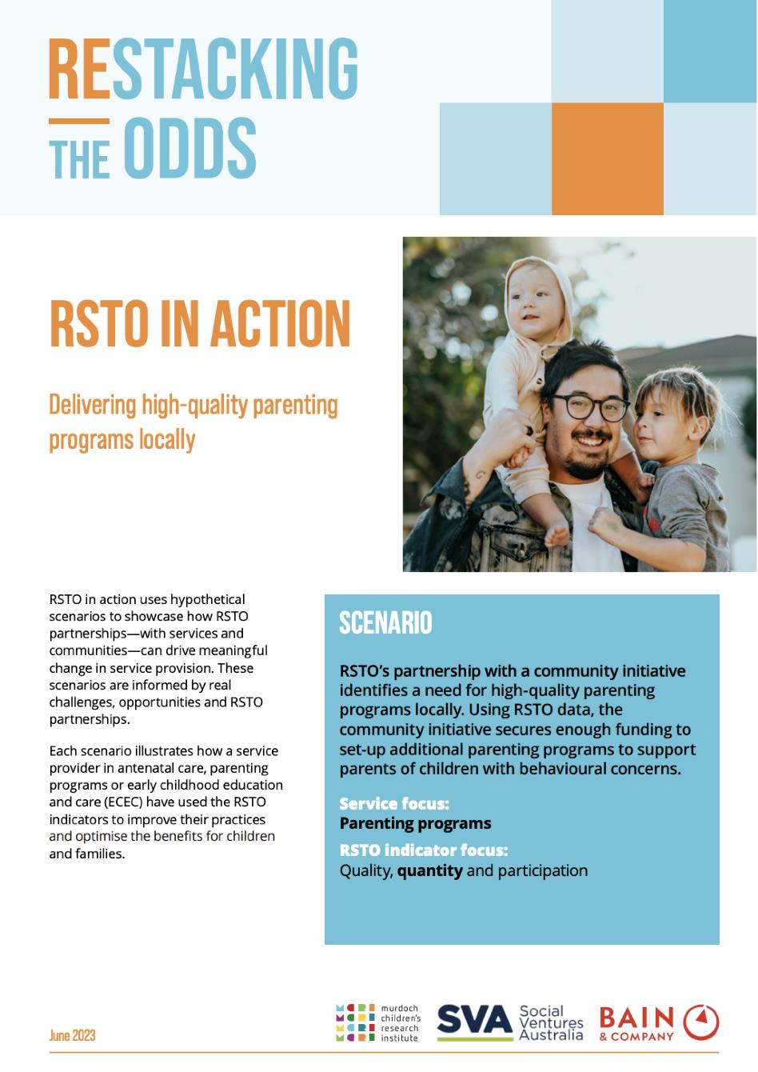
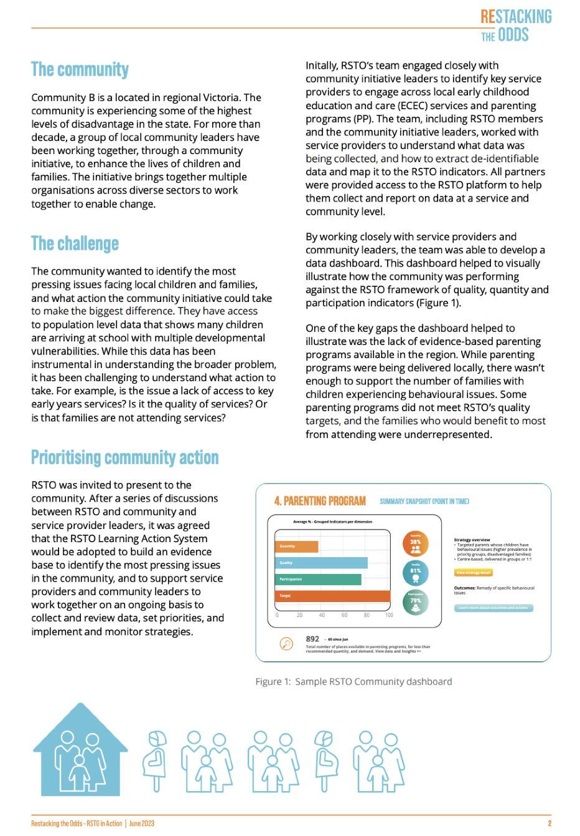

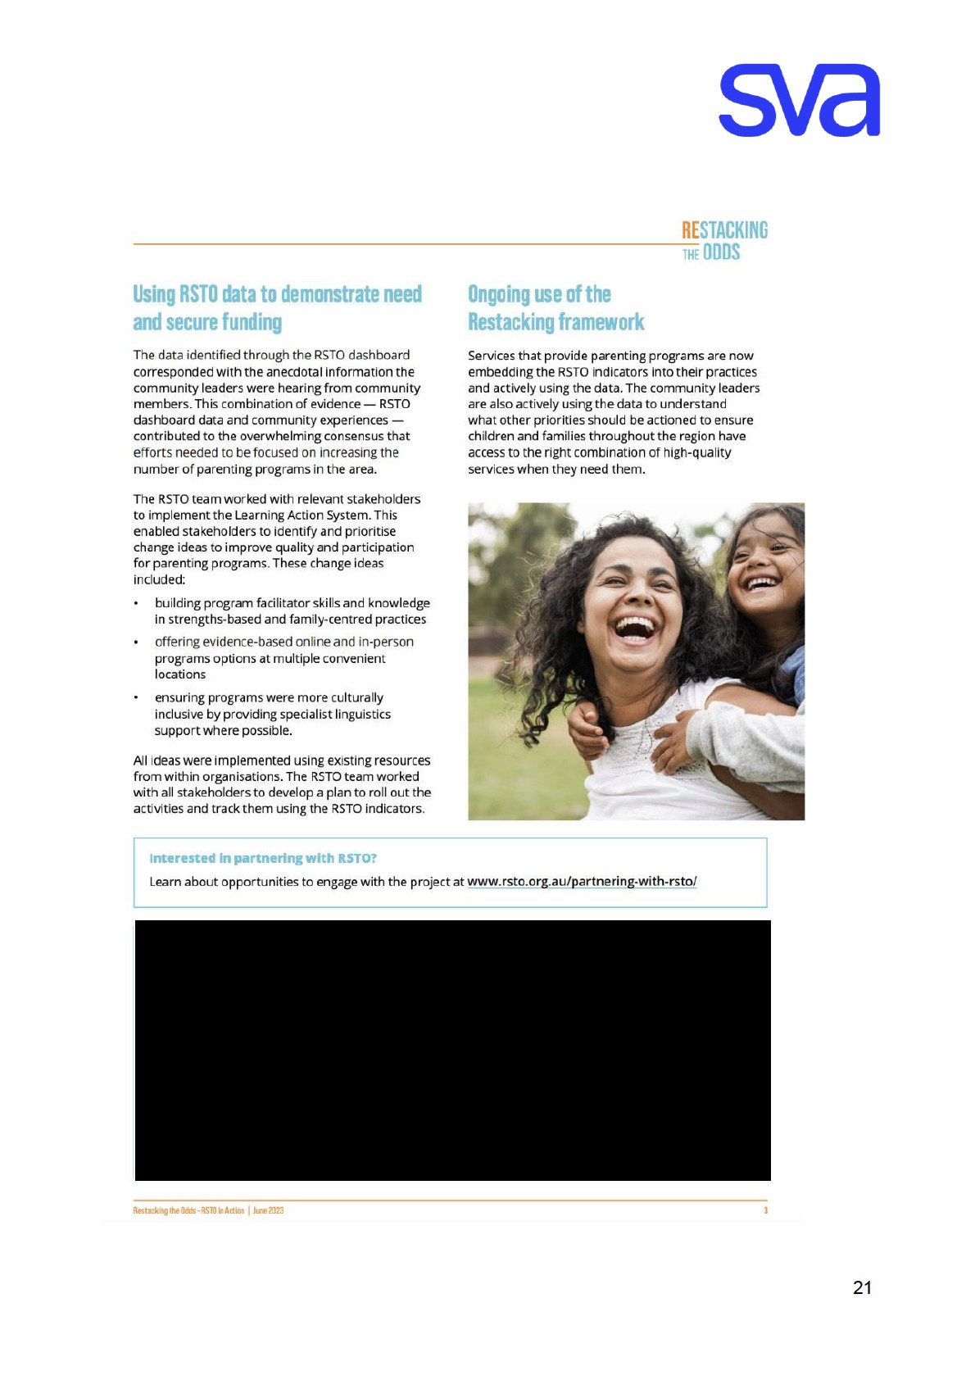

Molloy, C, Beatson, R, Fehlberg, Z., Macmillan, C, Harrop, C, Perini, N, & Goldfeld, S (2025). Participation in parenting programs: A mixed methods study of barriers and facilitators experienced by families in three Australian communities. Children & Youth Services Review, 179, https://doi.org/10.1016/j.childyouth.2025.108610
SVA, Deloitte Access Economics and the Mitchell Institute (2025), Targeting Investment Where it Counts: identifying communities for priority investment in integrated learning models’ https://www.socialventures.org.au/wp-content/uploads/2025/02/Targetinginvestment-where-it-counts-report-Feb2025.pdf
Pham, C; Downes, M; Guo, J; Jahan, F; De Silva, S; O'Connor, E, Goldfeld, S (2024). Measuring vulnerability and disadvantage in early childhood data collections: Phase Two. Murdoch Children’s Research Institute. https://doi.org/10.25374/MCRI.26300749.v2
Barrett E, Grummitt L, Jones S, Rowlinson, K, Vasilopoulos, F, Teeson, M, Mills, The prevalence of potentially traumatic events in childhood and associations with mental disorders, suicide and physical health in adulthood: An Australian nationally representative cross-sectional study. Australian & New Zealand Journal of Psychiatry. doi:10.1177/00048674251381004
Restacking the Odds (2024) The right data, in the right hands supports better outcomes’ https://www.socialventures.org.au/ourimpact/the-right-data-at-the-right-time-in-the-right-hands-supports-better-outcomes/
Department of Social Services (2024) Not-for-profit Sector Development Blueprint https://www.dss.gov.au/system/files/documents/2024-11/d24-1528640-not-profit-sector-development-blueprint-web-accessible.pdf
SVA and Centre for Social Impact (2022) Paying what it takes: funding indirect costs to create long-term impact’ https://www.socialventures.org.au/our-impact/paying-what-it-takes-report/
SVA (2024) Towards a trauma-informed Australian ECEC system: considerations for system change https://www.socialventures.org.au/wp-content/uploads/2024/12/Towards-a-Trauma-Informed-Australian-ECEC-System-FINAL-Dec2024.pdf

