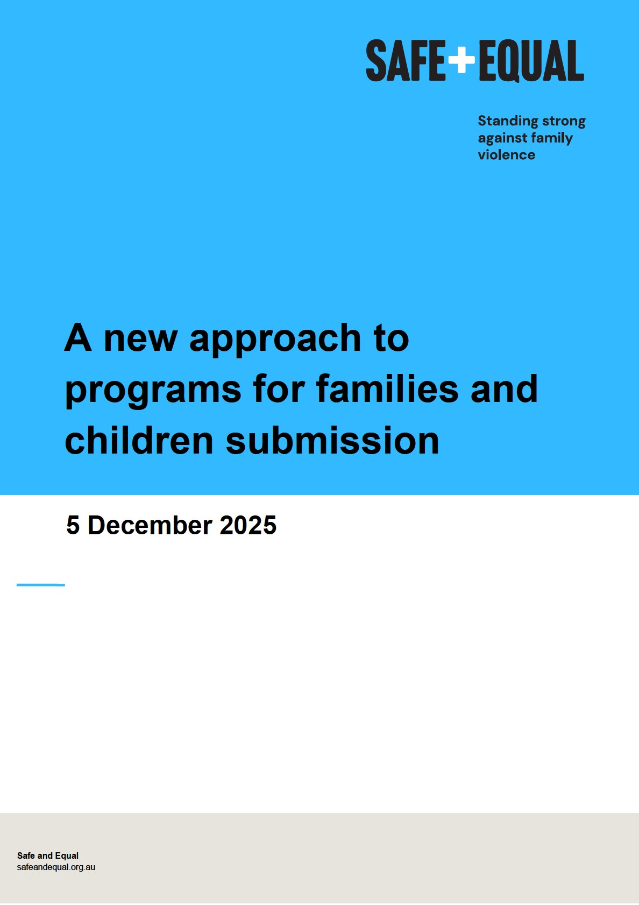

Acknowledgement of Traditional Owners

Acknowledgement of Aboriginal and Torres Strait Islander peoples
Safe and Equal is based on Wurundjeri Country. We acknowledge Aboriginal and Torres Strait Islander peoples as the traditional and ongoing custodians of the lands on which we live and work, and we pay respects to Elders past and present. We acknowledge that sovereignty has never been ceded and recognise First Nations peoples’ rights to selfdetermination and continuing connections to land, waters and community.

Honouring Victim Survivors
Safe and Equal recognises the strength and resilience of adults, children and young people who have experienced family violence and recognises that it is essential that responses to family violence are informed by their expert knowledge and advocacy. We pay respects to those who have not survived and acknowledge the lasting impacts of this preventable violence on families and communities.

About Safe and Equal
At Safe and Equal, we work towards a world where everyone is safe, respected and thriving, living free from family and gender-based violence.
We are the peak body for Victorian organisations that specialise in family and genderbased violence across the continuum, including primary prevention, early intervention, response and recovery. We are an independent, non-government organisation.
Our work prioritises the safety of all people experiencing, recovering from or at risk of family and gender-based violence. While we know that most family violence is perpetrated by men against women and children, we recognise that family violence impacts people across a diversity of gender identities, social and cultural contexts, and within various intimate, family and other relationships. We apply an intersectional feminist lens in our work to address the gendered drivers of violence, and how these overlap and intersect with additional forms of violence, oppression and inequality.
As a peak, we work with and for our members to prevent and respond to violence, building a better future for adults, children and young people experiencing, at risk of, or recovering from family and gender-based violence.
© 2025 Safe and Equal

Introduction
Safe and Equal welcomes the opportunity to contribute to the consultation on A new approach to programs for families and children and on the proposed changes to five Families and Children Activity Programs, including the Specialised Family Violence Services program.
While we support in principle efforts to reduce red-tape, streamline administrative processes and ensure funding is more flexible, we are concerned that the proposal, does not accurately reflect the work of Specialist Family Violence Services (SFVSs). Currently, the existing Specialised Family Violence Services program could be further strengthened and will be further diluted if collapsed into a generic funding program. This risks funding being allocated away from specialist family violence services to larger, generalist organisations.
We are not aware of specialist family violence services in Victoria receiving Specialised Family Violence Services program funding. However, due to growing demand for specialist family violence support, it is critical the funding criteria accurately reflects the work of the sector, so these funds are available to the specialist sector to support victim survivors. We recommend that the existing Specialised Family Violence Services program remains standalone, and that it is strengthened to embed the foundational philosophies, principles and practice of the SFVS sector. We also recommend a family violence lens is embedded across each of the Family and Children Activity programs, due to the ubiquitous nature of family violence and the significant impacts on families, individuals and children.
The Commonwealth government must ensure safe and meaningful responses for victim survivors to fulfil its treaty obligations for the elimination of violence against women and gender-based violence as included in the United Nations Convention on the Elimination of All Forms of Discrimination Against Women (CEDAW), to achieve the ambition to end gender-based violence in a generation in the National Plan to End Violence against
Women and Children 2022-23. Ensuring culturally safe and self-determined responses to
Aboriginal women and children experiencing family violence is critical to accomplish
Target 13 of the National Agreement on Closing the Gap
Our primary recommendation is to retain an improved, standalone SFVS program stream. We have also responded to the proposal via relevant grouped discussion questions that

reflect our areas of expertise as the peak body for SFVSs in Victoria. We make recommendations to strengthen the proposed approach to make it fit-for-purpose to respond to adult, child and young person victim survivors of family violence. If the SFVS program stream does not remain standalone, embedding a family violence lens across the new program must be a priority.

Responses to discussion questions

Vision and outcomes
- Does the new vision reflect what we all want for children and families?
  - Proposed Vision: All children and young people are supported by strong families who have the skills and confidence to nurture them.
- Are the two main outcomes what we should be working towards for children and families? Why/why not?
  - Outcome 1: Parents and caregivers are empowered to raise healthy, resilient children.
  - Outcome 2: Children are supported to grow into healthy, resilient adults.
Victim survivor safety, perpetrator accountability, child-centred practice and Aboriginal self-determination are all guiding principles of specialist family violence work. Victim survivor safety is fundamental and involves victim survivor agency. Victim survivor agency recognises that victim survivors often have the most knowledge and practiced skills in keeping themselves and their children safe, and that this experience and knowledge need to be respected and guide service support. It is critical that each of these SFVS principles are reflected in the proposed model.
The proposed vision and outcomes highlight families, parents and caregivers; however, do not recognise that in a family violence context not all members of a family (including parents or carers) are safe for adult or child victim survivors. Additionally, language used in the current proposed vision and outcomes on “empowering” parents to have “skills and confidence” to raise healthy kids risks problematising safe parents by implying that they are at fault or at a deficit, instead of recognising that a safe parent’s skills and confidence are actively undermined and they are purposefully being disempowered by the perpetrator of family violence. It also fails to interrogate any other underlying impacts family violence might have, inclusive of experiences of trauma, impacts on mental health and coping strategies including alcohol and other drug use.
It must be made explicit that a parent who perpetrates family violence against another parent or family member, who abuses and harms children and/or exposes them to the

effects of abuse, is choosing to make family violence part of their children’s lives. This is a parenting choice. Therefore, they are not a safe person/parent/carer for that child. It is critical perpetrators can be supported by Men’s Behaviour Change Programs (MBCPs) to understand and work to amend their behaviour, particularly as a parent. This also supports victim survivor safety.
Reframing the violence in this way ensures the perpetrator remains in view and accountable. Without recognising adult victim survivors as safe and protective parents and addressing adult and child victim survivor safety as fundamental, perpetrator accountability is lost and programs and services risk perpetrator collusion. It is critical that perpetrators are held responsible for using family violence, and victim survivors are not at fault or blamed for experiencing violence.
There is also a gap in applying a family violence lens to the experiences of children and young people. It is well-established that family violence has significant impact on infants, children and young people as victim survivors in their own right, whether they are directly targeted with abuse, witness violence towards their parent or carer, or are otherwise exposed to the effects of family violence. SFVSs use child-centred practice, which involves working with children in a way that is safe, positive and empowering and recognises children’s voice – meaning services involve children in decision-making for their lives. Outcome 2 speaks of supporting children to grow into healthy adults. To achieve this, children need to be supported as victim survivors of family violence in their own right and the effects of these experiences addressed.
As family violence is widespread, we expect that all the organisations that may receive funding will incorporate how to work with victim survivors safely and hold perpetrators to account. We note that MBCPs are currently funded under the Specialised Family Violence Services program and we support MBCPs and other specialist family violence organisations receiving grants in recognition of their work prioritising victim survivor safety and perpetrator accountability, and their ability to work collaboratively across the system.
Principles of victim survivor safety and perpetrator accountability also need to be incorporated into any family or child wellbeing work. Without this family violence lens, the work ‘may lead to ineffective responses that do not address the underlying cause of the concerns’, and makes invisible the significant negative impact family violence has on adult, child and young victim survivors as individuals, the bond between adult and child or young victim survivors, and on the adult victim survivors’ parenting ability.

We recommend that the proposed vision and outcomes need to include references to victim survivors being safe and people who use violence being held accountable. The vision should prioritise safety for non-offending parents and/or caregivers, as this would foster a safe, and stable environment for children. Outcome 1 should be amended to recognise ‘safe and protective’ parents and caregivers, and Outcome 2 should include the principle of child-centered practice, the importance of children’s voices, acknowledge them as victim survivors of family violence in their own right, and uphold the right of children to participate in decisions that affect them when safe to do so.

Program structure
- Will a single national program provide more flexibility for your organisation?
- Does the service or activity you deliver fit within one of the three funding streams? Do these streams reflect what children and families in your community need now – and what they might need in the future?
Stream 1: National programs and information services
  - Activities that have a large geographical footprint, deliver services to all types of families in Australia, and have few or no restrictions regarding who can access the support.
Stream 2: Prevention and early intervention
  - Evidence-informed services that help prevent problems early and keep families strong and safe.
  - Programs that support children and young people’s development and wellbeing.
  - Services that offer targeted help to parents, caregivers and families.
Stream 3: Intensive family supports
  - Evidence-informed services that support families at risk of contact with child protection services.
  - Support for families facing multiple, complex challenges – offering tailored help to meet their specific needs.

- Are there other changes we could make to the program to help your organisation or community overcome current challenges?
As previously noted, our priority recommendation is for the role of specialist services that address family violence including victim survivor focused SFVSs, MBPC’s and Sexual Assault Services to remain a recognised and specialised program. Collapsing the Specialised Family Violence Services program into one generic funding program that does not accurately reflect the work of these specialised sectors puts this specialisation at risk, by making it unlikely that specialised services will successfully access funding when competing against larger, but more generalist services. This includes small, grassroots and community-led organisations who provide tailored specialist family violence support to communities such as Aboriginal communities, multicultural communities, LGBTQIA+ communities, and people with disability. These tailored services need increased funding, not only to participate in the grants application processes, but also to deliver services due to the additional system complexities they must navigate on behalf of their clients.
Whether or not the SFVS program is retained as standalone, we recommend the Commonwealth work with states and territories to identify who the community-led organisations are best placed to do this work, to be funded at levels that accurately reflect the complexity of the work due to increased systemic harm committed against Aboriginal and marginalised victim survivors.
The specialised work undertaken by the specialist family violence sector requires working in alignment to specific frameworks and guidance that are not generalist. We recommend that, if the SFVS program is combined as proposed, the program must have a specialist family violence stream added (stream 4) that reflects the principles, practices and work of the SFVS sector.

Prioritising investment
- Do you agree that the four priorities listed on page 4 are the right areas for investment to improve outcomes for children and families?
  - Invest early to improve family wellbeing, break cycles of disadvantage, and reduce the need for later interventions – like child protection.
  - Prioritise connected, co-located, and integrated services that work together to meet family needs.
  - Ensure services are informed by, and respond to, community needs.
  - Improve outcomes for First Nations children and families by increasing the number of Aboriginal and Torres Strait Islander communitycontrolled organisations (also called ACCOs) delivering supports in locations with high First Nations populations.
- Are there any other priorities or issues you think the department should be focusing on?
We are broadly supportive of these investment priorities. However, an additional priority that explicitly focuses on family violence, and SFVS principles including victim survivor safety, perpetrator accountability, child-centred practice and Aboriginal self-determination is needed.
We support the need to invest early, and note that effective early intervention for adult and child victim survivors requires long-term support to ensure victim survivors can be safe and supported without having to re-engage with services in the future. In addition to earlier intervention, investment in recovery initiatives can also be critical interventions that help break cycles of violence and prevent future experiences of violence. On this basis, we suggest that long-term recovery initiatives should also be a priority for investment.

Investing early to support family wellbeing
- Do the proposed focus areas – like supporting families at risk of child protection involvement and young parents – match the needs or priorities of your service?
The proposed focus areas are:
  - Families at risk of child protection involvement.
  - Prevention and early intervention support for children aged 0-5 years.
  - Young parents aged under 25.
- Are there other groups in your community, or different approaches, that you think the department should consider to better support family wellbeing?
There is a large gap in support for children from the age of five onwards. Engaging with children and young people at all ages who experience family violence is critical to ensure they receive the long-term, trauma informed care and support required for their recovery into adulthood. This intervention contributes to long-term efforts to stop the intergenerational transmission of family violence for this population that is at high risk of perpetrating and/or experiencing family violence, with research indicating almost 90% of adolescents using violence have been victims of family violence themselves. This early intervention work is also recovery work, to support children and young people’s long-term healing from experience and/or exposure to family violence, including in the specialist family violence sector.
We recommend that the focus areas are expanded to include children and young people of all ages. If this is not possible, DSS may consider limiting the focus area from 0-14 years old, in recognition that, in a survey of adolescents using violence who could remember their age when they started using violence, 42% indicated it was before they turned 10.

Co-located and connected services
We are supportive of co-located and connected services that provide holistic support. For this to be effective, services need to retain their specialist areas of expertise, have a shared understanding of family violence, and have respect for each other’s roles and responsibilities. We would recommend a shift in language from ‘integrated’, which could be mistaken as the assimilation of services, to ‘coordinated’, ‘collaborative’ or ‘multidisciplinary.’
This type of work requires intentional effort and dedicated resourcing should be considered as part of funding streams.

Ensuring services are connected to community need
- What would you highlight in a grant application to demonstrate a service is connected to the community it serves? What should applicants be assessed on?
- Beyond locational disadvantage, what other factors should the department consider to make sure funding reflects the needs of communities?
- What’s the best way for organisations to show in grant applications, that their service is genuinely meeting the needs of the community?
We agree with the priority of ensuring services are responsive to community needs. One lever is to invest in organisations that have pre-established expertise in an area and preexisting community connections.
There is an opportunity for DSS to establish a nationwide reference group with SFVS peak bodies and State and Territory Governments to determine local, pre-existing SFVSs services embedded within local communities and any current resourcing gaps and community needs that could be met.
Another approach would be to require any organisation applying to work with a certain community to demonstrate a genuine partnership with a pre-existing service with a proven track record working in that community or specialist area of practice. Partnerships must be designed to equalise power differences, and with accountability mechanisms. Partnerships should also consider a process of hand over to smaller organisations particularly if they are ACCOs. This speaks to Priority Reform 2 – Building the Community-Controlled Sector – of the National Agreement on Closing the Gap. A partnership approach gives grassroots organisations connected to their communities a better chance at accessing this funding. This is effective and financially responsible, as it costs more to establish a new local service.

Supporting Aboriginal Organisations
As Aboriginal victim survivors are located Australia-wide, DSS should consider ACCOs in any area for the grant funding, not just those in areas with high First Nations populations.
To support self-determination, the program should recognise Aboriginal definitions of families and family violence, and that Aboriginal Community Controlled Organisations (ACCOs) may have their own ways of working with victim survivors, children and young people, and perpetrators. We also recognise ACCOs may not self-identify as Specialised

Family Violence Services, and this should not exclude any ACCO that has family violence as its core business from receiving program funding. In addition, any funding allocation to Aboriginal services should be at a higher rate for ACCOs to provide culturally appropriate and safe services, and to recognise the lengthier time it takes to navigate the service system due to colonisation, discrimination and the cumulative systemic harm caused to Aboriginal people.

Recommendations
Priority recommendation:
- For the Specialised Family Violence Services program to remain a standalone grants program. As part of this we also recommend:
  - The existing Specialised Family Violence Services program is strengthened to embed the foundational philosophies, principles and practice of the SFVS sector, particularly victim survivor safety, perpetrator accountability, childcentred practice and Aboriginal self-determination, and to include recommendations 4, 9, 10 and 11 as outlined below.
  - A family violence lens is embedded across each of the Family and Children Activity programs.
Proposal recommendations:
If the Department opts to amalgamate the Specialised Family Violence Services program as proposed, we recommend the following to reflect the principles of the SFVS sector and prioritise safety for adult, child and young person victim survivors:
- Apply a family violence lens throughout the proposed program, inclusive of applying SFVS principles of victim survivor safety, perpetrator accountability, child-centred practice and Aboriginal self-determination.
- Amend the vision and outcomes to include safety for victim survivor and perpetrator accountability, and incorporate:
  - Outcome 1: a recognition of ‘safe and protective’ parents
  - Outcome 2: the principle of child-centred practice
- If there is a move to the proposed new stream structure, an additional stream for specialist family violence should be added (stream 4) to reflect the principles, practices and work of the SFVS sector.
- Funding for ACCOs and other specialised targeted community organisations should account for the system complexity these organisations have to navigate on behalf of their clients to overcome systems bias and discrimination. This should also apply to the Specialised Family Violence Service grant program if retained as standalone.
- Create an additional priority that explicitly focuses on family violence and SFVS principles of victim survivor safety, perpetrator accountability, child-centred practice and Aboriginal self-determination.
- Long-term recovery initiatives should also be a priority for investment.
- The proposed focus areas should be expanded to include children and young people of all ages, or the focus area should be expanded to 0-14 years old.
- For co-located and connected services, a shift in language from ‘integrated’, to ‘coordinated’, ‘collaborative’ or ‘multi-disciplinary’.
- Collaborative multi-disciplinary work requires intentional effort and dedicated resourcing should be considered as part of funding streams. This should also apply to the Specialised Family Violence Service program if retained as standalone.
4. DSS to establish a nationwide reference group with SFVS peak bodies and State and Territory Governments to determine local, pre-existing SFVSs services embedded within local communities and any current resourcing gaps and community needs that could be met. This should also apply to the Specialised Family Violence Service program if retained as standalone.
10. To support Aboriginal self-determination, the proposed model should recognise the causes and broader societal context within which family violence occurs for Aboriginal victim survivors, the Aboriginal definition of family violence and families, and that ACCOs will have their own ways for working with victim survivors including safe adult parents, children and young people victim survivors, and perpetrators of family violence. The proposed model should also recognise ACCOs may not self-identify as Specialised Family Violence Services, however this should not exclude any ACCO that has family violence as its core business from receiving program funding. This should also apply to the Specialised Family Violence Service program if retained as standalone.

For more information on the foundational frameworks, principles and standards of the Specialist Family Violence Services sector in Victoria, please see the Code of Practice (2nd Edition). Safe and Equal (2020). Code of Practice: Principles and Standards for Specialist Family Violence Services for Victim-Survivors. 2nd Edition. https://safeandequal.org.au/working-in-family-violence/service-responses/specialist-familyviolence-services/the-code-of-practice/
Department of Social Services (2024). National Plan to End Gender Based Violence. https://www.dss.gov.au/national-plan-end-gender-based-violence
Target 13 states: “By 2031, the rate of all forms of family violence and abuse against Aboriginal and Torres Strait Islander women and children is reduced at least by 50%, as progress towards zero.” Commonwealth of Australia, Department of the Prime Minister and Cabinet (n.d.). Closing the Gap. https://www.closingthegap.gov.au/
Safe and Equal (2020). Code of Practice: Principles and Standards for Specialist Family Violence Services for Victim-Survivors. 2nd Edition. See Principle 2: Person-Centred Empowerment, p. 38-39. https://safeandequal.org.au/working-in-family-violence/service-responses/specialist-family-violenceservices/the-code-of-practice/
Safe and Together Model™, referenced in Humphreys, C., & Healey, L. (2017). PAThways and Research Into Collaborative Inter-Agency practice: Collaborative work across the child protection and specialist domestic and family violence interface: Final report. Sydney: ANROWS.
Safe and Equal (2020). Code of Practice: Principles and Standards for Specialist Family Violence Services for Victim-Survivors. 2nd Edition. See Principle 5: Perpetrator Accountability, p. 44.
Department of Human Services (2014). Working with families where an adult is violent: Best interests case practice model, Specialist practice resource. Melbourne, Vic: State of Victoria. pp. 10-11.
State Government of Victoria. (2021) Child Protection Manual: Assessing and managing family violence during protective intervention phase. https://www.cpmanual.vic.gov.au/policies-andprocedures/phases/protective-intervention/assessing-and-managing-family-violence
Family Safety Victoria. (2020) Family Violence Multi Agency Risk Assessment and Management Framework Practice Guides p. 40
Fitz-Gibbon, K., Meyer, S., Boxall, H., Maher, J., & Roberts, S. (2022). Adolescent family violence in Australia: A national study of prevalence, history of childhood victimisation and impacts (Research report, 15/2022). ANROWS.
Australia’s National Research Organisation for Women’s Safety (2022) Adolescent family violence in Australia [Fact Sheet].
Commonwealth of Australia, Department of the Prime Minister and Cabinet (n.d.). Closing the Gap. https://www.closingthegap.gov.au/
Aboriginal definitions of family violence are broader than mainstream understandings. The Victorian Indigenous Family Violence Task Force defined family violence as: ‘an issue focused around a wide range of physical, emotional, sexual, social, spiritual, cultural, psychological and economic abuses that occur within families, intimate relationships, extended families, kinship networks and communities. It extends to one-on-one fighting, abuse of Indigenous community workers as well as self-harm, injury and suicide.’ Department of Victorian Communities (2003) Victorian Indigenous Family Violence Task Force: Final Report, State Government of Victoria, Melbourne.

